

FIELD TRAINING PROJECT REPORT
AI & Robotics Summer Camp Workshop
Project Title | Bilingual Voice Assistant with Python Backend and Flutter GUI
Student Name(s) | Youssef Abdelaziz Ezzat Nour Eldin  Mohamed Osama Abd Elalim Elsheikh  Yasmin Mohsen Abd Elghafour Mahgoub  Lina Mohamed Mahmoud Ahmed Abu Elmoaty  Nour Mohamed Abd Elkader Taha Elsaeidy
Student ID(s) | 223101399 | 223101295 | 223101388 | 223101282 | 223101373
Training Track | Robotics
Robot / Platform | Other — Linux desktop/laptop with microphone, speakers and optional NVIDIA GPU; Flutter desktop GUI
Academic Supervisor
Technical Trainer
Training Period | 29/07/2026 : /08/2026
Submission Date

02 Approval Page
Supervisor and training committee approval
Project Title | Bilingual Voice Assistant with Python Backend and Flutter GUI
Student(s) | Youssef Abdelaziz Ezzat Abd Elaziz Nour Eldin | 223101399  Mohamed Osama Abd Elalim Elsheikh | 223101295  Yasmin Mohsen Abd Elghafour Mahgoub | 223101388  Lina Mohamed Mahmoud Ahmed Abu Elmoaty | 223101282  Nour Mohamed Abd Elkader Taha Elsaeidy | 223101373

Technical Trainer | Name: __________________ Signature: __________ Date: ________
Academic Supervisor | Name: __________________ Signature: __________ Date: ________
Program Coordinator | Name: __________________ Signature: __________ Date: ________
Head of Department / Dean | Name: __________________ Signature: __________ Date: ________

03 Student Declaration
Academic integrity and authorship statement

We declare that this report documents the development and field-training work for the Bilingual Voice Assistant with Python Backend and Flutter GUI. The implementation was developed in Python and Dart/Flutter and integrates third-party libraries and models including Google Gemini Transcribe, Qwen2.5-1.5B-Instruct, Piper TTS, pyttsx3, RapidFuzz, langdetect, Provider and SharedPreferences. The two project repositories and external technical documentation used during development are acknowledged in the References section. No proprietary source code is reproduced as a substitute for the project repositories.

Student signature(s):

04 Acknowledgment
Recognize the people and institutions that supported the project
We would like to express our appreciation to New Mansoura University and the Faculty of Computer Science & Engineering for providing the AI & Robotics Summer Field Training environment in which this project was developed.
We thank the academic supervisors and technical trainers for their guidance, feedback, and support throughout requirements analysis, implementation, debugging, testing, and final integration.
Our thanks also go to the training laboratory and technical support team for providing the computing, networking, audio, and development environment required to evaluate a voice-based AI application.
We are grateful for the opportunity to combine artificial intelligence, natural language processing, software engineering, and human-computer interaction in one practical system.
Finally, we acknowledge the open-source projects and documentation that made the implementation possible, including the Flutter ecosystem, Python libraries, Qwen, Piper, and the related voice-assistant platforms reviewed in this report.

05 Executive Summary / Abstract
A concise overview of the complete project
Keywords | voice assistant; Egyptian Arabic; speech-to-text; intent classification; Flutter GUI; desktop automation

This project presents a bilingual desktop voice assistant designed for academic field training, with an emphasis on Egyptian Arabic, English, and Arabic-English code-switching.
The main engineering problem is the reliable conversion of short spoken commands into useful desktop actions while maintaining low response time and a clear user interface.
The system uses a Linux desktop/laptop with a microphone and speakers. Speech is recorded as 16 kHz mono audio and transcribed by the Gemini 3.5 Transcribe service. Because the current backend has no local STT provider, network availability is required for spoken input.
After transcription, a local Qwen2.5-1.5B GGUF model performs semantic intent parsing. When the LLM is unavailable or below the configured confidence threshold, the backend falls back to deterministic regular-expression patterns and fuzzy matching. Supported actions include time, date, system usage, opening applications, and web search.
Responses are synthesized locally with Piper as the primary text-to-speech engine, followed by pyttsx3 and a text-print fallback. Application launching uses Arabic normalization, built-in mappings, user aliases, application indexing, and fuzzy matching.
The Flutter GUI starts the Python backend with --gui-mode and exchanges newline-delimited JSON commands and events over standard input/output. The GUI provides Voice, Chat, Settings, Voice Enrollment, and Microphone Test experiences.
Repository-documented performance is approximately 300 ms for local LLM parsing, approximately 300 ms for TTS, and about 1.5-2.0 seconds end-to-end on an RTX 3050 Ti 4 GB system, with STT latency depending on network and cloud API response time.
The resulting system demonstrates a practical bridge between AI speech processing, deterministic intent handling, local speech synthesis, Linux desktop automation, and a responsive Flutter interface. Key limitations are cloud-only STT, several GUI/backend configuration mismatches, and limited intent scope.

06 Table of Contents
Recommended report structure and suggested starting pages:
Section | Page
Executive Summary | 5
Chapter 1: Introduction | 9
Chapter 2: Related Work | 12
Chapter 3: Problem Analysis & Requirements | 15
Chapter 4: Methodology & System Design | 18
Chapter 5: Implementation | 22
Chapter 6: Testing & Results | 25
Chapter 7: Conclusion & Future Work | 28
References | 29
Appendices | 30

07 Lists of Figures and Tables
A navigation page for visual material

List of Figures
Figure 1 | End-to-end system architecture ........................................ Page 21
Figure 2 | Main voice-command workflow .......................................... Page 22
Figure 3 | Flutter-Python JSON-lines protocol ................................. Page 25

List of Tables
Table 1 | Comparison of related voice and NLU systems ........................ Page 14
Table 2 | Functional and non-functional requirements ..................... Page 17
Table 3 | Project risks and mitigation ................................................. Page 18
Table 4 | Test cases and observed behavior .................................... Page 26

08 Abbreviations and Technical Terms
Define terms used throughout the report

Abbreviation | Meaning
AI | Artificial Intelligence
API | Application Programming Interface
CLI | Command-Line Interface
GUI | Graphical User Interface
LLM | Large Language Model
NLP | Natural Language Processing
STT | Speech-to-Text
TTS | Text-to-Speech
JSONL | JSON Lines
RTL | Right-to-Left

09 Chapter 1 — Introduction
1.1 Field Training Context and Technology Area

The project sits in the AI, natural language processing, speech technology, and human-computer interaction part of the AI & Robotics field-training area. Although it does not use a physical robot, it applies the same perception-decide-action pattern commonly used in intelligent systems: audio is perceived, language is interpreted, a decision is made, and an action or response is produced.
The application target is a Linux desktop environment. The user can speak in English, Egyptian Arabic, or a mixture of both and receive a voice response while the computer performs simple utility actions.
The project is relevant to education because it demonstrates an end-to-end AI pipeline using real software components instead of a single black-box interface. It combines cloud speech recognition, local language modeling, deterministic NLP, desktop automation, and a graphical interface.
The Flutter GUI increases accessibility for demonstrations and daily use by exposing the same backend capabilities through Voice, Chat, Settings, Voice Enrollment, and Microphone Test views.
From a training perspective, the project also demonstrates software integration skills: process management, configuration, event protocols, error handling, automated tests, CI, and performance measurement.

10 Project Background
1.2 Technical Background
Speech capture: The backend records mono audio at 16 kHz using sounddevice. A configurable input gain and optional automatic gain adjustment are applied before the audio is encoded as 16-bit PCM WAV.
Speech-to-text (STT): The current implementation uses Gemini 3.5 Transcribe through the Google GenAI SDK. Arabic is mapped to ar-EG and English to en-US; the system allows both languages and uses language detection thresholds.
Intent understanding: A local Qwen2.5-1.5B-Instruct GGUF model is used as the primary semantic parser. Its structured output contains intent, entities, language, confidence, response text, and reasoning. The confidence threshold is 0.7.
Deterministic fallback: The NLP engine loads intent patterns from config/intents.json, compiles regex patterns for Arabic and English, detects language, and then uses fuzzy SequenceMatcher matching when a direct pattern does not match.
Action layer: psutil provides CPU, memory, and disk statistics; subprocess and the system application index support launching desktop applications; webbrowser opens a browser search URL.
Speech output: Piper is the preferred local TTS engine with Arabic and English voices. pyttsx3 is a secondary fallback, and the final fallback prints the response text rather than crashing.
GUI protocol: Flutter starts the Python executable with --gui-mode and communicates through newline-delimited JSON. This keeps stdout machine-readable while logs are sent to stderr.
11 Aim, Objectives and Scope
1.3 What the Project Will Achieve

Overall aim: Develop and integrate a bilingual desktop voice assistant that converts short spoken or typed commands into reliable utility actions, returns a natural response, and exposes the same backend through a Flutter graphical interface.
Objective 1: Implement a 16 kHz mono audio capture and Gemini-based STT path with Arabic and English support.
Objective 2: Implement local LLM intent parsing with confidence validation and structured JSON output.
Objective 3: Provide deterministic regex and fuzzy matching fallback for supported commands and short/noisy utterances.
Objective 4: Execute time, date, system-info, application-launch, and web-search actions with localized responses.
Objective 5: Integrate local TTS with fallback engines and language-aware Arabic/English voices.
Objective 6: Build a Flutter GUI connected to the backend through a JSON-lines process protocol, including chat, settings, enrollment, and mic diagnostics.
Scope: Included: Linux desktop operation, Arabic/English commands, desktop actions, local TTS, Flutter GUI, configuration, tests, and CI. Excluded: physical robot hardware, multi-turn conversational memory, broad open-domain dialogue, and fully offline STT.

12 Chapter 2 — Related Work
2.1 Existing Systems and Similar Projects
Rasa: Rasa NLU structures user messages into intents and entities and supports regex/lookup mechanisms for intent and entity handling. This is closely related to the project’s deterministic fallback layer, but Rasa is a general conversational framework rather than a desktop action launcher. [3]
Rhasspy: Rhasspy follows a voice-command pipeline in which recognized intents can be emitted as JSON, handled through MQTT, HTTP, or an external command. This resembles the project’s structured intent/action boundary, although Rhasspy relies on a broader voice-assistant ecosystem. [4]
OpenVoiceOS (OVOS): OVOS provides a modular voice-assistant platform with separate services, plugins, skills, and optional GUI/desktop integrations. Its architecture demonstrates the value of pluggable STT/TTS and modular skills, but it is broader than the focused desktop task set of this project. [5]
The proposed system adopts ideas common to these projects—intent/entity abstraction, modular speech services, and structured action interfaces—but specializes them for Egyptian Arabic + English code-switching, local semantic parsing, Linux desktop control, and a Flutter front end.
The related-work review therefore supports a lightweight architecture with a small, explicit intent vocabulary rather than a large platform dependency. This matches the project’s training objective: demonstrate an understandable end-to-end implementation that can be inspected and extended.
13 Comparative Analysis
2.2 Comparison of Related Systems

System | Platform | Main Feature | Limitation | Source
Rasa | Software NLU framework | Intent/entity extraction; regex support | Framework setup required; not a desktop audio/action stack | [3]
Rhasspy | Desktop/RPi voice assistant | Speech commands -> structured JSON/MQTT events | Broader profile/integration ecosystem than this focused project | [4]
OpenVoiceOS | Python voice-assistant platform | Modular listener, skills, plugins, GUI options | Larger multi-service architecture for a narrow desktop use case | [5]
Proposed system | Linux desktop + Flutter | Arabic/English assistant; local LLM + deterministic fallback; desktop actions | Current STT is cloud-only; intent/action set is intentionally limited | [1], [2]

The comparison shows that the project sits between a small rule-based command utility and a full conversational platform. It deliberately keeps the intent set small enough to test and explain, while adding an LLM layer for semantic flexibility.
The project also differs from the reviewed platforms by using a Flutter desktop GUI as a separate client process over a simple JSON-lines protocol.

14 Research / Design Gap
2.3 Identified Gap and Project Contribution
Gap: Many voice-assistant examples either rely on fixed phrases or become part of larger conversational platforms. The project needed a small educational system that is easy to inspect, supports Egyptian Arabic

Gap: A pure rule-based recognizer is predictable but can be brittle when speech is incomplete, code-switched, or phrased differently. A pure LLM path is flexible but introduces latency and possible ambiguity.and English, and performs useful Linux desktop actions.
Contribution 1: A hybrid intent pipeline uses a local Qwen2.5-1.5B model first, then falls back to regex and fuzzy matching with language-specific thresholds.
Contribution 2: Arabic dialect normalization, application-name transliteration, built-in app mappings, and user aliases make desktop actions more tolerant of Egyptian Arabic wording.
Contribution 3: The Python backend exposes a well-defined JSON-lines GUI protocol, allowing the Flutter application to reuse the same core without duplicating speech/intent/action logic.
Contribution 4: The system includes practical diagnostics such as microphone quality measurement, gain adjustment, voice enrollment, response time logging, automated tests, type checking, linting, and CI configuration.

15 Chapter 3 — Problem Definition
3.1 Problem Statement
The target user needs a simple way to control common desktop tasks through short spoken commands without memorizing rigid command syntax. The main engineering difficulty is that speech is variable, bilingual, and sometimes code-switched, while the actions must remain deterministic and safe.
The system must accept short audio input, obtain a transcription, infer the user’s intended command, extract any required entity such as an application or search query, execute the correct desktop action, and return a response quickly enough for natural interaction.
The project is constrained by microphone quality, short recording duration, cloud STT latency, local model availability, TTS voice availability, Linux desktop conventions, and the need to keep the Flutter client synchronized with a separate Python process.
The engineering challenge is therefore a hybrid AI integration problem: combine probabilistic language understanding with deterministic action execution and a robust inter-process communication layer.

16 Users and Requirements
3.2 Stakeholders, Use Cases and Requirements

ID | Type | Requirement | Priority
FR-01 | Functional | The system shall record a voice interaction as mono 16 kHz audio for up to the configured maximum listen duration. | High
FR-02 | Functional | The system shall transcribe supported English and Egyptian Arabic speech and return a detected language. | High
FR-03 | Functional | The system shall classify get_time, get_date, get_sys_info, open_app, or web_search, or return unknown. | High
FR-04 | Functional | The system shall extract app or query entities when required and execute the corresponding desktop action. | High
FR-05 | Functional | The system shall produce an Arabic or English spoken response using the configured TTS fallback chain. | High
FR-06 | Functional | The GUI shall send voice/text/settings/enrollment/microphone-test commands and display backend events. | High
FR-07 | Functional | The system shall recover from parsing, audio, action, or TTS errors without terminating the main interaction process. | Medium
NFR-01 | Non-functional | End-to-end interaction should remain below 2.5 s where network/API conditions permit; repository documentation reports about 1.5-2.0 s on the tested GPU. | High
NFR-02 | Non-functional | The design should remain maintainable through modular engines, configuration files, typed interfaces, tests, linting, and CI. | Medium
NFR-03 | Non-functional | The GUI should provide usable Arabic RTL text, English text, light/dark/system themes, and persisted settings. | Medium
NFR-04 | Non-functional | Application installation should not execute automatically when no confirmation is provided; missing applications should first produce install suggestions. | High

Primary users: Students and trainees using short English, Arabic, or code-switched commands.
Secondary users: Demonstrators and developers inspecting GUI responses and diagnostics.
Operator/developer: Developer or trainer managing models, API credentials, executable, and runtime.
Environment: Linux desktop/laptop with microphone, speakers, Python, Flutter, local Qwen model, and network for Gemini STT.
Main use cases: Time/date/system info, application launch, web search, voice/text commands, mic test, enrollment, and settings.

17 Project Plan and Success Criteria
3.3 Tasks, Timeline, Risks and Evaluation Metrics

Risk | Likelihood | Impact | Mitigation
Gemini STT unavailable or slow | High | High | Use explicit errors, retry 429/rate-limit calls, and retain text-input mode for testing.
LLM unavailable / low confidence | Medium | Medium | Fall back to deterministic regex + fuzzy NLP with language-specific thresholds.
Poor microphone levels/noise | Medium | Medium | Expose RMS/peak/clipping diagnostics, input gain, and optional auto-gain.
GUI/Python process disconnect | Medium | High | Use JSONL status/error events, a response timeout, cleanup logic, and restartable process management.
Unsafe or unintended installation | Low | High | Default path only suggests install commands; confirmed-install path is separate and should be guarded by future UI confirmation.

Phase 1 - Analysis: Review the user goal, command vocabulary, bilingual constraints, platform assumptions, and success metrics. Phase 2 - Backend: implement STT, LLM intent parsing, deterministic NLP fallback, actions, TTS, configuration, and CLI modes.
Phase 3 - Integration: add --gui-mode and the JSON-lines protocol, then connect the Flutter process manager and response/event models. Phase 4 - UI: implement Voice, Chat, Settings, Enrollment, and Microphone Test with state-driven feedback and Arabic RTL rendering.
Phase 5 - Hardening: add exception handling, latency logging, automated tests, lint/type checks, package build verification, and CI. Evaluation metrics include intent coverage, bilingual/code-switch handling, action completion, GUI event order, diagnostics, and documented latency.
Risk focus and mitigation: cloud/API outage -> error handling and retry; LLM uncertainty -> confidence threshold plus deterministic fallback; microphone clipping/noise -> gain controls and diagnostics; GUI/backend mismatch -> explicit JSONL protocol and contract tests; environment differences -> configurable CLI path and anchored project paths.

18 Chapter 4 — Methodology
4.1 Development Approach
The development approach was incremental and test-oriented. The system was decomposed into independent engines so that each stage could be developed, tested, and replaced without rewriting the whole assistant.
Step 1: Define a small, explicit set of user intents and entities. The intent file separates English and Arabic examples so deterministic matching can be tuned independently.
Step 2: Build the backend pipeline from audio capture through STT, semantic parsing, fallback NLP, action execution, and TTS. Lazy engine initialization keeps startup modular.
Step 3: Add reliability mechanisms: confidence thresholds, validation of LLM JSON, explicit exceptions, STT retry behavior, TTS fallbacks, and microphone diagnostics.
Step 4: Expose the backend through a JSON-lines protocol. The Flutter application then acts as a client rather than duplicating the assistant logic.
Step 5: Integrate the GUI and verify event ordering, state transitions, settings propagation, enrollment flow, and error recovery through automated tests.
Step 6: Record documented latency targets and maintain quality gates through Ruff, mypy, pytest, coverage, package build, and pre-commit in the CI workflow.

19 Robot / Platform Description
4.2 Selected Laboratory Equipment

Platform type: Other - Linux desktop/laptop rather than a physical robot platform.
Input hardware: Microphone connected to the Linux host; sounddevice records mono audio at 16 kHz.
Output hardware: Desktop speakers/headphones through the local audio stack; Piper/pyttsx3 synthesize response audio.
Compute: Repository documentation reports testing the local Qwen2.5-1.5B quantized model with CUDA on an NVIDIA RTX 3050 Ti 4 GB system.
Connectivity: Network connection is required for Gemini cloud STT. Flutter connects to the Python backend through a local child process rather than HTTP.
Why suitable: This platform supports the AI workload, microphone/speaker interaction, Linux desktop automation, local model inference, and Flutter desktop UI in one training environment.

20 System Architecture
4.3 Hardware and Software Architecture

Inputs are provided by either the microphone (voice command) or the Flutter chat field (typed command). The Python core then selects the appropriate processing path.
The voice path records 16 kHz mono audio, encodes it as WAV, sends it to Gemini Transcribe, and receives text plus language information.
The intent layer is hybrid: Qwen2.5-1.5B parses semantics first; if unavailable or below confidence 0.7, the deterministic NLP engine applies regex patterns and fuzzy matching.
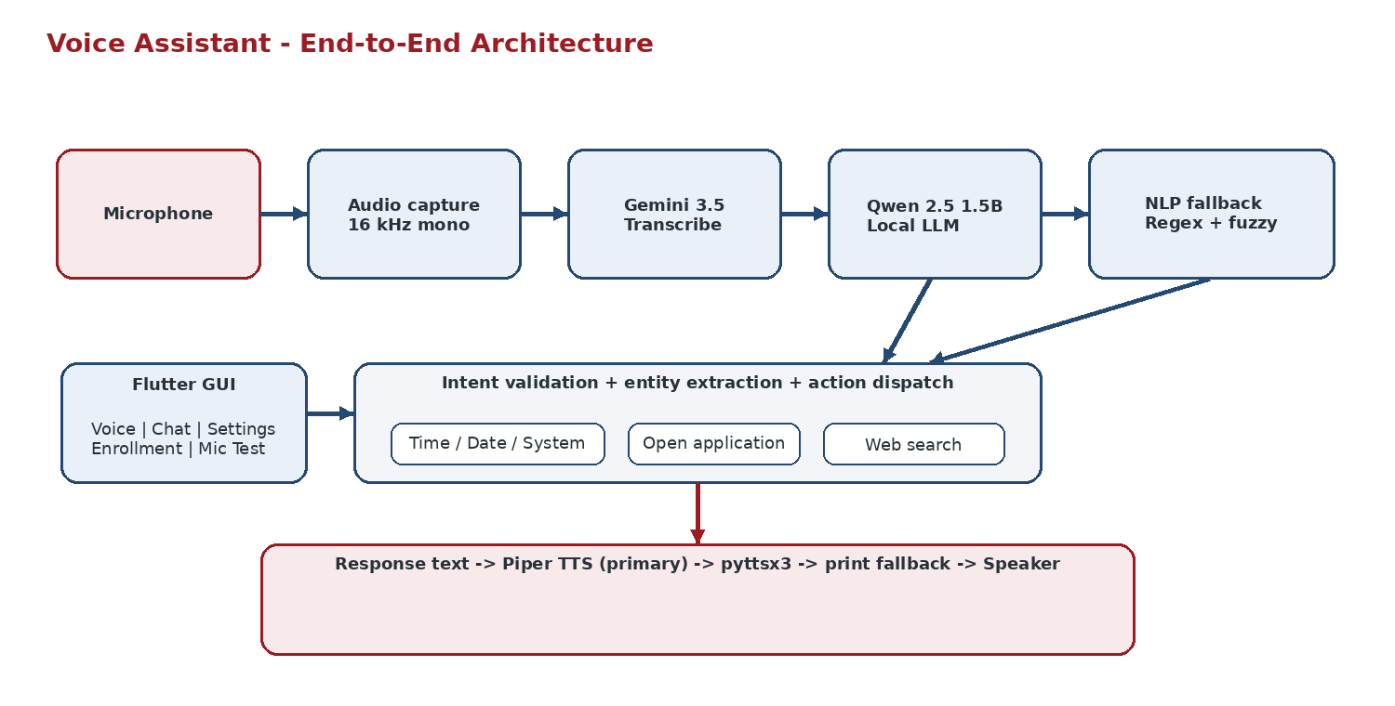
Figure 1. End-to-end system architecture.

21 Algorithm and Workflow
4.4 System Logic and AI / Robotics Pipeline

Main logic: receive voice/text input -> obtain text and language -> try the local LLM -> validate intent/entities/confidence -> fall back to regex/fuzzy NLP when needed -> execute action -> create response text -> synthesize with TTS -> emit GUI events.
Open-app resolution: normalize Arabic/English names -> check built-in transliteration -> check user aliases -> exact application index match -> fuzzy application match -> installation suggestion. Confirmed installation is a separate code path.
Language logic: STT language is the primary signal for short commands; longer text can be checked with langdetect, while Arabic-script detection is used as a final fallback.
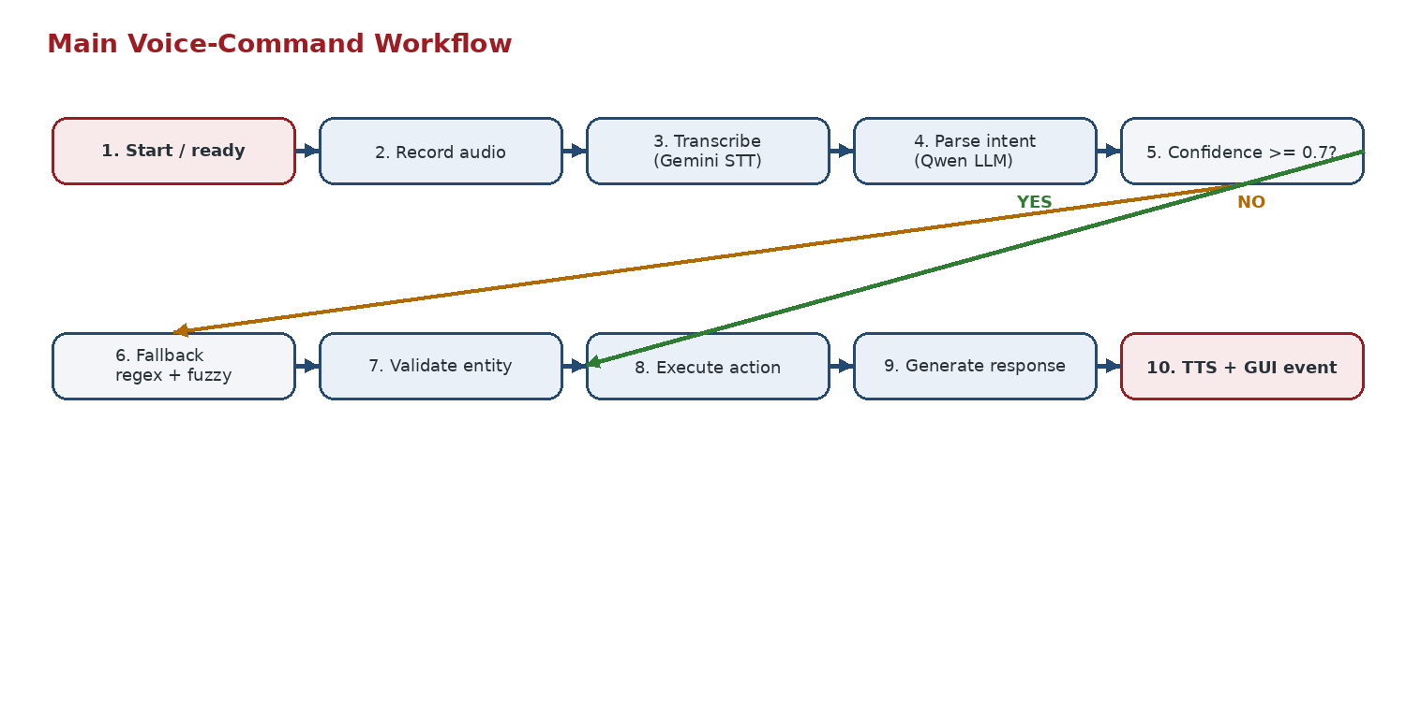
Figure 2. Main voice-command workflow.

22 Chapter 5 — Implementation
5.1 Setup and Integration Steps

1. Prepare a Linux development environment with Python 3.11+ and the system audio dependencies used by the repository.
2. Create the Python environment with uv or venv and install the project in editable mode, including the development tools. Install llama-cpp-python with GPU support when CUDA is available.
3. Configure the STT provider as Gemini and provide GEMINI_API_KEY (or the corresponding configuration value). Keep secrets outside source control.
4. Download/place the Qwen2.5-1.5B GGUF model at models/llm/qwen2.5-1.5b-instruct-q4_k_m.gguf and the configured Piper voice models under models/tts/.
5. Run backend smoke tests through CLI modes such as --once --text, --list-intents, --test-mic, and --enroll before launching the GUI.
6. Install Flutter dependencies and launch the GUI. The GUI starts voice-assistant --gui-mode as a child process and uses the configured CLI path/working directory.
7. Verify the full path: connect -> issue voice or text command -> observe transcription/response/TTS status -> inspect errors and diagnostics -> repeat with Arabic and code-switched commands.

23 Programming and Configuration
5.2 Code Structure and Key Functions

Python entry point: voice_assistant/main.py owns the VoiceAssistant class, CLI options, engine lifecycle, interaction loops, and high-level intent execution.
GUI protocol: voice_assistant/gui_mode.py defines GuiSession and the JSONL command/event protocol used by Flutter.
STT: core/stt_engine.py defines the engine contract/factory; core/stt_gemini.py implements recording, gain control, WAV encoding, Gemini upload/transcription, language mapping, and rate-limit retries.
Semantic parsing: core/llm_engine.py loads Qwen2.5-1.5B GGUF with llama-cpp-python, builds the bilingual prompt, parses JSON, validates results, and generates fallback response text.
Deterministic NLP: core/nlp_engine.py loads config/intents.json, compiles Arabic/English regex patterns, extracts entities, detects language, and applies fuzzy matching.
Actions: core/actions.py handles time/date/system info, desktop app indexing and launching, Arabic transliteration/aliases, fuzzy app resolution, and search/install suggestions.
TTS and Flutter: core/tts_engine.py provides Piper -> pyttsx3 -> print fallback; Flutter services manage process/events/state while UI files render Voice, Chat, Settings, Enrollment, and Microphone Test.

24 Application Scenario
5.3 Complete System Operation

Initial state: the Flutter application starts, loads persistent settings, creates Provider-managed services, and starts the Python backend in --gui-mode. The Python session emits a ready status event.
User input: the user taps the microphone button. Flutter sends a voice_command JSON object. The backend emits listening, records audio, transcribes it, and emits a transcription event with the detected language.
Decision: the backend passes the text to process_text. Qwen may return a structured open_app intent with an app entity; otherwise the regex/fuzzy fallback can infer the same application from Arabic or English wording.
Action: open_app resolves the application using normalization, aliases, application indexing, and fuzzy matching. On success, the application is launched as a separate process.
Output: the backend emits a response event and speaks the response through local TTS, then emits tts_playing. Flutter updates the conversation state and microphone visual state without reimplementing the backend logic.
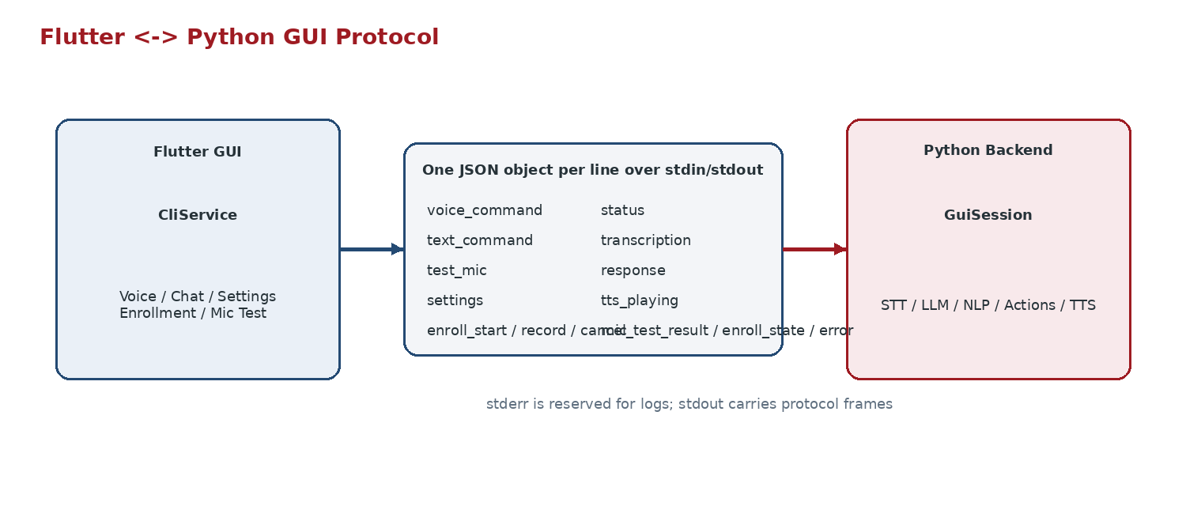
Figure 3. Flutter-Python JSON-lines protocol.

25 Chapter 6 — Testing
6.1 Test Plan and Test Cases

ID | Test | Input / Condition | Expected | Actual | Status
T-01 | Text command | "what time is it" via --once --text | get_time + TTS response | Test asserts NLP/action/TTS calls | Pass*
T-02 | GUI voice event order | voice_command with fake STT/TTS | listening -> transcription -> response -> tts_playing | Protocol test asserts ordering | Pass*
T-03 | Silence handling | STT returns empty text | no-speech status; session continues | GUI-mode test covers repeated voice commands | Pass*
T-04 | Runtime settings | gain=1.75, auto_gain=true, language=ar | STT settings updated | GUI-mode test checks live values | Pass*
T-05 | Microphone diagnostics | test_mic duration=2.0 | mic_test_result with RMS/peak/clipping/language | Protocol test checks required keys | Pass*
T-06 | Error recovery | missing mic / unknown intent / action error / TTS error | fallback response; process does not crash | Integration tests assert exit code 0 and recovery | Pass*
T-07 | Enrollment | start + six captures | six phrases saved; completion event | GUI-mode tests assert state sequence and saved file | Pass*

* “Pass” indicates that the repository contains an automated assertion for the behavior; tests were not independently executed during report generation.
The CI workflow is configured to run these tests on Ubuntu with Python 3.12 and a coverage gate of at least 50% for core/.

26 Results and Evaluation
6.2 Measurements and Observed Performance

End-to-end latency: The repository README documents about 1.5-2.0 seconds from speech end to audio start on the tested RTX 3050 Ti 4 GB configuration. The documented component figures are about 300 ms for local Qwen intent parsing and about 300 ms for Piper TTS.
STT: The target is below 1.5 seconds, but actual time depends on network and Gemini API latency. The current implementation is therefore not fully offline for speech recognition.
Supported intent coverage: Five operational intents are defined: get_time, get_date, get_sys_info, open_app, and web_search, with unknown as the failure class. The microphone test reports RMS, peak, clipping, detected language, transcription, assessment, and suggested gain.
Engineering quality: The repository contains unit/integration tests, Ruff formatting/linting, mypy type checking, package build, pre-commit checks, and CI with a 50% core coverage floor.
Interpretation: The strongest documented result is a compact, testable end-to-end pipeline rather than a broad conversational feature set. Performance values are repository-documented under a specific hardware/API configuration and should not be treated as universal benchmarks.

27 Discussion and Limitations
6.3 Interpretation of Results

What worked well: the modular engine design isolates speech recognition, semantic parsing, deterministic fallback, action execution, and TTS. This makes the project easier to test and easier to explain in a field-training setting.
What worked well: the hybrid intent strategy combines LLM flexibility with deterministic behavior. The repo explicitly handles Egyptian Arabic normalization, application aliases, code-switching, and fuzzy desktop application matching.
Limitation 1 - cloud STT: the current STT factory supports Gemini only and raises an error when credentials are absent. Spoken interaction therefore depends on network/API availability; the project is not fully offline despite some “offline-first” wording in metadata.
Limitation 2 - action correctness: the high-confidence LLM path returns the model-generated response for time, date, and system-info intents instead of always calling the authoritative local action functions. A future revision should execute the local action first and use the LLM only for phrasing.
Limitation 3 - GUI/backend mismatches: the Flutter test-microphone command model currently serializes duration into a text field and does not forward gain in the generated command object, while the Python protocol expects explicit duration/gain fields. The backend consequently falls back to its defaults for this path.
Limitation 4 - Auto Start: the setting is persisted in Flutter, but HomePage currently starts the CLI during initialization regardless of the stored Auto Start value. The option therefore behaves more like a stored preference than a complete startup policy.
Limitation 5 - installation confirmation: the backend has a confirmation parameter and a background installation path, but the current GUI protocol does not implement a full interactive confirmation dialogue before installation. This should be treated as an unfinished safety feature.
Corrective direction: prioritize protocol/data-model consistency, authoritative action execution for dynamic facts, a local STT fallback, and explicit confirmation UX for side-effecting operations.

28 Chapter 7 — Conclusion and Future Work
Summary, Learning Outcomes and Next Steps

The project implemented a bilingual desktop voice assistant with a Python CLI/backend and a Flutter GUI. The system combines Gemini cloud speech recognition, a local Qwen2.5-1.5B intent parser, deterministic regex/fuzzy NLP fallback, Linux desktop actions, and local TTS.
The main architectural achievement is separation of concerns: the Python core owns the AI and action pipeline, while Flutter provides the user-facing interaction layer through a simple JSON-lines protocol. This keeps the same capabilities available to CLI and GUI users.
The field-training work also developed skills in Python software architecture, audio handling, language processing, local model inference, Linux process automation, Flutter state management, inter-process communication, automated testing, type checking, CI, and technical documentation.
Recommended next steps: add a local/offline STT provider; expand the intent/action catalog; route dynamic facts through deterministic action functions; complete safe installation confirmation; fix GUI/backend command-model mismatches; connect the Auto Start setting to startup behavior; add multi-turn context and richer evaluation across microphones, environments, and Arabic dialect variation.

29 References

[1] Rasa, "Intents and Entities," Rasa Documentation, 2026. https://rasa.com/docs/reference/primitives/intents-and-entities/
[2] Rhasspy, "Intent Handling," project documentation, 2026. https://github.com/rhasspy/rhasspy/blob/master/docs/intent-handling.md
[3] OpenVoiceOS, "Installation and Extras," project documentation, 2026. https://github.com/OpenVoiceOS/OpenVoiceOS/blob/main/docs/installation.md
[4] Qwen Team, "Qwen2.5-1.5B-Instruct," Hugging Face model card, 2024. https://huggingface.co/Qwen/Qwen2.5-1.5B-Instruct
[5] Open Home Foundation, "Piper: Fast and local neural text-to-speech engine," GitHub, 2026. https://github.com/OHF-Voice/piper1-gpl
[6] Flutter, "shared_preferences," pub.dev package documentation, 2026. https://pub.dev/packages/shared_preferences

30 Appendices
Supporting Evidence and Project Records

Appendix A - Backend structure: config.yaml; config/intents.json; voice_assistant/main.py; voice_assistant/gui_mode.py; voice_assistant/enrollment.py; core/stt_gemini.py; core/llm_engine.py; core/nlp_engine.py; core/actions.py; core/tts_engine.py.
Appendix A - Flutter structure: lib/main.dart; services/cli_service.dart; services/chat_service.dart; services/settings_service.dart; models/command.dart; models/response.dart; ui/home_page.dart; ui/chat_view.dart; ui/settings_page.dart; ui/enrollment_screen.dart; ui/mic_button.dart.
Appendix B - Protocol commands: voice_command, text_command, test_mic, settings, enroll_start, enroll_record, enroll_cancel.
Appendix B - Protocol events: status, transcription, response, tts_playing, mic_test_result, enroll_state, error.
Appendix B - Enrollment set: six phrases - three Arabic and three English - covering greeting, application opening, and time queries.
Appendix B - Testing evidence: integration and GUI protocol tests cover the full mocked pipeline, error recovery, event ordering, settings, microphone diagnostics, silence handling, enrollment, and working-directory behavior.
Appendix C - Repository quality controls: Ruff, mypy, pytest/coverage, package build, and pre-commit checks are defined in CI.
Appendix D - Known integration limitations: the Flutter mic-test factory does not serialize duration/gain in the same fields expected by the Python protocol; Auto Start is stored as a preference but startup currently starts the CLI unconditionally; the debug environment loader references GROQ_API_KEY although backend STT is configured for Gemini.
Evidence note: No passwords, API keys, private network details, or machine-specific secrets are included in this report. Repository-defined behavior and documented measurements are used.

