Smart Odoo


Prepared by :

Omar Ahmed Wahby Emam - 20236554919

Supervisor : Dr. Ahmed Moustafa
2025/2026

Contents :
1 Introduction 4
1.1 Background . . . . . . . . . . . . . . . . . . . . . . . . . . . . . . . . . . . . . . . . . 4
1.2 Motivation . . . . . . . . . . . . . . . . . . . . . . . . . . . . . . . . . . . . . . . . . . 4
1.3 Problem Statement . . . . . . . . . . . . . . . . . . . . . . . . . . . . . . . . . . . 6
1.4 Goals . . . . . . . . . . . . . . . . . . . . . . . . . . . . . . . . . . . . . . . . . . . . . . 7
1.5 Currently Available Solutions . . . . . . . . . . . . . . . . . . . . . . . . . . . . 8
1.6 Feature Matrix . . . . . . . . . . . . . . . . . . . . . . . . . . . . . . . . . . . . . . . 9
1.7 Final Result. . . . . . . . . . . . . . . . . . . . . . . . . . . . . . . . . . . . . . . . . . 10
1.8 Software Methodology . . . . . . . . . . . . . . . . . . . . . . . . . . . . . . . . . 10
2 Requirements Analysis 11
2.1 Functional Requirements . . . . . . . . . . . . . . . . . . . . . . . . . . . . . . . 11
2.2 Non-Functional Requirements . . . . . . . . . . . . . . . . . . . . . . . . . . . 12
2.3 Use Case Diagram . . . . . . . . . . . . . . . . . . . . . . . . . . . . . . . . . . . . 13
3 System Design 14
3.1 Sequence Diagram . . . . . . . . . . . . . . . . . . . . . . . . . . . . . . . . . . . . 14
3.2 Entity Relationship Diagram ( ERD ) . . . . . . . . . . . . . . . . . . . . . . . 15
3.2.1 Online Analytical Processing (OLAP) . . . . . . . . . . . . . . . . . . 15
3.2.2 Online Transaction Processing (OLTP) . . . . . . . . . . . . . . . . 16
3.3 Data Flow Diagram . . . . . . . . . . . . . . . . . . . . . . . . . . . . . . . . . . . . 17
3.4 State Diagram . . . . . . . . . . . . . . . . . . . . . . . . . . . . . . . . . . . . . . . . 18
3.5 Use Case Diagram . . . . . . . . . . . . . . . . . . . . . . . . . . . . . . . . . . . . . 19
4 Implementation Aspects 20
4.1 System Architecture. . . . . . . . . . . . . . . . . . . . . . . . . . . . . . . . . . . 20
4.2 Tools and Technologies . . . . . . . . . . . . . . . . . . . . . . . . . . . . . . . . 22
4.2.1 Data Engineering Technologies. . . . . . . . . . . . . . . . . . . . . . 22
4.2.2 Business Intelligence Technologies . . . . . . . . . . . . . . . . . . . 23
4.2.3 Full Stack Web Technologies . . . . . . . . . . . . . . . . . . . . . . . 24
4.3 Prototype . . . . . . . . . . . . . . . . . . . . . . . . . . . . . . . . . . . . . . . . . . . 26
5 Data Engineering 27
5.1 Data Source . . . . . . . . . . . . . . . . . . . . . . . . . . . . . . . . . . . . . . . . . 27
5.2 Odoo Ingestion Layer . . . . . . . . . . . . . . . . . . . . . . . . . . . . . . . . . . 27
5.3 Medallion Data Architecture . . . . . . . . . . . . . . . . . . . . . . . . . . . . . 28
5.4 Bronze Layer . . . . . . . . . . . . . . . . . . . . . . . . . . . . . . . . . . . . . . . . . 29
5.5 Silver Layer . . . . . . . . . . . . . . . . . . . . . . . . . . . . . . . . . . . . . . . . . . 30
5.6 Gold Layer . . . . . . . . . . . . . . . . . . . . . . . . . . . . . . . . . . . . . . . . . . 30
5.6.1 Galaxy Schema . . . . . . . . . . . . . . . . . . . . . . . . . . . . . . . . . . 31
5.6.2 Gold Layer Tables . . . . . . . . . . . . . . . . . . . . . . . . . . . . . . . . 32
5.7 Data Pipeline Orchestration . . . . . . . . . . . . . . . . . . . . . . . . . . . . . 33
5.8 Security and Access Control . . . . . . . . . . . . . . . . . . . . . . . . . . . . . 35
5.9 Data Consumption Layer . . . . . . . . . . . . . . . . . . . . . . . . . . . . . . . . 36

6 Business Intelligence & Analytics 37
6.1 Business Intelligence Platform Overview . . . . . . . . . . . . . . . . . . . 37
6.2 Dashboard Portfolio Overview . . . . . . . . . . . . . . . . . . . . . . . . . . . 38
6.3 Semantic Model Architecture . . . . . . . . . . . . . . . . . . . . . . . . . . . 39
6.4 Domain-Oriented Data Marts . . . . . . . . . . . . . . . . . . . . . . . . . . . 40
6.5 Business Analytics Dashboards . . . . . . . . . . . . . . . . . . . . . . . . . . 46
6.5.1 Revenue Performance Analytics . . . . . . . . . . . . . . . . . . . . . 46
6.5.2 Procurement Analytics . . . . . . . . . . . . . . . . . . . . . . . . . . . . 48
6.5.3 Inventory Analytics . . . . . . . . . . . . . . . . . . . . . . . . . . . . . . . 49
6.5.4 CRM Analytics . . . . . . . . . . . . . . . . . . . . . . . . . . . . . . . . . . . 52
6.5.5 HR Analytics . . . . . . . . . . . . . . . . . . . . . . . . . . . . . . . . . . . . 54
6.5.6 Invoice Analytics . . . . . . . . . . . . . . . . . . . . . . . . . . . . . . . . . 55
6.6 KPIs Framework . . . . . . . . . . . . . . . . . . . . . . . . . . . . . . . . . . . . . . 58
6.7 Reusable Analytical Data Marts . . . . . . . . . . . . . . . . . . . . . . . . . . 59
6.8 Navigation and User Experience . . . . . . . . . . . . . . . . . . . . . . . . . . 60
6.8.1 Multi-Level Navigation System . . . . . . . . . . . . . . . . . . . . . . 61
6.8.2 Domain Filter Panels . . . . . . . . . . . . . . . . . . . . . . . . . . . . . 62
6.8.3 Global Date Control Panel . . . . . . . . . . . . . . . . . . . . . . . . . 63
6.8.4 Detailed Analysis Navigation . . . . . . . . . . . . . . . . . . . . . . . 64

7 Machine Learning & Predictive Analytics 65
7.1 Overview . . . . . . . . . . . . . . . . . . . . . . . . . . . . . . . . . . . . . . . . . . . . 65
7.2 Business Domains and System Vision . . . . . . . . . . . . . . . . . . . . . 65
7.3 Data Description . . . . . . . . . . . . . . . . . . . . . . . . . . . . . . . . . . . . . . 66
7.4 Data Preprocessing and Feature Engineering . . . . . . . . . . . . . . . 67
7.5 Model Descriptions . . . . . . . . . . . . . . . . . . . . . . . . . . . . . . . . . . . . 67
7.5.1 Sales Forecasting Model . . . . . . . . . . . . . . . . . . . . . . . . . . . 67
7.5.2 Inventory Movement Prediction Model . . . . . . . . . . . . . . . . . 68
7.5.3 Inventory Stockout Prediction Model . . . . . . . . . . . . . . . . . . 68
7.5.4 Lead Scoring Model . . . . . . . . . . . . . . . . . . . . . . . . . . . . . . . 69
7.5.5 Invoice Payment Delay Prediction Model . . . . . . . . . . . . . . . 69
7.5.6 Customer Segmentation Model . . . . . . . . . . . . . . . . . . . . . . 70
7.6 Model Training and Validation Strategy . . . . . . . . . . . . . . . . . . . . . 70
7.7 Evaluation Metrics and Business Justification . . . . . . . . . . . . . . . . 71
7.8 Results and Business Insights . . . . . . . . . . . . . . . . . . . . . . . . . . . 71
7.9 System Architecture and Model Integration . . . . . . . . . . . . . . . . . 72
7.10 Model Usage and Deployment Considerations . . . . . . . . . . . . . . . 72
7.11 Limitations . . . . . . . . . . . . . . . . . . . . . . . . . . . . . . . . . . . . . . . . . . . 72

8 Conclusion 73
8.1 Conclusion . . . . . . . . . . . . . . . . . . . . . . . . . . . . . . . . . . . . . . . . . . . . . . 73
8.2 Future Enhancements . . . . . . . . . . . . . . . . . . . . . . . . . . . . . . . . . . . . . 74
8.3 Reference . . . . . . . . . . . . . . . . . . . . . . . . . . . . . . . . . . . . . . . . . . . . . . . 75

Chapter 1

Introduction

1.1 Background

Over the past decades, organizations have experienced significant growth in the volume, variety, and complexity of business data. Initially, many business operations such as accounting, inventory management, human resources, and sales tracking were performed manually using paper-based records. Although this approach was sufficient for small organizations, it was highly prone to errors, data loss, duplication, and inefficiencies.

As businesses expanded, spreadsheet applications such as Microsoft Excel became widely adopted as a digital alternative for storing and managing operational data. While spreadsheets improved data accessibility and reduced manual effort, they introduced new limitations when dealing with large-scale business environments. The increasing volume of transactions, growing number of departments, and diversity of data sources made spreadsheet-based management difficult to maintain, prone to inconsistency, and incapable of providing integrated organizational insights.

To address these challenges, Enterprise Resource Planning (ERP) systems emerged as a comprehensive solution for managing and integrating business processes across multiple departments within a single platform. Modern ERP systems, such as Odoo, provide a centralized environment that supports finance, sales, inventory, purchasing, manufacturing, human resources, customer relationship management, and many other business functions. These systems can contain hundreds of interconnected data models and generate vast amounts of operational data on a daily basis.
However, despite the advantages offered by ERP systems,extracting meaningful insights from such complex and highly interconnected datasets remains a significant challenge. Traditional reporting tools often provide limited analytical capabilities and may not adequately support advanced business intelligence, strategic decision-making, or predictive analytics Consequently, organizations require specialized analytical platforms capable of transforming raw ERP data into actionable insights that support operational efficiency and business growth.

1.2 Motivation
The rapid growth of enterprise data has created an increasing demand for intelligent analytical solutions that can transform raw operational data into valuable business insights. Although ERP systems such as Odoo successfully centralize and manage organizational data, decision-makers often face difficulties in accessing clear, comprehensive, and real-time analytical information.

Many organizations rely on fragmented reports, manual analysis, or basic dashboarding capabilities that do not fully exploit the potential of their data assets. As a result, important patterns, trends, and performance indicators may remain hidden, limiting the organization's ability to make informed decisions.

The motivation behind the Smart Odoo is to bridge the gap between enterprise data management and advanced business analytics. The proposed solution aims to provide an integrated analytical platform that consolidates ERP data, applies modern data engineering and business intelligence techniques, and delivers interactive dashboards, key performance indicators (KPIs), and data-driven insights.
By doing so, Smart Odoo enables organizations to improve decision-making processes, enhance operational visibility, and unlock greater value from their existing ERP infrastructure.

1.3 Problem Statement
Modern ERP systems such as Odoo generate and store massive amounts of business data across multiple organizational functions, including finance, sales, inventory, purchasing, human resources, manufacturing, and customer relationship management. While this data is valuable for decision-making, its volume, complexity, and highly interconnected structure make it difficult for organizations to efficiently extract meaningful insights.

Although Odoo provides a set of built-in reports and operational views, these capabilities are often insufficient for comprehensive business intelligence and cross-departmental analysis. Decision-makers frequently face challenges in obtaining a unified view of organizational performance, monitoring key performance indicators, identifying trends, and performing advanced analytical investigations.

Furthermore, the growing number of data models, transactions, and business processes increases the complexity of analyzing enterprise data manually or through traditional reporting methods. This creates a gap between data availability and data-driven decision-making.

Therefore, there is a need for an integrated analytics platform capable of consolidating data from multiple Odoo modules, transforming raw operational data into meaningful information, and delivering interactive visualizations, business intelligence dashboards, and actionable insights that support strategic and operational decision

1.4 Goals
The Smart Odoo aims to develop an integrated Business Intelligence and Analytics platform that transforms complex ERP data into actionable insights for decision-makers. The main objectives of the project are as follows:
1. Integrate data from multiple Odoo modules.
2. Build a centralized analytical platform.
3. Establish a dedicated OLAP environment.
4. Automate data extraction and transformation processes.
5. Improve data quality and consistency.
6. Develop an optimized analytical data model.
7. Provide interactive business intelligence dashboards.
8. Monitor organizational KPIs in real time.
9. Enable cross-departmental business analysis.
10. Generate actionable business insights.
11. Reduce manual reporting efforts.
12. Improve operational decision-making.
13. Support predictive analytics using machine learning models.
14. Enhance organizational performance visibility.

1.5 Currently Available Solutions
The following solutions are commonly used to analyze and report data from Odoo ERP systems:
- Odoo Native Reports
  - Built-in reports provided by Odoo.
  - Suitable for operational reporting.
  - Limited in advanced analytics and customization.
- Spreadsheet-Based Reporting
  - Tools such as Microsoft Excel and Google Sheets.
  - Widely used for manual analysis and reporting.
  - Difficult to maintain for large and complex datasets.
- Standalone Business Intelligence Solutions
  - Platforms such as Power BI, Tableau, and Qlik Sense.
  - Provide advanced visualization and analytical capabilities.
  - Require additional integration and data preparation efforts.
- Odoo Analytics Add-ons
  - Third-party analytical modules available through the Odoo Apps Store.
  - Offer additional dashboards and reporting features.
  - May involve licensing costs and limited customization depending on business requirements.
- Custom-Built Reporting Solutions
  - Tailor-made reporting developed for specific business needs.
  - Provide high flexibility and customization capabilities.
  - Require significant development, maintenance, and technical expertise.

1.6 Feature Matrix

Feature | Odoo Native Reports | Spreadsheet Reporting | Standalone BI Solutions | Odoo Analytics Add-ons | Smart Odoo
F1: Centralized Analytics Platform | ✗ | ✗ | ✗ | ✗ | ✓
F2: Cross-Department Analysis | ✗ | ✗ | ✓ | ✗ | ✓
F3: Interactive Dashboards | ✗ | ✗ | ✓ | ✓ | ✓
F4: Automated Data Integration | ✗ | ✗ | ✗ | ✗ | ✓
F5: OLAP Environment | ✗ | ✗ | ✗ | ✗ | ✓
F6: KPI Monitoring | ✗ | ✗ | ✓ | ✓ | ✓
F7: Real-Time Reporting | ✗ | ✗ | ✓ | ✗ | ✓
F8: Machine Learning Support | ✗ | ✗ | ✗ | ✗ | ✓
F9: Scalability | ✗ | ✗ | ✓ | ✗ | ✓
F10: Customization | ✗ | ✓ | ✓ | ✗ | ✓
Table 1.1: Feature Matrix

1.7 Final Result
Smart Odoo has successfully delivered the following outcomes :

- Improved visibility across business departments.
- Faster access to business insights and KPIs.
- Reduced manual reporting efforts.
- Enhanced data consistency and reliability.
- More efficient decision-making processes.
- Better utilization of enterprise data assets.
- Support for predictive and data-driven analytics.
- Increased operational efficiency through automation.

1.8 Software Methodology ( Iterative & Incremental )
The Smart Odoo project adopted the Iterative and Incremental Development methodology.
This methodology was selected because the project consists of multiple components, including UI/UX design, front-end development, back-end development, data engineering, business intelligence, and machine learning. The system was developed incrementally, where each component was implemented, tested, and enhanced throughout the project lifecycle.
The iterative approach allowed the team to continuously improve the system, integrate new features, and validate intermediate results while reducing development risks and improving overall project quality.

Chapter 2

Requirements Analysis

2.1 Functional Requirements
The system shall:
- Allow users to log in securely.
- Support role-based authorization.
- Display Sales Dashboard KPIs.
- Display Purchase Dashboard KPIs.
- Display HR Dashboard KPIs.
- Display Inventory Dashboard KPIs.
- Display CRM Dashboard KPIs.
- Retrieve data from Databricks.
- Generate charts and reports.
- Display recent transactions and activities.
- Cache frequently requested data to improve performance.
- Provide AI-powered business insights (future enhancement).

2.2 Non-Functional Requirements

- Performance
Dashboard pages should load quickly.
Cached data should reduce response time.

- Security
Authentication and authorization must be enforced.
User roles must restrict access to protected modules.

- Scalability
The system should support additional modules in the future.

- Reliability
Data retrieval should remain available and accurate.

- Usability
The user interface should be simple and easy to navigate.

- Maintainability
The system should follow a layered architecture to simplify future modifications.

2.3 Use Case Diagram

Overview
The Use Case Diagram represents the interaction between the system and its users.
The system is designed as an ERP Analytics Dashboard where users access business insights through email-based authentication.
Actor
- User
Use Cases
The system provides the following functionalities:
- Login using Email and Password
- Logout from the system
- View Sales Dashboard
- View Purchase Dashboard
- View HR Dashboard
- View Inventory Dashboard
- View CRM Dashboard
- View KPIs and Analytical Charts
- Retrieve Data from Databricks

Chapter 3

System Design

3.1 Sequence Diagram

For Example Sales Dashboard
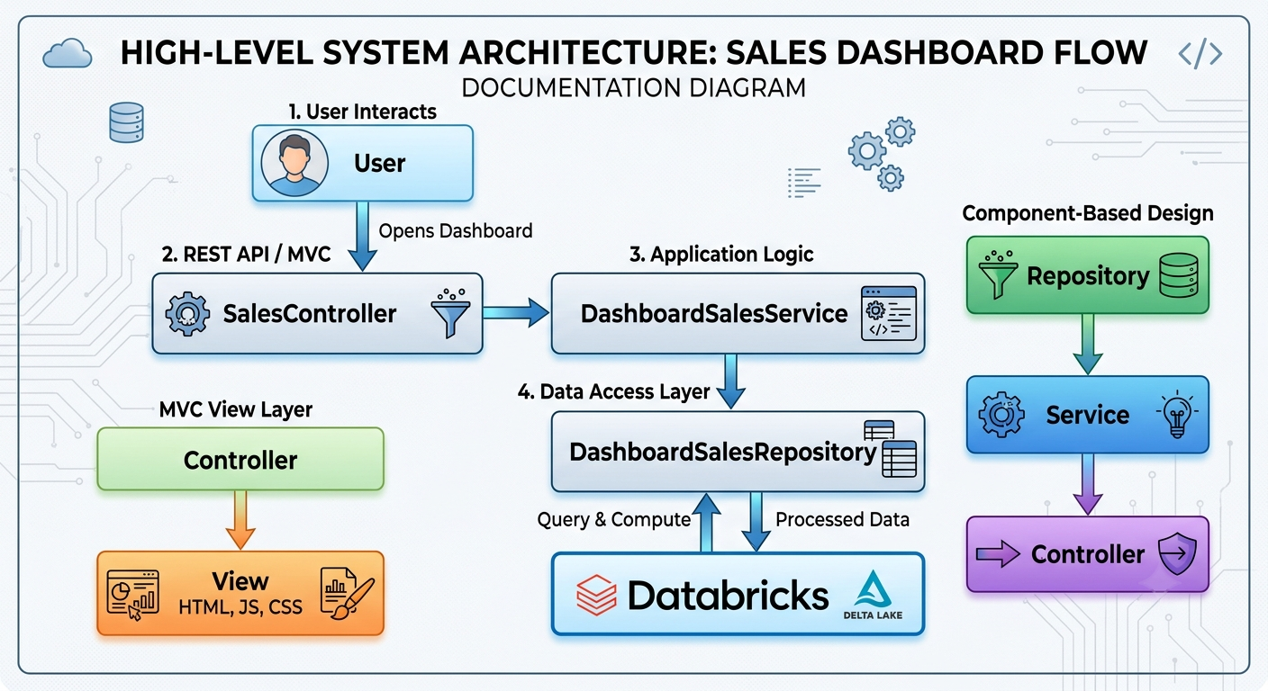
Figure 3.1: Sequence Diagram

When the user requests the Sales Dashboard, the controller receives the request and calls the service layer. The service layer communicates with the repository layer, which retrieves data from Databricks. The returned data is then passed back through the service layer to the controller and displayed in the dashboard view.

3.2 Entity Relationship Diagram ( ERD )

3.2.1 Online Transaction Processing (OLAP)

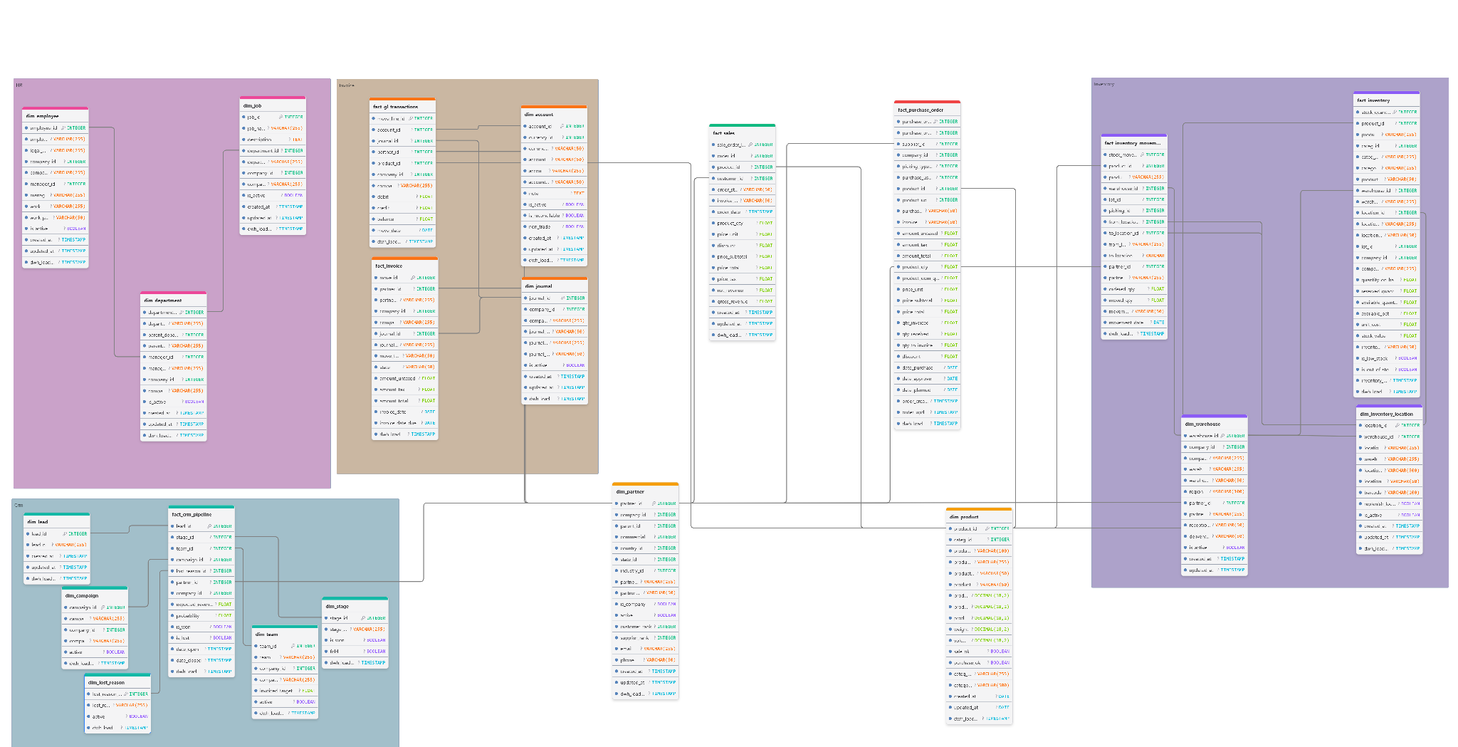
Figure 3.2 : Data Warehouse Schema

Figure 3.2 illustrates the analytical data model implemented within the Gold Layer of the Smart Odoo platform. The model follows a dimensional design approach, organizing enterprise data into fact and dimension tables across multiple business domains, including Sales, Purchasing, Inventory, Accounting, Human Resources, and CRM. This structure provides a unified and business-ready data foundation that supports reporting, analytics, and decision-making activities.

3.2.2 Online Transaction Processing (OLTP)

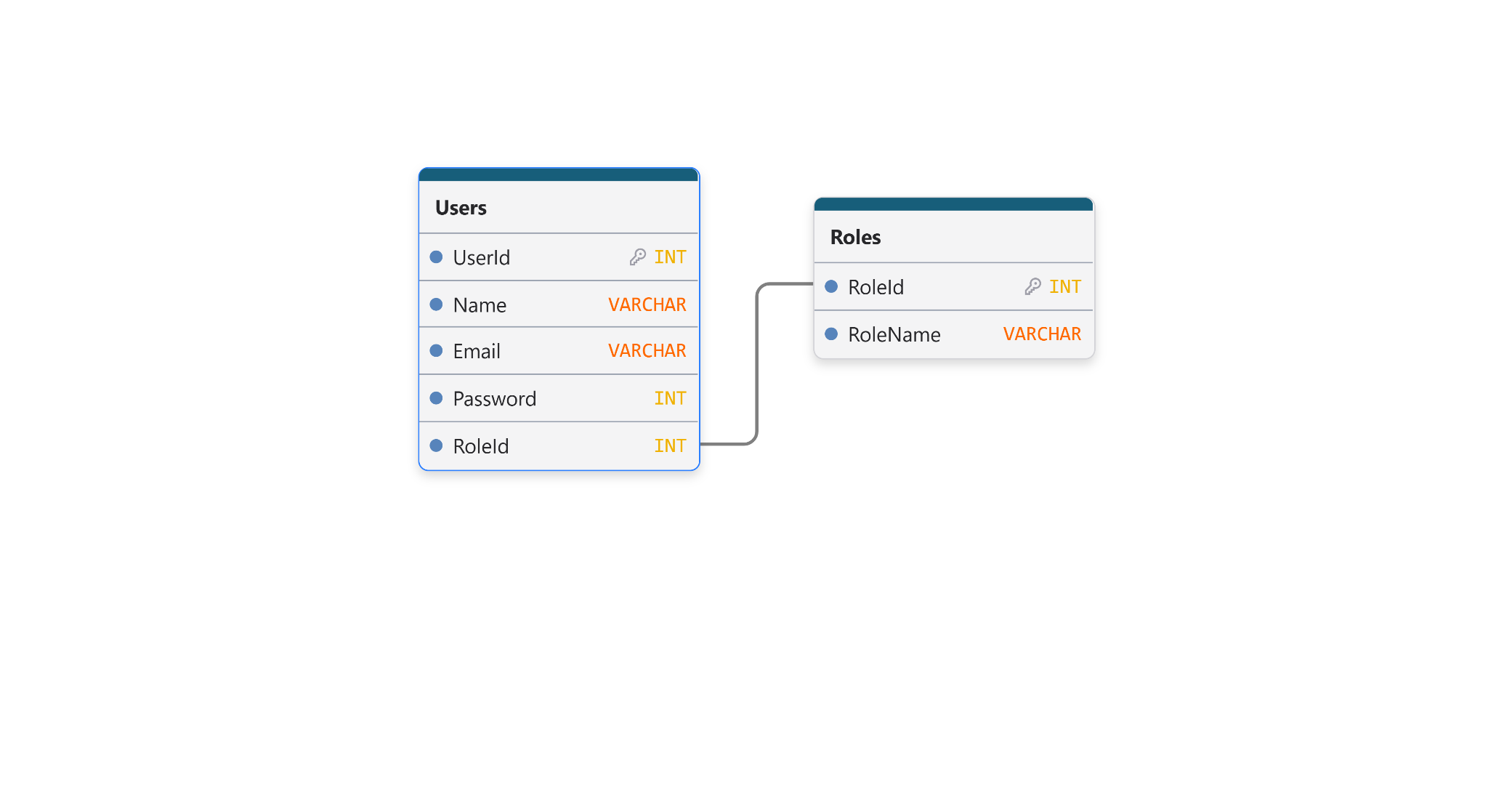
Figure 3.3 : Smart Odoo OLTP

3.3 Data Flow Diagram
DFD Level 0 :
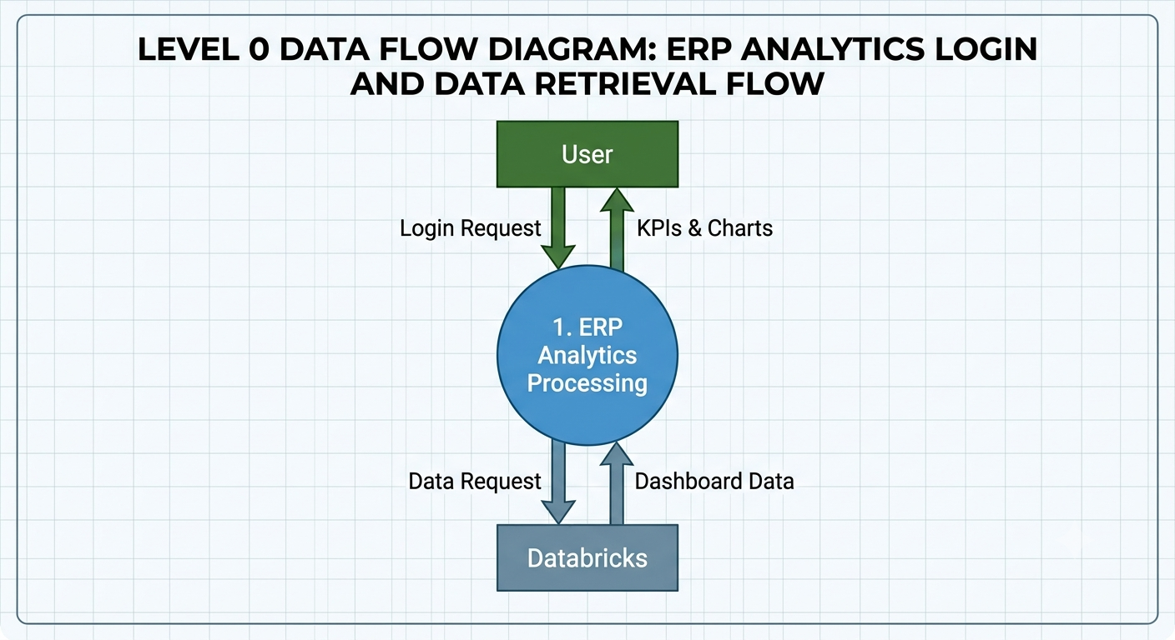
Figure 3.4 : DFD Level 0
DFD Level 1 :
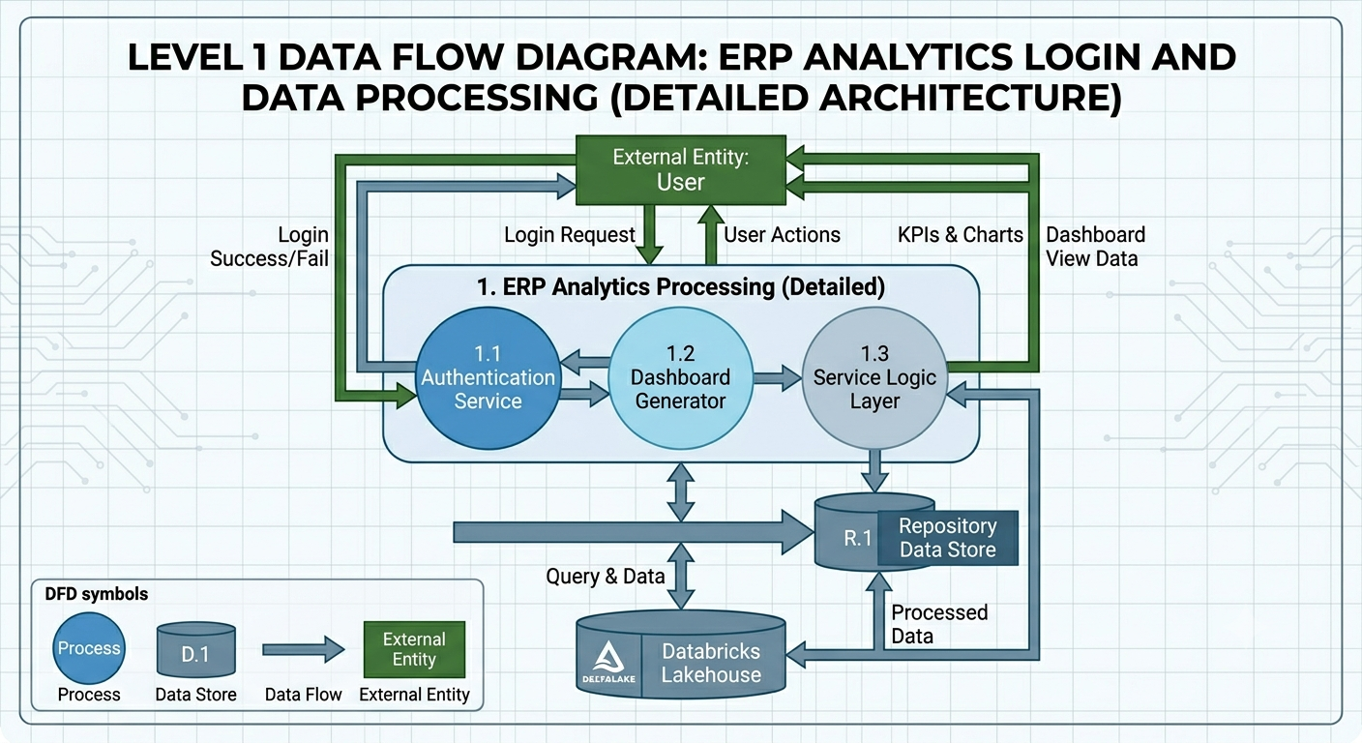
Figure 3.5 : DFD Level 1
The user interacts with the ERP Analytics System, which retrieves analytical data from Databricks and presents dashboards and reports.

3.4 State Diagram
The State Diagram represents the different states of user authentication within the ERP Analytics System. It shows the transition from accessing the login page, validating user credentials, granting access to dashboards, and logging out from the system.
The main states are:
- Login Page
- Authentication
- Login Failed
- Authenticated
- Dashboard View
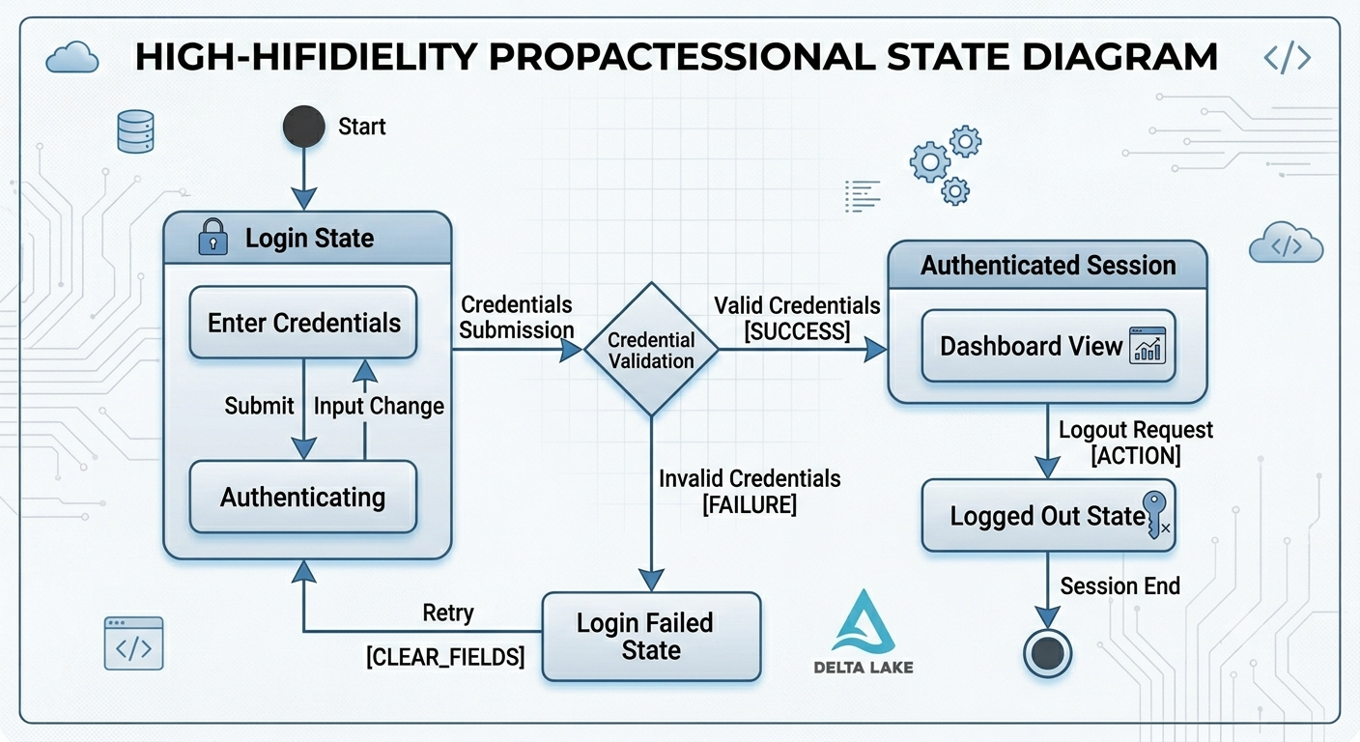
- Logged Out

Figure 3.6 : Authentication path

3.5 Use Case Diagram
The UML Class Diagram illustrates the structure of the ERP Analytics System by representing the main classes and their relationships.
The system follows a layered architecture consisting of Controllers, Services, Repositories, and Models.
- Controllers handle user requests and communicate with the Service Layer.
- Services contain the business logic and coordinate data retrieval operations.
- Repositories handle communication with the Databricks data source.
- Models represent the data structure transferred between different layers.
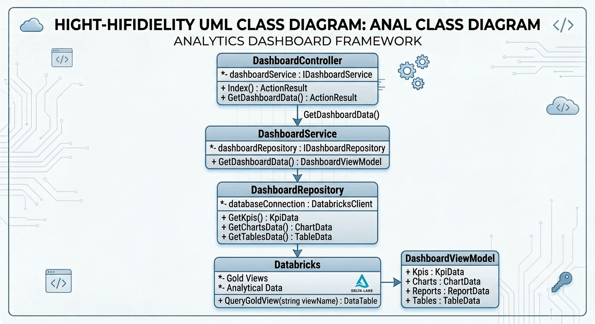
This architecture improves code organization, maintainability, and scalability.
Figure 3.7 : UML Diagram

Chapter 4

Implementation Aspects

4.1 System Architecture
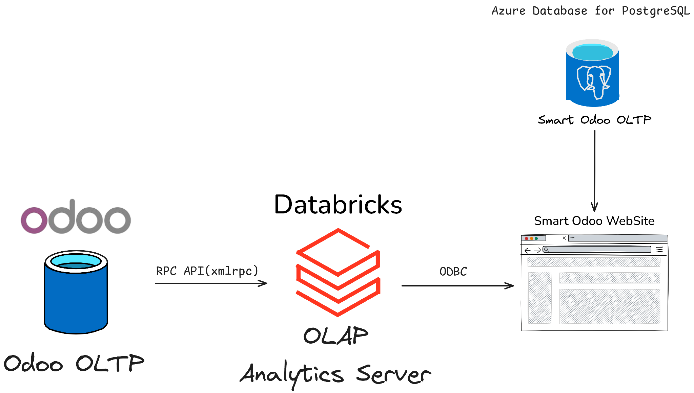
Figure 4.1: Overall System Architecture
Figure 4.1 shows the overall architecture of Smart Odoo. Data flows from the Odoo ERP system to the Databricks analytics server, where analytical processing is performed before the results are delivered to the Smart Odoo web platform.

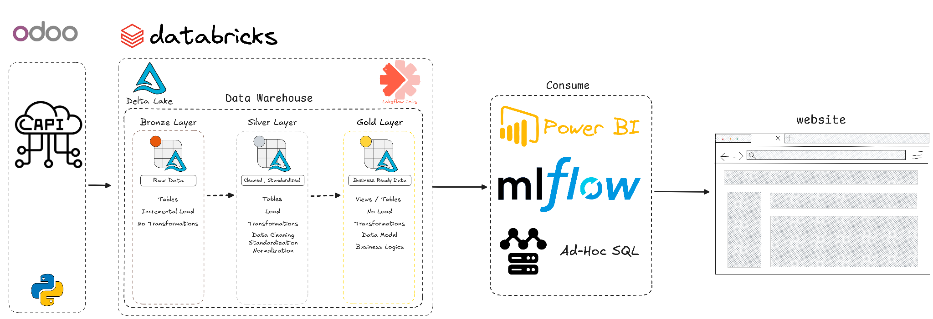
Figure 4.2: Analytics Server Architecture

Figure 4.2 presents the analytics architecture of the Smart Odoo platform. The architecture illustrates the flow of data from the Odoo ERP system to the analytics environment, where data is processed and prepared for business consumption. The platform leverages Databricks as the central analytics engine and integrates various technologies for data processing, reporting, machine learning, and visualization. The processed data is then consumed through analytical tools and delivered to the Smart Odoo web platform, enabling users to access insights and business intelligence services through a unified interface.

4.2 Tools and Technologies

4.2.1 Data Engineering Technologies

- Databricks served as the main analytics and processing platform, enabling large-scale data transformation, integration, and analytical operations.

- Delta Lake was used to provide reliable and efficient data storage with support for data consistency,versioning, and optimized analytical workloads.

- Databricks Asset Bundles were used to manage, package, and deploy analytics resources across different environments, improving project organization and deployment consistency.

- Python was utilized for data extraction, transformation, automation, and machine learning development throughout the project.

- Lakeflow Jobs were used to automate and schedule data processing workflows within the analytics environment.

- Apache Spark was used as the distributed processing engine within Databricks to handle large-scale data transformation, aggregation, and analytical workloads efficiently.

- PySpark was used to perform large-scale data transformation, cleansing, and processing tasks within the Databricks environment.

- Spark SQL was utilized to query, manipulate, and analyze large datasets efficiently using SQL-based operations on Spark.

- The XML-RPC protocol was used to establish communication with the Odoo ERP system and retrieve business data from multiple modules.

- ODBC was used to establish secure connectivity between Databricks and the Smart Odoo application, enabling access to analytical data and reporting services.

- Git and GitHub were used for version control, source code management, and collaborative development throughout the project lifecycle.

4.2.2 Business Intelligence Technologies

- Power BI & Power BI Service was used to develop interactive dashboards and visualizations that support business intelligence and decision-making processes.

- DAX (Data Analysis Expressions) was used to create calculated measures, business KPIs, and analytical logic within Power BI reports.

- Dimensional Data Modeling Techniques were used to organize enterprise data into fact and dimension tables, enabling efficient analytical processing and business intelligence reporting.

4.2.3 FullStack Web Technologies
- ASP.NET MVC was used as the main web application framework, providing a structured Model-View-Controller architecture that separates business logic, data access, and user interface components, improving maintainability and scalability.

- C# was used as the primary programming language for implementing the application's business logic, controllers, services, and data access layers.

- Entity Framework Core was utilized as the Object-Relational Mapper (ORM) to simplify database interactions, manage entities, and reduce the complexity of writing raw SQL queries.

- Repository Pattern was adopted to separate data access logic from business logic, resulting in a cleaner architecture and improved maintainability.

- Service Layer Architecture was implemented to centralize business rules and coordinate communication between controllers and repositories.

- Memory Caching was used to improve dashboard performance by reducing repetitive requests to Databricks and storing frequently accessed analytical data temporarily.

- Asynchronous Programming (Async/Await) was utilized to improve system responsiveness and execute multiple data retrieval operations concurrently.

- Bootstrap was used to build responsive and modern user interfaces that adapt to different screen sizes and devices.

- JavaScript was utilized to provide client-side interactivity, dynamic content updates, and enhanced user experience throughout the application.

- Chart.js was used to visualize business data through interactive charts, graphs, and KPI dashboards.

- Role-Based Authentication and Authorization were implemented using ASP.NET Identity to secure the application and control access to system resources based on user permissions.

- Azure PostgreSQL was utilized to provide a cloud-hosted database environment for the Smart Odoo, ensuring scalability, availability, and centralized data access.

4.3 Prototype
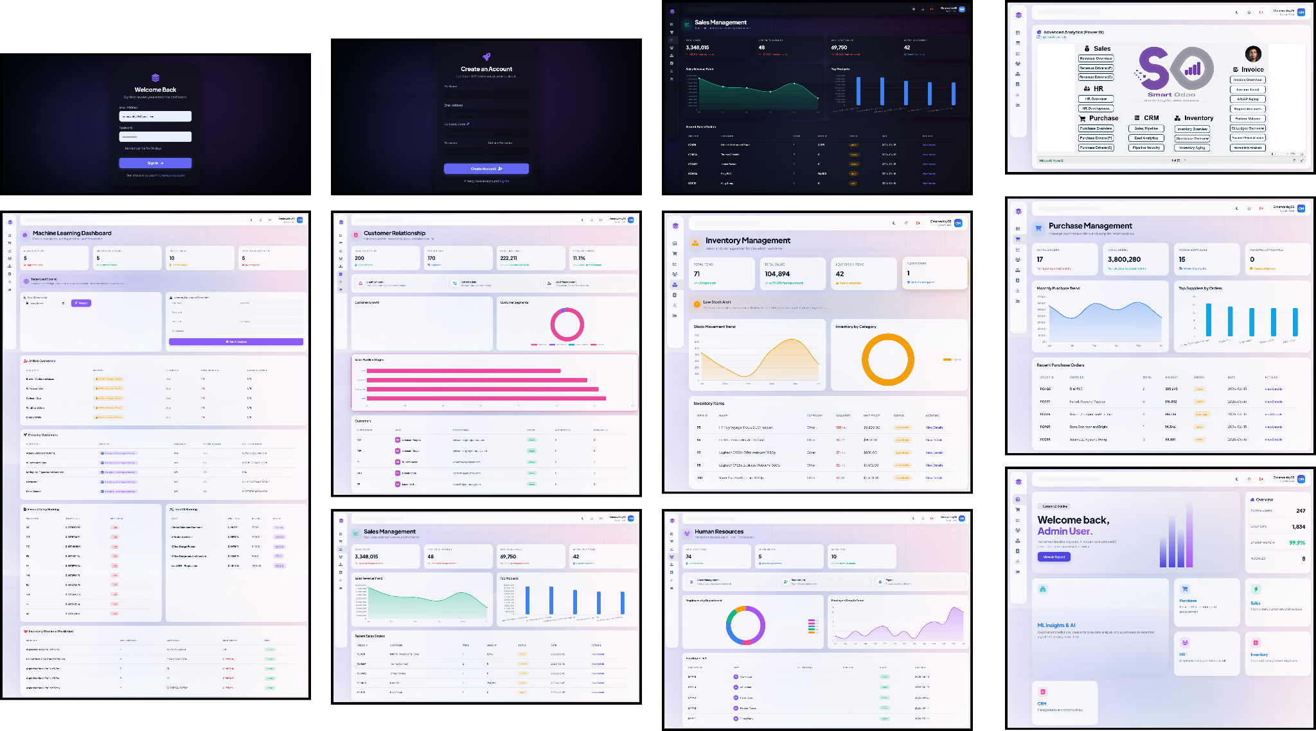
Figure 4.3 : Website Prototype

Chapter 5

Data Engineering

5.1 Data Sources
The primary data source for Smart Odoo is the Odoo ERP system. The Odoo database contains 570 tables covering technical, configuration, and operational data. However, not all tables provide analytical value. Therefore, a source assessment process was conducted to identify and select only business-relevant entities for the analytics platform. The selected datasets focused on core business domains, including :

- Sales
- Purchasing
- Inventory
- Accounting
- Human Resources
- Customer Relationship Management (CRM)
These modules generate large volumes of interconnected operational data that serve as the foundation for analytical processing, business intelligence, and decision-making activities within the Smart Odoo platform.

5.2 Odoo Ingestion Layer

To extract data from the Odoo ERP system, a dedicated ingestion layer was developed using Python and the XML-RPC protocol. The ingestion process connects to the Odoo API, retrieves business-relevant entities, and loads them into the analytics environment for further processing.

The ingestion layer was designed to support multiple business domains,
ensuring consistent and automated data collection from the source system.

5.3 Medallion Data Architecture

Figure 5.1: Medallion Data Architecture

Figure 5.1 illustrates the Medallion Data Architecture adopted in Smart Odoo. The architecture is designed to transform operational data extracted from the Odoo ERP system into business-ready analytical datasets. Data progresses through a series of refinement layers, where it is ingested, standardized, and modeled before being delivered to reporting, analytics, and decision-support applications. This layered approach improves data quality, scalability, and maintainability while providing a reliable foundation for enterprise analytics.

5.4 Bronze Layer
The Bronze Layer serves as the raw data ingestion layer within the Smart Odoo analytics platform. Data extracted from the Odoo ERP system is stored in Delta Lake tables while preserving the original source structure, including table schemas and column names.
The initial data load is performed as a full load, while subsequent loads are executed incrementally using the Odoo write_date field. This approach enables the platform to capture newly created and updated records efficiently while minimizing data movement and processing overhead.
To maintain complete traceability, metadata columns such as dwh_loaded_at and dwh_source_db are added during ingestion. No business transformations, validations, or data cleansing operations are applied at this stage.
The primary objective of the Bronze Layer is to maintain an accurate and reliable copy of the operational data source, providing a consistent foundation for downstream processing in the Silver and Gold layers.

Any updates made to records in the Odoo ERP system are automatically reflected in the Bronze Layer through the incremental loading mechanism based on the write_date field.

5.5 Silver Layer
The Silver Layer serves as the data preparation and standardization layer within the Smart Odoo platform. Data is loaded incrementally from the Bronze Layer using the same change-tracking mechanism based on the write_date field, ensuring that new and updated records are continuously propagated through the pipeline.
At this stage, data is transformed into a more structured and analytics-ready format. Key processing activities include data type standardization, naming convention alignment, light data cleansing, and normalization. Source attributes stored as strings in the Bronze Layer are converted to their appropriate data types, while column names are standardized to maintain consistency across datasets.
In addition, normalization techniques are applied to reduce redundancy and improve data organization by separating related entities into dedicated tables. The resulting datasets provide a clean, consistent, and well-structured foundation for the Gold Layer, where business-oriented analytical models are developed.

5.6 Gold Layer

Metric | Value
Source Models | 50
Fact Tables | 7
Dimension Tables | 14
Total Gold Tables | 21
Modeling Approach | Galaxy Schema

Table 5.1: Gold Layer Model Summary

5.6.1 Galaxy Schema
Figure 5.2 : Galaxy Schema
The Gold Layer represents the final analytical layer of the Smart Odoo platform. Data from approximately 50 business-relevant source entities is transformed into 21 integrated analytical tables, consisting of 7 fact tables and 14 dimension tables organized using a Galaxy Schema design.

At this stage, business entities from multiple domains are consolidated into a unified analytical model. Business rules and analytical logic are applied where required to enhance data usability and support decision-making processes.

Unlike the Bronze and Silver layers, which focus on data ingestion and preparation, the Gold Layer is specifically designed for analytics consumption. The resulting datasets provide a business-ready foundation for reporting, dashboarding, machine learning, ad-hoc analysis, and application services across the Smart Odoo platform.

5.6.2 Gold Layer Tables
Business Domain | Fact Tables | Dimension Tables
Sales | 1 | 0
Purchasing | 1 | 0
Inventory | 2 | 2
Accounting | 2 | 2
CRM | 1 | 5
Human Resources | 0 | 3
Shared Dimensions |  | 2 (Partner, Product)
Total | 7 | 15

Table 5.2: Gold Layer Tables by Business Domain

The Gold Layer consists of 22 analytical tables organized using a Galaxy Schema design. Shared dimensions such as Partner and Product across multiple fact tables to support cross-functional business analysis.

5.7 Data Pipeline Orchestration
To ensure fully automated data processing, Smart Odoo implements an orchestration framework using Databricks Workflows and Databricks Asset Bundles. The orchestration layer manages the execution sequence of all data engineering tasks, ensuring that dependencies between pipeline stages are respected and that data flows consistently across the Medallion Architecture.

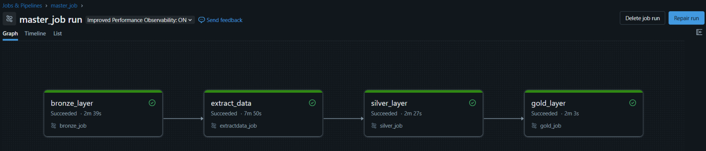
Figure 5.3: Master Pipeline
Figure 5.3 illustrates the master orchestration workflow responsible for coordinating all data engineering processes within Smart Odoo.
The Master Job orchestrates the execution of all pipeline stages through predefined task dependencies. Each task is triggered only after the successful completion of its predecessor, ensuring data consistency and preventing downstream processes from operating on incomplete datasets.

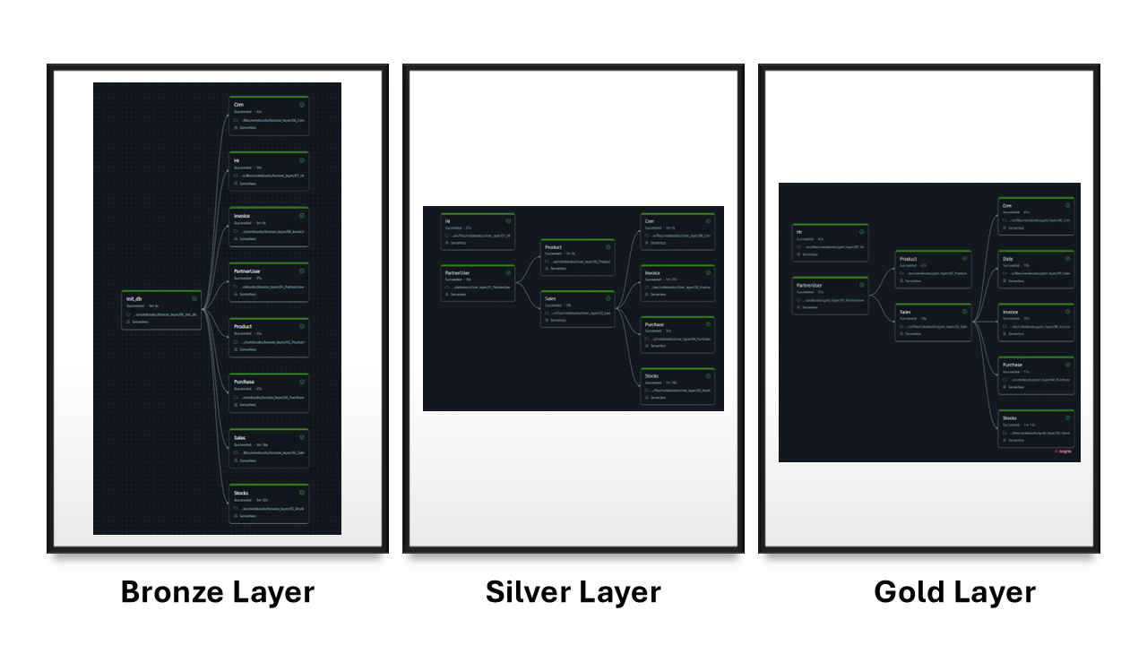
Figure 5.4:Data Pipeline Orchestration Components
Figure 5.4 presents the orchestration components implemented in Smart Odoo. Databricks Workflows were used to automate pipeline execution,while Databricks Asset Bundles provided deployment and version control capabilities through a Git-based workflow.

Databricks Asset Bundles (DAB)
Were used to manage and deploy all data engineering assets through a Git-based development workflow. This approach enables version control, reproducible deployments, and centralized management of notebooks, workflows, and configuration files across the project environment.
Incremental Processing
To improve efficiency and reduce processing time, incremental loading was implemented using the write_date field, allowing only newly created or modified records to be processed during pipeline execution.

5.8 Security and Access Control
Security mechanisms were implemented to protect sensitive business data and ensure secure access to platform resources. Authentication credentials, database connection parameters, and API secrets were stored using Databricks Secret Scopes. This approach prevents sensitive information from being exposed within notebooks, workflows, or source code repositories.
Secret management was handled through the Databricks CLI, enabling secure administration of credentials across environments. In addition, access permissions were configured at the data asset level to restrict unauthorized access and ensure controlled interaction with analytical datasets. Furthermore, no credentials, passwords, or API keys were stored in the GitHub repository, supporting secure version control and deployment practices.

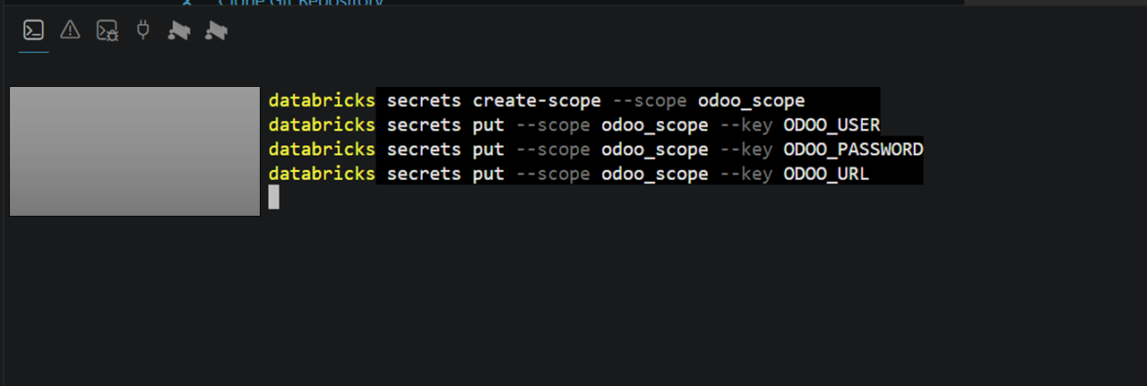
Figure 5.5: Secret Management in Databricks CLI

Figure 5.5 illustrates the use of Databricks Secrets for secure credential management. Sensitive connection parameters are stored within a Secret Scope and accessed programmatically during pipeline execution, eliminating the need for hardcoded credentials.

5.9 Data Consumption Layer

The Gold Layer serves as the primary analytical foundation for downstream applications, including business intelligence dashboards, advanced analytics, and machine learning workflows. By providing integrated and business-ready datasets, the layer enables efficient reporting, decision support, and predictive modeling activities.

The Gold Layer acts as a centralized analytical repository that serves multiple consumers across the Smart Odoo platform. Business users interact with the data through Power BI dashboards and reports, while analysts leverage the datasets for ad-hoc analysis and performance monitoring. In addition, the prepared datasets provide a reliable foundation for machine learning workflows and predictive analytics applications.
Unlike traditional reporting environments that are designed for a single purpose, the Smart Odoo analytical model was developed to support multiple use cases simultaneously. The same Gold Layer datasets can be consumed by business intelligence tools, analytical applications, machine learning pipelines, and web-based services, ensuring consistency of business metrics and reducing data duplication across the platform.

The dashboards, analytical insights, and machine learning models built on top of the Gold Layer will be presented and discussed in the next chapter…

Chapter 6

Business Intelligence & Analytics

6.1 Business Intelligence Platform Overview
Following the construction of the analytical data warehouse, Microsoft Power BI was adopted as the primary business intelligence platform for data visualization, reporting, and decision support. The platform consumes business-ready datasets from the Gold Layer and transforms them into interactive dashboards covering multiple business domains.
The Smart Odoo analytical environment was designed to provide a unified reporting experience across Sales, Purchasing, Inventory, CRM, Human Resources, and Finance. The resulting dashboard portfolio enables users to monitor operational performance, track key performance indicators (KPIs), and explore business insights through interactive visual analytics.
Metric | Value
Dashboard Pages | 29
Visuals | 1200+
DAX Measures | 250+
Bookmarks | 180+
Fact Tables | 7
Dimension Tables | 16
Relationships | 90+

Table 6.1: Power BI Overview

6.2 Dashboard Portfolio Overview
The Smart Odoo Business Intelligence platform was developed as a comprehensive analytical environment designed to support multiple business functions through a unified reporting experience. The dashboard portfolio consists of 29 analytical pages covering Sales, Purchasing, Inventory, Customer Relationship Management (CRM), Human Resources, and Financial operations.
The solution is built upon an enterprise-scale semantic model containing 7 fact tables, 16 dimension tables, and more than 90 relationships. To support advanced analytical requirements, over 250 DAX measures were developed to calculate key performance indicators, business metrics, trend analysis, and operational insights across different organizational domains.
In addition to the analytical model, the platform incorporates more than 1,200 visual elements, 181 navigation bookmarks, and multiple drill-through pages that enable users to explore data at different levels of granularity.
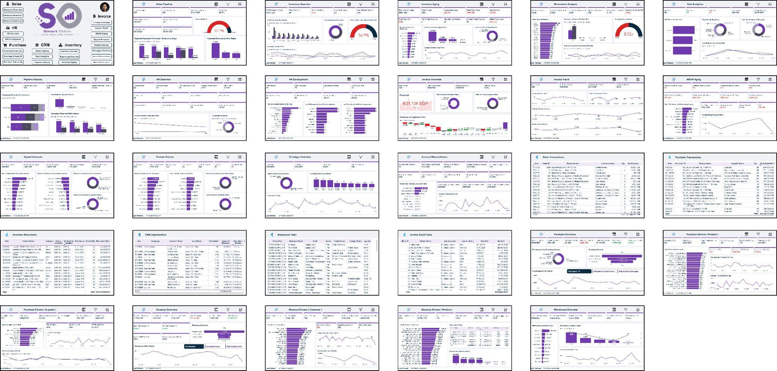
Figure 6.1: presents the complete Smart Odoo dashboard portfolio consisting of 29 analytical pages distributed across multiple business domains.

6.3 Semantic Model Architecture

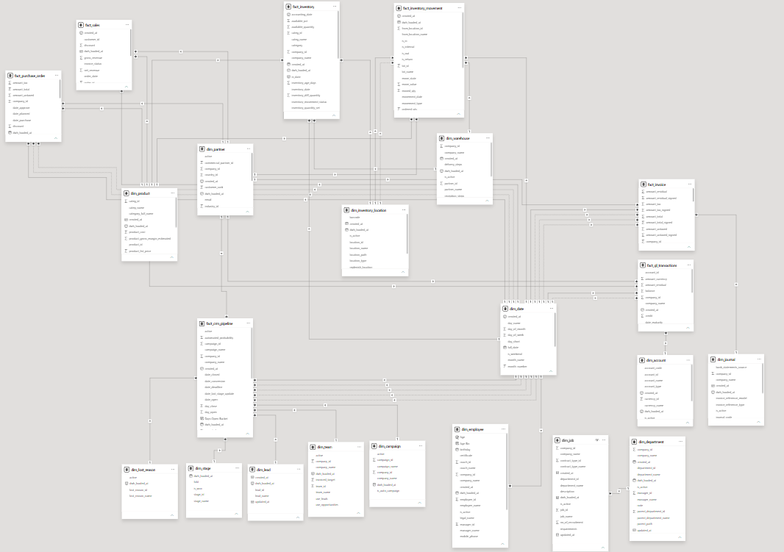

Figure 6.2 : Complete Semantic Model

Figure 6.2 illustrates the complete Power BI semantic model used within Smart Odoo. Due to the size and complexity of the model, individual business domains are presented separately through dedicated data marts in the following sections.
These figures highlight the scale and complexity of the implemented business intelligence solution, demonstrating its capability to address both operational and strategic analytical requirements.

6.4 Domain-Oriented Data Marts
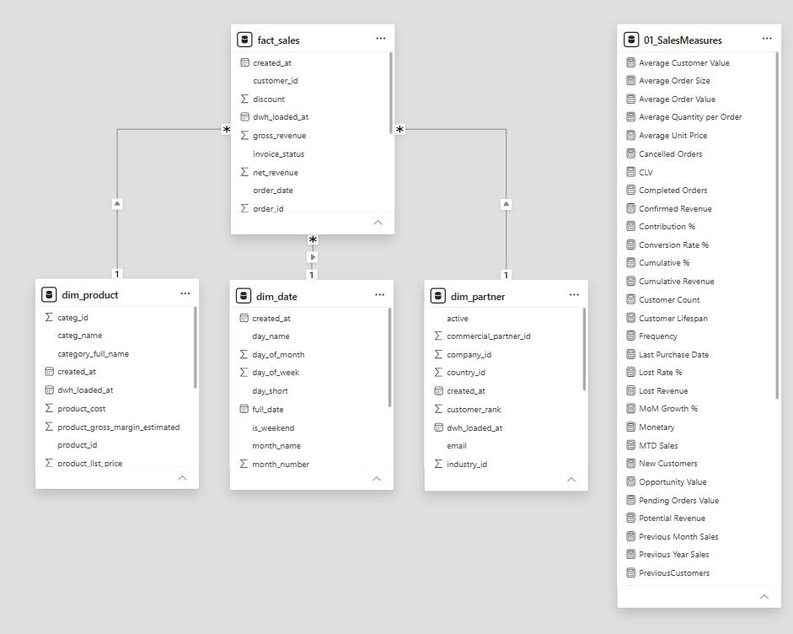
Figure 6.3 : Sales Mart
The Sales Data Mart focuses on sales transactions and customer-related analytics. It integrates sales facts with shared dimensions such as Date, Product, and Partner to support revenue analysis, customer behavior tracking, and sales performance monitoring.

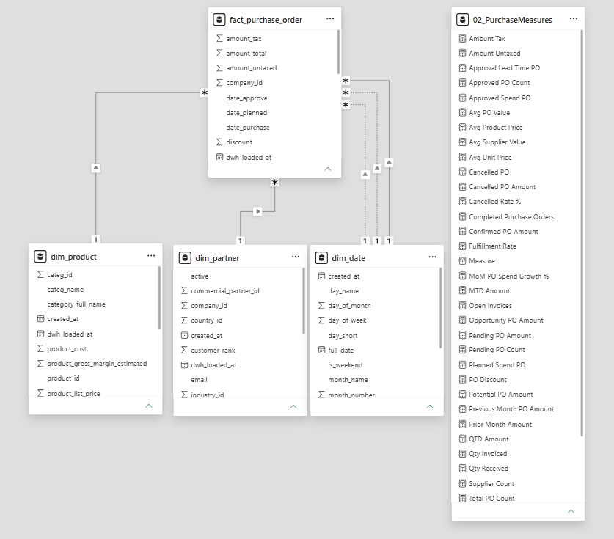
Figure 6.4 : Purchase Mart

The Purchase Data Mart provides a dedicated analytical view of procurement operations. By integrating purchase order transactions with supplier, product, and date dimensions, the model enables spend analysis, supplier assessment, purchase order tracking, and strategic procurement decision-making.

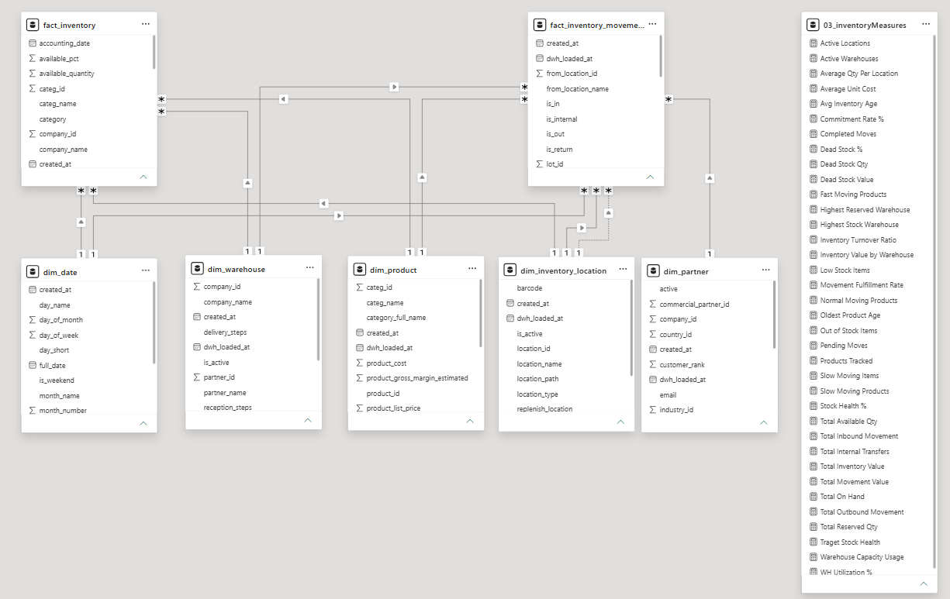
Figure 6.5 : Inventory Mart

The Inventory Data Mart provides a structured view of stock operations by combining inventory facts with warehouse and location dimensions. The model supports inventory valuation, stock movement analysis, and operational monitoring.

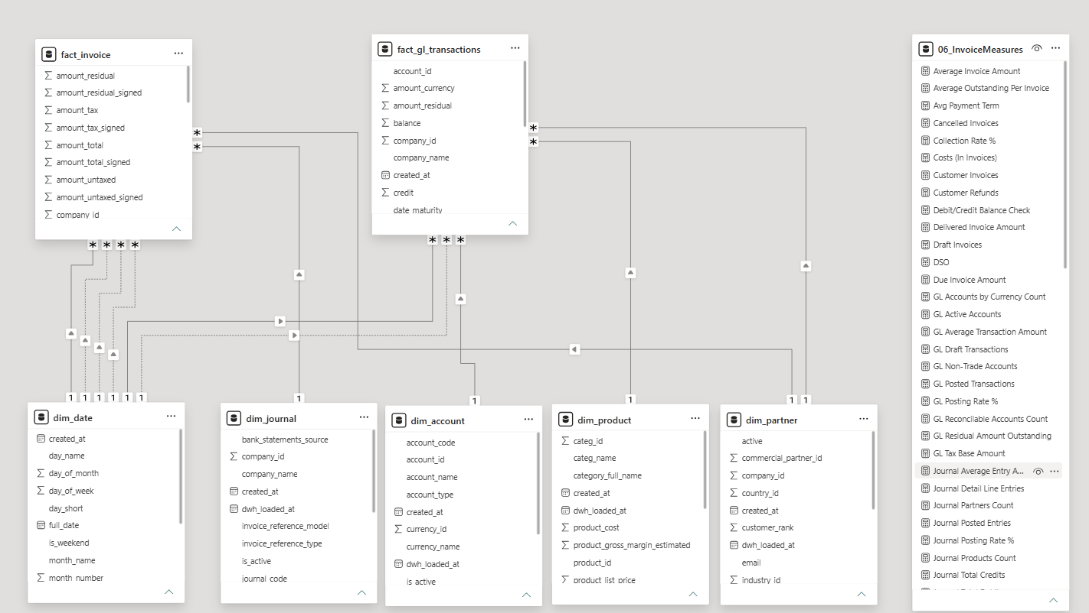
Figure 6.6 : Invoice Mart

The Invoice Data Mart integrates accounting and invoicing information to support financial reporting activities. The model enables revenue tracking, accounts receivable analysis, invoice monitoring, and financial performance assessment.

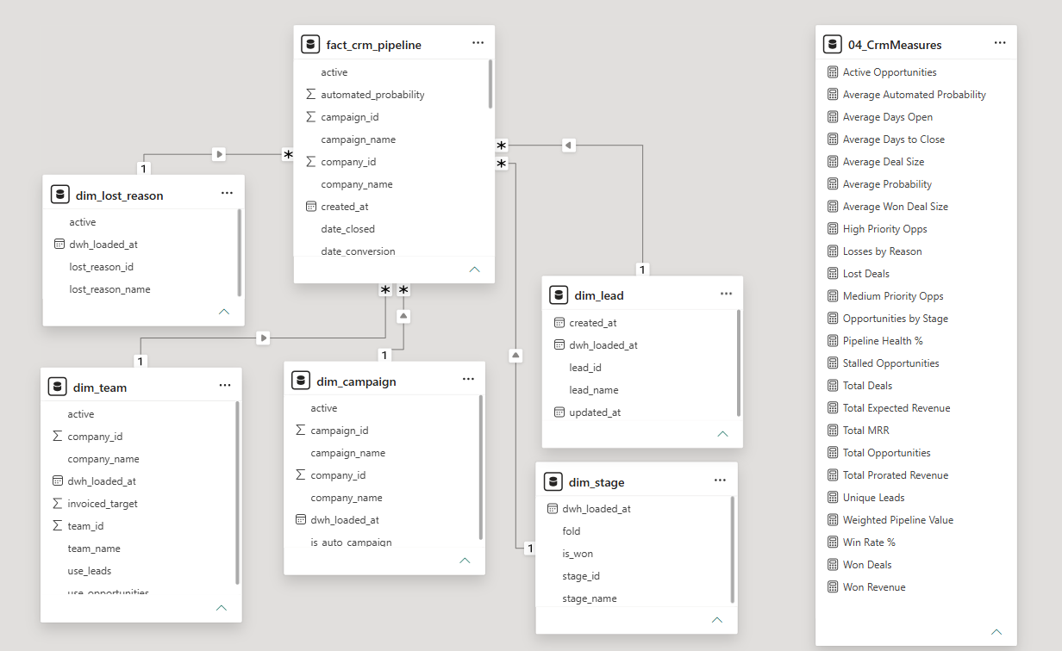
Figure 6.7 : Crm Mart

The CRM Data Mart consolidates lead management and pipeline information into a dedicated analytical model. It enables conversion analysis, pipeline monitoring, campaign evaluation, and sales opportunity tracking.

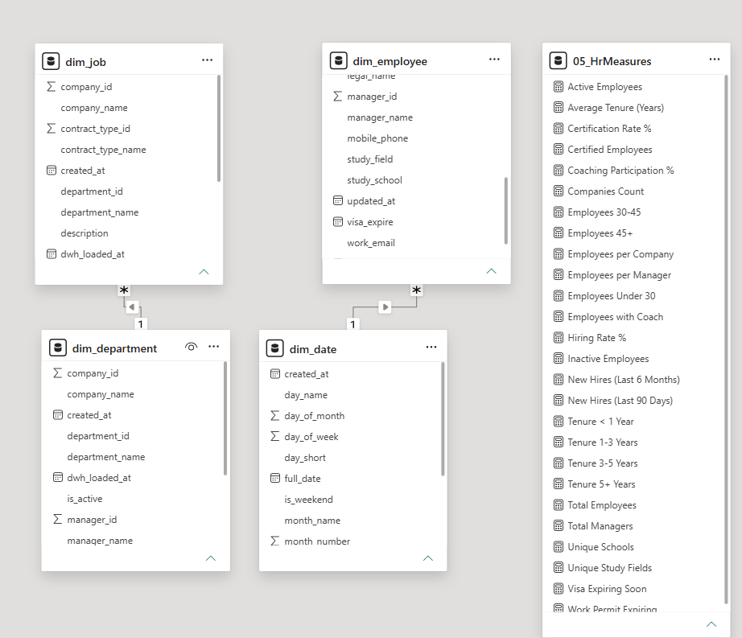
Figure 6.8 : HR Mart
The Human Resources Data Mart organizes employee-related information through dedicated workforce dimensions. The model supports headcount analysis, organizational structure reporting, and workforce performance monitoring.

6.5 Business Analytics Dashboards

6.5.1 Revenue Performance Analytics
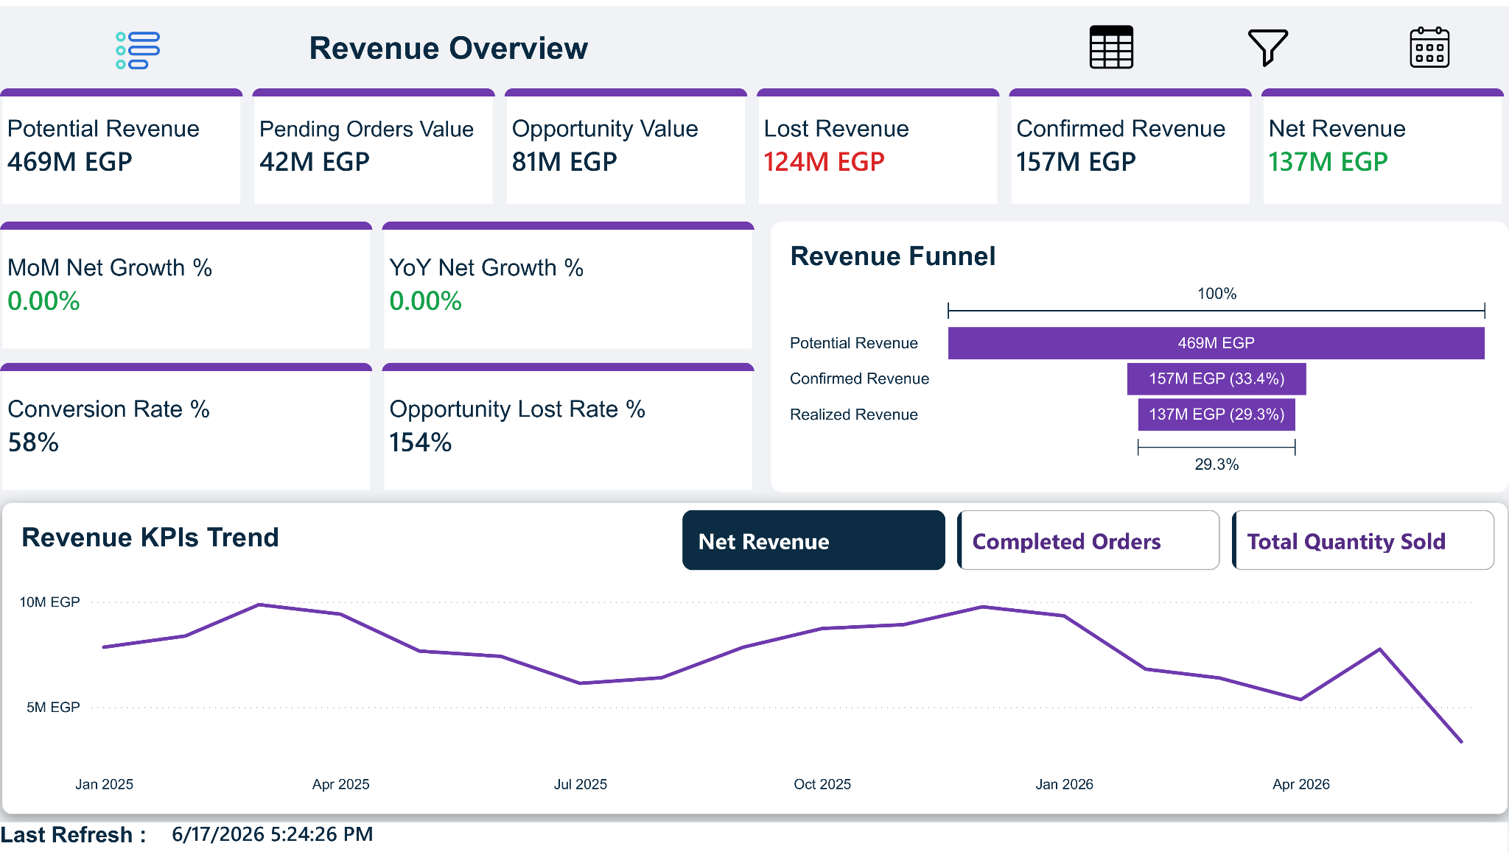
Figure 6.9 : Revenue Journey Dashboard
This dashboard provides a comprehensive view of the revenue generation process, enabling decision-makers to track revenue performance from potential opportunities to realized revenue. The analysis begins with the total potential revenue and progressively breaks it down into pending opportunities, active opportunities, lost revenue, and net revenue, providing clear visibility into the sales conversion process.
To support performance evaluation, the dashboard incorporates KPIs including Month-over-Month (MoM) Growth, Year-over-Year (YoY) Growth, Conversion Rate, and Opportunity Loss Percentage

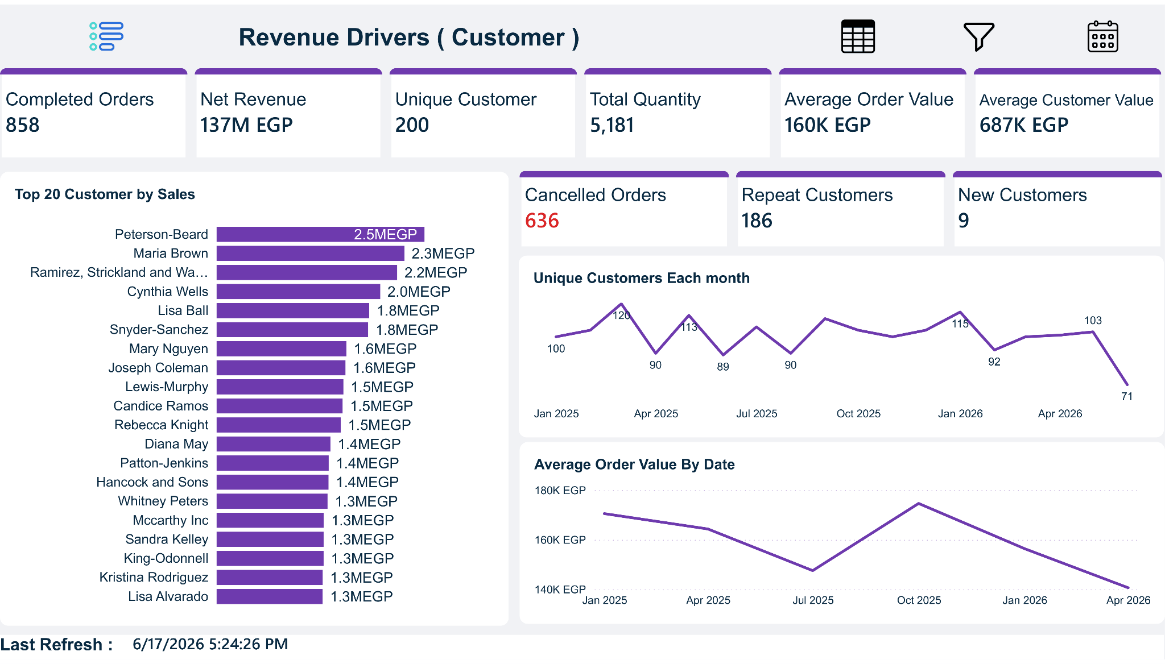
Figure 6.10 : Revenue Customer Dashboard

This dashboard focuses on customer behavior and the key drivers behind sales performance. It provides visibility into customer acquisition, retention, purchasing patterns, and product contribution to overall revenue generation.
The analysis includes customer-centric KPIs such as Repeat Customers, Average Customer Value, Average Order Value (AOV), and Cancelled Orders. In addition, Top Customers and Top Products analyses help identify the most valuable contributors to business performance and revenue growth.
By combining customer and product analytics within a unified view, decision-makers can better understand purchasing behavior, evaluate customer loyalty, identify high-performing products, and optimize sales strategies.

6.5.2 Procurement Analytics
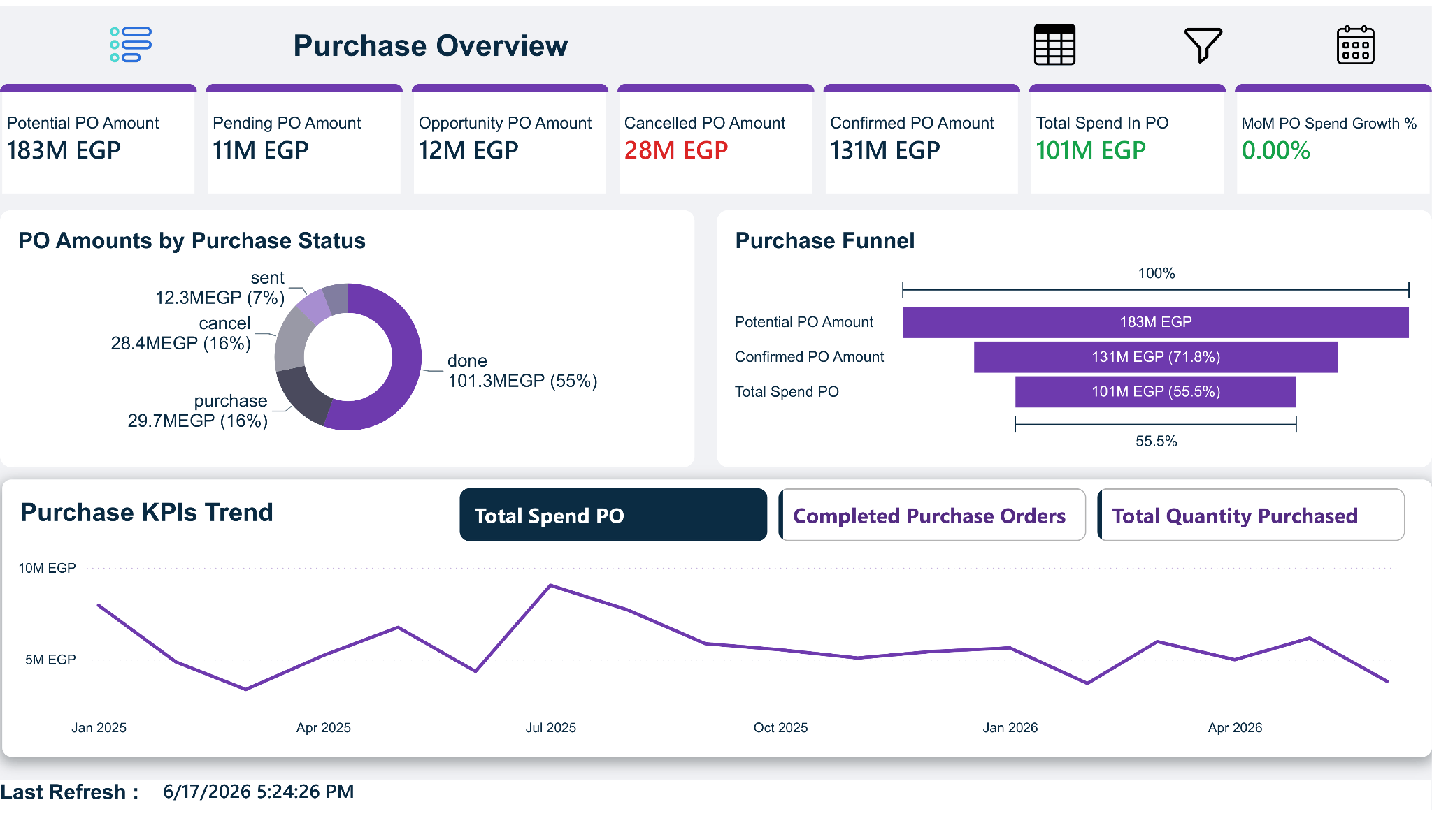
Figure 6.11: Purchase Analytics Dashboard
This dashboard provides a comprehensive view of procurement activities and supplier-related performance. It enables users to monitor purchasing trends, track purchase order status, evaluate supplier contribution, and analyze organizational spending patterns.
Key indicators include Total Spend, Purchase Order Count, Average Purchase Order Value, Supplier Count, and procurement growth metrics. These measures support cost control initiatives and help management optimize purchasing decisions and supplier relationships.

6.5.3 Inventory Analytics
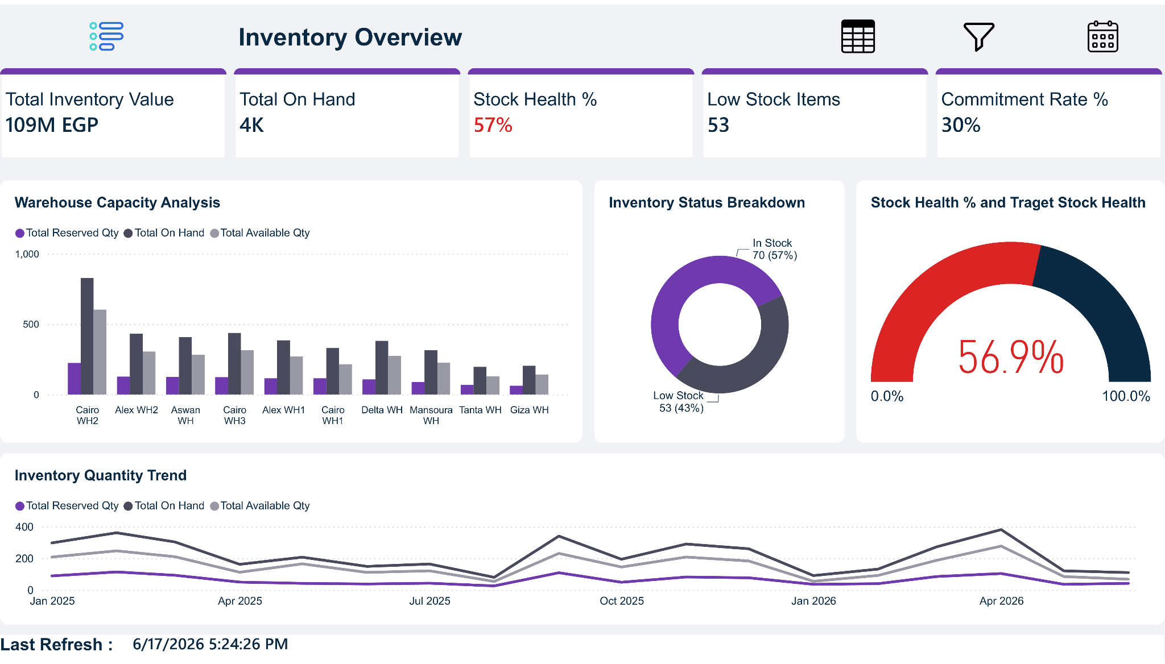
Figure 6.12: Inventory Analytics Dashboard

The Inventory Overview dashboard delivers a comprehensive snapshot of inventory operations through key metrics such as Total Inventory Value, Stock Health, Low Stock Items, and Commitment Rate. It also provides visibility into warehouse capacity and inventory quantity trends, supporting proactive inventory planning and stock optimization.

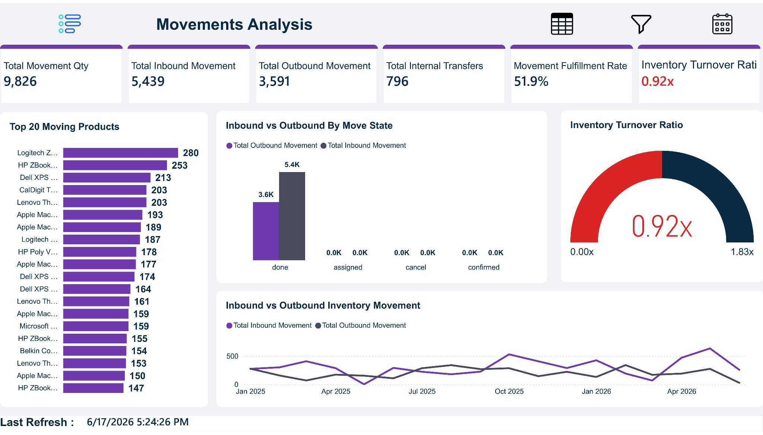
Figure 6.13: Inventory Movements Analytics

The Inventory Movement Analysis dashboard provides visibility into inventory flow and stock movement activities across the organization. It enables users to monitor inbound inventory operations, evaluate fulfillment performance, and measure inventory turnover efficiency.
The dashboard also highlights movement trends over time and identifies the most active products based on movement volume. These insights support demand planning, inventory optimization, and operational efficiency improvements.

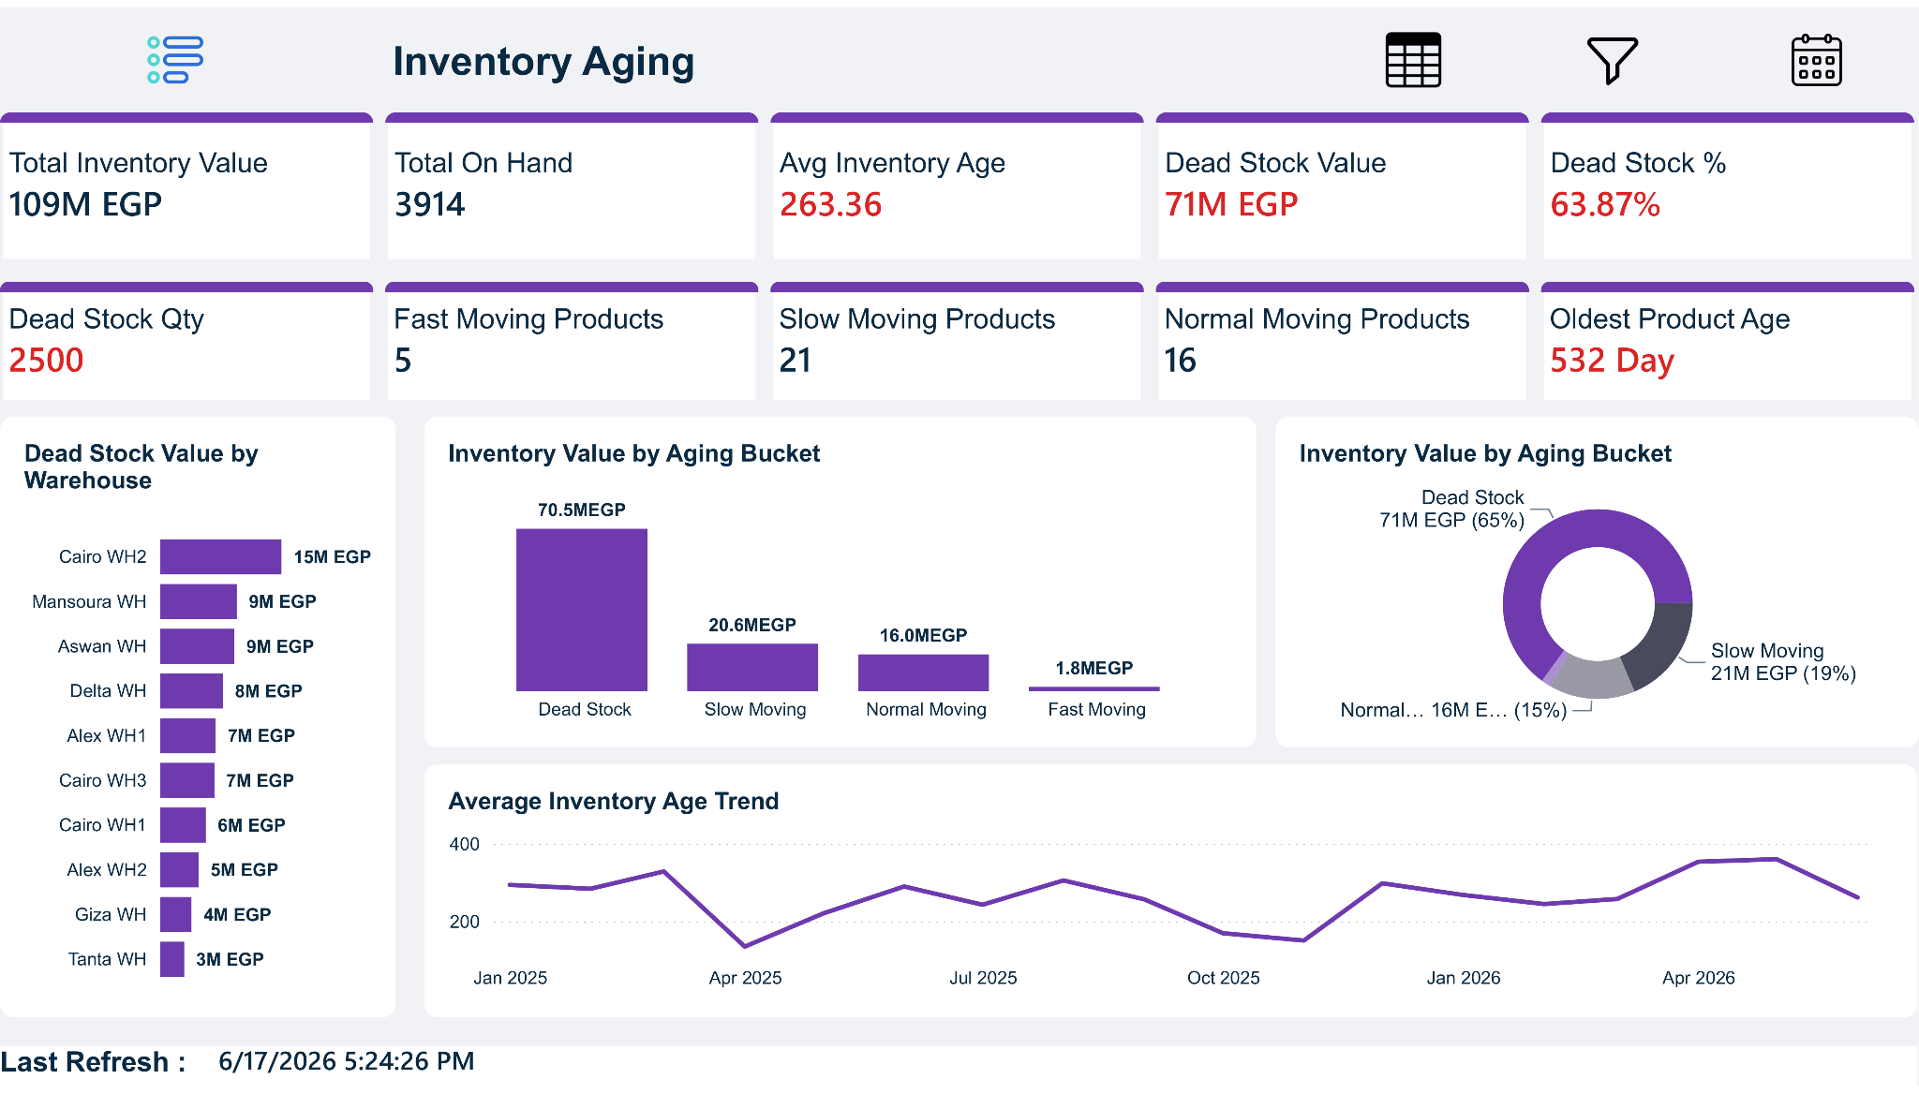
Figure 6.14: Inventory Aging Analytics

The Inventory Aging dashboard evaluates inventory quality by analyzing stock holding periods and identifying slow-moving or obsolete inventory. Key indicators such as Average Inventory Age, Dead Stock Value, Dead Stock Quantity, and Dead Stock Percentage provide visibility into inventory efficiency and potential carrying-cost risks.
The dashboard further examines inventory distribution across aging buckets and warehouses while tracking aging trends over time. These insights support inventory optimization initiatives, improve stock turnover, and help reduce capital tied up in non-moving inventory.

6.5.4 CRM Analytics
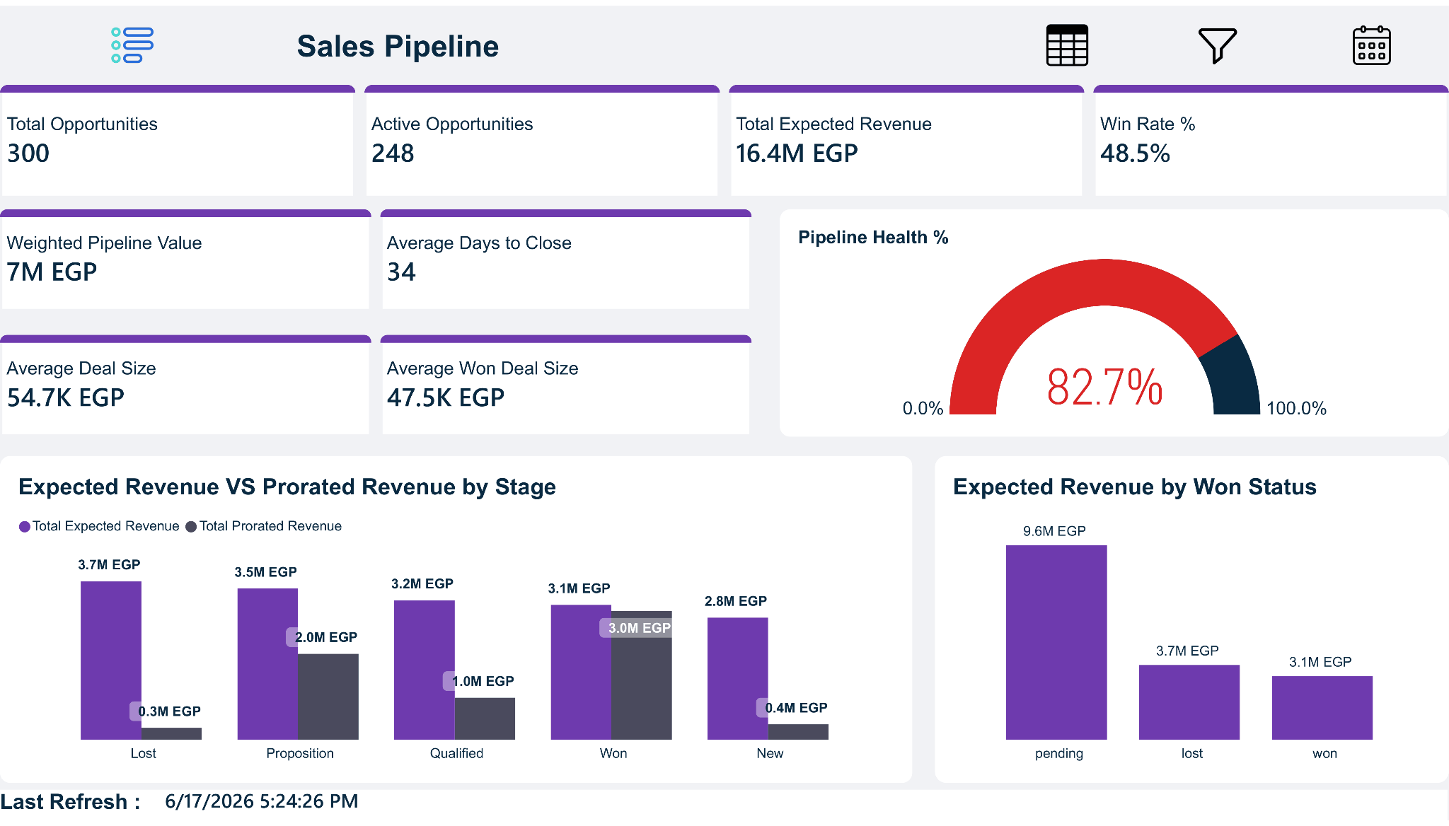
Figure 6.15: Sales Pipeline
The Sales Pipeline dashboard provides a comprehensive view of sales opportunities and pipeline performance throughout the customer acquisition process. It enables management to monitor active opportunities, evaluate expected revenue, and assess the overall health of the sales pipeline.
Key performance indicators include Total Opportunities, Win Rate, Weighted Pipeline Value, Expected Revenue, Average Deal Size, and Average Days to Close. These metrics help sales teams measure pipeline efficiency, forecast future revenue, and identify opportunities with the highest probability of conversion.

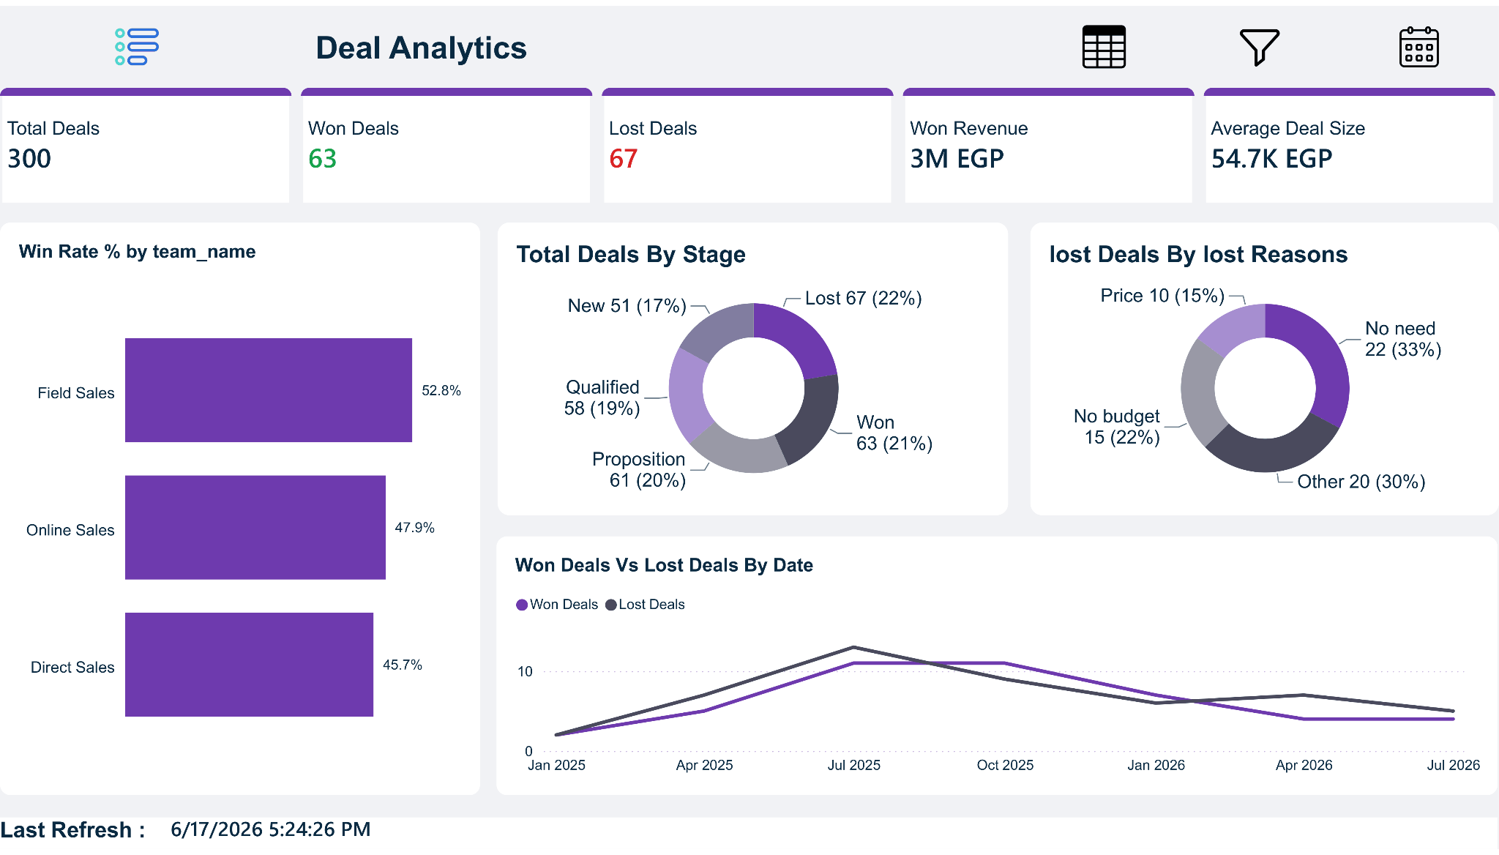
Figure 6.16: Deal Analytics Dashboard
The Deal Analytics dashboard evaluates sales opportunity outcomes by analyzing won and lost deals across different stages of the sales process. It provides visibility into deal performance, revenue generation, and conversion effectiveness, enabling management to assess the overall success of sales activities.
The dashboard includes key metrics such as Total Deals, Won Deals, Lost Deals, Won Revenue, and Average Deal Size. In addition, stage-level analysis and win-rate comparisons help identify bottlenecks within the sales process and highlight areas for performance improvement.
To support deeper business analysis, the dashboard examines lost opportunities by loss reason and compares won versus lost deals over time. Team-level win rate analysis further enables organizations to evaluate sales performance and identify high-performing sales teams.

6.5.5 HR Analytics
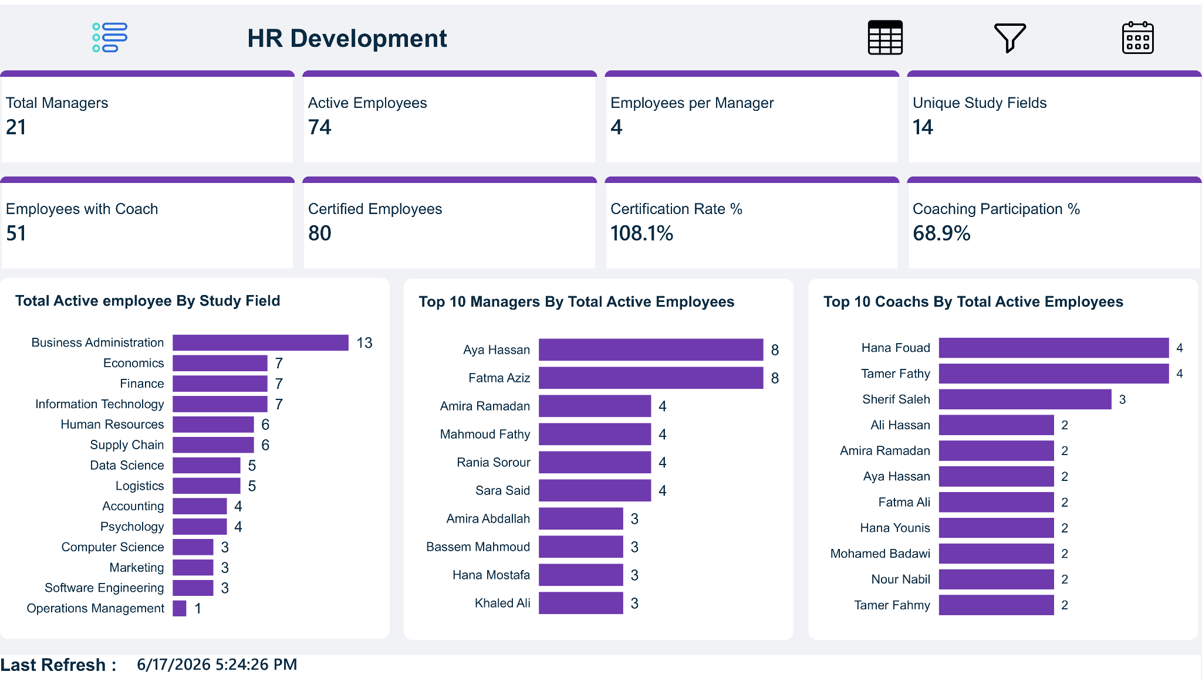
Figure 6.17: HR Development
The Human Resources dashboard provides a comprehensive overview of workforce composition, organizational structure, and employee development activities. It enables management to monitor workforce distribution, managerial coverage, and employee participation in training and coaching programs.
Key indicators include Active Employees, Total Managers, Employees per Manager, Certified Employees, Coaching Participation Rate, and workforce distribution by educational field. These metrics support talent management initiatives and help organizations evaluate employee development efforts.

6.5.6 Invoice Analytics
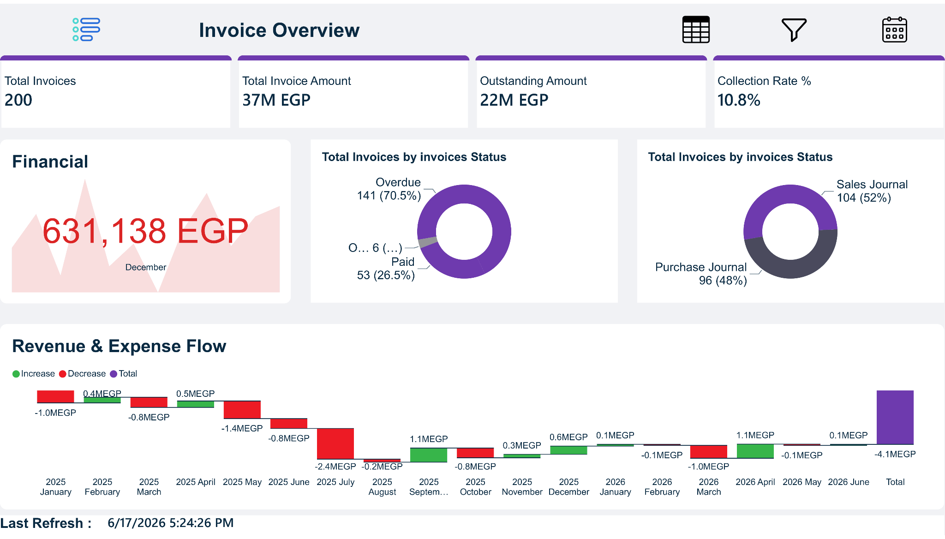
Figure 6.17: Invoice Overview

performance across the organization. It enables users to monitor invoice volumes, total invoiced amounts, outstanding balances, and collection efficiency through a unified analytical interface.
Key performance indicators include Total Invoices, Total Invoice Amount, Outstanding Amount, and Collection Rate. In addition, the dashboard analyzes invoice distribution by status and visualizes revenue and expense flows, providing decision-makers with a clear understanding of financial activity and cash collection performance.

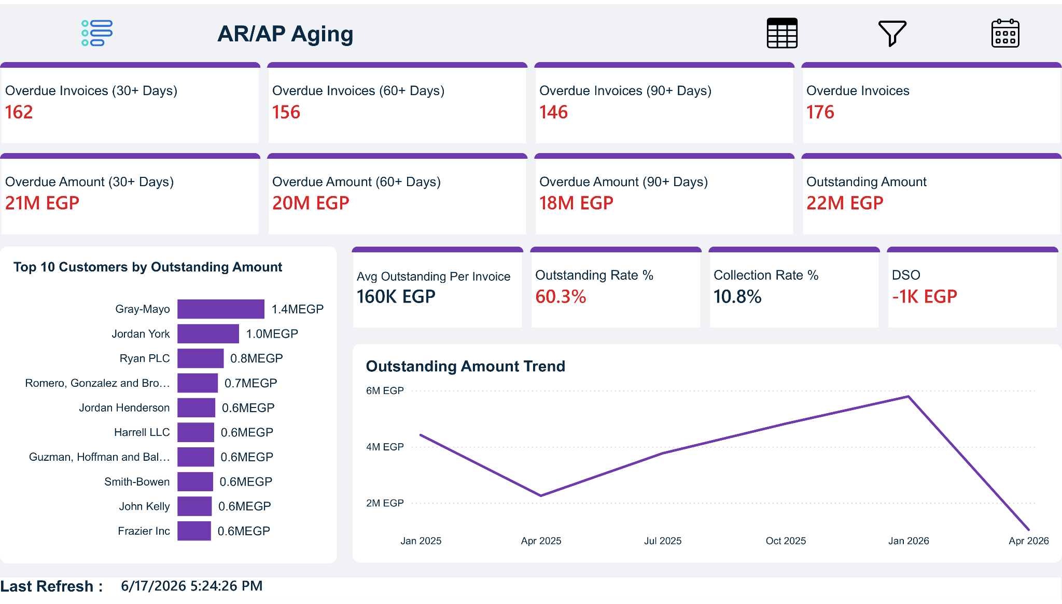
Figure 6.18: AR/AP Aging Dashboard
The AR/AP Aging dashboard provides a comprehensive analysis of outstanding receivables and payables by categorizing balances according to aging periods. This enables financial managers to monitor overdue obligations, evaluate collection performance, and identify potential liquidity risks.
The dashboard includes key metrics such as Outstanding Amount, Total Overdue Balance, Average Outstanding Amount per Invoice, Collection Rate, and Outstanding Rate. Aging indicators for invoices exceeding 30, 60, and 90 days provide additional visibility into payment delays and credit risk exposure.
Furthermore, the dashboard highlights customers with the highest outstanding balances, tracks collection trends over time, and incorporates Days Sales Outstanding (DSO) analysis to support cash flow management and improve the efficiency of accounts receivable operations.
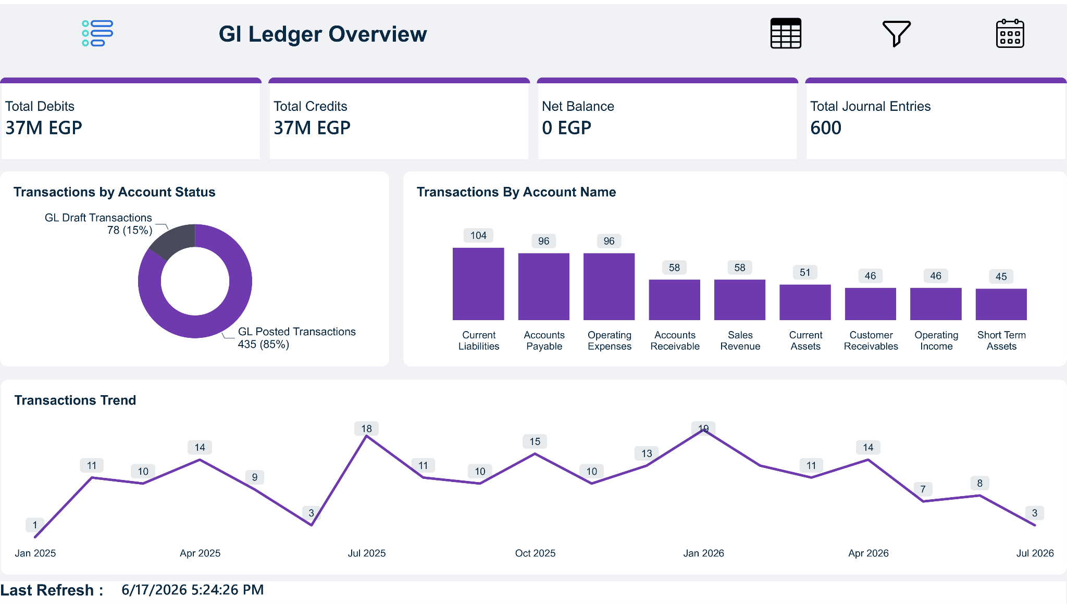
Figure 6.19 : General Ledger Dashboard

The General Ledger dashboard provides a high-level overview of accounting activities and financial transactions recorded across the organization. It enables users to monitor debit and credit movements, evaluate account balances, and track overall ledger activity.

Key indicators include Total Debits, Total Credits, Net Balance, and Total Journal Entries. The dashboard also analyzes transaction distributions across account categories and monitors transaction trends over time, supporting financial control and accounting oversight processes.

6.6 KPIs Framework

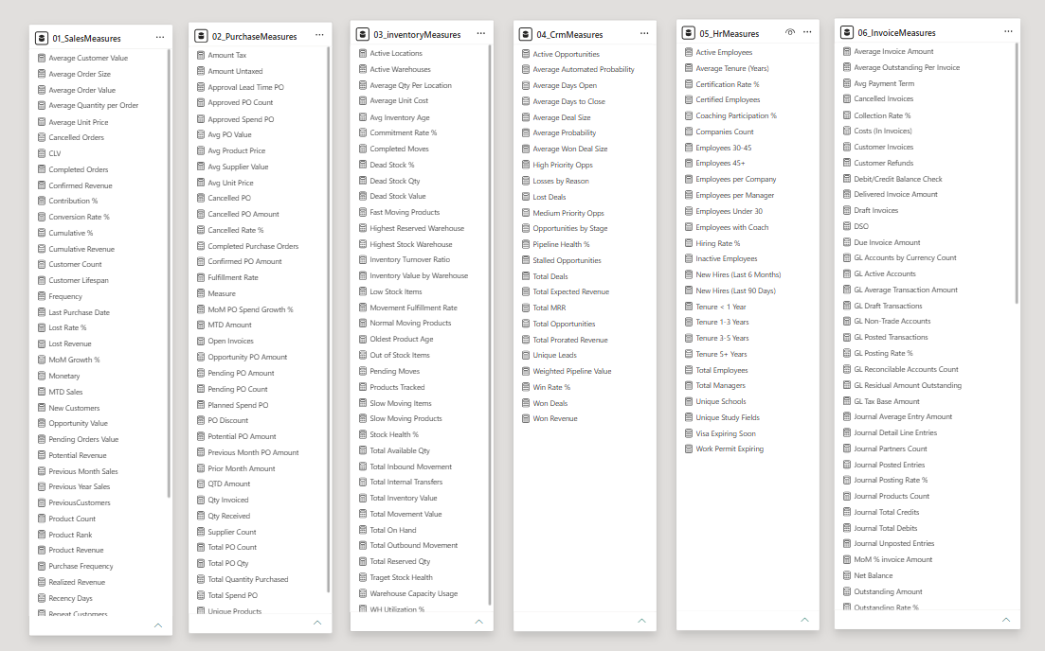
Figure 6.19 : Measure Tables
Measure Group | Count | Measure Group | Count
Sales | 45 | Inventory | 36
Purchase | 37 | CRM | 24
HR | 26 | Invoice | 84
Table 6.2 : Measure Group Count
More than 250 DAX measures were developed to support operational monitoring, business performance evaluation, trend analysis, forecasting, and decision-making activities across all analytical domains.

6.7 Reusable Analytical Data Marts

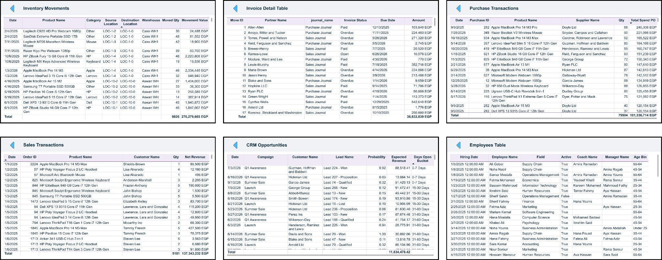
Figure 6.20 : Marts Tables
In addition to the enterprise semantic model, a set of domain-specific analytical data marts was developed to support modular analytics and future extensibility. These datasets can be independently consumed by dashboards, analytical applications, or external reporting tools without requiring direct access to the complete enterprise model.

This approach improves scalability, simplifies analytical development, and enables organizations to deploy business-domain solutions independently while maintaining consistency with the centralized data warehouse architecture.

6.8 Navigation and User Experience
To enhance usability and provide a seamless analytical experience,Smart Odoo dashboard portfolio was designed with a comprehensive navigation framework that enables users to efficiently explore multiple business domains while maintaining a consistent user interface across all analytical pages.
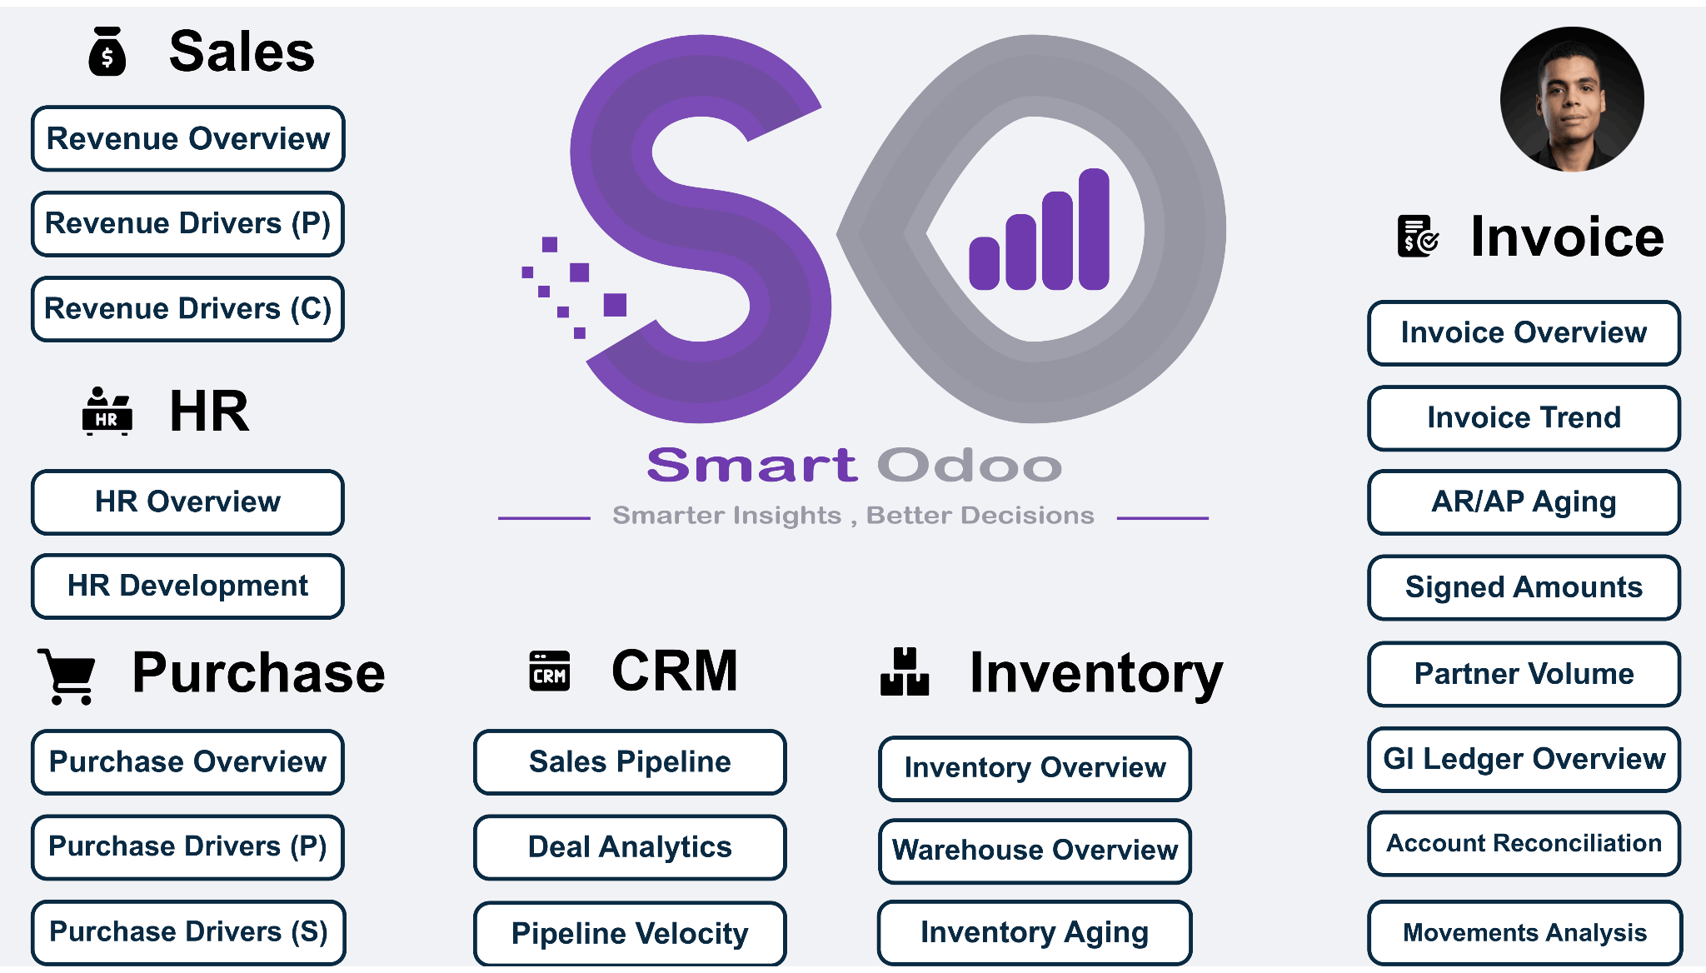
The navigation system combines centralized domain access, advanced filtering capabilities, interactive drill-through functionality, and dynamic page navigation mechanisms. These features were implemented to simplify dashboard exploration, reduce navigation complexity, and improve the overall user experience when analyzing large volumes of business data.
Figure 6.21 : Landing Page
Users begin their analytical journey through the centralized landing page, which provides direct access to all business domains.

6.8.1 Multi-Level Navigation System
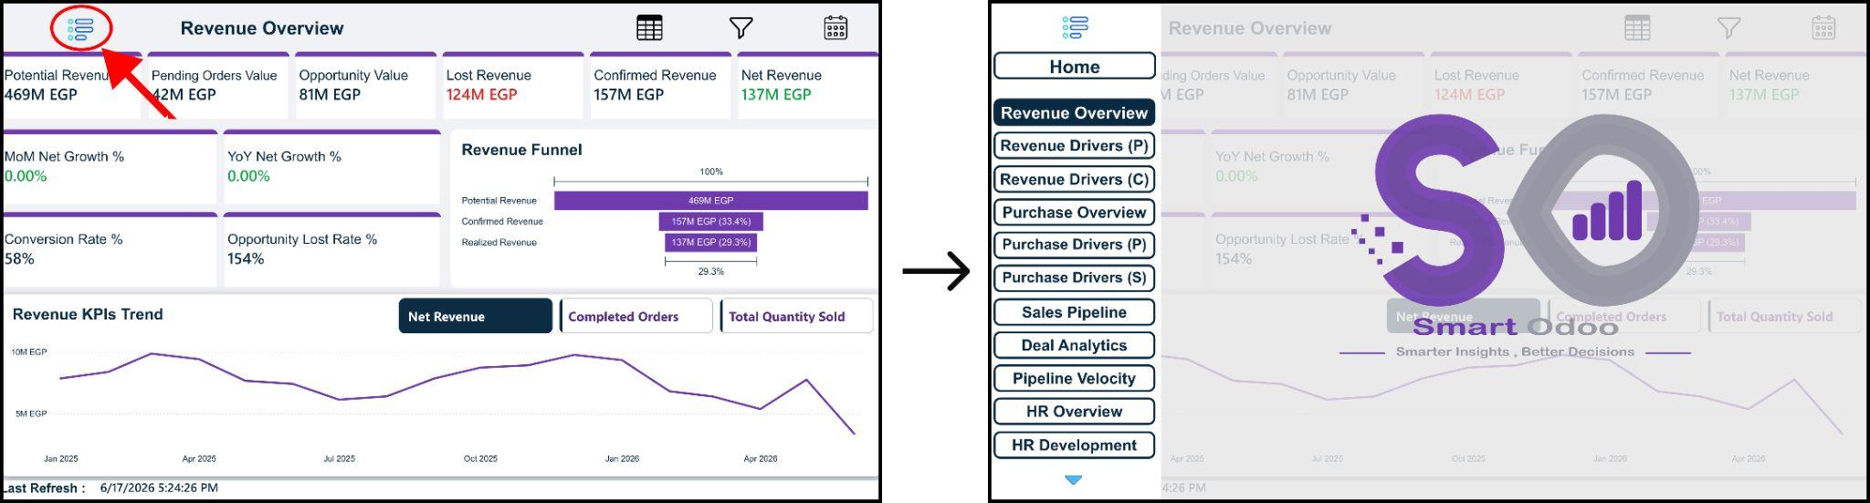
Figure 6.22 : Open First Nav Bar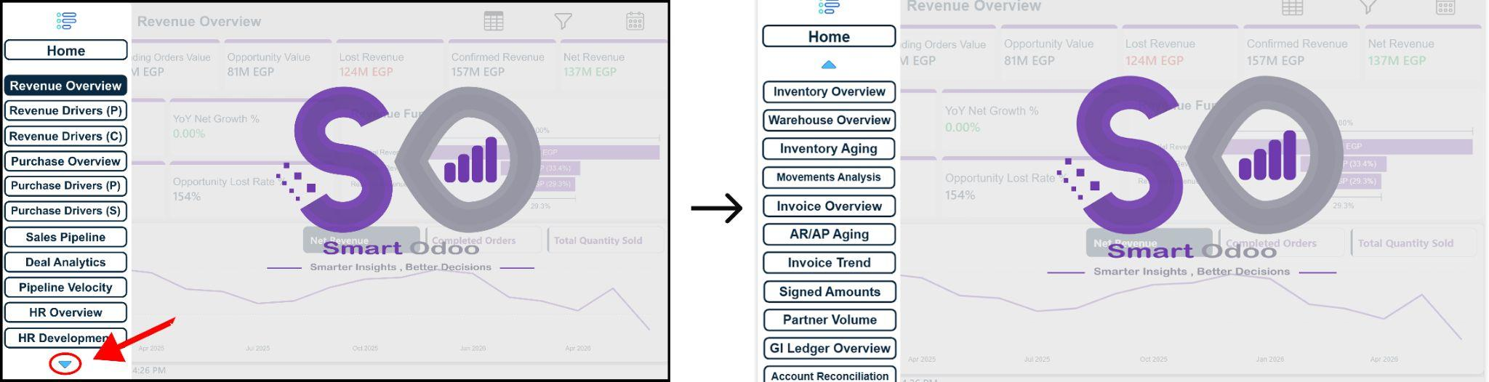
Figure 6.23 : Open Second Nav Bar
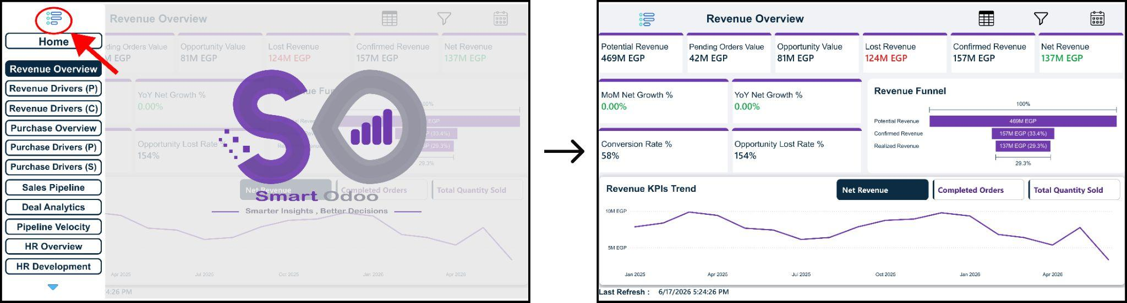Figure 6.24 : Close Nav Bar
A dedicated navigation panel was developed on the left side of the dashboard environment. Expandable menus supported by bookmark actions provide access to more than 29 analytical pages while maintaining a clean and organized user interface.

6.8.2 Domain Filter Panels

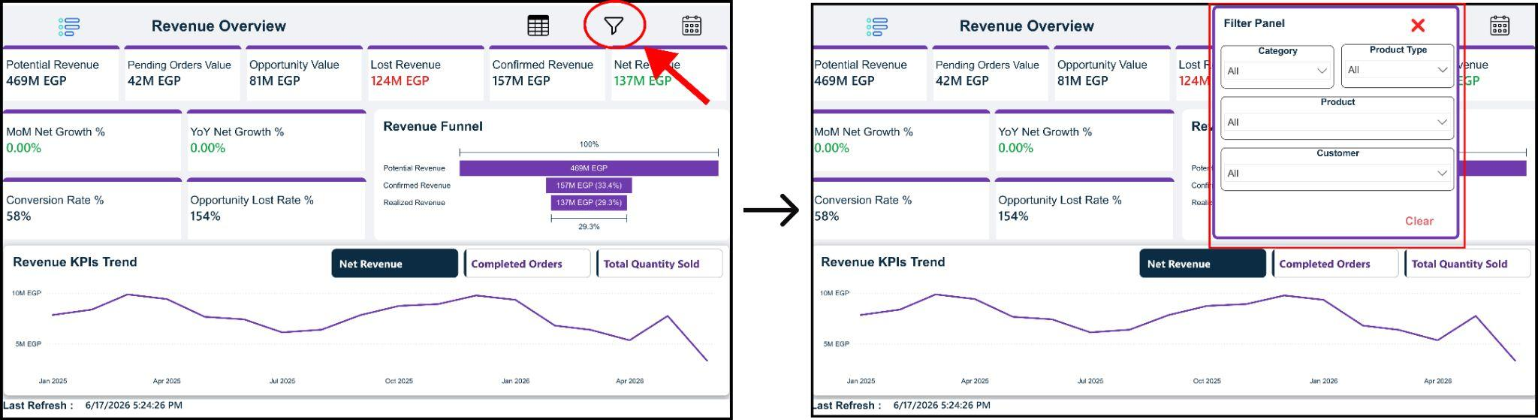
Figure 6.25 : Open Filter Panel

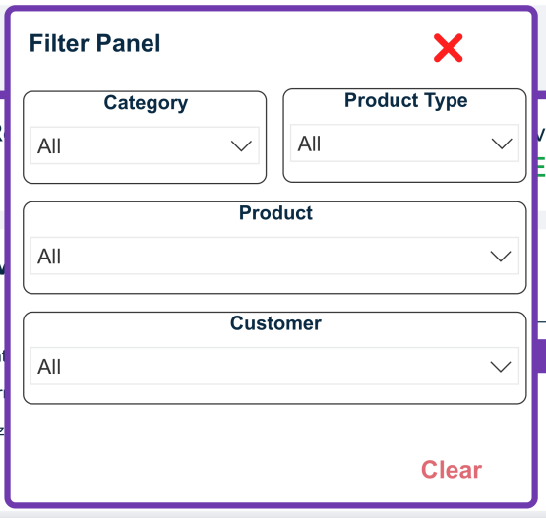
Figure 6.26 : Filter Panel

Each business domain includes dedicated filter panels that allow users to refine analysis according to operational requirements and business-specific dimensions.

6.8.3 Global Date Control Panel

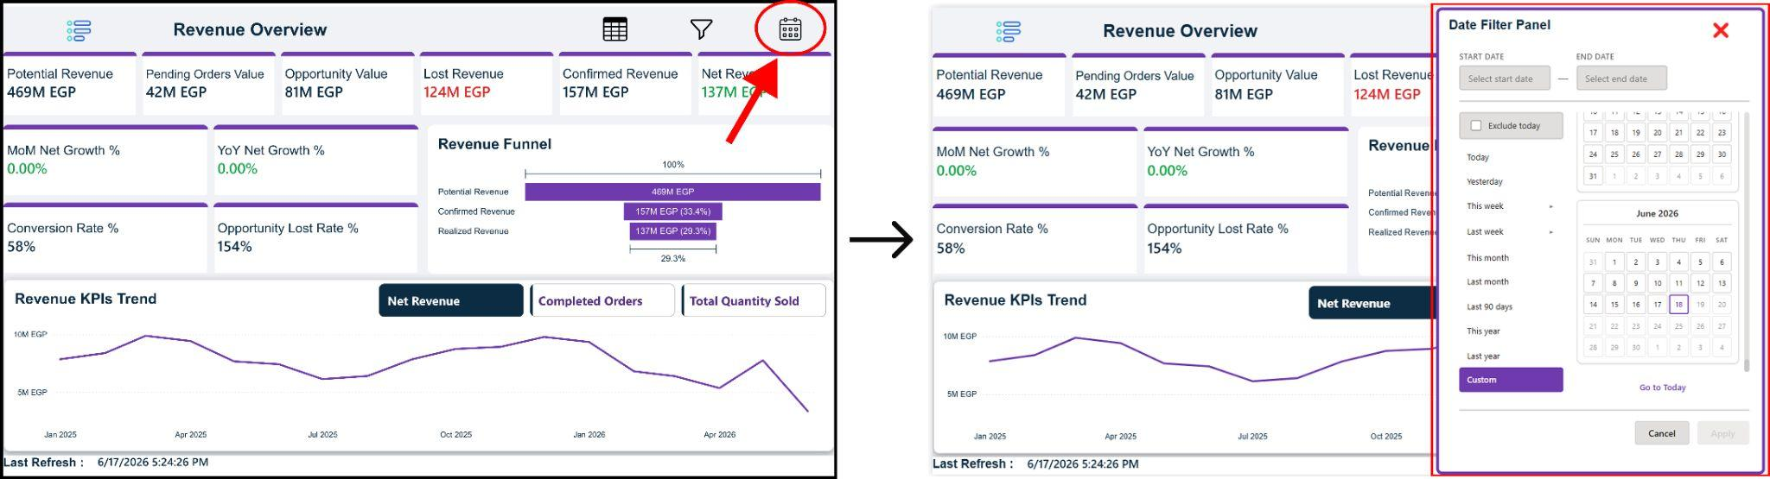
Figure 6.27 : Open Global Date Panel
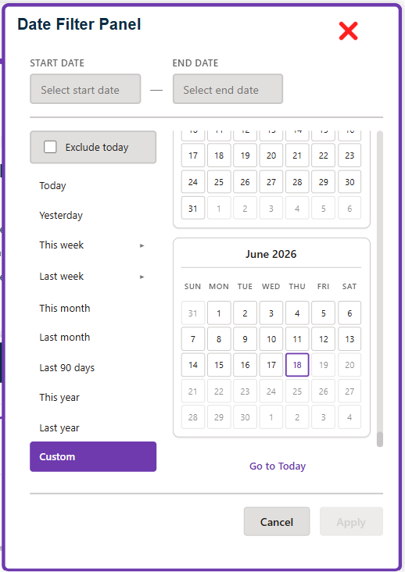
Figure 6.28 : Global Date Panel
A centralized date filtering panel was implemented to provide unified time-based analysis across the dashboard portfolio. This feature allows users to dynamically adjust reporting periods and instantly synchronize analytical views across multiple business domains.

6.8.4 Detailed Analysis Navigation

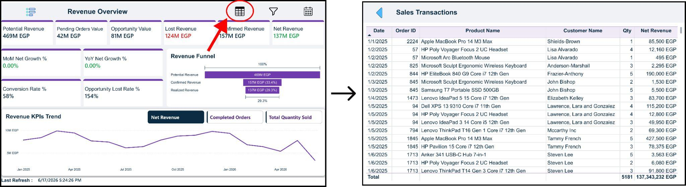Figure 6.29 : Open Table Page
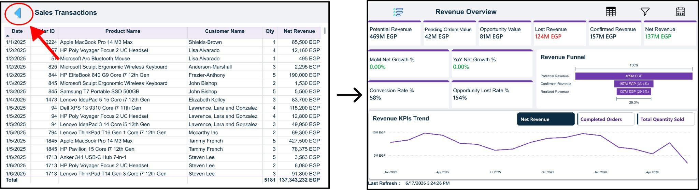
Figure 6.30 : Back From Table Page

Detail View Navigation : Allows users to navigate from summary dashboards to dedicated tabular views containing detailed transactional records and operational data.

Chapter 7

Machine Learning & Predictive Analytics

7.1 Overview
This chapter presents the Machine Learning and Predictive Analytics layer of the proposed data analytics platform built for Odoo-based enterprise systems. The overall project aims to design and implement an intelligent analytics and forecasting platform that enables organizations using Odoo ERP to transform raw operational data into actionable business insights and future-oriented predictions.
The platform follows a modern analytical architecture in which data is extracted from Odoo transactional systems, centralized in an analytical environment, and processed using advanced machine learning models. This chapter focuses specifically on the design, implementation, and business value of the machine learning models developed to support decision-making across sales, inventory, customer management, and financial risk domains.

7.2 Business Domains and System Vision
The system is designed around the concept that real-world business operations are interconnected. Sales performance impacts inventory demand, inventory availability affects customer satisfaction, customer behavior influences cash flow, and financial risks shape strategic planning. The project therefore addresses multiple business domains within a unified analytical framework.
From a business perspective, the system aims to function as a centralized decision-support layer that augments human expertise with data-driven intelligence. Each machine learning model contributes a specific analytical capability, while collectively they provide a comprehensive view of business health, risk, and opportunity.
The system covers the following domains: sales intelligence, inventory intelligence, customer and pipeline intelligence, and financial risk intelligence. The integration of these domains enables more informed, timely, and consistent business decisions

7.3 Data Description
The project assumes realistic, structured data originating from enterprise systems commonly used in business environments. Sales data consists of historical transactional records aggregated at a monthly level, capturing revenue patterns over time. Inventory data includes product-level stock quantities, inflow transactions such as purchases or returns, and outflow transactions such as sales or transfers.
Customer and CRM data describe sales leads and customers throughout their lifecycle, including attributes related to lead creation, progression through the sales pipeline, assigned sales representatives, and deal values. Financial data includes invoice records, payment due dates, payment histories, and customer payment behavior.
All datasets are time-indexed, enabling temporal analysis and ensuring that predictive models reflect realistic operational conditions. The data structure supports both supervised and unsupervised learning tasks across multiple business objectives.

7.4 Data Preprocessing and Feature Engineering
Data preprocessing is a critical step to ensure reliability, consistency, and suitability for machine learning. Raw enterprise data often contains missing values, inconsistencies, and noise that can negatively affect model performance. Appropriate data cleaning techniques are applied based on feature type and business context.
For time-dependent datasets, temporal ordering is preserved to prevent data leakage and ensure realistic model evaluation. Sales data is aggregated to a consistent monthly frequency to enable stable time series forecasting. Inventory data is transformed to reflect meaningful stock movements over time.
Feature engineering is tailored to each business problem. For inventory and financial models, lagged features and rolling statistics are created to capture historical behavior and recent trends. Customer and lead-related features are engineered to represent lifecycle progression, engagement intensity, and historical outcomes. Categorical variables are encoded in a manner that preserves business meaning while remaining compatible with machine learning algorithms

7.5 Model Descriptions

7.5.1 Sales Forecasting Model
The sales forecasting model addresses the problem of predicting future monthly sales based on historical sales behavior. This task is formulated as a time series forecasting problem, where capturing trends and seasonal patterns is essential.
The selected approach is a time series model designed specifically for business data that exhibits recurring seasonality and long-term trends. This model decomposes historical sales into trend, seasonal, and residual components, allowing it to produce interpretable and robust forecasts. The choice of this model is motivated by its strong performance on business time series, minimal preprocessing requirements, and suitability for strategic planning scenarios.
The output of the model provides forward-looking sales estimates that support budgeting, procurement planning, and inventory alignment.

7.5.2 Inventory Movement Prediction Model
Inventory movement prediction focuses on estimating future inventory inflows and outflows for products. This problem is framed as a regression task, where the objective is to predict the magnitude of inventory changes over a defined horizon.
A gradient-boosting–based algorithm is selected due to its ability to handle complex, non-linear relationships in structured business data. Inventory movement is influenced by multiple interacting factors, including historical demand, product behavior, and recent trends, which makes this modeling approach particularly suitable.
The model supports operational planning by enabling businesses to anticipate inventory fluctuations and optimize replenishment strategies.

7.5.3 Inventory Stockout Prediction Model
The inventory stockout prediction model addresses a classification problem aimed at identifying products that are at risk of running out of stock in the near future. Stockouts represent a direct business risk, leading to lost sales and reduced customer satisfaction.
The model uses historical consumption patterns, current stock levels, and recent movement trends to assess stock depletion risk. A gradient-boosting classifier is chosen for its high predictive accuracy and ability to model complex feature interactions.
This model functions as an early warning system, allowing inventory managers to take preventive actions before stock shortages occur.

7.5.4 Lead Scoring Model
The lead scoring model focuses on predicting the probability that a sales lead will successfully convert into a closed deal. Each lead is treated as a complete narrative, encompassing its creation, progression through the sales pipeline, assigned ownership, deal value, and historical interactions.
The problem is formulated as a binary classification task with probabilistic outputs. A gradient-boosting model is selected due to its effectiveness in handling heterogeneous features and capturing subtle patterns in sales behavior.
The model enables sales teams to prioritize high-potential leads, allocate resources more effectively, and improve overall conversion rates

7.5.5 Invoice Payment Delay Prediction Model
The invoice payment delay prediction model addresses financial risk by identifying invoices that are likely to be paid late. Delayed payments negatively impact cash flow and financial planning.
This task is modeled as a classification problem using invoice attributes, customer payment history, and temporal factors. A gradient-boosting classifier is selected for its robustness and strong performance in risk prediction tasks.
The model provides finance teams with early insights into potential payment delays, supporting proactive cash flow management and risk mitigation.

7.5.6 Customer Segmentation Model
Customer segmentation aims to group customers based on payment behavior and reliability. Unlike previous models, this task is unsupervised, as it seeks to discover hidden patterns rather than predict a predefined target.
A similarity-based clustering approach is used to group customers with comparable behavioral characteristics. This method is chosen for its interpretability and effectiveness in identifying meaningful customer segments.
The resulting segments enable differentiated customer management strategies, such as prioritizing reliable customers and applying stricter payment policies to higher-risk segments.

7.6 Model Training and Validation Strategy
Model training and validation strategies are designed to reflect real-world deployment conditions. For time-dependent problems, chronological data splits are used to ensure that models are evaluated on future data relative to their training period.
This approach prevents information leakage and provides a realistic assessment of predictive performance. For supervised learning tasks, separate training and testing periods are defined, while validation strategies emphasize stability and generalization rather than optimization on a single snapshot of data.

7.7 Evaluation Metrics and Business Justification
Evaluation metrics are selected based on their alignment with business objectives. For sales forecasting and inventory movement prediction, error-based regression metrics are used to quantify prediction accuracy in a manner that directly relates to planning decisions.
For classification tasks such as stockout risk, lead conversion, and payment delays, metrics that balance sensitivity and reliability are emphasized. The choice of metrics reflects the business cost of different types of errors, such as missed risks or unnecessary alerts.
This metric-driven evaluation ensures that model performance is assessed not only from a technical standpoint but also from a business impact perspective

7.8 Results and Business Insights
The system provides a comprehensive set of insights across business domains. Sales forecasts reveal demand trends and seasonal behavior, supporting strategic planning. Inventory models identify movement patterns and stockout risks, improving operational resilience.
Lead scoring outputs help sales teams focus on opportunities with the highest likelihood of success, while financial models enhance visibility into payment risks and customer reliability. Together, these insights enable more informed, proactive, and coordinated decision-making.

7.9 System Architecture and Model Integration
The system is designed as a modular architecture in which each model operates independently while contributing to a unified decision-support framework. Data flows from enterprise systems into a centralized preprocessing layer, followed by model-specific prediction pipelines.
Model outputs can be integrated into dashboards, reports, or downstream business processes. This modular design supports scalability, maintainability, and future expansion.

7.10 Model Usage and Deployment Considerations
In a production environment, models can be scheduled to run at appropriate intervals based on business needs. Sales forecasts may be updated monthly, while inventory and financial risk models can operate on shorter cycles.
Clear interpretation of model outputs is essential to ensure adoption by business stakeholders. The system is designed to complement human decision-making rather than replace it, providing transparent and actionable insights.

7.11 Limitations
The system relies on historical data and assumes that past patterns are indicative of future behavior. External factors such as market disruptions, policy changes, or unexpected supply chain events are not explicitly modeled.
Model performance is also dependent on data quality and availability, which may vary across organizations.

Chapter 8

Conclusion

8.1 Conclusion
This project presented the design and implementation of Smart Odoo, an integrated business intelligence and analytics platform built on top of the Odoo ERP system. The proposed solution combines modern data engineering practices, enterprise data warehousing principles, business intelligence reporting, and machine learning techniques to transform operational data into actionable business insights.
A complete analytical ecosystem was developed, beginning with automated data extraction from Odoo, followed by data processing through a Medallion Data Architecture implemented on Databricks. The resulting analytical datasets were then utilized to build an enterprise-scale Power BI solution containing multiple business domains, interactive dashboards, advanced KPIs, and domain-specific analytical data marts.
The platform enables organizations to monitor sales performance, procurement activities, inventory operations, customer relationship management processes, human resources metrics, and financial performance through a unified analytical environment. In addition, predictive models were incorporated to support data-driven decision-making and enhance business forecasting capabilities.
Overall, the project demonstrates how modern analytics technologies can be integrated into a single platform that supports operational visibility, strategic planning, and intelligent decision-making across multiple business functions.

8.2 Future Enhancements
Future enhancements may focus on expanding the platform's analytical capabilities through the integration of additional business modules and external data sources. Incorporating market indicators, economic data, and operational benchmarks could provide broader business context and improve analytical accuracy.
The platform can also be extended to support real-time data processing and streaming analytics, enabling organizations to react more rapidly to operational changes. Additional machine learning models, automated retraining pipelines, and advanced forecasting techniques may further improve predictive performance and decision-support capabilities.
From a business intelligence perspective, future work may include the development of self-service analytics features, enhanced mobile reporting experiences, and broader integration with enterprise systems and cloud services. These enhancements would increase scalability, flexibility, and accessibility while supporting the evolving analytical needs of modern organizations.

8.3 Reference
- Databricks Documentation. Available: https://docs.databricks.com
- Odoo Documentation. Available: https://www.odoo.com/documentation
- Microsoft Power BI Documentation. Available: https://learn.microsoft.com/power-bi
- Apache Spark Documentation. Available: https://spark.apache.org/docs/latest
- Delta Lake Documentation. Available: https://docs.delta.io
- PostgreSQL Documentation. Available: https://www.postgresql.org/docs
- GitHub Documentation. Available: https://docs.github.com
- Databricks Asset Bundles Documentation. Available: https://docs.databricks.com/aws/en/dev-tools/bundles
- Odoo XML-RPC API Documentation. Available: https://www.odoo.com/documentation/19.0/developer/reference/external_rpc_api
- Github Link : https://github.com/OmarAhmedWahby/Smart_Odoo

