Question 1: Using VI editor only!!!!

1. Implement the binary search algorithm inside the binary_search function. Ensure that it returns the index of the searched element or -1 if the element is not present.

2. In the main function, declare an array and an element to search. Call the binary search function with appropriate arguments.

3. Make sure to print the output of the search using printf()

4. Compile and run your program to verify the correctness of your binary search implementation.

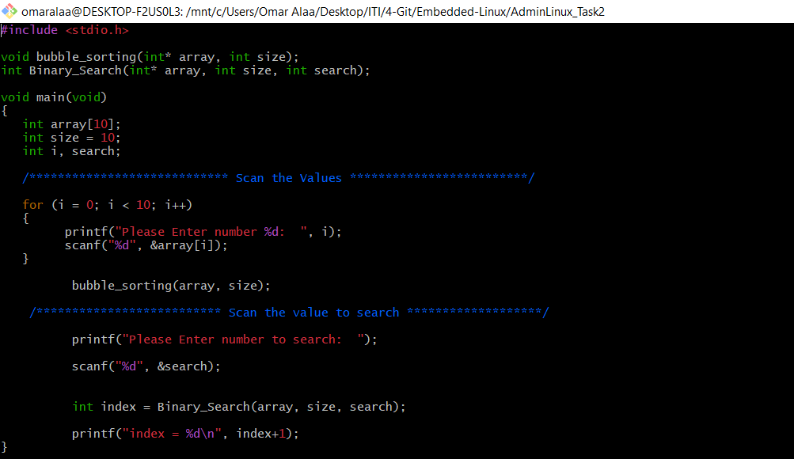

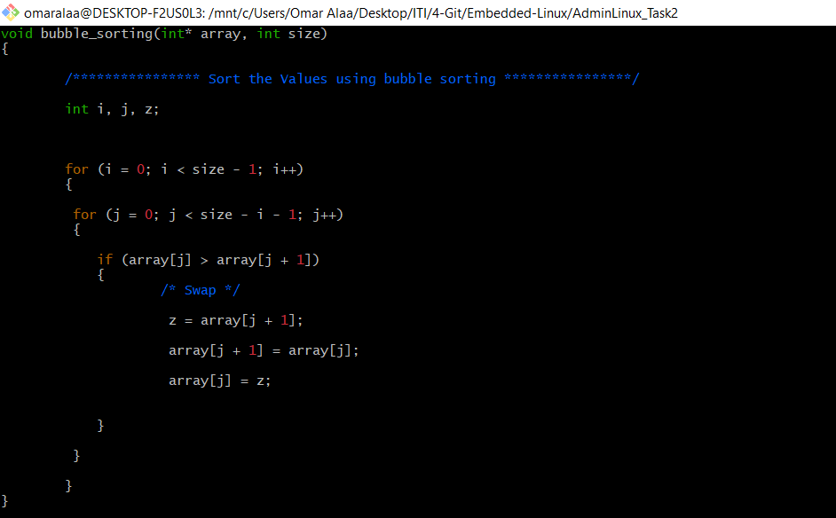

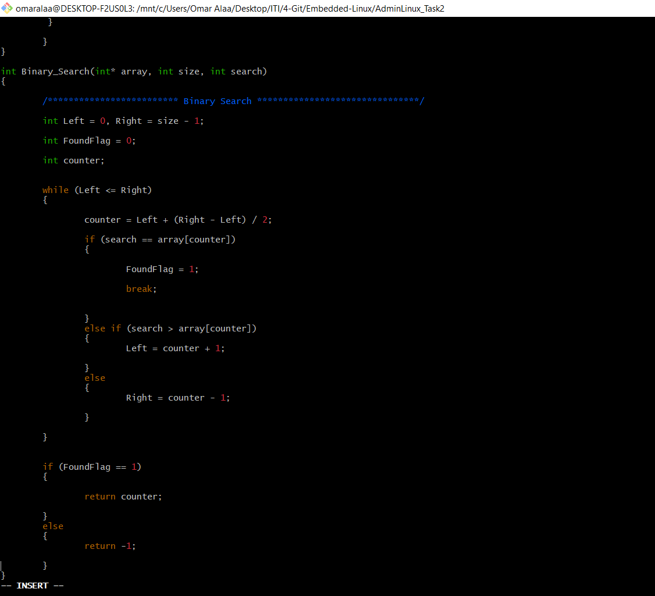

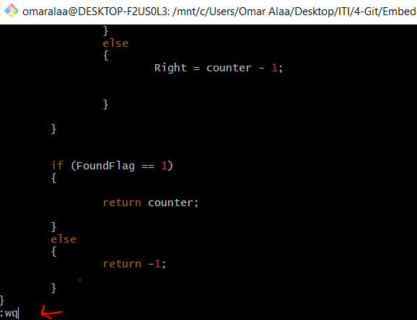

;

OUTPUT:

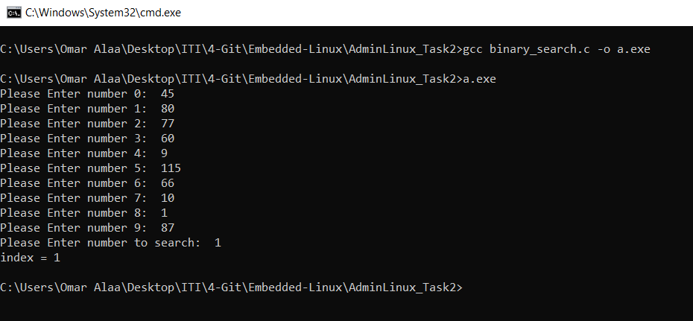

Question 2:

Move the binary file output to the directory /usr/local/bin with sudo permissions. Afterward, attempt to execute the binary from any working directory and explain the outcome. Provide a detailed explanation supported by evidence as to why the binary can be executed from any location.

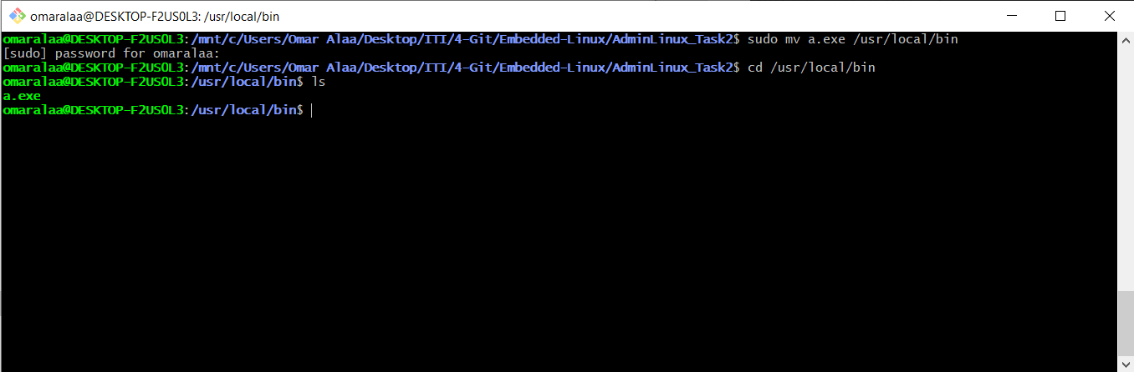

Run from Root ( / )

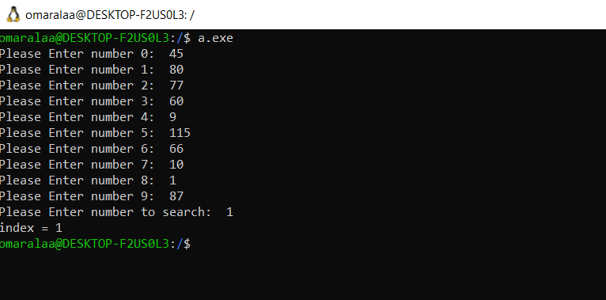

Run from another directory

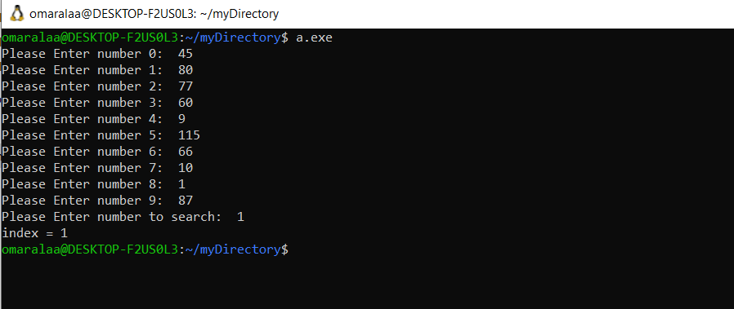

The explanation: The PATH variable is a colon-separated list of directories that the shell searches when you run a command.so we can check the current PATH with

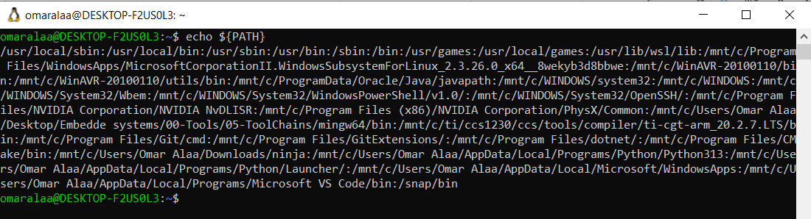

Because /usr/local/bin is in the PATH, the shell automatically finds and executes binaries located there when you type their name.soThe binary executes successfully from any working directory because the shell finds it in the PATH. This behavior is standard for executables located in directories listed in the PATH environment variable.

Na2na2a:

1. 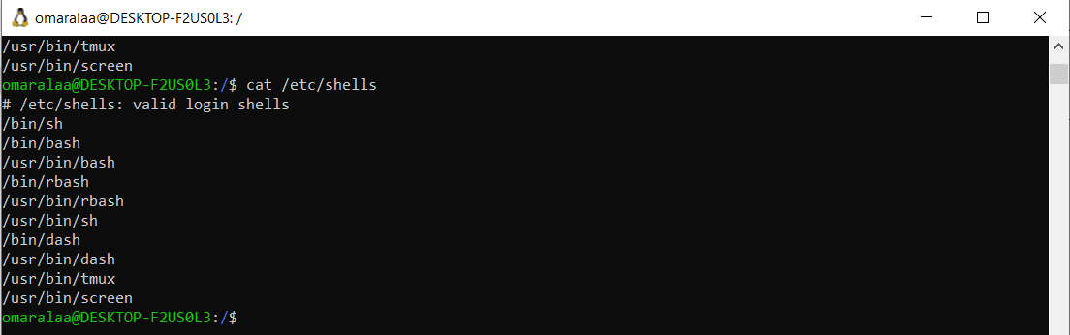List the available shells in your system.
2. List the environment variables in your current shell.

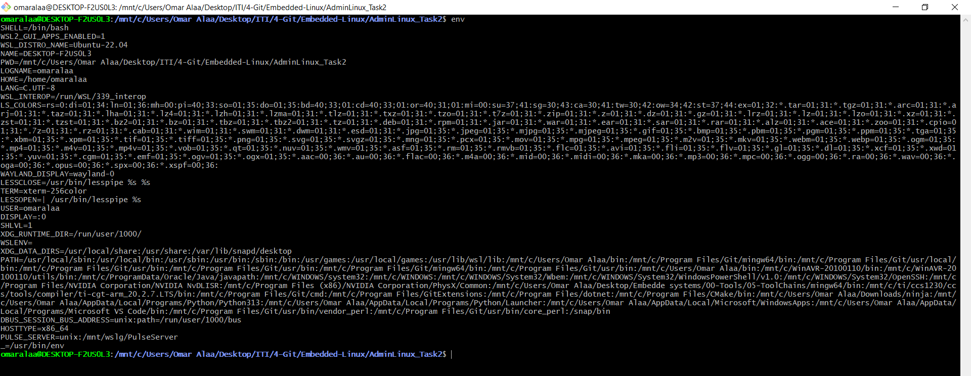

1. Display your current shell name.

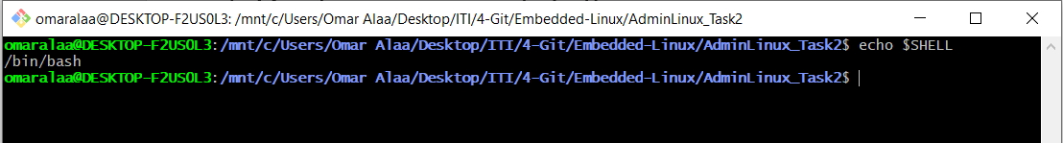

1. Execute the following command :

echo \ then press enter What is the purpose of \ ?

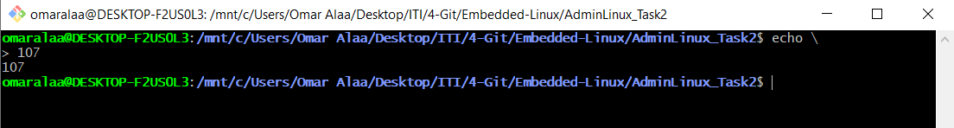

The backslash (\) is a tool for command-line readability and structuring, enabling commands to span multiple lines for clarity or complex scripting needs.

1. Create a Bash shell alias named PrintPath for the “echo $PATH” command

