1- Task Capsloack.

1- Create new file using touch and edit it using vim
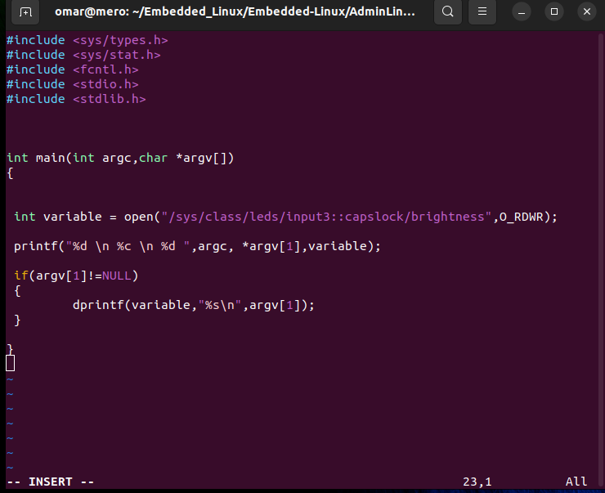
2- Compile the file using gcc
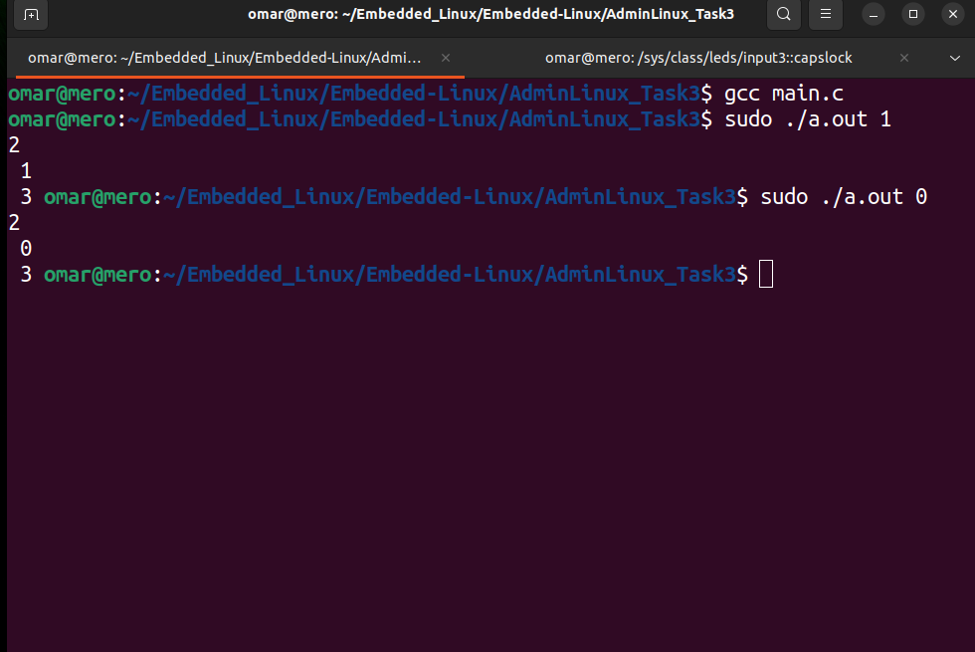
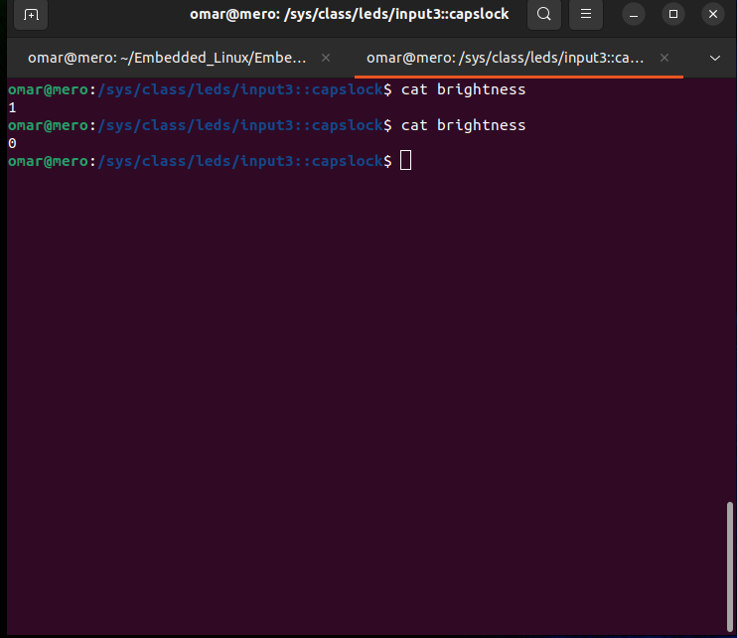
3.Check the r/w values on the brightness

