Section 1:

Write a Bash script that checks IF the .bashrc file exists in the user's home
directory. If it does, append new environment variables to the file: one called
HELLO with the value of HOSTNAME, and another local variable called LOCALwith the value of the whoami command. Additionally, the script should include a command to open another terminal at the end. Describe what happens when the terminal is opened.
1-create script and use vim to edit it
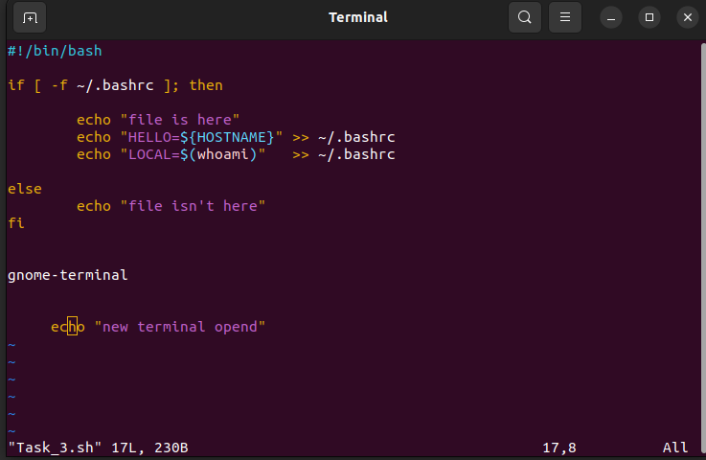

2- check the .bashrc using cat
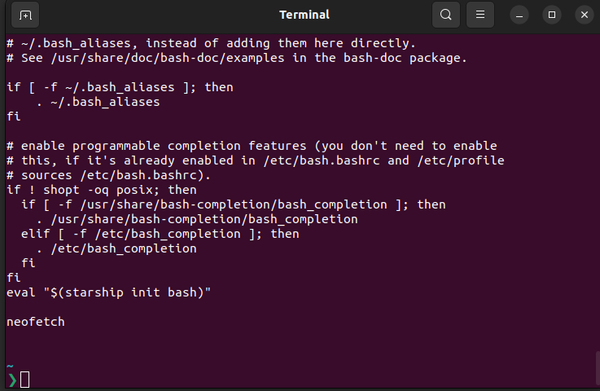
3- source script and the source .bashrc
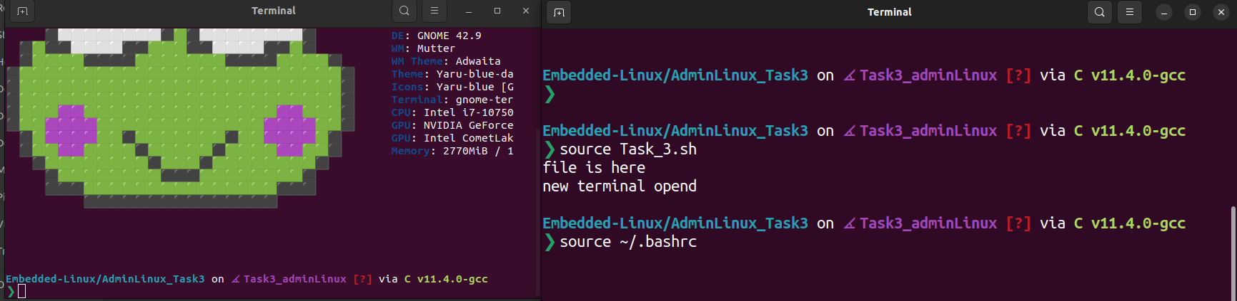
*the new terminal will open and the new variables are appended in bashrc file
4- check the new variables
