Section 2:
1. List the user commands and redirect the output to /tmp/commands.list
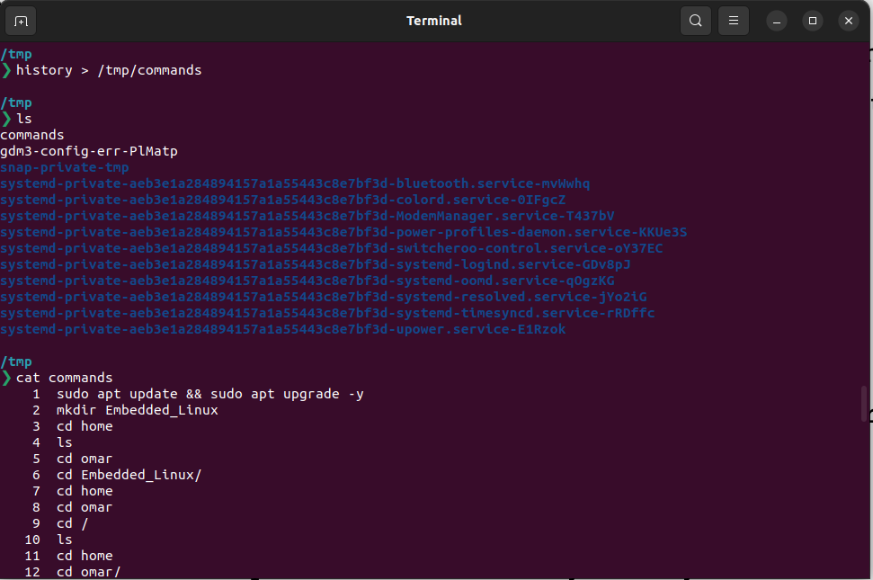
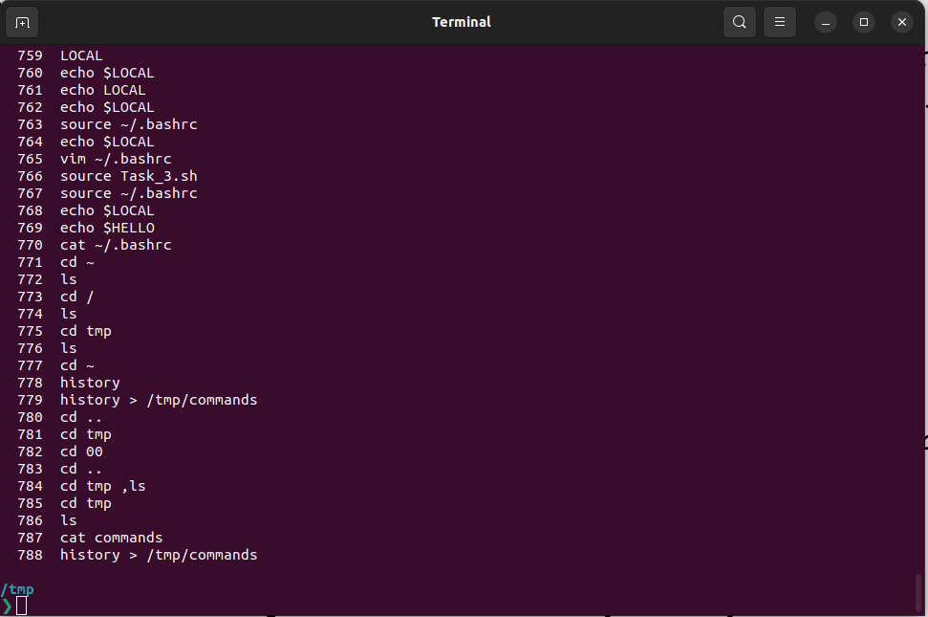

2. Edit in your profile to display date at login and change your prompt permanently.

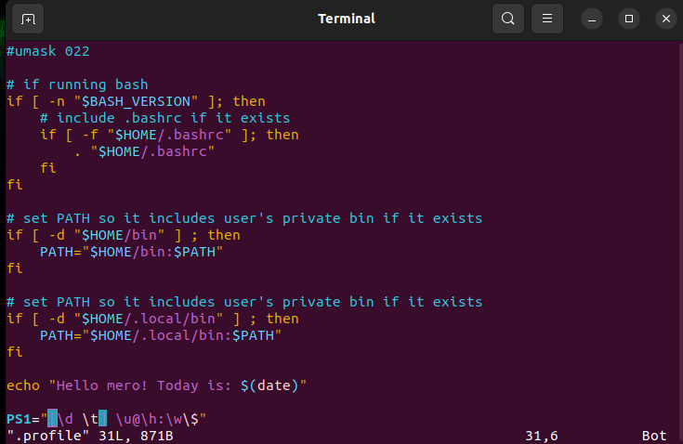
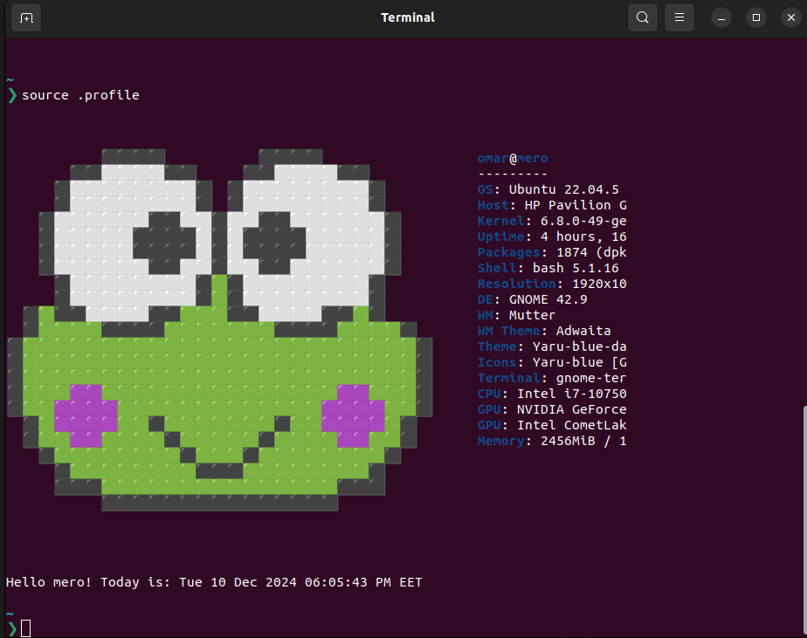

3. What is the command to count the word in a file or number of file in directory.
a. Count the number of user commands

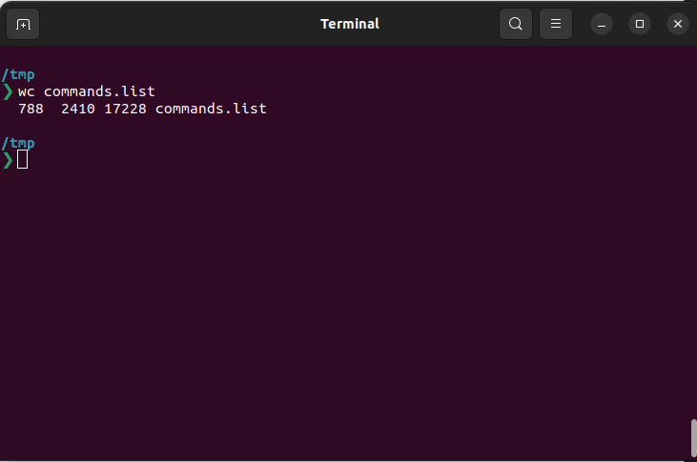
4. What happens if you execute:
a. cat filename1 | cat filename2
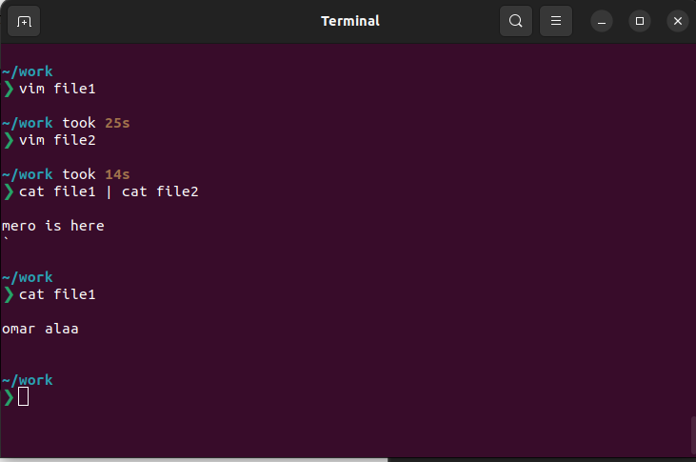
here in this case the process of 2nd cat will open file2 and give priority to it and ignor the piping
b. ls | rm
Expects arguments (file or directory names) but doesn’t read from standard input. Instead, it will ignore the piped input and produce an error like:
- doesn’t work and can result in errors.
- Use rm with caution and always preview the files before deleting.
- rm doesn’t support piping.

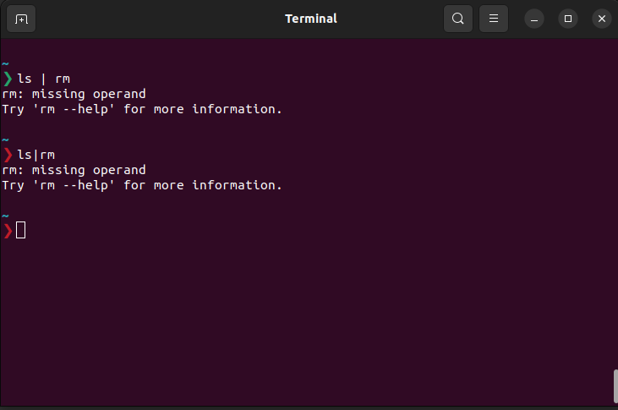
c. ls /etc/passwd | wc –l

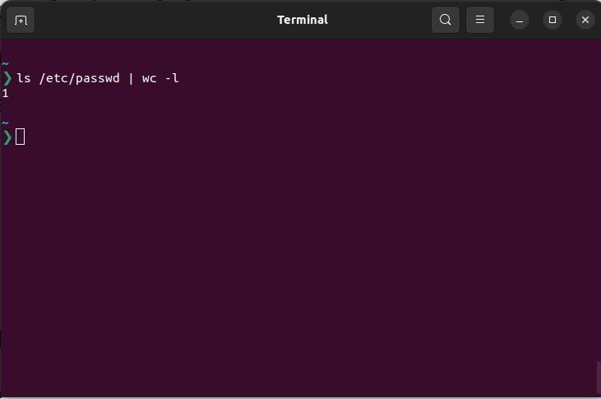
5. Write a command to search for all files on the system that, its name is “.profile”.

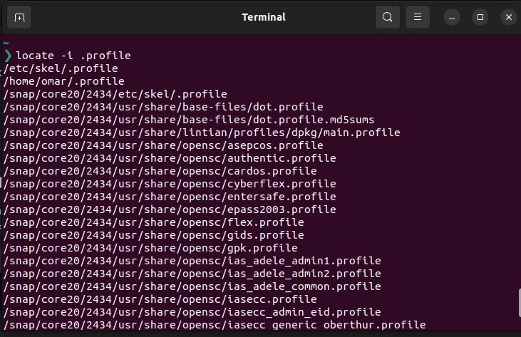
6. List the inode numbers of /, /etc, /etc/hosts.

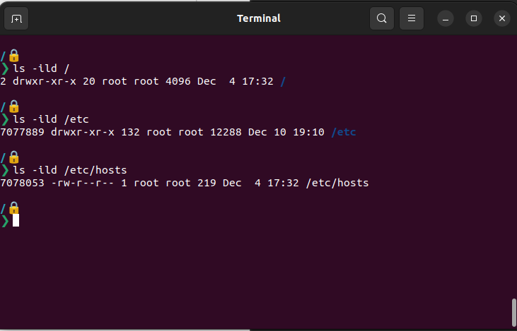

7. Create a symbolic link of /etc/passwd in /boot.

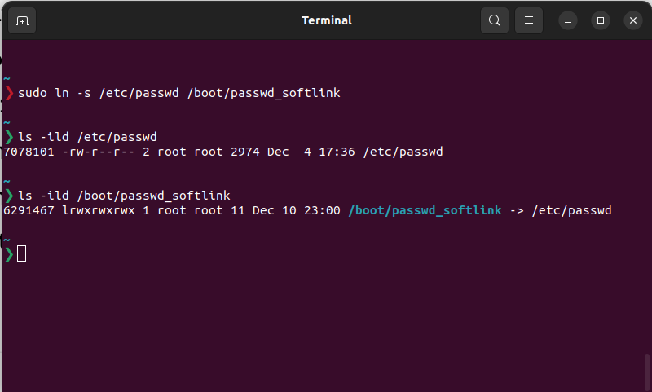

8. Create a hard link of /etc/passwd in /boot. Could you? Why?
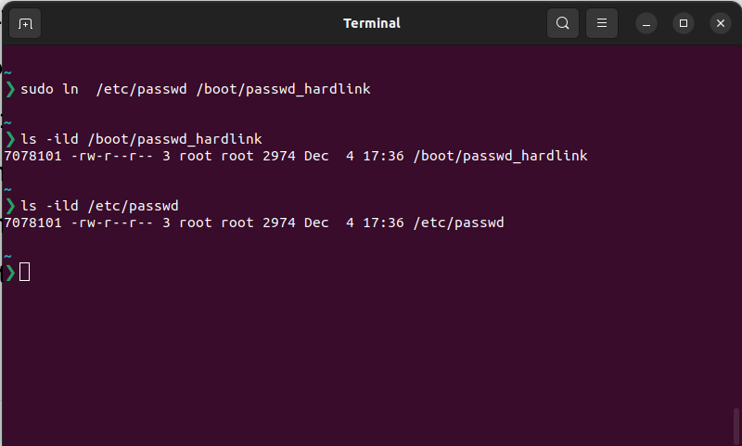
9. Echo \ it will jump to the next line, and will print >
Notice the prompt ”>” what is that? and how can you change it from “>” to “:”.

1- edit .bashrc using vim

