## Exercise 1

URL: <https://www.npmjs.com/package/http-server>.

IP: 142.250.181.111

Requests: 30

Type of form :

• text/html

• image/svg+xml+png

• application/javascript

• text/css

Largest file: HTML file, 12.2 KB.

Load time=1.02s

## Exercise 2

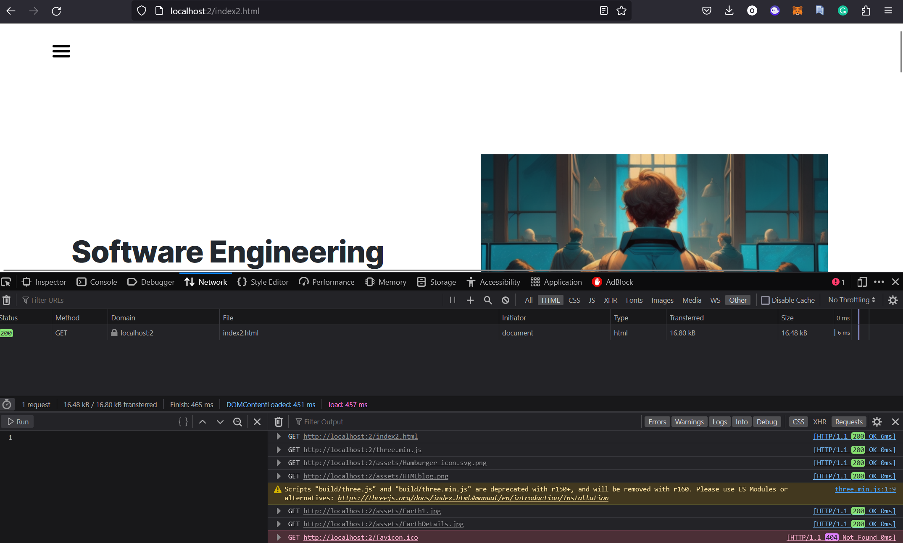

## Exercise 3

Domain: 0marAlfawaz.com