Project Title: KFUPM E-Activities Web Application

Team ##

Abdullah Khayat 201526910

Omar Alghamdi 201528950

Mohammad Alattas 201513050

Phase 01 Report

19-Sep-2019

**Table of Contents**

**1.** **Project Purpose** 1

**2.** **Project Goal** 1

**3.** **Product Features** 1

**4.** **Models** 3

**4.1.** **Use Case Diagram** 3

**4.2.** **Activity Diagram** 5

**4.3.** **Class Diagram** 18

**4.4.** **Database Diagram** 19

**4.5.** **Navigation Diagram** 20

**4.6.** **Presentation Diagram** 20

**4.7.** **User Interface** 21

1. **Project Purpose**

The primary goal of this document is to define and describe the functions and specifications

of the KFUPM e-activities web app to help the developer team to not deviate from the requirements by documenting them professionally and providing guidance and reference for the upcoming phases. This Document clearly illustrates user requirements, use case diagrams, activity models, class models, database models, navigation models, presentation models, and user interface.

A second goal for the document, is to help making a contract with the customer that includes system requirements that are professionally documented. To make things clear to the customer, so he can either accepts or declines the software project.

1. **Project Goal**

The objective of this project is to design a KFUPM e-activities web app for KFUPM. The system shall provide a platform that unify and present all the extracurricular activities that are ongoing in KFUPM. This will provide the students with a one stop shop website where they can check and participate in all of the activities that are taking place in KFUPM, thus saving them time and the hassle of keeping up with every activity organizer on his own.

1. **Product Features**

1. Anonymous user

1.1. The anonymous user shall be able to register in the system.

1.2. The anonymous user shall be able to sign into the system.

1.3. The anonymous user shall be able to browse activities.

1.4. The anonymous user shall be able to search for particular activities.

2. Registered user

2.1. The registered user shall be able to update his profile

2.2. The registered user may be able to view his notifications

2.3. The registered user shall be able to browse activities

2.4. The registered user shall be able to search for particular activities

2.5. The registered user shall be able to request activity participation

2.6. The registered user shall be able to view his own participation request activities

2.7. The registered user shall be able to edit his own participation request activities

2.8. The registered user shall be able to cancel his own participation request activities

2.9. The registered user shall be able to offer an activity

2.10. The registered user shall be able edit an activity

2.11. The registered user shall be able end an activity

2.12. The registered user shall be able view incoming participation requests

2.13. The registered user shall be able accept incoming participation requests

2.14. The registered user shall be able reject incoming participation requests

2.15. The registered user shall be able to send a feedback

2.16. The registered user may be able to reply to a comment

3. Admin

3.1. The admin shall be able to sign in

3.2. The admin shall be able to accept user registration

3.3. The admin shall be able to reject user registration

3.4. The admin shall be able to delete a user

3.5. The admin shall be able to block a user

3.6. The admin shall be able to accept an activity offer

3.7. The admin shall be able to reject an activity offer

3.8. The admin shall be able to generate a report

1. **Models**
   1. **Use Case Diagram**

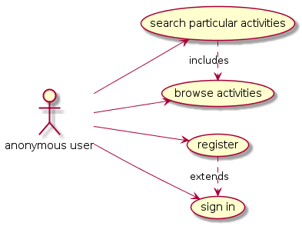

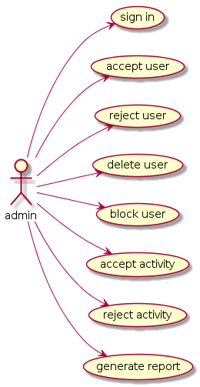

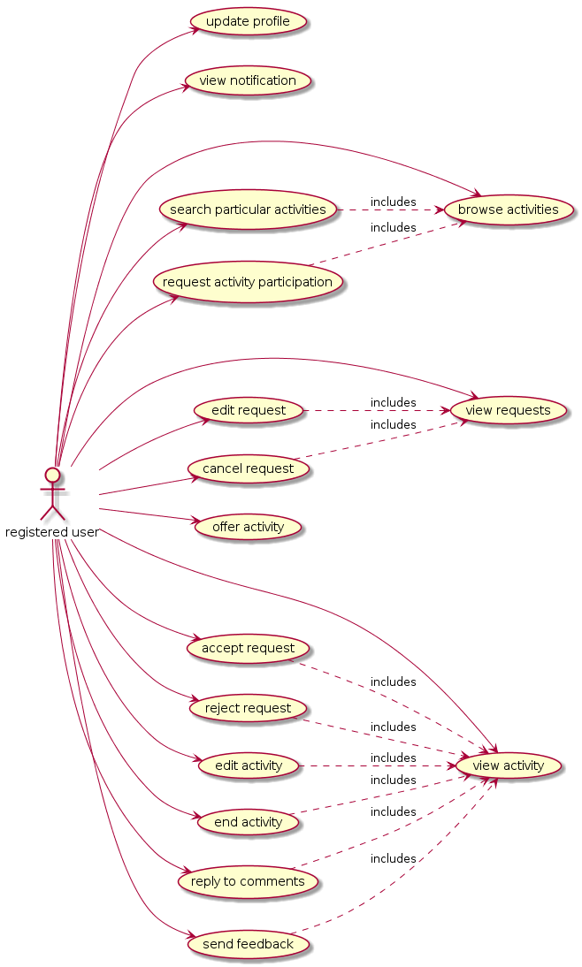

* 1. **Activity Diagram**

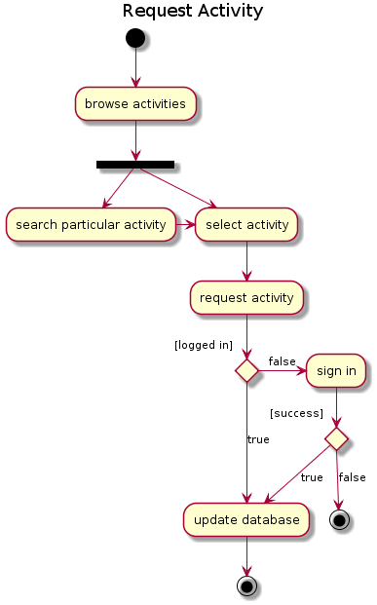

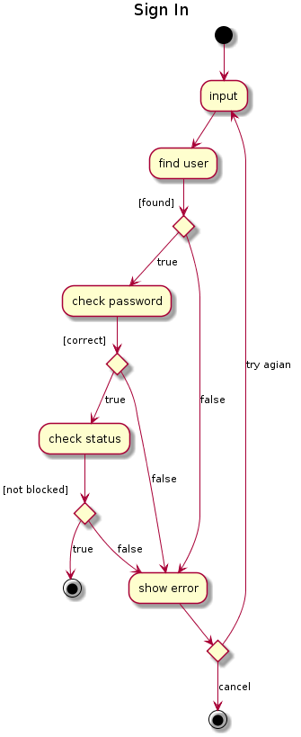

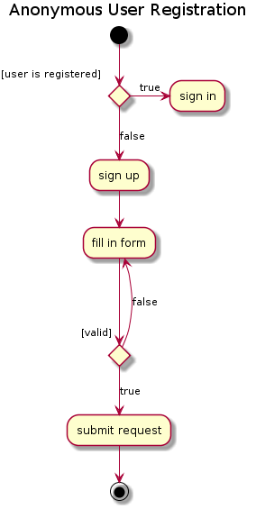

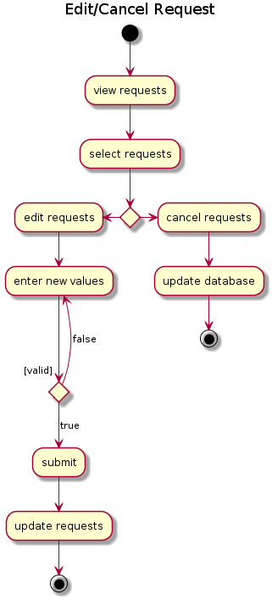

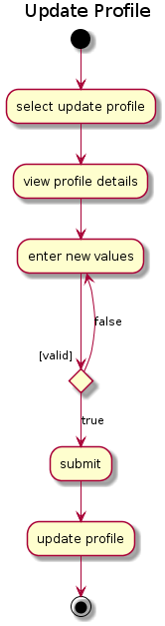

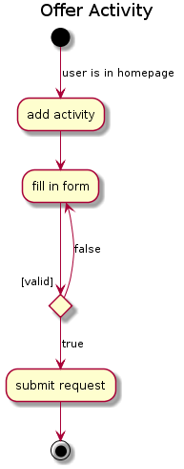

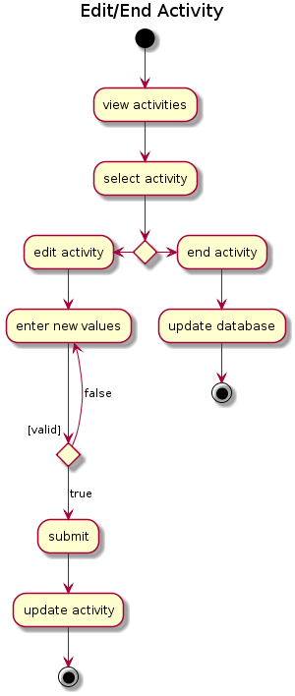

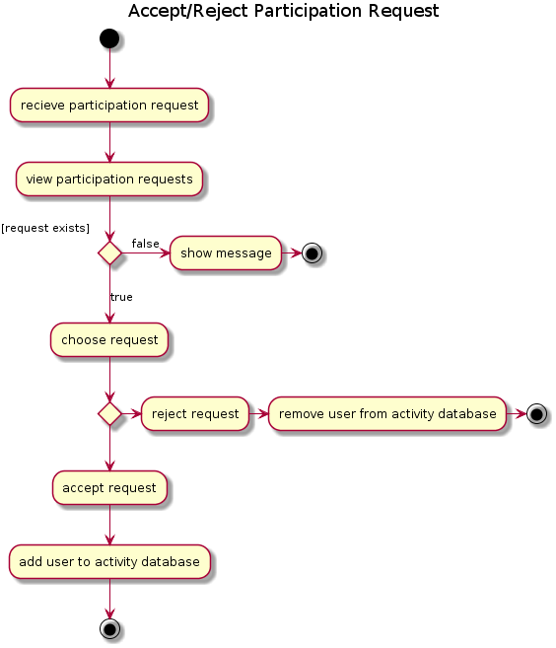

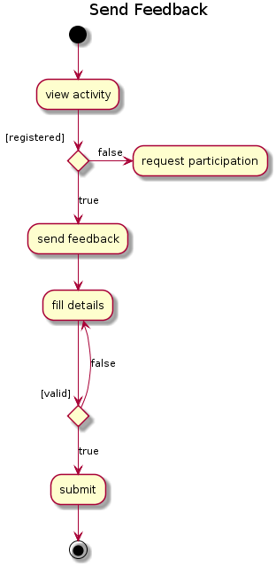

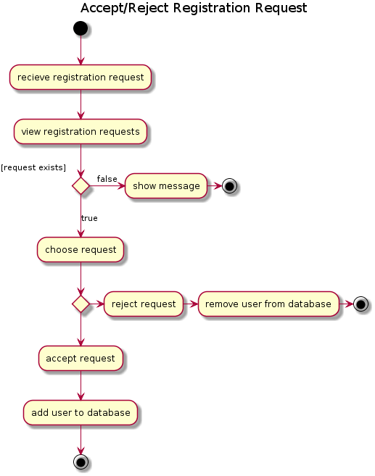

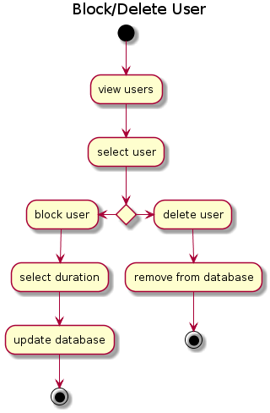

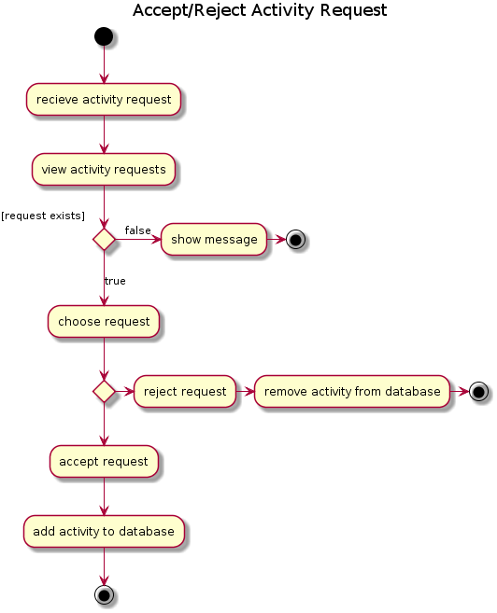

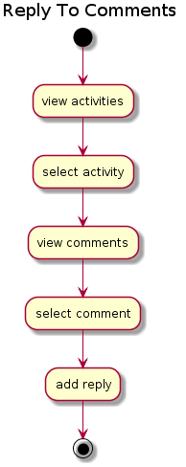

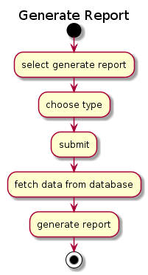

* 1. **Class Diagram**

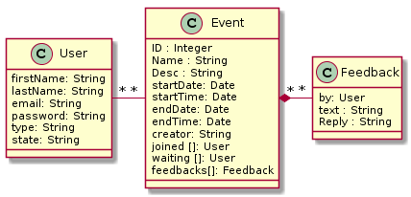

* 1. **Database Diagram**

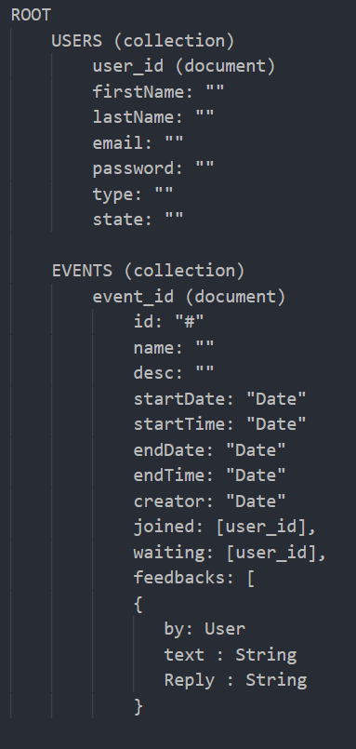

* 1. **Navigation Diagram**

Landing page

Users

Activities

Reports

New Event

Edit Event

History

Profile

Sign in

* 1. **Presentation Diagram**
  2. **User Interface**

Landing page

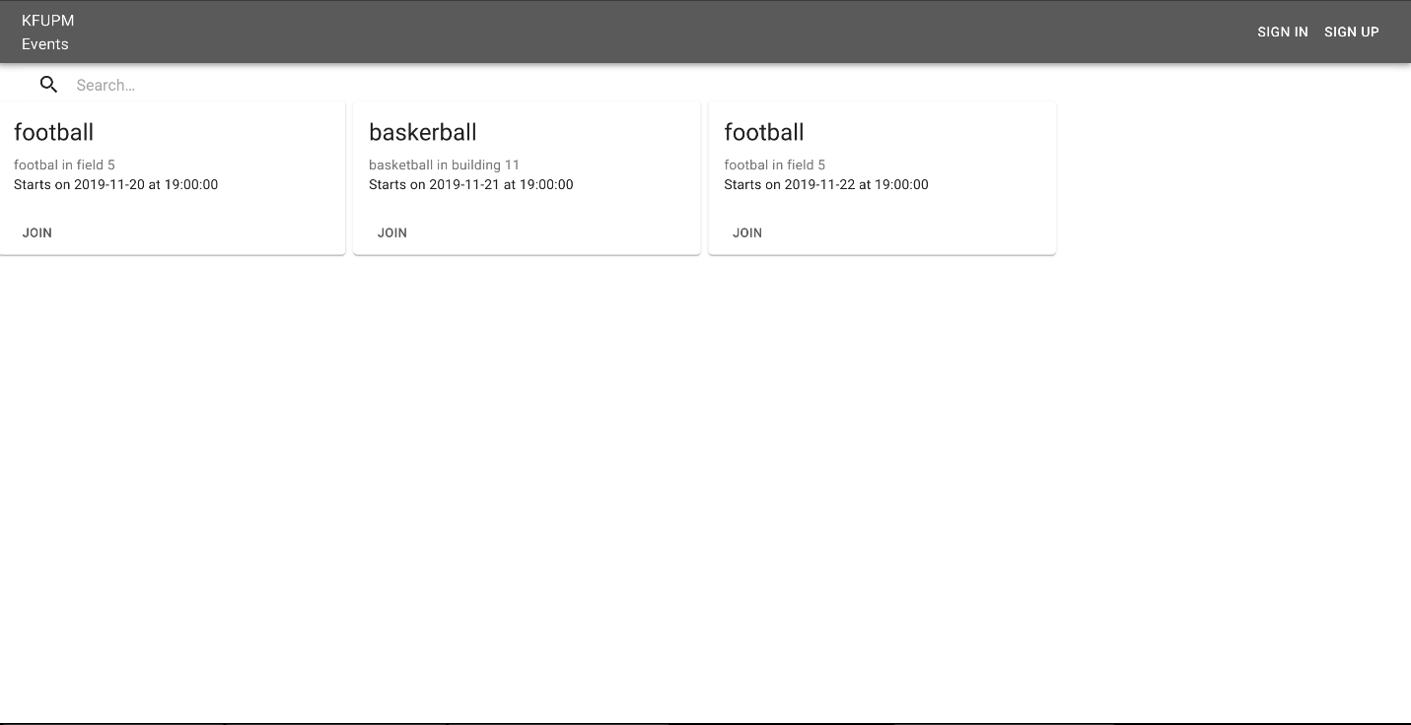

Users

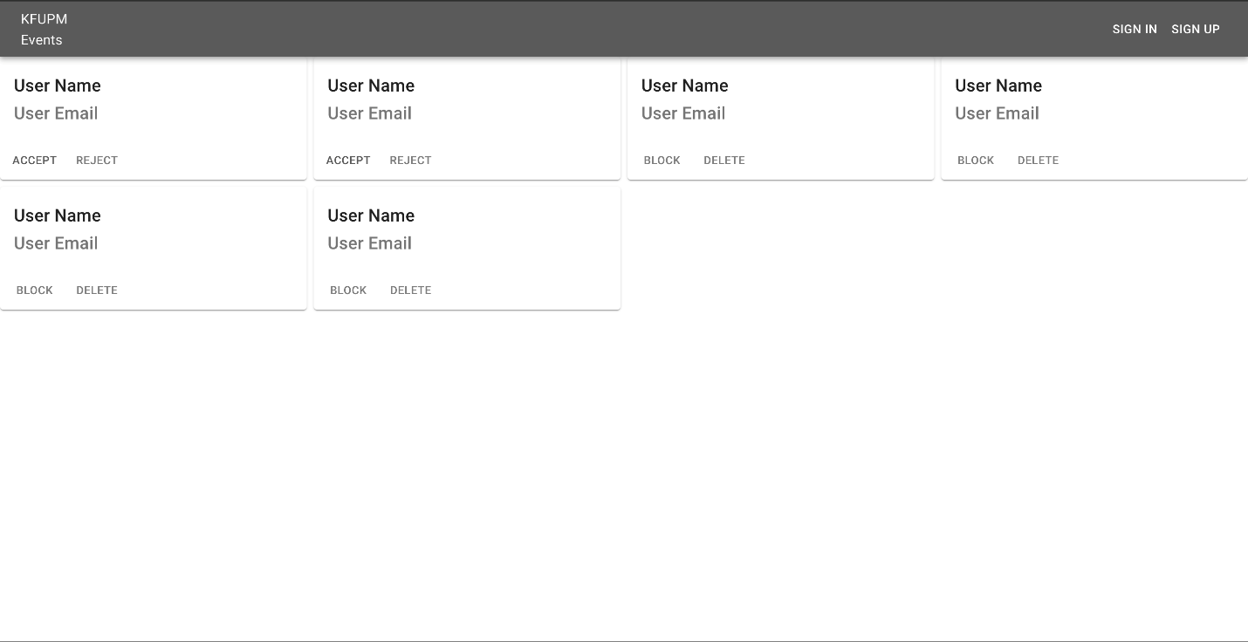

Activities

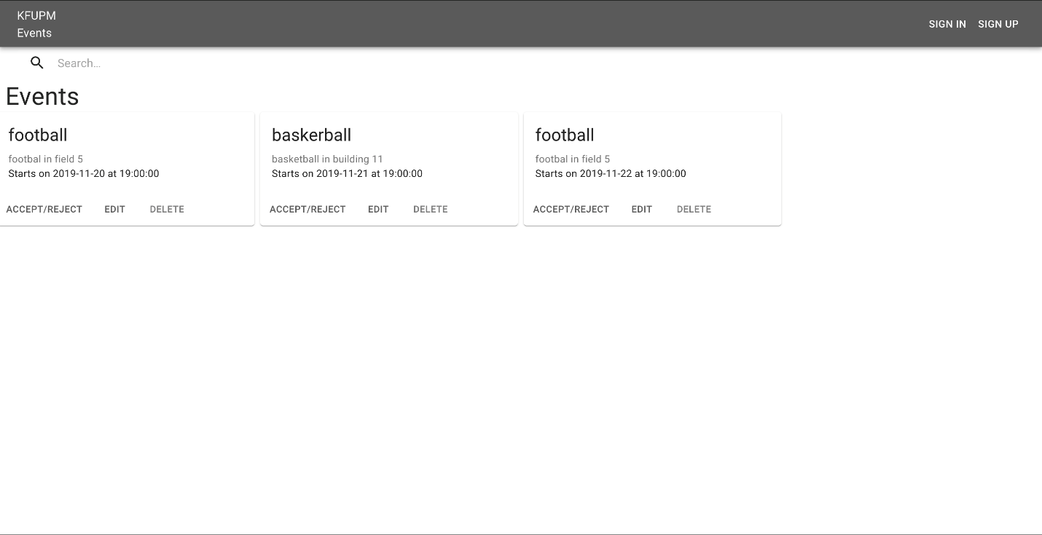

Reports

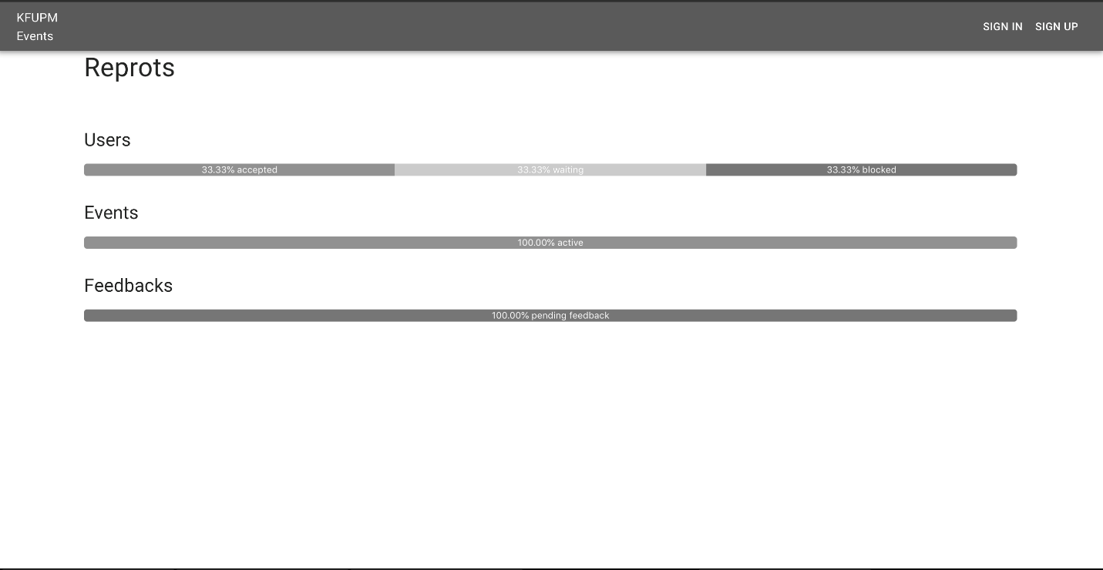

New Event

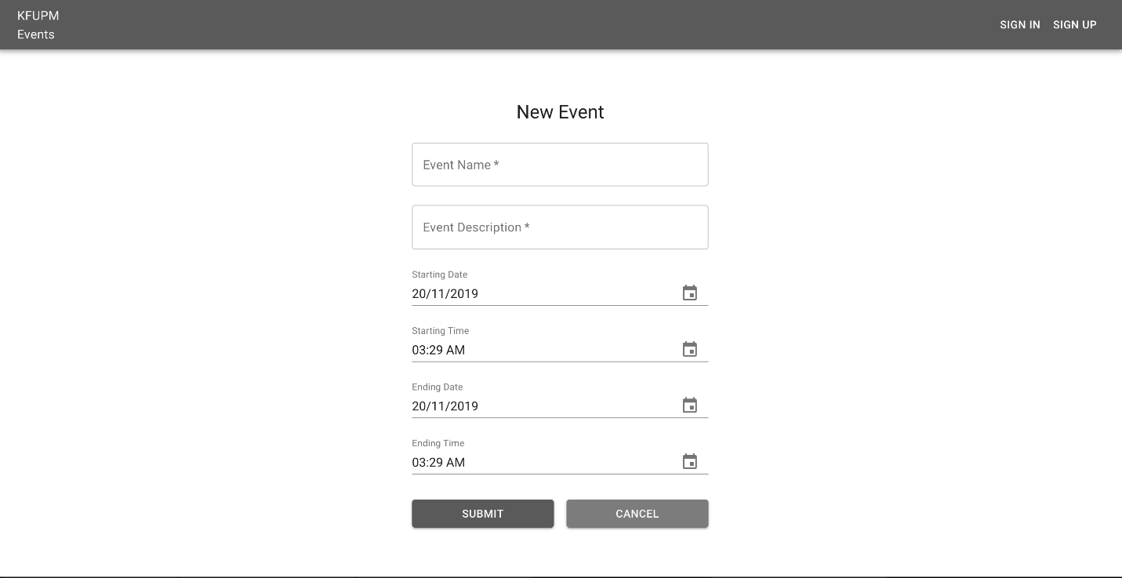

Edit Event

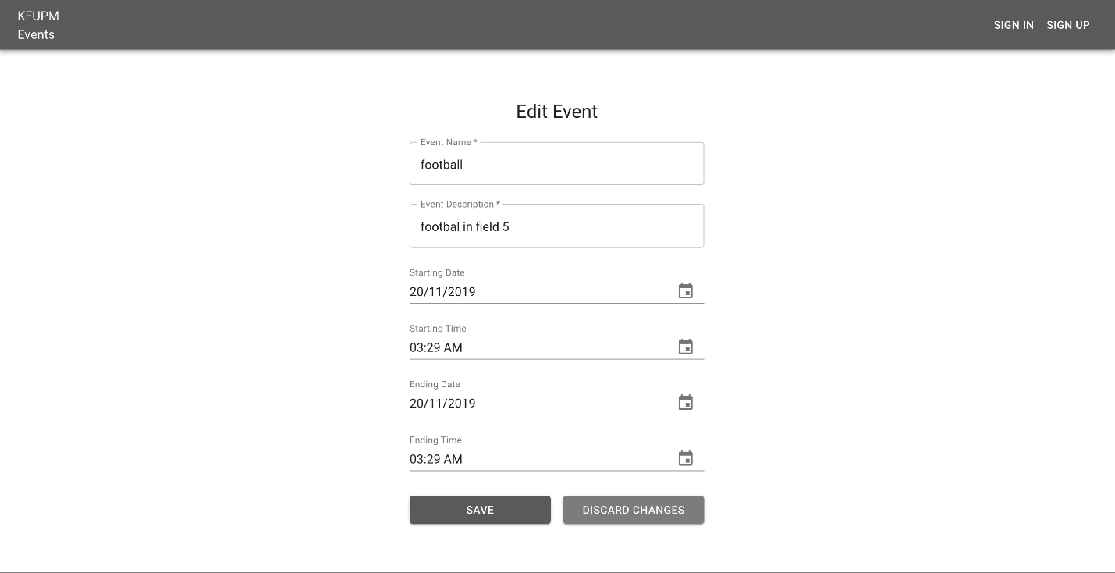

History

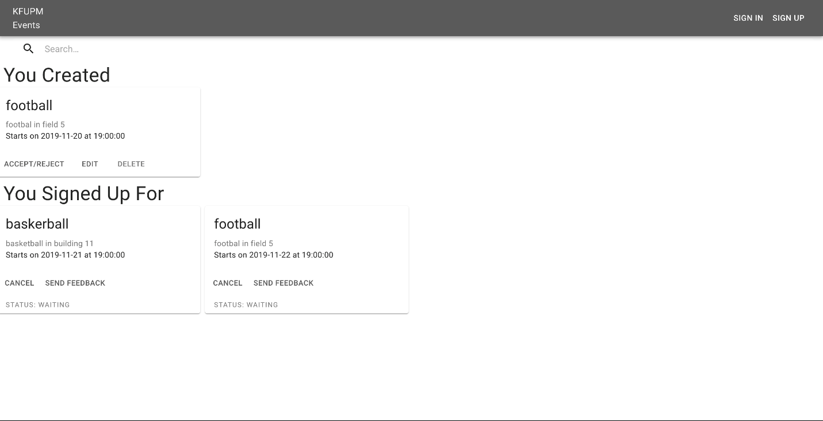

Profile

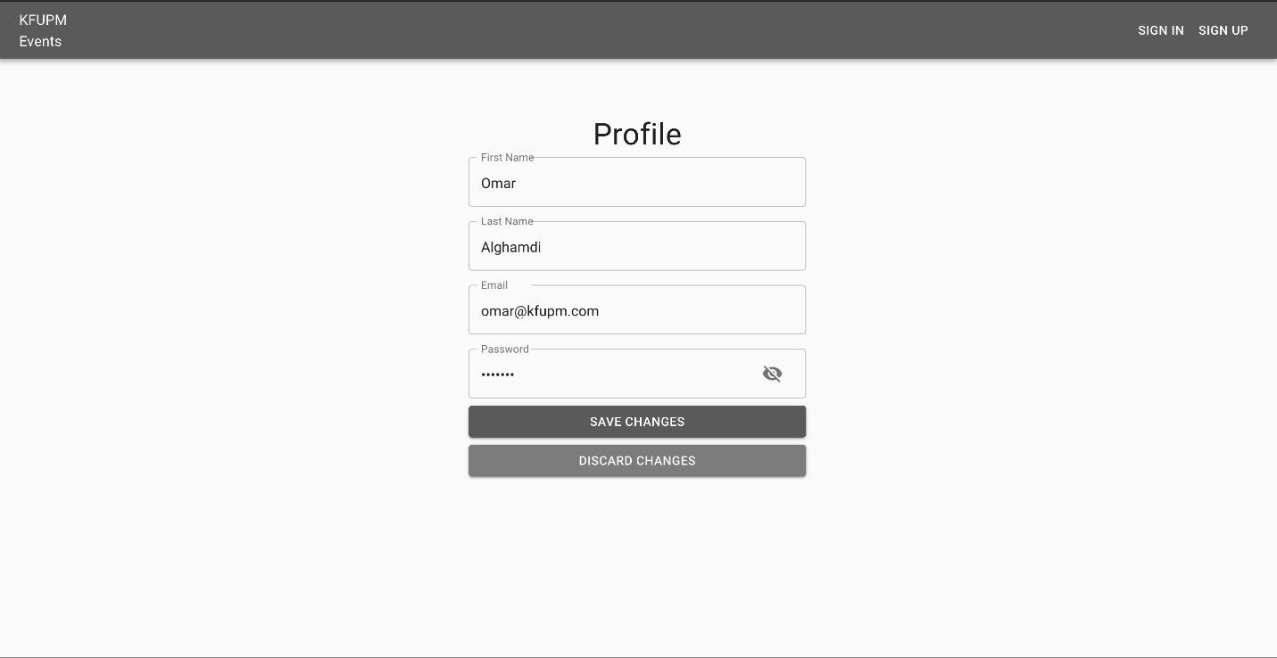

Sign in

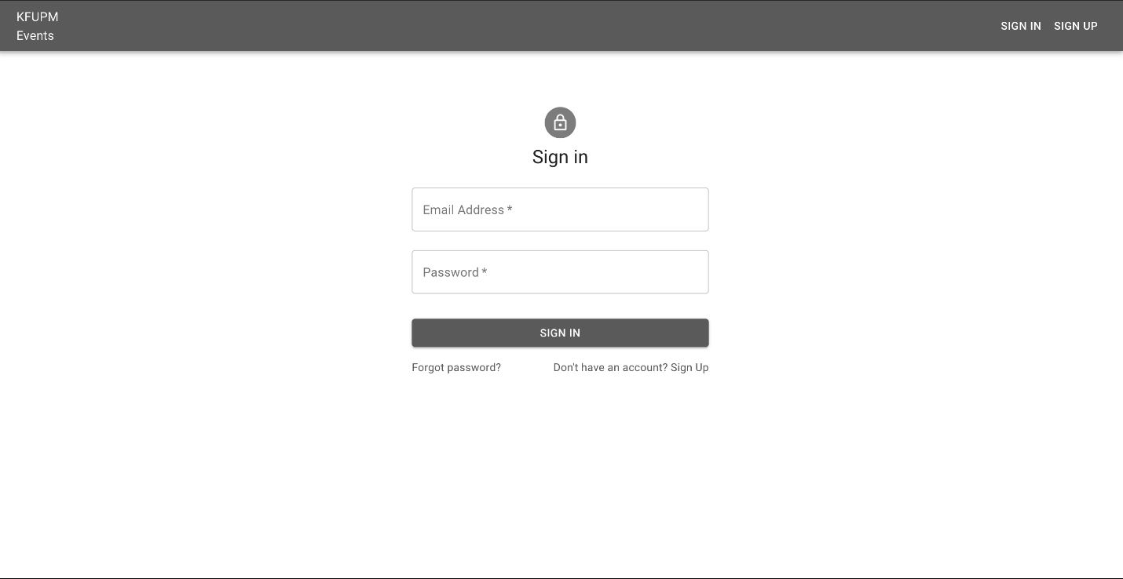

Sign Up

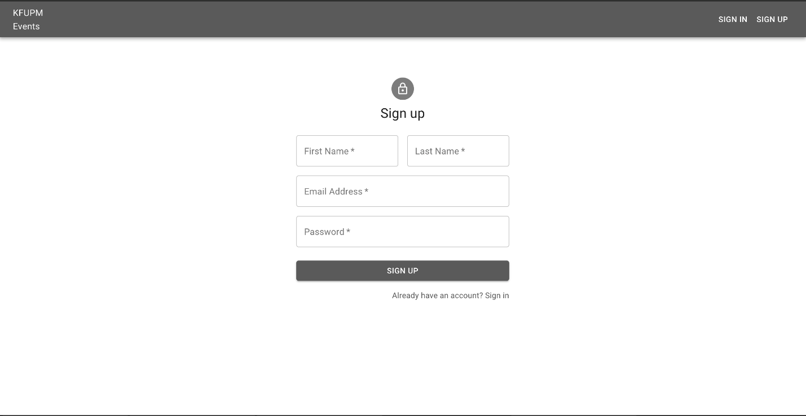

Send Feedback

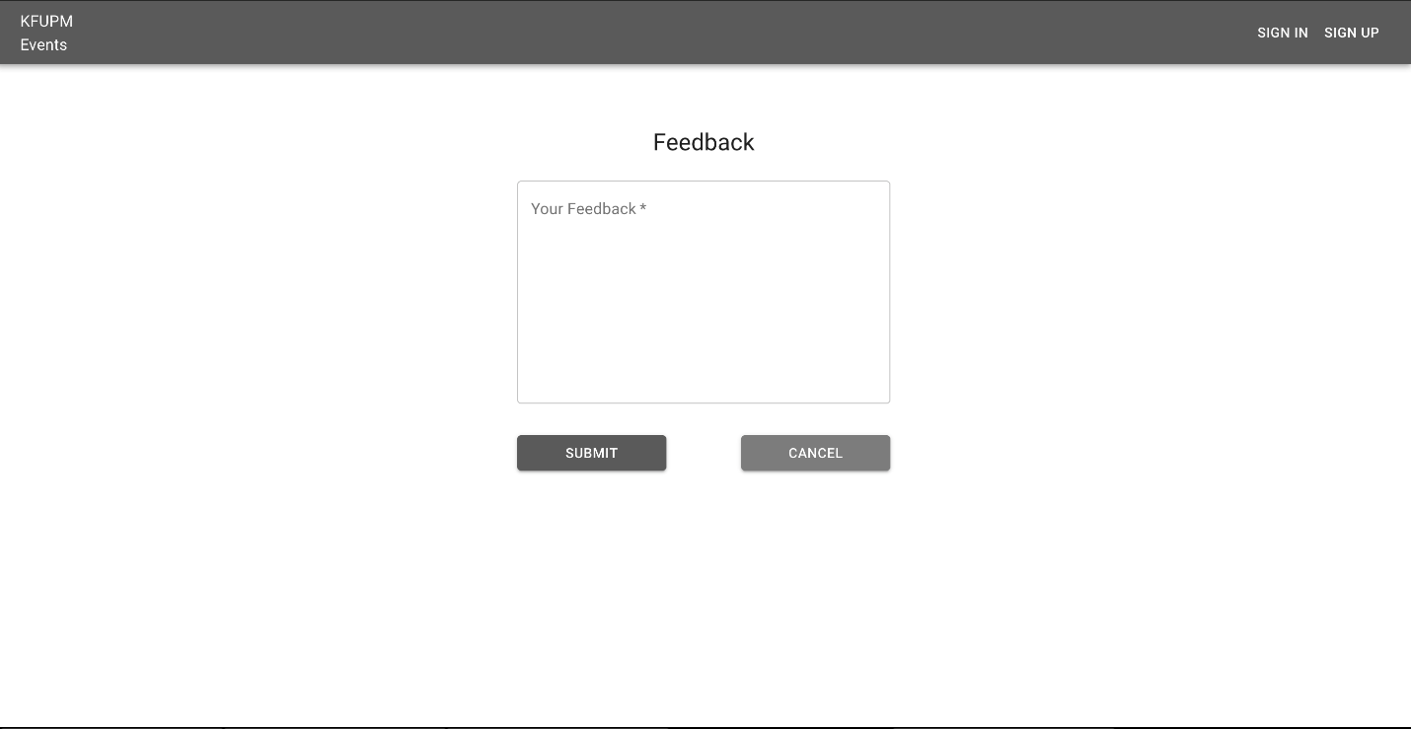

Feedback

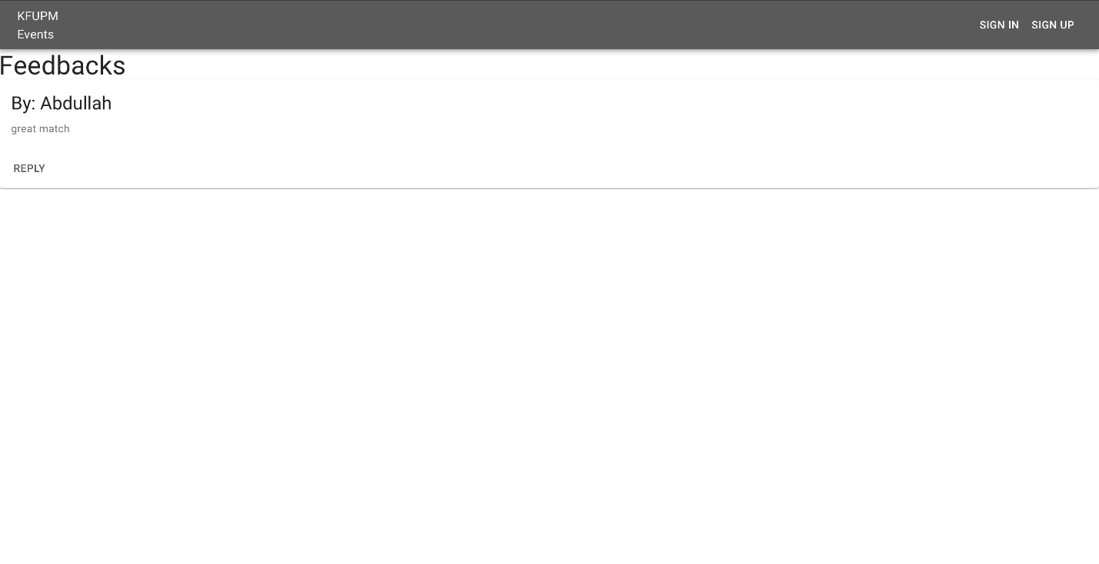

Reply Feedback

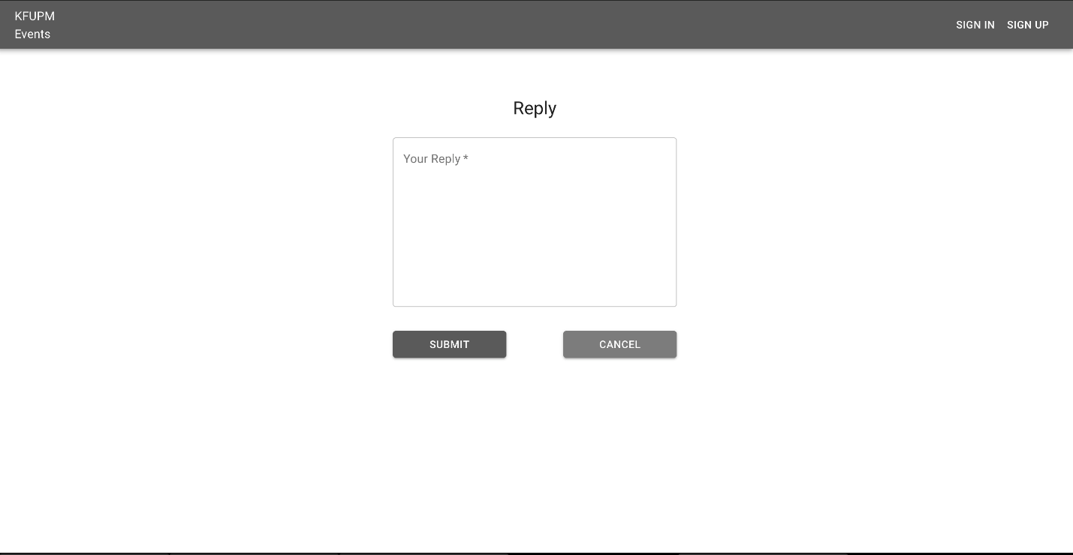

Reset Password

