**Example1**

**Example2**

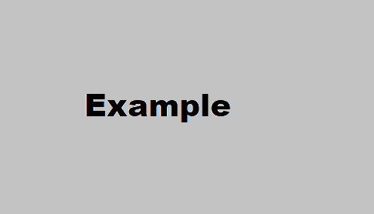

|  |  |  |  |  |  |
| --- | --- | --- | --- | --- | --- |
| **Example** | **Example** | **Example** | **Example** |  | **Example** |
| **Example** |  |  |  | **Example** |  |
|  | **Example** |  | **Example** |  | **Example** |

|  |  |
| --- | --- |
| **Example** | **Example** |
| Example | Example |
| Example | * Example * Example * Example * Example * Example * Example * Example * Example |