As we can see in the following graph, the ticket prices for Big Mountain resort are slightly higher than average.

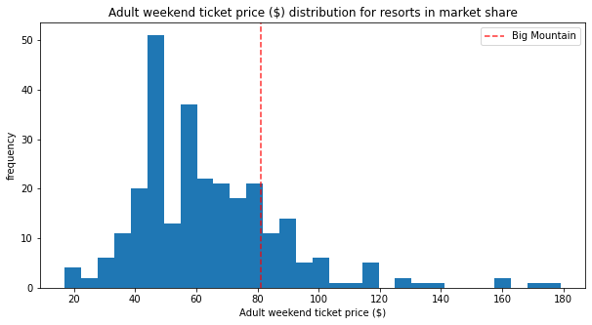

However, the Big Mountain resort just installed a chair lift, which cost about 1.5 million dollars to operate, that on top of all the cost that the big mountain spends on over most other resorts, would lead us to assume that the ticket price is undervalued. So, after creating a model and predicting the price of the tickets for Big Mountain resort, we concluded that the price should be about 96$ with a 10$ mean absolute error, since the ticket price is 81$, then we are definitely undervaluing the tickets. Furthermore, on average the resort has about 350,000 visitors per season, with an average of a 5 day stay, which means that the number of tickets sold is 1.75 million tickets sold each season. That tells us that increasing the price by a single dollar would cover all the costs from the new chair lift, however the price could be increased by about 15$ to reach the predicted price which would add over 26 million dollars in revenue.

Big Mountain resort should also consider cutting the number of undesirable runs they have. As we can see in the figure in the following page, closing a single run would not affect the predicted price, but anything more than that would. However, closing 3-5 runs all affect the price in the same way, it’s dropping the price by about 0.70$ per ticket, which would result in about 1.3 million dollars in revenue, but if the price to maintain the five runs is higher than lose in revenue, then it’s a net positive.

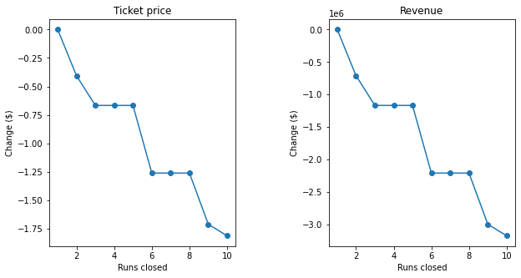

Finally, another idea that could be considered is adding one more run for a higher vertical drop by 150 ft, and another chair lift for that run, would increase revenue by about 3.5 million dollars according to our model. So unless the cost to maintain those is higher, then it should be considered by Big Mountain Resort.