### **Table of Contents**

**Table of Contents** 1

1 OVERVIEW 2

2 DATA QUALITY 2

3 IDENTIFY KEY DRIVERS OF CHURN 4

3.1 Demographic Attributes 4

3.2 Financial Information. 5

***3.2.1*** **Revolving Balance and Attrition Probability** 6

***3.2.2*** **Zero Utilization Ratio and Attrition Risk** 6

***3.2.3*** **Credit Limit Discrepancies and Attrition Patterns** 6

***3.2.4*** **Revisiting the Total Revolving Balance Distribution** 7

***3.2.5*** **Hypothesis on Credit Limits and Attrition** 8

3.3 Behavioral Data 9

***3.3.1*** **Analysis of Inactive Months and Customer Attrition With a 0% Utilization Ratio** 10

***3.3.2*** **Contacts per Total Relationship** 12

***3.3.3*** **Analysis of Transaction Amount & Attrition Rate** 12

4 CONCLUSIONS 14

5 PREDICT CUSTOMERS CHURN 14

6 RETURNING CUSTOMERS 15

6.1 Strategies to Encourage Reuse 15

7 CHURNERS MARKETING CAMPEIGN 16

7.1 Campaign Overview: 16

7.2 Tactics: 16

7.3 KPIs to Measure Success: 17

# **OVERVIEW**

In the banking industry, customer relationships are paramount. Acquiring new customers is costly, and retaining existing customers is key to sustained profitability and growth. Customer churn, or attrition, represents a significant challenge for banks, impacting revenue, market share, and overall financial performance. Recognizing the need to address churn proactively, our bank aims to leverage data-driven insights to improve customer retention.

Customer churn refers to the situation where customers close their accounts or significantly reduce their engagement with the bank. Understanding the factors that drive churn is crucial for implementing effective retention strategies. We seek to develop a predictive model that can accurately identify customers who are at risk of churning. By gaining insights into customer behavior and preferences, we can tailor our services and engagement efforts to enhance customer satisfaction and loyalty.

# **DATA QUALITY**

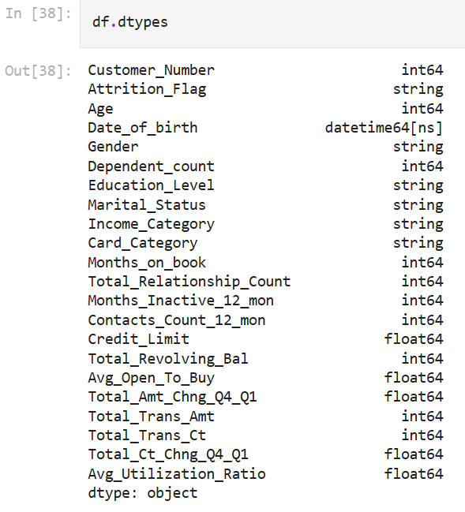To ensure the validation of our data is valid We have to set first a primary key, our data has 22 fields, each field is either integer, string, float or datetime. Each of them can be repeated but the significant one that cannot be repeated is the ID or in our case customer_number.

Our data has 12,127 records, that's an enormous amount of data but after using the remove duplicates data tool on Excel we get a 11,725 record (401 records removed).

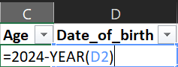Some of these fields are derived from other fields. Such as Age, it’s derived from the date of birth column, that’s because it’s included in the customer’s ID (Personal identification papers), while age is not. So, age shouldn’t be a number. It's a function, that would make the Date of birth useless, we can delete it, if we will then we should copy and paste the value of age to prevent the function from being deleted too.

Second field that has to be organized is education, as it carries some data that has the same meaning, such as N/A and unknown, and graduate and post-graduate they both deliver the same meaning. So, I choose to make both N/A and Graduate. Very easy, we filtered on unknown and post_graduate in the education_level field and write ‘N/A’ and ‘Graduate’ manually and respectively then drag them all down to the end

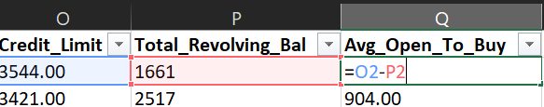Now, we move to the average open to buy field, which is the total difference between the credit limit and total revolving balance, while if we move to the end we find the average utilization ratio, which is the ratio between the total revolving balance and the credit limit, let’s move it after the average open to buy field by copying it and by right clicking on the column V at the top and click insert the copied that will appear when we right click on the column R, and then delete the average utilization ratio at column W and then perform our calculation, and at the end drag both down to the bottom.

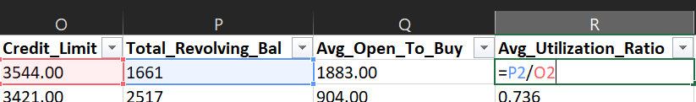After performing calculations we investigate our data, and the first thing that caught our attention is the age, we naturally don’t see a boy that has 9 or 10 years has a credit card, or if he has one that could because his father gave it to him as it’s essential these days for everyone, but that doesn’t mean he is the decision maker of being existed or attired, and same goes for the people who are over a 100 years both of them are considered 200 and 196 records respectively and that would leave us with 11,329 record.

Here’s an essential part of the game, in the data we have some duplicate records that carry the same data with different ID numbers. These data must be eliminated to reduce over-counting and misrepresentations in the analysis, skewing results like averages, totals, and frequencies. By removing duplicates, I ensured that each data point is represented only once, leading to more accurate and meaningful results. This ensures that insights such as trends, patterns, or correlations are based on unique and correct data, which is essential for reliable decision-making.

This can be resolved by removing 464 records of duplicates based on all columns except for customer number, leaving us with 10,666 records.

The last part of our cleaning is replacing the not available/ unknown data, it took time but was really helpful, not just for knowing what is this null data, but also when it’s replaced it creates another duplicated record. Let’s break it down

First, we concatenated the data from month_on_book to total_ct_chng_Q4_Q1, and then we counted each one how many times it was repeated.

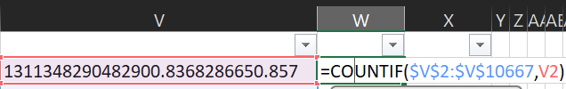Then we filter for the repeated 2 times or more while sorting all the data from A to Z and then substitute each missed one with the corresponding value. That will lead to a 385 newly duplicated value leaving us with 10,281 unique records making the data ready for the analysis.

# **IDENTIFY KEY DRIVERS OF CHURN**

To identify key drivers of churn (attrition), we will perform an analysis using the demographic, financial, and behavioral attributes provided in our dataset. This analysis will focus on the three main categories which are: demographic attributes, financial indicators, and behavioral data. Let's break down the approach for each.

## ***Demographic Attributes***

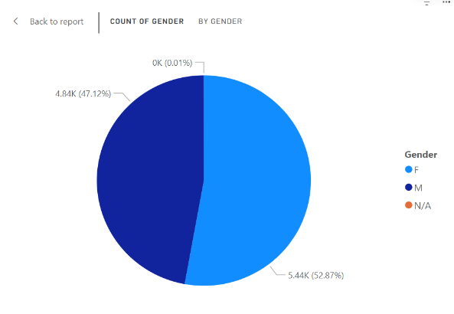Age, Gender, Dependents, Education Level, Marital Status: The goal here is to identify whether specific customer segments based on demographic attributes are more prone to attrition. For example:

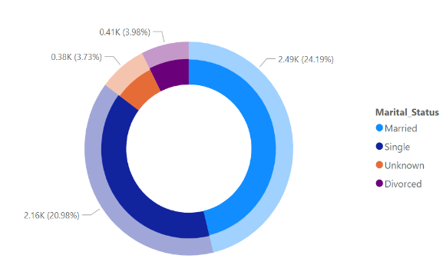Do older customers tend to attrite more than younger ones? Are single customers more likely to attrite compared to married customers?

Is there a difference in attrition between male and female customers?

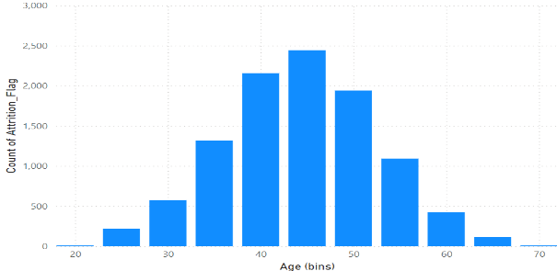It Is obvious in the chart that most of the customers who carry a credit card are females (52%) this may be because most of the women do like spending money on shopping while men don’t really care, as most of these ladies are married, they don’t have as much responsibility as men have. also, they make annually less than $60k.

Demographic attributes may not provide significant insights in this case, as the data generally aligns with averages, and individual characteristics can vary widely across the population.

**For instance, the age distribution chart follows a symmetric, bell-shaped curve, which reflects the typical age range of individuals who engage with banks, aligning closely with real-world data. Similarly, the chart for dependents indicates that the average household consists of 4 to 5 individuals, which corresponds to standard demographic trends.**

## ***Financial Information.***

Income Category, Credit Limit, Total Revolving Balance, Avg Open to Buy, Transaction Patterns (Total_Trans_Amt, Total_Trans_Ct): This analysis will help uncover if customers with lower income, higher balances, or irregular spending habits are more prone to attrition. For instance:

Are customers with lower credit limits or higher utilization ratios more likely to leave?

Do customers with a lower average transaction amount tend to attrite more frequently?

### **Revolving Balance and Attrition Probability**

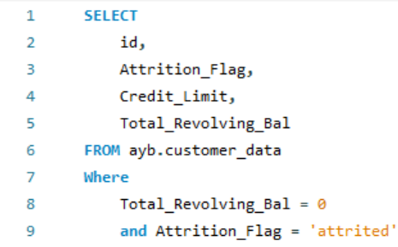The relationship between total revolving balance and customer attrition reveals an important insight. Customers with a total revolving balance of zero exhibit a significantly higher likelihood of attrition. Specifically, **36.2%** of customers with a zero revolving balance have already attrited. This translates to **912 attrited customers** out of a total of **2,517 customers** with a revolving balance of zero. This suggests that customers who either pay off their balance in full or do not use their card at all are at greater risk of leaving. The lack of an active balance may indicate disengagement, and these customers might be more inclined to close their accounts.

### **Zero Utilization Ratio and Attrition Risk**

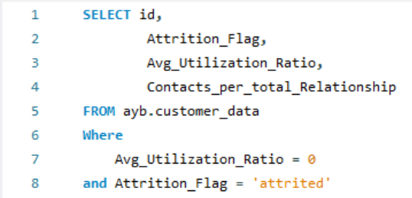Further analysis shows that customers with an average utilization ratio of **zero** are either already attrited or at high risk of doing so. This segment includes **2,583 customers**, of which **925 customers (35.8%)** have already attrited. The remaining customers in this category, who are not utilizing their credit cards at all, represent a high-risk group that may attrite in the near future. These customers are not engaging with the credit card, and the absence of any usage is a strong indicator of potential attrition. This behavior suggests a need to proactively engage these customers to prevent further losses.

### **Credit Limit Discrepancies and Attrition Patterns**

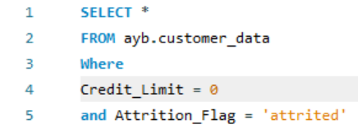Anomalies in the credit limit data present some interesting insights. There are instances where customers appear to have a **credit limit of zero**, yet they simultaneously carry a **total revolving balance**, leading to negative average open-to-buy values. While this is technically possible due to credit usage exceeding available limits, it raises questions about the data's accuracy and the real credit standing of these customers. Furthermore, it was observed that all customers with a zero-credit limit had already attrited (**13 customers** in total). This situation seems contradictory, as customers with no credit limit should not be able to utilize their credit cards, let alone carry a balance. These cases point to potential data quality issues that should be addressed to ensure the integrity of the analysis and to prevent misleading conclusions.

### **Revisiting the Total Revolving Balance Distribution**

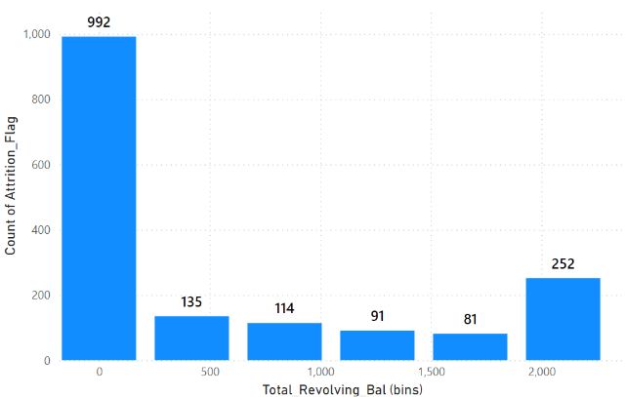The total revolving balance plays a critical role in understanding attrition behavior. The histogram depicting the distribution of customer attrition across various bins of total revolving balance highlights an interesting observation. The first bin, which corresponds to customers with a total revolving balance between **$0 and $419.5**, contains **992 customers**. However, it is important to note that **912 of these customers** have a total revolving balance of exactly **$0**, significantly skewing the distribution within this range.

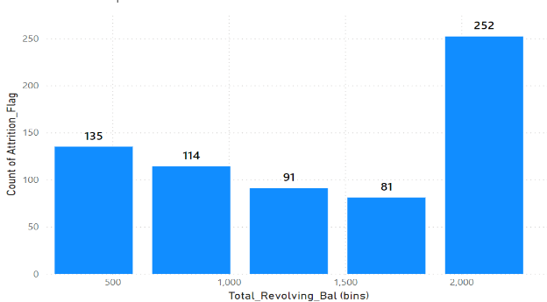To obtain a more accurate representation of attrition behavior, it would be prudent to exclude customers with a zero revolving balance from this analysis. These customers likely represent a distinct subset, and their inclusion distorts the overall understanding of attrition patterns across different balance ranges. By focusing solely on customers with an active revolving balance, we can gain a clearer view of how attrition is distributed across different balance levels, providing more actionable insights.

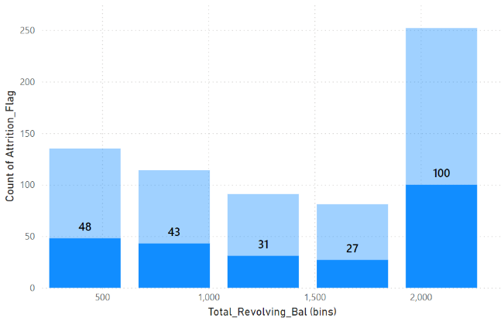An interesting finding from the analysis is the behavior of customers with higher credit balances in relation to their income levels and marital status. Specifically, there are **1,371 customers** with a credit balance between **$2,097.50 and $2,517**. Of these, **252 customers (18.3%)** have already attrited. A closer look at the demographics of these attrited customers reveals that **100** of them have an annual income of less than **$40,000**, and notably, **all of these customers are married**.

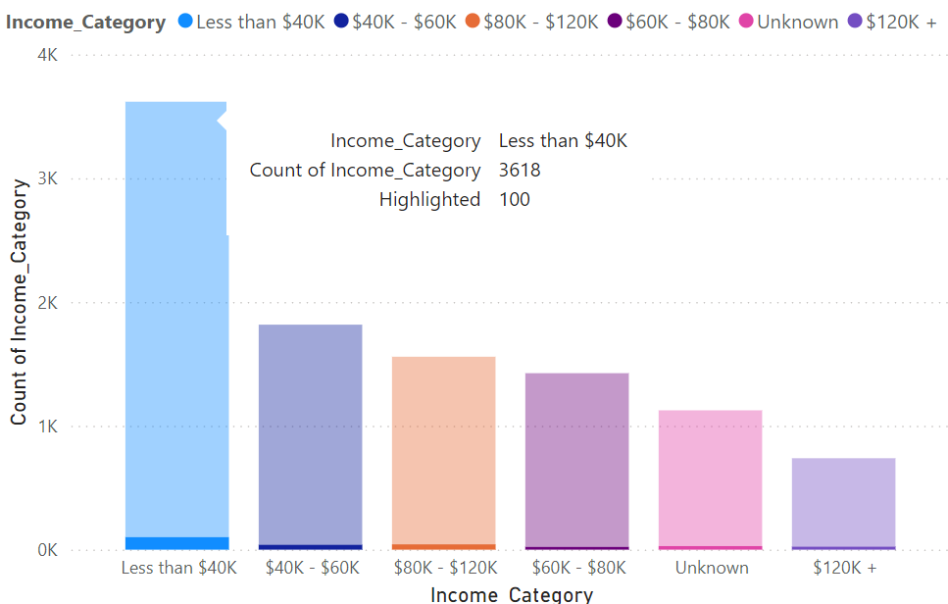This correlation between low income, marital status, and higher credit balances suggests a potential oversight in the credit risk management strategy. Married customers with lower incomes and higher credit balances may be at greater risk of attrition or financial strain, yet they do not appear to be receiving adequate attention or intervention from the credit risk analysis team. The combination of higher balances and lower incomes may indicate financial stress, which could lead to higher attrition rates if not addressed.

Given these findings, it is recommended that the credit risk management team closely monitor and implement proactive engagement strategies for married customers in this segment, particularly those with lower income levels and high credit balances. Targeted financial support, customized product offerings, or early interventions could help mitigate the risk of attrition in this group.

### **Hypothesis on Credit Limits and Attrition**

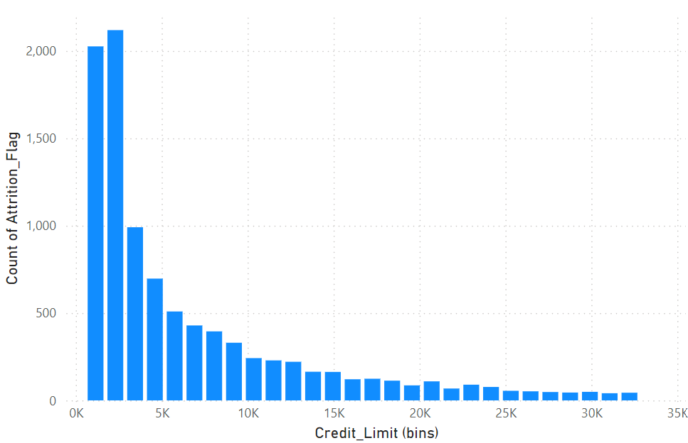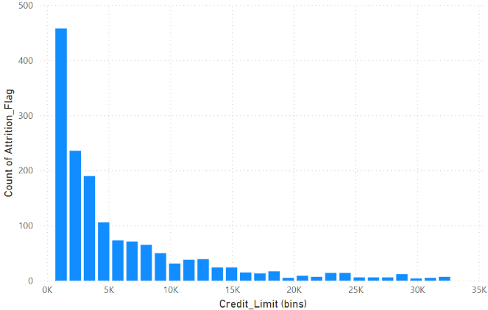 It was initially hypothesized that customers with lower credit limits are more likely to attrite. This hypothesis is supported by the data, as the majority of attrited customers had credit limits concentrated in the lower range. Specifically, **36% of all customers** are granted a credit limit below **$2,301**, and this group appears to exhibit higher rates of attrition. The steep decline in customer counts as the credit limit increases indicates that lower credit limits may be a significant factor influencing customer attrition.

This insight suggests that customers with limited access to higher credit lines may feel underserved or find more competitive offers elsewhere, leading to higher attrition rates.

## ***Behavioral Data***

Months on Book, Total Relationship Count, Inactivity (Avg_Utilization_Ratio), Contact Frequency (Contacts_per_total_Relationship): This will help analyze patterns of engagement, such as:

Is there a pattern in customers' contact frequency (those who contact more or less tends to leave)?

How does inactivity, as measured by revolving balance correlate with churn?

The analysis of the average open-to-buy for attrited customers reveals distinct patterns. Most attrited customers have average open-to-buy values concentrated at **$0**, **$1,438**, **$31,999**, or **$34,516**.

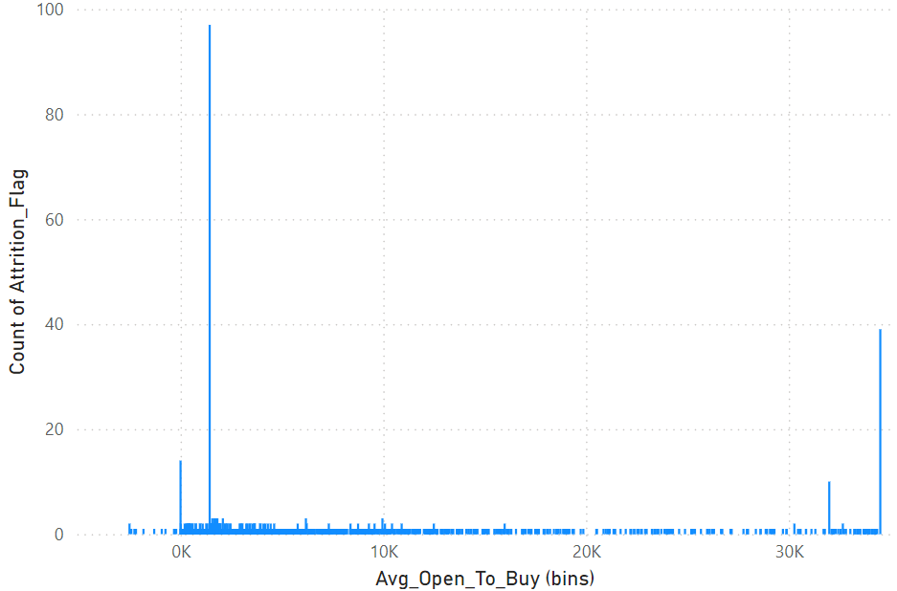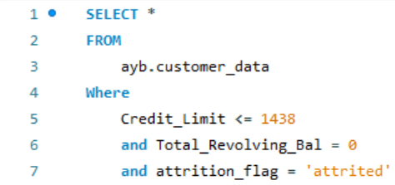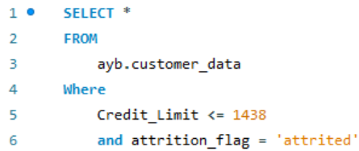Customers with **$0 and $1,438** average open to buy represent the lower end of available credit limit, typically associated with customers who are granted the smallest credit limits. In total, **609 customers, 151 out of them are attrited and 110 out of them have $0 revolving balance** fall into this category, indicating a higher likelihood of attrition among those with lower credit limits.

Customers with **$34,516** average open to buy represents the maximum available credit limit granted to customers. Interestingly, customers in this category have a **0% average utilization ratio**, meaning they are not utilizing their available credit despite having high limits. Furthermore, the maximum amount spent by this group is only **$2,517**, which highlights a significant gap between their credit limit and actual usage.

These observations suggest that customers at both ends of the credit limit spectrum are prone to attrition. Those with lower credit limits may feel financially constrained, whereas customers with higher limits and a **0% utilization ratio** may not fully engage with their credit accounts, potentially leading to disengagement or account closure. The underutilization of credit in the higher-limit group signals a need to explore retention strategies, particularly for high-limit customers who may not be leveraging their credit lines.

### **Analysis of Inactive Months and Customer Attrition With a 0% Utilization Ratio**

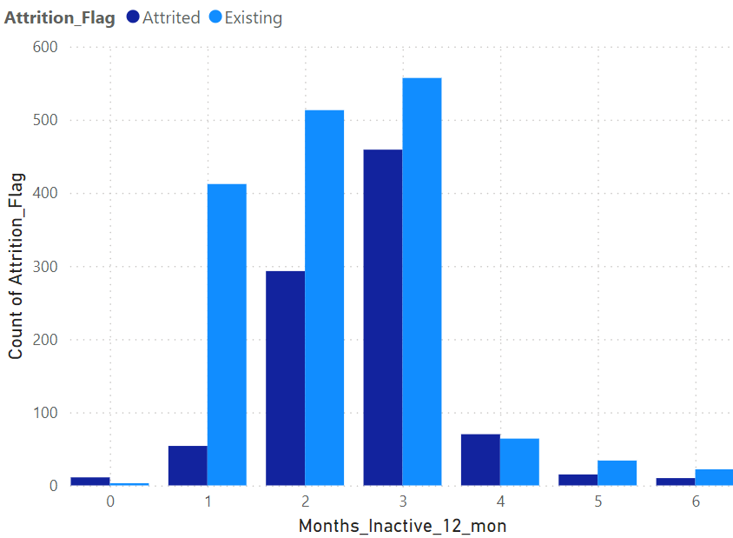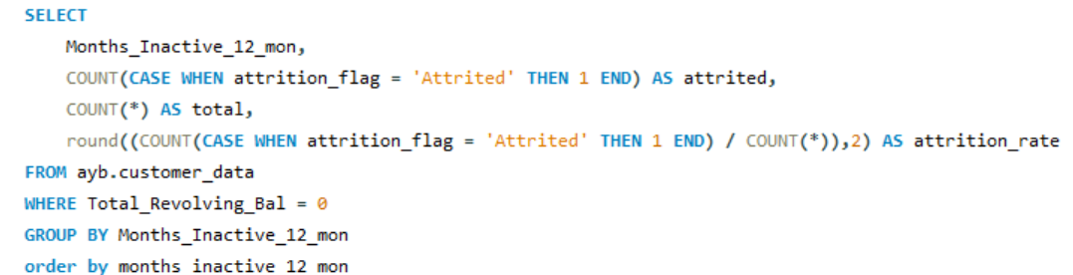Inactive customers are those who haven’t used their account for a specific period. In this analysis, inactivity ranges from **one to six months**. While some level of inactivity is normal, it becomes concerning when coupled with a **0% average utilization ratio**. Customers who are inactive and have a **0% utilization ratio** are either already attrited or at high risk of attrition. This supports the notion that **attrition is closely linked to inactivity** and lack of card usage.

**High Attrition Rate at 0 Months**: Customers who are inactive for **0 months** exhibit an unusually high attrition rate of **0.79**. However, this is likely due to the small total count of **14**, where **11** of these customers have already attrited. The small sample size skews this value, but it highlights that early attrition, even among newly inactive customers, can occur.

**Low Attrition at 1 Month**: After 1 month of inactivity, the attrition rate drops significantly to **0.12**. This suggests that most customers do not immediately close their accounts after short-term inactivity, but their risk increases with longer periods of inactivity.

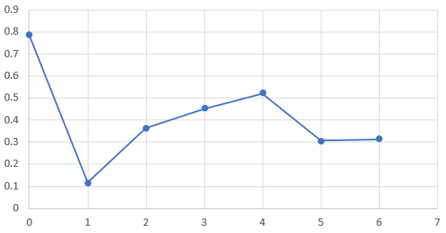**Rising Attrition from 2 to 4 Months**: The attrition rate steadily increases for customers inactive for **2 to 4 months**. By **4 months**, the attrition rate reaches its highest point at **0.52**, indicating that customers in this range are at a critical point where the risk of attrition is the greatest.

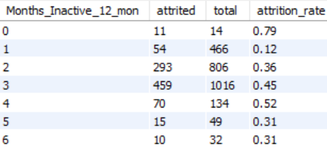**Moderate Risk at 5 and 6 Months**: Customers with **5 and 6 months of inactivity** have attrition rates of **0.31**, which is still substantial but lower than those observed at **3 to 4 months**. It is worth noting that customers who remain inactive for this long and have not yet attrited are still at risk. However, some may remain in the system, potentially due to account retention strategies or extended inactivity policies.

Customers with **6 months of inactivity** have likely progressed through **0 to 5 months** of inactivity without using their accounts. It makes sense that the attrition rate is moderate at this point because many customers will have already attrited in the earlier months. The pattern suggests that most customers who are not using their credit cards tend to attrite by **3 to 4 months** of inactivity, and after this point, the total number of customers remaining declines.

Additionally, many customers who are inactive for **5 to 6 months** are still at risk of attrition despite not having left the service yet. These customers, especially with a **0% utilization ratio** and no revolving balance, may soon attrite if no intervention is applied.

The analysis highlights that attrition risks are highest for customers with **2 to 4 months of inactivity**. The steep increase in attrition rates during this period indicates that customers should be closely monitored and targeted with engagement strategies before they reach **4 months** of inactivity. Meanwhile, those with **5 to 6 months** of inactivity remain at significant risk and may require retention strategies to prevent further attrition.

### **Contacts per Total Relationship**

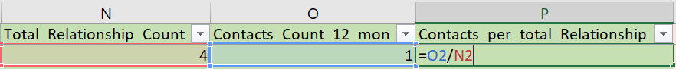To gain deeper insights from our data, we introduced a new column that calculates the ratio of customer contacts in the last 12 months against their Total Relationship Count. This ratio, shown as Contacts per Total Relationship, helps to identify how engaged a customer has been recently in relation to the overall length or breadth of their relationship with the company.

This metric allows us to see the percentage of recent contacts (from the last 12 months) relative to the total number of interactions a customer has had over time. A higher ratio may indicate increased recent engagement, whereas a lower ratio could suggest a decrease in customer interaction, potentially signaling a risk of attrition.

### **Analysis of Transaction Amount & Attrition Rate**

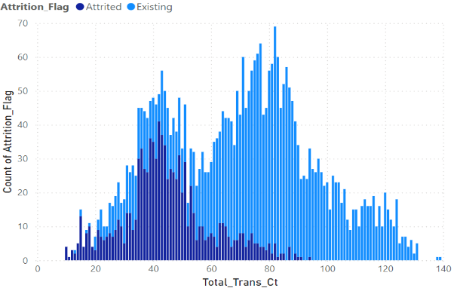The following stacked column chart illustrates the relationship between total transaction amount and the count of attrition flags, segmented by varying levels of customer interaction (contact per total). A clear pattern emerges as the total number of contacts increases, leading to higher attrition rates. Below, we analyze the results for different contact per total relationship thresholds.

In this chart, we observe that customers with a contact per total ratio of greater than or equal to 1 show a significant concentration of attrition within the 40 to 60 transaction range. Interestingly, customers with more than 83 transactions show no attrition at all.

Attrition is at its highest between **40 and 60 transactions**, where both the transaction amounts and attrition rates peak. The overall attrition rate for this group is **26.9%**, a notable figure considering the total number of customers who fall into this category (**3,472 customers**). This demonstrates that frequent interaction (contact per total ≥ 1) correlates strongly with increased attrition, particularly within this transaction range.

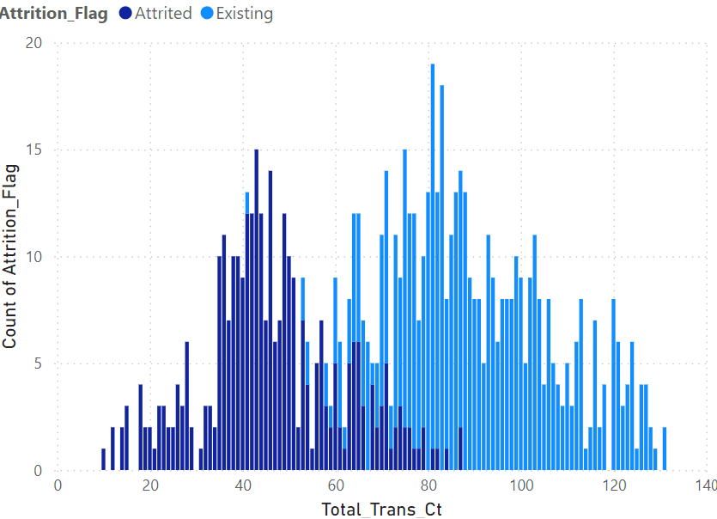The second chart examines customers with a **contact per total relationship ratio** of **greater than or equal to 2**. The data shows an increase in the **attrition rate to 39.6%**, which is substantially higher than the rate seen in the previous group.

However, this group has a significantly smaller number of customers—**796 customers** compared to the 3,472 in the previous group. The sharp drop in the number of customers is likely contributing to the higher attrition rate, as this segment represents a more focused group of high-contact individuals who may be experiencing more pressing or unresolved issues. The fact that attrition increases while the customer base shrinks suggests that customers with frequent interaction (contact per total ≥ 2) are at an even higher risk of leaving.

For customers with a **contact per total ratio greater than or equal to 3**, the data shows that the attrition rate remains similar to the previous group. Since the attrition rate stabilizes at this point, we can infer that the incremental impact of each additional contact is diminishing after a certain threshold. It appears that frequent contact has already exposed the customers' dissatisfaction, and further interaction does not significantly change the likelihood of attrition.

Thus, customers who reach a **contact per total ratio of 3 or more** have already experienced issues that make them prone to attrition, and adding more contacts doesn’t significantly alter the outcome.

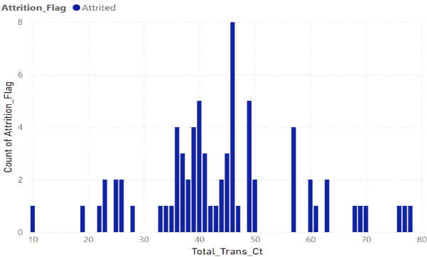The most striking observation comes from customers with a **contact per total relationship ratio of 4 or more**. In this segment, **all customers are attrited**, indicating a clear link between extremely frequent contact and eventual departure.

This finding suggests that customers who contact the company this often are likely facing ongoing issues that either remain unresolved or have led to such frustration that attrition becomes inevitable. These customers represent a critical group in need of intervention, as they are clearly at the end stage of their relationship with the company.

# **4 CONCLUSIONS**

The analysis of customer data revealed several key insights regarding attrition, customer behavior, and engagement with the bank's services. The critical factors driving attrition include:

**Zero Revolving Balance and Zero Utilization:** Customers with a revolving balance or utilization ratio of zero show a significantly higher risk of attrition. This indicates disengagement and non-usage, making them more likely to close their accounts.

**Credit Limit and Financial Stress:** Customers with lower credit limits tend to attrite more often, likely due to feeling underserved or finding better offers elsewhere. Additionally, married customers with lower incomes and higher revolving balances represent a high-risk group.

**Inactivity and Engagement Patterns:** Customers inactive for 2 to 4 months are at the highest risk of attrition. Further analysis showed that increasing frequency of customer interaction, particularly in cases where customers reach a "contact per total relationship" ratio of 3 or more, correlates with higher attrition rates, indicating unresolved issues.

The findings suggest that targeted engagement strategies focused on these at-risk groups can reduce churn and improve customer retention

# **5 PREDICT CUSTOMERS CHURN**

# **6 RETURNING CUSTOMERS**

To identify customers with the highest potential to return, we can prioritize those who:

**Have been inactive for 2-4 months** (as they are at the highest risk but have not yet fully attrited).

**Have a low utilization ratio but maintain a positive balance or high credit limit**, as these customers are still financially engaged, just not actively using their credit cards.

**Had frequent contact with the bank in the past**, indicating that they had a meaningful relationship with the bank but might have unresolved issues.

6.1 Strategies to Encourage Reuse

**1 Personalized Offers:**

* Provide special discounts, cashback rewards, or fee waivers for returning customers, particularly those with zero utilization. These personalized offers can be tailored to match customer behavior and financial preferences.

**2 Credit Line Adjustments:**

* Reduce Credit Limit for Low-Income Customers: For customers in the low-income category, reducing the credit limit to a more manageable level can reduce the risk of overextension and improve their financial engagement. This can also help reduce financial stress, making customers feel more in control and less likely to attrite.
* Increase Credit Limit for Loyal Customers: On the other hand, offer credit limit increases to returning customers with good payment history and higher income levels. This can make them feel valued and foster a stronger connection with the bank.

**3 Engagement Campaigns:**

* Regular notifications or personalized messages reminding customers about unused credit lines, new banking services, or exclusive promotions tailored to their spending behavior can rekindle interest and encourage reactivation.

**4 Loyalty Programs:**

* Implement a loyalty program that rewards customers for re-engaging with their accounts. Offering points for transactions, referrals, or simply maintaining an active account can incentivize long-term engagement.

**6 Education and Financial Guidance:**

* Offer personalized financial advice or tools, such as budget calculators or credit monitoring services, particularly for low-income customers. Empowering customers with knowledge can help them make better financial decisions, which will increase their likelihood of returning.

# **7 CHURNERS MARKETING CAMPEIGN**

## 7.1 ***Campaign Overview:***

The marketing campaign will focus on win-back strategies for customers identified as churners, targeting the following groups:

* Customers inactive for 2-4 months.
* Customers with a zero-revolving balance or low utilization ratio.
* Customers with high contact rates but unresolved issues, based on the "contact per total relationship" ratio.

## ***7.2 Tactics:***

1. **Email and SMS Outreach:**
   * **Personalized Messaging:** Address customers by name and provide clear incentives such as a cashback offer, waived fees, or higher interest on savings accounts for a limited time.
   * **Reminders:** Gentle reminders for customers about their unused credit lines or underutilized accounts can prompt action.
2. **Direct Mail Campaign:**
   * Send customized offers that align with the customer’s past behavior or profile (e.g., promotions for a product they used frequently).
3. **Targeted Digital Ads:**
   * Use data from the bank’s CRM to target churners with digital ads via social media and online channels, offering personalized rewards for returning to the bank.
4. **Customer Service Outreach:**
   * Deploy a customer service initiative to contact churners directly and offer solutions to any unresolved issues they might have had. This can include exclusive product offers based on their profile, increased credit limits, or specialized financial guidance.

7.3 KPIs to Measure Success:

* **Churn Rate Reduction:** Track the decrease in churn rate after implementing the campaign.
* **Customer Reactivation Rate:** Measure the percentage of customers who engage with the bank again after being inactive.
* **Average Transaction Amount and Utilization Ratio:** Monitor the change in the average transaction amount and utilization ratio for customers who return.
* **Campaign Conversion Rate:** Track the conversion rate of churners who reactivate their accounts as a result of the campaign.

These KPIs will give a clear indication of the campaign’s effectiveness in retaining churned customers and reducing the overall churn rate.