Healthcare Billing Amount Prediction

1. General Information on Dataset
- Dataset Name: Healthcare Dataset (healthcare_dataset.csv)
- Total Number of Samples: 55,500 records
- Target Variable: Billing Amount (Regression Problem)
- Initial Feature Columns: Age, Gender, Blood Type, Medical Condition, Date of Admission, Discharge Date, Insurance Provider, Admission Type, Medication, Test Results, Billing Amount
- Data Splitting:
- Total Samples: 55,500
- Training Set: 80%
- Testing Set: 20%
2. Implementation Details
- Data Preprocessing and Transformation:
- Outlier/Skewness Handling: Records with negative billing amounts were removed, and extreme billing values were removed using the Interquartile Range (IQR) method.
- Feature Engineering: Created a new numerical feature, Length_of_Stay, calculated as Discharge Date − Date of Admission (in days).
- Final Feature Set (X):
- Number of Features: 9 (2 Numerical + 7 Categorical)
- Preprocessing Pipeline (ColumnTransformer):
- Numerical Features: ['Age', 'Length_of_Stay'] with StandardScaler
- Categorical Features: ['Gender', 'Blood Type', 'Medical Condition', 'Insurance Provider', 'Admission Type', 'Medication', 'Test Results'] with OrdinalEncoder
3. Model-Specific Implementation and Results
Model 1: Linear Regression (LR)
- Model Type: Linear Regression
- Cross-Validation: No
- Hyperparameters: Default Scikit-learn parameters
- Testing Data Results:
- MAE: 12,267.20
- RMSE: 14,168.83
- R2 Score: -0.0001
Model 2: K-Nearest Neighbors (KNN)
- Initial Hyperparameters: n_neighbors=5, weights='uniform'
- Testing Data Results (Default):
- MAE: 12,825.42
- RMSE: 15,320.57
- R2 Score: -0.1694
- Hyperparameter Tuning (GridSearchCV):
- Cross-Validation: 5-fold
- Scoring Metric: neg_mean_absolute_error
- Hyperparameter Search Space: n_neighbors=[3,5,7], weights=['uniform'], p=[2]
- Best KNN Model Results:
- Best Hyperparameters: n_neighbors=7, weights='uniform', p=2 (Euclidean distance)
- MAE: 12,670.39
- RMSE: 14,985.03
- R2 Score: -0.1187
4. Conclusion and Comparison
- The tuned KNN model slightly outperformed Linear Regression in terms of MAE.
- Both models have negative R2 scores, indicating limited generalization performance.
- The dataset may contain complex, non-linear relationships better suited for advanced models.

Project Description Document: Image Classification using Logistic Regression and K-Means on Fashion-MNIST (5 Classes)

a. General Information on Dataset
- Dataset Name: Fashion-MNIST
- Number of Classes: 5 selected classes (subset from original 10-class dataset)
- Class Labels:
  - 0: T-shirt/top
  - 1: Trouser
  - 2: Pullover
  - 3: Dress
  - 4: Coat
- Total Number of Samples in Full Dataset: 70,000 grayscale images
- Total Number of Samples Used (5-class subset): 35,000 images (7,000 per class, as the dataset is perfectly balanced)
- Image Size: 28 × 28 pixels (grayscale), flattened to 784 pixel values per image
- Training/Validation/Testing Split:
  - Training: 28,000 samples (80%)
  - Testing: 7,000 samples (20%)
  - No separate validation set; validation performed via cross-validation only for Logistic Regression hyperparameter tuning

b. Implementation Details

Feature Extraction Phase
- Method: Histogram of Oriented Gradients (HOG)
- HOG Parameters: orientations=9, pixels_per_cell=(4,4), cells_per_block=(2,2), block_norm="L2-Hys"
- Number of Extracted Features: 1,296 features per image
- Feature Names: Not named individually; they represent histogram counts of gradient orientations in local cells and normalized blocks
- Dimension of Resulted Features (after HOG): 1,296
- Post-processing:
  - Standardization using StandardScaler
  - Dimensionality reduction using PCA (retaining 95% of variance)
- Final Dimension after PCA: 383 components (X_train_pca shape: (28000, 383), X_test_pca shape: (7000, 383))

Cross-Validation
- Used only in Logistic Regression for hyperparameter tuning
- Number of folds: 5-fold cross-validation
- Ratio in each fold: Approximately 80% training / 20% validation (applied on the 28,000 training samples)

c. Results Details

Model 1: K-Means Clustering (Used as Classifier)

Loss Curve
The following figure shows the K-Means loss curve using the Elbow Method (inertia vs. number of clusters K from 1 to 10). A noticeable bend (elbow) appears around K=5, supporting the choice of 5 clusters.
Figure 1: K-Means Loss Curve (Elbow Method)

Accuracy on Testing Data
- Accuracy: 66.17%

Confusion Matrix on Testing Data
True \ Predicted | 0 | 1 | 2 | 3 | 4
0 (T-shirt) | 998 | 3 | 224 | 175 | 0
1 (Trouser) | 0 | 1255 | 39 | 106 | 0
2 (Pullover) | 12 | 0 | 1367 | 21 | 0
3 (Dress) | 17 | 222 | 149 | 1012 | 0
4 (Coat) | 2 | 0 | 1236 | 162 | 0

Classification Report on Testing Data
Class | Precision | Recall | F1-score | Support
0 (T-shirt) | 0.97 | 0.71 | 0.82 | 1400
1 (Trouser) | 0.85 | 0.90 | 0.87 | 1400
2 (Pullover) | 0.45 | 0.98 | 0.62 | 1400
3 (Dress) | 0.69 | 0.72 | 0.70 | 1400
4 (Coat) | 0.00 | 0.00 | 0.00 | 1400
Accuracy |  |  | 0.66 | 7000
Macro avg | 0.59 | 0.66 | 0.60 | 7000
Weighted avg | 0.59 | 0.66 | 0.60 | 7000

Additional Clustering Metrics
- Silhouette Score (on training data): 0.0666
- Purity Score (on testing data): 0.9731
Note: No ROC curve is provided for K-Means because it does not produce class probability estimates.

Model 2: Logistic Regression

Hyperparameters
- Tuning performed via GridSearchCV (5-fold CV)
- Best parameters found: {'C': 0.01, 'penalty': 'l2', 'solver': 'lbfgs'}
- Other fixed settings: max_iter=300

Accuracy on Testing Data
- Accuracy: 91.13%

Confusion Matrix on Testing Data
True \ Predicted | 0 | 1 | 2 | 3 | 4
0 (T-shirt) | 1303 | 4 | 45 | 38 | 10
1 (Trouser) | 2 | 1359 | 0 | 35 | 4
2 (Pullover) | 28 | 3 | 1217 | 28 | 124
3 (Dress) | 38 | 24 | 21 | 1276 | 41
4 (Coat) | 7 | 5 | 104 | 60 | 1224

Classification Report on Testing Data
Class | Precision | Recall | F1-score | Support
0 (T-shirt) | 0.95 | 0.93 | 0.94 | 1400
1 (Trouser) | 0.97 | 0.97 | 0.97 | 1400
2 (Pullover) | 0.88 | 0.87 | 0.87 | 1400
3 (Dress) | 0.89 | 0.91 | 0.90 | 1400
4 (Coat) | 0.87 | 0.87 | 0.87 | 1400
Accuracy |  |  | 0.91 | 7000
Macro avg | 0.91 | 0.91 | 0.91 | 7000
Weighted avg | 0.91 | 0.91 | 0.91 | 7000

ROC Curve on Testing Data
Figure 2: ROC Curve - Logistic Regression (Macro-average) ROC Curve
- Macro-average ROC AUC: 0.9901
Note: No iterative training loss curve is shown for Logistic Regression because the 'lbfgs' solver converges in a small number of iterations without per-iteration logging.

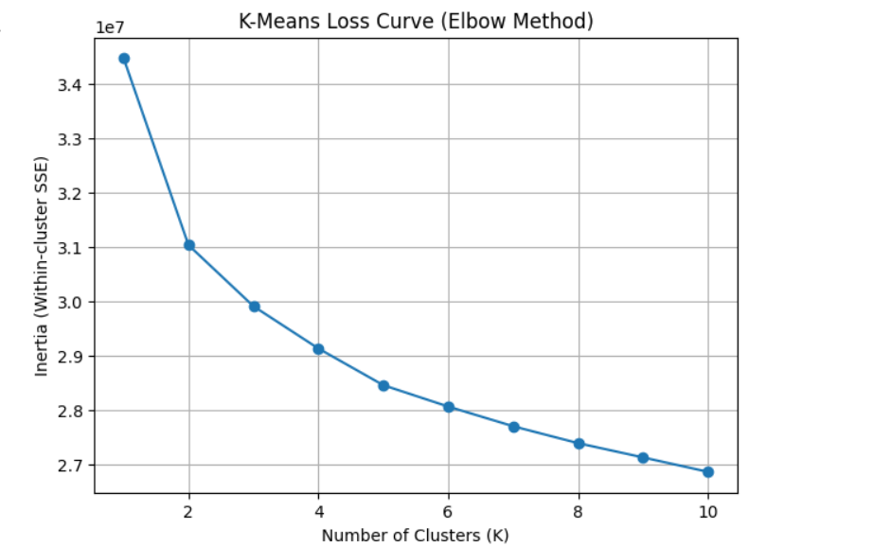
Figure 1
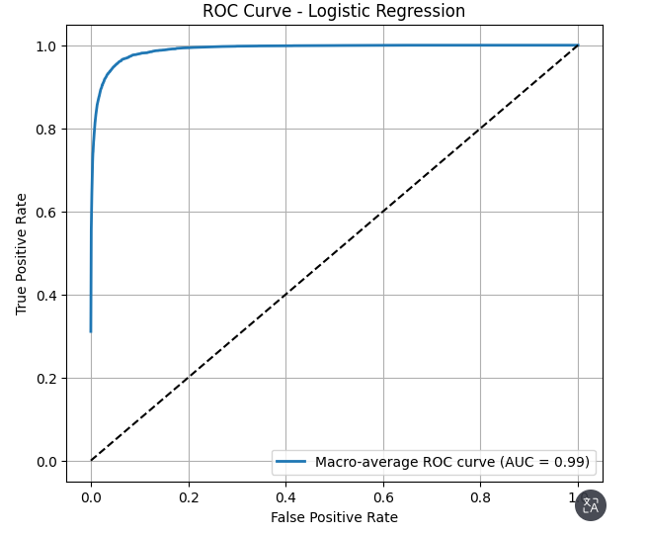

Figure 2

Summary and Comparison
Logistic Regression achieved significantly higher performance (91.13% accuracy, 0.99 macro AUC) compared to K-Means (66.17% accuracy). This is expected, as Logistic Regression is a supervised method that directly uses label information, while K-Means is unsupervised and relies on cluster-to-label mapping. The high purity (97.3%) but lower accuracy of K-Means indicates good cluster separation but suboptimal alignment with true class boundaries.
Both models benefited from the same HOG + PCA feature pipeline, confirming its effectiveness for this task.

