
Project Proposal
Automated Passive Reconnaissance Platform for Web Application Penetration Testing
Team Names:
Omar Badran 202301042 (Team leader)
Salma Farag 202400265
Youssef Ahmed 202300216
Research Question/Objective
To design and implement a fully automated platform that will perform passive reconnaissance of web applications for penetration testing within a given scope. The platform will support both core and advanced profiling modes for penetration testing applications, as well as support for testing multiple targets within a given session.
Brief Rationale/Background
One of the most critical aspects of penetration testing is the conduct of reconnaissance. However, reconnaissance is often one of the most time-consuming and error-prone aspects of penetration testing. Furthermore, many of the tools that are used during reconnaissance are performed manually.
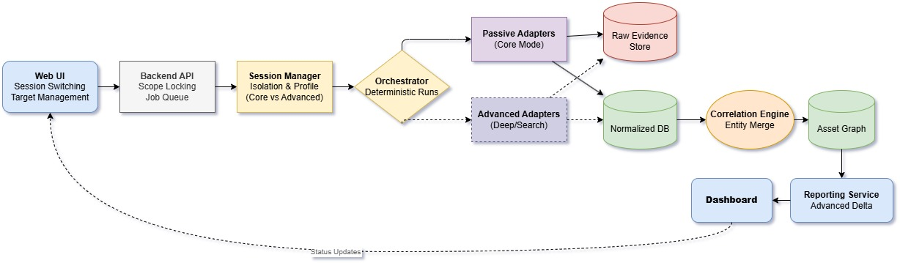
To address these issues, an automated platform will orchestrate the reconnaissance process, normalize the data from the individual tools, correlate that data to provide a thorough reconnaissance report of the target applications, and output reports that can be understood by penetration testing professionals.

Methodology/Approach: The project will be done following a structured software engineering approach to build a functional prototype. Development will be divided into three main areas with clear responsibilities, while maintaining strong teamwork and knowledge sharing across the team.
Team Structure & Task Assignment:
- Omar Badran - Web Application Development & Backend Integration
responsible for building the main web application, including the frontend interface (like target management, session switching, and the dashboard). On the backend side, he develops the API, Job Queue, Session Manager, and Orchestrator. He also handles integrating all system components together into one fully working platform.
- Salma Farag - Automation of Tools
focuses on automating the reconnaissance tools. She works on implementing both Passive Adapters (core mode) and Advanced Adapters, and integrates tools like subfinder, Amass, theHarvester, DNSRecon, and waybackurls. Her role is basically making sure data collection runs smoothly and automatically based on different profiles.
Youssef Ahmed - Database Design & Reporting

is in charge of the data side of the system. He designs and implements the database structure (including raw evidence storage and the normalized database). He also develops the Correlation Engine and confidence scoring logic, and builds the Reporting Service along with dashboards that show clear evidence tracking.
The Team Leader will organize regular knowledge-sharing sessions so that every team member understands all parts of the project. Each member will deliver their completed component to the Team Leader for final integration. All team members will participate in testing, documentation, and the final demonstration.
Preliminary Timeline:
- April 17 - April 23 (Week 1): Finalize architecture, data model, tool selection, task breakdown, and planning documents.
- April 24 - April 30 (Week 2): Implement core backend components, Session Manager, Orchestrator, and basic passive tool adapters + initial database setup.
- May 1 - May 7 (Week 3): Develop normalization & correlation logic, advanced adapters, confidence scoring, and frontend UI foundation.
- May 8 - May 14 (Week 4): Complete Web UI features, Reporting Service, dashboard views, and full integration of all modules.
- May 15 - May 18 (Week 5): Comprehensive testing, session isolation validation, core vs. advanced comparison, evidence traceability checks, QA, documentation finalization, and demo preparation.
Required Resources:
- Standard local development machines.
- Python/Node.js environment and Docker.
- Public passive reconnaissance tools and libraries.
- No specialized hardware required.

