

Faculty of Information Technology

Department of Computer Information Systems

Graduation Project

**Dilni for Governmental Services**

**Software Team Members:**

Saba’ Al-Tarawneh 120172203054

Omar Bani Kenana 120172203003

Fu’ad Abu Awad 120172201011

Diala Al_Huniti 120172203039

**Project Supervisor:**

Dr. Ahmad Al-Abadlleh "Inspiring"

January, 2021d

**Abstract**

E-government (short for electronic government) is the use of technological communications devices, such as computers, mobile, and the Internet, to provide public services to citizens and other persons in a country or region. E-government offers new opportunities for more direct and convenient citizen access to government, and for government provision of services directly to citizens without their presence in the ministries and government institutions.

There are many goals for e-government, including creating a better environment for business, as the use of information and communication technology in the government helps to simplify interaction and interactions between the government sector and the business sector and the transparency in dealing between the citizen and the government institution to get the services the citizen need. This is what our project report on “Dilni” app is doing in partnership with the Crown Prince Award for Best Government Service Application in the Business Sector.

During the development of this project, we explored new ideas and functions. This project is the output of our planning, schedule, programming skill and the hard work, and this document reflects our steps taken at various levels of programming skill, planning and schedule.

We have learnt a lot during this project and liked the improvement in our testing skills and deep concept related to these kinds of projects.

**Keywords**: E-government, business, environment for business, Dilni app, Mobile.

**Acknowledgment**

We would like to express our great appreciation Dr. Ahmad Al-Abadlleh for his valuable and constructive suggestions while planning and developing this project work. His willingness to give his time generously was greatly appreciating

Thank you very much…

**List of Figures**

**Figure 2.1:** «:Development method » **5**

**Figure 4.1:** « Context diagram » **13**

**Figure 4.2:** « dfd » **13**

**Figure 4.3:** « erd » **14**

**Figure 4.4:** « database diagram » **15**

**Figure 4.5:** « NOSQL Design table » **16**

**Figure 4.6:** « UML » **17**

**Figure 4.7:** « Splash screen » **18**

**Figure 4.8:** « search page » **20**

**Figure 4.9:** « Resultes searching process page » **21**

**Figure 4.10** « information tab page 1» **23**

**Figure 4.11:** « information tab page 2» **24**

**Figure 4.12:** « Mobile tab page » **25**

**Figure 4.13:** « location tap page » **26**

**Figure 4.14:** « Direction button » **27**

**Figure 4.15:** « Drawer Page » **29**

Figure 4.16:« Personal information befor login» 31

**Figure 4.17:** « personal information after login » **32**

**Figure 4.18:** « Drawer Page after login » **33**

**Figure 4.19:** « History page » **34**

**Figure 4.20:** « About us page » **35**

**Figure 4.21:** « How to use the app 1» **37**

**Figure 4.22:** « How to use the app 2 » **38**

**Figure 4.23:** « suggestions page » **39**

**Figure 4.24:** « Search process code » **40**

**Figure 4.25:** « design code .xml (1) » **41**

**Figure 4.26:** « design code .xml (2) » **42**

**Figure 4.27:** « invoking data from database/information fragment » **43**

**Figure 4.28:** « code to move from dilni app to other » **44**

**Figure 4.29:** « Tabbed Page code » **45**

**Figure 4.29:** « login &authentication code » **46**

**List of Tables**

**Table 1.1** « Gantt chart » **7**

**Table 1.2** « project Budget » **7**

**List of Symbols and Abbreviations**

Dilni The name of application.

TraGiver Transaction in a government.

Name It is could be name of government or service.

Finfess Financial fees of the services.

R_id Requirements ID.

GovID Government ID.

HID History ID

LocID Location ID.

Img Image.

DFD Data Flow Diagram

ERD Entity Relationship Diagram

UML Use Case Diagram

GUI Graphical User Interface.

**Table of Contents**

**Contents** ………………………………………………………………………………………………………...... i

**Abstract** ……………………………………………………………………………………………...……….….. ii

**Acknowledgment** ……………………………………………………………………..……………….……… iii

**List** **of** **Figures** …………………………………...………………………………………………………………. iv

**List** **of** **Tables** …………………………………………………………………...………………………….……. v

**List of Symbols** **and Abbreviations** …...……………………..………...……………………….... vi

**1.0 CHAPTER ONE: INRODUCTION**  ……………………………………………………………… 1

* 1. Context ……………………………………………………………………………………………. 1
  2. Motivation and Problem ………………………………………………………………… 1
  3. Contribution ……………………………………………………………………………………. 1
  4. Report Outline…………………………………………………………………………………… 2

**2.0 CHAPTER TWO: PLANNING** ……………………………………………………………………… 3

* 1. Feasibility Study ………………………………………………………………………………. 4
  2. Development Method (waterfall model) …………………………………………… 4

2.3 Project Schedule (Gantt Chart) …………………………………………………………. 6

**3.0 CHAPTER THREE: SOFTWARE SPECIFICATION …**……….……….………………………. 8

3.1 Requirements Elicitation and Analysis……………………………………………… 9

3.2Requirements Specifications (Functional and non-Functional requirements) ………………………………………………………………………………………………… 10

3.3User Characteristics……………………………………………………………………………11

3.4Constraints…………………………………………………………………………………………11

**4.0 CHAPTER FOUR: SOFTWARE DESIGN……**…….……….…………………………………… 12

4.1 Context Diagram…………………………………………………………………………………13

4.2 Data Flow Diagram (DFD) ………………………………………………………………….13

4.3 Entity Relationship Diagram (ERD) …………………………………………………….14

15 4. 1 : database diagram………………………………………………………………

4. 2 : NOSQL Design table……………………………………………………………………..16Picture 4. 3 : NOSQL Design table

4.6 UML Use Case Diagram……………………………………………………………………….17

**5.0 CHAPTER FIVE: SYSTEM IMPLEMENTATION ……………**……………………………. 47

5.1 Introduction…………………………………………………………………………………….48

5.2 Database Implementation ……………………………………………………………….49

5.3 Other Components Implementation …………………………………………………49

**6.0 CHAPTER SIX: PROJEECT OBSTACLES AND CONCLUSION AND FUTURE VISION ……………………………………………………………………………………………………………………50**

6.1 Project Obstacles ………………………………………………………………………….…51

6.2 Future Vision …………………………………………………………………………………..51

6.3 Project Conclusion ……………..……………………………………………………………51

CHAPTER ONE

INTRODUCTION

CHAPTER ONE page|1

* 1. **Context**

This document present whole details about Dilni mobile application for graduation project for students in Mutah University.

* 1. **Motivation and Problem/ Problem Statement**

Most citizens face problems with government transactions because they:

* They do not know the paperwork required for each transaction.
* What are the procedures required to complete the transaction?
* What are the documents that must be provided?
* What are the locations of the government departments closest to the citizen to perform the required transactions?
* What is the cost required for each transaction?
* What is the closest government department to the citizen?
  1. **Contribution**

The main functions of the application are the citizen's access to know the necessary procedures, the expected fees and the exact location of the department that completes the process and the necessary papers and documents, as it enables him to search across the map to find the closest place to him and the date of the transaction is also reserved and thus a large part of the work in the departments is reduced and the largest possible number of transactions at a time Short, where each department suffices with a specific number and the citizen is informed of the department necessary to file transactions.

CHAPTER ONE page|2

* 1. **Report Outline**

This document is organized into five chapters.

Chapter 1: Introduction

This chapter presents the motivation and problem, and our contribution of work for this document. chapters are briefly summarized to give a quick inside of their contents.

Chapter 2: Planning

This section details the plan we made to create the application it is contain feasibility study, the method we used to develop the app, in addition, schedules for budget and timeline.

Chapter 3: Software Specification

This section discusses the techniques that the team used it to elicit the requirements and describe the functional and non-functional requirements, also properties and constraints of the user.

Chapter 4: Software design

This section deals with database designing and the interfaces of the application.

Chapter 5: System implementations

This section presents the specific topics related to database, and how we use NOSQL database and why we use it?

Chapter 5: Project Obstacles and Conclusion and Future Vison.

This is the last section in document describe our future image, and the problems we faced in implementation the application**.**

CHAPTER TWO

PLANNING

CHAPTER TOW page|4

To discuss the feasibility study in an efficient way, it is important to discuss four main categories:

**2.1 Feasibility Study**

The Dillni e-services window is dedicated to every citizen. They can get all the information he needs, and this is to facilitate access to the information the citizen needs and everyone who has access to this project.

**2.2 Development Method**

In order to develop this project, Android Studio (4.1.1) program was used, and the application was built using Kotlin language. The accompanying and familiar tools were used in the software such as buttons, text areas and images.  
Internal databases were used to reassure the data and deal with it smoothly, and for safety and security.

This is the first release of the application.

CHAPTER TOW page|5

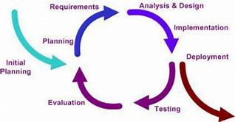

Figure 2.1 :Development method

This model provides structured approach through separate phases that are easy to understand and interpret and provides features that are easy to identify in the development process and can be suitable for projects where the scope requirements.

**System and software requirements:**

Available in the product requirements documentation.

**Analysis:**

Results into models, schema, and business rules. **Design:** Show results in building and engineering software.

CHAPTER TOW page|6

**Coding:**

development and proofing, and software integration.

**Testing:**

Discovery of methodologies and correction of defects.

**Processes:**

installation, migration, support, and full system

**2.3 Project Schedule (Gantt Chart)**

**Feasibility table:**

Must be adhered to in order to get the project on time and

Not be modified except by the responsible students and the teacher.

Supervising the project

CHAPTER TOW page|7

**Gantt chart:**

Table 1. 1:Gantt chart

|  |  |  |
| --- | --- | --- |
|  | **Description of Work** | **Start and End Dates** |
| **Phase One** | Requirements collecting | 10/10/2020 – 11/10/2020 |
| **Phase Two** | Database design | 12/10/2020 – 20/10/2020 |
| **Phase Three** | Backend coding | 1/11/2020 – 30/11/2020 |
| **Phase Four** | Frontend Coding | 1/12/2020 – 30/12/2020 |
| **Phase Five** | Installation and Delivery | 1/5/2020 –1/5/2020 |

**Project Budget:**

Table 1. 2: project Budget

|  |  |  |
| --- | --- | --- |
|  | **Description of Work** | **Anticipated Costs** |
| **Phase One** | Requirements collection | 0 JD |
| **Phase Two** | Website build | 0 JD |
| **Phase Three** | Installation | 0 JD |
|  | **Total** | **0 JD** |

CHAPTER THREE

SOFTWARE SPECIFICATION

CHAPTER THREE page|9

**3.1 Requirements Elicitation and Analysis**

The hardest part of our app is to collect the right and better data required for the database. As a result, we used many techniques to elicit the data we need from governments:

1.**Interviews:**

we made many interviews with some officials in government institutions to know the procedures, requirements and financial fees for some government transactions.

2.**Observation:**

The team visited some government institutions and observed the procedures that the citizen takes to get the service.

3.**Internet:**

The team conducted many searches on the Internet using approved and reliable government websites to get information from the site.

CHAPTER THREE page|10

**3.2 Requirements Specifications (Functional and non-Functional requirements)**

**Functional Requirements:**

Hardware requirements

* Smart phone.
* Internet connection.

Software requirements

* Application

**Non-functional Requirements:**

1. **Security**: All user information entered is data created.
2. **Maintainability**: the application is made using kotlin language so the Algorithmic application able to be updated and its possible to add more functionalities.
3. **Reliability:** All user information must be real,
4. **Availability:**

**The application will run android operating system for version up to 5.1 if the internet connection is available.**

1. **Usability:**
2. **Portability:**

**The capability adapted for different specified environments without applying action or means other than those provided for this purpose in the product. Since, phones are portable, so do the application.**

CHAPTER THREE page|11

**3.3 User Characteristics:**

**The user should have basic knowledge of using android phones.**

**3.4 Constraints:**

* **The phones having the application should either be connected over LAN or Internet.**
* **Sign-in option is used for the identification of user.**

CHAPTER FOUR

SOFTWARE DESIGN

CHAPTER FOUR page|13

**4.1 Context Diagram**

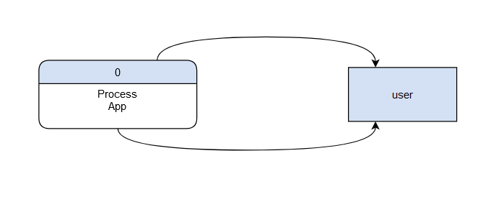

Picture 4. :Context diagram

**4.2 Data Flow Diagram (DFD)**

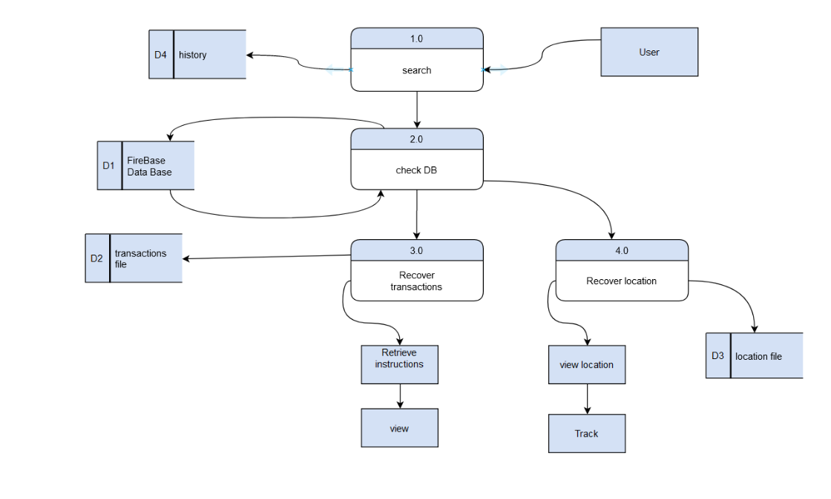

Picture 4. : dfd

CHAPTER FOUR page|14

**4.3Entity Relationship Diagram (ERD)**

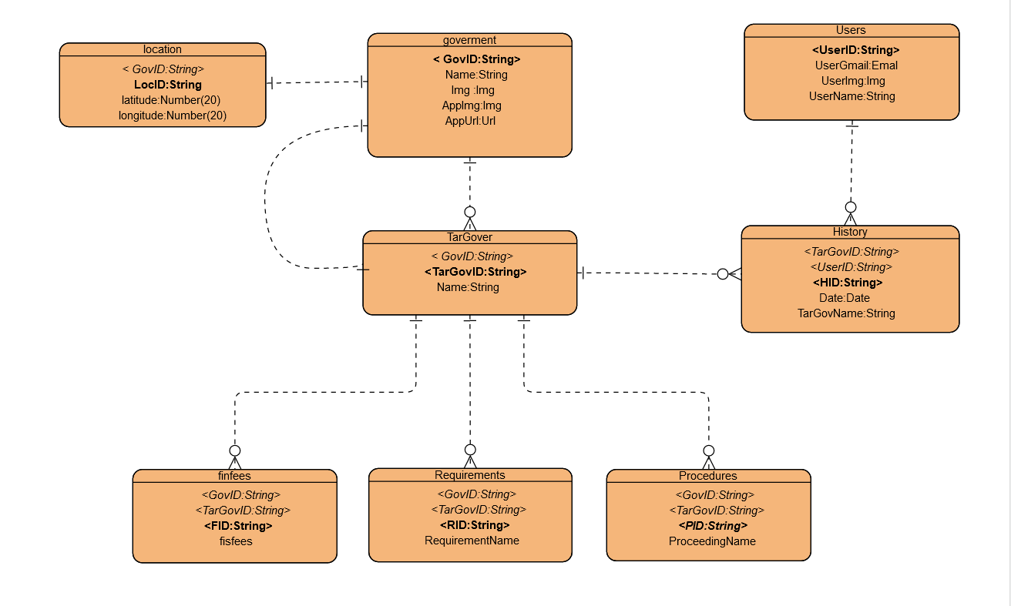

Picture 4. 3: erd

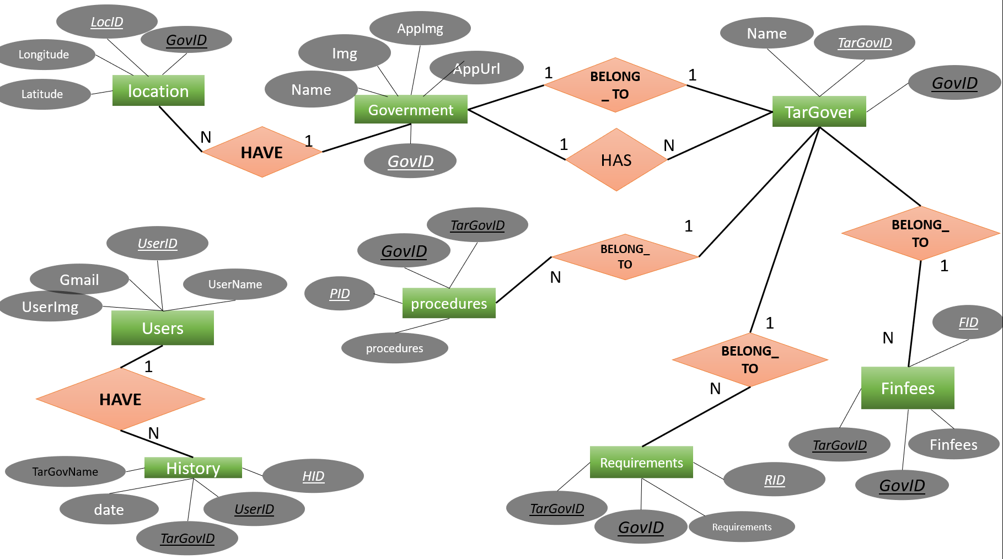CHAPTER FOUR page|15

Picture 4. : database diagram

CHAPTER FOUR page|16

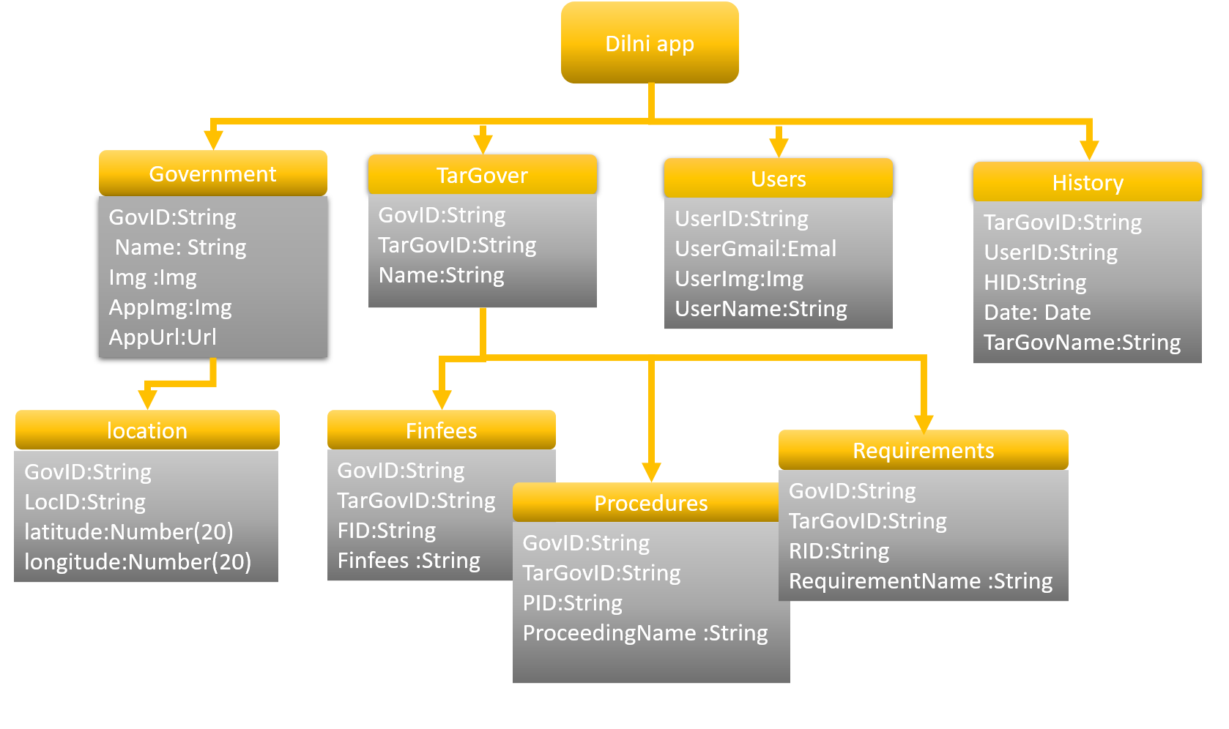

Picture 4. : NOSQL Design table

CHAPTER FOUR page|17

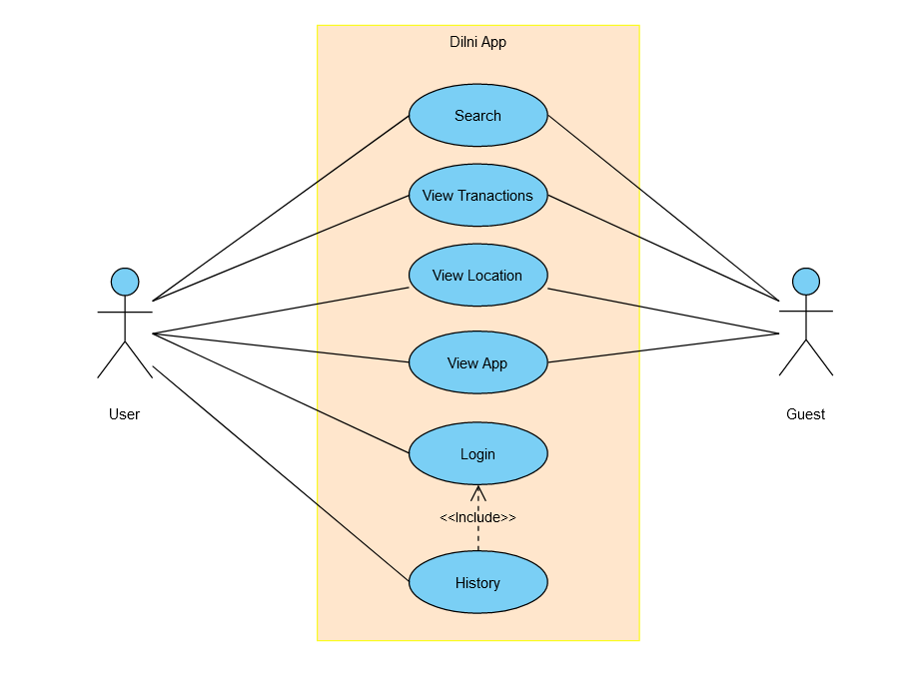4**.4 UML Use Case Diagram**

Picture 4. : UML

CHAPTER FOUR page|18

4.5 Graphical User Interface

1)Splash Screen:

splash screen is a graphical control element consisting of a window the logo "Dilni" of the application. This screen usually appears while application is launching. A splash page is an introduction page.

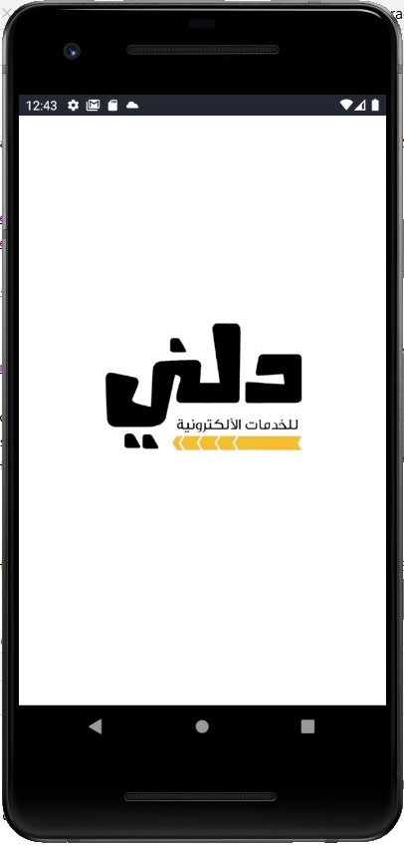

Picture 4. : Splash screen

CHAPTER FOUR page|19

2-Search Page:

This application home page comprises:

1-Application logo.

2-Search engine for e-government services through it the user types the name of the government service he needs for the program to search for.

3-Button suggestions: to present government services to the user based on a search history related to his previous searching process.

4- Drawer Button.

CHAPTER FOUR page|20

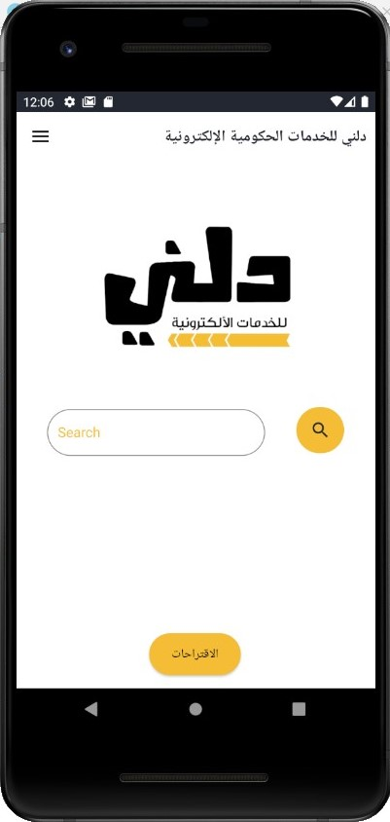

Picture 4. : search page

CHAPTER FOUR page|21

3-Results Searching Process:

This page shows the preliminary results of the search process as Views in List, each view contains the name of the government service, the name of the government ministry or institution, and the logo of that institution appear in this llist.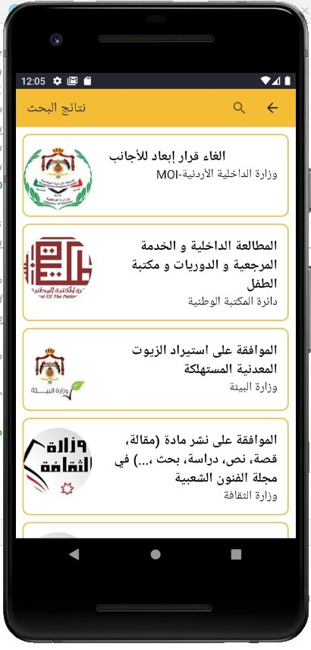

Picture 4. 11: Resultes searching process page

CHAPTER FOUR page|22

When user click on one of the views/services, he will move to next page.

4- Details of Services:

This page called tabbed page comprises three tabs each tab has specific details for the service.

A-Information Tab:

It is the first tab contain on:

a-Picture of the government/institute that the user wants to go.

b-Name of this government/institute.

c-Name of the service.

d-All the requirements documents need it to get the service.

e- All the procedures need it to get the service from A to Z.

d- Financial fees that the citizen needs to get the service.

CHAPTER FOUR page|23

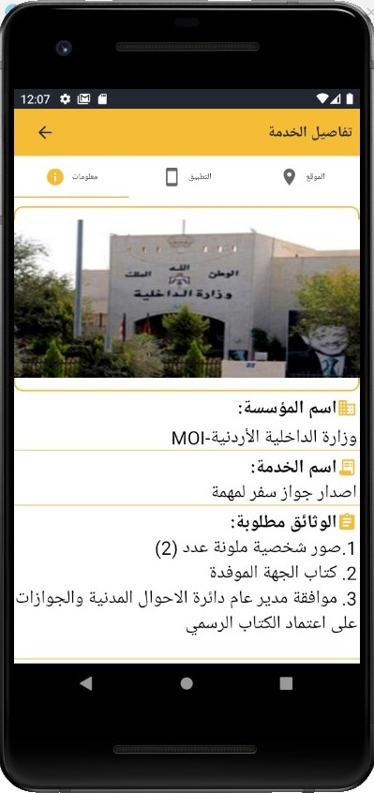

Picture 4. : information tab page 1

CHAPTER FOUR page|24

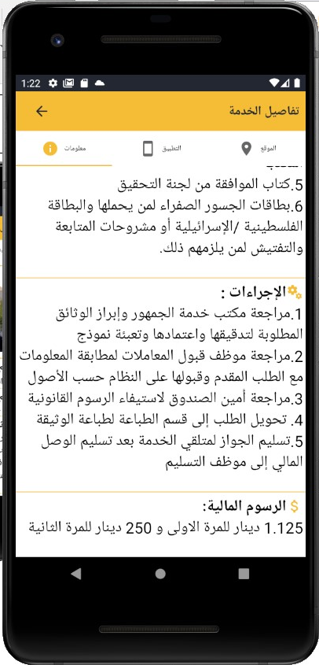

Picture 4. : information tab page 2

CHAPTER FOUR page|25

B- Mobile Tab:

This tab allows the user to get the service online if the service exists online by the web page or by downloading application for the government.

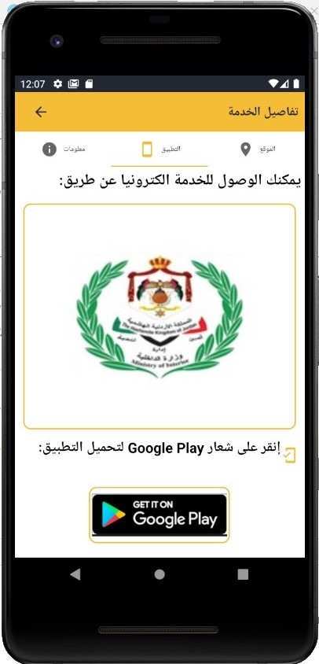

Picture 4. : Mobile tab page

CHAPTER FOUR page|26

C- Location Tab:

This tab allows the user to know the exact address of the government/Institute. In addition, Direction button to get the route from your location to arrive the organization.

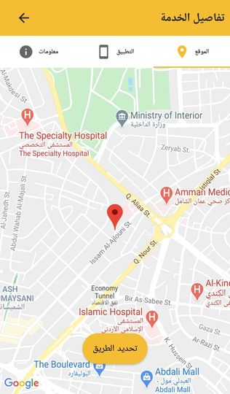

Picture 4. : location tap page

CHAPTER FOUR page|27

-Once the User Click on the button Directions

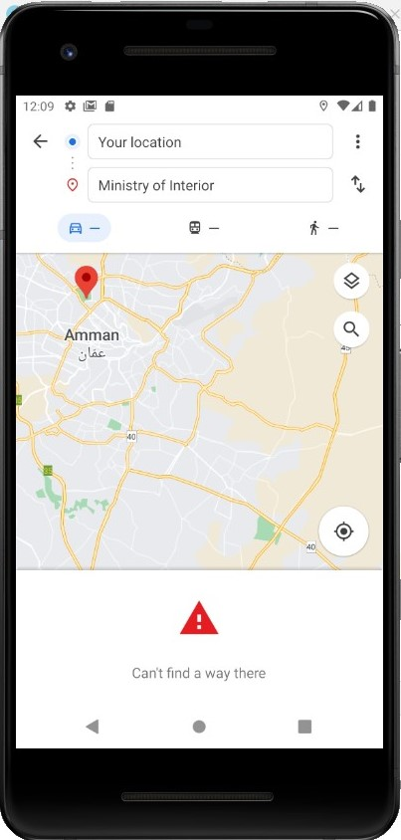

Picture 4. 16: Direction button

CHAPTER FOUR page|28

5- Drawer Page:

If the user clicks on the top left button in the first page, he will get this page. Drawer page contain five components:

1-Main Page:

When the user clicks on it, the application will go to search page.

CHAPTER FOUR page|29

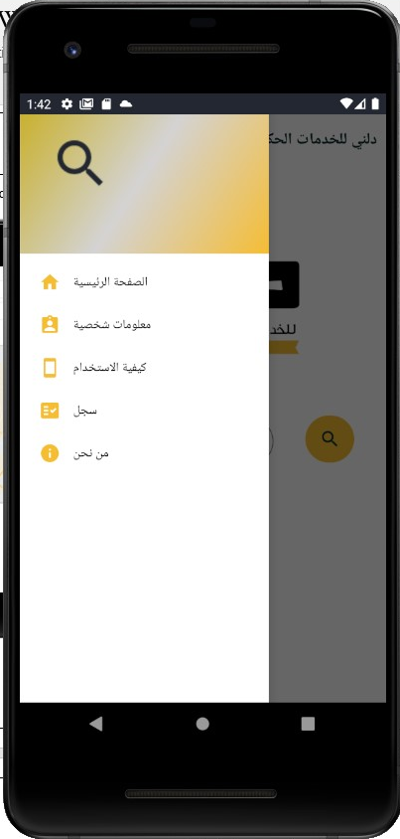

Picture 4. : Drawer Page

CHAPTER FOUR page|30

2-personl information:

In this page the user can login and register to application by entering his email. After he log in the app will save all the search processes he made it in History and Suggestion button in search page will turn on to present government services may the user need based on his history.

CHAPTER FOUR page|31

Before Login to App:

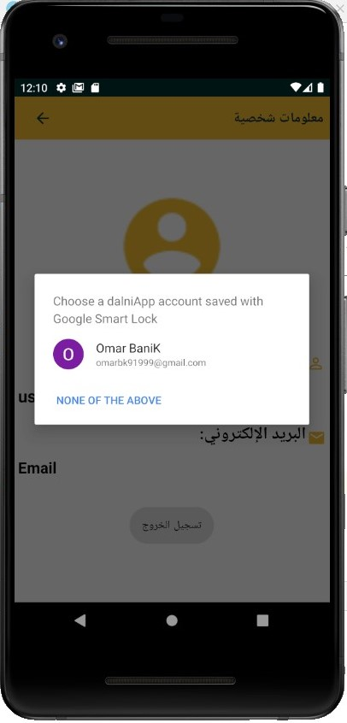

Picture 4. : Personal information befor login

CHAPTER FOUR page|32

After Login to App:

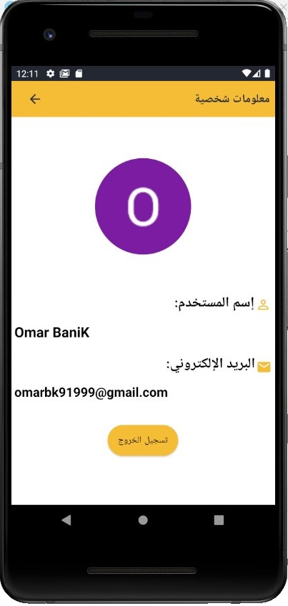

Picture 4. : personal information after login

CHAPTER FOUR page|33

After Login to App:

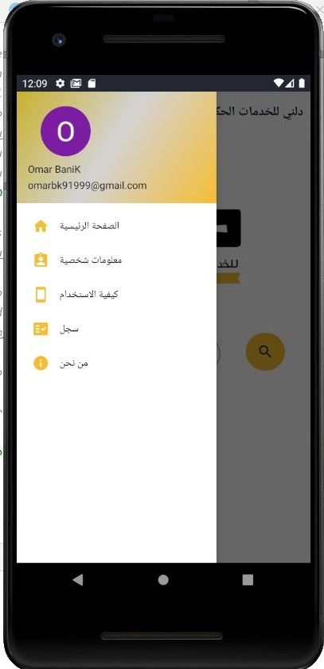

Picture 4. : Drawer Page after login

CHAPTER FOUR page|34

3-History:

Search record for previously applied searches. It is consisting the name of service, also date and time of each search process.

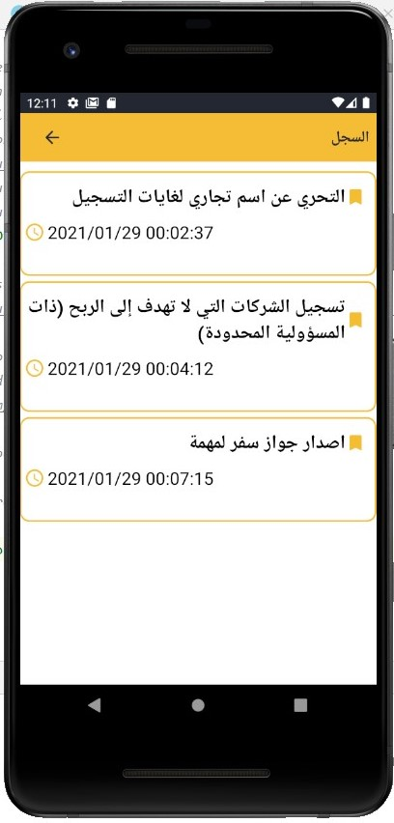

Picture 4. : History page

CHAPTER FOUR page|35

4-About Us:

This option talks a little bit about idea and programmers of the app.

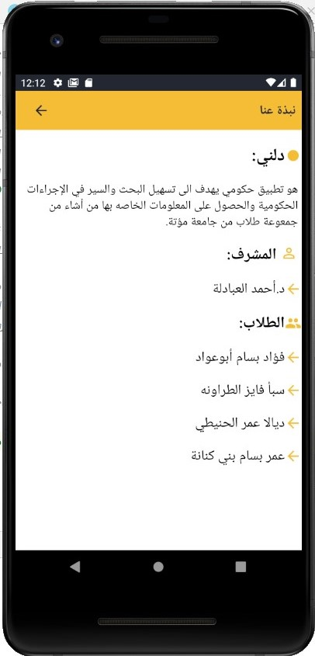

Picture 4. : About us page

CHAPTER FOUR page|36

5-How to use the app:

This is screen slides are transitions between one entire screen to another.it is created to explain to user how to use the application to make his experience easy with Dilni app.

CHAPTER FOUR page|37

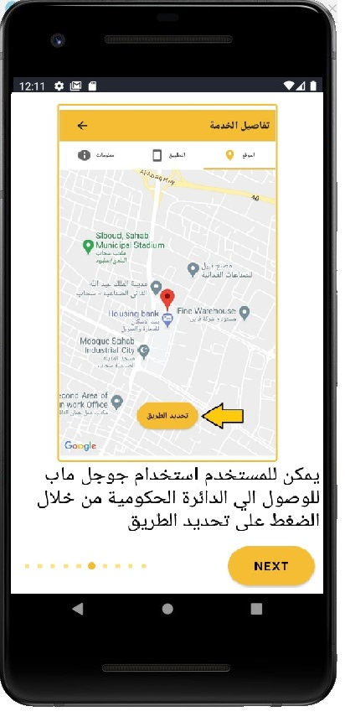

Picture 4. : How to use the app 1

CHAPTER FOUR page|38

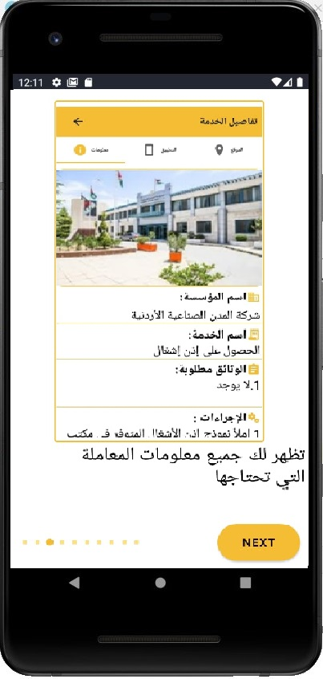

Picture 4. : How to use the app 1

CHAPTER FOUR page|39

6- suggestions:

This page to give the user some suggestions related to his history record it can be developing by using machine learning.

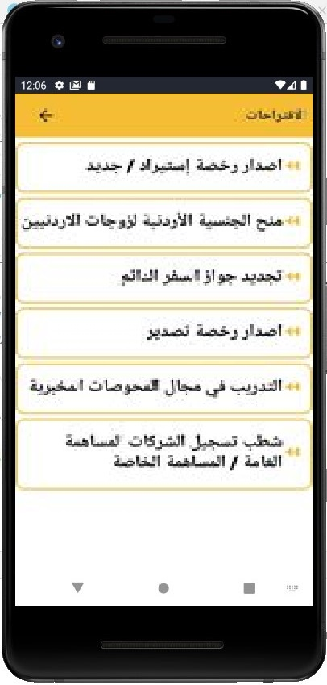

Picture 4. :suggestions page

CHAPTER FOUR page|40

Important Code:

1)Search process:

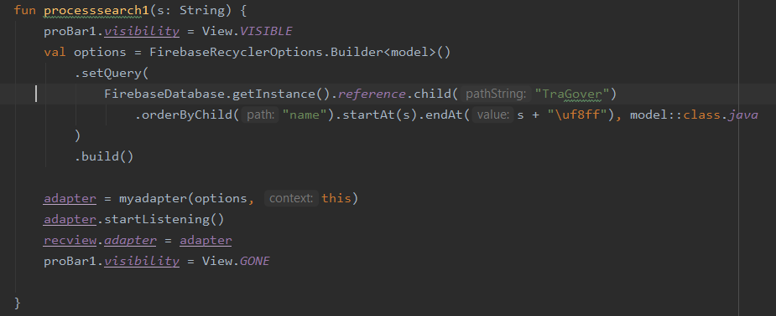

Picture 4. : search process code

CHAPTER FOUR page|41

2)Design code for search page (.XML)

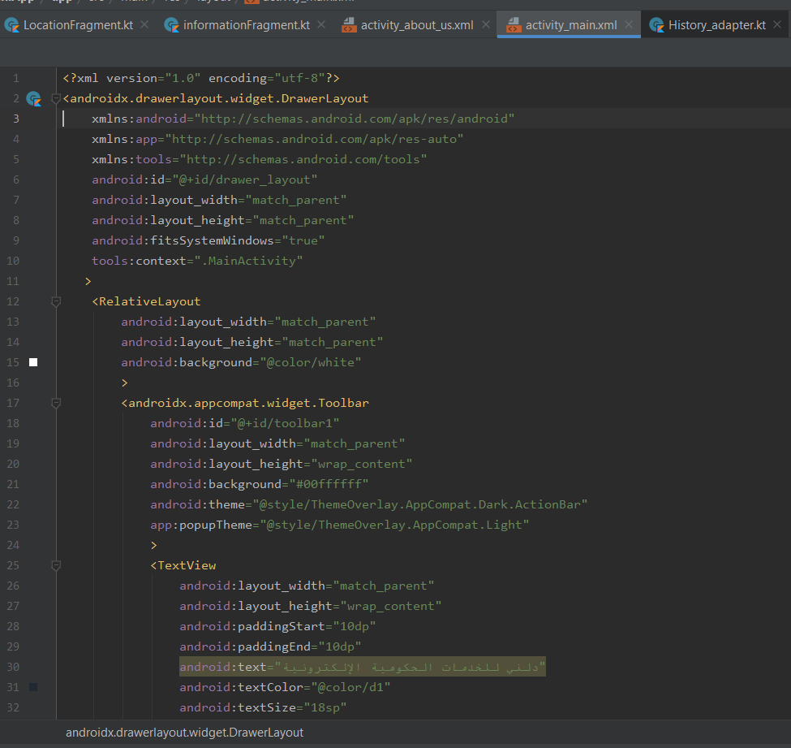

Picture 4. :design code .xml (1)

CHAPTER FOUR page|42

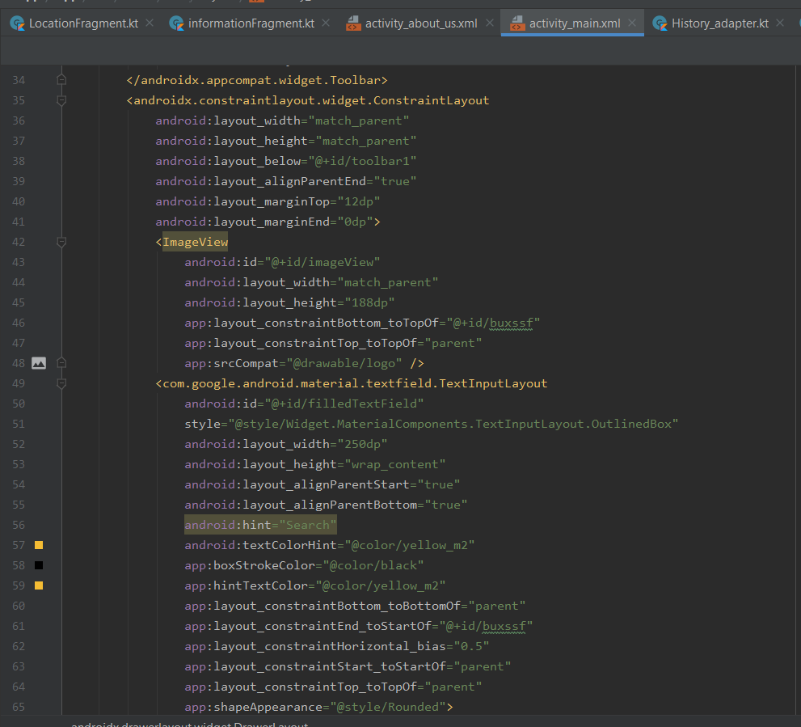

Picture 4. : DESIGN CODE .XML (2)

CHAPTER FOUR page|43

3)Information fragment/ invoking data from firebase database.

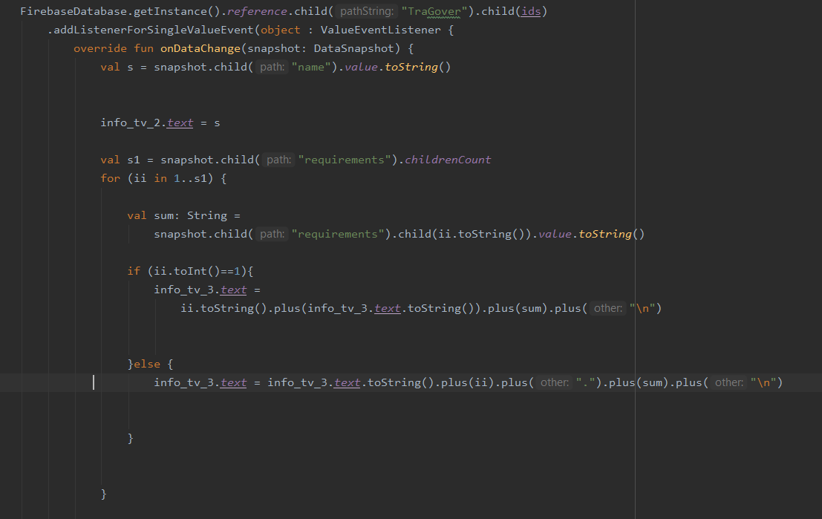

Picture 4. : invoking data from database/information fragment

CHAPTER FOUR page|44

4)App fragment/move to other app by url:

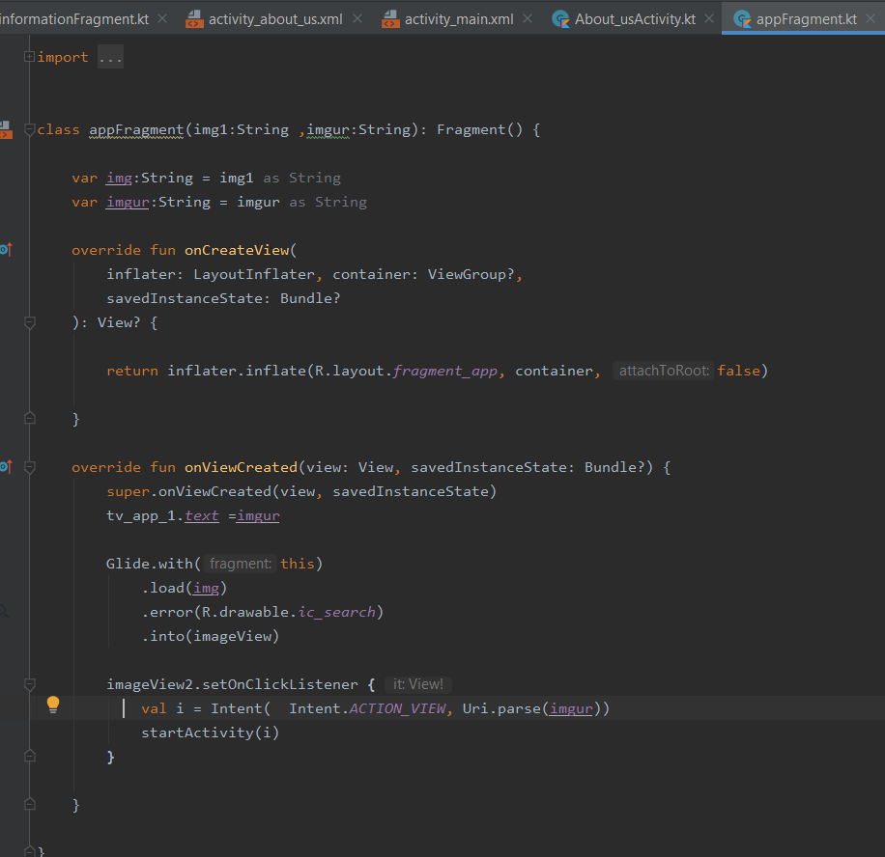

Picture 4. : code to move from dilni app to other

CHAPTER FOUR page|45

5)tabbed pager:

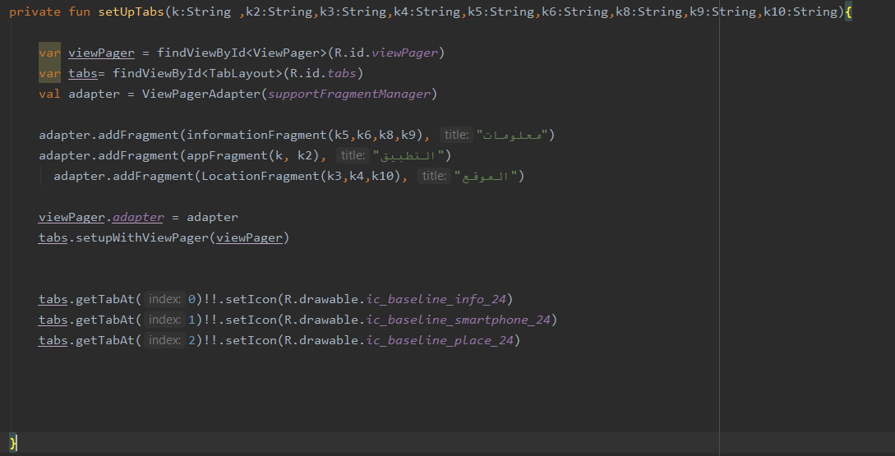

Picture 4. : tabbed page code

CHAPTER FOUR page|46

6)Login user and authentication:

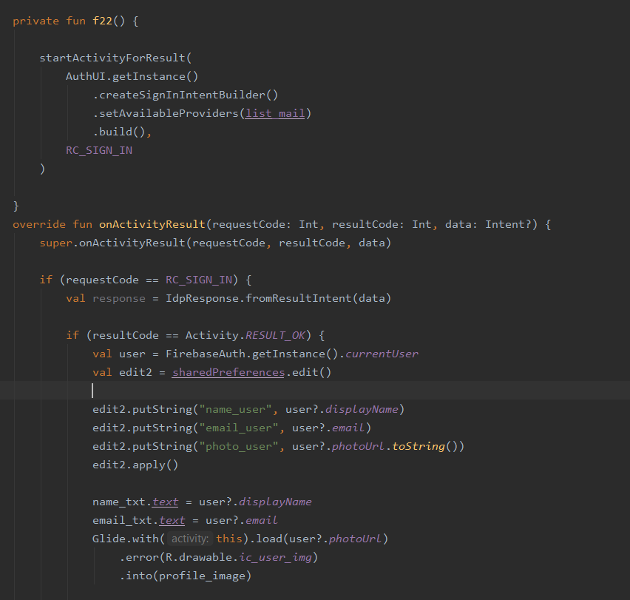

Picture 4. : login &authentication code

CHAPTER FIVE

SYSTEM IMPLEMENTATION

CHAPTER FIVE page|48

**5.1 Introduction**

The server used for Android apps is Oracle SQL, Microsoft SQL Server, and MySQL, which are connected to the server with PHP files that use a table (rows and columns) format for storing data. Then Firebase came into existence for Android apps which uses JSON for storing data. Firebase is NoSQL based. There are very few clouds-based servers available which are like firebase, like AWS Mobile, It is integrated console that helps to create, build, test, and monitor the mobile apps that leverages AWS services.

**5.2 Database Implementation:**

Firebase is considered as web application platform. It helps developers build high-quality apps. It stores the data in JavaScript Object Notation (JSON) format which does not use a query for inserting, updating, deleting or adding data to it. It is the backend of a system that is used as a database for storing data.

**The services available are:**

**1- Firebase Analytics**

**2- Machine Learning**

**3- Firebase Auth:**

Firebase Auth supports social login provider like Facebook, Google GitHub, and Twitter. It is a service that can authenticate users using only client-side code and it is a paid service. It also includes a user management system whereby developers can enable user authentication with email and password login stored with Firebase.

**4-Real-time Database:**

CHAPTER FIVE page|49

Firebase provides services like a real-time database and backend. An API is provided to the application developer, which allows application data to be synchronized across clients and stored on Firebase's cloud. The client libraries are provided by the company.

**5.3 Other Components Implementation**

CHAPTER SIX

PROJEECT OBSTACLES AND CONCLUSION AND FUTURE VISION

CHAPTER SIX page|51

**6.1 Project Obstacles:**

1-One of the hardest times periods through the team went through is the data collection process for the database because the data must be correct, accurate, effective and up to date. The team was forced to take actions and use some requirements engineering techniques to obtain this information. The problem became more difficult because of the Corona pandemic and government closures of ministries.

2- The team did not receive any teaching material or college courses for the software used in the project in all the academic years at the university.

**6.2 Future Vision:**

1- Making the search engine process smarter by using artificial intelligence and data analysis software by giving the services that many users frequently accessed in order to include it in the list of services defined to display them first.

2-Make the application login process based on the national identity in order to locate the user to make the search process display the services that the user needs in the ministry that is located in his governorate, especially the ministries existed in each governorate. This occurs by dividing the Hashemite Kingdom of Jordan into 13 parts into order 12 parts are for the services that exist in each of the governorates of Jordan, and one part is for services in a ministry with one location in Jordan, such as the Ministry of Higher Education.

CHAPTER SIX page|52

**6.3 Project Conclusion**

This app is officially for all people in Jordan they want to know more guidelines about the government transactions, after that when anybody need to get any information about governmental services, he uses Dilni app to make the process easier, aware, limpidity, and satisfied.