**Requirements Document**

**Table of Contents**

1. Introduction
   1. 1.1.  Purpose
   2. 1.2.  Scope
2. General description
   1. 2.1.  Product perspective
   2. 2.2.  Product functions
   3. 2.3.  General constraints
3. Requirements
   1. 3.1.  User requirements
   2. 3.2. System requirements
4. Appendices
   1. 4.1.  Use case diagrams and textual use cases
   2. 4.2.  Data flow diagrams

**1. Introduction**

**1.1. Purpose**

This document describes the user requirements for the Future House System as requested by “Esteem”, a client whose aim is to raise environmental awareness and incentivize positive actions for the home dwellers as well as home managers. The System is intended to be used by members of the general population who will own the ‘future-proofed, zero-carbon, solar-powered’ house that will be presented by Esteem as part of World Expo 2020 in Dubai. The system will track and record energy generation and energy consumption inside the house, provide control over Internet enabled devices and make behavioral suggestions for the home dwellers and managers. The document is created for the benefit of “Esteem”, and the developers, Group Name developers.

It is therefore intended that the readers are:

1. Esteem and their appointed representatives: for the client to gain an insight and understanding of what exactly the end product will be capable of.
2. Group Name: to act as a guide for us during the development process.

**1.2. Scope**

There is one software product – Future House System.

The System will consist of a native mobile application, web-based application, as well as a tablet-like screen installed inside the house, interacting with a backend server to provide the user with energy data information and control over IoT devices in the house. The backend server will be receiving the relevant information about the energy data of the house from a Central Monitoring Unit (CMU), which is pre-installed in the solar-powered house. The database will hold all the energy data, as well as the user information data.

The main functionality of the system is to record energy generation and consumption inside the smart house, and display these data in a user-friendly format through the mobile app as well as the web app. Also, the user will be able to control and manage IoT devices through the app. Furthermore, the user will be receiving daily feedback on the energy generation and consumption inside the house, and suggestions to improve the energy efficiency of the house.

.

1. General Description
   1. Product perspective

The development of this product is being sponsored by Esteem. It will provide a unique service for the owners and dwellers of Esteem’s solar powered houses. It will allow the users to view the energy consumption and as well as energy generation data, and will help them interact with IoT devices, lighting and A.C. in their home.

As this product will be providing a relatively unique service from most current smart home systems it has great potential for long­ term development and the capability to adapt to ever changing needs of the market.

* 1. Product functions

The system has 4 main functionalities:

* Record energy generation
* Record energy consumption
* Provide feedback to the user based on the usage patterns
* Provide control over IoT devices
  1. General constraints

The general constraints that would be encountered by the smart home system can be classified into the below categories:

* **User based constraints**: Users may find it very hard to keep pace with the smart home device configuration as they will be updated every time there is a change in preference or when new habits and routines are formed.

Users may also be burdened with the additional expense that will incur when an IoT device has to be replaced or when the server has to be updated as the income capacity of these users may not always be predictable.

* **Technological constraints:** There is always a chance of risk of malfunctioning of the IoT devices, or sensors or the central unit in smart home systems, along with the potential damage to the power storage which would all lead to hindrance in the working of the smart home system.

The risk of traffic overload in IoT devices in the network is also prevalent as extensive number of IoT devices are involved in the system.

* **Security based constraints:** There is a possibility of the loss of control of a thermostat or a smoke detector that will have consequences on the user safety. In case of fire, the emergency number has to be dialed which won’t happen in case of a power down of the system.
* **Energy Constraints**: Majority of devices are operated with battery power and the availability of battery power is based on the frequency of the storage data and computations. Therefore, energy is limited for smart home devices. Energy limitations provide vulnerability to resource depletion attacks
* **Physical Access**: If an intruder is successful to obtain the physical access of a device in a smart home in some way, then he/she will be able to take out all the encryption keys and other sensitive information. Therefore, they become easy targets of tampering attacks.

1. Requirements

We have used the MoSCoW method to prioritize the requirements. In every section the requirements are ordered from the most required to the least required, i.e:

Must have > Should have > Could have > Won’t have this time.

|  |  |
| --- | --- |
| **M** | Must have |
| **S** | Should have |
| **C** | Could have |
| **W** | Won’t have this time |

* 1. User Requirements

|  |  |  |  |
| --- | --- | --- | --- |
| **Registration** | | |  |
| F-UR1 | | **Register as home manager**  Users who are home owners/managers shall be able to register as home managers. | **M** |
| F-UR2 | | **Register as home dweller**  Users who are not home owners/managers shall be able to register as home dwellers. | **M** |
| F-UR3 | | **Login**  Users shall be able to sign in using their email or username and password. | **M** |
| F-UR4 | | **Logout**  Users shall be able to logout of their account and invalidate the current auth token. | **M** |
| F-UR5 | | **Email Verification**  Users shall be sent a confirmation email after they finish the Registration process. | **C** |
|  |

|  |  |  |
| --- | --- | --- |
| **Home Dweller Specific Functionalities** | |  |
| F-UR6 | **Add House**  The user shall be able to register/add a home to his account using his unique ID on the Central Monitoring Unit (CMU) | **M** |
| F-UR7 | **Remove House**  The user shall be able to remove a house which he/she no longer lives in. | **M** |
| F-UR8 | **Control IoT Devices**  The user shall be able to manage and control IoT devices, such as: switch on/off IoT devices | **M** |
| F-UR9 | **IoT devices feedback**  The user shall be able to get a comprehensive feedback on the various IoT devices in the house, such as battery level and energy consumption. | **S** |
| F-UR10 | **Recommendations**  The user shall get recommendations based on his usage to improve energy efficiency | **S** |
| F-UR11 | **Sharing Statistics**  Home dwellers shall be able to share statistics to various social media platforms. | **C** |
| **Home Manager Specific Functionalities** | |  |
| F-UR12 | **Detailed Data usage**  Home managers shall be able to get a more detailed information on energy usage | **M** |
| F-UR13 | **Register multiple houses**  Home managers shall be able to register more than one house to their account. | **S** |
| F-UR14 | **Remove House Management**  A user who is a home manager shall be able to remove a house from the list of houses that he/she manages/owns. | **S** |
| F-UR15 | **Compare data usage**  Home managers shall be able to compare data usage of the different homes registered to their account. | **C** |
| **Home Manager/Dweller universal functionalities** | |  |
| F-UR16 | **House rooms usage**  The user shall be able to view energy usage of each room separately and compare it with other rooms | **S** |
| F-UR17 | **Technical support**  The user shall be able to get technical support, for example through email, in case the user needed that, plus have access to FAQ section. | **C** |
| F-UR18 | **Send Invitation**  The user shall be able to send email invitations to use the app to his friends and family. | **C** |

|  |  |  |
| --- | --- | --- |
| **Account** | |  |
| F-UR19 | **Change login credentials**  The user shall be able to change his email, username and password. | **M** |
| F-UR20 | **Delete account**  The user shall be able to delete his account and all the data associated to that account. | **M** |
| F-UR21 | **Deactivate account**  A user shall be able to deactivate his/her account preventing access to all the account’s data as long as the account is being deactivated | **C** |

* 1. System Requirements

|  |  |  |  |
| --- | --- | --- | --- |
| **Backend Software** | | |  |
|  | |  |  |
| NF-SR1 | | **Server OS**  The backend server application is going to be hosted on a Linux server. | **S** |
| NF-SR2 | | **Environment**  The backend server application will be running Python 3 specifically python 3.6 | **S** |
| NF-SR3 | | **Database**  The Relational Database Management System that the backend database will be running is PostgreSQL. | **S** |
| NF-SR4 | | **MVC Architecture**  The system shall use an open source Model-View-Controller framework. | **S** |
| NF-SR5 | | **Database backup**  Critical data shall be stored on a backup database in case of data loss from the main data base. | **C** |
|  |

|  |  |  |
| --- | --- | --- |
| **Frontend Software** | |  |
| NF-SR6 | **Support multiple mobile platforms**  The Mobile App shall support the Android operating system and iOS | **M** |
| NF-SR7 | **Browser Support**  The Web App shall be able to run across all widely supported web browsers. | **M** |
| NF-SR8 | **Startup time**  The mobile application shall have a startup time of no more than 5 seconds | **S** |
| NF-SR9 | **Response time**  The frontend application shall response to any touch or click in under 300ms. | **S** |
| NF-SR10 | **Splash screen**  The mobile application shall display a splash screen when it is starting up. | **C** |
|  |  |  |
| NF-SR11 | **Desktop App support**  There shall be Windows, MacOS and Linux desktop apps for the system. | **W** |
|  |
| **Security** | |  |
|  |  |  |
| NF-SR12 | **HTTPS**  All requests to the backend server application shall only happen over https | **M** |
| NF-SR13 | **Hashing passwords**  The system shall hash passwords, such that no raw passwords are stored on the database. | **M** |
| NF-SR14 | **Auth Token**  The system shall issue an Authentication token related to a particular user when a user successfully logs in and invalidate that token when the user logs out. | **M** |
| NF-SR15 | **Secure Storage Bucket**  The system shall have a secure storage bucket which only authorized users can modify | **M** |
| NF-SR16 | **Password criteria**  The system shall require passwords to be at least 6 characters long | **S** |

|  |  |  |
| --- | --- | --- |
| **Performance** | |  |
| NF-SR17 | **Uptime**  The backend server application shall have an uptime of at least over 95% | **S** |
|  |  |  |
| NF-SR18 | **Transaction capacity**  The backend database shall be able to handle a minimum of 1000 IOPS. | **S** |
| NF-SR19 | **Responsiveness**  The backend server application shall have a latency of less than 300ms. | **S** |
| NF-SR20 | **Scalability**  The backend server application shall be hosted on a scalable service which can provide more throughput and speed when the number of users increases | **C** |
| NF-SR21 | **Multiple backend servers**  The system shall have multiple backend servers around the world to provide the most optimum latency for every user based on his location. | **W** |
|  |  |  |

1. **Appendices**
   1. **Use case diagram**

**4.2 Data Flow Diagrams**

**A. Report**

**B. Manager Report**

**C. Voice Request**

**D. Normal Request**

**E. Motion Detect**

**Risk Analysis Document**

|  |  |  |  |
| --- | --- | --- | --- |
| **L – Likelihood** | | **C – Consequence** | |
| **A** | Almost Certain | **A** | Severe |
| **B** | Likely | **B** | Major |
| **C** | Possible | **C** | Moderate |
| **D** | Unlikely | **D** | Minor |
| **E** | Rare | **E** | Trivial |

|  |  |  |  |  |  |  |
| --- | --- | --- | --- | --- | --- | --- |
| **Risk** | **Risk type** | **L** | **C** | **Indicators** | **Strategy type** | **Strategy** |
| **Student dropout** | Project:  People | E | B | The student may indicate that he/she would dropout | Mitigate | Reorganize team so that there is more overlap of work and therefore we understand more each other’s work |
| **Student illness** | Project:  People | D | C | Usually illness happens suddenly | Mitigate | The ill student can have less work while ill, and then can catch up later by putting in extra work. |
| **Technology discontinued** | Business:  Technology | D | D | Software company announcement | Mitigate | Use open source frameworks, so our work won’t be affected even if the technology is discontinued. |
| **Natural Disaster** | Project:  People | E | A | Could happen without an indicator | --- | In case of a catastrophic natural disaster that would lead to the termination of the project, nothing could be done. |
| **Inability to meet deadlines** | People:  Estimation | C | B | Having several other deadlines in a short time period | Management | Re-evaluate current plan ASAP |
| **Poor communication** | Project:  People | D | B | Poor relationships amongst team members | Monitor | Monitor and resolve any conflicts among team members. |
| **Specifications change** | Product:  Requirements | E | B | An announcement from the project Co-Ordinator | Management | Although very unlikely to have changes in the specifications mid-project, but we would re-evaluate our plan in case that happened. |
| **Management change** | Business:  Organization | E | E | An announcement that we would have a new manager | Mitigate | Having a new line manager won’t affect our plan of work. |
| **Buggy software** | Project:  People | C | A | Discovering bugs while testing | Management | Have more people to focus on the buggy part till the issue is resolved. |
| **Server crash** | Business:  Technology | E | A | An announcement from the service provider | Mitigate | We will be deploying our backend server on AWS, which have an uptime of over 99%. |

**Project Decisions & Plan**

**Contents**

1. Project decisions

1. 1.1 Software process
2. 1.2 Frameworks
3. 1.3 Database
4. 1.4 Programming languages
5. 1.5 Version controls
6. 1.6 Server Hosting
7. 1.7 Top level design
8. 1.8 Assessment & testing
9. 1.9 Communication tools

2. Team roles

3. Project plan

1. 2.1.  Overview
2. 2.2.  Stage 1
3. 2.3.  Stage 2
4. 2.4.  Stage 3

**1. Project Decisions**

1.1 Software process

<https://whatis.techtarget.com/definition/WaterScrumFall-water-Scrum-fall>

We have decided to use a hybrid software process model called Water-Scrum-Fall, which combines Scrum and Water-Fall development methodologies. It is a flexible approach that embraces both traditional and Agile development principles and gives more freedom to development teams to use whatever techniques and practices that best meets the needs of their project. We will be using Agile principles and Scrum communication techniques in our day-to-day product development, but we will employ traditional waterfall methodologies for planning and documenting the project’s progress.

1.2 Frameworks

We will be using several web and mobile frameworks which will help us reduce the development time and increase our efficiency. The different frameworks we will be using for different parts of the system are summarized as follows:

* Backend: Django & Django REST Framework
* Web App: React & Redux
* Mobile App: React Native

1.3 Database

We have decided that we will be using PostgreSQL as our relational database management system as it is easy to use, open source, has a big community and on top of that integrates very well with Django.

1.4 Programming Languages

Since we are using Django, so the backend will be developed entirely using Python. On the frontend JavaScript will be used to enrich the functionalities and the design of the web app, which is also the programming language we have to use with React. On the mobile app, most of the code we will be writing is going to be JavaScript as we are using React Native, but still we will have to write some parts using Java on Android and Objective-C on iOS.

1.5 Version Control

Git will be used to track changes in our source code during the development process. Specifically, we will be hosting our project on a private repo on GitHub. This will help us to easily coordinate work among us.

1.6 Server Hosting

We will be hosting our backend server as well as our database and media storage on AWS which has a lower cost compared to other competitors and an uptime of over 99%.

1.7 Top level design

The complete product of Future House System is divided into the following sub-systems:

**Central Monitoring Unit (CMU)**

The CMU is the most vital piece of hardware in the system. It is responsible for monitoring and recording the energy generation and energy consumption inside the house and uploading these data to the backend server.

**Database**

The database is where all the energy generation and energy consumption data as well as the users’ data will be stored. Other forms of data such as IoT devices data will also be stored on the database.

**Storage Bucket**

The database will be connected to a storage bucket to store any necessary media.

**Server**

The backend server application will be responsible of processing all energy generation and energy consumption data, generation charts, providing recommendations, controlling IoT devices. It will also be responsible for user Authentication and user Authorization.

**Mobile App**

The frontend mobile application will be the main media through which the user can communicate with the system. Using the mobile app, the user will be able to view all the energy generation and energy consumption data, get more insights into this data using different graphs and charts, receive recommendations and control IoT devices.

**Web App**

In addition to the mobile app, the user will able to communicate with the system through the web app. The user will able to access the web app through Desktop computers or mobile phones. The web app will provide similar functionalities to the mobile app.

**Built-in App**

All “Future House System” houses will have a pre-installed tablet-like screen through which the user can communicate with the system. The build-in app will provide similar functionalities to the mobile app and web app.

1.8 Testing & assessment

**Usability assessment**

To test the usability of the software system we will run a usability study through which we will present to the participants mock-up screens and observe their actions and get feedback from them. More details about the usability study in the usability report.

**Technical assessment**

Throughout the development process we will be collaborating in testing every bit of the system to ensure a bug-free end product. We will be using open source testing software in addition to manual testing on the frontend application to ensure a reliable smooth flow throughout the application.

**Customer expectations**

During the development process our main objective will be to meet all the functional and non-functional requirements so that our end product will be what our customer is expecting from us. Any feedback from our customer during the development process is welcome.

1.9 Communication tools

# For maximum collaboration and communication between team members, we will make use of Slack which will help us simplify the workflow for faster deploys.

**2. Team roles**

We carried out an in-depth discussion to identify every person’s weaknesses and strengths, what their skills are, and which areas are they particularly more experienced and based on that we have decided on how work will be divided between us. The following summarizes what each member will be working on throughout the project

* + - Omar Basem
      * Formal role: Technical manager
      * Primary contribution: leading the development of the system
    - Ibrahim
      * Formal role: Reporter
      * Primary contribution:
    - Mahmoud
      * Formal role: Liaison
      * Primary contribution:
    - Harshan
      * Formal role: Organizational manager
      * Primary contribution:
    - Malek
      * Primary contribution:
    - Arathi
      * Primary contribution:

**3. Project Plan**

3.1. Overview

|  |  |  |  |  |  |
| --- | --- | --- | --- | --- | --- |
| **ID** | **Type** | **Title** | **Start date** | **End date** | **Team member** |
| 1 | Task | Group allocation | 09/24/2019 | 09/24/2019 |  |
| 2 | Task | Setting up communications | 09/24/2019 | 09/25/2019 |  |
| 3 | Milestone | Stage 1 begin | 09/24/2019 | 09/24/2019 |  |
| 4 | Task | Arranging for our first meeting | 09/26/2019 | 09/26/2019 |  |
| 5 | Task | Initial online discussion | 09/27/2019 | 09/28/2019 |  |
| 6 | Task | Group meeting 1 | 09/29/2019 | 09/29/2019 |  |
| 7 | Task | Draft work plan | 09/29/2019 | 09/30/2019 |  |
| 8 | Task | Mentor meeting 1 | 10/02/2019 | 10/02/2019 |  |
| 9 | Task | Creating requirements | 10/03/2019 | 10/08/2019 |  |
| 10 | Task | Group meeting 2 | 10/07/2019 | 10/07/2019 |  |
| 11 | Task | Requirements review | 10/07/2019 | 10/08/2019 |  |
| 12 | Task | Requirements write-up | 10/09/2019 | 10/11/2019 |  |
| 13 | Task | Project Introduction write-up | 10/12/2019 | 10/12/2019 |  |
| 14 | Task | General description write-up | 10/13/2019 | 10/13/2019 |  |
| 15 | Task | Creating UML & DFD | 10/14/2019 | 10/16/2019 |  |
| 16 | Task | Group meeting 3 | 10/17/2019 | 10/17/2019 |  |
| 17 | Task | UML & DFD review | 10/17/2019 | 10/17/2019 |  |
| 18 | Task | Requirements report review | 10/17/2019 | 10/19/2019 |  |
| 19 | Task | Risks discussion | 10/17/2019 | 10/17/2019 |  |
| 20 | Task | Team Progress review 1 | 10/17/2019 | 10/17/2019 |  |
| 21 | Task | Creating risks drafts | 10/18/2019 | 10/21/2019 |  |
| 22 | Task | Group meeting 4 | 10/22/2019 | 10/22/2019 |  |
| 23 | Task | Risks review | 10/22/2019 | 10/22/2019 |  |
| 24 | Task | Software discussion | 10/22/2019 | 10/22/2019 |  |
| 25 | Task | Project planning | 10/22/2019 | 10/27/2019 |  |
| 26 | Task | Creating grantt chart | 10/23/2019 | 10/26/2019 |  |
| 27 | Task | Risks report write-up | 10/23/2019 | 10/26/2019 |  |
| 28 | Task | Group meeting 5 | 10/27/2019 | 10/27/2019 |  |
| 29 | Task | Project costing discussion | 10/28/2019 | 10/28/2019 |  |
| 30 | Task | Project plan review | 10/28/2019 | 10/28/2019 |  |
| 31 | Task | Team Progress review 2 | 10/28/2019 | 10/28/2019 |  |
| 32 | Task | Project costing draft | 10/28/2019 | 10/29/2019 |  |
| 33 | Task | Project plan write-up | 10/28/2019 | 11/02/2019 |  |
| 34 | Task | Creating project costing | 10/29/2019 | 11/02/2019 |  |
| 35 | Task | Group meeting 6 | 11/03/2019 | 11/03/2019 |  |
| 36 | Task | Project costing review | 11/03/2019 | 11/03/2019 |  |
| 37 | Task | UI mockup discussion | 11/03/2019 | 11/03/2019 |  |
| 38 | Task | Project costing write-up | 11/03/2019 | 11/06/2019 |  |
| 39 | Task | creating mockups | 11/04/2019 | 11/09/2019 |  |
| 40 | Task | Group meeting 7 | 11/10/2019 | 11/10/2019 |  |
| 41 | Task | mockups review | 11/11/2019 | 11/11/2019 |  |
| 42 | Task | Creating usability study | 11/12/2019 | 11/16/2019 |  |
| 43 | Task | Group meeting 8 | 11/17/2019 | 11/17/2019 |  |
| 44 | Task | Team progress review 3 | 11/17/2019 | 11/17/2019 |  |
| 45 | Task | Usability study review | 11/17/2019 | 11/17/2019 |  |
| 46 | Task | Carrying out usability study | 11/18/2019 | 11/20/2019 |  |
| 47 | Task | Usability report write-up | 11/21/2019 | 11/23/2019 |  |
| 48 | Task | Group meeting 9 | 11/24/2019 | 11/24/2019 |  |
| 49 | Task | Review Stage 1 reports | 11/24/2019 | 11/24/2019 |  |
| 50 | Task | Making modifications to stage 1 report | 11/24/2019 | 11/26/2019 |  |
| 51 | Task | Final review for stage 1 report | 11/27/2019 | 11/28/2019 |  |
| 52 | Task | Submit stage 1 report | 11/28/2019 | 11/28/2019 |  |
| 53 | Milestone | Stage 1 complete | 11/28/2019 | 11/28/2019 |  |
| 54 | Task | 3 weeks break for finals | 11/29/2019 | 12/21/2019 |  |
| 55 | Milestone | Stage 2 Begin | 12/22/2019 | 12/22/2019 |  |
| 56 | Milestone | Sprint 1 | 12/22/2019 | 12/22/2019 |  |
| 57 | Task | React Training | 12/22/2019 | 01/11/2020 |  |
| 58 | Task | Develop DB models | 12/22/2019 | 12/31/2019 |  |
| 59 | Task | Develop backend server | 01/01/2020 | 01/11/2020 |  |
| 60 | Milestone | Sprint 2 | 01/12/2020 | 01/12/2020 |  |
| 61 | Task | Group meeting 10 | 01/12/2020 | 01/12/2020 |  |
| 62 | Task | Backend server & DB review | 01/12/2020 | 01/12/2020 |  |
| 63 | Task | Frontend plan | 01/12/2020 | 01/12/2020 |  |
| 64 | Task | Web app basic functionalities | 01/13/2020 | 01/18/2020 |  |
| 65 | Task | Mobile app basic functionalities | 01/13/2020 | 01/18/2020 |  |
| 66 | Task | Authentication | 01/13/2020 | 01/14/2020 |  |
| 67 | Task | House registration | 01/15/2020 | 01/16/2020 |  |
| 68 | Task | Energy data simulation | 01/17/2020 | 01/18/2020 |  |
| 69 | Milestone | Sprint 3 | 01/19/2020 | 01/19/2020 |  |
| 70 | Task | Group meeting 11 | 01/19/2020 | 01/19/2020 |  |
| 71 | Task | Functionalities review 1 | 01/19/2020 | 01/19/2020 |  |
| 72 | Task | Functionalities testing 1 | 01/20/2020 | 01/22/2020 |  |
| 73 | Task | Continue working on web app functionalities | 01/20/2020 | 01/25/2020 |  |
| 74 | Task | Continue working on mobile app functionalities | 01/20/2020 | 01/25/2020 |  |
| 75 | Task | IoT devices screen | 01/20/2020 | 01/22/2020 |  |
| 76 | Task | House rooms screen | 01/23/2020 | 01/25/2020 |  |
| 77 | Milestone | Sprint 4 | 01/26/2020 | 01/26/2020 |  |
| 78 | Task | Group meeting 12 | 01/26/2020 | 01/26/2020 |  |
| 79 | Task | Functionalities review 2 | 01/26/2020 | 01/26/2020 |  |
| 80 | Task | Functionalities testing 2 | 01/27/2020 | 01/27/2020 |  |
| 81 | Task | Bugs fixing 1 | 01/28/2020 | 02/01/2020 |  |
| 82 | Task | Code Unit testing 1 | 01/28/2020 | 02/01/2020 |  |
| 83 | Milestone | Sprint 5 | 02/02/2020 | 02/02/2020 |  |
| 84 | Task | Group meeting 13 | 02/02/2020 | 02/02/2020 |  |
| 85 | Task | Report preparation | 02/02/2020 | 02/03/2020 |  |
| 86 | Task | Demo rehearsal | 02/03/2020 | 02/04/2020 |  |
| 87 | Task | Stage 2 final review | 02/05/2020 | 02/06/2020 |  |
| 88 | Task | Submit Stage 2 | 02/06/2020 | 02/06/2020 |  |
| 89 | Milestone | Stage 2 complete | 02/06/2020 | 02/06/2020 |  |
| 90 | Milestone | Stage 3 begin | 02/07/2020 | 02/07/2020 |  |
| 91 | Milestone | Sprint 6 | 02/08/2020 | 02/08/2020 |  |
| 92 | Task | Group meeting 14 | 02/09/2020 | 02/09/2020 |  |
| 93 | Task | Project progress review | 02/09/2020 | 02/09/2020 |  |
| 94 | Task | Review any missed tasks | 02/09/2020 | 02/09/2020 |  |
| 95 | Task | Recommendations screen | 02/10/2020 | 02/12/2020 |  |
| 96 | Task | Sharing to social media feature | 02/13/2020 | 02/15/2020 |  |
| 97 | Milestone | Sprint 7 | 02/16/2020 | 02/16/2020 |  |
| 98 | Task | Group meeting 15 | 02/16/2020 | 02/16/2020 |  |
| 99 | Task | Functionalities review 3 | 02/16/2020 | 02/16/2020 |  |
| 100 | Task | Functionalities testing 3 | 02/17/2020 | 02/18/2020 |  |
| 101 | Task | Energy charts | 02/19/2020 | 02/20/2020 |  |
| 102 | Task | Detailed Graphs screen | 02/21/2020 | 02/22/2020 |  |
| 103 | Milestone | Sprint 8 | 02/23/2020 | 02/23/2020 |  |
| 104 | Task | Group meeting 16 | 02/23/2020 | 02/23/2020 |  |
| 105 | Task | Functionalities review 4 | 02/23/2020 | 02/23/2020 |  |
| 106 | Task | Functionalities testing 4 | 02/24/2020 | 02/25/2020 |  |
| 107 | Task | Push Notifications | 02/26/2020 | 02/29/2020 |  |
| 108 | Milestone | Sprint 9 | 03/01/2020 | 03/01/2020 |  |
| 109 | Task | Group meeting 17 | 03/01/2020 | 03/01/2020 |  |
| 110 | Task | Functionalities review 5 | 03/01/2020 | 03/01/2020 |  |
| 111 | Task | Functionalities testing 5 | 03/02/2020 | 03/03/2020 |  |
| 112 | Task | Preparing usability study | 03/04/2020 | 03/05/2020 |  |
| 113 | Task | Carrying out usability study | 03/06/2020 | 03/07/2020 |  |
| 114 | Milestone | Sprint 10 | 03/08/2020 | 03/08/2020 |  |
| 115 | Task | Group meeting 18 | 03/08/2020 | 03/08/2020 |  |
| 116 | Task | Usability study results review | 03/08/2020 | 03/08/2020 |  |
| 117 | Task | Preparing usability report | 03/09/2020 | 03/10/2020 |  |
| 118 | Task | Code unit testing 2 | 03/11/2020 | 03/14/2020 |  |
| 119 | Task | Bug fixing 2 | 03/11/2020 | 03/14/2020 |  |
| 120 | Milestone | Sprint 11 | 03/15/2020 | 03/15/2020 |  |
| 121 | Task | Group meeting 19 | 03/15/2020 | 03/15/2020 |  |
| 122 | Task | Expo preparation | 03/15/2020 | 03/18/2020 |  |
| 123 | Task | Functionalities review 6 | 03/15/2020 | 03/15/2020 |  |
| 124 | Task | Functionalities testing 6 | 03/16/2020 | 03/18/2020 |  |
| 125 | Task | Expo | 03/19/2020 | 03/19/2020 |  |
| 126 | Task | Two days break | 03/20/2020 | 03/21/2020 |  |
| 127 | Milestone | Sprint 12 | 03/22/2020 | 03/22/2020 |  |
| 128 | Task | Group meeting 20 | 03/22/2020 | 03/22/2020 |  |
| 129 | Task | Updating stage 2 progress report | 03/22/2020 | 03/28/2020 |  |
| 130 | Milestone | Sprint 13 | 03/29/2020 | 03/29/2020 |  |
| 131 | Task | Group meeting 21 | 03/29/2020 | 03/29/2020 |  |
| 132 | Task | Project evaluation | 03/29/2020 | 03/31/2020 |  |
| 133 | Task | Final Stage 3 review | 04/01/2020 | 04/01/2020 |  |
| 134 | Task | Submit Stage 3 | 04/02/2020 | 04/02/2020 |  |
| 135 | Milestone | Stage 3 Complete | 04/02/2020 | 04/02/2020 |  |
| 136 | Milestone | PROJECT COMPLETE | 04/02/2020 | 04/02/2020 |  |

**Project Costing**

Table of content

* 1. Introduction
  2. Costing Analysis
  3. Calculations
  4. Costing References

**1. Introduction**

**1.1. Overview**

This document explains the costing breakdown of the Future House System, how the costs where arrived at, calculations, analysis and costing references.

* 1. **Costing Analysis**

**2.1 Backend server**

We will be hosting our backend server on AWS, so the costs of running a server, database and storage are all from AWS. This includes DNS, server, DB, Storage, Data transfer and domain name. [1]

**2.2 Hosting mobile app**

Since our app will support both iOS and Android, we need to host our app on the App store and the Play store. This requires an Apple developer subscription as well as an Android developer subscription. [2] [3]

**2.3 Staff cost**

We are a group of 6, so if in reality a group of 6 would develop such an app a potential staff breakdown would be the following: [4]

* 1 Project manager
* 3 Software developers
* 1 UX/UI designer
* 1 Software tester

**2.4 Cost of house hardware**

In order for our system to work, any solar powered house would need to have a Central Monitoring Unit (CMU) which capable of monitoring the energy generations and consumption in the house and upload these data to our backend server. Also, a tabled-sized screen needs to be installed in the house. In addition, the houses are supposed to be already solar powered, however the average cost of installing solar panels into a house in the UK has been included. Below in an in-depth analysis of the solar panels and CMU cost:

**Solar panels**

The average UK home uses around 4648 kWh/year. [5]

A mid-range solar panel has an about of 250 watts per hour. [6]

The average sun-time in the UK is 4.5 hours. [7]

250-watt solar panel would produce 1,125 watt-hours or 1.125kWh of electricity per day (4.5 x 250).

Based on the above data one solar panel output per year is equal to 1.125 x 365 = 410 kWh/year.

Therefore, the average UK home needs 4648/410 = 12 Solar panels

Average price of solar panels per watt is $0.75 per watt therefore a 250-watt panel would cost $187.50. [8]

Therefore, the average cost of installing solar panels into a house in the UK is 187.50 x 12 = $2250.00.

**CMU**

The average solar monitoring unit price is $500.00. [9]

Our CMU in addition to monitoring, needs computation and processing capabilities and being able to upload to server, so it will need extra components that cost around the average price of a laptop which is $500.00, so adding that to the average cost of a solar monitoring unit would give us a good estimate of the price of our Central Monitoring Unit. [10]

**Screen**

Out system will have a built-in screen in the house about the size of a tablet, from which the user can communicate with the system. Its cost will be around the average cost of a tablet. [11]

* 1. **Calculations**

**3.1** **Cost of hosting on AWS**

|  |  |  |  |
| --- | --- | --- | --- |
| **Type** | **Units** | **Cost/unit/month** | **Cost/Year** |
| DNS | 1 | $0.50 | $6.00 |
| Server | 1 | $9.50 | $114.00 |
| Database | 1 | $10.22 | $123 |
| Storage (GB) | 10* | $0.023 | $2.76 |
| Data transfer (GB) | 5* | $0.09 | $5.40 |
| Domain name | 1 | $1 | $12.00 |
| Total cost/year |  |  | $263.00 |

*The storage and data transfer values are expected to be increasing every year.

**3.2** **Cost of hosting mobile app**

|  |  |  |
| --- | --- | --- |
| **Type** | **units** | **Cost/year** |
| App store | 1 | $99.00 |
| Play store | 1 | $25.00* |
| Total 1st year |  | $124.00 |
| Total following years |  | $99.00 |

*The play store subscription fee is a one-time pay.

**3.3** **Staff cost**

|  |  |  |  |  |  |
| --- | --- | --- | --- | --- | --- |
| **Type** | **Count** | **Hours** | **Cost/hour** | **Total cost/unit** | **Total cost** |
| Project manager | 1 | 150 | $65 | $9750.00 | $9750.00 |
| Software developer | 3 | 150 | $33 | $4950.00 | $14850.00 |
| UX/UI designer | 1 | 150 | $41 | $6150.00 | $6150.00 |
| Tester | 1 | 150 | $32 | $4800.00 | $4800.00 |
| Total |  | | | | $35550.00 |

It is assumed that the project will need 25 hours of maintenance from every individual worker every year after the first year. Therefore, total maintenance cost would be (65+33+33+33+41+32) x 25 = $5925.00 per year after the first year.

**3.4** **Cost of House hardware**

|  |  |  |  |
| --- | --- | --- | --- |
| **Type** | **units** | **Cost/unit** | **Total cost** |
| Solar panel | 12 | $187.50 | $2250.00 |
| CMU | 1 | $1000.00 | $1000.00 |
| Tablet-size screen | 1 | $270.00 | $270.00 |
| Total cost for solar powered houses |  |  | $1270.00 |
| Total cost for non-solar powered houses |  |  | $3520.00 |

**3.5** **Total cost of the system**

|  |  |
| --- | --- |
| Type | Cost |
| Server Hosting / year * | $263.00 |
| Mobile app hosting / year ** | $124.00 |
| Staff cost (1st year) | $35550.00 |
| Staff cost for maintenance (following years) | $5925.00 |
| Software system total cost (1st year) | $35937.00 |
| Cost Solar powered house / unit | $1270.00 |
| Non-solar powered house / unit | $3520.00 |

As an example, the total cost for the first year of building Future House System including the software cost, staff cost and installing the necessary hardware into 100 solar powered houses would be:

35937 + (1270 * 100) = $162,937.00

*The server hosting cost is expected to be increasing every year.

**The mobile app hosting cost is $99.00 for the following years.

**4. Costing references**

1. All backend server costs are from AWS website: <https://aws.amazon.com/>

2. Apple developer subscription: <https://developer.apple.com/support/purchase-activation/>

3. Google developer subscription: <https://support.google.com/googleplay/android-developer/answer/6112435?hl=en>

4. All salaries are from: [https://www.salary.com](https://www.salary.com/research/salary/benchmark/project-management-manager-hourly-wages)

5. On Average. Average Electricity Usage [Internet]. 2019 [cited 22 November 2019]. Available from: <https://www.onaverage.co.uk/consumption-averages/average-electricity-usage>

6. Vasili, Alex. Solar Panel Output [Internet]. 2019 [cited 22 November 2019].

Available from: <https://www.theecoexperts.co.uk/solar-panels/electricity-power-output>

7. Catlow, Amy. How many solar panels do I need? [Internet]. 2019 [cited 22 November 2019]. Available from: <https://www.theecoexperts.co.uk/solar-panels/how-many-do-i-need>

8. Energy sage. How much do solar panels cost? [Internet]. 2019 [cited 22 November 2019]. Available from: <https://news.energysage.com/how-much-does-the-average-solar-panel-installation-cost-in-the-u-s/>

9. Casey, Brandi. How much does the average DIY solar system cost? [Internet]. 2019 [cited 22 November 2019]. Available from: <https://www.solaris-shop.com/blog/how-much-does-the-average-diy-solar-power-system-cost/>

10. Cost Helper Electronics. Laptop computer cost [Internet]. 2019 [cited 22 November 2019]. Available from: <https://electronics.costhelper.com/computers-notebook.html>

11. Statista. Average price of consumer tablets [Internet]. 2019 [cited 22 November 2019]. Available from: <https://www.statista.com/statistics/619505/tablets-average-price-in-the-us/>

**Usability Document**

**Table of Contents**

1. Introduction
   1. 1.1 Aims & Objectives
2. Design decisions
   1. 2.1 Overview
   2. 2.2 Mockups
3. Experimental Plan
   1. 3.1 Experimental method
   2. 3.2 Responses details
   3. 3.3 Results Analysis
   4. 3.4 Conclusion
4. Appendices
   1. 4.1.  Usability test plan
   2. 4.2 Mock-up testing protocol
   3. 4.3 Sample questionnaire
   4. 4.4 Sample consent form

**1. Introduction**

**1.1. Aims & Objectives**

This document describes the UI design decisions of the Future House System as well as the usability experimental plan, experimental method, data collection and testing protocol. In addition, in includes analysis for the usability study responses, results and conclusion.

**2. Design decisions**

**2.1. Overview**

The first thing we needed to consider when making the design decisions, is who will be using our product. Our product will be used by people of all ages: children, adults and elderly, so we needed to focus on making the design not complex and the most usable possible. The following sections shows some mockups of our design for both Mobile and Desktop, along with some design explanation for each mockup.

**2.2. Mockups**

**2.2.1 Login (Index) screen**

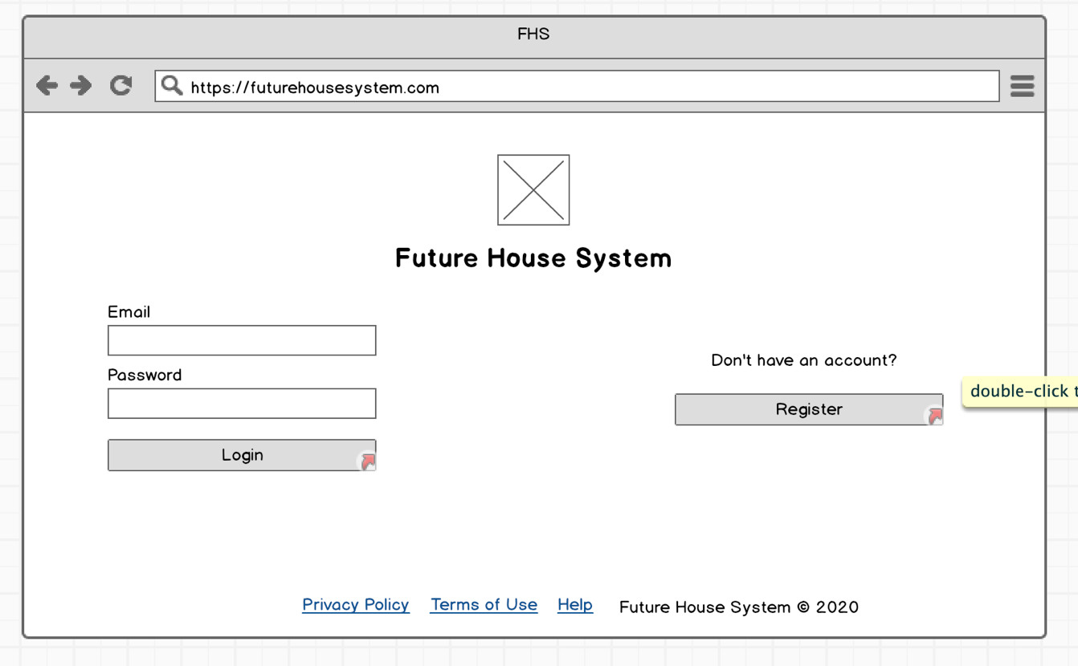

The login screen is a very simple one. The screen is divided into four corners. The logo and the name of the system is shown at the top corner of the screen. Input fields for email and password are shown on the left corner, and a register button on the right corner. The bottom corner contains links to help section, privacy policy section and terms of use section.

The mobile login screen is also similar in simplicity, but in a vertical alignment.

**2.2.2 Register screen**

In the register screen the user is asked for 6 inputs: first name, last name, age, email, password and whether he/she is a Home manager or a Home dweller.

Registering on mobile is composed of 3 screens instead of 1 screen for more clarity on the mobile’s smaller screen.

**2.2.3 Home screen**

The first thing that will be shown to the user on the home screen is the last 24 hours stats. The user will be shown in kilo Watts the electric power generated, consumed, wasted and saved. The user can navigate to different screen from the top right corner.

On mobile, the stats will be shown in a vertical manner. The navigation bar will be located at the bottom of the screen.

**2.2.4 IOT screen**

In the IOT devices screen, a picture of every device will be shown, and a switch to control the device. Next to every IOT device a graph will be shown to give the user more insight into the device’s usage of electric power.

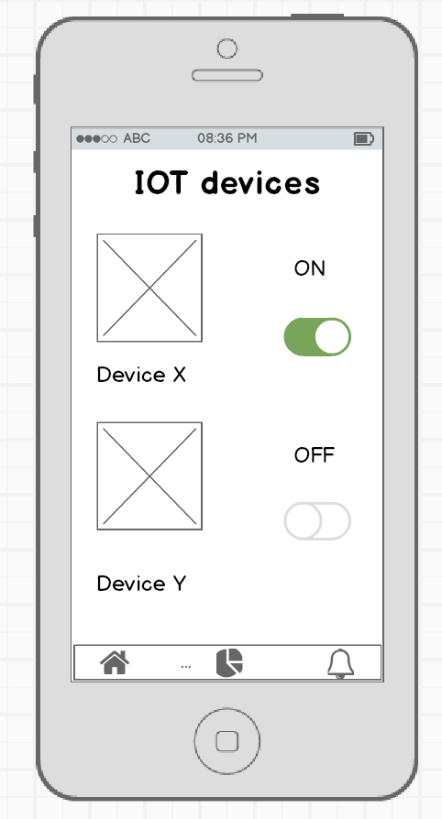

On mobile, similarly the user can control IOT devices, and also can click on any IOT device to get more info about it and graphs showing the device’s usage of electric power.

**2.2.5 House rooms screen**

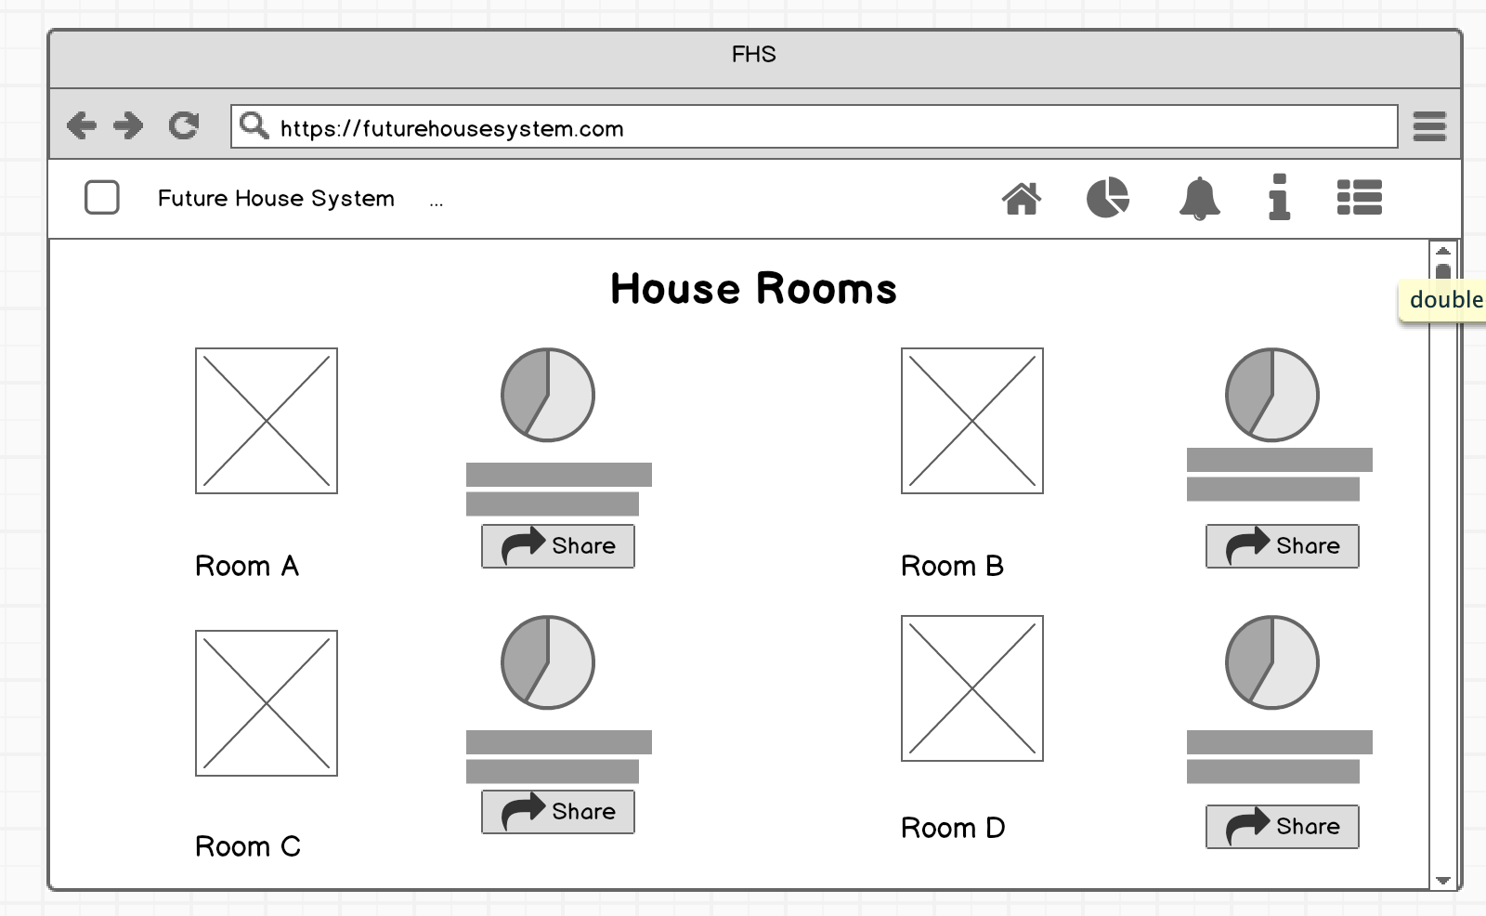

In the House rooms screen, a picture of every room will be displayed along with a pie chart showing some statistics about power usage and more info beneath it. Also, a share button will be there to allow the user to share the statistics to different social media.

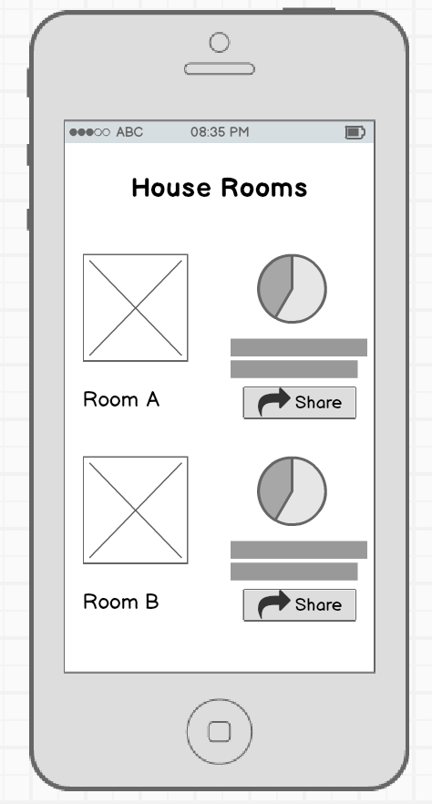

On mobile it will look similar, but again in a vertical manner.

**2.2.6 Recommendations screen**

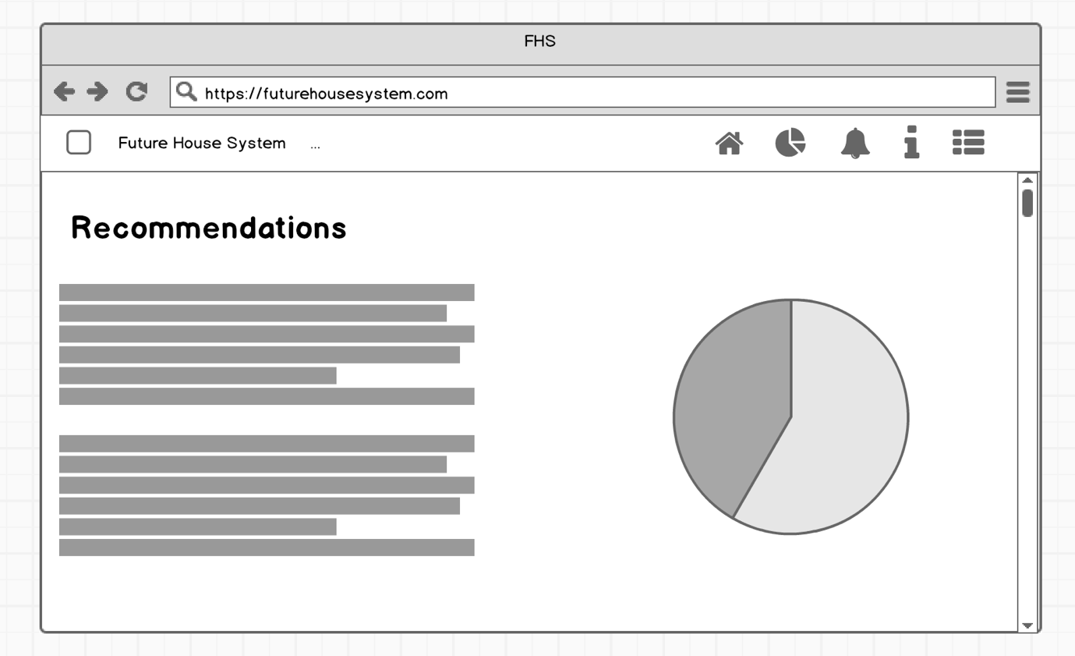

The recommendations screen will show the user some recommendations based on his/her usage on the left side of the screen and support those recommendations using graphs and charts on the right side of the screen.

**2.2.7 No house screen**

When the user has not added/registered yet a house with his account, a screen will be displayed on the home page having a big button asking the user to add a new House.

**2.2.8 Adding house screen**

On the “Adding house” screen which the user can reach by clicking the button in the “No house” screen, a big input field will be displayed asking the user to enter his unique ID which is associated with the Central Monitoring Unit, and beneath it a big “Add” button to add/register the house.

**3. Experimental plan**

**3.1 Experimental method**

The experimental method we used is a “Usability” study rather than an “Experimental” study. We observed the participants actions, and how they interacted with the different screens we present to them. The main objective of the testing plan is to test the usability of the user interface of the Future House System in order to get some feedback on whether the design is good or bad, and how easy it is to use the application.

**Data Collection**

The data was collected in compliance with GDPR. No personal information was obtained from the subjects at all. Every subject was given an ID. This means that the data is “Anonymous and unlinked” by GDPR standards. Data was collected through the pre-questionnaires and post questionnaires, in addition to our observations.

**Testing Protocol**

During testing the participants, we followed the following protocol:

* 1. Welcome the participants and explain to them aim of this session which is to try out some of the features of a prototype app which aims to provide control system over a solar powered house.
  2. Give the participants more insight into the system’s main functionalities.
  3. Explain to the participants how the test will be run, and that all their responses will stay anonymous.
  4. Ask the participants to answer the prequestionnaire.
  5. Start testing: show the participants several mock-up screens asking some to describe what they see on each screen in addition to other questions specific to every screen.
  6. Ask the participants to answer the postquestionnaire, then thank them for participating.

**3.2 Responses Details**

**3.2 Result analysis**

**3.4 Conclusion**

**4. Appendices**

**4.1. Usability testing test plan**

1. **Objectives**

We are testing the usability of the user interface of the Future House System in order to get some feedback on whether the design is good or bad, and how easy it is to use the application.

1. **Participants**

Future House System will be used by people of all ages, but all our subjects will be at least 18 years old.

1. **Task Scenarios**

* What they see:

We will show the participants some mock-ups and get feedback from them on what they think is displayed on the mock-up screen.

* Task 2 – Perform some tasks:

We will ask the participants to perform some tasks through the mock-ups, for example: “If you want to create a new account where can you click?”.

1. **Metrics**

* Time spent to determine what they see on the mock-up screen (quantitative – objective).
* Success rate of knowing what is displayed on the mock-up screen correctly (quantitative – objective).
* Ratings given by participants in the questionnaires (quantitative – subjective).

1. **Questions**

Before, during and after testing we will ask the participant the following questions:

* Do you consider yourself experienced with using technology?
* What do you think of the design of that screen?
* Do you think that part of the screen is useful?
* What do you think of the overall design and usability of the application?

Remember to say something like this with each new subject:

I’ll ask you to look at the various screens and describe what you see, and I will ask you to complete a few simple tasks. I’ll be taking notes to record your feedback and actions but my notes won’t identify you and they will be completely anonymous. Following this we will ask you to complete an anonymous questionnaire to collect your general comments/feedback on the app. There are no right or wrong answers, and your interpretation of the information presented will be very useful in improving the design. Please tell the facilitator if you wish to stop at any time.

**4.2 Mock-up testing protocol**

Facilitator initials:

Session number:

**iSneeze**

Future House System testing protocol

20 November 2019

Heriot Watt University

Notes for facilitator

Please read through the aims and introduction with the participant and take notes alongside each of the questions to record the session. Please use a new protocol sheet for each participant and record your name and session number on the top right corner. In your notes please record the participant’s responses and any issues they may have had in completing the tasks.

**Aim**

The aim of this session to try out some of the features of a prototype app which aims to provide control system over a solar powered house. The app is in early developmental stage and your input will be used to improve the functions and the way that the information is presented.

**Introduction**

The control system will record the energy consumption and generation in a House, and display these information to user inside the app in the form of different charts, as well as provide control over IoT devices in the house, give some recommendations based on the user’s usage to improve the energy efficiency inside the house.

I’ll ask you to look at various screens, both mobile and desktop, and describe what you see, and I will ask you to complete a few simple tasks. I’ll be taking notes to record your feedback and actions, but my notes won’t identify you and they will be completely anonymous. Following this we will ask you to complete an anonymous questionnaire to collect your general comments/feedback on the app. There are no right or wrong answers, and your interpretation of the information presented will be very useful in improving the design. Please tell the facilitator if you wish to stop at any time.

Let’s begin.

1. **Login screen**

1. Can you describe this screen?
2. What are the steps you would follow to login?
   1. **Register Screen 1**

1. What would you do on that screen?
   1. **Register screen 2**

1. Can you describe that screen?
2. When would you choose a Home manager and when would you choose a Home dweller?
   1. **Register screen 3**

1. How would you go back to change your age?
2. Where should you press after filling all the fields?
3. **Home screen**

1. Can you describe the screen?
2. How much energy was generated in the last 24 hours?
3. What do you think every element of the top navigation bar do?
4. **IoT screen**



1. Can you describe this screen?
2. How would you turn on Device Y?
3. **IoT details screen**

1. What do you think is displayed on the screen?
2. How do you think you can get to that screen from the previous screen?
3. **House rooms screen**

1. What do you think is displayed on the screen?
2. Where would you click to share this information to another app?
3. **Recommendations screen**

1. Can you describe that scree?
2. **No houses screen**

1. Can you describe that screen?
2. What can you do on that screen?
3. **Adding new house screen**

1. Can you describe that screen?
2. Where can you find your unique ID?

OK, that’s our short test complete. I’ll now set up the questionnaire for you to complete. This is intended to gather some more general feedback on the app. It should only take 5-10 minutes to complete, and then you are done.

**4.3 Blank Pre-Questionnaire**

**Future House System Application Pre-Questionnaire**

For all the following questions tick only one answer:

1. Age

* 18-29
* 30-49
* 50+

1. Gender
   * Male
   * Female
2. Do you consider yourself experienced with technology?
   * Yes
   * No
   * Not sure
3. Have you ever used a House Control System application before?
   * Yes
   * No

**4.4 Blank Post-Questionnaire**

**Future House System Application Post-Questionnaire**

Thank you for participating in this usability testing. Please take the time to answer the following questions.

On a scale from 1 to 5, 1 being “Strongly Disagree” and 5 being “Strongly Agree”, answer the following questions:

1. I think I would enjoy using this app.

Strongly Disagree 1 2 3 4 5 Strongly Agree

1. This application has a good design.

Strongly Disagree 1 2 3 4 5 Strongly Agree

1. I found this application unnecessarily complex.

Strongly Disagree 1 2 3 4 5 Strongly Agree

1. I would imagine that most people would learn to use this app very quickly.

Strongly Disagree 1 2 3 4 5 Strongly Agree

1. I was able to describe every screen with confidence and ease

Strongly Disagree 1 2 3 4 5 Strongly Agree

1. I think I would need the support of a technical person to be able to use the app.

Strongly Disagree 1 2 3 4 5 Strongly Agree

1. I think I would be using this app frequently

Strongly Disagree 1 2 3 4 5 Strongly Agree

1. The overall experience with this app was enjoyable.

Strongly Disagree 1 2 3 4 5 Strongly Agree

1. What did you like about this application?

…………………………………………………………………………………………

…………………………………………………………………………………………

1. What did you not like about this application?

…………………………………………………………………………………………

…………………………………………………………………………………………

1. What do you think can be improved in this application?

…………………………………………………………………………………………

…………………………………………………………………………………………

That’s the end of the questionnaire. Thank you for participating with us.

**4.5 Blank consent form**

Future House System

Heriot-Watt University

**Consent to Act as a Subject in an Experimental Study**

**Principal Investigator**: Omar, Ibrahim, Mahmoud, Harshan, Malek, Arathi

**Description**: The purpose of this study is to study the usability of the user interface of the Future House System.

There are minimal risks for you to participate in this study. All personal information will be kept confidential in a secure filing cabinet or in password-protected computer directories. Your participation will not affect how well you do in your courses (if you are a student) or affect your relationship with the university in any way

You are free to decline to participate in this study. Should you decide to participate, you are free to end your participation at any time. Such a decision by you will not adversely affect or alter you status with the university in any way.

**Voluntary consent**: I certify that I have read the preceding and that I understand its contents. Any questions I have pertaining to the research have been and will be answered by the team. My signature below means that I have freely agreed to participate in this study, and that I agree to the publication of the results for scientific purposes and to the distribution of the recordings and transcripts of the sessions for research purposes so long as my identity is not revealed.

________________ ______________________________ __________

Date Subject Signature Inv. Initials

**Investigator's certification**: I certify that I have explained to the above individual the nature and purpose, the potential benefits, and possible risks associated with participation in this research study, have answered any questions that have been raised, and have witnessed the above signature.

________________ _______________________________

Date Investigator Signature