Module2 - R Markdown Document 1

Omar Bassem

2025-07-05

# This is a level 1 header

## R Markdown

### This is a level 3 header

This is an R Markdown document. Markdown is a simple formatting syntax for authoring HTML, PDF, and MS Word documents. For more details on using R Markdown see <http://rmarkdown.rstudio.com>.

Here is a link to [GOOGLE](https://google.com)

Here is a word in **bold** and another word in **bold**

Here is a word in *italics* and another word in *italics*

When we compile our document, we are using the rmarkdown package.

Here is an example of a non-numbered list:

* Breakfast
  + food
    - eggs
    - toast
    - bacon
  + drink
    - apple juice
* Lunch
  + taco
* Dinner
  + baked chicken
  + broccoli
  + rice

Here is an example of a numbered list:

1. Breakfast
   1. food
      1. eggs
      2. toast
      3. bacon
   2. drink
      1. apple juice
2. Lunch
   1. taco
3. Dinner
   1. baked chicken
   2. broccoli
   3. rice

Here is an example of a blockquote:

This is a block quote. This paragraph has two lines.

1. This is a list inside a block quote.
2. Second item.

Here is an example of a nested blockquote:

This is a block quote. This paragraph has two lines.

This text is nested

Here is an example of code in a blockquote:

2+2  
mean(c(1,2,3,4,5))

When you click the **Knit** button a document will be generated that includes both content as well as the output of any embedded R code chunks within the document. You can embed an R code chunk like this:

summary(cars)

## speed dist   
## Min. : 4.0 Min. : 2.00   
## 1st Qu.:12.0 1st Qu.: 26.00   
## Median :15.0 Median : 36.00   
## Mean :15.4 Mean : 42.98   
## 3rd Qu.:19.0 3rd Qu.: 56.00   
## Max. :25.0 Max. :120.00

## Including Plots

You can also embed plots, for example:

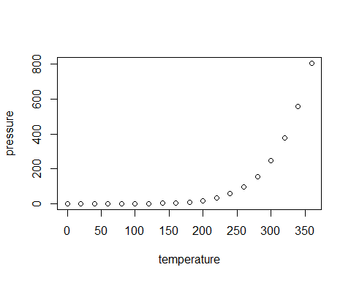

Note that the echo = FALSE parameter was added to the code chunk to prevent printing of the R code that generated the plot.

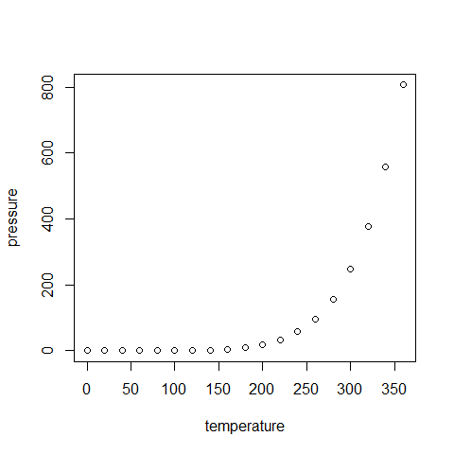

## Insert Tables

knitr::kable(head(cars))

| speed | dist |
| --- | --- |
| 4 | 2 |
| 4 | 10 |
| 7 | 4 |
| 7 | 22 |
| 8 | 16 |
| 9 | 10 |