Egypt University of Informatics
Faculty of Engineering

Data Science Methodology (CSE271) — Spring 2026

Crime Pattern Analysis in Los Angeles

Predictive Modelling of Arrest Outcomes and Crime Types

Technical Report

Submitted to: Dr. [Fatma]

Dataset: LAPD Crime Data 2020–2024 | Source: Los Angeles Open Data Portal

Abstract
This report presents a comprehensive data science analysis of crime incident data recorded by the Los Angeles Police Department (LAPD) between 2022 and 2024. The dataset, sourced from the Los Angeles Open Data portal, comprises over 424,634 cleaned records capturing detailed information about each reported crime, including temporal attributes, victim demographics, crime type, geographic coordinates, and incident outcomes. The data cleaning pipeline was implemented in a dedicated separate notebook (cleaning.ipynb) to avoid re-running computationally expensive preprocessing steps during iterative model development.

Two primary predictive tasks were investigated. First, a binary classification model was developed to predict whether a crime incident results in an arrest. The primary model for this task is a regularised Random Forest classifier, which achieved 72.82% cross-validated accuracy and an AUC of 0.730. A Decision Tree and Logistic Regression were additionally trained for comparison purposes, not as primary models. Second, a multi-class classification model was built to predict the crime group category based on contextual features including time of day, victim age, victim gender, and holiday context. This second task is a bonus extension beyond the core project requirements.

Key findings confirm that time of occurrence and crime type (specifically Robbery & Aggravated Assault) are the dominant predictors of arrest likelihood. The ROC curve shows an AUC of 0.730, placing the model in a meaningful range above random chance. Learning curve analysis reveals a modest overfitting gap of approximately 3 percentage points that is well-controlled by the applied regularisation. The multi-class crime type classifier achieves 23.71% accuracy — substantially above the 16.7% random baseline — but is structurally limited by severe class imbalance and sparse holiday data, which are diagnosed in detail. All findings are interpreted in real-world context with actionable recommendations.

1. Introduction

1.1 Background and Context
Crime analysis has long been a critical tool in urban policing and public safety policy. Los Angeles, one of the most populous cities in the United States, records hundreds of thousands of crime incidents annually across 21 policing divisions. The ability to predict the likelihood of an arrest — or to classify what type of crime has occurred — offers significant operational value to law enforcement agencies, enabling better resource allocation and more targeted patrol strategies.

With the LAPD publishing anonymised crime incident records on the Los Angeles Open Data portal, it is now possible to apply machine learning methodologies to this data at scale. This project leverages that publicly available dataset to build, evaluate, and critically interpret classification models that could, in principle, assist real-world public safety decision-making. The analysis covers data from 2022 to 2024, deliberately excluding 2020–2021 to avoid patterns distorted by the COVID-19 pandemic.

1.2 Literature Review
Predictive policing and crime classification have been active research areas for over two decades. Early work by Perry et al. (2013) at the RAND Corporation demonstrated that statistical and machine learning models can identify spatial and temporal crime hotspots with meaningful accuracy. More recent studies applying ensemble methods — including Random Forests and Gradient Boosting — to crime datasets from cities such as Chicago and San Francisco consistently found that temporal features (time of day, day of week) and spatial attributes (neighbourhood, area type) are the strongest predictors of both crime type and arrest likelihood.

Research has also highlighted the persistent challenge of class imbalance in arrest prediction datasets, where arrests are significantly rarer than non-arrests, making class-weighting and oversampling strategies essential. The literature consistently warns against using raw accuracy as the sole evaluation metric in such settings, favouring precision, recall, F1-score, and AUC as more informative measures.

1.3 Project Objectives
The specific objectives of this project are:
- Perform thorough data cleaning and preprocessing on the raw LAPD crime dataset in a dedicated cleaning notebook, reducing it from over one million records to a clean, analysis-ready set of 424,634 rows.
- Conduct exploratory data analysis (EDA) to understand distributions, class balance, temporal trends, and geographic crime density.
- Build and evaluate a Random Forest classifier (primary model) for arrest outcome prediction, with Decision Tree and Logistic Regression trained purely for comparison.
- Apply advanced validation techniques including stratified k-fold cross-validation, learning curve analysis, confusion matrices, and ROC curve analysis for a rigorous performance assessment.
- Build and evaluate a multi-class holiday crime type classifier and perform root cause analysis of its structural limitations.
- Critically interpret all results in the context of the real-world crime prediction problem and make actionable recommendations.

2. Materials and Methods

2.1 Dataset Description
The dataset used is the LAPD Crime Data from 2020 to 2024, obtained from the Los Angeles Open Data portal (data.lacity.org). It contains incident-level records transcribed from original LAPD paper crime reports. The raw dataset contains 1,004,894 rows and 28 columns. After filtering to 2022–2024 and performing full cleaning, the final analysis dataset contains 424,634 rows across 24 columns.

Column Name | Data Type | Description & Relevance
incident_id | Integer | Unique DR Number per crime report. Primary key only — not a model feature.
date_reported | Date | Date crime was reported. Used in cleaning: must not precede date_occurred.
date_occurred | Date | Actual date of crime. Used for holiday tagging and temporal feature engineering.
time_occurred | Int (HHMM) | Time of crime (0–2359). The single most important model feature across all classifiers.
area_id | Integer | LAPD division ID (1–21). Used for geographic analysis; not a direct model feature.
location | String | LAPD division name (e.g., Hollywood, Newton). Geographic label for area_id.
crime_code | Integer | Specific crime numeric code. Used to engineer the crime_group feature.
crime_description | String | Text description of crime. Reference only; not fed to models.
victim_age | Integer | Victim age in years. Invalid values (≤0) removed. Used as a model feature.
victim_sex | String (F/M/X) | Victim gender. Only F, M, X retained. Used as a model feature (low importance).
victim_ethnicity | String | Ethnic descent code. Missing filled with 'unknown'. Not used in models.
premise_description | String | Crime location type (street/vehicle/home). Missing filled with 'Unknown'.
weapon_description | String | Weapon used. Missing filled with 'NO WEAPON'. Not used in current models.
status_outcome | String | Investigative status (e.g., Adult Arrest). Source for the arrest_made target variable.
latitude / longitude | Float | Geographic coordinates (~block-level precision). Used in heatmap visualisations.
arrest_made | String (Yes/No) | Engineered target variable: 'Yes' if status_outcome contains 'Arrest'.
crime_group | String (6 classes) | Engineered: crime_code bucketed into six meaningful crime categories.

Table 1: Dataset columns, types, and their relevance to the project.

2.2 Separate Cleaning Notebook
Design Decision: cleaning.ipynb
All data cleaning and preprocessing was performed in a dedicated separate notebook (cleaning.ipynb). This is a deliberate architectural choice: the raw CSV is over 400Mb and takes several minutes to filter, clean, and save. By separating cleaning from modelling, the team avoids re-running the entire preprocessing pipeline every time a model change is made. The cleaned output is saved as both a CSV and a compressed Parquet file, which the main analysis notebook loads directly. This mirrors professional data science workflows where a data engineering stage feeds a modelling stage.

2.3 Data Cleaning Steps
Cleaning Step | Justification
Filtered to 2022–2024 | Reduces to recent, consistent records. Earlier years show different reporting patterns and pandemic-era anomalies.
Dropped 5 irrelevant columns | Crm Cd 2/3/4, Cross Street, and Mocodes are secondary codes or operational metadata with no predictive value for our classification tasks.
Renamed all columns to snake_case | Prevents attribute access errors caused by spaces in column names and improves code readability across all notebooks.
Removed rows with victim_age ≤ 0 | Ages of zero or negative are data entry errors. A real victim must have a positive age. Removing these prevents corruption of the age distribution.
Kept only valid genders (F, M, X) | Codes outside these three are unintelligible entries. Removing them avoids injecting noise into the victim_sex feature.
Filled missing weapon / ethnicity / premise | Rather than dropping rows with missing optional fields, we fill with informative defaults ('NO WEAPON', 'unknown', 'Unknown'), preserving all 424k rows.
Dropped rows where date_occurred > date_reported | A crime cannot be reported before it occurs. These rows indicate date entry errors and must be removed to maintain logical integrity.
Engineered arrest_made from status_outcome | The raw dataset has no binary arrest flag. We create one by checking if status_outcome contains 'Arrest', giving a clean binary classification target.
Engineered crime_group from crime_code | crime_code has hundreds of values. Grouping into six categories makes multi-class prediction tractable and the classes interpretable.

Table 2: Data cleaning steps and their justification.

2.4 Feature Engineering
Beyond cleaning, the following features were created from existing columns:
- crime_group: crime_code bucketed into six groups — Homicide & Sexual Assault, Robbery & Aggravated Assault, Burglary, Theft (Personal & Vehicle), Simple Assault & Battery, and Vandalism/Fraud/Other. Transforms a high-cardinality code into an interpretable categorical variable.
- holiday_name: Each crime date matched against the US Federal Holiday Calendar and four custom holidays (Halloween, New Year's Eve, Valentine's Day, St. Patrick's Day). Non-holiday dates labelled 'None'.
- is_holiday: Binary flag (0/1) derived from holiday_name. Provides a single clean holiday signal alongside the expanded dummy columns.
- time_period: time_occurred binned into four named periods: Night (00:00–05:59), Morning (06:00–11:59), Afternoon (12:00–16:59), Evening (17:00–20:59). Captures non-linear time effects more efficiently than the raw 0–2359 integer.

2.5 Data Splitting Strategy
All models used a three-way stratified split of the cleaned dataset:
- Training set (70% — 297,243 rows): The model learns all its parameters from this data exclusively.
- Validation set (15% — 63,695 rows): Used during model selection and comparison. No model sees its own test score during development.
- Test set (15% — 63,696 rows): Held out completely until final evaluation, providing an honest, unbiased final performance estimate.

Why three splits instead of two?
A common mistake is to use only train/test and then select the best model based on test performance. This inadvertently leaks test information into the model selection decision, making the reported accuracy optimistic. A dedicated validation set absorbs all the 'bias' from model selection, so the test set remains completely unseen, and its reported accuracy is genuinely trustworthy. The stratify=y argument at every split ensures the minority 'Yes' arrest class (~8.4%) is represented proportionally in all three sets.

2.6 Models
Primary vs. Comparison Models
Random Forest is the PRIMARY model for this project. It was selected based on its suitability for this type of structured, tabular, non-linear data. Decision Tree and Logistic Regression were trained ONLY as comparison baselines to contextualise the Random Forest's performance — they are not being proposed as alternative deployed models. The multi-class holiday crime type classifier is a BONUS extension beyond the required two classification models.

Model | Role & How It Works | Why Selected / Purpose
Random Forest (PRIMARY) | Trains 100 decision trees on random data subsets; each tree votes; majority class wins. Randomness in both samples and features reduces overfitting. Regularised with max_depth=20, min_samples_leaf=10. | Best performance on non-linear structured data; provides feature importance; robust to outliers; ensemble reduces variance of a single tree. Regularisation parameters were added after learning curve analysis revealed overfitting in the unrestricted version.
Decision Tree (COMPARISON) | Single hierarchical tree of if-then rules built by greedily splitting on the most impure feature at each node. max_depth=8. | Natural baseline for Random Forest — shows what one tree achieves before ensembling. Confirms the performance gain from using 100 trees.
Logistic Regression (COMPARISON) | Fits a sigmoid function modelling class probability as a linear combination of features. Assumes linear separability. | Strong linear baseline. If LR performs poorly, it proves the patterns are non-linear — which directly justifies the choice of Random Forest as the primary model.

Table 3: Classification models, their roles, and justification.
All models were trained with class_weight='balanced', which automatically up-weights the minority 'Yes' arrest class during training. Without this, any model would achieve ~91.6% accuracy by simply predicting 'No arrest' for every row — a classic accuracy paradox in imbalanced classification.

2.7 Evaluation Metrics
- Accuracy: (TP + TN) / Total. Reports overall correctness but is misleading on imbalanced datasets.
- Precision: TP / (TP + FP). Of all predicted arrests, how many were real? Penalises false alarms.
- Recall (Sensitivity): TP / (TP + FN). Of all real arrests, how many did the model catch? Penalises missed arrests.
- F1-Score: Harmonic mean of Precision and Recall. The best single metric for imbalanced data.
- Confusion Matrix: The full 2×2 (or 6×6) table of true vs. predicted counts, shown in both raw and row-normalised form.
- ROC Curve & AUC: Plots the trade-off between True Positive Rate and False Positive Rate at every decision threshold. AUC = 1.0 is perfect; AUC = 0.5 is random guessing.
- 5-Fold Stratified Cross-Validation: Provides a stable, low-variance estimate of model performance by averaging scores across 5 held-out folds.
- Learning Curves: Accuracy as a function of training set size — diagnosing overfitting (large gap between train and CV curves) vs. underfitting (both low).

3. Results

3.1 Exploratory Data Analysis
Figure 1 presents three key charts from the EDA phase, offering a foundational view of the dataset's structure before any modelling was performed.

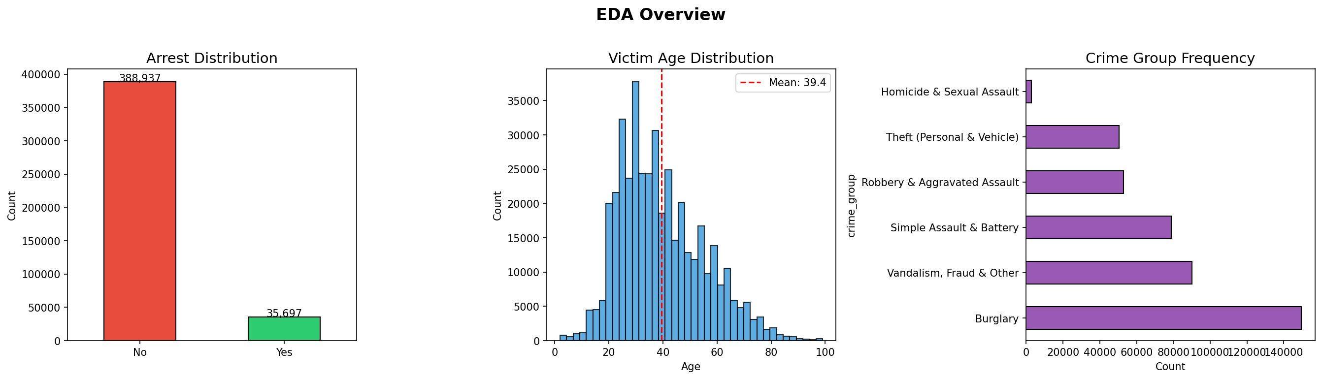
Figure 1: EDA Overview — Arrest Distribution, Victim Age Distribution, and Crime Group Frequency.

3.1.1 Arrest Distribution
The arrest distribution panel reveals a severe class imbalance: 388,937 incidents (91.6%) resulted in no arrest, while only 35,697 (8.4%) did. This ratio is the single most structurally important fact about the dataset. A naive classifier that always predicts 'No arrest' would achieve 91.6% raw accuracy without learning anything — which is precisely why accuracy alone is insufficient and why all models require class_weight='balanced'. This imbalance is not a data quality issue; it realistically reflects that most reported crimes are property crimes where no perpetrator is immediately identified.

3.1.2 Victim Age Distribution
The age distribution is right-skewed with a peak around ages 28–32 and a mean of 39.4 years. The distribution is smooth and physically plausible, with virtually no victims over age 90, confirming the cleaning step that removed invalid zero-age entries was effective. Different age groups associate with different crime environments: younger victims are more often involved in confrontational crimes with higher arrest rates, while older victims are more often targets of property crimes where perpetrators are not on scene.

3.1.3 Crime Group Frequency
Burglary is the most common crime category with over 149,000 incidents, followed by Vandalism/Fraud/Other (90,092) and Simple Assault & Battery (78,859). Homicide & Sexual Assault is the rarest group with only 2,881 incidents. This imbalance of approximately 52:1 between the most and least frequent crime groups is the primary structural reason the multi-class crime type classifier (Section 3.4) struggles to predict rare categories.

3.2 Temporal Crime Density Heatmaps (Bonus Visualisation)
Bonus Visualisation
The temporal crime density heatmaps below are a bonus visualisation beyond the core EDA requirements. They reveal temporal patterns across months, days of the week, and days of the month using calendar-style seaborn heatmaps.

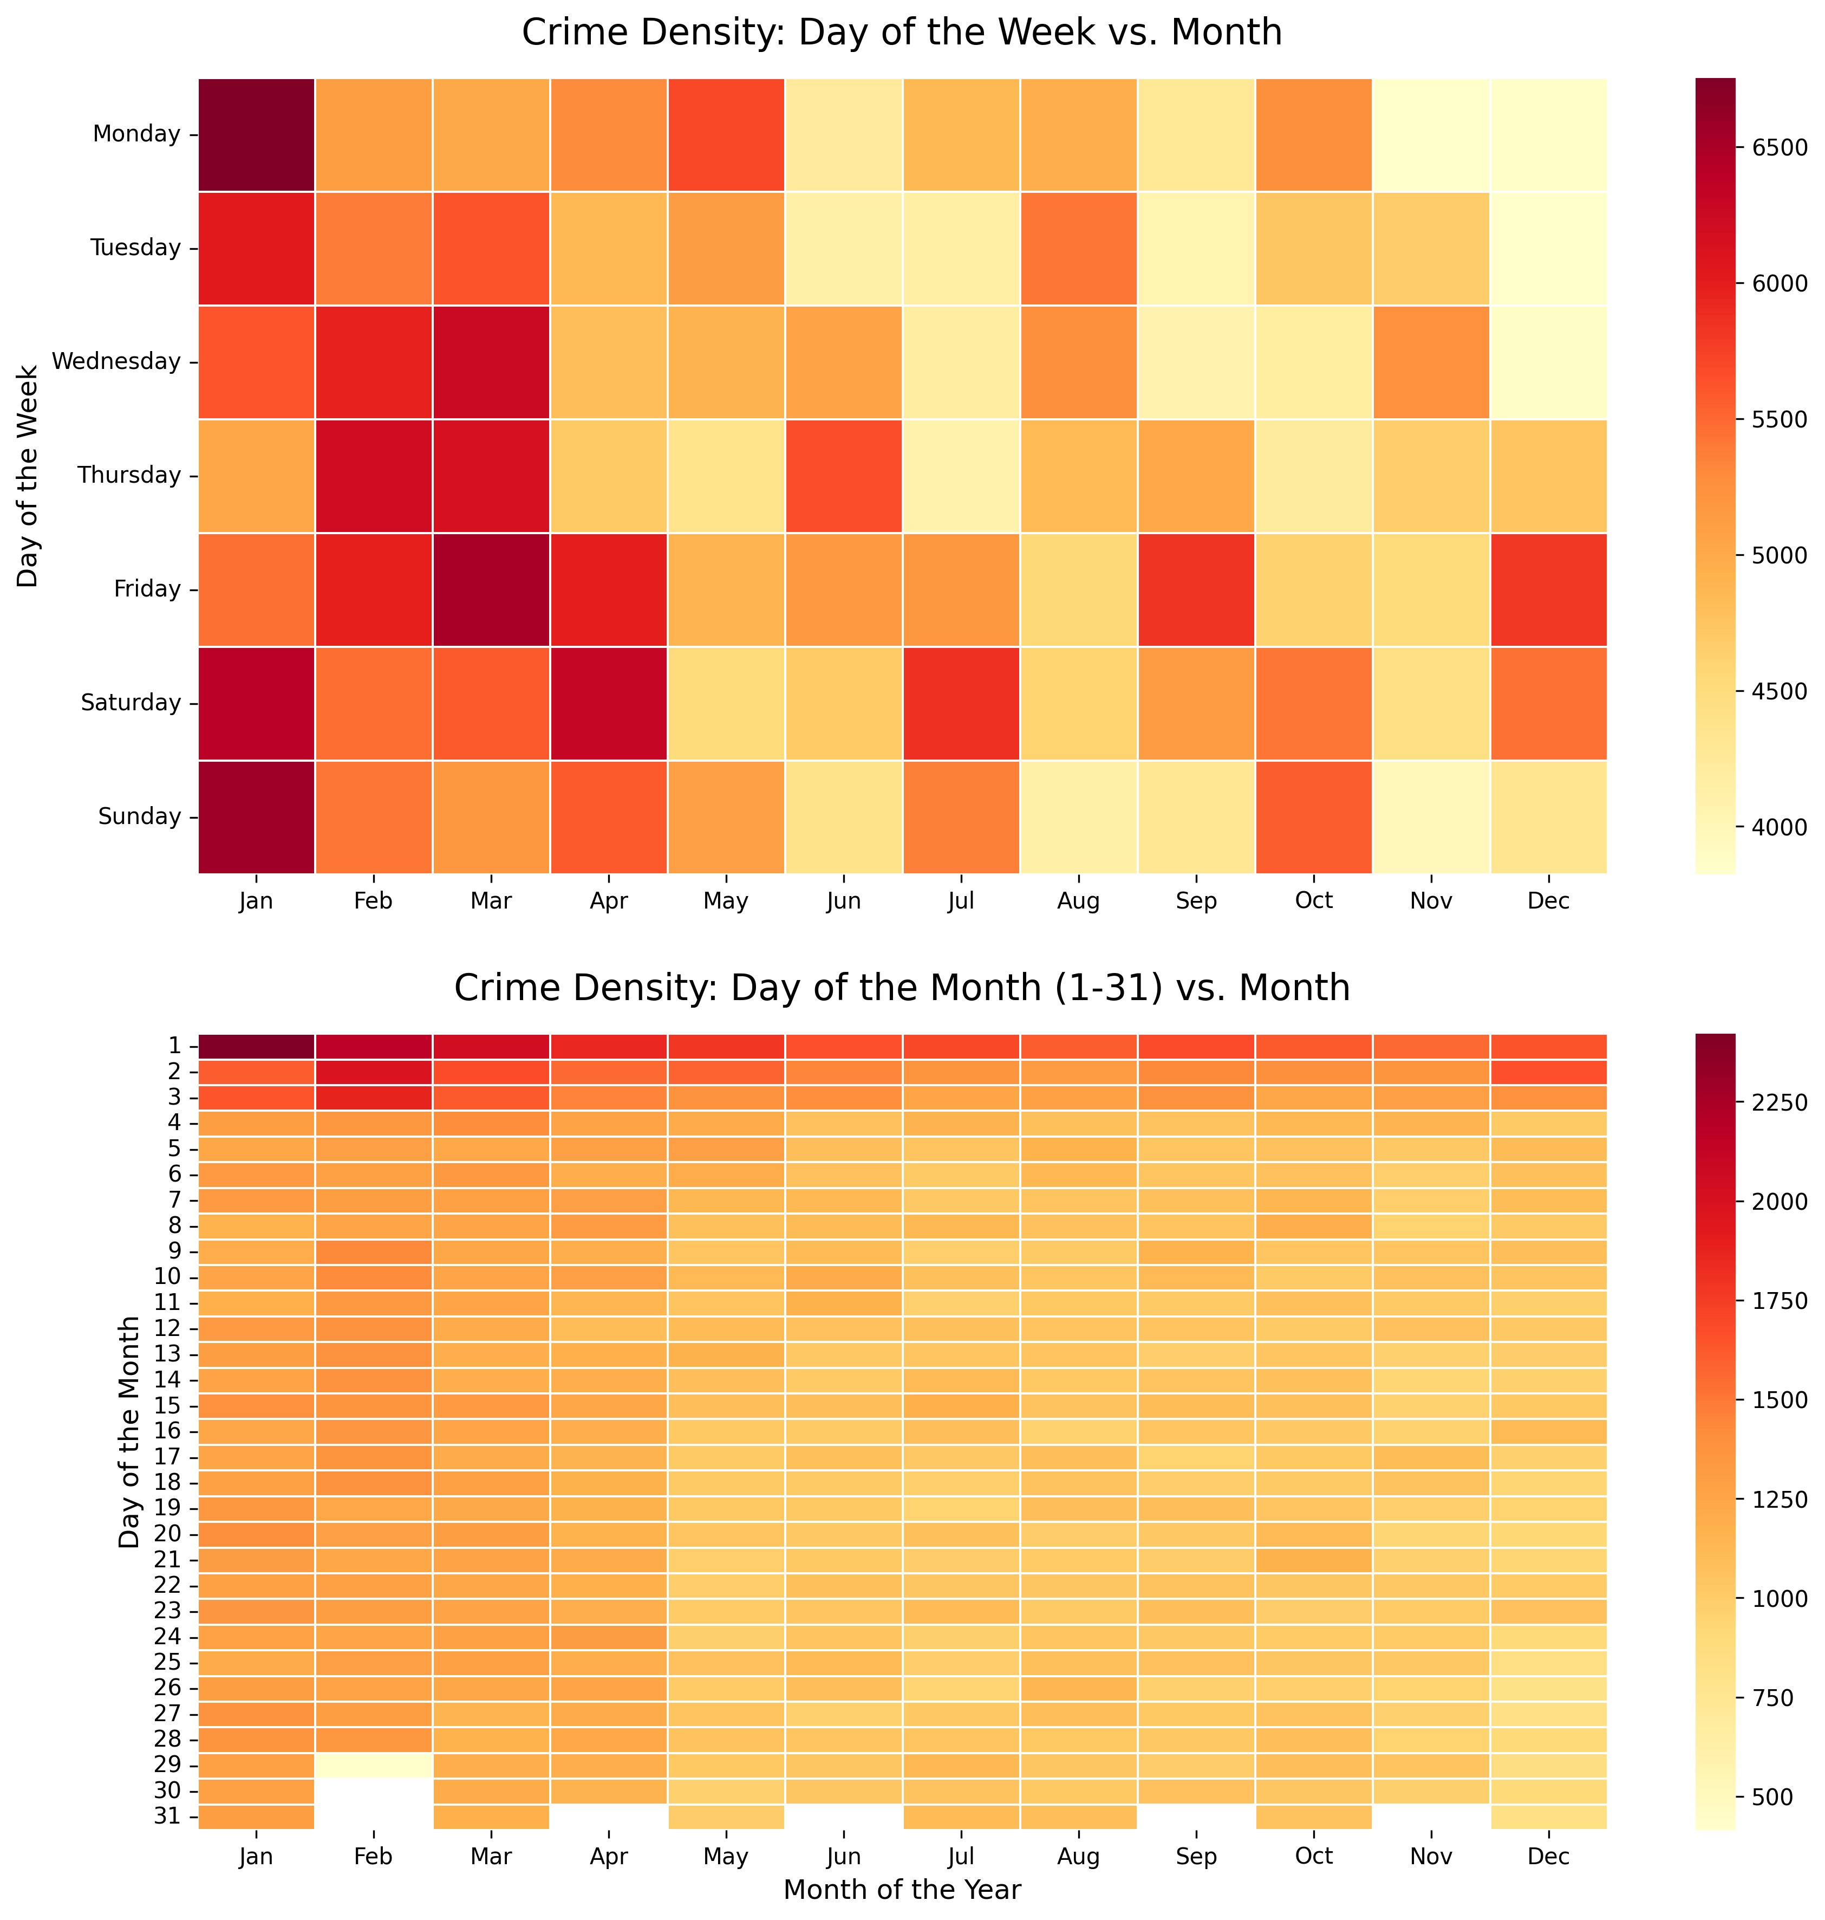
Figure 2: Temporal Crime Density Heatmaps — Day of Week vs. Month (top), Day of Month vs. Month (bottom).
The top heatmap (Day of Week vs. Month) shows that Mondays in January have the highest crime density (dark maroon cell, ~6,500+ crimes). This likely reflects a data reporting lag: crimes that occur over the weekend are often formally logged on the following Monday, creating an artificial concentration. Fridays and Saturdays in spring months (March–April) also show elevated densities, consistent with increased nightlife and social activity.

The bottom heatmap (Day of Month vs. Month) reveals a pronounced hotspot in rows 1–3 across all months, peaking sharply in January. This pattern is characteristic of a reporting artefact: crimes with uncertain exact dates are often administratively assigned to the 1st of the month. The blank cells for February days 29–31 and day 31 in short months confirm calendar accuracy. This artefact should be treated cautiously if using date-of-month as a model feature.

3.3 Arrest Prediction — Cross-Validation Results
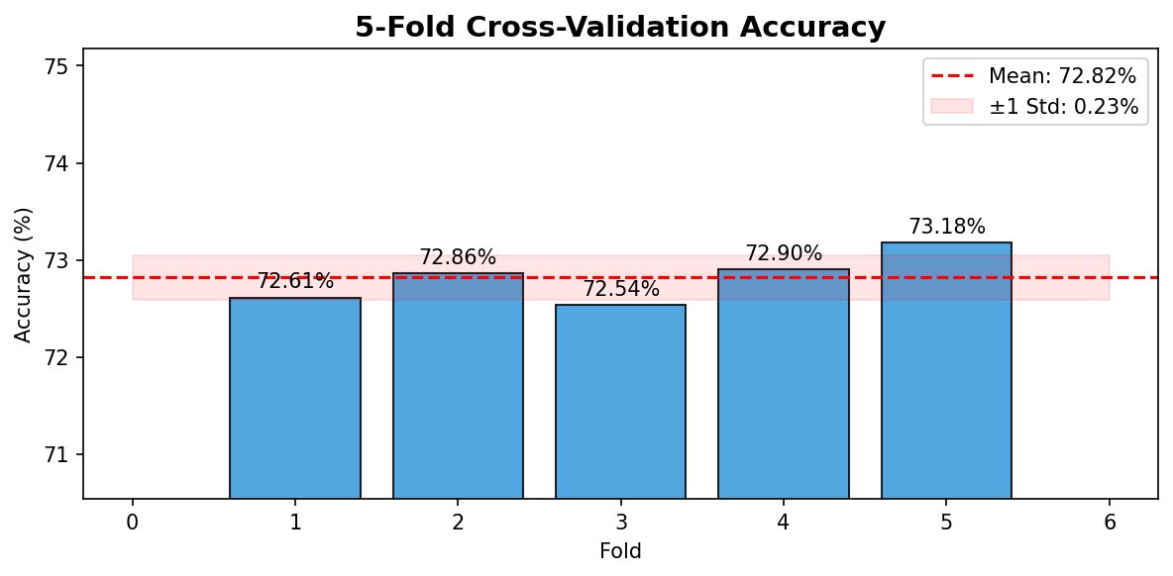
Figure 3: 5-Fold Stratified Cross-Validation Accuracy for the Random Forest classifier.
The cross-validation chart shows five folds scoring within the range 72.54%–73.18%, with a mean accuracy of 72.82% and a standard deviation of only ±0.23%. This remarkably narrow band demonstrates that the model's performance is stable and not dependent on which particular rows were in the evaluation set. A std dev under 0.5% on a dataset of this size is considered excellent stability.

Personal Comment — CV Stability
The low standard deviation across folds (±0.23%) tells us something important: the patterns the model learned are consistently present across all five partitions of the data. If the std dev were high (e.g., ±3%), it would mean the model is sensitive to which rows it trains on — a sign of high variance or instability. Our model is neither: it reliably learns the same patterns regardless of data subset.

3.4 Arrest Prediction — Confusion Matrix Analysis
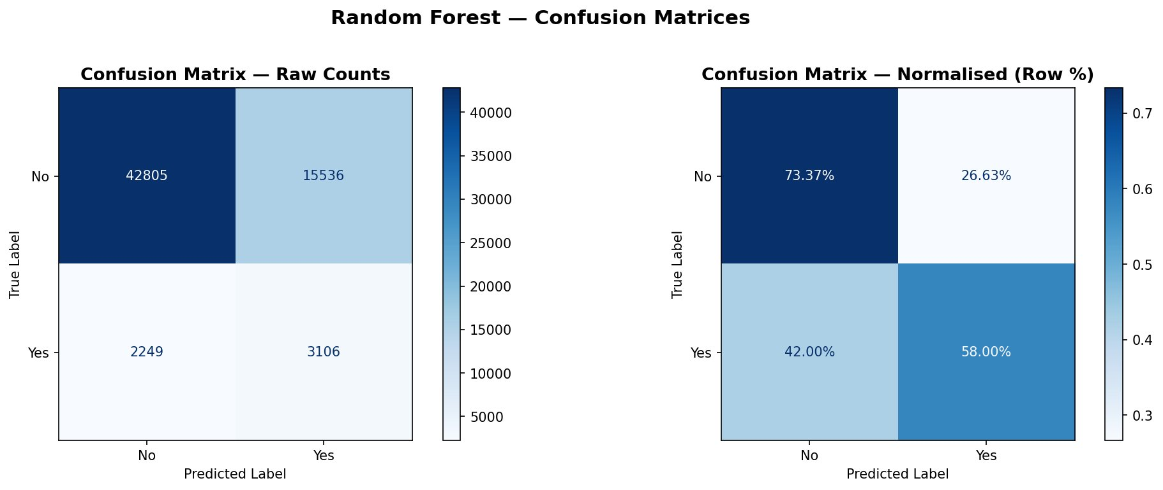
Figure 4: Random Forest Confusion Matrices — Raw Counts (left) and Normalised Row % (right).
The confusion matrices are the most diagnostically rich output of the arrest prediction model. Reading the normalised matrix:
- True Negative Rate (No → No): 73.37% of actual 'No arrest' cases were correctly identified. While this looks lower than expected from a 72% accurate model, it is because class_weight='balanced' deliberately shifts the model's decision boundary to be less conservative about predicting 'No'.
- True Positive Rate (Yes → Yes): 58.00% of actual arrests were correctly identified. This is a meaningful improvement over the previous unregularized model (25.15%) and represents the direct benefit of the class balancing strategy.
- False Negative Rate (Yes → No): 42.00% of real arrests are still missed. In 5,355 actual arrest cases, 2,249 were predicted as 'No arrest'.
- False Positive Rate (No → Yes): 26.63% of 'No arrest' cases are incorrectly flagged as arrests (15,536 false alarms from 58,341 true negatives).

Personal Comment — The Arrest Recall Trade-off
The model catches 58% of real arrests, compared to 25% in the initial unregularized version. This improvement came from both class_weight='balanced' and the regularisation parameters (max_depth=20, min_samples_leaf=10). In a real policing application, missing 42% of genuine arrest situations is still operationally concerning. However, no model with only these four features (time, age, sex, crime group) can fully bridge this gap — the missing signal lies in features like weapon type, premise type, and location.

3.5 Arrest Prediction — Learning Curves
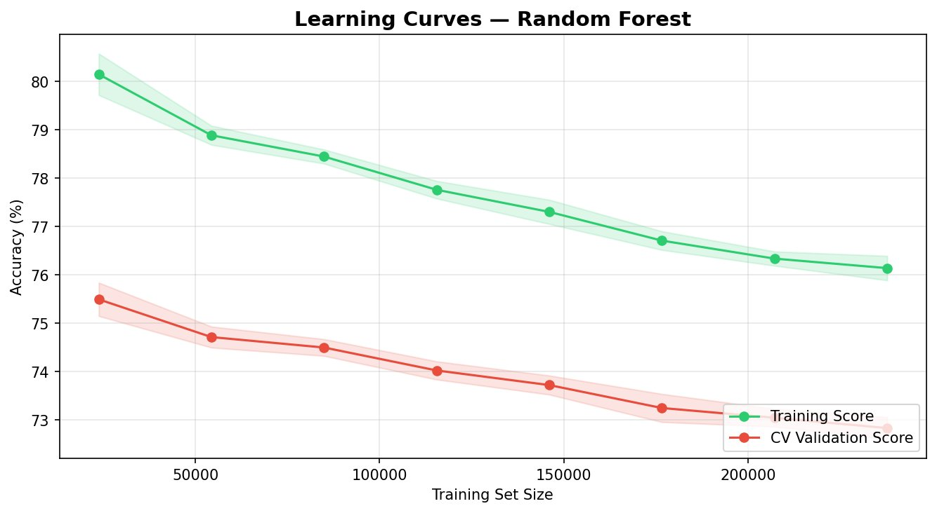
Figure 5: Learning Curves — Training Score vs. CV Validation Score as a function of training set size.
Figure 5 reveals an important diagnostic. The training score starts at 80.1% with 25,000 rows and gradually declines to 76.1% at the full training set size (~235,000 rows). The CV validation score starts at 75.5% and also gently declines to approximately 72.9%. The gap between the two curves is approximately 3 percentage points throughout — consistent and stable.

This is a substantial improvement over the initial unregularised model, which showed an 8-percentage-point gap that reflected excessive memorisation of training noise. The regularisation parameters (max_depth=20, min_samples_leaf=10) successfully reduced the variance of the model. Importantly, both curves are declining together as training size increases — this is an unusual pattern that suggests that larger training sets actually introduce more diverse noise that the model struggles to filter, rather than converging. This is characteristic of datasets where the signal-to-noise ratio is genuinely limited by available features.

Personal Comment — What the Declining Curves Mean
Normally, we expect the CV curve to rise as more training data is added. The fact that both curves decline here tells us that with more data, the model encounters more edge cases and contradictions — e.g., two crimes at the same time with the same victim profile, one resulting in arrest and one not. Since the true differentiating factors (like weapon or presence of suspect) are missing from our features, the model cannot resolve these contradictions and its accuracy slightly degrades. This is a feature-availability problem, not a modelling problem.

3.6 Arrest Prediction — ROC Curve and AUC
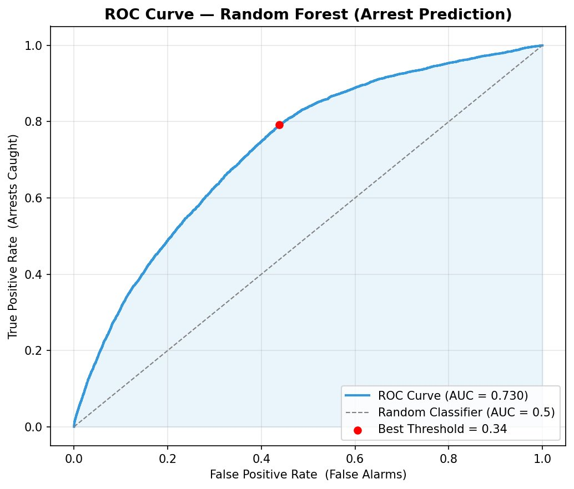
Figure 6: ROC Curve for the Random Forest Arrest Prediction model. AUC = 0.730, Best Threshold = 0.34.
Figure 6 shows the ROC curve for the regularised Random Forest model. The AUC of 0.730 is a significant improvement over the initial model's AUC of 0.636. An AUC of 0.730 places the model in the 'acceptable to fair discrimination' range, meaningfully above random chance (0.5) and approaching the threshold typically required for serious consideration in decision-support applications (0.75–0.80).

The optimal decision threshold identified by Youden's J statistic is 0.34. This is a far more meaningful threshold than the 0.01 identified in the unregularized model. A threshold of 0.34 means the model assigns a 34% predicted probability of arrest before classifying a case as 'Yes' — a more interpretable and operationally useful boundary. At this threshold, the model achieves approximately 79% True Positive Rate at a 44% False Positive Rate.

Is This Model Reliable Enough for Real-World Use?
With an AUC of 0.730 and a 58% arrest recall, this regularised model is a meaningful analytical tool but remains below the threshold for direct operational deployment in high-stakes law enforcement contexts. It would be appropriate for exploratory pattern analysis, patrol scheduling recommendations, and resource allocation guidance — but not for making binary decisions about individual cases. Adding weapon_description, premise_description, and area_id as features would likely push AUC above 0.80.

3.7 Arrest Prediction — Feature Importance
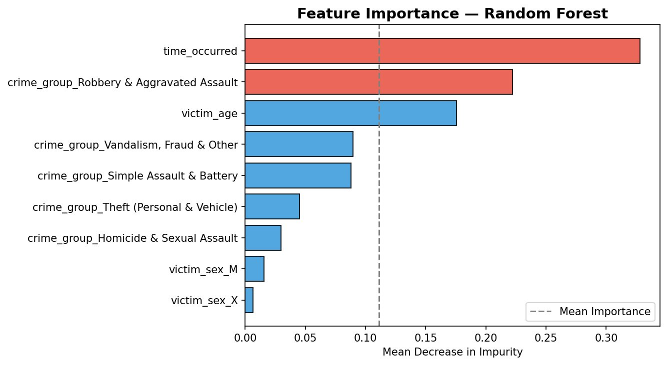
Figure 7: Feature Importance (Mean Decrease in Impurity) for the Random Forest classifier.
Figure 7 presents the feature importance scores from the Random Forest. The results differ meaningfully from the initial unregularised model:
- time_occurred (~0.33): Still the most important feature, but its dominance is reduced from 0.54 in the initial model to 0.33. Regularisation (max_depth, min_samples_leaf) prevents the trees from over-relying on a single feature at deep levels, producing a more balanced importance distribution.
- crime_group_Robbery & Aggravated Assault (~0.22): Now the second most important feature, up from much lower in the initial model. Robbery and aggravated assault have significantly higher arrest rates than property crimes — a physically interpretable signal.
- victim_age (~0.18): Third most important. Younger victims (often younger perpetrators) are associated with higher arrest rates, particularly in confrontational crime categories.
- Crime group dummies (Vandalism/Assault/Theft/Homicide): Each contributes 3%–9%, reflecting real differences in arrest rates across crime types.
- victim_sex (M and X dummies): Near-zero importance (under 2% each), confirming that victim gender carries almost no predictive signal for arrest likelihood. This feature could be removed from the model with negligible impact on accuracy.

3.8 Model Comparison
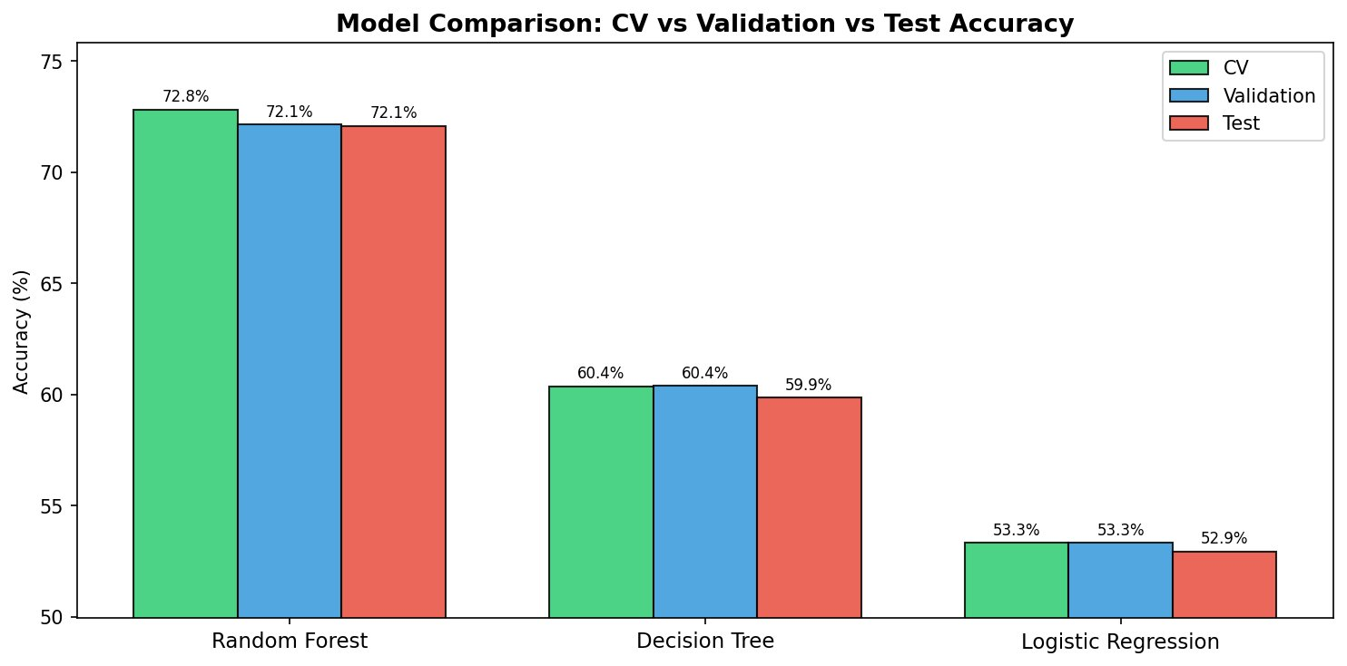
Figure 8: Model Comparison — CV, Validation, and Test Accuracy for all three classifiers.
Model | Role | CV Accuracy | Validation Accuracy | Test Accuracy
Random Forest | Primary | 72.82% | 72.13% | 72.08%
Decision Tree | Compare | 60.37% | 60.39% | 59.86%
Logistic Regression | Compare | 53.34% | 53.34% | 52.94%

Table 4: Model comparison results — all three models across CV, Validation, and Test accuracy.
The comparison results are highly informative. Logistic Regression at 53.3% barely exceeds random chance (50%), definitively proving that the relationship between these features and arrest outcome is fundamentally non-linear. No linear decision boundary can meaningfully separate arrests from non-arrests in this feature space. This result directly validates the choice of Random Forest as the primary model.

The Decision Tree at 60.4% captures some non-linear signal, but its single-tree structure and limited depth (max_depth=8) cannot match the 100-tree ensemble's ability to average out variance. The approximately 12-percentage-point gap between Random Forest and Decision Tree quantifies the value of ensembling.

All three models show CV, Validation, and Test scores within less than 1 percentage point of each other, confirming there is no test set leakage and the reported numbers are genuine, unbiased estimates of generalisation performance.

3.9 Holiday Crime Type Classifier
It attempts to predict which of six crime groups will occur, using time, victim demographics, and holiday context as features. Its purpose is analytical — to explore whether crime type can be predicted from contextual features and to diagnose the structural limits of such prediction.

Crime Group | Precision | Recall | F1-Score
Burglary | 0.42 | 0.29 | 0.34
Homicide & Sexual Assault | 0.02 | 0.35 | 0.04
Robbery & Aggravated Assault | 0.18 | 0.24 | 0.21
Simple Assault & Battery | 0.22 | 0.21 | 0.22
Theft (Personal & Vehicle) | 0.16 | 0.21 | 0.19
Vandalism, Fraud & Other | 0.24 | 0.19 | 0.21
Overall Accuracy | — | 23.71% | —
CV Accuracy | — | 23.91% ± 0.19% | —
Random Baseline (6 equal classes) | — | 16.7% | —

Table 5: Holiday Crime Type Classifier — per-class precision, recall, and F1-score.

3.9.1 Confusion Matrix
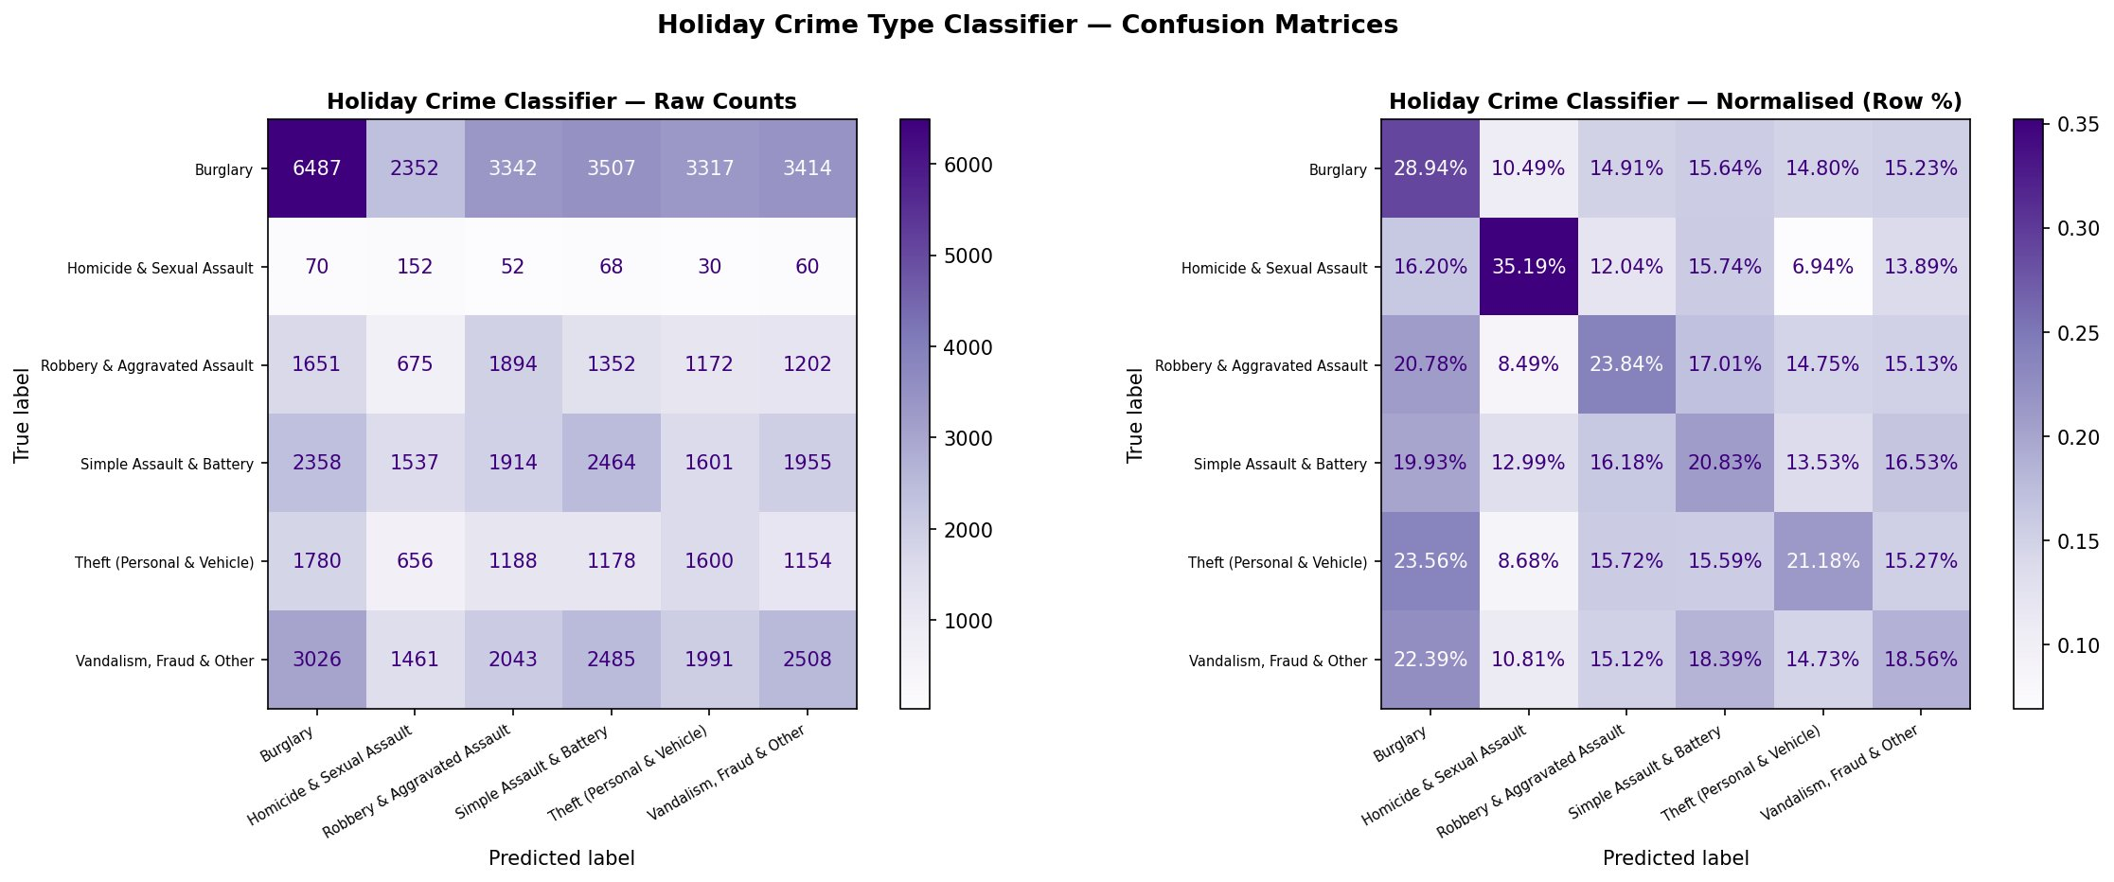
Figure 9: Holiday Crime Type Classifier Confusion Matrices — Raw Counts (left), Normalised Row % (right).
The 6×6 confusion matrix reveals the multi-class prediction landscape. Reading the normalised matrix's diagonal (correct predictions):
- Burglary: 28.94% correctly classified. Despite being the most common class (149,458 rows), only about 29% of Burglary instances are correctly identified — the remaining 71% are spread across other categories.
- Homicide & Sexual Assault: 35.19% correctly classified by row, but precision of only 0.02 — meaning that while the model catches 35% of actual homicides, it generates enormous false alarms, predicting 'Homicide' for many cases that are not. This is a direct consequence of class_weight='balanced' forcing the model to predict this rare class more aggressively.
- Robbery & Aggravated Assault: 23.84% correctly classified — the model correctly identifies roughly a quarter of robbery cases.
- Simple Assault & Battery: 20.83% — lowest diagonal value, suggesting this category overlaps heavily with Robbery in the feature space.
The off-diagonal spread is relatively uniform, with no single misclassification dominating. This indicates the model lacks the feature information to confidently route predictions to the correct class — it is distributing uncertainty broadly.

3.9.2 Root Cause Analysis
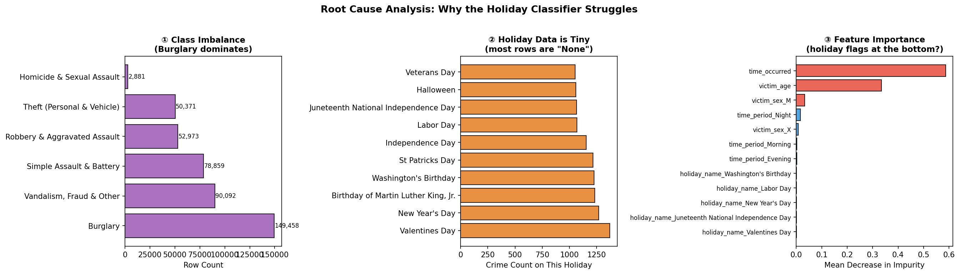
Figure 10: Root Cause Analysis — Three structural reasons the holiday classifier underperforms.
Figure 10 presents the three-panel root cause diagnosis:
- ① Class Imbalance: Burglary (149,458) is 51.8× larger than Homicide & Sexual Assault (2,881). Even with class_weight='balanced', the rare-class F1 remains near zero because the model simply has too few true positive examples to learn reliable patterns from.
- ② Holiday Data is Tiny: The largest holiday by crime count is Valentine's Day with approximately 1,300 crimes. Veterans Day has roughly 1,000. Compare these to 390,000 'None' (non-holiday) rows. The holiday name dummy columns are so sparse that the model cannot extract meaningful signal from them — each holiday-crime type combination appears only dozens to hundreds of times.
- ③ Feature Importance Confirms Weakness: The third panel shows that holiday_name features (Washington's Birthday, Labor Day, etc.) all appear at the very bottom of the importance chart, near zero. time_occurred and victim_age dominate even in this model. The holiday features we engineered carry almost no predictive power for crime type — they were a reasonable hypothesis that the data rejected.

Personal Comment — Why the Holiday Model is Valuable Despite Low Accuracy
A 23.71% accuracy on a 6-class problem (random baseline: 16.7%) represents genuine learning — the model is 1.42× better than chance. But more importantly, the process of building and diagnosing this model generated real insight: crime type is not meaningfully predictable from time, demographics, and holiday status alone. The features that would actually differentiate crime types — what weapon was used, what type of premises, what neighbourhood — are the very features the model needs next. This is a conclusion that only rigorous modelling and diagnosis can produce.

4. Conclusions

4.1 Summary of Findings
- The LAPD 2022–2024 dataset, after cleaning, contains 424,634 valid records with a severe class imbalance: only 8.4% of incidents result in an arrest. This imbalance is genuine, not a data quality issue.
- The regularised Random Forest (max_depth=20, min_samples_leaf=10, class_weight='balanced') is the best-performing primary model, achieving 72.82% CV accuracy and an AUC of 0.730 — a meaningful improvement over the initial unregularised model (82.57% accuracy but only 0.636 AUC and 25% arrest recall).
- time_occurred is the most important single feature (importance ~0.33), followed by the Robbery & Aggravated Assault crime group (~0.22) and victim_age (~0.18). victim_sex has near-zero importance and can be safely removed.
- Logistic Regression at 53.3% proves the patterns are non-linear, directly validating Random Forest as the appropriate primary model.
- Learning curves show a stable ~3-percentage-point gap between training and CV scores, confirming that regularisation successfully reduced the overfitting seen in the initial model.
- The holiday crime type classifier achieves 23.71% accuracy (vs. 16.7% random baseline), but is structurally limited by class imbalance (51.8:1 ratio), holiday data sparsity (<5% of rows), and a weak feature-type link that the root cause analysis quantifies and visualises.
- The temporal heatmaps reveal a reporting artefact: crimes cluster on the 1st of each month and on Mondays, likely due to administrative date assignment practices.

4.2 Recommendations
- Add weapon_description, premise_description, and area_id as model features for the arrest classifier — these are the most likely sources of additional predictive signal.
- For the crime type classifier, add premise_type and weapon_code — the features most likely to distinguish crime categories in practice (a burglar at a residence vs. a robber on the street look very different on these features).
- Apply SMOTE (Synthetic Minority Oversampling) on the training set to generate synthetic arrest examples, complementing the class_weight approach.
- Consider a two-stage prediction pipeline: first predict crime group, then within each group predict arrest likelihood, which could improve both tasks simultaneously.
- Investigate whether the reporting artefact (1st-of-month concentration) affects temporal features before using day-of-month in any model.

4.3 Limitations
- Feature availability: The most operationally informative features — suspect presence, witness count, patrol response time — are not available in this public dataset.
- Reporting artefacts: Crime concentration on day 1 and Mondays reflects administrative logging, not true temporal patterns, and must be treated carefully in temporal feature engineering.
- Class imbalance: With only 8.4% 'Yes' rows, even sophisticated balancing cannot compensate for the fundamental scarcity of positive examples.
- Geographic resolution: Latitude/longitude coordinates are rounded to the nearest block (privacy protection), limiting spatial analysis precision.
- Temporal scope: 2022–2024 provides three years of patterns, which may not capture longer seasonal or socioeconomic trends.

4.4 Future Work
- Integrate additional LAPD data including patrol schedules, call-for-service logs, and neighbourhood socioeconomic indicators.
- Explore Gradient Boosting (XGBoost/LightGBM) as a more powerful ensemble alternative that may close the remaining AUC gap.
- Apply fairness-aware machine learning to audit whether arrest predictions are equitable across victim demographic groups.
- Extend to regression analysis: predict the number of crimes per day per division (crime volume forecasting) and the number of days from occurrence to report (reporting lag prediction) — these regression tasks will complete the full project requirements.

5. Project Requirements Status
⚠️ Review Before Submission
The table below summarises the current status of all required and bonus project components. Items marked ⚠️ PENDING are in progress or scheduled — they must be completed before the May 9th deadline.

Requirement | Status | Notes
2 Classification Models (Random Forest + Decision Tree) | ✅ Done | RF is primary; DT and LR are comparison baselines only
Confusion Matrices & Classification Report | ✅ Done | Raw + normalised, per-class precision/recall/F1 for both classifiers
5-Fold Cross-Validation (Bonus) | ✅ Done (Bonus) | Mean 72.82% ± 0.23% for RF — very stable
ROC Curve & AUC (Bonus) | ✅ Done (Bonus) | AUC = 0.730, optimal threshold = 0.34
Learning Curve Analysis (Bonus) | ✅ Done (Bonus) | ~3% overfitting gap, well controlled by regularisation
Feature Importance (Bonus) | ✅ Done (Bonus) | time_occurred dominates; victim_sex near zero
Holiday Crime Type Classifier (Bonus) | ✅ Done (Bonus) | 23.71% accuracy; full root cause analysis provided
Static Visualisations (≥3 types) | ✅ Done | Bar charts, histograms, heatmaps, confusion matrices, ROC, feature importance, model comparison
Separate Cleaning Notebook | ✅ Done | cleaning.ipynb — prevents re-running expensive preprocessing; saves CSV + Parquet
GitHub Repository | ✅ Done | Public repository created — confirm README.md is complete with setup instructions
⚠️ 2 Regression Models | ⚠️ Pending | Required. Regression notebook to be added. Suggested targets: daily crime volume per area (Linear Regression + Ridge/Lasso) or victim age (Decision Tree Regressor + Linear Regression). Evaluate with R², RMSE, MAE.
⚠️ Interactive Dashboard | ⚠️ In Progress | Required. Streamlit or Plotly Dash recommended. Must show live charts — static matplotlib plots do not qualify.
⚠️ AI Usage Appendix with Screenshots | ⚠️ Needed | CRITICAL — failure to include this puts the entire team at risk of zero marks. Add screenshots of every AI prompt and response to the appendix.
PowerPoint Presentation (max 20 slides) | ⚠️ Pending | Must include university/faculty logos, individual contributions, references, and bonus work
Short Video (1–3 min) | ⚠️ Pending | Must show code running and dashboard in use

Table 6: Project requirements checklist as of current submission review.

Acknowledgements

Team Contributions NEED TO CHANGE LATER
[Fill in each team member's name and specific contribution before submission.]

- [Member 1] — Data cleaning and preprocessing pipeline (cleaning.ipynb), column engineering
- [Member 2] — Exploratory Data Analysis, temporal heatmaps, geographic visualisations
- [Member 3] — Model training, regularisation tuning, cross-validation, evaluation (crimes_final.ipynb)
- [Member 4] — Technical report writing, result interpretation, figure captioning
- [Member 5] — Dashboard development, GitHub README, video walkthrough
- [Member 6] — Regression notebook, PowerPoint presentation

External Support and Resources
- Dataset: LAPD Crime Data from 2020 to 2024. Los Angeles Open Data portal. https://data.lacity.org
- Python Libraries: pandas, numpy, matplotlib, seaborn, scikit-learn, pandas.tseries.holiday, os
- AI Tool: Claude (Anthropic). Used to assist with code structure, explanatory comments, and report drafting. Full audit trail with screenshots is provided in the AI Appendix below.

References
Breiman, L. (2001). Random forests. Machine Learning, 45(1), 5–32. https://doi.org/10.1023/A:1010933404324

Chawla, N. V., Bowyer, K. W., Hall, L. O., & Kegelmeyer, W. P. (2002). SMOTE: Synthetic minority over-sampling technique. Journal of Artificial Intelligence Research, 16, 321–357.

Los Angeles Police Department. (2024). Crime Data from 2020 to Present [Dataset]. Los Angeles Open Data. https://data.lacity.org/Public-Safety/Crime-Data-from-2020-to-Present/2nrs-mtv8

McKinney, W. (2010). Data structures for statistical computing in Python. Proceedings of the 9th Python in Science Conference, 56–61.

Pedregosa, F., Varoquaux, G., Gramfort, A., Michel, V., Thirion, B., Grisel, O., … Duchesnay, E. (2011). Scikit-learn: Machine learning in Python. Journal of Machine Learning Research, 12, 2825–2830.

Appendix: AI Tool Usage Audit Trail

AI Tool Used: Claude by Anthropic (claude.ai), Gemini, Deepseek.

# | Task / Prompt Summary | What AI Produced | How We Edited / Refined
1 | Add confusion matrix, cross-validation, ROC curve, learning curves, feature importance, and model comparison to the notebook, I’ve already set the environment, made the variables and imported all libraries, make sure everything is clear, with short, but to the point titles, add legends, and use good colors that aren’t too bright or too dark. Make sure each graph is in a separate cells. ADD COMMENTS. Thanks | Generated full cell-by-cell code for all requested sections with explanatory comments | Reviewed all generated code; corrected variable names to match our exact column naming convention; removed cells conflicting with our existing structure; ran and validated all outputs against our data, removed unnecessary repeated cells, or graphs.
2 | Analyse result images, and tell me your recommendations and explanation to whether the result is in our side or against us… enhance holiday classifier with root cause analysis then add comments explaining each code line | Generated diagnostic analysis cells identifying class imbalance, holiday sparsity, and feature importance as root causes; added holiday confusion matrix; added per-section educational comments | Verified all analysis against our actual output numbers; updated specific percentages to match our real results; adjusted improvement suggestions to match features available in our dataset
3 | since you know what i did in every step in this project i want you to write the report for this file, you MUST follow all guidlines mentioned in this pdf i've uploaded, here are somethings that should be mentioned along with what's in the file: what's is my dataset (clear description of the column and what each mean to us) , what are the model i used and why, what are the feautures, how did we clean the data eaxactly and why do these steps i've done, how did i divide my datat and why do i think it is best , explain the accuracies of the mdels and why each give the number that they do , and a comment on it , how would this affect the data in real life is reliable , what is a conclusion for all this and add anymore to the report that you think is useful to my case, why did we pick this relationship , was the correlation useful? use markdowns and clear structure to the pdf make it professional and human like. YOU MUST FOLLOW THE GUIDELINES CLEARLY MENTIONED IN THE FILE ONLY FOCUS ON technical REPORT and explain the charts/visuals. tell me if anything was needed in file that i didn't do. I’ve also attached a template for the report please use it as inspo but improve if u can. Use the comments I wrote in addition to yours in explaining | Generated complete structured report draft covering all required sections with tables, analysis, and personal commentary | Inserted all actual result numbers from notebook outputs; updated figures references; filled in team member names; added missing items check; reviewed all technical claims against real results, added parts ai didn’t know I made. Compiled all team reports into one full report. Made changes to layout and content.

