 | 
Entrepreneurial Project Report
FitForge - Medical Services Hub
A unified digital platform connecting Heliopolis residents to doctors, pharmacies, clinics, labs, medicine availability, and live consultations.
Idea Title | FitForge - Medical Services Hub
Prepared by | Amar Hamed Sayed  Omar Ahmed Farag  Mariem Sayed Ahmed  Mostafa Amr Mostafa  Rawan Khaled Hussien  Adel Mahfouz Gouda  Mahmoud hueissen Ali
Instructor / Doctor | [Dr.Sayed Elfar]
Teaching Assistant | Dalia Hany Masry
Course | Entrepreneurship
Date | [9/5/2026]

Better Care. Better Access. Better You.

Report Structure and Guidelines Compliance
This report follows the Entrepreneurial Project Report Guidelines. Items that require exact class information or actual field data are kept as editable placeholders so the final submission can be updated accurately.
Guideline Item | Where It Is Covered
Cover Page | Includes project logo, idea title, student names placeholder, doctor placeholder, and TA name.
1. Project Overview | Project idea, problem, target audience, and value proposition.
2. Market Research & Survey | Survey design, questions, target sample, and analysis template.
3. Persona | Primary user persona based on the canvas: Yasmin Khaled, Heliopolis resident.
4. Mind Map | Visual map and structured explanation of problem, solution, features, users, benefits, technology, implementation, and future expansion.
5. SCAMPER | Before-and-after development table with changed and unchanged items.
6. Business Model Canvas | Nine components of the business model explained in table format.
7. Tool | Logo, web-app explanation, usage flow, technologies, and prototype screen mockups.
8. Conclusion | Future steps and project impact.

Note: Actual survey response numbers and real application screenshots should be added if they become available before submission.

1. Project Overview

Project Idea
FitForge is a medical services hub designed for Heliopolis residents. It brings together doctor search, clinic and lab discovery, medicine availability and prices, live chat consultation, verified medical articles, and a personal health dashboard in one accessible platform.

Problem to Be Solved
People often waste time searching across scattered sources for healthcare information. The main problems identified in the canvas are long waits, manual healthcare processes, medicine unavailability, limited access to specialists, and unreliable online medical information.
- Scattered information about doctors, pharmacies, clinics, and labs.
- Difficulty checking medicine stock and prices before visiting a pharmacy.
- Limited time for users who need fast, local, and trusted healthcare support.
- Low confidence in unverified online health content and informal advice.

Target Audience
- Primary users: Heliopolis residents who need quick access to nearby healthcare services.
- Healthcare partners: private doctors, clinics, pharmacies, labs, diagnostic centers, and medicine supply partners.
- Secondary customers: corporate health programs and health insurance providers looking for localized healthcare access.

Value Proposition
FitForge offers a one-stop, localized healthcare platform that saves time, improves the accuracy of information, and connects users to verified providers. The solution focuses on speed, trust, convenience, and privacy.
Core Value Delivered
- Real-time medicine availability and price comparison.
- Doctor directory organized by location and specialty.
- Live chat consultation between patients and doctors.
- Trusted medical articles and a personal health dashboard.
- Local network focused on Heliopolis, with expansion potential.

2. Market Research and Survey
Because the uploaded materials do not include actual survey responses, this section is prepared as a complete survey design and analysis framework. Replace the placeholders with the collected response count and final percentages after distributing the survey.

Survey Objective
The survey aims to validate whether Heliopolis residents need a unified digital healthcare platform and to identify which features have the highest adoption potential.

Recommended Target Sample
Segment | Suggested Respondents | Purpose
Patients / residents | 30-60 respondents from Heliopolis and nearby areas | Measure demand for nearby search, medicine availability, and consultations.
Doctors / clinics | 5-10 private doctors or clinics | Understand onboarding needs, consultation process, and trust requirements.
Pharmacies | 5-10 local pharmacies | Validate real-time stock and price update feasibility.
Labs / diagnostic centers | 3-5 labs or centers | Assess service listing and booking partnership potential.

Survey Design
Suggested survey type: online Google Form or Microsoft Form, with a mix of multiple choice, Likert scale, and short-answer questions. Recommended survey length: 8-12 questions to maximize completion rate.

Suggested Survey Questions
# | Question | Question Type
1 | How often do you need to search for a doctor, clinic, pharmacy, or lab? | Multiple choice
2 | What is your biggest difficulty when looking for healthcare services? | Multiple choice + Other
3 | Have you ever visited a pharmacy and found the medicine unavailable? | Yes / No
4 | How important is real-time medicine availability and price comparison to you? | Likert scale 1-5
5 | Would you use a live chat consultation with a verified doctor? | Yes / Maybe / No
6 | Which feature would you use most: doctor directory, medicine search, live chat, articles, or dashboard? | Multiple choice
7 | What would make you trust a healthcare platform? | Multiple choice
8 | How much time do you usually spend finding reliable healthcare information? | Multiple choice
9 | Would you prefer a mobile app, website, or both? | Multiple choice
10 | What concerns would stop you from using this service? | Short answer

Response Count and Analysis Template
Number of responses | [Insert actual number of responses]
Survey period | [Insert dates]
Main location | Heliopolis, Cairo
Collection method | Online form + direct interviews

Insight Area | What to Calculate | Expected FitForge Decision
Healthcare search difficulty | Percentage of respondents who struggle to find doctors, clinics, or labs. | Prioritize simple search and filtering by location and specialty.
Medicine availability problem | Percentage who experienced out-of-stock medicine. | Prioritize pharmacy stock updates and price comparison.
Trust and verification | Top reasons users trust a healthcare platform. | Add verified doctors, clinic badges, reviews, and privacy messaging.
Preferred platform | Website vs mobile app preference. | Launch responsive web MVP first, then mobile app in future expansion.
Live consultation demand | Percentage willing to use chat consultation. | Develop secure chat and doctor response workflows.

Expected Key Findings Based on the Canvas
- Users value quick access to trusted doctors, medicines, and consultations in their neighborhood.
- Real-time availability and verified information are likely to be stronger differentiators than general health content alone.
- A localized Heliopolis launch can build trust before expansion to other regions.

3. Persona
The primary persona is based on the project canvas and represents a busy professional in Heliopolis who prefers fast, reliable, and verified digital healthcare services.

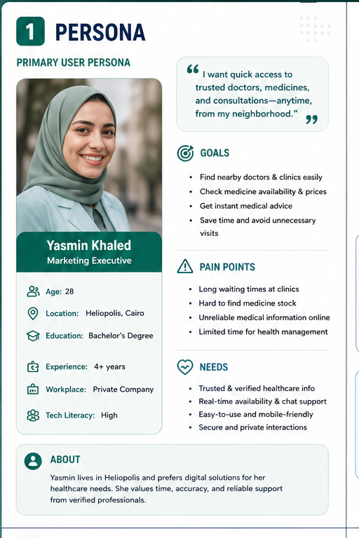

Figure 1. Primary persona visual from the FitForge canvas.
Name | Yasmin Khaled
Age | 28
Location | Heliopolis, Cairo
Occupation | Marketing Executive at a private company
Education | Bachelor's Degree
Tech literacy | High

Persona Goals
- Find nearby doctors and clinics easily.
- Check medicine availability and prices before going out.
- Get instant medical advice from a trusted source.
- Save time and avoid unnecessary visits.

Pain Points
- Long waiting times at clinics.
- Hard to find medicine stock information.
- Unreliable medical information online.
- Limited time for personal health management.

Needs and Behaviors
- Needs verified healthcare information, real-time availability, chat support, and privacy.
- Prefers mobile-friendly and simple digital solutions.
- Chooses platforms that reduce stress, uncertainty, and repeated phone calls.

4. Mind Map
The mind map organizes the FitForge concept around the central idea of a local medical services hub. It connects the problem, solution, features, users, benefits, technology, implementation plan, and future expansion.

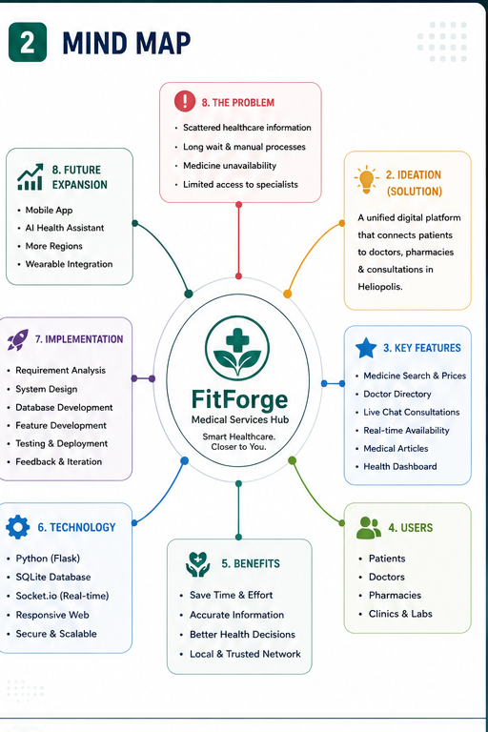

Figure 2. Mind map visual from the FitForge canvas.

Mind Map Branch | Explanation
Problem | Scattered healthcare information, long waits, manual processes, medicine unavailability, and limited specialist access.
Ideation / Solution | A unified digital platform connecting patients to doctors, pharmacies, and consultations in Heliopolis.
Key Features | Medicine search and prices, doctor directory, live chat, availability, articles, and dashboard.
Users | Patients, doctors, pharmacies, clinics, and labs.
Benefits | Saves time and effort, improves information accuracy, supports better health decisions, and builds a trusted local network.
Technology | Python Flask, SQLite database, Socket.IO for real-time features, responsive web design, secure and scalable architecture.
Implementation | Requirement analysis, system design, database development, feature development, testing, deployment, and feedback.
Future Expansion | Mobile app, AI health assistant, more regions, and wearable integration.

5. SCAMPER Analysis
SCAMPER shows how the original idea changed into a stronger, more localized healthcare platform.

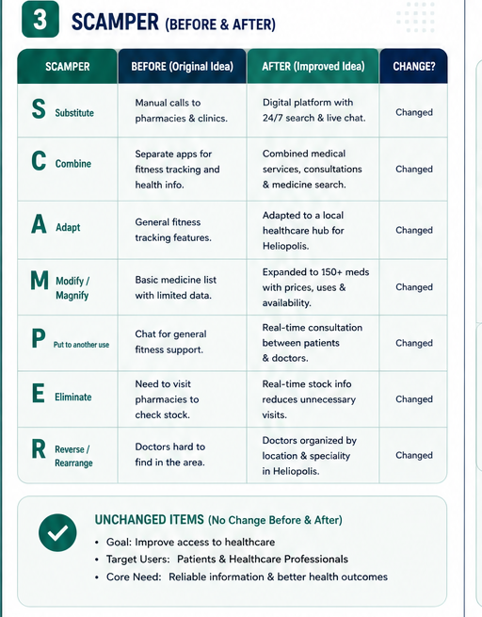

Figure 3. SCAMPER before-and-after visual from the canvas.

SCAMPER | Before | After | Change?
Substitute | Manual calls to pharmacies and clinics. | Digital platform with 24/7 search and live chat. | Changed
Combine | Separate apps for fitness tracking and health information. | Combined medical services, consultations, and medicine search. | Changed
Adapt | General fitness tracking features. | Adapted to a local healthcare hub for Heliopolis. | Changed
Modify / Magnify | Basic medicine list with limited data. | Expanded to 150+ medicines with prices, uses, and availability. | Changed
Put to another use | Chat for general fitness support. | Real-time consultation between patients and doctors. | Changed
Eliminate | Need to visit pharmacies to check stock. | Real-time stock information reduces unnecessary visits. | Changed
Reverse / Rearrange | Doctors are hard to find in the area. | Doctors are organized by location and specialty in Heliopolis. | Changed

Unchanged Items
- Goal: improve access to healthcare.
- Target users: patients and healthcare professionals.
- Core need: reliable information and better health outcomes.

6. Business Model Canvas
The business model is based on connecting local healthcare demand with verified healthcare supply. The model combines user convenience with partner visibility and recurring revenue opportunities.
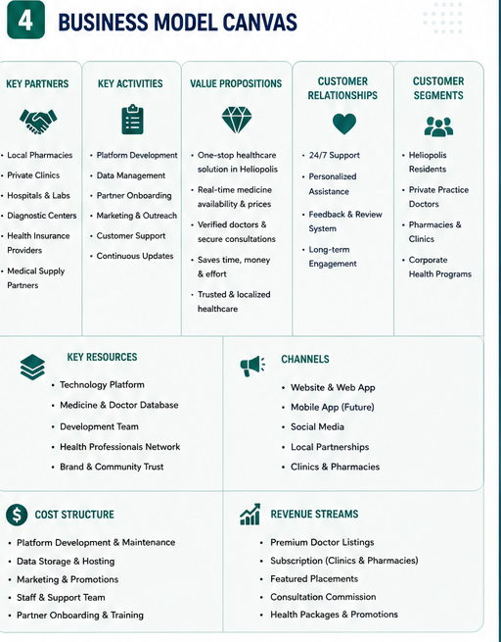

Figure 4. Business Model Canvas visual from the FitForge canvas.

Component | FitForge Business Model
Customer Segments | Heliopolis residents, private practice doctors, pharmacies and clinics, corporate health programs.
Value Propositions | One-stop healthcare solution, real-time medicine availability and prices, verified doctors and secure consultations, saves time and money, trusted localized healthcare.
Channels | Website and web app, future mobile app, social media, local partnerships, clinics and pharmacies.
Customer Relationships | 24/7 support, personalized assistance, feedback and review system, long-term engagement.
Revenue Streams | Premium doctor listings, subscriptions for clinics and pharmacies, featured placements, consultation commission, health packages and promotions.
Key Resources | Technology platform, medicine and doctor database, development team, health professionals network, brand and community trust.
Key Activities | Platform development, data management, partner onboarding, marketing and outreach, customer support, continuous updates.
Key Partners | Local pharmacies, private clinics, hospitals and labs, diagnostic centers, health insurance providers, medical supply partners.
Cost Structure | Platform development and maintenance, data storage and hosting, marketing and promotions, staff and support team, partner onboarding and training.

7. Tool / Prototype
The FitForge tool is designed as a responsive web application. The first version focuses on the web because it is faster to launch, easier to access from different devices, and suitable for testing the core healthcare workflow before building the mobile app.

Figure 5. FitForge tool logo.

Technology Stack
Layer | Technology / Approach | Purpose
Backend | Python Flask | Handles web routes, service logic, and application workflow.
Database | SQLite | Stores doctors, medicines, availability, users, and service information for the MVP.
Real-time | Socket.IO | Supports live chat and real-time communication.
Frontend | Responsive web templates, CSS, JavaScript | Makes the platform easy to use from desktop and mobile browsers.
Security | Private interactions and verified information | Protects user trust and supports safe healthcare communication.

Main User Flow
- User opens FitForge and searches for a doctor, medicine, clinic, lab, or health article.
- The platform filters results by location, specialty, availability, or price.
- The user views trusted details and chooses the best option.
- For consultation needs, the user opens live chat with a verified healthcare professional.
- The dashboard saves useful information and improves future recommendations.

Prototype Screen Mockups
The following mockups illustrate the expected tool screens. Replace them with screenshots from the running web app if actual screenshots are required for final submission.

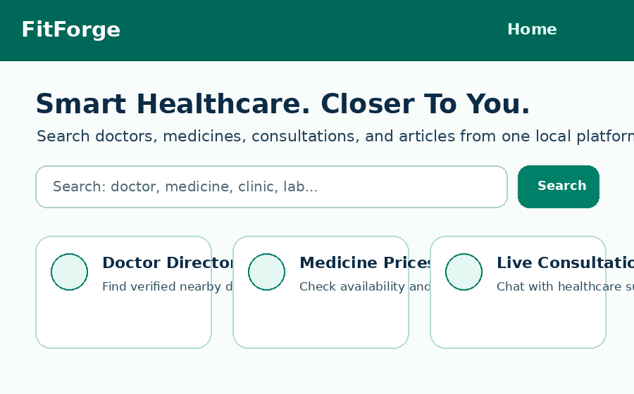
Home and search entry point
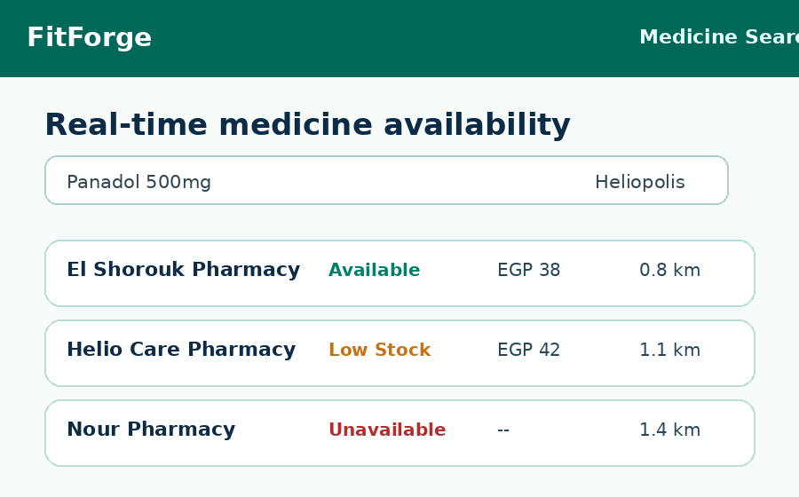
Medicine availability and price search

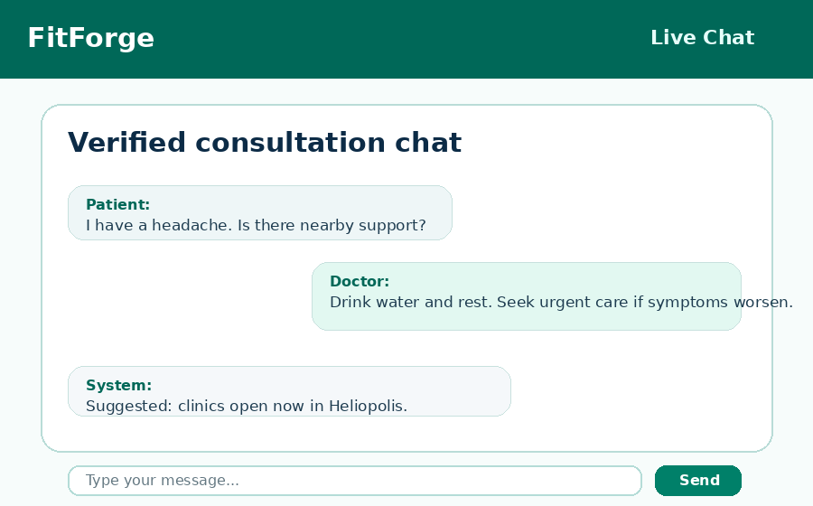
Live consultation chat

8. Conclusion and Future Steps
FitForge addresses a clear local healthcare access problem by combining verified healthcare information, real-time medicine availability, doctor search, and live consultation in one platform. The project is especially relevant for busy Heliopolis residents who need fast, trusted, and nearby medical support.

Project Impact
- Reduces time spent calling or visiting multiple providers.
- Improves trust through verified doctors, partners, and structured information.
- Supports better health decisions by making availability and prices visible.
- Creates a scalable model that can expand beyond Heliopolis after validation.

Future Steps

Phase | Action | Expected Outcome
1. Validate | Collect survey responses and interview pharmacies, doctors, and clinics. | Confirm strongest customer needs and partner interest.
2. Build MVP | Develop search, listings, medicine database, and live chat. | Launch a functional web version for Heliopolis.
3. Test | Run usability tests with patients and partner providers. | Improve interface, data accuracy, and support process.
4. Launch | Onboard initial pharmacies, clinics, doctors, and labs. | Create a trusted local healthcare network.
5. Expand | Add mobile app, AI health assistant, more regions, and wearable integration. | Scale the platform and increase long-term value.

Final Recommendation
The project should launch as a localized responsive web MVP in Heliopolis. The team should prioritize verified provider onboarding, accurate medicine stock data, and a simple user experience before expanding into advanced AI features or other regions.

Appendix A: Full Project Canvas
The full canvas below was used to prepare the report sections: persona, mind map, SCAMPER, business model canvas, brand direction, and tool positioning.

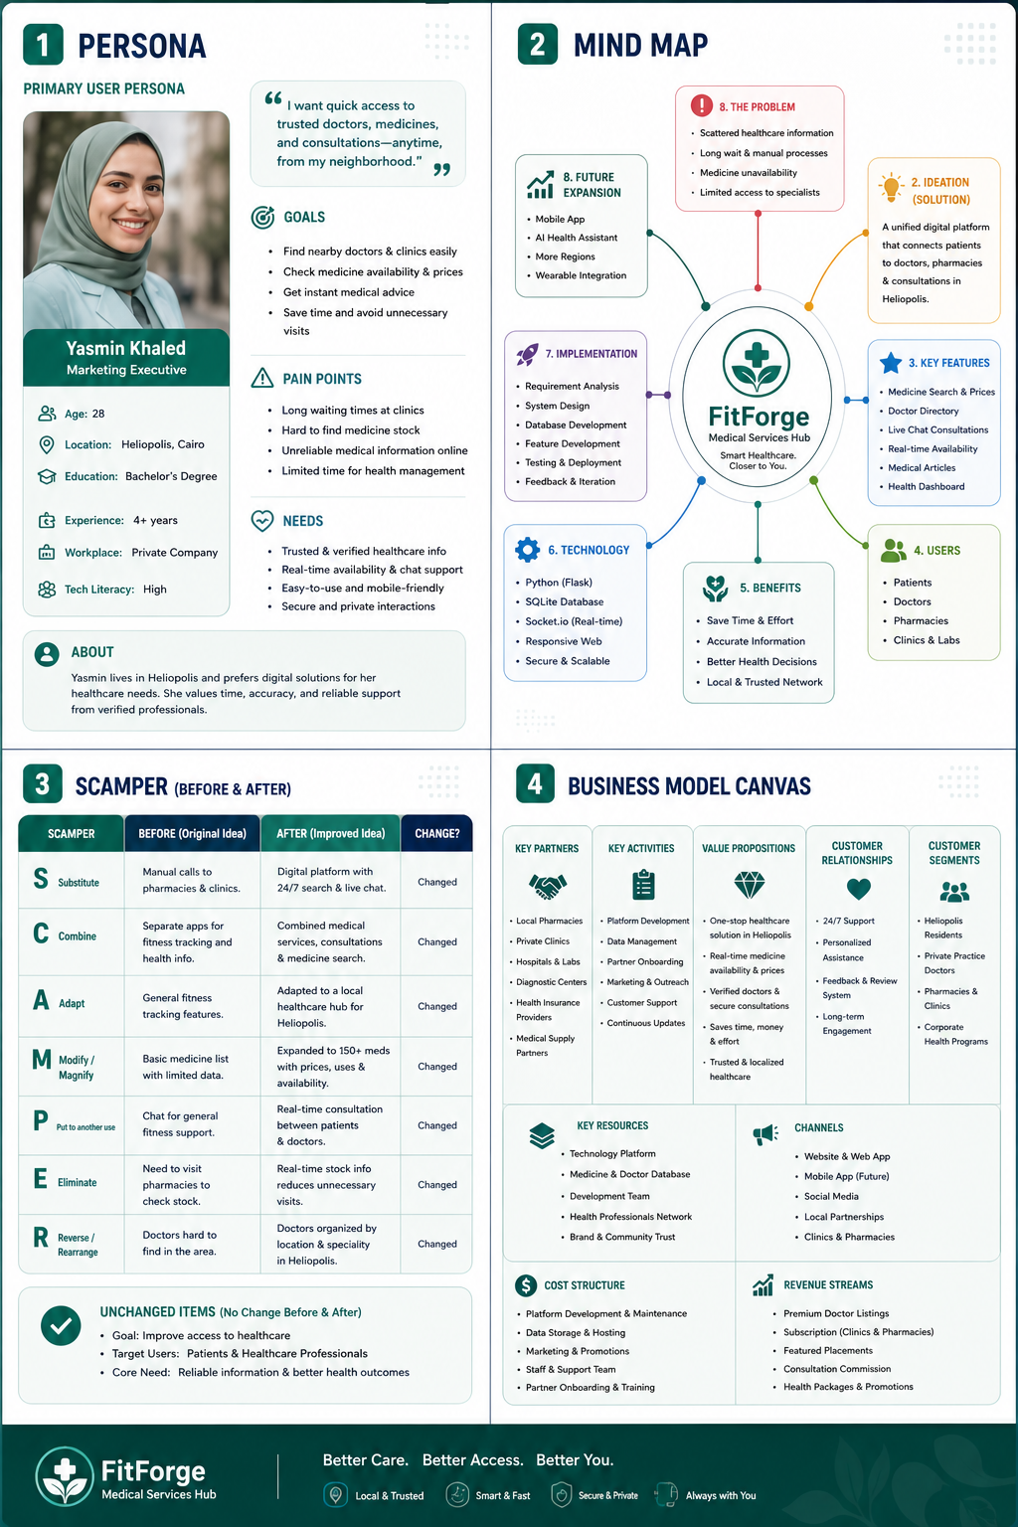
Figure 6. Full FitForge project canvas.

