

Please add your service request name here:
Server Request

Service Card
V.02

Service Name: Server Request
Service Request: Server Creation Request
Service Description: This service enables authorized users to submit requests for new server provisioning, including specifying server location, environment, type, and hardware specifications.
The server request follows a multi-step approval process: Requestor Manager Approval, Business Owner Approval, Enterprise Architecture (EA) Approval, Database Team Approval (if DB server), Network Team IP/Port Assignment, System Team Server Creation, and Monitoring Team Setup (if Production)..

Work Flow
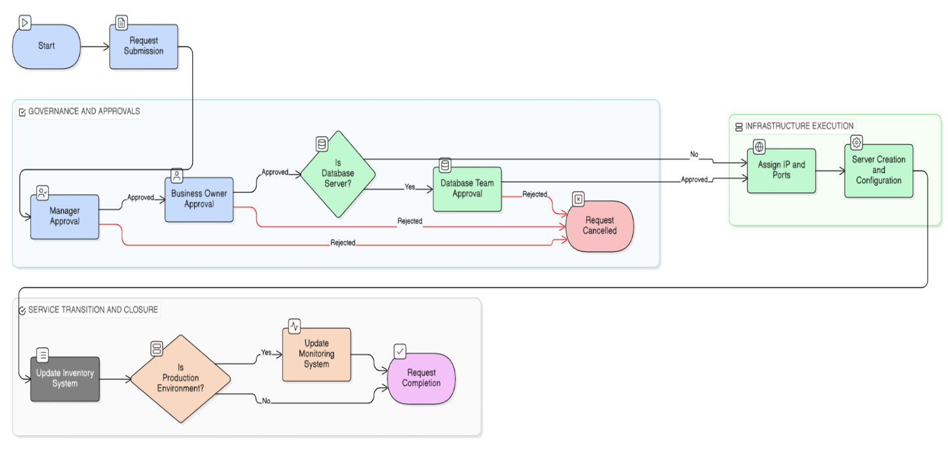

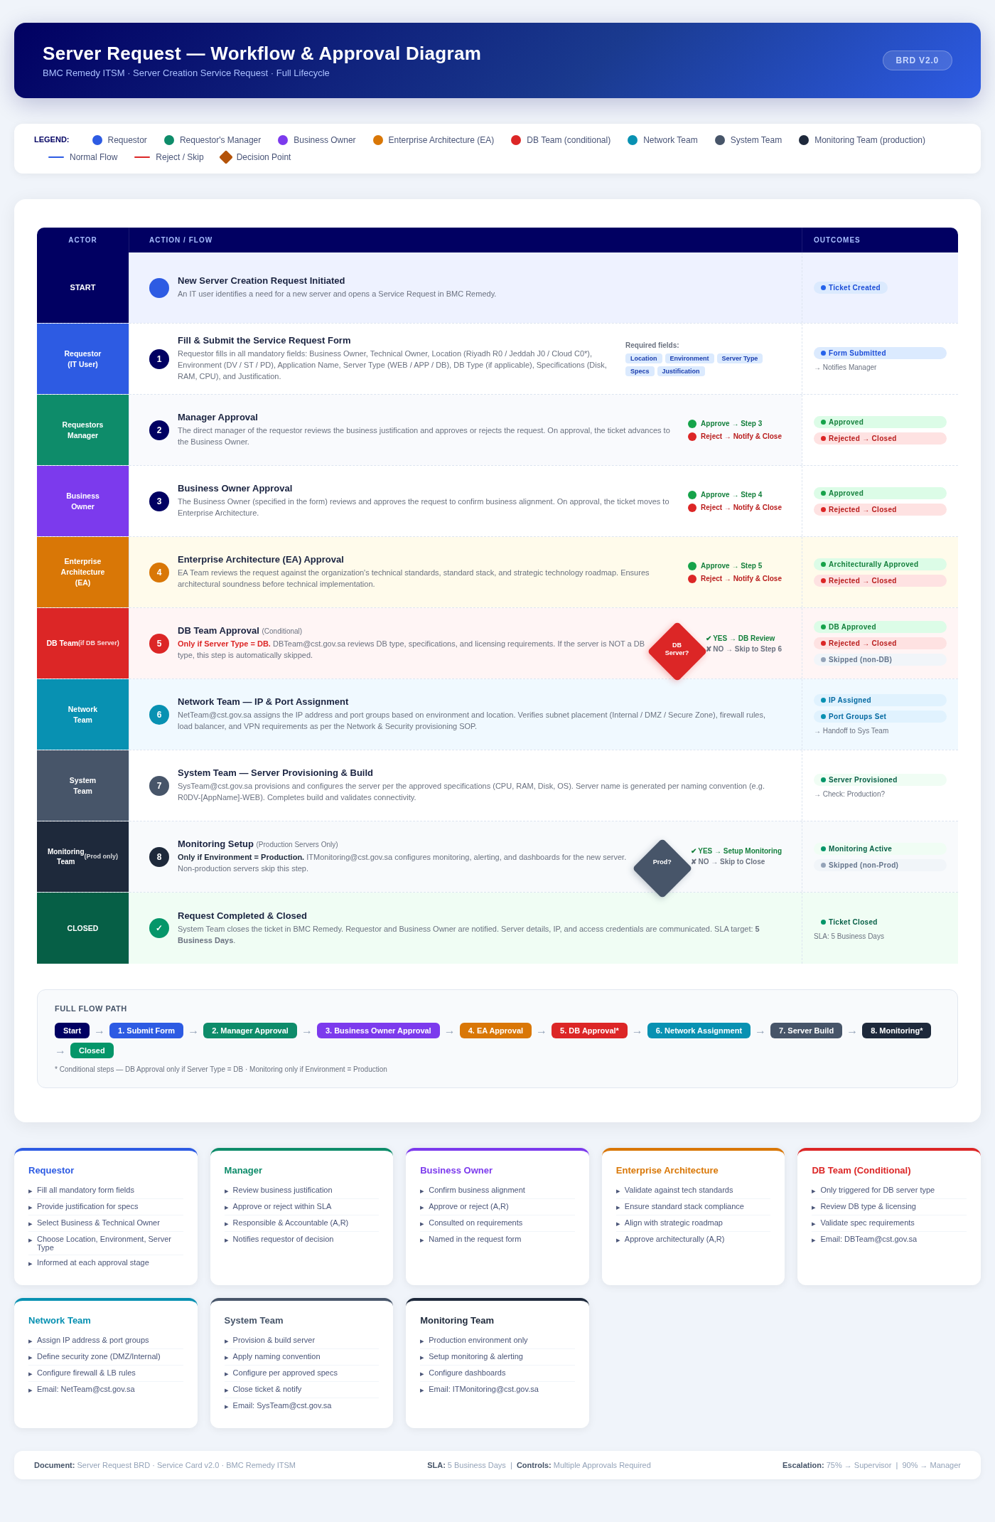

Form Template
# | Field Name (Arabic and English) | Field Type | Field Initial Values | السؤال بالعربية | Mandatory | Dependency
1 | Business/Project Owner Details  (Name, Email, Phone)  تفاصيل مالك المشروع | Text (AD Browse) | Auto-populated from Active Directory / Exchange after selecting the name | تفاصيل مالك المشروع | X
2 | Technical/IT Owner Details  (Name, Email, Phone)  تفاصيل المالك التقني | Text (AD Browse) | Auto-populated from Active Directory / Exchange after selecting the name | تفاصيل المالك التقني | X
3 | Location  الموقع | Menu | Riyadh (R0) / Jeddah (J0) / Cloud (C0) *Production* | الموقع | X
4 | Server Environment  بيئة الخادم | Menu | Development (DV) / Staging (ST) / Production (PD) | بيئة الخادم | X
5 | Application/Service Name  اسم التطبيق/الخدمة | Text | Maximum 15 characters | اسم التطبيق / الخدمة | X
6 | Type of Server  نوع الخادم | Menu | Web Server (WEB) / Application Server (APP) / Database Server (DB) | نوع الخادم | X
7 | Database Type  نوع قاعدة البيانات | Menu | MSSQL / Oracle / PostgreSQL / MongoDB / MySQL / Other | نوع قاعدة البيانات | X | 6 (Database Server)
8 | Server Specifications  (Hard Disk, Memory, CPU)  مواصفات الخادم | Multiple Fields | Hard Disk: 80 GB (Default)  Server Memory: 8 GB (Default)  Server CPU: 2 CPUs (Default)  Number of Disks: [Input]  Disk Size per disk: [Input GB] | مواصفات الخادم | X
9 | Justification  المبررات | Long Text | Provide justification for any custom specifications or configurations | المبررات | X

RACI
# | STEP | Requester | Business Owner | Requester Manager | System Team / Network / DB Team / EA Team
1 | Fill out the form and Submit the request | A,R | I | - | -
2 | Manager Approval | I | - | A,R | -
3 | Business Owner Approval | I | A,R | - | -
4 | Enterprise Architecture (EA) Approval | I | - | - | A,R
5 | Network / System Team - Server Provisioning | I | - | - | A,R
6 | Monitoring Team Setup (Production servers only) | I | - | - | A,R

Support Group
# | Support Group | Names | Emails
1 | System Team |  | SysTeam@cst.gov.sa
 | Network Team |  | NetTeam@cst.gov.sa
 | Monitoring Team |  | ITMonitoring@cst.gov.sa
 | DC Team |  | DCTeam@cst.gov.sa

SLA and Escalation Table
Service | Requester(s) | Pre-Requisites | Support group | Controls | Duration | Approval Notification  Who | Approval Notification  When
Server Request | IT Users | - | System Team | Multiple Approvals Required | 5BD | Notification 1- System Team supervisor  Notification 2- System Team Manager | Notification1-75%  Notification 2-90%

Appendix:
KPIs | Formula | Target | Responsibility | Frequency measurement
% Of request  Completed within agreed time | # Count  # Of request within target time /Total # of requests | 95% of request within target time | System Team | Monthly

