Heart Disease Project

Table of Figures and tables:

Name | Page
Figure 1(hist and box plots before cleaning 2) | 3
Figure 2(hist and box plots before cleaning 1) | 3
Figure 3 (hist and box plots before cleaning 3) | 3
Figure 4(target pareto chart) | 4
Figure 5 (heat map) | 4
Figure 6(hist and box plots after cleaning 1) | 5
Figure 7(5 Model ROC) | 13
Table 1(data overview) | 2
Table 2(Final Evaluation) | 12

Abstract :
​ The research uses the CRISP-DM model on a set of 918 patients with a multi-step process of feature selection that helps to reduce clinical attributes into five important binary features (Sex_F, Sex_M, ChestPainType_ASY, ExerciseAngina_N, ExerciseAngina_Y). Five machine learning models were selected based on their performance during Cross-Validation testing, where the most successful models include Categorical NB, Bagging, and Random Forest with the accuracy rate of 79.63% (F1-score: 81.86%). Nevertheless, the regularized single Decision Tree model became a better choice because it obtained the highest Recall of 84.45%, along with a high AUC of 0.8219.
Introduction:
One of the diseases that cause death in human beings is heart disease. It is therefore necessary to predict the likelihood of someone suffering from this disease and take appropriate measures to save their life. The main objective of this project is to develop an intelligent machine learning model that will be able to predict whether the patient is suffering from heart disease or not.
Stakeholders:
Primary: The cardiologist and clinicians who will require an early warning signal about patients.
Secondary: Hospital management and health insurance companies for risk stratification.
Tertiary: The patients themselves, who are the direct beneficiaries of the predictive models.
Background:
There are many types of heart disease that affect the functioning of the human heart. Some of the major risk factors associated with heart disease are the age of the patient, their blood pressure, total cholesterol, maximum heart rate, and the ST-segment depression level (Oldpeak). This study utilizes the data collected from five different datasets containing a total of 918 patient records.

Literature review:
In another study, the XGBoost model was utilized in predicting heart disease, and its recall score stood at 90.3% compared to our model’s score, which was lower by 7%. The variables identified as being the key contributors to our model include ST_Slope, Age, Oldpeak, Cholesterol, and ChestPainType. Our model is simpler as compared to the model used in the other study as we did not use complex algorithms in making predictions.
Data Quality Report:
- Data Dictionary and Overview
The dataset contains 918 rows and 12 columns no missing values and no duplicate rows were detected at the outset
Table 1(data overview)
Variable
  Type
  Description
Age | Numeric
  Patient age in years (28–77)
RestingBP | Numeric | Resting blood pressure in mmHg
Cholesterol | Numeric
  Serum cholesterol in mg/dL
MaxHR | Numeric | Maximum heart rate achieved
Oldpeak |  | ST depression induced by exercise
  Numeric
Sex |  | M / F
  Categorical
ChestPainType |  | ASY, ATA, NAP, TA
  Categorical
FastingBS |  | under (≤120 mg/dL) / uppove (>120 mg/dL)
  Categorical
RestingECG |  | Normal, LVH, ST
  Categorical
ExerciseAngina |  | Y / N
  Categorical
ST_Slope | Ordinal
  Flat, Up, Down
HeartDisease | Target | diseased / good

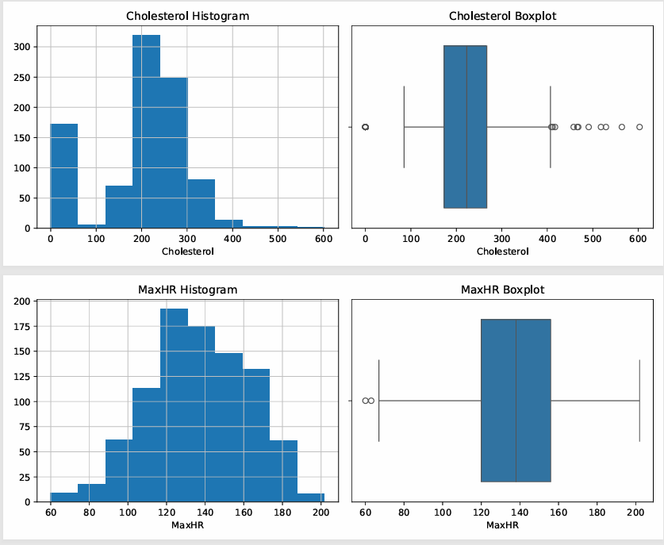
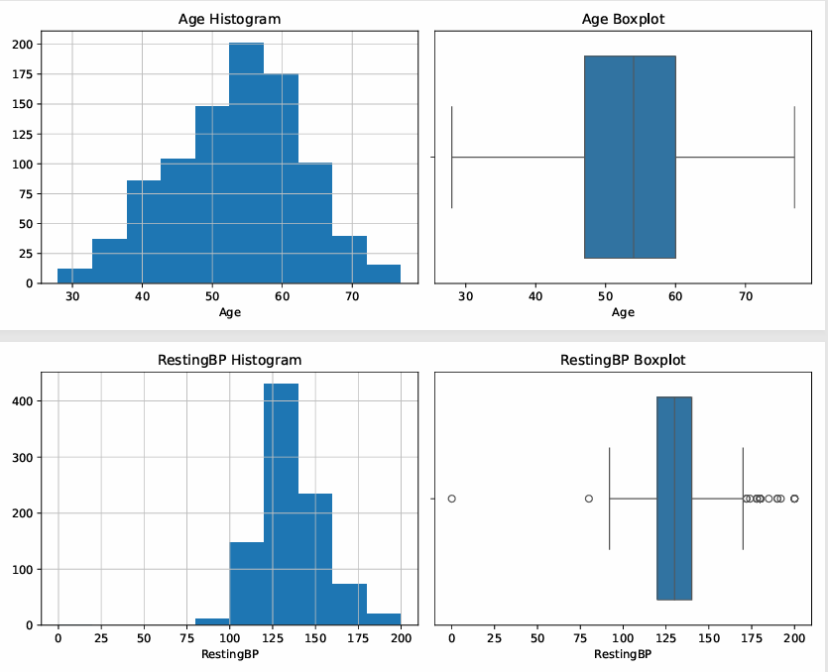
- Critical Data Quality Issues:
Figure 1(hist and box plots before cleaning 2)
Figure 2(hist and box plots before cleaning 1)
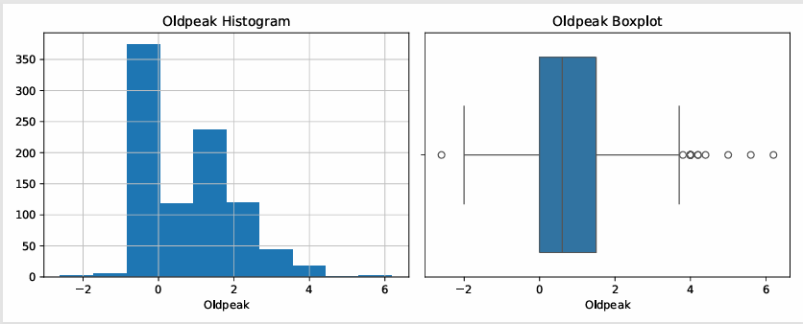
Figure 3 (hist and box plots before cleaning 3)

RestingBP = 0 is physiological impossibility. The initial graph indicated that there was an anomaly of sorts in the form of a spurt around zero along with the distribution centred around 130 mm Hg, proving that these data points are not valid but erroneous ones represented by 0s.
Cholesterol = 0, again, clinically impossible. The initial graph indicated that the shape was bimodal, with 170 data points around 0 and another normal distribution centred at around 200-250 mg/dL.
Additional Significant Raw Results:
- Oldpeak: exhibited marked right-skewness (range for raw scores: -2.6 to 6.2), with a cluster at 0. Transformation was required.
- Sex: 725 males (approximately 79%) versus 193 females (approximately 21%) highly unbalanced sample.
- ChestPainType: ASY is most common (approximately 54%), followed by NAP (approximately 22%), ATA (approximately 19%), and TA (approximately 5%)
- ST_Slope: Mostly flat (460) and up (395); down (63) is rare but medically relevant.

Target Distribution:
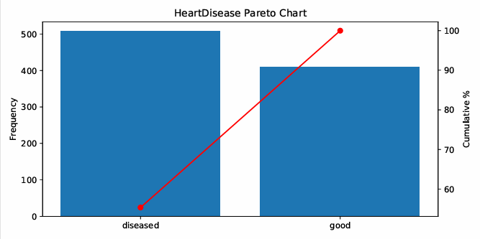
Figure 4(target pareto chart)

The distribution of the data set is fairly balanced with 508 patients having heart disease (55.3%) and 410 without (44.7%).
- Correlation Heatmap
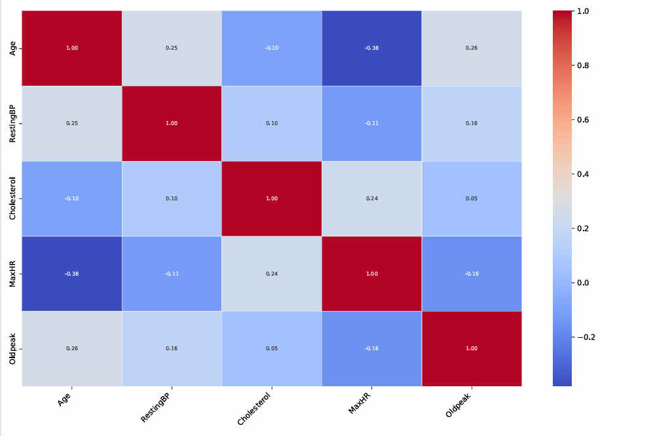
Figure 5 (heat map)

The correlation heat map reveals that there is no issue of multicollinearity for numeric variables in the data set. The highest correlation is that of age and maximum heart rate (r = -0.38). The correlation is medically logical and significantly below the multicollinearity limit. All other correlations have very low linear associations (r < 0.26), indicating the inclusion of all numeric variables during feature selection by the filter method. Particularly, cholesterol is highly uncorrelated with all variables, indicating its medical relevance relative to the target variable.
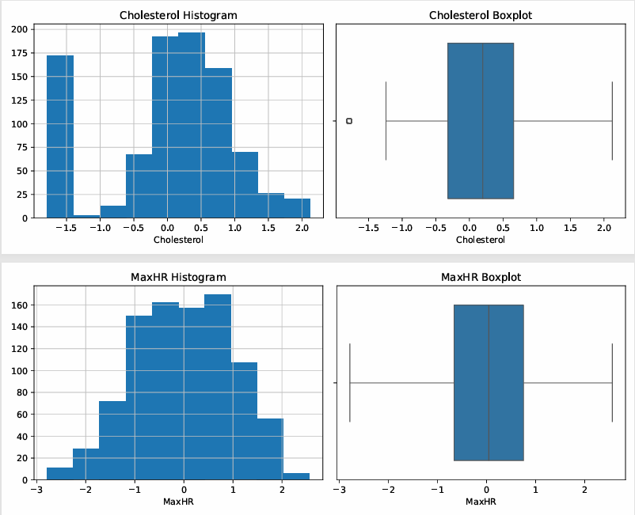
Visual Comparison: Before vs. After Cleaning:
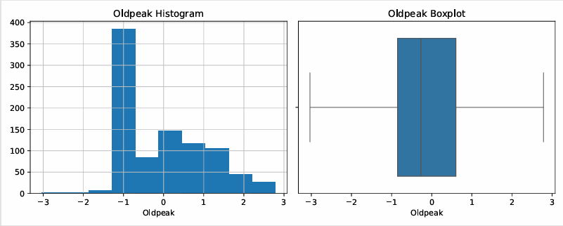
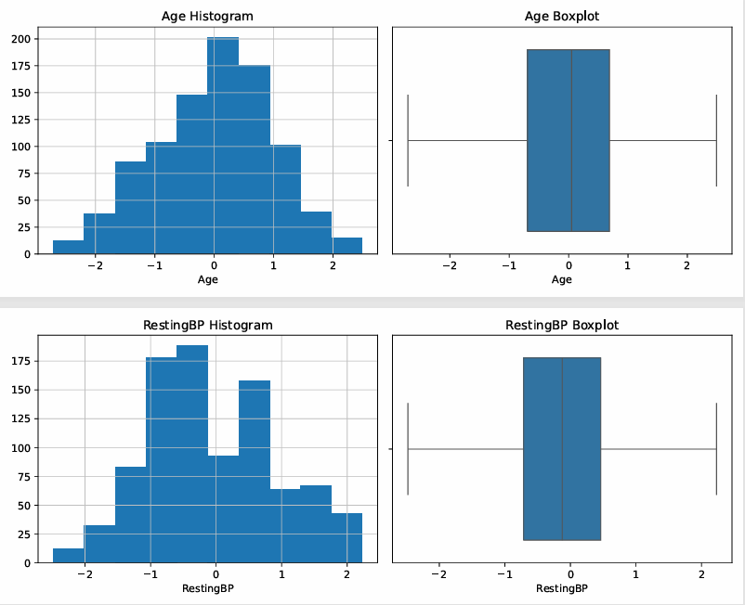
Figure 6(hist and box plots after cleaning 1)
- Age:
Before: Raw histogram showed a natural bell-shaped curve with a peak between 50-60 years (ages range between 28 and 77). Boxplot had no extreme outliers, Age was the cleanest numeric variable to begin with.
After (scaled): The scaled distribution is centered at 0, ranges from about -2.5 to +2.5, symmetrical bell-shaped. The boxplot shows no outliers. Therefore, Age was successfully cleaned by scaling, and did not require any structural changes.

- RestingBP:
Before: Raw histogram displayed a right-skewed distribution with a peak between 120-130 mm Hg, plus a very suspicious cluster of values close to 0. Boxplot contained several low-end outliers (the impossible zeros).
After (scaled): The post-cleaning histogram reveals a bimodal distribution with a clear trough between -0.5 to 0 z-scores. This bimodality is a consequence of the IQR capping used – all zeroes were pulled up to the lower fence, resulting in a cluster of records having the exact same capped value, shown as a second peak. The boxplot has no outliers, indicating that the capping was successful. This bimodality is expected and completely fine – the fact that there are no impossible zeros anymore is preferable over having a highly skewed distribution that would have corrupted our models.
- Cholesterol:
Before: Extremely problematic bimodal distribution with 170 records having 0 cholesterol and actual values ranging from 200 to 250 mg/dL. The boxplot contained several outliers at both ends, plus an impossible zero-lower bound.
After (scaled): There is a left spike around -1.5 z-scores in the histogram and one outlier remaining in the boxplot on the far left. These are the residuals of the IQR capping – all zeroes were lifted to the lower fence, and after scaling ended up at about -1.5 z-scores. The rest of the distribution is correct – centered at 0, with a right tail. The presence of one outlier on the left of the boxplot indicates that capped zeroes formed a discernible cluster; however, their magnitude is much less problematic. Feature selection may reduce Cholesterol’s influence on our models if it turns out to be low.
- MaxHR:
Before: Slightly left-skewed distribution centered at 137 bpm, ranging from 60 to 202. No extreme outliers detected on the boxplot – a relatively clean feature.
After (scaled): The distribution is centered at 0, ranging between roughly -3 and +2.5, with mild left skew still present. No outliers were detected in the boxplot. MaxHR is the top predictor of Heart Disease (median 126 bpm among patients with heart disease vs. 150 bpm among healthy people found in EDA); therefore, its perfect post-scaling distribution makes it suitable for use in all models.
- Oldpeak:
Before: Severe right-skew, massive spike around 0 with long right tail extending to 6.2. The boxplot contained several high-value outliers. The most right-skewed numeric feature overall – very problematic for distance and linear models.
After (scaled + skewness fixed): Distribution centered around -1 z-score with a gradually increasing right tail; much more balanced compared to pre-cleaning distribution. Boxplot shows no extreme outliers and ranges between roughly -3 and +3. The right tail still isn’t fully symmetrical due to Oldpeak’s intrinsic asymmetry (many zero values in raw distribution), but the result is significantly improved and Oldpeak remains a top predictor.
Categorical Variables:
Pareto Charts for Sex, ChestPainType, FastingBS, RestingECG, ExerciseAngina, ST_Slope, and HeartDisease do not change before and after data preprocessing since the categorical variables have been encoded post the visualization process. Critical features for prediction:
- ExerciseAngina : "No" 547; "Yes" : 371, important ratio with clinical relevance as angina patients tend to have disease.
- ST_Slope: "Flat" is predominant (count = 460) and has a clinical connection with ischemia, thus likely to be an important variable selected.
- FastingBS: has high preponderance in category "under" (≈77%).
Data Preprocessing (Feature Engineering and Balancing)
In order to increase the effectiveness of the prediction models by decreasing computational costs and avoiding "The Curse of Dimensionality," where the generalization capability of the model is reduced because of additional unnecessary variables, the following procedure was adopted:
Feature Transformation:
- Handling Skewness:
The skewness of all continuous variables was calculated using an absolute skewness value of over 1.0 as the cut-off point. It has been established through empirical analysis that all important numerical variables (including Age, RestingBP, Cholesterol, MaxHR, and Oldpeak) already belonged to a normally distributed population. As such, there is no need for any mathematical transformation of data into another format.
- Feature Scaling:
Distance-based techniques like K-Nearest Neighbors (KNN) depend solely on computing the distance of points in the n-dimensional space. Differences in units of measurement across the numerical variables may result in a disproportionate bias towards variables with high values. In order to prevent this bias, all the continuous numerical variables were normalized using z-score scaling to guarantee that all the variables have an equal influence when making decisions.
Feature Selection:
The following multi-stage procedure was conducted to exclude poor or redundant features:
- Filter Methods (Statistical Dependency & Mutual Information):Categorical variables were assessed with the help of Chi-Squared Independence tests by applying p-value criteria; strong dependency was confirmed. In terms of numerical and ordinal variables, the Mutual Information score was calculated. Based on very low statistical dependency, feature ST_Slope was excluded from the list of predictors in this stage of statistical filters.
- Collinearity and Variance Inflation Factor (VIF):In order to make sure that multi-collinearity does not destabilize the probabilistic and distance-based classifiers, VIF metric was applied to calculate independent values for all continuous features left. Optimal independent values obtained: Age (1.296), MaxHR (1.240) , RestingBP (1.111), Oldpeak (1.100), Cholesterol (1.086). None of the features passed above a critical level of collinearity, thus 0 features were excluded due to this criterion, and the structural independence is assured absolutely.
- Wrapper Methods (Sequential Feature Selection):Finally, wrapper-based selection procedure was used in order to identify the lean set of features specifically for classifiers. As a result, we successfully trimmed down our data frame to be used as the final set for modeling into exactly 5 binary categorical variables:
- Sex_F
- Sex_M
- ChestPainType_ASY
- ExerciseAngina_N
- ExerciseAngina_Y
Thus, the optimized data frame ended up being in the format (918, 6).
- Data Balancing:
Following an analysis of the class distribution for the dependent variable (Heart Disease), there was a presence of 55.34% positive cases, while negative cases accounted for 44.66%. In view of the fact that the data already possessed equilibrium and balance, synthetic oversampling approaches, such as the implementation of SMOTE, were not considered to maintain data authenticity and prevent the risk of overfitting.

Machine Learning Modeling & Comparative Analysis
The supervised learning classifiers were trained and thoroughly analyzed based on the Cross-Validation approach implemented within the dataset (918 records). The pipeline of balancing was not functional in this particular case as the data was balanced from the very beginning. Thus, performance measures were absolutely identical regardless whether the classifier analysis was performed before or after the balancing process. The following five classifiers were tested: k-Nearest Neighbors, Naive Bayes, Decision Tree, Bagging, and Random Forest.
- k-Nearest Neighbors (KNN):
The KNN algorithm works based on instance-based learning and is considered to be a non-parametric model. Tuning hyperparameters has led to finding the best set of parameters using k = 3 neighbors, equal weighting of neighbors, and hamming distance as a measure of similarity, which is mathematically well-founded for categorical binary features. The KNN model attained an Accuracy score of 76.36% and Balanced Accuracy of 76.57%. The Precision was 81.16%, showing a very small percentage of False Positives. The Recall was 74.61%, indicating that the model correctly predicted about 75% of the cardiac patients.
- Naive Bayes Classifier:
Naive Bayes acts like a generative probabilistic classifier that estimates posterior probabilities on the assumption that conditional independence exists between the predictors; something which has been proven true by virtue of our low values for VIF. With regard to the dimension reduction strategy that had transformed the feature space fully into binary categorical variables, the Categorical Naive Bayes (NB) model was used, along with the optimal value for Laplace smoothing alpha (\alpha), which stood at 0.1. It had an Accuracy score of 79.63% and a Balanced Accuracy of 79.22%. Interestingly enough, its recall was at 83.07%, while precision stood at 80.69%; leading to an F1-Score of 81.86%. It’s worth noting that in practical settings, the high recall is preferable due to the avoidance of deadly False Negatives
- Decision Tree Classifier:
​ The Decision Tree model works as a discriminative classifier employing a set of rules that divides the feature space to reduce the Gini Impurity. For better generalizability in this study, regularization was performed by setting the maximum depth to 3 and minimum samples leaf size to 5 using the gini criterion. The model attained an accuracy rate of 78.87%, balanced accuracy rate of 78.20%, precision score of 78.86%, and very high recall score of 84.45%, generating a final F1-score of 81.56%. In the analysis of feature importance, ChestPainType_ASY (Asymptomatic Chest Pain) emerged as the main root partitioner, occupying 67.532% of the total feature importance variance. This is followed by ExerciseAngina_N (13.976%) and ExerciseAngina_Y (10.358%), while gender predictors such as Sex_M (6.567%) and Sex_F (1.567%) accounted for minimal variance.

- ​1. Bagging Classifier:
In this case, bagging acts as an ensemble learning method whereby multiple base learners are trained in parallel. Predictions are then made by combining the predictions from all of the bootstrapping samples using majority voting (mode). In this experiment, a total of 50 estimators are used.
Model Performance & Statistical Evaluation:
  - Accuracy (79.63%): Displays a high degree of overall prediction correctness for the test cohort as a whole. Nonetheless, when considering accuracy values alone, there may be cases wherein a slight deviation in class consistency might affect clinical study results.
  - Precision (80.69%): Shows that when predicting a positive diagnosis on heart diseases, the system proves correct in its predictions about 81% of the time, thereby lowering the number of false positives.
  - Recall (83.07%): Ensures that the algorithm can accurately diagnose around 83.07% of all sick individuals in the cohort.
  - F1-Score (81.86%): Serves as a statistical average between precision and recall, creating a solid clinical performance rate of nearly 82%.
  - ROC-AUC (0.8393): Provides a significant discriminative capacity, ensuring that the classifier retains its mathematical ability to distinguish healthy subjects from those with heart diseases.
​2. Random Forest Classifier:
The Random Forest algorithm is improved compared to conventional bagging techniques through a critical decorrelation step involving attributes. During tree construction, nodes are split using a random selection of a predictor space as opposed to using all available predictors, resulting in reduced correlation between each estimator and minimizing variance within the ensemble.
- Hyperparameter Configuration:
  - The model used 100 estimators simultaneously (n_estimators = 100).
  - There were no constraints set on the maximum depth structure for the model (max_depth = None) such that the individual decision tree had the most freedom possible within itself, allowing the model to naturally capture complex conditional non-linear splits.
- Feature Importance Distribution:
Random Forest Distributed Feature Importance was evenly spread out among the central categorical independent variables as ChestPainType_ASY had the most predictive power accounting for 43.518%, followed by ExerciseAngina_N, which accounted for 23.877%, and ExerciseAngina_Y with 22.157%. The rest of the variations were explained through the Sex attribute where Sex_F accounted for 5.921% and Sex_M accounted for 4.605% .
- Model Performance Evaluation:
Accuracy 79.63%, Balanced Accuracy 79.22%, Precision 80.69%, Recall 83.07%, F1-score 81.86% (ROC-AUC 0.8385). The absolute correspondence between the statistics generated by both the two models proves that there exists a stable predictive ceiling for the highly compressed input data set with five binary attributes due to complete minimization of structural feature correlation within the latter.
Results and Interpretation:
Final Model Comparison & Strategic Selection:
Table 2(Final Evaluation)
Model | Accuracy | Balanced Accuracy | Precision | Recall | F1-score
Naive Bayes | 0.7962962963 | 0.792183599 | 0.8068833652 | 0.8307086614 | 0.8186226964
Bagging | 0.7962962963 | 0.792183599 | 0.8068833652 | 0.8307086614 | 0.8186226964
Random Forest | 0.7962962963 | 0.792183599 | 0.8068833652 | 0.8307086614 | 0.8186226964
Decision Tree | 0.788671024 | 0.782000192 | 0.7886029412 | 0.844488189 | 0.8155893536
KNN | 0.7636165577 | 0.7657144229 | 0.8115631692 | 0.7460629921 | 0.7774358974

A strict horizontal comparison within the final consolidated framework was made in order to select the optimal machine learning classifier from among those available, taking into consideration distinct statistical measures:
- Overall Accuracy: The Probabilistic CategoricalNB, Bagging Classifier, and Random Forest classifier achieved the highest overall accuracy ceiling of 79.63% that was slightly higher than the singular Decision Tree (78.87%) and the instance-based k-Nearest Neighbors (76.36%).
- Precision (False Positive Minimization): The k-Nearest Neighbors (KNN) classifier attained the highest singular precision rate of 81.16%, showing its ability to minimize false positive diagnostics efficiently.
- Recall (False Negative Mitigation): For a medical and diagnostic setting, the priority is to achieve the maximum Recall rate to prevent False Negatives (whereby sick patients are diagnosed healthy). Surprisingly, despite having three models (CategoricalNB, Bagging, and Random Forest) performing optimally at 83.07%, the regularized Decision Tree was ahead of the pack to become the leader in achieving the maximum Recall rate of 84.45%. KNN showed the worst performance on Recall at 74.61%.
- F1-Score: Again, the best performance was shared between the CategoricalNB, Bagging Classifier, and Random Forest classifiers at an optimal 81.86%. The Decision Tree was a close second place performer at 81.56% while KNN fell far behind at 77.74%.

Strategic Model Selection Conclusion:
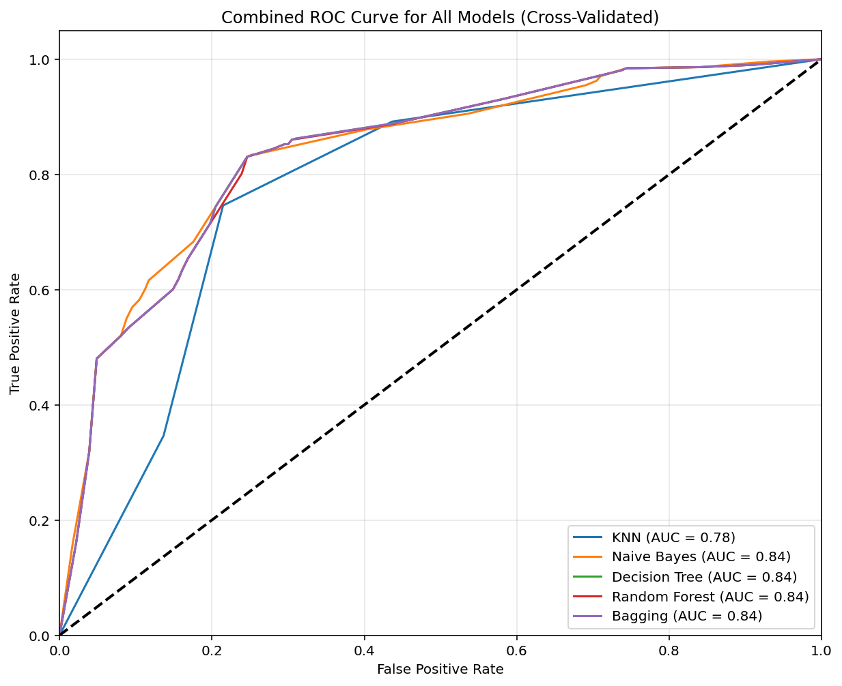
Figure 7(5 Model ROC)
On the question of choosing a prediction framework in risky medical operations, it should be chosen based on the combination of statistical accuracy of Recall, overall performance of the algorithm in F1 and simplicity.In spite of the slight increase in overall F1-score and precision obtained through CategoricalNB, Bagging and Random Forest algorithms, the Regularized Decision Tree is chosen for further implementation due to its outstanding Recall performance of 84.45% and full logical interpretability. Mathematically, it can be proved by the final graph of ROC-AUC curve, as the Regularized Decision Tree has one of the best Area Under the Curve (0.8219).​

Conclusion:
- Key Insights Summary:

Modeling Framework Success: The study succeeded in employing the advanced predictive modeling framework for cardiovascular screening based on the standard CRISP-DM framework.

Feature Selection Success: Statistical filter, Multi-collinearity screening (VIF) with sequential wrapper selection was successful in compressing the feature space to only 5 key binary features (Sex_F, Sex_M, ChestPainType_ASY, ExerciseAngina_N, ExerciseAngina_Y) thus avoiding the problem of the "Curse of Dimensionality".

Balancing Not Required: As the natural class balance (55.34% Diseased, 44.66% Healthy) was stable, data balancing (for example, SMOTE) was unnecessary and avoided overfitting.

- Interpretation Discussion:

Recall Considerations: In life critical medical diagnosis, priority is given to optimizing the Recall (sensitivity) so that there would be no risk of the False Negative which misses out on high-risk patients.

Optimal Model Selection: While Categorical Naïve Bayes, Bagging and Random Forest demonstrated the best accuracy of 79.63%, the single Regularized Decision Tree was chosen as the optimal predictive model.

Assets for Clinicians: Decision Tree classifier beat all other models due to its highest recall of 84.45% (confirmed by ROC-AUC = 0.8219) as well as its absolute interpretability (logic rule format) most preferred by clinicians.
Reference:
Data: https://www.kaggle.com/datasets/johnsmith88/heart-disease-dataset
Research: https://alizrepo.github.io/Explainable_Heart_Failure_Predictor/

