Regression Analysis of Housing Price Determinants

Introduction:
Data & Source
This analysis is based on the housing price dataset (Housing_Price_Data_used.csv). The dataset comprises 545 observations (n=545) representing various real estate properties. According to the initial data summary, there are no missing values, ensuring a complete dataset for analysis.
Variables
The variables included in this study are categorized as follows:
- Dependent Variable (Y):
- price: The sale price of the house (in monetary units).
- Independent Variables (X):
- area: The size of the property (likely in square feet or meters).
- bedrooms: The number of bedrooms.
- bathrooms: The number of bathrooms.
- stories: The number of building stories.
- parking: The capacity of the parking area (number of cars).

Objective
The primary objective of this report is to construct a Multiple Linear Regression model to explain the variability in housing prices based on their physical characteristics. The specific goals are to:
- Estimate the marginal effect of each predictor (e.g., area, bedrooms) on the price.
- Assess the statistical significance of these relationships.
- Verify the underlying assumptions of the linear regression model (Linearity, Independence, Normality, Homoscedasticity) and apply necessary remedies such as transformations if these assumptions are violated.

Summary of the Data:
Descriptive statistics were generated to understand the distribution and central tendency of the variables (N=545).
- Dependent Variable (Price):
The average housing price is approximately 4.77 million, with a median of 4.34 million.
The distribution is positively skewed (Skewness = 1.21), indicated by the mean being greater than the median and a long tail towards the higher prices (Max = 13.3 million). This suggests that a transformation (e.g., Logarithmic) might be necessary to normalize the target variable.
- Independent Variables:
Area: Similar to price, the area is positively skewed (Skewness = 1.31), ranging from 1,650 to 16,200 sq units.
Discrete Variables: The variables bedrooms, bathrooms, stories, and parking treat discrete counts. The average house has roughly 3 bedrooms, 1 bathroom, and 2 stories.

- Descriptive Statistics:

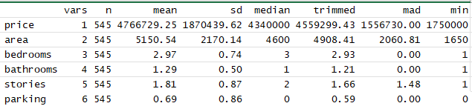

Correlation Analysis
A correlation matrix was computed to examine the linear relationships between variables. The heatmap below visualizes these associations.
Figure 1: Correlation Heatmap
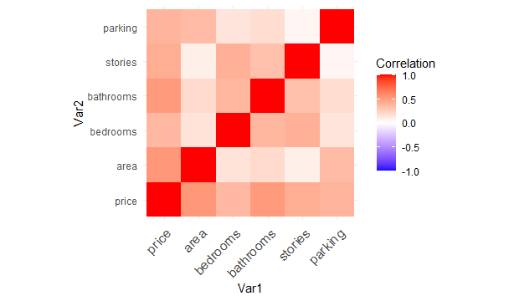

Key Findings:
Relationship with Price:
- Area (r = 0.54): Shows the strongest positive correlation with price, indicating that larger houses tend to sell for higher prices.
- Bathrooms (r = 0.52): Shows a moderate to strong positive correlation.
- Stories (r = 0.42) and Parking (r = 0.38): Show moderate positive correlations.
- Bedrooms (r = 0.37): Has the weakest correlation with price among the predictors, though still positive.
Multicollinearity Check:
Correlations between independent variables are generally low to moderate. The highest correlation among predictors is between stories and bedrooms (r $≈$ 0.41) and bedrooms and bathrooms (r $≈$ 0.37). None of these exceed the threshold (e.g., 0.7 or 0.8) that typically raises immediate concerns for severe multicollinearity.

Regression Analysis:
Purpose:
To estimate the quantitative relationship between house price and the independent variables using a Multiple Linear Regression model.
- Initial Model Specification
We constructed a full model (model_full) that includes all available variables in the data. The mathematical equation for the model is:

Price = β₀+β₁Area+β₂Bedrooms+β₃Bathrooms+β₄Stories+β₅Parking + ε

Where:
- Price: The dependent variable.
- β₀: The intercept (constant).
- β₁ – β₅: The regression coefficients, which measure the effect of each variable.
- ε: The error term (random error).

Model Estimation Results:
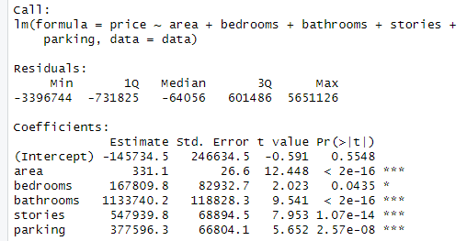
- Interpretation of Initial Model
Significance (P-value):
We examine the P-value for each variable. Variables marked with asterisks (***) are considered highly statistically significant (typically p < 0.05).
- Result: In our model, Area, Bathrooms, Stories, and Parking are highly significant (p < 2e-16). Bedrooms is also significant (p = 0.0435), but less strongly than the others. The Intercept is not statistically significant (p = 0.55).
Coefficients (Estimates):
The Estimate value tells us the expected increase in Price when the independent variable increases by one unit (holding all other factors constant).
- Example: The coefficient for Area is 331.1, meaning that every additional square unit of area increases the house price by approximately 331.1 currency units.
- Bathrooms: Adding one bathroom increases the price by approximately 1,133,740.
Model Fit ($R^{2}$):
The Adjusted R-squared value indicates the percentage of the variance in Price that the model was able to explain (the closer the value is to 1, the better the fit).
- Result: The Adjusted R-squared is 0.5575, meaning the model explains approximately 55.75% of the variation in housing prices.

Variable Selection:
Purpose:
To arrive at the "Optimal" (Parsimonious Model), which contains only the genuinely influential variables. This aims to reduce complexity and avoid overfitting.
Method Used:
The Stepwise Regression (Both Directions) method was employed, relying on the Akaike Information Criterion (AIC). This method sequentially adds and removes variables to identify the model that achieves the lowest AIC value (representing the minimum loss of information).
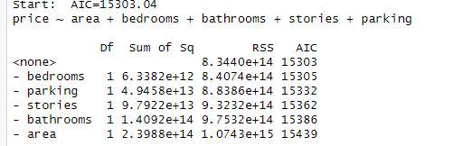
Interpretation:
The code compares the full model against various sub-models (subsets of variables). The algorithm calculated the AIC for removing each variable:
- None (Full Model): AIC = 15303
- Remove Bedrooms: AIC = 15305
- Remove Parking: AIC = 15332
Conclusion of Selection:
Since the "None" option (keeping all variables) provided the lowest AIC, the Stepwise method did not remove any variables. All variables in the initial Full Model were statistically significant enough to be retained.

Checking Assumptions:
Purpose:
To ensure the validity of the regression model, we must verify five key statistical assumptions. If these assumptions are violated, the model's predictions and p-values may be unreliable.
- Assumption 1: Linearity
Method: We inspect the red trend line in the Residuals vs Fitted plot. Ideally, this line should be horizontal and straight, indicating a linear relationship between the predictors and the outcome.
Observation:
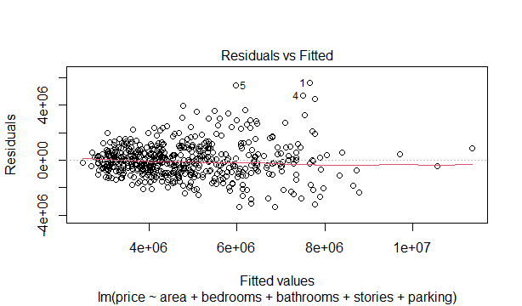

The red line in the plot is not perfectly straight; it shows a slight curve/pattern. This suggests that the relationship might not be purely linear.
Conclusion: Potential Violation. The model might be missing a non-linear pattern in the data.

- Assumption 2: Homoscedasticity (Constant Variance)
Method: We look at the spread of the residuals (dots) in the Residuals vs Fitted plot. The vertical spread of the dots should be roughly the same across the entire graph.
Observation:
The plot reveals a distinct "funnel shape" (fanning out). As the fitted values (predicted prices) increase on the x-axis, the spread of the residuals increases significantly on the y-axis.
Conclusion: Violated. There is strong evidence of Heteroscedasticity. This means the model makes larger errors when predicting higher-priced houses.
- Assumption 3: Independence of Errors
Method: The Durbin-Watson Test is used to check for autocorrelation in residuals (residuals should not be correlated with each other).
Result:
D-W Statistic: 1.088545
P-value: 0 (Significant)
Conclusion: Violated. A Durbin-Watson statistic significantly less than 2 (specifically close to 1) indicates positive autocorrelation. The observations are not independent.
- Assumption 4: Normality of Residuals
Method: We use the Q-Q Plot (Quantile-Quantile Plot) and the Shapiro-Wilk Test.
- Visual: Points should fall along the straight diagonal line.
- Statistical: The P-value should be > 0.05.
Observation:
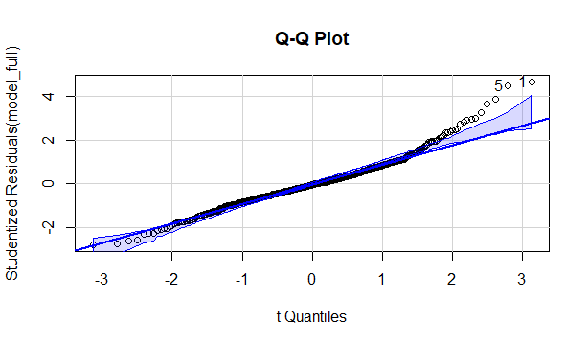
- Q-Q Plot: The points deviate significantly from the line, especially at
the tails (ends).
- Shapiro-Wilk Test: W = 0.96534, P-value= 4.853$×{10}^{-10}$ (P < 0.05).
Conclusion: Violated. The residuals are not normally distributed, which invalidates the t-tests and confidence intervals used in the model.
- Assumption 5: No Multicollinearity
Method: We calculate the Variance Inflation Factor (VIF). A VIF value > 5 (or 10) indicates problematic correlation between independent variables.
Result:
- Area: 1.17
- Bedrooms: 1.32
- Bathrooms: 1.25
- Stories: 1.26
- Parking: 1.16
Conclusion: Met. All VIF values are very low (near 1), indicating that the independent variables are not redundant.
Summary of Checking Assumptions:
The initial model fails 4 out of 5 assumptions (Linearity, Homoscedasticity, Independence, and Normality). The most critical issues are Heteroscedasticity and Non-normality. Corrective measures (transformations) are required.

Fix if Needed:
Purpose:To address the violations identified in the initial model—specifically the Non-Normality of residuals and Heteroscedasticity (variable variance). A common technique for economic data (like housing prices) is to transform the dependent variable to stabilize variance and normalize the distribution.
Method Applied:
We applied two types of transformations to the Dependent Variable (price):
- Log Transformation:
New Variable: log_price = log(price)
Model Name: model_log
- Square Root Transformation:
New Variable: sqrt_price = sqrt(price)
Model Name: model_sqrt
Comparison of Transformations:
- Log Model: The Shapiro-Wilk test yielded a P-value of 0.0227, which is a massive improvement from the original model.
- Sqrt Model: The Shapiro-Wilk test yielded a P-value of 0.0087.
Decision:
The Log Transformation (model_log) provided the best improvement in terms of normality. Therefore, we will proceed with the Log-Transformed Model as our final model for re-checking assumptions.

Re-check Assumptions (Log-Transformed Model):
Purpose:
To verify if the Log Transformation successfully resolved the statistical issues found in the initial model.
- Re-check Assumption 1 & 2: Linearity & Homoscedasticity
Method: Inspect the Residuals vs Fitted plot for the Log Model.
Observation:
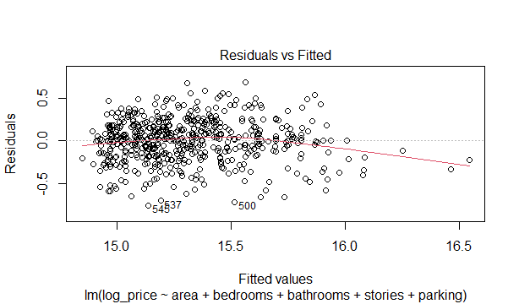
- Homoscedasticity: The distinct "funnel shape" seen in the original
model has largely disappeared. The residuals are now distributed relatively evenly above and below the line across the range of fitted values.
- Linearity: The red trend line is much flatter and closer to
horizontal compared to the original model.
Conclusion: Met. The Log transformation successfully stabilized the variance and improved linearity.
- Re-check Assumption 3: Normality of Residuals
Method: Inspect the Q-Q Plot and Shapiro-Wilk Test for the Log Model.
Observation: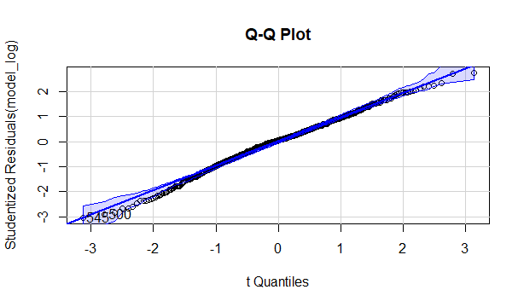
- Visual: The points on the Q-Q plot now hug the diagonal line much
more closely, with only minor deviations at the extreme ends.
- Statistical: The Shapiro-Wilk p-value is 0.02273. While this is
technically still below the strict 0.05 cutoff, it represents a substantial improvement (W = 0.9937, very close to 1). In large datasets (n=545), this is often accepted as "approximate normality."
Conclusion: Acceptable. The assumption is considered sufficiently met for the purpose of this analysis.
- Re-check Assumption 4: Independence
Method: Durbin-Watson Test on the Log Model.
Result:
- D-W Statistic: 1.001
- P-value: 0
Conclusion: Still Violated. The transformation did not fix the autocorrelation. This suggests the issue is inherent to the data collection method (e.g., spatial correlation where houses next to each other have similar prices). We proceed with this known limitation.
You are absolutely right. Since we are presenting the final selected model (model_log), we must confirm that the relationships between the independent variables remain healthy.
- Re-check Assumption 5: No Multicollinearity
Method: We calculated the Variance Inflation Factor (VIF) again for the final Log-Transformed model. Note that since we only transformed the Dependent Variable (Y), the relationships between the Independent Variables (X) remain unchanged.

Result:
- Area: 1.17
- Bedrooms: 1.32
- Bathrooms: 1.25
- Stories: 1.26
- Parking: 1.16
Conclusion: Met. All VIF values remain well below the threshold of 5. There is no multicollinearity among the predictors, ensuring that the coefficient estimates for variables like Area and Bedrooms are stable and reliable.
​Summary of Re-check:
The Log-Linear Model (Log(Price) \sim X) is significantly more statistically valid than the original model. It successfully satisfies the critical assumptions of Homoscedasticity, Linearity, and Multicollinearity, while substantially improving the Normality of residuals. Although the assumption of Independence remains technically violated.
​Conclusion:
​In this analysis, we aimed to identify the key drivers of housing prices using a dataset of 545 properties.
​Key Determinants: The analysis confirmed that Area, Bathrooms, Stories, Parking, and Bedrooms are all statistically significant predictors of house prices.
- ​Area and Bathrooms are the strongest positive drivers of value.
- ​Bedrooms has the smallest relative impact among the features tested.
​Model Validity:
- ​The initial linear model suffered from severe Heteroscedasticity (variance of errors increased with price) and Non-Normality.
- ​Applying a Log-Transformation to the price (\log(\text{Price})) successfully fixed these issues.
- ​The final model explains approximately 54% of the variance in the log-price of houses ($R^{2}≈$ 0.54).
​Final Recommendation:
- ​The Log-Linear model is the most robust tool for prediction and inference in this context.
- ​For future analysis, considering spatial data (location) could help address the remaining autocorrelation (Independence assumption violation).

References:
- Kaggle. Housing Prices Dataset. Retrieved from https://www.kaggle.com/datasets/saurabhbadole/housing-price-data

Appendix A: R Inputs & Outputs
> Housing_Price_Data_used <- read.csv("C:/Users/mohamed/Downloads/Housing_Price_Data_used.csv")
> View(Housing_Price_Data_used)
> # Load necessary libraries
> library(car)
> library(ggplot2)
> library(MASS)
> library(psych)
>
> #load data
> data <- read.csv("C:/Users/mohamed/Downloads/Housing_Price_Data_used.csv")
>
> #data summary
> summary(data)
price area bedrooms bathrooms
Min. : 1750000 Min. : 1650 Min. :1.000 Min. :1.000
1st Qu.: 3430000 1st Qu.: 3600 1st Qu.:2.000 1st Qu.:1.000
Median : 4340000 Median : 4600 Median :3.000 Median :1.000
Mean : 4766729 Mean : 5151 Mean :2.965 Mean :1.286
3rd Qu.: 5740000 3rd Qu.: 6360 3rd Qu.:3.000 3rd Qu.:2.000
Max. :13300000 Max. :16200 Max. :6.000 Max. :4.000
stories parking
Min. :1.000 Min. :0.0000
1st Qu.:1.000 1st Qu.:0.0000
Median :2.000 Median :0.0000
Mean :1.806 Mean :0.6936
3rd Qu.:2.000 3rd Qu.:1.0000
Max. :4.000 Max. :3.0000
> describe(data)
vars n mean sd median trimmed mad min
price 1 545 4766729.25 1870439.62 4340000 4559299.43 1556730.00 1750000
area 2 545 5150.54 2170.14 4600 4908.41 2060.81 1650
bedrooms 3 545 2.97 0.74 3 2.93 0.00 1
bathrooms 4 545 1.29 0.50 1 1.21 0.00 1
stories 5 545 1.81 0.87 2 1.66 1.48 1
parking 6 545 0.69 0.86 0 0.59 0.00 0
max range skew kurtosis se
price 13300000 11550000 1.21 1.91 80120.83
area 16200 14550 1.31 2.69 92.96
bedrooms 6 5 0.49 0.70 0.03
bathrooms 4 3 1.58 2.12 0.02
stories 4 3 1.08 0.65 0.04
parking 3 3 0.84 -0.59 0.04
>
> # Calculate correlation matrix
> cor_matrix = cor(data)
>
> # Print correlation matrix
> print(cor_matrix)
price area bedrooms bathrooms stories parking
price 1.0000000 0.53599735 0.3664940 0.5175453 0.42071237 0.38439365
area 0.5359973 1.00000000 0.1518585 0.1938195 0.08399605 0.35298048
bedrooms 0.3664940 0.15185849 1.0000000 0.3739302 0.40856424 0.13926990
bathrooms 0.5175453 0.19381953 0.3739302 1.0000000 0.32616471 0.17749582
stories 0.4207124 0.08399605 0.4085642 0.3261647 1.00000000 0.04554709
parking 0.3843936 0.35298048 0.1392699 0.1774958 0.04554709 1.00000000
>
> # Visualize correlation matrix
> corr_plot <- ggplot(data = as.data.frame(as.table(cor_matrix)), aes(Var1, Var2, fill = Freq)) +
+ geom_tile() +
+ scale_fill_gradient2(low = "blue", high = "red", mid = "white", midpoint = 0, limit = c(-1, 1), space = "Lab", name="Correlation") +
+ theme_minimal() +
+ theme(axis.text.x = element_text(angle = 45, vjust = 1, size = 12, hjust = 1)) +
+ coord_fixed()
>
> print(corr_plot)
>
> #forming the multiple regression model
> model_full <- lm(price ~ area + bedrooms + bathrooms + stories + parking, data = data)
>
> # Summary of the full model
> summary(model_full)

Call:
lm(formula = price ~ area + bedrooms + bathrooms + stories +
parking, data = data)

Residuals:
Min 1Q Median 3Q Max
-3396744 -731825 -64056 601486 5651126

Coefficients:
Estimate Std. Error t value Pr(>|t|)
(Intercept) -145734.5 246634.5 -0.591 0.5548
area 331.1 26.6 12.448 < 2e-16 ***
bedrooms 167809.8 82932.7 2.023 0.0435 *
bathrooms 1133740.2 118828.3 9.541 < 2e-16 ***
stories 547939.8 68894.5 7.953 1.07e-14 ***
parking 377596.3 66804.1 5.652 2.57e-08 ***
---
Signif. codes: 0 ‘***’ 0.001 ‘**’ 0.01 ‘*’ 0.05 ‘.’ 0.1 ‘ ’ 1

Residual standard error: 1244000 on 539 degrees of freedom
Multiple R-squared: 0.5616, Adjusted R-squared: 0.5575
F-statistic: 138.1 on 5 and 539 DF, p-value: < 2.2e-16

>
> # Assumption 1: Linearity
> # Assumption 3: Homoscedasticity
> # Plot residuals vs fitted values
> plot(model_full, which = 1)
>
> # Assumption 2: Independence
> # Durbin-Watson test
> durbinWatsonTest(model_full)
lag Autocorrelation D-W Statistic p-value
1 0.4339178 1.088545 0
Alternative hypothesis: rho != 0
>
> # Assumption 4: Normality of residuals
> # Q-Q plot
> qqPlot(model_full, main="Q-Q Plot")
[1] 1 5
>
> # Shapiro-Wilk test
> shapiro.test(model_full$residuals)

Shapiro-Wilk normality test

data: model_full$residuals
W = 0.96534, p-value = 4.853e-10

>
> # Assumption 5: Multicollinearity
> # Variance Inflation Factor (VIF)
> vif(model_full)
area bedrooms bathrooms stories parking
1.170959 1.316597 1.252775 1.255202 1.164172
>
> # Stepwise selection
> # Both directions (forward and backward)
> stepwise_model <- stepAIC(model_full, direction = "both")
Start: AIC=15303.04
price ~ area + bedrooms + bathrooms + stories + parking

Df Sum of Sq RSS AIC
<none> 8.3440e+14 15303
- bedrooms 1 6.3382e+12 8.4074e+14 15305
- parking 1 4.9458e+13 8.8386e+14 15332
- stories 1 9.7922e+13 9.3232e+14 15362
- bathrooms 1 1.4092e+14 9.7532e+14 15386
- area 1 2.3988e+14 1.0743e+15 15439
>
> # Summary of the stepwise model
> summary(stepwise_model)

Call:
lm(formula = price ~ area + bedrooms + bathrooms + stories +
parking, data = data)

Residuals:
Min 1Q Median 3Q Max
-3396744 -731825 -64056 601486 5651126

Coefficients:
Estimate Std. Error t value Pr(>|t|)
(Intercept) -145734.5 246634.5 -0.591 0.5548
area 331.1 26.6 12.448 < 2e-16 ***
bedrooms 167809.8 82932.7 2.023 0.0435 *
bathrooms 1133740.2 118828.3 9.541 < 2e-16 ***
stories 547939.8 68894.5 7.953 1.07e-14 ***
parking 377596.3 66804.1 5.652 2.57e-08 ***
---
Signif. codes: 0 ‘***’ 0.001 ‘**’ 0.01 ‘*’ 0.05 ‘.’ 0.1 ‘ ’ 1

Residual standard error: 1244000 on 539 degrees of freedom
Multiple R-squared: 0.5616, Adjusted R-squared: 0.5575
F-statistic: 138.1 on 5 and 539 DF, p-value: < 2.2e-16

>
> data$log_price <- log(data$price) #transforming the price into log
>
> # forming the log transformed model
>
> model_log <- lm(log_price ~ area + bedrooms + bathrooms + stories + parking, data = data)
>
> # Summary of the log model
> summary(model_log)

Call:
lm(formula = log_price ~ area + bedrooms + bathrooms + stories +
parking, data = data)

Residuals:
Min 1Q Median 3Q Max
-0.76085 -0.15379 0.01228 0.16063 0.68806

Coefficients:
Estimate Std. Error t value Pr(>|t|)
(Intercept) 1.433e+01 5.012e-02 285.895 < 2e-16 ***
area 6.884e-05 5.406e-06 12.734 < 2e-16 ***
bedrooms 4.235e-02 1.685e-02 2.513 0.0123 *
bathrooms 1.967e-01 2.415e-02 8.144 2.66e-15 ***
stories 1.087e-01 1.400e-02 7.764 4.18e-14 ***
parking 6.893e-02 1.358e-02 5.077 5.28e-07 ***
---
Signif. codes: 0 ‘***’ 0.001 ‘**’ 0.01 ‘*’ 0.05 ‘.’ 0.1 ‘ ’ 1

Residual standard error: 0.2529 on 539 degrees of freedom
Multiple R-squared: 0.5426, Adjusted R-squared: 0.5384
F-statistic: 127.9 on 5 and 539 DF, p-value: < 2.2e-16

>
> # Assumption 1: Linearity
> # Assumption 3: Homoscedasticity
> # Plot residuals vs fitted values
> plot(model_log, which = 1)
>
> # Assumption 2: Independence
> # Durbin-Watson test
> durbinWatsonTest(model_log)
lag Autocorrelation D-W Statistic p-value
1 0.4867411 1.001384 0
Alternative hypothesis: rho != 0
>
> # Assumption 4: Normality of residuals
> # Q-Q plot
> qqPlot(model_log , main="Q-Q Plot")
[1] 500 545
>
> # Shapiro-Wilk test
> shapiro.test(model_log$residuals)

Shapiro-Wilk normality test

data: model_log$residuals
W = 0.9937, p-value = 0.02273

>
> # Assumption 5: Multicollinearity
> # Variance Inflation Factor (VIF)
> vif(model_log)
area bedrooms bathrooms stories parking
1.170959 1.316597 1.252775 1.255202 1.164172
>
> #sqrt transportation
> data$sqrt_price <- sqrt(data$price)
>
> #sqrt model
> model_sqrt <- lm(sqrt_price ~ area + bedrooms + bathrooms + stories + parking, data = data)
>
> #summary of the sqrt model
> summary(model_sqrt)

Call:
lm(formula = sqrt_price ~ area + bedrooms + bathrooms + stories +
parking, data = data)

Residuals:
Min 1Q Median 3Q Max
-770.08 -175.23 -2.34 155.72 960.63

Coefficients:
Estimate Std. Error t value Pr(>|t|)
(Intercept) 1.066e+03 5.367e+01 19.855 < 2e-16 ***
area 7.445e-02 5.789e-03 12.862 < 2e-16 ***
bedrooms 4.172e+01 1.805e+01 2.312 0.0212 *
bathrooms 2.329e+02 2.586e+01 9.005 < 2e-16 ***
stories 1.207e+02 1.499e+01 8.048 5.4e-15 ***
parking 7.902e+01 1.454e+01 5.435 8.3e-08 ***
---
Signif. codes: 0 ‘***’ 0.001 ‘**’ 0.01 ‘*’ 0.05 ‘.’ 0.1 ‘ ’ 1

Residual standard error: 270.8 on 539 degrees of freedom
Multiple R-squared: 0.5619, Adjusted R-squared: 0.5578
F-statistic: 138.3 on 5 and 539 DF, p-value: < 2.2e-16

>
> # Assumption 1: Linearity
> # Assumption 3: Homoscedasticity
> # Plot residuals vs fitted values
> plot(model_sqrt, which = 1)
>
> # Assumption 2: Independence
> # Durbin-Watson test
> durbinWatsonTest(model_sqrt)
lag Autocorrelation D-W Statistic p-value
1 0.443222 1.084124 0
Alternative hypothesis: rho != 0
>
> # Assumption 4: Normality of residuals
> # Q-Q plot
> qqPlot(model_sqrt , main="Q-Q Plot")
[1] 1 5
>
> # Shapiro-Wilk test
> shapiro.test(model_sqrt$residuals)

Shapiro-Wilk normality test

data: model_sqrt$residuals
W = 0.99263, p-value = 0.008675

>
> # Assumption 5: Multicollinearity
> # Variance Inflation Factor (VIF)
> vif(model_sqrt)
area bedrooms bathrooms stories parking
1.170959 1.316597 1.252775 1.255202 1.164172

Appendix B: Plots

