Analyzing Profitability Factors in a Commercial Company

Abstract:
The research examines the determinants of profitability in a business firm whose enterprise was not able to achieve its anticipated profit margins. With a data set consisting of 8,399 records, this research contrasts quantitative variables (discount and order quantity) with qualitative variables (region, customer segment, shipping mode, and product category) through statistical analysis employing IBM SPSS version 26. The study says higher order quantities equate to increased profit and proper discounts can be used to increase profitability but excessive discounting can result in low returns. Amongst qualitative variables, the 'Delivery Truck' shipping mode and selling in the 'Northwest Territories' territory recorded highest mean profits, but in lower usage frequency terms. The 'Corporate' buyer type and 'Technology' category product were similarly most profitable. These are consistent with the prevailing literature regarding strategic discounting and territorial profitability. In line with the analysis, the research advises maximizing shipping modes through doing regions and customer segments, profitable product categories, and strategic discounting in order to maximize overall profitability.
Keywords: Profitability Analysis, Order Quantity, Discount Strategy, Shipping Mode, Customer Segment, Product Category, SPSS, Strategic Management.
Introduction:
This research was done to discuss the problem of a commercial company in which the company was not fulfilling the expectation profit. The company opted to research and analyze the determinants affecting profitability by reviewing data on 8,399 samples. The research included quantitative variables like order quantity, discount, and profit and qualitative variables like shipmode, customer segment, region, and product category.
We also mentioned some literature that explains the relationship of these variables to profit. Using statistical analysis through SPSS , the research was intended to determine the most critical variables influencing profitability and provide suggestions so that the company can enhance its bottom-line performance and maximize profits.
Literature Review:
applies systems theory to examine growth and profitability in multiregional systems. The study explores the degree to which economic regions that are interdependent influence firm-level profitability as well as long-term growth, with specific focus on structural capital flow, goods flow, and labor flow. Webber's conclusion is that profitability in any region may be determined by the dynamics and health of nearby regions, identifying the applicability of systemic thinking in strategic economic planning. This approach goes against localized choice- into account when making profitability assessments. His contribution making and highlights the need for companies to take interdependence across regions continues to direct spatial economics and regional science (Paige, 1970).
provides a quantity discount price model that aims to maximize vendor profitability as well as advantage buyers. The model formulates order quantity choices and price incentives and shows how vendors can get the best out of price strategy in a bid to maximize total profit and reduce buyer inventory cost. The study gives a mathematical model that harmonizes reducing buyers' cost with sellers' revenue maximization. This research is foundational to supply chain and operations management as it illustrates how cooperative pricing mechanisms can align incentives throughout the supply chain and lead to mutually beneficial results (Monahan, James P, 1984).
consider the reasons behind poor product-level profitability analysis and their implications for managerial decision-making. They argue that traditional cost accounting practices have a tendency to neglect the real financial performance of distinct products, thus leading to unsuccessful strategic and operational decisions. Their empirical evidence demonstrates how inaccurately stated profitability reports can deceive price, development, and discontinuation decisions. It requires more integrated and transparent accounting tools to enable decisions on facts. It contributes to the management accounting literature by revealing the importance of integrating financial data with product-level strategic planning ( Sievänen, Suomala, , & Paranko, 2004).
discuss the impact of location patterns of firms and market access on profitability at the regional level. Their economic geography perspective focuses on the fact that firms at the center benefit from proximity to demand and reduced transport costs, which increase their relative profitability compared to firms located at the periphery. The article illustrates how geographic concentration leads to uneven profit dispersion by the forces of the market and cost conditions. This research bridges the void between spatial economics and microeconomic theory, with significant implications for regional policy, location strategy, and competitive analysis in more globalized markets (Overman, 2004).
This study examines the impact of discounts during the stock-out period on profitability by converting lost sales into backorders within the economic order quantity (EOQ) framework with partial backorders. The authors created a model that relates the backorder rate to the discount size, using a linear function. The study determines the optimal discount level and order quantity. The results include conditions for establishing discounts, how to determine the optimal discount, and the resulting gains and profits. A numerical example is provided to demonstrate that a higher number of strategic discounts reduces costs and increases backorders, demonstrating the model's effectiveness in making inventory decisions (David W. Pentico & Matthew J. Drake, 2010).
This study examines the impact of private label brands on customer loyalty and product category profitability in an American supermarket chain. The results revealed a significant negative relationship between private label sales penetration and the number of customers and total department sales. However, the total spending of loyal customers had a positive impact on profitability. The study emphasized the importance of balancing the promotion of private label brands with national brands, which increases traffic and sales (Pepe, Abratt, & Dion , 2011).
discuss the strategic behavior of emerging-market multinational firms (EMNEs) in terms of strategic factor markets (SFMs). To them, EMNEs gain competitive advantages not just through leveraging firm-specific assets but through seizing distortions in global SFMs. The study outlines how such firms tap underpriced assets, rapidly learn, and engage in strategic arbitrage geographically. They shatter the traditional internationalization views, suggesting that access and timing in SFMs are essential for guaranteeing profitability as well as global competitiveness. This research offers a new perspective on EMNEs' emergence in the global economy (Kim, Hoskisson, & Lee, 2015).
discuss how product–market planning capability drives firm profitability. The authors suggest that effective planning capabilities allow companies to anticipate more effectively market changes, align company resources internally, and make decisions that improve performance. The research emphasizes strategic decision-making and organizational learning roles in realizing profitable results from planning. They find, based on several firms' data, that possessing well-established planning abilities is linked with sustainable competitive advantage. The research contributes to knowledge in dynamic capacities by concentrating on how strategic foresight and adaptability have a direct effect on financial performance (Hughes, Hodgkinson, Morgan, Hughes, & Hughes, 2020).
examine how market competition influences firm profitability and discount rates applied to firm cash flows by investors. Drawing from empirical observations across industries, they illustrate that increased competition leads to constrained profit margins, which in turn has a bearing on perceived risk as well as discount rates. In accordance with their findings, investors adjust discount rates through competitive pressure, which captures updates in future profit expectations. The findings contribute to corporate finance by filling the gap between competitive forces and valuation models, delivering insights into how market structure affects firm value and investment (Dou, Ji, & Wu, 2021).
This research studies the impact of sectoral and geographical diversity on corporate profits in Kuwait. By studying and analyzing the theory with the applied study, 28 non-financial companies in the Kuwaiti market were analyzed. The results did not show a noticeable impact of sectoral and geographical diversity with statistical significance on the quality of profits. The study provides insights into the limited impact of diversity on the quality of financial reports in emerging markets ( Abdullah, Al-Sayed, & Al-Ajmi, 2023).
This study examines the impact of economic order quantity (EOQ) on the profits of the top 100 medium-sized enterprises (MSEs) in Kenya, analyzing and describing data from 171 participants. The analysis reveals a slight and weak correlation between EOQ and profitability. Statistical analysis suggests that EOQ is more significant in large economies but has a minimal impact on MSEs (SHIBU, FWAMBA, & MUGANDA, 2023).
This study examines the role of market segmentation in improving pricing for new products, comparing loyal and bargain customers. The researchers created a price differentiation model and a time-segmentation model. The results showed that segmentation leads to higher prices for loyal customers and increased sales for bargain customers. The optimal timing for price changes and discounts was identified to maximize profit ( Tavor, Gonen, & Spiegel, 2023).
Objectives and Research Questions:
The research seeks to examine the root causes of the failure of the company to record the anticipated profit, by investigating the correlation between profitability and a range of quantitative and qualitative variables. Statistical analysis will be done using statistical software and tools like SPSS. The precise objectives and related research questions are specified as follows:
1. To compare quantitative variables like order quantity and discount, and determine their effect on profit.
Research Question: What is the effect of order quantity and discount rates on profitability for the company?
2. To study qualitative variables like shipping mode, customer segment, region, and product category, to determine their correlation with profit.
Research Question: What qualitative variables have a significant correlation with profitability?
3. In order to compare average profit between various categories of qualitative variables with SPSS, with the objective of determining most profitable segments.
Research Question: Do there exist statistically significant differences in average profit between various shipmode, customer segment, regions, or product classes?
4. In order to use descriptive statistics and graphical plots in order to describe patterns and relationships between profit and the other research variables under consideration.
Research Question: What overall trends and patterns can be detected in the correlation of profitability with the variables under study?
5. In an effort to confirm the findings through pertinent literature and prior research, in order to corroborate the correlations observed.
Research Question: Are the results consistent with those of previous academic literature?
6. To deliver pragmatic and actionable suggestions that are able to boost the profitability of the firm, based on the analysis findings.
Research Question: What are the company's segments or strategies to be prioritized for enhancing its profit margin?
From the above, the study aims to provide an extensive insight into the quantitative as well as qualitative factors influencing profitability to assist in well-informed managerial and strategic decisions on behalf of the company in question.
Data Descriptions:
We got a sample that consisted of 8399 records of profit discounts and more, and we focused on 6 variables to compare to the profit and answer the questions that have been asked, and to find out which variable effects the profit and how to increase profit based on every one of them and these variables were discounts and order quantities as the quantitative and shipment mode, region, customer segment, and product category as the qualitative data and all these will be compared to the profit.
We will be describing the profit parameters as we will be only comparing it to the other variables in the body of the research itself, so from (Table 1) we can see that the least profit was -14140.7, which indicates that there was a loss in the profit. The maximum was 27220.69, and the mean was 181.18, indicating that the total profit wasn’t the best, and that’s why we are doing this research to find out how to maximize it.
Data analysis and main findings
We started working on the analysis using IBM SPSS version 26, and we started with the Shipment mode first we did a frequency test. We made a pie chart using the charts section from the frequencies window. We came out with (Figure 1) and (Table 2) and from them we found out that the variable had 3 categories which were Delivery Truck, Regular Air, and Express Air with the most used method to ship orders being the Regular Air seen from (Figure 1) with more than 74% seen in (Table 2) and second to that came Delivery Trucks with almost 14% and the least one was the Express AIR with 11.7% which is close to second.
Then we used the tool compare means to find the correlations between the shipment mode and the profit, and then we used the tool chart builder to make a figure to visualize that, and we came out with (Table 6) and (Figure 5) from them we found out that the most profitable shipment mode was the Delivery Truck method with the highest mean being almost 235 seen in (Table 6) which suggests that it’s the best Shipment method since it was only used 14% from the times in the sample so that suggest using it more is profitable.
Then we started with the regions and we did the frequencies first like the shipment mode and we found out that it had 8 main regions that the company got orders from and these can be seen in (Table 3) and (Figure 2) and from that figure we see that the most region that had orders was west with 23.7% seen in (Table 3) and the least was Nunavut with only 0.9% and then we compared means to find out the correlations and we found out that the most profitable region was the Northwest Territories which had the highest mean seen in (Figure 6) equaling 255.46 seen in (Table 7) which was surprising because Northwest Territories was the second least occurring with 4.7% frequency percentage, and that indicates that the region effecting on the profit and the company should increase the sales in the profitable regions.
Then we took the third variable, the customer segment and applied the same frequency tool to it to get (Table 4) and (Figure 3) and from the pie chart we find that the variable has 4 categories which are consumer, corporate, home office, and small business with the highest category recorded was the corporates with 36.6% seen in (Table 4) and the least was the small businesses with 19.5%
And then we compared means to find the correlations between the profit and the customer segment and we found out that the highest mean was at the corporate seen in (Figure 7) and it equals 194.97 seen in (Table 8) also corporates had the highest frequency as we said so most probably the customer segment doesn’t affect the profit since the highest profit is also the highest frequency
Then we started working on the last qualitative variable, the product category and after doing the frequency table and the pie chart we got (Table 5) and (Figure 4) and from that figure we see that there is 3 categories which were Furniture, Office Supplies, and Technology with the most bought category was the office supplies with 54.9% frequency percentage seen in (Table 5)
And then we compared means and made a bar chart to find the correlation between the profit and the product category and we found out that the most profitable category was the Technology which is seen in the bar chart (Figure 8) and the mean was 429.2 seen in (Table 9) which was significantly higher than the other 2 categories seen in the bar chart (Figure 8) and that indicates that the technology category was the best and we suggest trying to increase sells in that category
And with that we are finished with the qualitative variables and we started with the quantitative variables and we did that by making a line graph using the chart builder tool to make it between the mean of the profit and the other variable one by one and next we discuss the findings
From (Figure 9) we find that there is an imperfect positive correlation between the mean of the profit where it got lower at first when the quantity got from 3 to 4 and then gone higher from 4 to 9 then got lower at 10 and so on but the full figure suggests that it is a positive correlation and with that we suggest trying to convince the customers to by more quantities to increase the profit
Then we did the same stuff to find the correlation between the profit and the discounts and that we will see in (Figure 10)
From (Figure 10) we can see that the mean of the profit got higher when the discount went from 0.01 to 0.02, which was the highest profit compared to the discounts, but then the relation was an imperfect negative correlation but that doesn’t mean that a discount is bad it just has to be reasonable so the sells could cover the costs of the order and shipment like what happened in the 0.03 discount which was the highest mean of profit point on the figure and we recommend that the company try to make a reasonable discounts to make the highest profit
And with that we finished the analysis and we will discuss our recommendations to make the profit higher and to answer our questions in the conclusion and find the best recommendation for increasing the profit.
Conclusion
Our goal in this research was to examine the most important factors impacting the profitability of a business firm that was unable to reach its expected levels of profit. From the examination of a database of 8,399 records with SPSS, we examined quantitative factors like order quantity and discount and qualitative factors like ship mode, customer segment, region, and product category to see how they relate to profit.
Our results readily resolve the research questions and goals investigated at the start of the research:
1. Discount and Order Quantity's Impact on Profit
Order quantity was positively related to profit, especially in larger order quantities. The profit association with discount was more complex: selective small discounts (e.g., 0.03) were profitable, but high discounts lowered profitability.
These findings validate Objective 1 and respond to Research Question 1.
2. Effect of Qualitative Variables
Of the qualitative factors, Delivery Truck was the most profitable shipping method even though it was not being used extensively. Northwest Territories, although not common in orders, had the highest regional average profitability. The corporate segment showed the highest frequency and profitability, which would be an indication of alignment and not causality. Technology was the most profitable product category, which would mean that it must be prioritized.
These findings address Objectives 2 and 3 and Research Questions 2 and 3.
3. Descriptive Analysis and Visualization
We saw overall patterns and trends using pie charts, bar graphs, and line graphs, for instance, a trend in Regular Air shipping and Office Supplies expenditures but with latent profitability in less frequent alternatives such as Delivery Truck and Technology.
This addresses Objective 4 and Research Question 4.
4. Consistency with Past Studies
We have consistency with many past studies discussed in the literature review. For example, strategic discounting models (Pentico & Drake, 2010), geographic profitability (Overman, 2004), and category performance (Sievänen et al., 2004) all conform with our empirical results.
This has an alignment with Objective 5 and addresses Research Question 5.
Recommendations:
1. Use highest preference for truck delivery:
This mode of transport achieved the maximum average profit (235.29) as opposed to the remaining shipping methods. It is advisable to utilize it wherever and whenever possible in a bid to save funds and obtain maximum returns.
2. Optimize sales in the Northwest Territories:
In spite of limited orders (394), this area saw the maximum average profit (255.46). It is advisable to optimize marketing and advertisement for customers in this area.
3. Target business customers:
This group showed the highest average profit (194.98) and highest number of orders (3,076). Special offers and discounts have to be offered in an attempt to attract additional customers from this group.
4. Give emphasis on technology product range:
It's the most profitable range with the highest average profit (429.21). These products have to be promoted and stock and availability increased on a regular basis.
5. Trigger large orders with smart discounts:
The results suggested that there was a positive but not perfect correlation between profit and orders. Deep discounts on large orders can be offered to trigger greater profits and sales volume.
6. Reduce deep discounts:
The findings suggested that deep discounts can lead to lower profits. Therefore, it is recommended to offer easy, smart discounts, especially for target consumers such as enterprises and large orders.
7. Continue to analyze data on a regular basis:
In order to monitor customer trends and profits changing, and thus help make strategic decisions based on up-to-date and accurate data.

Tables and Figures :
Table 1
Descriptive Statistics
 | N | Minimum | Maximum | Mean | Std. Deviation
ORDERQUANTITY | 8399 | 1 | 50 | 25.57 | 14.481
DISCOUNT | 8399 | .00 | .25 | .0497 | .03182
PROFIT | 8399 | -14140.70 | 27220.69 | 181.1844 | 1196.65337
Valid N (listwise) | 8399

Table 2
SHIPMODE
 |  | Frequency | Percent | Valid Percent | Cumulative Percent
Valid | Delivery Truck | 1146 | 13.6 | 13.6 | 13.6
Valid | Express Air | 983 | 11.7 | 11.7 | 25.3
Valid | Regular Air | 6270 | 74.7 | 74.7 | 100.0
Valid | Total | 8399 | 100.0 | 100.0

Table 3
REGION
 |  | Frequency | Percent | Valid Percent | Cumulative Percent
Valid | Atlantic | 1080 | 12.9 | 12.9 | 12.9
Valid | Northwest Territories | 394 | 4.7 | 4.7 | 17.5
Valid | Nunavut | 79 | .9 | .9 | 18.5
Valid | Ontario | 1826 | 21.7 | 21.7 | 40.2
Valid | Prarie | 1706 | 20.3 | 20.3 | 60.5
Valid | Quebec | 781 | 9.3 | 9.3 | 69.8
Valid | West | 1991 | 23.7 | 23.7 | 93.5
Valid | Yukon | 542 | 6.5 | 6.5 | 100.0
Valid | Total | 8399 | 100.0 | 100.0

Table 4
CUSTOMERSEGMENT
 |  | Frequency | Percent | Valid Percent | Cumulative Percent
Valid | Consumer | 1649 | 19.6 | 19.6 | 19.6
Valid | Corporate | 3076 | 36.6 | 36.6 | 56.3
Valid | Home Office | 2032 | 24.2 | 24.2 | 80.5
Valid | Small Business | 1642 | 19.5 | 19.5 | 100.0
Valid | Total | 8399 | 100.0 | 100.0

Table 5
CUSTOMERSEGMENT
 |  | Frequency | Percent | Valid Percent | Cumulative Percent
Valid | Consumer | 1649 | 19.6 | 19.6 | 19.6
Valid | Corporate | 3076 | 36.6 | 36.6 | 56.3
Valid | Home Office | 2032 | 24.2 | 24.2 | 80.5
Valid | Small Business | 1642 | 19.5 | 19.5 | 100.0
Valid | Total | 8399 | 100.0 | 100.0

Table 6
Ship Mode Report
PROFIT
SHIPMODE | Mean | N | Std. Deviation
Delivery Truck | 235.2922 | 1146 | 2031.16261
Express Air | 149.9800 | 983 | 829.23320
Regular Air | 176.1870 | 6270 | 1027.78486
Total | 181.1844 | 8399 | 1196.65337

Table 7
Region Report
PROFIT
REGION | Mean | N | Std. Deviation
Atlantic | 221.2599 | 1080 | 1422.09923
Northwest Territories | 255.4647 | 394 | 1462.49194
Nunavut | 35.9634 | 79 | 606.54182
Ontario | 189.9609 | 1826 | 1005.56535
Prarie | 188.2533 | 1706 | 1090.76749
Quebec | 179.8036 | 781 | 1203.38763
West | 149.1756 | 1991 | 1264.95024
Yukon | 136.2532 | 542 | 1198.99401
Total | 181.1844 | 8399 | 1196.65337

Table 8
Customer Segment Report
PROFIT
CUSTOMERSEGMENT | Mean | N | Std. Deviation
Consumer | 174.6270 | 1649 | 1370.39265
Corporate | 194.9759 | 3076 | 1224.12022
Home Office | 156.6703 | 2032 | 1054.26929
Small Business | 192.2704 | 1642 | 1121.38348
Total | 181.1844 | 8399 | 1196.65337

Table 9
Product Category Report
PROFIT
PRODUCTCATEGORY | Mean | N | Std. Deviation
Furniture | 68.1166 | 1724 | 1112.92326
Office Supplies | 112.3691 | 4610 | 744.61794
Technology | 429.2075 | 2065 | 1863.20838
Total | 181.1844 | 8399 | 1196.65337

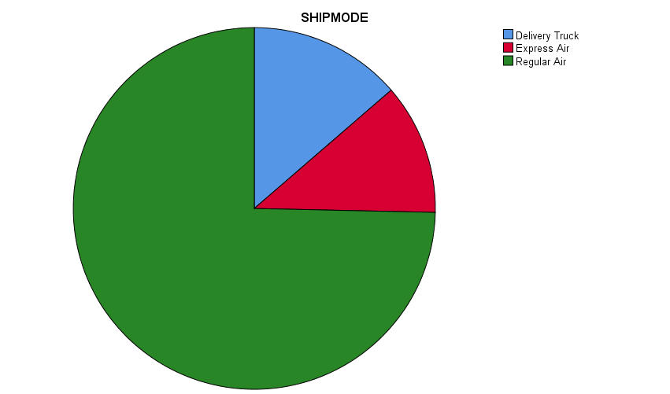
Figure 1
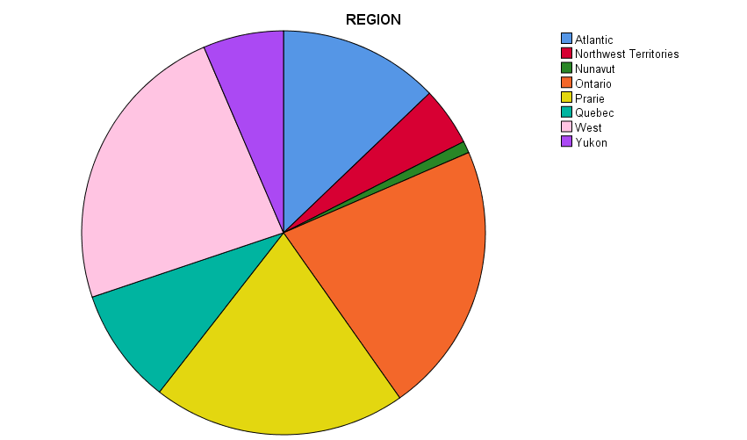
Figure 2
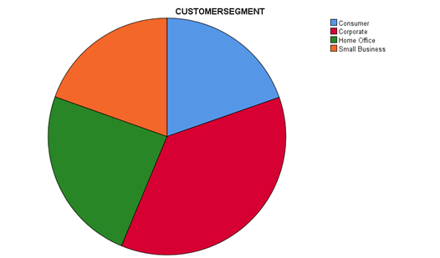
Figure 3
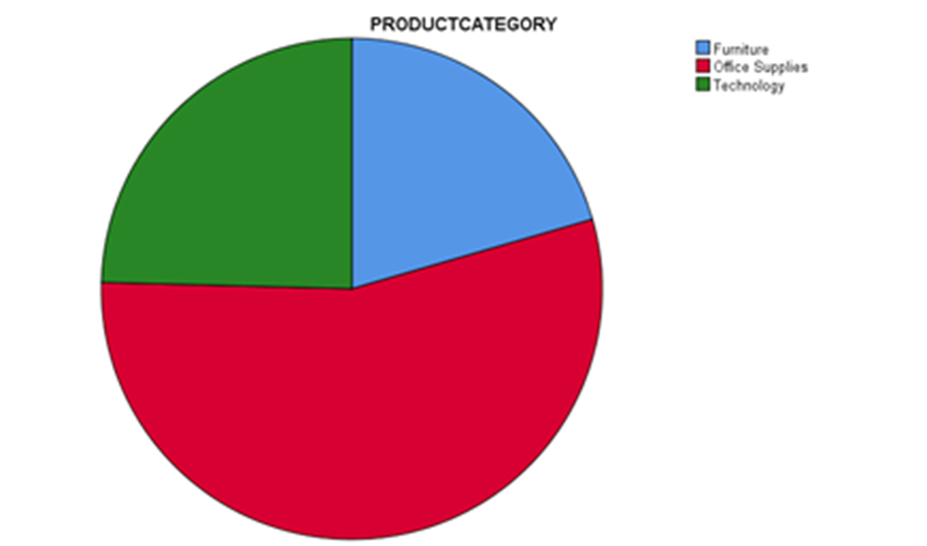
Figure 4

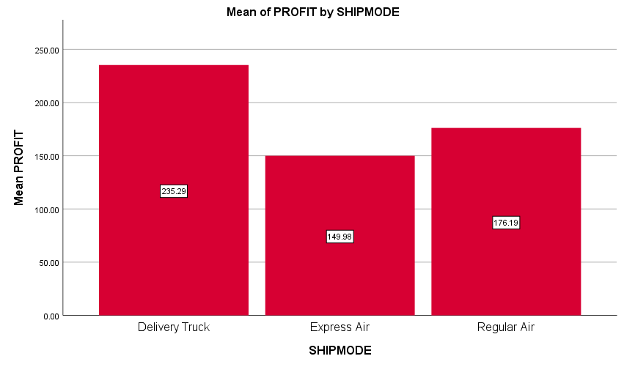
Figure 5
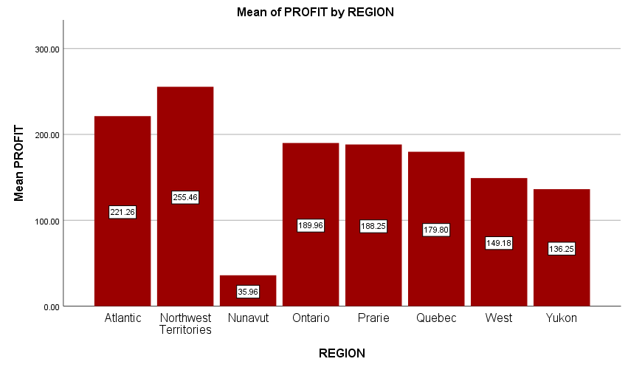
Figure 6

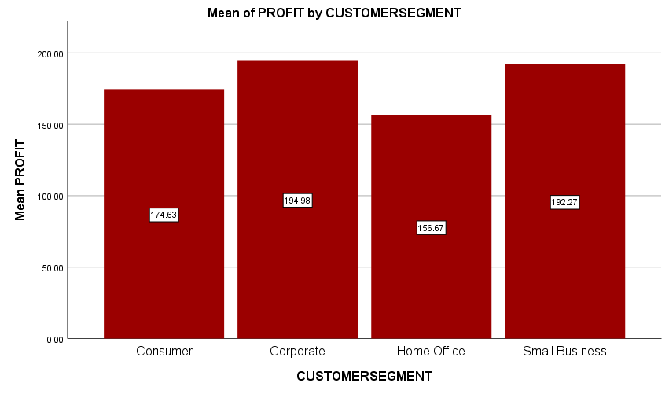
Figure 7
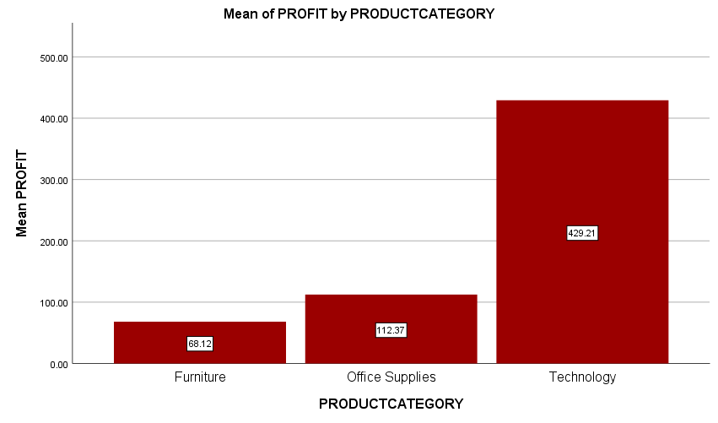
Figure 8

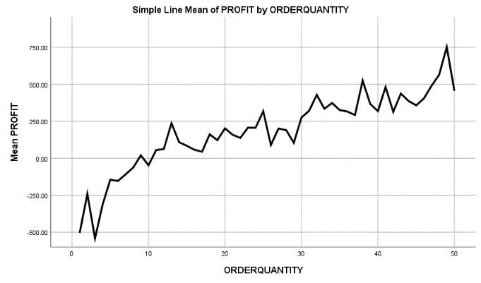

Figure 9

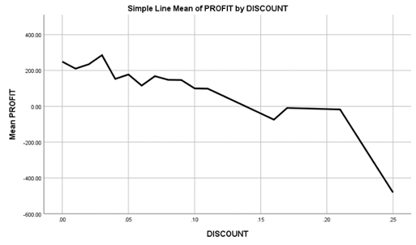

Figure 10

References:
Paige, C. C. (1970). Practical use of the symmetric Lanczos process with re-orthogonalization. BIT Numerical Mathematics, 183–195. https://doi.org/10.1007/BF01936866.
Monahan, James P. (1984). A Quantity Discount Pricing Model to Increase Vendor Profits. Management Science, 720-726. https://doi.org/10.1287/mnsc.30.6.720.
Sievänen, M., Suomala, P , & Paranko, J. (2004). Product profitability: Causes and effects. Industrial Marketing Management, 393-401. https://doi.org/10.1016/j.indmarman.2003.08.017.
Overman, H. G. (2004). Can we learn anything from economic geography proper? . Journal of Economic Geography, 501–516. https://doi.org/10.1093/jnlecg/lbh028.
David W. Pentico, & Matthew J. Drake. (2010). Price discounts for increased profitability under partial backordering. International Transactions in Operational Research18, 87-101. https://doi.org/10.1111/j.1475-3995.2010.00779.x.
Pepe, M. S., Abratt, R., & Dion , P. (2011). The impact of private label brands on customer loyalty and product category profitability. Journal of Product & Brand Management, 27-36. https://doi.org/10.1108/10610421111107996.
Kim, H., Hoskisson, R. E., & Lee, s. h. (2015). Why strategic factor markets matter: "New" multinationals' geographic diversification and firm profitability. Strategic Management Journal 36(4), 518-536. https://www.researchgate.net/publication/274720758_Why_strategic_factor_markets_matter_New_multinationals'_geographic_diversification_and_firm_profitability.
Hughes, P., Hodgkinson, I. R., Morgan, R. E., Hughes, M., & Hughes, C.-H. L. (2020). Product-market planning capability and profitability. Industrial Marketing Management, 370-379. https://doi.org/10.1016/j.indmarman.2020.08.007.
Dou, W. W., Ji, Y., & Wu, W. (2021). Competition, profitability, and discount rates. Journal of Financial Economics, 582-620. https://doi.org/10.1016/j.jfineco.2020.12.013.
Abdullah, M., Al-Sayed, A. M., & Al-Ajmi, H. A. (2023). The Impact of Sectoral Diversification and Geographical Diversification on the Earning Quality with an Applied Study on Kuwaiti Listed Firms . Journal of Contemporary Studies, 1124-1170. https://doi.org/10.21608/csj.2024.190914.1340.
SHIBU, J., FWAMBA, R., & MUGANDA, M. (2023). Effect of Economic Order Quantity (EOQ) Inventory Measurement on Profitability of Top 100 Medium Enterprises in Kenya. ICONIC RESEARCH AND ENGINEERING JOURNALS, 414-419. https://www.irejournals.com/formatedpaper/1705151.pdf.
Tavor, T., Gonen, L. D., & Spiegel, U. (2023). Customer Segmentation as a Revenue Generator for Profit Purposes. Mathematics, 4425. https://doi.org/10.3390/math11214425.
SPSS Codes:
* Encoding: UTF-8.

DATASET ACTIVATE DataSet1.
DESCRIPTIVES VARIABLES=ORDERQUANTITY DISCOUNT PROFIT
/STATISTICS=MEAN STDDEV MIN MAX.

FREQUENCIES VARIABLES=SHIPMODE CUSTOMERSEGMENT REGION PRODUCTCATEGORY
/PIECHART FREQ
/ORDER=ANALYSIS.

MEANS TABLES=PROFIT BY SHIPMODE
/CELLS=MEAN COUNT STDDEV.

MEANS TABLES=PROFIT BY REGION
/CELLS=MEAN COUNT STDDEV.

MEANS TABLES=PROFIT BY CUSTOMERSEGMENT
/CELLS=MEAN COUNT STDDEV.

MEANS TABLES=PROFIT BY PRODUCTCATEGORY
/CELLS=MEAN COUNT STDDEV.

* Chart Builder.
GGRAPH
/GRAPHDATASET NAME="graphdataset" VARIABLES=ORDERQUANTITY MEAN(PROFIT)[name="MEAN_PROFIT"]
MISSING=LISTWISE REPORTMISSING=NO
/GRAPHSPEC SOURCE=INLINE.
BEGIN GPL
SOURCE: s=userSource(id("graphdataset"))
DATA: ORDERQUANTITY=col(source(s), name("ORDERQUANTITY"))
DATA: MEAN_PROFIT=col(source(s), name("MEAN_PROFIT"))
GUIDE: axis(dim(1), label("ORDERQUANTITY"))
GUIDE: axis(dim(2), label("Mean PROFIT"))
GUIDE: text.title(label("Simple Line Mean of PROFIT by ORDERQUANTITY"))
ELEMENT: line(position(ORDERQUANTITY*MEAN_PROFIT), missing.wings())
END GPL.

* Chart Builder.
GGRAPH
/GRAPHDATASET NAME="graphdataset" VARIABLES=DISCOUNT MEAN(PROFIT)[name="MEAN_PROFIT"]
MISSING=LISTWISE REPORTMISSING=NO
/GRAPHSPEC SOURCE=INLINE.
BEGIN GPL
SOURCE: s=userSource(id("graphdataset"))
DATA: DISCOUNT=col(source(s), name("DISCOUNT"))
DATA: MEAN_PROFIT=col(source(s), name("MEAN_PROFIT"))
GUIDE: axis(dim(1), label("DISCOUNT"))
GUIDE: axis(dim(2), label("Mean PROFIT"))
GUIDE: text.title(label("Simple Line Mean of PROFIT by DISCOUNT"))
ELEMENT: line(position(DISCOUNT*MEAN_PROFIT), missing.wings())
END GPL.

* Chart Builder.
GGRAPH
/GRAPHDATASET NAME="graphdataset" VARIABLES=SHIPMODE MEAN(PROFIT)[name="MEAN_PROFIT"]
MISSING=LISTWISE REPORTMISSING=NO
/GRAPHSPEC SOURCE=INLINE.
BEGIN GPL
SOURCE: s=userSource(id("graphdataset"))
DATA: SHIPMODE=col(source(s), name("SHIPMODE"), unit.category())
DATA: MEAN_PROFIT=col(source(s), name("MEAN_PROFIT"))
GUIDE: axis(dim(1), label("SHIPMODE"))
GUIDE: axis(dim(2), label("Mean PROFIT"))
GUIDE: text.title(label("Simple Bar Mean of PROFIT by SHIPMODE"))
SCALE: linear(dim(2), include(0))
ELEMENT: interval(position(SHIPMODE*MEAN_PROFIT), shape.interior(shape.square))
END GPL.

* Chart Builder.
GGRAPH
/GRAPHDATASET NAME="graphdataset" VARIABLES=REGION MEAN(PROFIT)[name="MEAN_PROFIT"]
MISSING=LISTWISE REPORTMISSING=NO
/GRAPHSPEC SOURCE=INLINE.
BEGIN GPL
SOURCE: s=userSource(id("graphdataset"))
DATA: REGION=col(source(s), name("REGION"), unit.category())
DATA: MEAN_PROFIT=col(source(s), name("MEAN_PROFIT"))
GUIDE: axis(dim(1), label("REGION"))
GUIDE: axis(dim(2), label("Mean PROFIT"))
GUIDE: text.title(label("Simple Bar Mean of PROFIT by REGION"))
SCALE: linear(dim(2), include(0))
ELEMENT: interval(position(REGION*MEAN_PROFIT), shape.interior(shape.square))
END GPL.

* Chart Builder.
GGRAPH
/GRAPHDATASET NAME="graphdataset" VARIABLES=CUSTOMERSEGMENT MEAN(PROFIT)[name="MEAN_PROFIT"]
MISSING=LISTWISE REPORTMISSING=NO
/GRAPHSPEC SOURCE=INLINE.
BEGIN GPL
SOURCE: s=userSource(id("graphdataset"))
DATA: CUSTOMERSEGMENT=col(source(s), name("CUSTOMERSEGMENT"), unit.category())
DATA: MEAN_PROFIT=col(source(s), name("MEAN_PROFIT"))
GUIDE: axis(dim(1), label("CUSTOMERSEGMENT"))
GUIDE: axis(dim(2), label("Mean PROFIT"))
GUIDE: text.title(label("Simple Bar Mean of PROFIT by CUSTOMERSEGMENT"))
SCALE: linear(dim(2), include(0))
ELEMENT: interval(position(CUSTOMERSEGMENT*MEAN_PROFIT), shape.interior(shape.square))
END GPL.

* Chart Builder.
GGRAPH
/GRAPHDATASET NAME="graphdataset" VARIABLES=PRODUCTCATEGORY MEAN(PROFIT)[name="MEAN_PROFIT"]
MISSING=LISTWISE REPORTMISSING=NO
/GRAPHSPEC SOURCE=INLINE.
BEGIN GPL
SOURCE: s=userSource(id("graphdataset"))
DATA: PRODUCTCATEGORY=col(source(s), name("PRODUCTCATEGORY"), unit.category())
DATA: MEAN_PROFIT=col(source(s), name("MEAN_PROFIT"))
GUIDE: axis(dim(1), label("PRODUCTCATEGORY"))
GUIDE: axis(dim(2), label("Mean PROFIT"))
GUIDE: text.title(label("Simple Bar Mean of PROFIT by PRODUCTCATEGORY"))
SCALE: linear(dim(2), include(0))
ELEMENT: interval(position(PRODUCTCATEGORY*MEAN_PROFIT), shape.interior(shape.square))
END GPL.

