Omar Elsamahy 18102063

I Have Created **two** Models

1)

Generator Architecture

dense (Dense) multiple 3660800

batch_normalization (BatchN multiple 146432

ormalization)

leaky_re_lu (LeakyReLU) multiple 0

reshape (Reshape) multiple 0

upsample (Upsample) multiple 1639680

upsample_1 (Upsample) multiple 819840

upsample_2 (Upsample) multiple 205120

conv2d_transpose_3 (Conv2DT multiple 4803

Discriminator arch

input_1 (InputLayer) [(None, 104, 88, 3)] 0

cnn_block (CNNBlock) multiple 2432

cnn_block_1 (CNNBlock) multiple 51264

cnn_block_2 (CNNBlock) multiple 204928

cnn_block_3 (CNNBlock) multiple 819456

flatten (Flatten) multiple 0

dense_1 (Dense) multiple 585729

10 Images

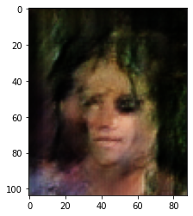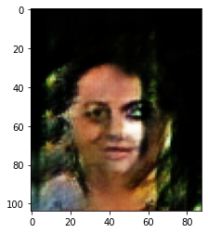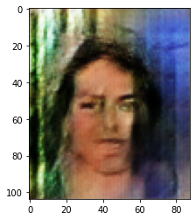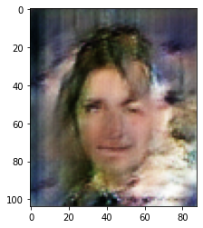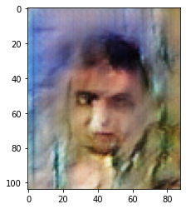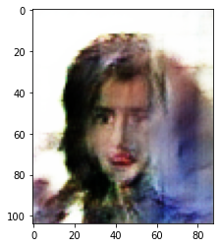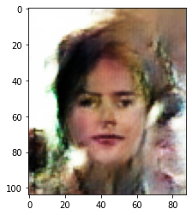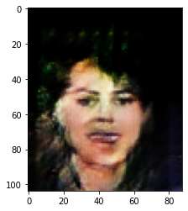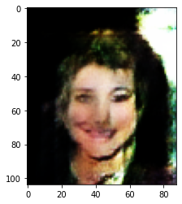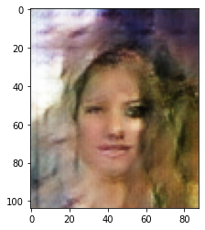

Discriminator Loss

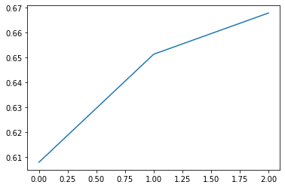

Generator Loss

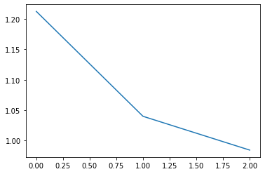

Second Model Architecture

Model: "discriminator"

_________________________________________________________________

Layer (type) Output Shape Param #

=================================================================

conv2d_7 (Conv2D) (None, 32, 32, 64) 3136

leaky_re_lu_15 (LeakyReLU) (None, 32, 32, 64) 0

conv2d_8 (Conv2D) (None, 16, 16, 128) 131200

leaky_re_lu_16 (LeakyReLU) (None, 16, 16, 128) 0

conv2d_9 (Conv2D) (None, 8, 8, 128) 262272

leaky_re_lu_17 (LeakyReLU) (None, 8, 8, 128) 0

flatten_1 (Flatten) (None, 8192) 0

dropout_1 (Dropout) (None, 8192) 0

dense_5 (Dense) (None, 1) 8193

=================================================================

Total params: 404,801

Trainable params: 404,801

Non-trainable params: 0

Model: "generator"

_________________________________________________________________

Layer (type) Output Shape Param #

=================================================================

dense_6 (Dense) (None, 8192) 1056768

reshape_4 (Reshape) (None, 8, 8, 128) 0

conv2d_transpose_12 (Conv2D (None, 16, 16, 128) 262272

Transpose)

leaky_re_lu_18 (LeakyReLU) (None, 16, 16, 128) 0

conv2d_transpose_13 (Conv2D (None, 32, 32, 256) 524544

Transpose)

leaky_re_lu_19 (LeakyReLU) (None, 32, 32, 256) 0

conv2d_transpose_14 (Conv2D (None, 64, 64, 512) 2097664

Transpose)

leaky_re_lu_20 (LeakyReLU) (None, 64, 64, 512) 0

conv2d_10 (Conv2D) (None, 64, 64, 3) 38403

=================================================================

Total params: 3,979,651

Trainable params: 3,979,651

Non-trainable params: 0

Discriminator Loss



Generator Loss



**Images Generated :**

