**Final Report Project CIE202**

**Names: IDs:**

**Omar Elsayed 202100597**

**Ahmed Ayman 202100172**

**Ahmed Hossam 202201150**

**Mahmoud Ayman 202200147**

**Save And Load feature**

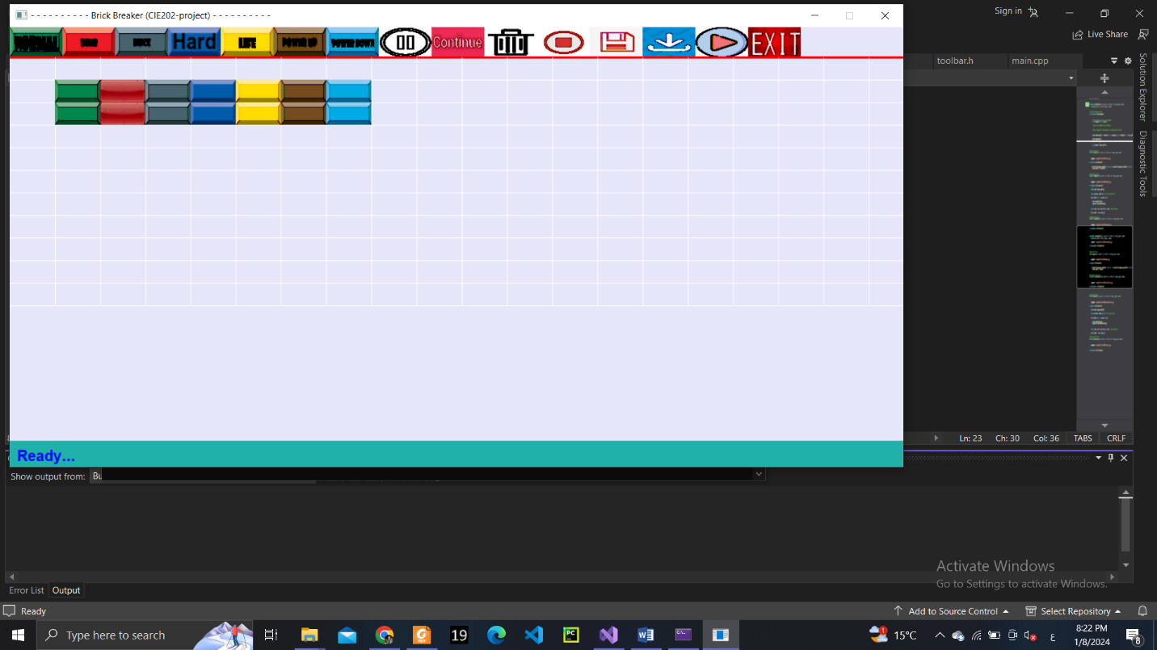

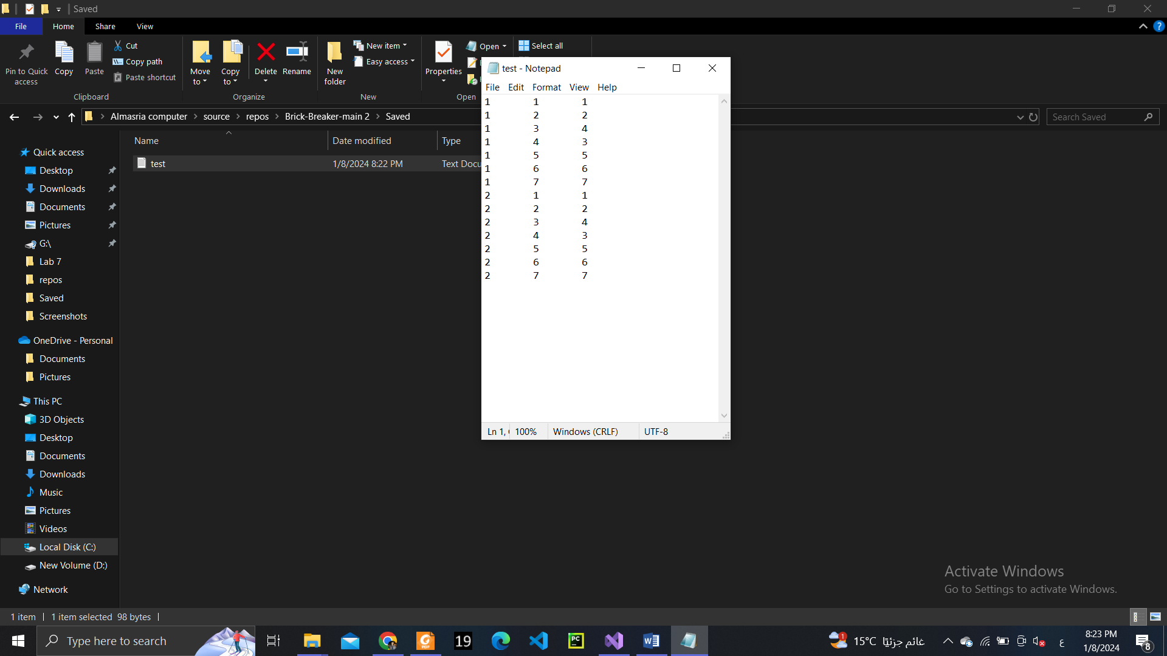 **1 🡪 Normal Brick**

**2 🡪 Bomb Brick**

**3 🡪 Hard Brick**

**4 🡪 Rock Brick**

**5 🡪 Life Brick**

**6 🡪 PowerUp Brick**

**7 🡪 PowerDown Brick**

|  |  |  |  |
| --- | --- | --- | --- |
| **#** | **Feature** | **Relative W.** | **Name** |
| **1** | * Draw Main page including:  1. Add Bricks empty grid 2. Game time and Score 3. 3 Lives | **5** | **Shared** |
| **2** | * Implement a player’s paddle and place it at the bottom of the window | **10** | **Omar Elsayed** |
| **3** | * Draw the toolbar with both design mode: * Brick types icons (Normal-Hard-Bomb-Rock) * Save * Load * Exit * And Play mode: * Play * Pause * Continue * Stop | **5** | **Shared** |
| **4** | * Implement actions related to toolbar brick icons to add bricks | **15** | **Ahmed Ayman** |
| **5** | * Implement Regular Brick:  1. Normal = 1 strength unit, Hard = 3 strength units 2. Collision action to reduce strength by -1, and increase score by +1 3. Disappear (destroy) when strength = 0 | **10** | **Ahmed Hossam** |
| **6** | * Implement Bomb Brick:   Collision Action  The touching bricks disappear (the bomb and 3 touching bricks)  Update the score by +4 | **10** | **Ahmed Hossam** |
| **7** | * Implement Rock Brick:   Collision Action Undestroyable but deflects the ball | **5** | **Ahmed Hossam** |
| **8** | Implement Power up/down bricks  Collision Action  Throw down one collectable vertically and disappear without updating the score | **10** | **Omar Elsayed** |
| **9** | * Implement new brick type   Has same strength as normal brick, increases the life count by 1 if the total lives are less than 3. | **10** | **Mahmoud Ayman** |
| **10** | * Delete a brick from the playground | **10** | **Shared** |
| **11** | * Save design to a file. | **20** | **Ahmed Ayman** |
| **12** | * Load design to a file. | **20** | **Ahmed Ayman** |
| **13** | * Implement the ball and attach it on the middle of the paddle when the play icon is pressed | **10** | **Ahmed Ayman & Omar Elsayed** |
| **14** | * Move paddle left and right using Keyboard | **10** | **Omar Elsayed** |
| **15** | * Implement Play | **5** | **Omar Elsayed** |
| **16** | * Implement Pause/Continue/Stop icon actions | **10** | **Ahmed Hossam** |
| **17** | * Launch the ball attaches to the paddle vertically when the spacebar is pressed | **5** | **Ahmed Ayman** |
| **18** | * Move the ball in straight line (vertical or inclined) | **10** | **Ahmed Ayman** |
| **19** | * Detect the collision between two collidable objects | **20** | **Omar Elsayed** |
| **20** | * If a ball collides with paddle -> the deflection angle ranges from vertical (0) to (45deg) based on distance from the paddle centre | **20** | **Ahmed Hossam** |
| **21** | * If ball collides with brick:   Change ball direction (deflection)  The direction is based on the length between the point of collision and the center of the brick to deflect at a varying angle from 0 to 45 deg. | **25** | **Ahmed Hossam** |
| **22** | If paddle collides with a collectable: Perform collectable action based on collectable type | **20** | **Omar Elsayed** |
| **23** | * Ball deflection from up/right-side/left side walls at equal incidence and deflection angles. | **10** | **Ahmed Ayman** |
| **24** | * If a ball crossed the bottom edge:   Lose life by -1  If all lives are lost, end game (return to design mode), and display “Game over, Final score: x” | **20** | **Mahmoud Ayman** |
| **25** | * Implement Power Ups collectables:   Fireball -> can destroy even rock brick and hard bricks in one hit. | **15** | **Mahmoud Ayman** |
| **26** | WindGlide -> It allows the paddle to move faster for 1 min | **10** | **Ahmed Ayman** |
| **27** | WidePaddle -> Extend the Paddle’s width for 1 min  NarrowPaddle -> Narrow the paddle width for 1 min | **15** | **Mahmoud Ayman** |
| **28** | Magnet -> Attach the ball to the paddle, until launched again by the space bar. | **15** | **Mahmoud Ayman** |
| **29** | MultipleBalls -> Releases multiple balls the fall towards the paddle and the player needs to play with them all. | **30** | **Omar Elsayed** |
| **30** | * Implement Power Down collectables:   ReverseDirection->Invert paddle’s movement controls for 2 mins | **10** | **Ahmed Ayman** |
| **31** | QuickSand-> Slowdown the paddle’s movement | **10** | **Ahmed Ayman** |
| **32** | If all bricks are destroyed, end game, display message with score | **5** | **Ahmed Hossam** |
| **33** | Implement different sound effects on different collision actions. | **10** | **Omar Elsayed** |
| **34** | Recursive action of Bomb Brick collision action | **25** | **Ahmed Hossam** |

**Total Points Distribution:**

**Omar Elsayed : 120 +5**

**Ahmed Ayman: 115 +5**

**Ahmed Hossam : 110 +5**

**Mahmoud Ayman : 75 +5**

**Shared: 20**