**Linux Commands**

**Link of list :** [**https://www.youtube.com/watch?v=gd7BXuUQ91w**](https://www.youtube.com/watch?v=gd7BXuUQ91w)

1. **Ssh : de bt login ll Linux machine bt3tk > ex : SSh username@ip > then yes and enter password**
2. **Ls > List all files in a directory > just : ls**
3. **Ls -L > btdehany b more details aktr zi l tare5 w no3 l file system w hakza**
4. **Ls -aL > nfs l klam bss kman btzhr l hidden files**
5. **Pwd > print which ( what ) directory > btbyn ehna f anhy directory ( working directory )**
6. **Cd > change directory , cd / > btwdena ll root user , cd .. > btrg3 one step ( directory ) , cd space > btrg3 ll home directory.**
7. **Touch > creating a file , touch name1 name2 name3 > create 3 files , touch omar {1..5 } > create 5 files b nfs l esm wl no3 bss arkam mo5tlfa y3ni > omar1 omar2 omar3… w hakza**
8. **Touch -d ( date you need file to be created on, ex : tomorrow ) filename > bt7dd l file yt create emta y3ni lw ktbt touch -d tomorrow filename > htla2y bokra l file mwgod w etcreate, bss lw mn sa3t ma ktbt l command w ktbt ls -l hyzhrlk 3ady bl date l lsa fl future 7ta**
9. **Echo > print something , [ echo “ something something “ > filename ] > bt7ot l klam da gowa l file l mo3yn da 7ta lw bytcreate l awl mra ( new or existing file )**
10. **Nano filename > bt create file w btd5lna gowa l file da zi l vim kda, nano commands b2a > ctrl + x + y to save and exit from the file**
11. **Vim filename > create brdo w kda w ehna 3arfenha, i > insert , then esc + :wq > save and quit , lakn :w save bss**
12. **Cat filename > bt print l mwgod fl file kolo n2rah**
13. **Shred filename > bt encrypt kol l fl file b 7es m7dsh y2rah 5alsss.**
14. **Mkdir > create directory**
15. **Cp > copy file aw directory aw ay haga bss lw directory fa htktb cp -r directory name, cp filename ./path/filename**
16. **Mv > move file aw directory brdo > b nfs l tare2a l copy fo2**
17. **Rm > remove file or directory ( rm -r > ll directory )**
18. **Ln > link to a file , ln -s filename nameofthelink , then write ls -l to see the link**
19. **Clear > clear l terminal**
20. **Whoami > know which user**
21. **Sudo > making command as a root user , sudo adduser ,sudo mkdir ,sudo pswd , sudo…**
22. **adduser > adding a new user and identifying its unique password and some other parameters if needed, sudo adduser user > set pswd for it**
23. **useradd > adding a new user without identifying a specific pswd for it, just enter the pswd of root user to authentication and authorization.**
24. **Su > Then to switch to any user , su user > then write exit to exit from the user.**
25. **Sudo passwd user > creating new password for the user**
26. **Sudo apt > Debian based , sudo yum > redhat based , sudo pacman > arch ,  
    and to install smth, 1- sudo apt update , 2- sudo apt install.**
27. **Finger > is a package you must install first from sudo apt install finger > and it is used to inspect a specific user > finger user**
28. **Man > used to help and figure out what any command does > man finger, man cat , man touch , .. de bt5lena y3ni n3rf l command da by3ml ehh bzbt bss.**
29. **Whatis > momkn nst5dmha zi man kda bss l fr2 enha bt3rfna da ehh bzbt mn gher d5ol f tfaselo wl commands bt3to l momkn nst5dmha beeh y3ni msln > whatis finger : htgelk enha user information lookup .. w da olnah fo2 w hakza**
30. **Which w whereis > l fr2 benhom en   
    which de btgby mkan wa7d bss ll package bt3ty aw l command bt3ty mt5zna fen,   
    lakn whereis de bt5lena n3rf kol l amakn l mt5zna feha l command de  
    ex : which finger , whereis finger ( minute 4:40 )**
31. **Wget > wget internet link > bt download haga mn 3la mwk3 mo3yn bst5dmha fl downloading y3ni**
32. **Curl : curl internet_link > a3mlha download w a7otha gowa file 3la tol**
33. **Zip : zip filename.zip filename > bt zip file 3ady**
34. **Unzip > unzip filename.zip**
35. **Less > lma yb2a 3ndk file kber awii w ynzlk t7t fa tktb less 34an tgeb saf7a saf7a kda**
36. **Head filename> btgeb awl 20 str mn l file aw momkn a7dd msln head -10 > awl 10 w hakza m3 l tail brdo**
37. **Tail filename> btgeb a5r 20 str mn l file**
38. **Cmp > compare two files aw two objects y3ni bss btdek mo5tlfen f ehh kda bss l size msln wl lines lakn msh b tfasel lakn l diff btdy tfasel aw exactly eh l difference fen**
39. **Sort > bt sort l haga alphabitcally zi msln enk t3rd haga b cat   
    cat filename | sort > hy3rd l file sorted**
40. **Find > lw 3ayz adwr 3la file mo3yn aw klma mo3yna f directory aw f file mo3yn  
    y3ni msln   
    lw 3ayz adwr 3la file f esmo klma mo3yna fa bktb : sudo find / -name “ kza kza “  
    l / de m3naha all directories y3ni mdtlosh path mo7dd fa hygbly kol l directories l fehom file bl esm da  
    lw 3ozt adwr 3la l files l hidden msln > sudo find . -type f -name “ . * ” > de htgeb kol l hidden files  
    lw 3ayz adwr 3la empty directories > sudo find . -type f -empty  
    lw 3ayz adwr 3l executable files > sudo find . -perm / a=x**
41. **Chmod > da lw 3ayz a8yr type l file y3ni lw 3ayz a5leeh executable msln  
    chmod +x filename  
    w 34an a execute l file b2a aw a run y3ni > ./filename**
42. **Chown > lw 3ayz a8yr l ownership bt3t file aw directory aw ayan kan y3ni l user mo3yn  
    msln > chown user filename**
43. **ifconfig > da lw 3ayz a3rf l ip address bta3y bss lazm l awl a install l package de  
    sudo apt install net-tools > then run ifconfig**
44. **ip address > brdo btgeb l ip address akid zi l fo2**
45. **grep > de lw 3ayz a filter f file aw f ay 7eta b line mo3yn feh klma mo3yna  
    y3ni msln 3mlt ip address fa hygbly klam kter gowah inet wl ip w kda  
    fa ana a3ml b2a ip address | grep inet   
    fa hygbly kol l lines l feha l klma de inet   
    y3ni mn l a5r l grep de bnst5dmha f enna nbst 3la nfsna l search lw 3arfen l klma f anhy file bss bdl ma n3od ndwr b 3enena w kda btgblna kol l 3yzeno**
46. **awk > haga kda more efficient aktr mn l grep kman bss hya zyha y3ni   
    awk bnst5dmha m3 l grep brdo b 7es en nta gowa l line wsltlo bl grep fa etb3ly l expression aw l klma l tanya fl line da   
    ip address | grep inet | awk ‘ { print $2 } ‘  
    fa kda httb3 l klma l tanya fl line lw $3 fa httb3 l talta w hakza**
47. **resolvectl status > de lw 3ayz a3rf l dns bta3y**
48. **ping > lw 3ayz a5tbr l website up aw la wl connection benna ehh , ping website name , zi msln ping google.com**

**w 34an a exit mn l ping > ctrl + c**

**aw bdl ma ab3t requests kter aw a5od responses kter momkn aktb kda : ping -c 5 websitename .. kda b limit y3ni**

1. **traceroute > lw 3ayz a3rf l path l 5dto 34an awsl l website mo3yn   
   y3ni lw 3ayz awsl l google mn masr msln fa b3dy 3la kza hub l 7d ma awsl ll main hub bta3 google fa hya btgbly l path da kolo b2a**
2. **netstat > btwreny kol l ports aw l switches l sh8ala aw connected 3ndy tb3y y3ni  
   netstat -tulpn > btwrek l switches a7sn**
3. **ss -tulpn > zi l netstat -tulpn > btwrek l switches a7sn**
4. **iptables > de bst5dmha f eni a7dd port mo3yn eno y access mn l firewall bt3ty**
5. **ufw > de a7sn mn l fo2 l2ny bdl ma aktb command kber ydobk bktb bs   
   “ sudo ufw allow port_number “ w 5las kda  
   bss ablha b3ml enable leha “ sudo ufw enable “**
6. **uname > bt5lek t3rf no3 l vm l 3ndk ehh bl config bt3tha   
   uname -a**
7. **neofetch > btgeb data w config l machine bt3tk brdo w no3ha y3ni linux ubuntu wl local host w hakza**
8. **cal > calendar**
9. **free > lw 3ayz a3rf l space l available 3l machine bt3ty ad ehh ydobk bktb free bs**
10. **df > btshof l available space in details ydobk aktb “ df “ bss aw “ df -H “ b details aktr**
11. **ps > btgeb kol l processes l sh8ala 3ndk , bs l a7sn aktb brdo “ ps -aux “ btgeb kol l processes l mwgoda wl kant mwgoda bl details bt3thom**
12. **top w htop > 34an ashof awl process sh8alaa dol kda 3amlin zi l task manager kda msln**
13. **kill > bt end aw bt kill process aw task mo3yn   
    bs lazm ageb l id bta3ha l awl mn eni a3ml ps w b3dha a5od l id bta3 l process de  
    w agy aktb “ kill -9 id “ w bs kda 5las**
14. **pkill > de b2a bt kill kol l processes l mn no3 mo3yn y3ni msln ana msh8l kza tap google fa bdl ma a5od kol tap a3ml endtask aw a kill  
    la de bktb “ pkill -f processname ( google msln ) “ w bs kda**
15. **systemctl > 34an at7km fl services l 3ndy zi apache w kda,  
    bktb “ sudo systemctl enable aw start aw stop service name “**
16. **history > kol l commands aw l actions l 3mltha**
17. **reboot > sudo reboot : restart**
18. **shutdown > sudo shutdown > bt2fl f d2e2a aw “ sudo shutdown -h now “ bt2fl f sa3tha**

**MTR :**

**The mtr command is a network diagnostic tool that combines the functionality of two popular commands: traceroute and ping. It allows you to trace the route that your data packets take from your system to the destination server, while also providing statistics about each hop along the way.**

**NMAP**

**Nmap is a network scanner.**

**Nmap is used to discover hosts and services on a computer network by sending packets and analyzing the responses. Nmap provides a number of features for probing computer networks, including host discovery and service and operating system detection.**

**DIG**

**DIG command (Domain Information Groper command) is a network tool with a basic command-line interface that serves for making different DNS (domain name system) queries. You can use the DIG command to: Diagnose your name servers. Check all of them or each individual server and their response**

**NSLookUp**

**The nslookup command queries internet domain name servers in two modes. Interactive mode allows you to query name servers for information about various hosts and domains, or to print a list of the hosts in a domain.**

**TelNet**

**The telnet command in Linux is used to communicate with another host using the Telnet protocol. You can use it to connect to a remote server by specifying the host and the port like this: telnet host port . Here's a simple example: telnet example.com 80 # Output: # Trying 93.184.**

**ARP**

**Description. The arp command displays and modifies the Internet-to-adapter address translation tables used by the Address in Networks and communication management. The arp**

**DNS**

**( Domain Name Server )**

**Stub Resolver : de l hya server l bta3 l lap bta3k nta l by5zn feh fl caches l IPs l kant mwgoda abl kda aw d5ltha abl kda fa nta lw ktbt esm mwk3 hwa ygbholk 3la tol bdl ma yro7 ys2l google w google ys2l nfso aw ys2l servers tanya w hakza**

**W brdo google nfso momkn ykon act as stub resolver ykon 7d mn l zone bt3tk d5l 3lih abl kda fa ygbbholk 3la tol lw msh kda fa hyro7 ys2l b2a**

**The roots : they are only concerned with the TLD ( Top Level Domains zi ( .com - .net w hakza )y3ni mn l a5r dol a5r mr7la twslhom dol owner bto3 ahm w akbr 13 DNServers fl 3alm w t7thom b2a aw gherhom y3ni servers a2l dol l ts2lhom l awl w lw 3tlt twsl ll fo2hom l 7d ma twsl ll the roots**

**Mn l a5r l roots dol lma 7d byb3tlhom byego yboso 3l TLD y2ololo ahh da .com tb 5las 5od da esm l department aw l authority aw l server l t7tena l mask w ms2ol 3n l .com 5osh es2lo hwa**

**W b3dha l gd3 da y2olo 5od server kman ms2ol 3n l ( SLD ) second level domain ro7 as2lo w hakza b2a l 7d ma awsl ll ip l 3yzo**

**W feh kman sub-SLD**

**De l sora kolha b2a l steps bt3tha**

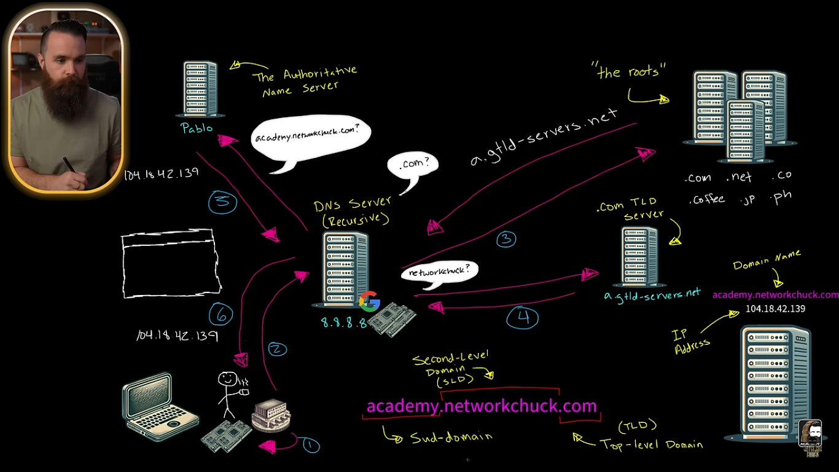

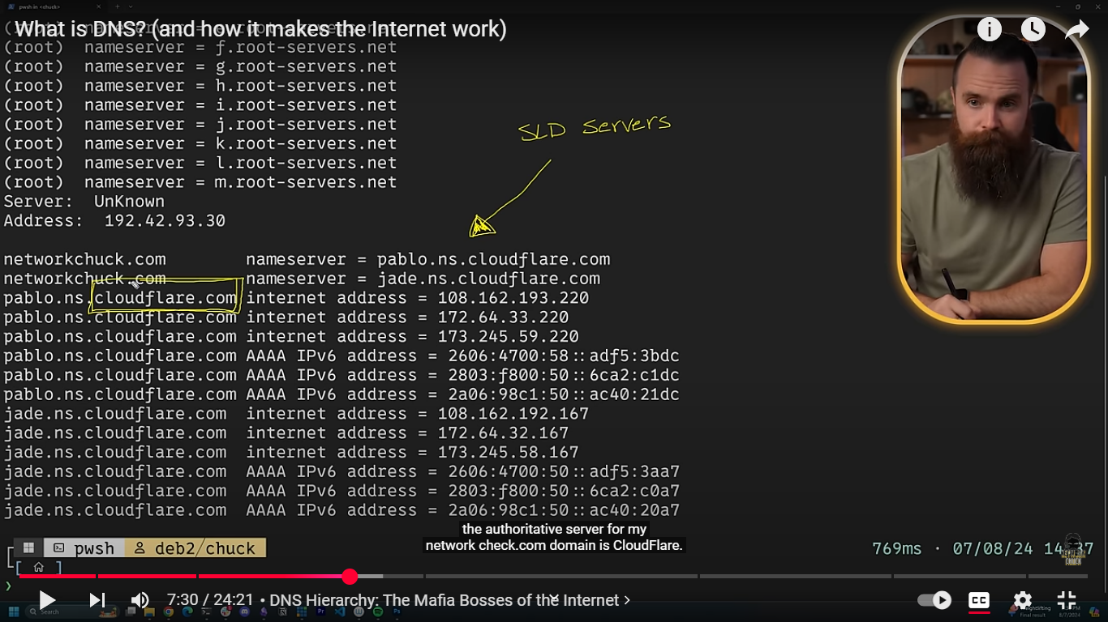

**W feh haga esmha mx records ( mail exchanger ) bt3ml nfs l klam ll dns lma tegy tb3t mail**

**PTR records ( reverse DNS ) de tdeha ip tdek l name b2a**

**W feh b2a l cname ( canonical name ) de l hya k2n nta 3ndk sub domains ( alias ) fa bywdo l eh b2a ll real domain aw l parent bta3hom**

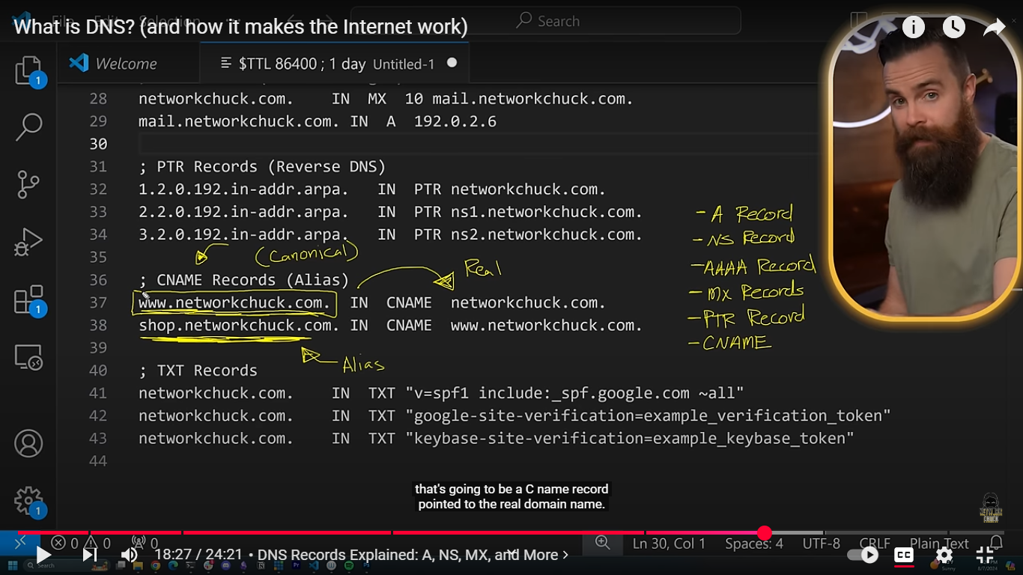

**W feh txt records : de ll secret messages aw secret subdomains y3ni**

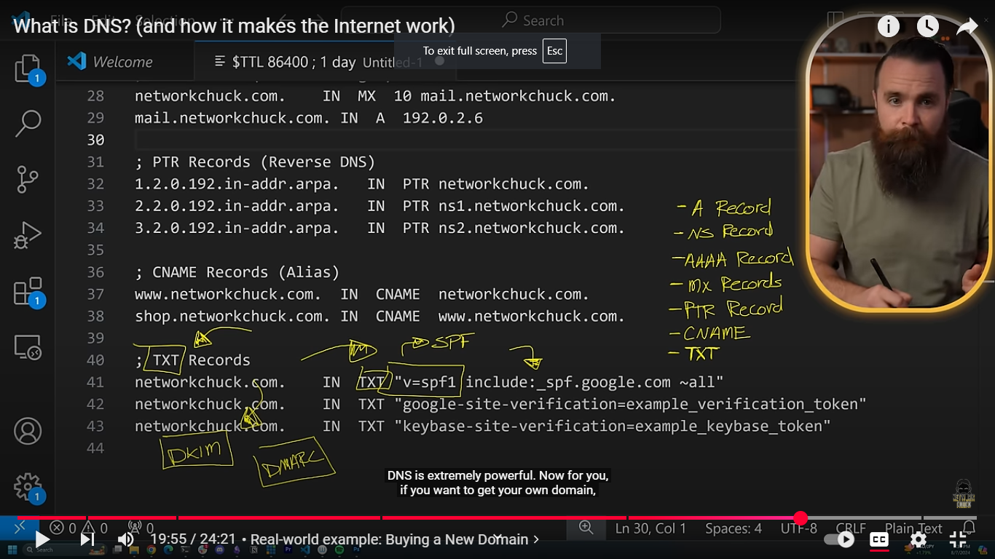

**ICANN : Internet Coporation for Assigned Name and Numbers > de l btdy l domains asln w bt assignha ll servers b2a wl root servers w kda**

**Bl nsba l goz2 l security b2a l stub resolver bta3y f awl 5atwa 5als w hwa bytlob l ip w byklm l dns**

**Fa momkn l hacker y3ml nfso en hwa l dns w y5osh yrod 3lih w ydelo ip l website aw l haga y2dr y5trko beha l2no asl l stub resolver da byklm l dns 3n tare2 l ( udb 53 ) f shkl plain text 3adyy w mk4of ll kol fa kda l hacker y2dr y3rf 3ady.**

**W da esmo DNS spoofing**

**Isp : internet service provider > de l bt5lek td5ol 3l internet asln bt3rf tshof kol l 7gat wl ips l nta zorthom**

**VmWare / VSphere**

**Sddc : Software-defined Data center**

* **server Virtualization** de l hya l physical component y3ni l 3ndk zi l cpu wl ram w kda 34an kda esmha compute ( VSphere )
* **Network de l hya switches w routers w firewalls w kda**
* **Storage de l hya mktoba t7t b2a :D**

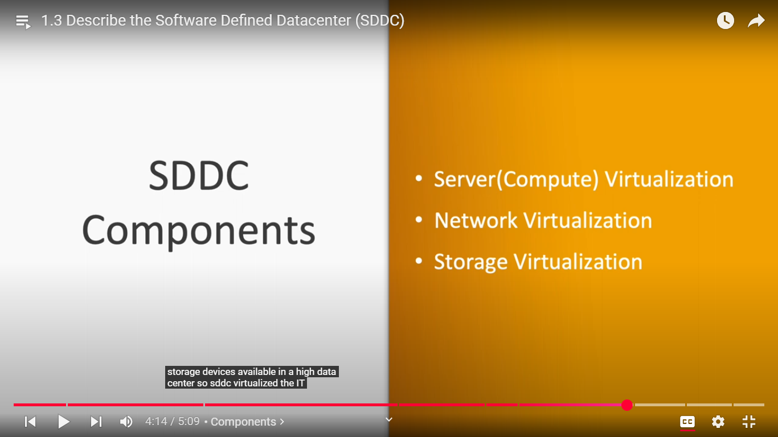

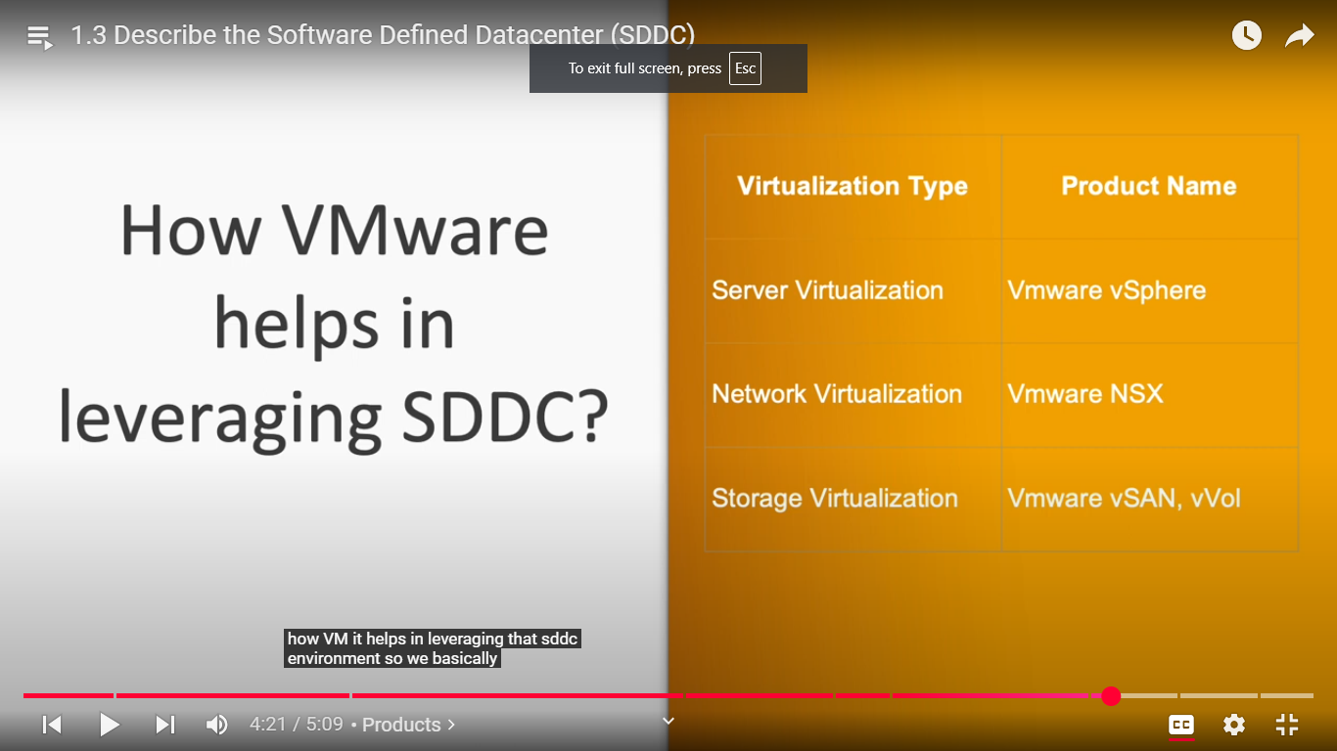

**Archeticture of server virtualization**

**( VSphere )**

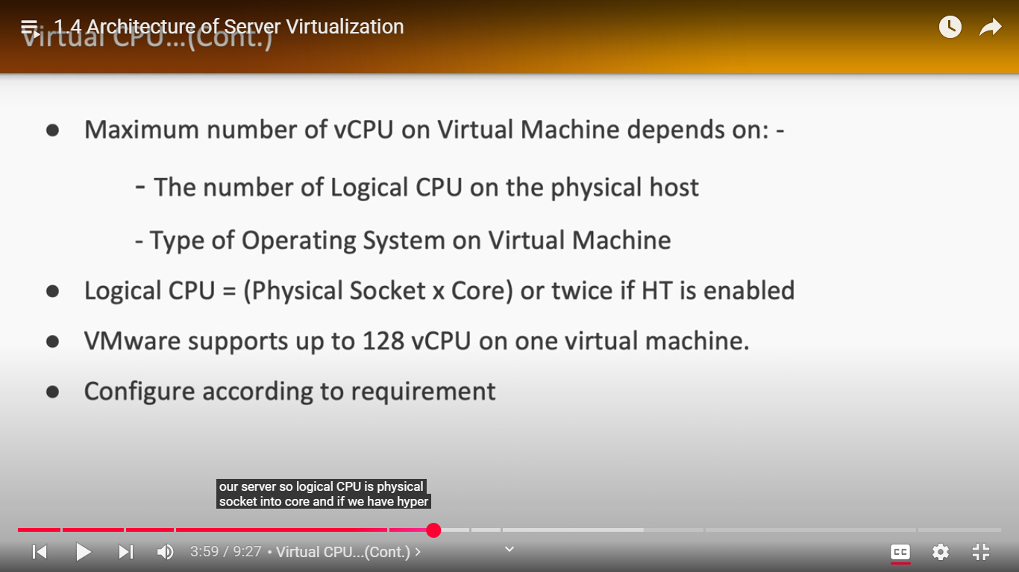

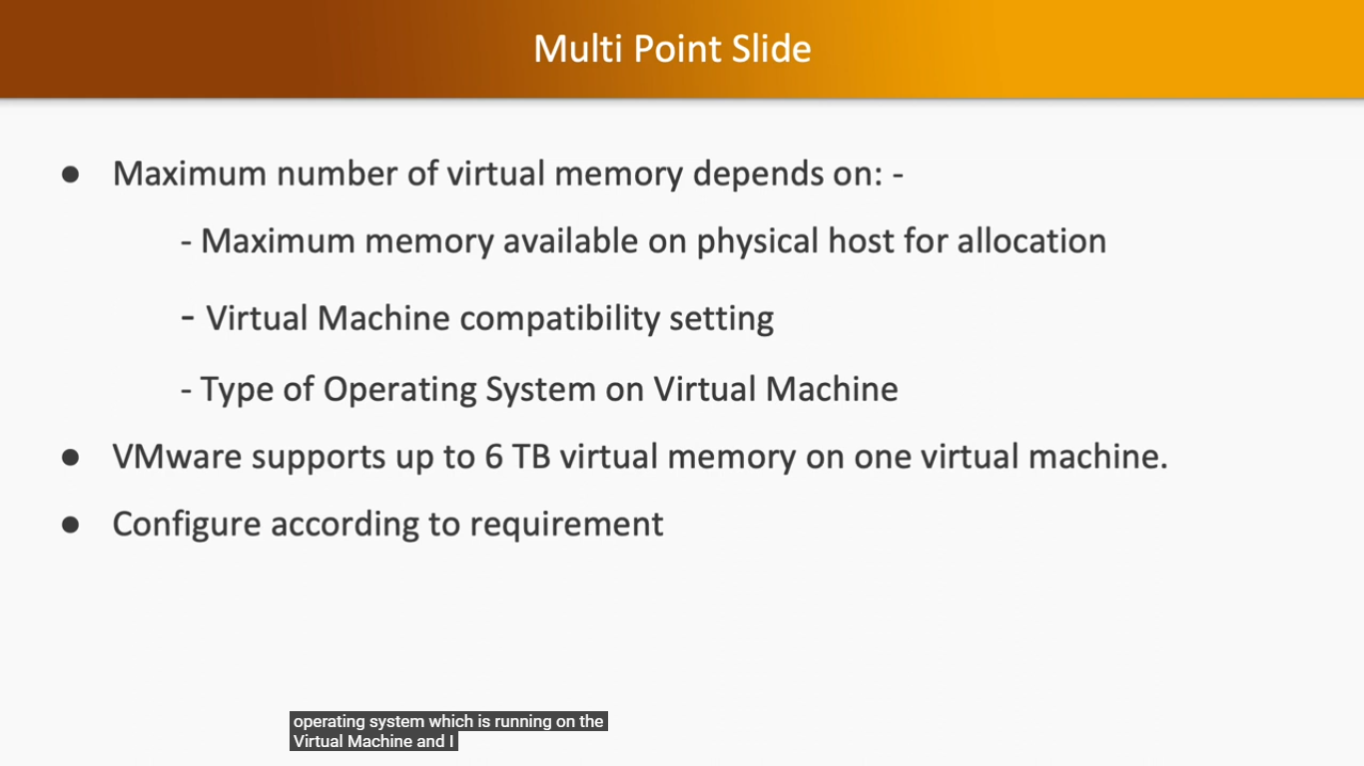

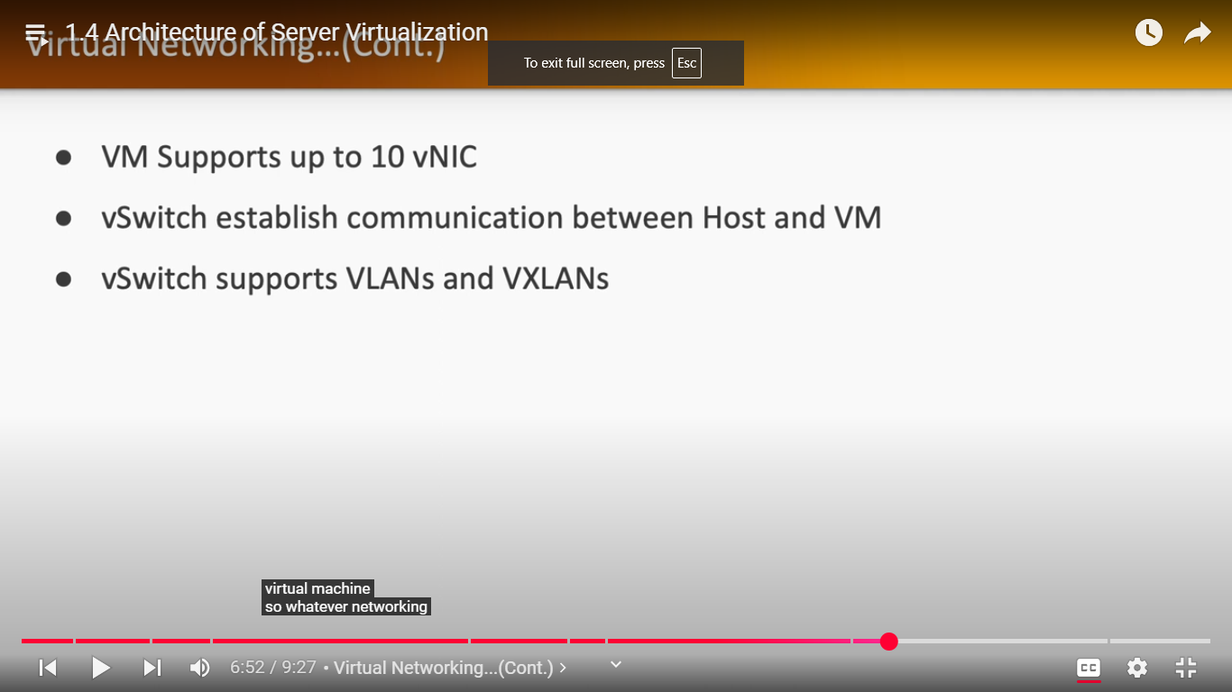

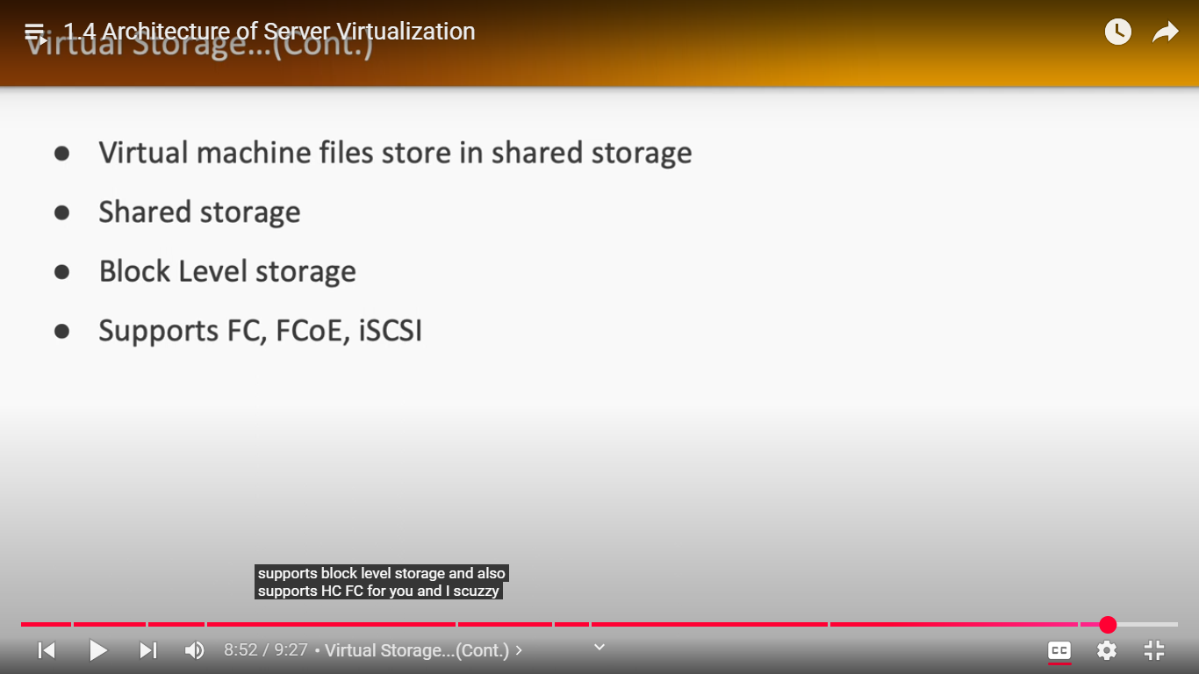

**VSphere**

