Introduction
Delwa2ty e7na bene2bad moratab kol shahr. El floos de haneshtery beha 7agat e7na 3ayzenha, w hayetba2a menha goz2 mesh me7tageen neshtery beeh 7aga delwa2ty. Tab3an el floos el hatefdal de mayenfa3sh tesebha cash 3ashan el inflation, lazem te invest it in a smart way to maintain its purchasing power. Ezay hane3mel keda? Howa da gharad el document de.

Order Your Financial Priorities
Mayenfa3sh teb2a betesref be tare2a 3ashwa2eya, shwaya tesref 3la 7agat mohema, shwaya te invest, shwaya tegeeb hadaya, shwaya tesafer, shwaya tegeeb dahab, da mayenfa3sh, lazem teb2a monazam. Maba2olaksh enena mesh hane3mel el 7agat de kolaha, hane3melha, bs be tare2a morataba w kol 7aga fi ma3adha. W 3ashan teb2a el denya morataba, lazem awel 7aga ne3raf tarteeb el 7agat el e7na benedfa3 fiha floos men 7ees el awlaweya:
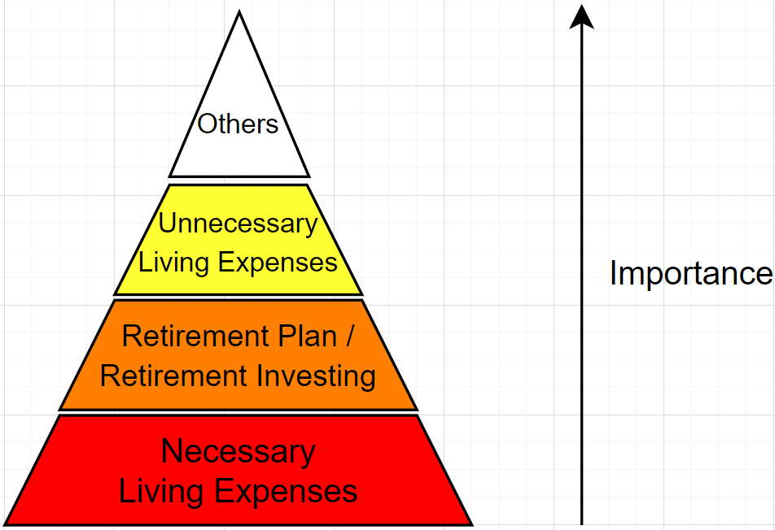

Necessary Living Expenses
These are the things that we can’t do without monthly; we MUST pay for. Some examples are (kol ma yezhar fi 7ayatak necessary living expenses ektebo ma3 el t7t dool 3ashan da haysa3dak b3d keda ama tegy tefteker eh momken yekon el necessary living expenses bta3t el shahr el gy):
- House Rent / Mortgage.
- Transportation.
- Insurances.
- Food (and here we mean necessary ones, not fast-food and delivery).
- Utility bills (electricity, gas, water, home internet, mobile credit, mobile internet, etc).
- Children education.
- Medical checks and medicine.
So, what you will do exactly is:
- Calculate your living expenses for the next month: awel ma moratabak yenzel, hato3od keda ma3 nafsak tefakar eh kol el necessary living expenses el da5la 3leek el shahr el gy da, w teshelhom cash 3la gamb.
- Emergency fund: da mablagh enta betshelo 3la gamb 3ashan el 7agat el mesh ma3mool 7esabha, zy la qadara allah 7adset 3arabeya fa el 3arabeya me7taga floos taslee7, 7ad haye3mel 3amaleya aw egra2 teby fel mostashfa me7tag floos keteer, el sherka fiha mashakel madeya w 2alet enaha hat2a5ar el moratabat, enta motar ta5od agaza le fatra mo3ayana be sabab 7aga 7asalet bdoon moratab, sebt el shoghl w lesa betdawar 3la shoghl tany, ay sabab momken ye5aleek fag2a me7tag mablagh OR ay sabab 5alla da5lak we2ef fag2a. El mablagh da hayeb2a 2ad eh? Tab3an de 7aga enta el te2dar te7adedha 7asab zorofak, bs as a rule of thumb nas bet2olak teseeb mablagh 2ad el necessary living expenses beta3tak le modet 3-6 months. Y3ny enta fi step 1 7asabt your necessary living expenses for the next month, yeb2a el emergency fund heya el raqam da madroob fi 3, 4, 5, or 6.
Example:
Your salary has just been put in your bank account. Immediately, you calculate:
$$Necessary Living Expenses=\$730$$
$$Emergency Fund=\$730×4=\$2920$$
$$Total=\$730+\$2920=\$3650$$
So, you make sure that you have just$\$3650$ left as cash in your bank account. UPDATE: notice that the necessary living expenses should be left as cash fe3lan because you really need them throughout the month. However, for the emergency fund, enta momken mate7tag-homsh w, actually, mo3zam el marat hatla2y enak magetsh gamb el emergency fund aslan. Fa hal hatsebhom cash keda? La2, momken t7otohom fi certificate aw time-deposit account for 1 month. Walahy e7tagtohom 5elal el shahr da, eksar el certificate aw el time deposit, ma7tagtohomsh 2adehom gabolak shwayet interest. One good example howa el wade3a bta3t NBE.

Retirement Plan / Retirement Investing
Planning for your retirement is the second most essential thing after necessary living expenses because:
- Necessary living expenses today’s expenses.
- Retirement plan tomorrow’s expenses.
We plan for retirement from now because, if you retired, you wouldn’t get a salary-based income anymore. So, if you don’t have other sources of income like a bulk of money from a retirement plan or passive income streams, you will be at a difficult situation and you will never retire!
After we have set aside a part of our salary for necessary living expenses:
- How much of the rest of the salary should we allocate for retirement plan?
- What investment vehicles should we invest in for our retirement plan?
These two questions are one of the most popular questions that everyone around the world asks. This is called “planning for retirement”. It depends on various factors such as your current age, desired retirement age, expected lifespan (which is in god’s hands for sure), anticipated retirement lifestyle, inflation rate, investment returns, any existing retirement savings or pensions, etc. Many people ought to financial advisors to help them plan for their retirement. For any information you learn about retirement plan, add it to “Retirement_Plan” document. Until then, a rule of thumb is to invest 10-20% of your remaining salary for retirement and stick to a stocks-only portfolio as long as you are still young (as you age, you might begin investing in bonds as well).
Example:
After deducting your necessary living expenses from your salary, you found you still have $800 cash. Let’s say we decided to invest 15% for retirement. Thus, you take $\$800×15\%=\$120$ and put them straight away in your retirement plan!

NOTE: living expenses can be variable from one month to another, and saving for retirement AFTER living expenses could accordingly be inconsistent. So, one way is to swap; save 10%-20% of your net salary for retirement first then handle living expenses and emergency fund. This makes retirement savings consistent every month. However, if saving for retirement first tightens your monthly living expenses and/or emergency fund, then definitely prioritize them first since they’re mandatory. But if saving 10%-20% of your monthly net income for retirement first makes you suffer in paying for living expenses, this means your living expenses exceed 80%-90% of your monthly net income, which is super unhealthy; you’re definitely overliving a fancy life!

Unnecessary Living Expenses
5aly balak ana delwa2ty el mafrood at a very good financial situation; ana shelt 3la gamb el masareef el daroreya kolaha, shelt mablagh 3la gamb e7tyaty in case 7asal 7aga mesh ma3mool 7esabha (i.e. emergency fund), w kaman invested goz2 lel mosta2bal, fa keda ana 3amel 7esab masaref el 7ader wel mosta2bal, perfect. Tyb el metba2y men el moratab ha3mel beh eh? Men 7a2y atbeset beh b2a :D Nebda2 b2a nshoof el “unnecessary living expenses”. That is, expenses heya unnecessary, y3ny a2dar a3eesh men gherha, bs heya still 7aga mohema belnesbaly eny a3melha 3ashan betebsetny w betebset el 7awalaya. Some examples are:
- Gym supplements.
- Travelling.
- Subscriptions (e.g. beIN sports).
- Hanging out with friends/family (including eating outside, going to the cinema, etc).
- Buying a present for your mother, wife, children, etc.
- Shopping.
5aly balak en e7na kol kalamna l7d delwa2ty howa on monthly basis. However, fel list el fatet de hatla2y 7agat mesh shart enaha tkoon expenses on a monthly basis. For example, el gym supplements momken akoon bashtereha kol 3 months, kol 3 months badfa3 5k masalan 3al gym supplements. Fa te3mel eh fel case de? Te7seb on monthly basis hayeb2a kam. Fa 5k/3 = 1666. Fa keda enta kol shahr tesheel 3la gamb 1666 b7ees lama yegy el wa2t el hateshtery fih el supplements teb2a el 5k gahza. Nafs el kalam masalan ma3 el travelling, ana 3aref eny hasafer masalan mara fel sana fel Christmas fi shahr 12 masalan, w hasref around $1000 fel safareya de. Fa lw e7na delwa2ty fi shahr 1 masalan, fa keda ana 3aref en fadel 11 shahr 3al safareya, yeb2a kol shahr a save 3la gamb $1000/11 = $90 3ashan lama wa2t el safareya tegy teb2a el floos gahza. And so on b2a ma3 ay 7aga.
5aly balak en even el list el fatet de enta momken bardo teratebha 7asab enta bet7eb eh aktar. Actually, el list el fatet de ana f3ln meratebha 7asab el 7agat el ba7ebaha aktar. Fana f3ln aktar 7aga unnecessary a7eb a spend my money on it heya el gym, then el safar, and so on. Fana el metba2y men el moratab awel 7aga hafakar fiha heya el gym supplements. Shelt 3la gamb floos el gym supplements w lesa metba2y floos? Abda2 a7ot 3la gamb floos el safar. Lesa metba2y floos? abda2 afakar fel subscriptions bta3ty, and so on. You can add whatever you want to the previous list.
5aly balak enak awel el shahr mesh hatroo7 dafe3 kol el unnecessary living expenses de mara wa7da, fi 7agat leha mawa3eed odam shwaya zy el travelling wel subscriptions and so on, hatla2y nafsak beterken floos 3la gamb 3ashan lama yegy wa2t el 7aga de teb2a tedfa3ha. Tyb el floos el enta 7atet-ha 3la gamb de hatsebha cash? Bos, howa madam floos enta me7tag-ha within a2al men 1 year, fa ghaleban mesh hatla2y investment vehicle te invest fiha el floos de fel moda el 2osayara de. Bs for now lw fi floos hato3od aktar men 28 days, fa momken t7otaha as USD fel deposit bta3 NBE. Fa masalan e7na fi January w el safareya lesa fi December, fa momken el floos el hatshelha lel safar 3la gamb this month t7otaha fi deposit for 11 months, w next month t7ot fi deposit for 10 months, and so on.

Others
Gebt/7awesht for kol el unnecessary living expenses w lesa fi floos metba2eya m3ak? Wow, very nice! Delwa2ty b2a momken tebda2 tbos 3ala el 7agat el rafaheyat awy el heya aslan me7taga enak te7aweshlaha le fatra tawela (usually more than one year). Some examples:
- الحج.
- Buying a new car.
- Buying a new house.
El 7agat el fel list hena 3adatan hateb2a 7agat malhash ma3ad mo7adad, enta el hat7aded ma3adha. Da gheer el unnecessary living expenses, el subscription bta3 beIN sports masalan leeh ma3ad mo7adad, el gym supplements lazem hatgebha lama te5las, el safareyat masalan hateb2a me7adedha ma3 so7abak / family kol sana. Laken el “others” hena de 7agat enta el hat7adedha. Fa masalan الحج, momken te7eg el sana el gaya, el ba3dha, el b3d ba3dha, enta el hatqarar. Nafs el kalam lw 3ayez teshtery 3arabeya (ela lw fag2a 3arabetak bazet, sa3et-ha ba2a buying a new car necessary living expense actually). Fa hena b2a enta mesh hat7awesh zy ma kona bene3mel for the unnecessary living expenses, la2 enta hat invest! Leeh? La2en el 7agat el hena lesa hashtereha odam, w bema eny m3aya wa2t, fa a2dar a invest. Fa el mafrood en enta te3mel investment plan te7aded fiha enta me target mablagh 2ad eh w hate7tago b3d 2ad eh 3ashan te2dar te7aded el investment vehicles el hat invest fiha. Fa check “Investment_Plan” document for more information.
Keda enta el mafrood mafeesh 7aga fi moratabak fadla. El moratab kolo et7at fi necessary living expenses (including the emergency fund), el etba2a gebt aw 7awesht meno for unnecessary living expenses, w el etba2a ebtadet te invest-o for 7agat ghalya want to buy in the future.

References
ما لن يخبرك به الأثرياء!! .. ما سر تكوين المحافظ الاستثمارية؟ (youtube.com)
ما سر الاستثمار الناجح؟ وكيف تحمي أموالك من التضخم وجنون الأسعار؟ (youtube.com)
وضع الميزانية بهدف الاستثمار (youtube.com)
صناديق الاستثمار.. مميزتها و عيوبها و استخداماتها و كمان تجيبها منين؟ .. بالعربي البسيط (youtube.com)

