- Inflation: lama el dewal betetzene2 fi floos bet2oom tab3a floos. Fa teba3et elf loos de betkatar el floos, w bel taly qemet-ha bet2el. 3ashan keda el tada5om bey2alel qemet flosna.
- 7ata lw enta 7aweet w olt hat5azen flosak bel dollar, fa 7abeb a2olak en fi fatret 2020-2022 bs, el bank el federaly el americy taba3 7awaly 80% men el dollar el mawgood fi el 3alam! Da 5alla mo3adal el tada5om yezeed 8%, y3ny lw kan m3ak dollarat sayebha zy ma heya men 2020, fa qemet-ha 2alet be nesbet 8%! Aw be ma3na tany, el as3ar ghelyet be nesbet 8%. W hena ana bakalemak 3al dollar el howa mostaqer gedan, fa ma balak be ba2y el 3omlat. W bel taly Whatever the currency you are saving your money in, your cash/liquid money is losing over time due to inflation. You should do “investments” to battle inflation.
- Stock market (البورصة): soo2 sharekat, el makan el te2dar tamtalek men 5elalo goz2 men kayanat eqtesadya. Fanta lw eshtareet sahm fi sherket Apple, fa enta keda esmak mosahem fi sherket Apple! W bel taly lama el sherka teksab, enta kaman hateksab, el heya betetargem en se3r el sahm zaad. W tab3an lw el sherka 5esret fanta bardo hate5sar. Therefore, lazem abl ma tebda2 estesmar fel borsa teb2a mezaker kwayes awy awy.
- Exchange Traded Funds (ETFs): da sandoo2 men selselet as-hom le sharekat keteer, beteshtery fel sharekat 3la 7asab 7agmaha w amakenha. Fa masalan fih ETF mash-hora esmaha VOO, de ETF fiha as-hom aham 500 sherka fel 3alam (Google, Apple, Microsoft, etc). Fanta badal ma t7ot flosak kolaha fi sherka wa7da w ya 3alem el sherka de hateksab wala hate5sar, la2 enta twaza3 el mo5atra 3la 500 sherka w teb2a keda eshtareet as-hom fi a7san 500 sherka fel 3alam. Tab hal guaranteed eny haksab? Mafeesh ay 7aga guaranteed fel borsa, bs 5aleny a2olak eno on average 100 sana wara, el 3a2ed bta3 el ETF de ta7dedan kan 10%! Y3ny on average nesbet el profit fel sana 10%. Fih seneen kan el 3a2ed a2al w fi seneen kan aktar bekteer, w on average 10%. Aham 7aga enak matesta3gelsh, y3ny 7ata akbar 500 sherka fel 3alam momken tela2y flosak bete5sar m3ahom, bs matro7sh raye7 baye3 awel ma tela2eha bet2el, el trend el tabe3y lel as-hom de en heya fi tazayod, ah momken te2el fi wa2t men el aw2at, laken el curve in general fi tazayod as shown below:
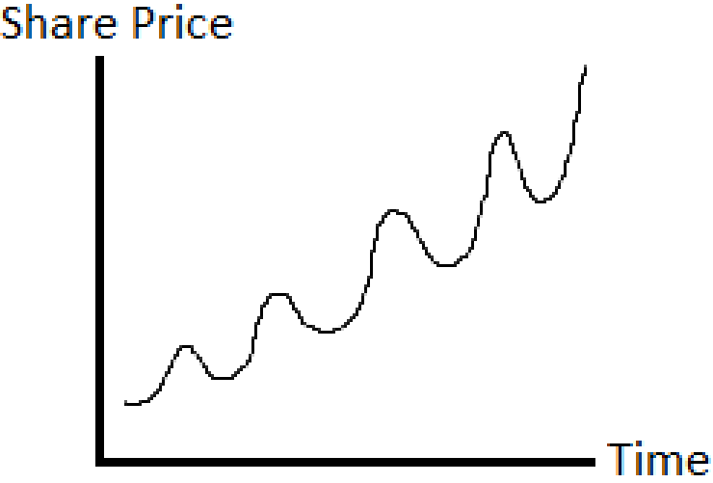
- 5alena nefara2 been 7agteen:
  - Speculation (مضاربة): enk teshtery sahm w b3deha be fatra soghayara awy se3ro yezeed gamed fa troo7 bay3o. El modarbat de el makaseb beta3et-ha beteb2a akbar, bs beteb2a more risky compared bel investments.
  - Investment (استثمار): hena benetkalem b2a fi 7aga beta5od wa2t taweel 3o2bal ma teksab, w beteb2a less risky compared to speculations.
- Peter Lynch bey2ol en a7san wa2t teshtery fih as-hom howa fi el kawares el tabe3eya, el 7orob, ay azma 3alameya 3amatan (e.g. corona virus). Leeh? La2en fel wa2t da el nas beteb2a 5ayfa flos-ha te5sar fa betroo7 bay3a, masalan sa3et el corona wa7ed yeb2a 5ayef en Amazon te2fel fa yroo7 baye3, fa el as-hom ter5as, t2oom enta b2a shary, w sanateen talata ahe el corona 5elset wel denya reg3et tabe3eya tany, fa el sahm hayerga3 yezeed tany, fanta kesebt.
- “Dollar Cost Averaging”: de strategy akbar el mostasmereen beyensa7o beha w heya enk tefdal teshtery fi as-hom be mo3adal sabet (e.g. kol shahr aw kol osboo3) be ghad el nazar 3an se3r el as-hom. El strategy de bet2olak en fekret enak teshtery be rate sabet a7san ma teshtery kolo mara wa7da. For example, lw enta m3ak mablagh kebeer (e.g. lesa baye3 beet, lesa wares, etc), fa matro7sh t7oto kolo fi el borsa, la2 eshtery be fixed rate a7san. Tab leeh? Bey2olak en 3ashan lw enta 7ateet flosak kolaha mara wa7da w bada2et te5sar, fa enta 3atefeyan lama tela2y flosak bete5sar hatroo7 baye3 w teb2a 5esert. Laken lama teshtery be rate sabet el denya hatwazen ba3d shwaya.
- Tyb delwa2ty lw ana ma3eesh mablagh kebeer astasmero, hal worth it eny afakar fel estesmar aslan? Yes, worth it, la2en enta hatestasmer el mablagh el soghayar el m3ak, yeksab w yerga3lak 3a2ed, fa t2oom mestasmer el floos el asleya w kaman el rege3lak men el estemsar, and so on, fa ma3 el wa2t flosak tekbar, which is known as compounding. For example, lw enta m3ak 1000 geneh delwa2ty, 7atet-hom fi ETF VOO w 3amalolak 10% fel sana, fa b3d awel sana b2a hayeb2a m3ak 1000 + 100 = 1100. El sana el ba3deha hayeb2a m3ak 1100 + 110 = 1210, and so on. Fa ma3 el wa2t el mablagh hayebda2 yekbar.
- Tab e7na delwa2ty ben2ool en el VOO de betgebly 10% profit kol sana. Tab ma el bank aslan fih shahadat el fayda beta3et-ha mesh we7sha, w ahe 7aga safe w mafehash risk, eh el ye5aleny aroo7 lel borsa wel risk wel qesa de? Sa7, w 3ashan keda aham 7aga fel investment howa el diversification, w howa enak tewaza3 el investments beta3tak 3la aktar men 7aga, zy bank, gold, stocks, real estate, bonds, etc.
- Mezet el ETFs enaha betsahel 3leek gedan el estesmar. Masalan enta mesh 3ayez tastasmer fi sharekat zy Apple w Amazon w keda, la2 3ayez tastasmer fel real estate, bs enta lesa betebda2 7ayatak w mate2darsh te afford beet tastasmer fih. T3ml eh? Delwa2ty enta te2dar teshtery 7aga esmaha reits, w de beteb2a sharekat beteshtery 3aqarat w betlem 2egarat w betbee3 w nas mota5asesa aktar menak, w b3d keda betwaza3 el arbaa7 3la el nas el betastasmer fel sherka, el howa enak teshtery el ETF el 5aas beha. Fanta keda estasmart fel 3aqarat wenta a3ed fel beet, men gheer b2a ma tedawar 3al sha2a w tefasel w tedawar 3la mosta2ger w bla bla bla. Masalan fih ETF esmaha VNQI, de betastasmer fel 3aqarat el mawgooda fel 3alam kolo. Fih ETF tanya lel bonds (السندات) masalan, wel estesmar fel bonds howa wa7ed men aktar el estesmarat el 2amena, w 3ashan keda el profit beta3o mesh beyeb2a kebeer awy. Fih ETF tanya lel dahab esmaha IAU, badal ma troo7 w teshtery sabayek w bta3, la2 online te2dar tegeeb dahab 3ady 5ales. Kol 7aga fel denya b2a leha ETF.
- Tab howa ana leeh a3mel kol da be nafsy, ma aroo7 le sherket estesmar heya el tedeer leya estesmaraty? Momken tab3an, bs el derasat bet2olena en 64% men el mota5aseseen dool beygebo nesab profit a2al men el S&P500 (el fehemto en el S&P500 da el howa el VOO, y3ny el da7ee7 bey2ool en 64% men sharekat el estesmar betgeblak profit a2al men enk troo7 ma3 nafsak teshtery VOO ETF). Mesh bs keda, 5ames aghna ragel fel 3alam Warren Buffet rahen sharekat el estesmar enaha lw 3amalt profit a3la men el VOO ETF hayedeha $1 million. In 10 years, el sharekat de 3amalet 36%, el VOO 3amalet 125%! Mota5ayel?
- This website is all about portfolios. Portfolio howa el tawze3et el investments bta3tak. Masalan ha7ot 40% investment fi banks, 20% real estate, 20% bonds, 10% stock, and 10% gold. Fa el website da beywarelak shwayet portfolios nas mash-hora 3amlaha.

