These are the sharia-compliant ETFs I found:
- SPUS.
- HLAL.
- AMAGX.
- UMMA.
- ISDU.
- ISWD.
- ISDE.
- WSHR.
- IGDA.
- ISUS: not included in the comparison because it is not in USD. Anyways, ISDU is the USD version of ISUS.
- SPRE: not included in the comparison because it is a REITs ETF, not stocks.
The full comparison can be found in the excel sheet named “Sharia_ETFs”. Notes regarding the comparison:
- VOO is included in the comparison just to be our benchmark.
- I got the information in the comparison from the following websites in addition to each ETF’s issuer website/prospectus:
  - https://portfoliovisualizer.com
  - Yahoo Finance - Stock Market Live, Quotes, Business & Finance News
  - Dividend.com - Dividend Stocks - Ratings, News, and Opinion - Dividend.com
  - Fidelity Investments - Retirement Plans, Investing, Brokerage, Wealth Management, Financial Planning and Advice, Online Trading.
  - ETF Database: The Original & Comprehensive Guide to ETFs (etfdb.com)
  - TradingView — Track All Markets
  - John Hancock Investment Management (jhinvestments.com)
- In the context of the stock market, "domicile" refers to the country where an investment fund, such as an ETF, is legally registered and regulated. The domicile of an ETF can have implications for investors in terms of taxation, regulation, and investor protections. A foreign investor (i.e. non-US investor) is liable for 30% tax on US-domiciled ETFs vs only 15% on Ireland-domiciled ETFs. The crucial point is that this is 30% of the dividend yield, which is itself only ~1%/year. The end result is almost negligible — at (30% - 15%) * 1% = 0.15%. Moreover, since Egypt has a tax treaty with the US, the taxes are even lower than 30% (not sure how much exactly). So, the performance difference between different ETFs is a much more important consideration; focus on comparing the ETFs’ performance and just ignore their domiciles. For more information about taxes, read this.
- For the performance mentioned, it is the all-time averaged annual performance of the ETF including the expense ratio of the ETF and assuming all dividends are reinvested. Thus, when looking at the performance numbers, you can comfortably compare between ETFs without bothering yourself about the expense ratio and the dividends of each ETFs. I mention the dividend yield and expense ratio of each ETF anyways in the excel sheet, but they are already included in the performance.
- It is worth mentioning that this comparison is made on the 14th of April.
- The given CAGR is not inflation-adjusted (i.e. inflation rate is not subtracted from the CAGR).
- Notice that I didn’t write the CAGR, standard deviation, and sharpe ratio of VOO in its column. Why? Because I want to compare those quantities between VOO and each ETF, and, of course, each ETF has a different inception date. So, what I did is that I wrote the CAGR, standard deviation, and sharp ratio of VOO between parenthesis in each ETF’s column from the inception date of the ETF so that you can easily compare these quantities for each ETF to those of VOO.
From the comparison, it is clear that the only qualified ETFs/funds are:
- SPUS.
- HLAL.
- AMAGX.
So, let’s compare the performance of these 3 since the inception of the newest of them (SPUS):
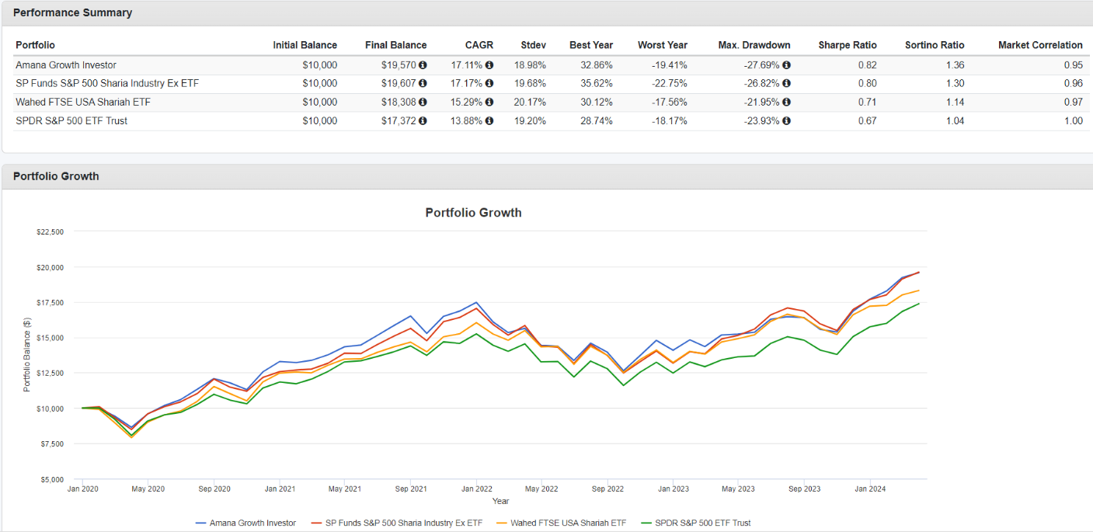
It is clear that AMAGX and SPUS have a very similar performance. Which one to choose? SPUS has an advantage that it is an ETF, while AMAGX is a mutual fund. On the other hand, AMAGX has an advantage that its inception date is 1994, which shows that the fund has successfully been able to beat the market for 30 years! I will choose SPUS because I prefer ETFs to mutual funds. But this doesn’t mean we completely discarded AMAGX and HLAL, I should redo the comparison between the 3 periodically since they were very close!
Notice that all Islamic filters filter halal companies according to 3 criteria that must be met:
  - The activity of the company must be halal.
  - The debt-to-market-cap ratio should be less than 30%.
  - The revenues of the company from haram sources (e.g. interest rates) to their total revenues ratio should be low (don’t know how much exactly, I think less than 30% bardo).
For me, I have already been convinced before that interest-based income is not haram. Accordingly, for me, a stock is halal if it meets the first criterion only. Accordingly, I will now look at most of the stocks in the S&P 500 index and see which of them is classified as haram due to its activity, and which is classified as haram due to the two other conditions. For the stocks classified as haram for the two other conditions, I will be comfortable to invest in them, no problem. Then, I will look at the stocks included in the SPUS ETF and see which of the stocks that I am comfortable to buy are not included, and maybe I buy them individually. You can view the 503 stocks in the S&P 500 index here. You can view the holdings of SPUS here. You can use Filterna to know whether a stock is halal or haram and why. I also check this page Halal Stock Reports | Practical Islamic Finance to see their opinion. Note: I checked the first 100 companies in the S&P 500 index only because there are too many of them (503 companies!).
After doing a thorough comparison, the following stocks are in the S&P 500 but not in the SPUS ETF holdings, however I am comfortable to invest in, so you can buy them individually:
- J.P. Morgan (JPM).
- Bank of America (BA).
- Wells Fargo & Company (WFC).
- T-Mobile US (TMUS).
- Verizon Communications (VZ).
- American Express Company (AXP).
- Comcast Corporation (CMCSA).
- Intel (INTC).
- Amgen Inc. (AMGN).
- Morgan Stanley (MS).
- Raytheon Technologies Corporation (RTX).
- NextEra Energy (NEE).
- The Goldman Sachs Group Inc. (GS).
- The Charles Schwab Corporations (SCHW).
- AT&T Inc. (T).
- Citigroup Inc. (C).
- Deere & Company (DE).
- The Boeing Company (BA).
- Airbnb (ABNB).
- Vertex Pharmaceuticals Incorporated (VRTX).
- Automatic Data Processing Inc. (ADP).
- Bristol-Myers Squibb Company (BMY).
Some of the popular but classified as haram stocks due to their activity (which I accordingly shouldn’t invest in):
- Amazon (AMZN): although most of the products that Amazon sell are halal, they sell some products and services that are haram (e.g. books that contain nude or dirty content).
- Netflix (NFLX): haram entertainment.
- The Walt Disney Company (DIS): entertainment. I don’t know what haram entertainment shows exactly does Disney offer.
- Blackstone Inc. (BX): its activity is assets management. I think they consider its activity to be haram because some of their investments are in insurances. Also, I believe that, since they are an asset management company, they might be investing in all the US companies including the haram ones.
- Philip Morris International Inc. (PM): tobacco.
- Honeywell (HON): it is a conglomerates corporation, which means a corporation that has a diverse range of businesses. I don’t really know which business/activity exactly does the filter consider haram, but, yeah, they might be indeed investing in a haram product since they have diverse range of businesses.
- BlackRock Inc. (BLK): its activity is assets management. I think they consider its activity to be haram because BlackRock surely invest in all the US companies including the haram ones.
- Prologis (PLD): its activity is REIT. I don’t really know what is haram about its real-estate activity.
- Chubb Limited (CB): insurance. Although I am somehow convinced that the idea of insurance is okay, but since an insurance company usually invests in many business and Chubb Limited is an American insurance company, they might be investing in a haram business in the US.
While the filter can’t decide, due to insufficient information, whether Berkshire (BRK.B) is halal or not, in my opinion, I don’t think it is halal because Buffett invests in the whole US stock market, whether halal or haram.

