This document is based on Jeff Nippard’s “Top 3 Science-Based Exercises For Six Pack Abs (Upper vs Lower Abs) ft. Matt Ogus” video.
“Abs are built in the gym and revealed in the kitchen…”
We usually say “abs”, but what we really mean is the whole region below the chest and above the waist. This region consists of three main muscles:
- Rectus Abdominis (this is what we call “six-pack abs”).
- Obliques.
- Serratus.
The anatomy is shown below:
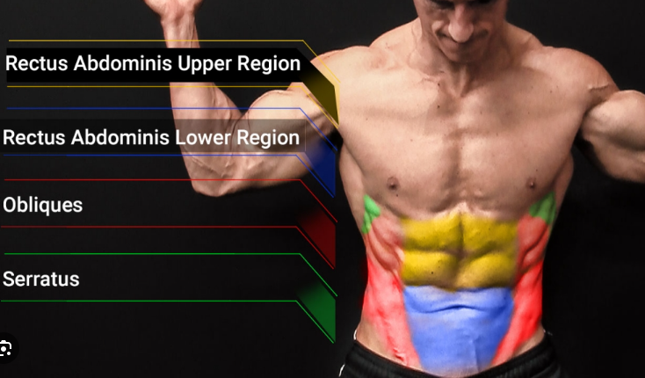
So, we want to make sure we include exercises that hit all parts of the core.

Rectus Abdominis Upper Region
According to the study shown below, the exercise that best targets the rectus abdominis upper region is the “Crunch, arms extended” exercise.
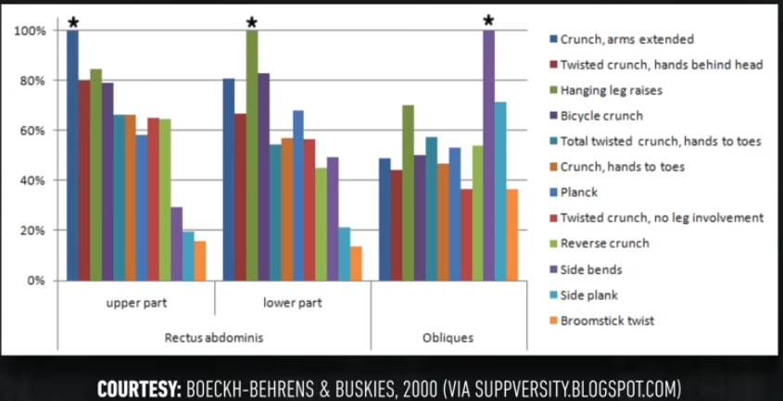
So, the exercise we will do is the “weighted crunch” exercise. This can be done on a machine:
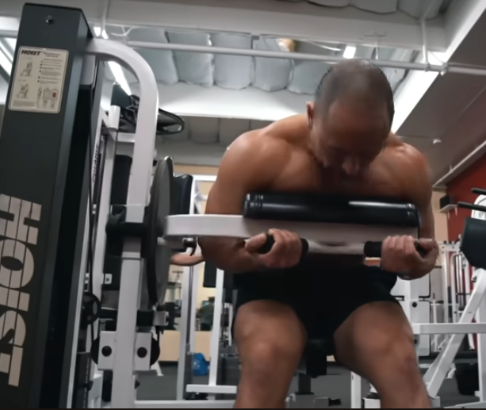
or using a cable:
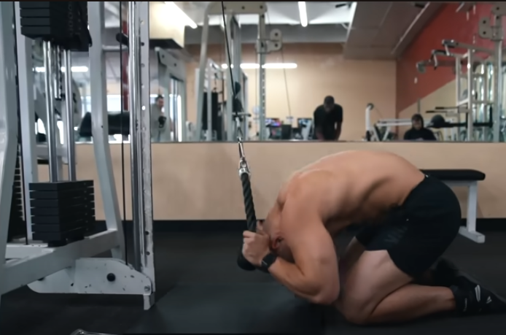
Watch the video from 2:12 to 4:07 for a detailed explanation of the exercise technique.

Rectus Abdominis Lower Region
According to the study shown below, the exercise that best targets the rectus abdominis lower region is the “hanging leg raises” exercise.

So, the exercise we will do is the “hanging leg raises” exercise. This can be done using a Romain chair:
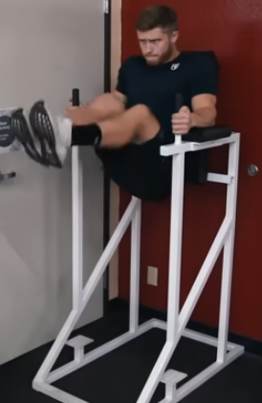
, decline reverse curls (also known as dragon flags):
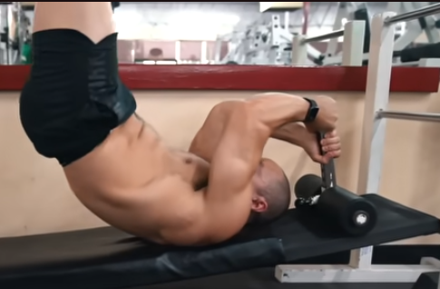
Or hanging (which is the most difficult):
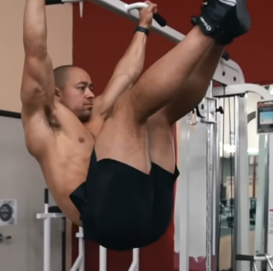
Watch the video from 4:09 to 5:46 for a detailed explanation of the exercise technique.

Obliques
I know that the study above suggests that “side bends” is the best obliques exercise. However, side bends solely targets obliques. Instead, we will do “bicycle crunches” that can primarily target obliques, and secondarily rectus abdominis.
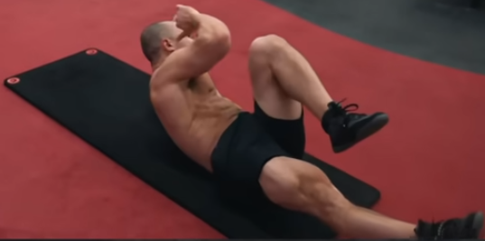
Watch the video from 6:23 to 7:14 for a detailed explanation of the exercise technique.

Serratus
For the serratus, we will do the “serratus jabs” exercise. You can watch Jeremy Either’s “The BEST 10 Minute Ab Workout For Six Pack Abs (HIT EACH AREA!)” video from 6:27 to 6:57 for a detailed description of the exercise technique.

Abs Workout
Exercise | Sets | Reps | Rest (Mins)
Machine Crunch  OR  Cable Crunch | 2-3 | 10-15 | 1
Roman Chair Leg Raises*  OR  Decline Reverse Curls  OR  Hanging Leg Raises* | 2-3 | AMRAP**  15-20  6-15 | 1
Bicycle Crunches | 2-3 | AMRAP** | 1
Serratus Jabs | 2-3 | 10-15 | 1
Notes:
- *If you cannot perform leg raises, you can start with knee raises and progress to leg raises.
- **AMRAP – as many reps as possible!

Frequency
Perform this abs workout 1-3 times per week, either after your main weightlifting workouts or on rest days.

