General Notes
- White whale we7sheen ka seyana w 5edma b3d el bee3, w malhash qeta3 gheyar.
- Beko we7sha ka 3yoob sena3a w 5edma b3d el bee3.
- El 3araby 5edmet ma ba3d el bee3 kwayesa.
- Eh el far2 been enak tegeeb for example men LG nafso aw merchant tany zy Btech? LG nafsohom da el wakeel, laken haga zy Btech da mowaze3. Tyb eh el far2? El quality wa7da, mafeesh b2a kalam farz awal w farz tany da, bs heya betefre2 fi el 5edma b3d el bee3 ta2reban zy el seyana wel tarkeeb wel 7agat de, bs mesh 3aref bsara7a el far2 beyeb2a fi eh bzbt, bs akeed fel floos aw sor3et el 5edma. Anyways y3ny, fa enta teshtery men LG a7san. Bs 5aly balak b2a en mesh kol foroo3 LG wakeel, fihom mowaze3een, only the following are LG bgd:
  - Madinaty 1: 01221130340
  - Madinaty 2: 01270785749
  - Helwan: 01270709393
  - Makram Ebid: 01270709911
  - Rehab: 01200340952
- Wakeel Elba w Gorenje fi masr howa sherket el waha.
- Currently, el t7t homa bs froo3 LG nafsohom, el ba2y kolo mowaze3een. You check this link lw fi updates, foroo3 LG nafsohom esmohom (union group):
  - Madinaty 1 (open air mall).
  - Madinaty 2 (strip mall).
  - Rehab (corner mall).
  - Makram Ebid.
  - Helwan.
- For official Beko branches, you can call the call center ask about them and their numbers. Some of them:
  - Tagamo3 (90 ganoby - vitaly mall): 01118588996
  - Tagamo3 (Rehab - corner mall): 01281305099
  - Tagamo3 (Madinty - open air mall): 01206667029
  - Zayed (26 July - mabna 2 - wara chillOut - odam Galleria 40): 01276207726
  - Zayed (mall of Egypt): 01289232599
  - Zayed (Mall of Arabia): 01270684175

Refrigerator
- LG is the best. Sharp follows.

Washing Machine
- LG “Vivace” is the best.
- Top-load is not efficient as the front-load (less motor power, less energy saving, …), front-load is the best.

Microwave
- Most brands function well, with Samsung, LG, and Sharp being the best.
- I chose LG as their microwaves have smart inverter technology that allows for even heating.

Dish Washer
Beko is top, LG follows.

Built-in Hood
- Fi tare2teen le shaft el hawa el tale3 men el cooker:
  - Ducted mode (طرد خارجي): en el hood yeb2a metwasal be mad5ana wasla bel manwar beta5od el hawa el tale3 men el cooker tetrodo 3la bara 3la tool.
  - Recirculation mode (فلترة داخلية): el hawa el gy men el cooker bey3ady 3la carbon filters betnadaf el hawa w teraga3o tany fel matba5 (bema en mafeesh mad5ana tetrodo bara).
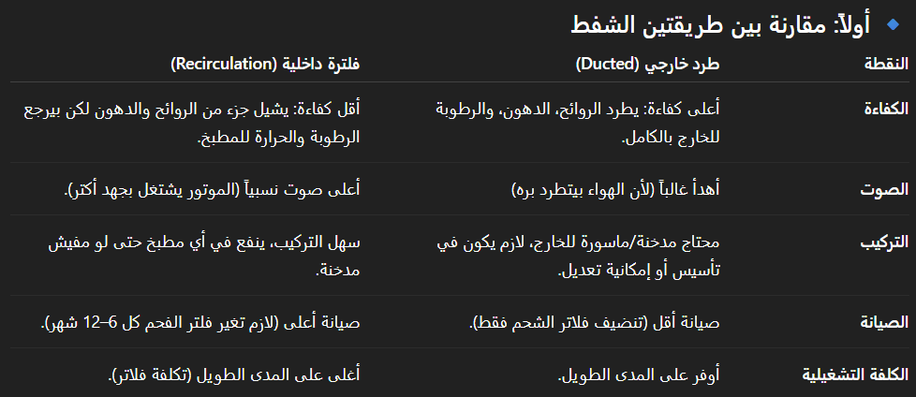
- Fi ashkal keteer lel hood. The main ones are:
  - Chimney (هرمي).
  - T-shape (like this one).
  - Flat (like the one in El Montazah house).
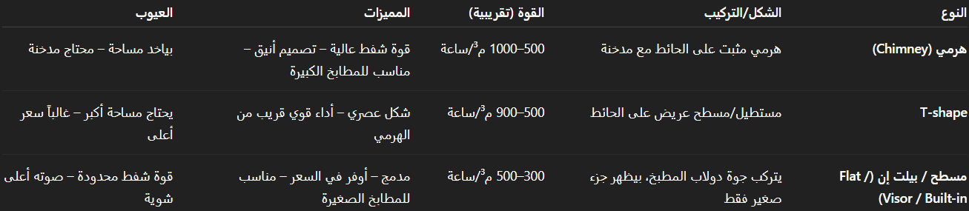
- El nas fel reviews mesh metef2een 5ales 3la brand, fa ay haga b2a.

Built-in Cooker
- Teka is top, but it’s rare and expensive.
- Dr. Islam says Ecomatic’s cooker bends after time.
- El nas fel reviews mesh metef2een 5ales 3la brand, fa ay haga b2a.

Built-in Oven

Heater

A/Cs
Carrier, Sharp, and LG are the most recommended.

TV
LG and Samsung are the best. Here is the ranking:
- Samsung QN90D
- Samsung QN85D
- LG QNED86
- Samsung Q80D
- Samsung QN70F
- Samsung Q8F
- Samsung Q70D
- Samsung The Frame
- Samsung Q7F
- LG QNED70
- Samsung Q60D

Water Dispenser

Iron
- Teval and Philips are the most recommended.
- Avoid Tornado.
- Recommended wattage level: 2600 – 2900 W.

Vacuum Cleaner
- Panasonic & Bosch are the most recommended.
- Bosch > Panasonic, but harder to find spare parts.
- Japanese Panasonic > Malaysian Panasonic, but more expensive.

Electric Kettle/Boiler

Sandwich Maker
- The most recommended are Kenwood, Philips, and Black & Decker.
- Make sure it has 3 plates (toast, roll, and waffle).

Hand Blender
- The most recommended is Braun.
- The essential parts are:
  - Hand blender.
  - Whisk.
  - Kabba.
- The optional parts are:
  - Beaker.
  - Chopper (looks like kabba soghayara).

