**Project Report**

**Introduction:**

This project is basically designed according to my course teacher’s requirement which I named **“SWPU Final Project”.** By this app a user able to register an account with a unique user name, phone number and password. Then the registered user can log in with log in activity according to his registered information. And after successfully log in user can add product or commodity, can view added commodity and also can edit and edit and delete data from database. For doing whole thing I used SQLite database for store and fetch data. I also used Android Studio core feature and library for UI design and

**Data Requirements:**

The set of data that is involved in any project is defined using data requirements. For this project, the main data required is the login information to register the application and the item’s information. Without this information the application cannot process the transaction.

**Functional Requirements:**

Functional requirements are properties that must exist in the final system. For any mobile application, we need to download the application from the play store. The application could be either free or paid depending upon the store or merchant. To use the application, the user needs to register and login to the application after installing by providing login information. Once, he or she logins into the application, they can use all the features

**Validation:**

Validating any application is an important criterion before releasing the application to the users. If there is no validation, the information entered by users may be redundant, formatted inappropriately and cannot be maintained. For example, we can validate the user name is unique or not. Because duplicate user will conflict the user data, if the validation is not done, there are chances insert more user with same name. Similarly when user does registration there are two fields for set password. So in this case we also need validation if both filed password are some or not. If the validation is not done, there are chance to miss registration from users. Registration, Sign in and Home activity also need one validation which will check all the Edit text field filled up or not. If the validation is not done for this case, there is also chance to insert data without proper information.

**Application Design**

The main aim of the system design is to explain the scenario using use case diagrams. Use case diagrams clarify the flow of the application by deriving the use cases for all the functionalities in form of diagrams for the users.

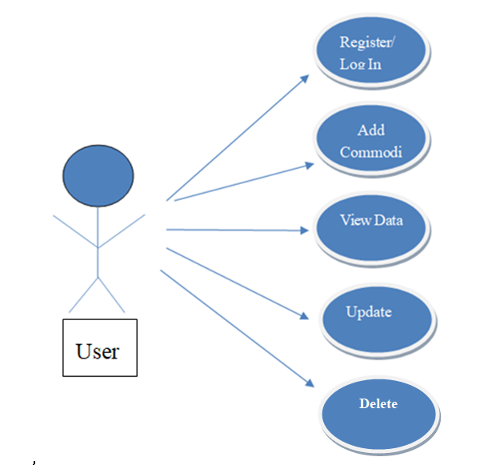

**Use case diagram for user**

**User Interface Design:**

User Interface Design for any application should be very simple. We should have only a few clicks or navigation among the features when using the application to avoid hassle. In this application, there are 4 main activities, which are main activity, Log in activity, Home activity and View Commodity activity. The registration page is the first page which appears when the user uses the application. In that page, if the user has account already, he can move to login page with clicking a button.. The next screen is the homepage where the users can use the app.

The following interface are the main xml design of this app.

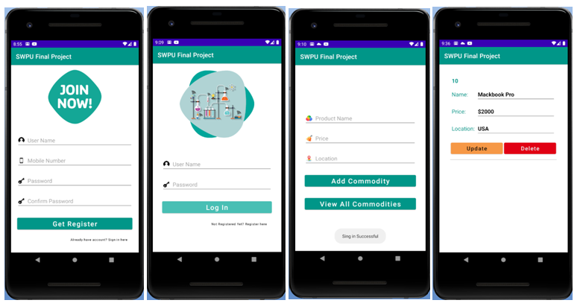

**Database Design:**

The database should be designed in such a way that it should be easy to access and manipulate. Database definition and database manipulation operations should be performed accordingly to add, delete, and update values. In this project, I have used a SQLite database which is an open source database, easy to install and use.

**Screenshot of running results**

