**Share for unlock**

**Installation:** Download plugin from provided link and unzip it. After that upload it to your server using cpanel or upload via WordPress admin. For upload using wordpress admin see below screenshot:

For upload using WordPress admin, use zip file.

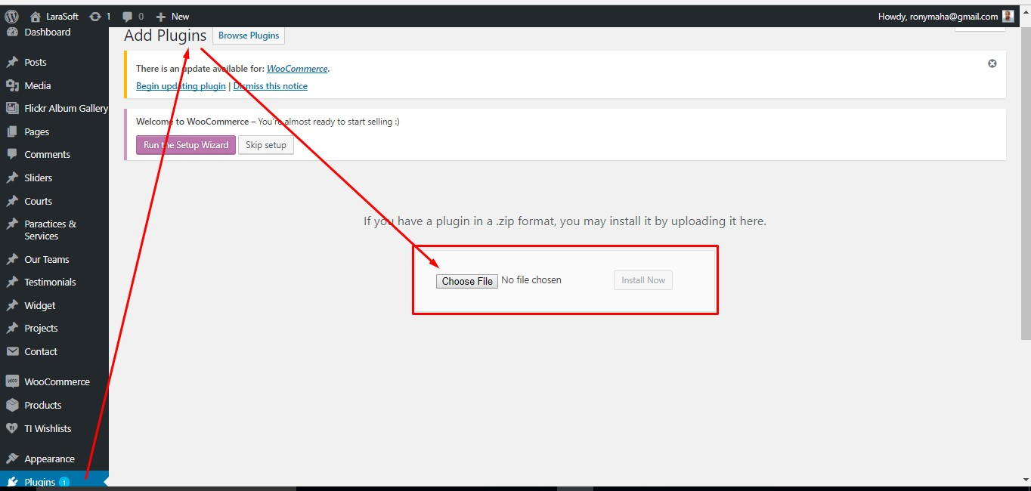

Settings: After install plugin go to settings > share for unlock. You can see below screen and you should fill all of settings and save it.

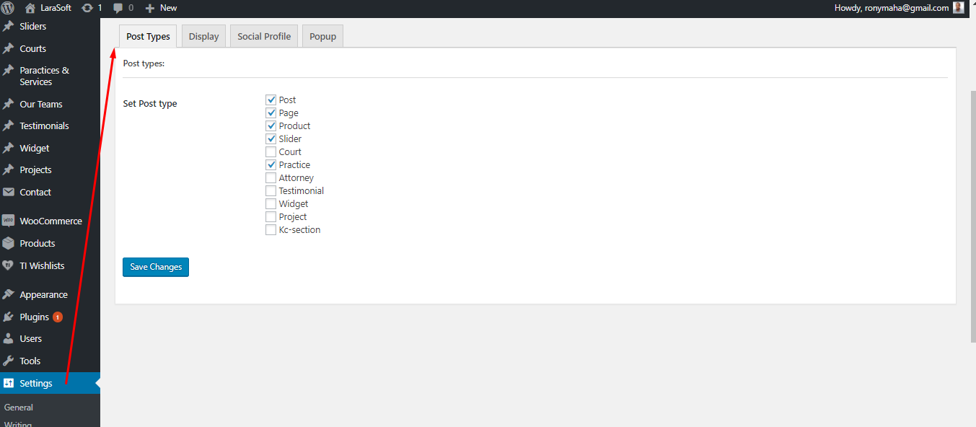

**#Post Option:**

After complete all of settings you can use “shere for unlock”. Now go to make a new post or edit existing post. In post edit window you can see a "Unlock/ social share“ option like below screen. Active button if you need to show share option in your post and set amount for share.

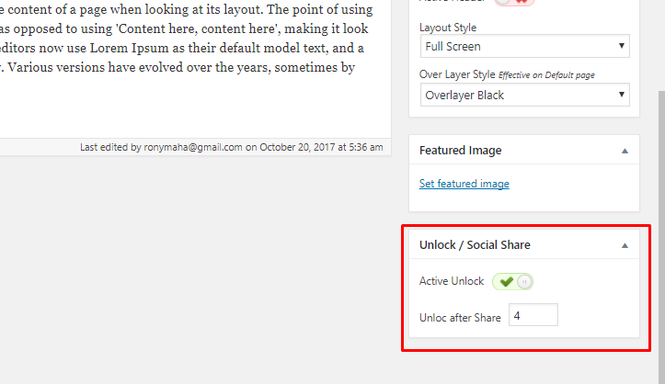

**#Front View:**

In front view, until user complete your share amount, they only see your share message and share icon. When they click share icon, it open a popup with social share button and custom advertisement clickable image with link.

**View before complete share:**

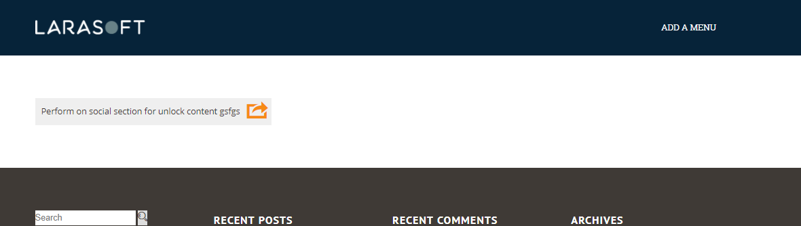

**View after complete:**

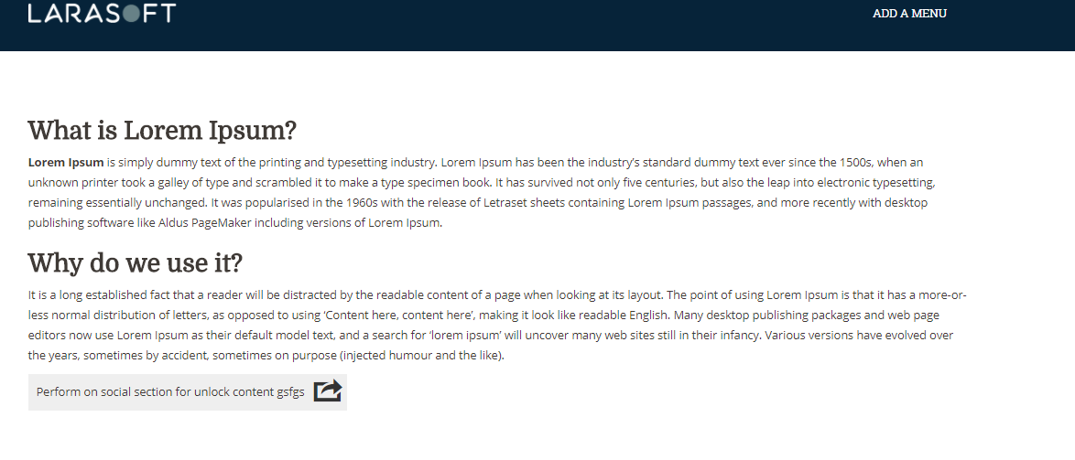

**#POPUP:**

Right now 5 social button for share and subscribe. In bottom custom image with link, as default link are site homepage.

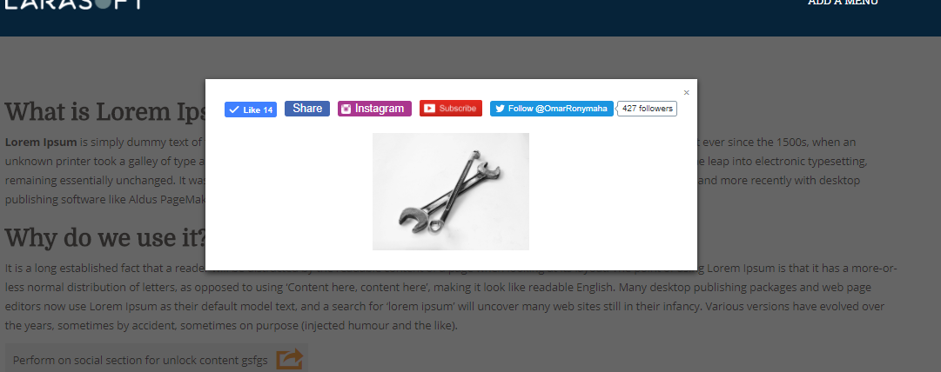

**####### END ########**