Revision request on Sticky Comments

Date 06/01/2020

1. The border still appears inside the comment box while one wants to comment. It should not be displayed. *[Not Solved]*

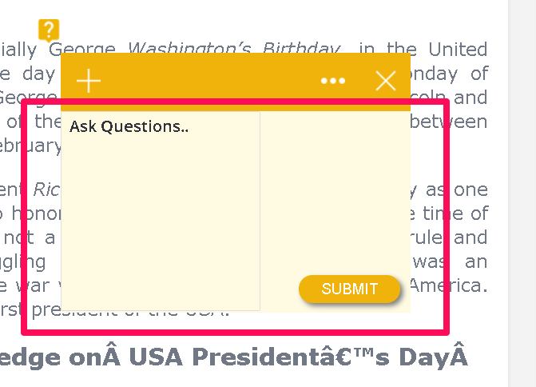

1. Right now , Admin reply is being shown on top , where as it should come below the user comment

**User comment -01/01/2020** : This is user comment

**Admin reply 03/01/2010** : This is Admin reply

This is what conversation should look like **[not solved]**

1. When the Admin replies , but conversation switch is OFF, the comment and admin reply does not appear even if approved. Pl. **Watch the video**
2. Pl make the popup that appears as “ yin Green is SMALLER and set for 4 seconds.
3. On two website , two different results came. On one web site comments appeared and on another when the comments were made and reply was given by admin, the comments and replies were not showing.. Better you put a new button called **Reply ..**.that appears **only when** Admin allowed conversation . <https://screencast-o-matic.com/watch/cYVDezvEua>
4. Date beside the user and admin comment is missing

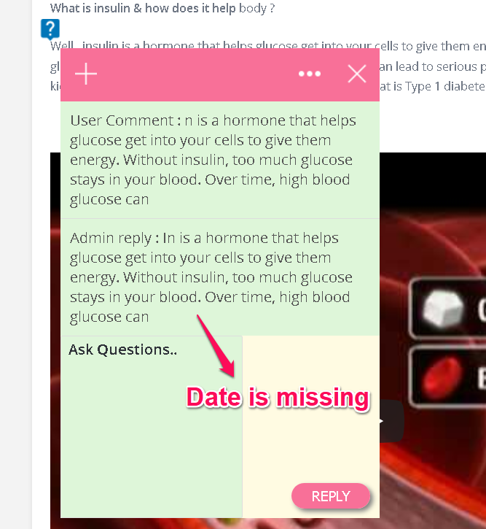

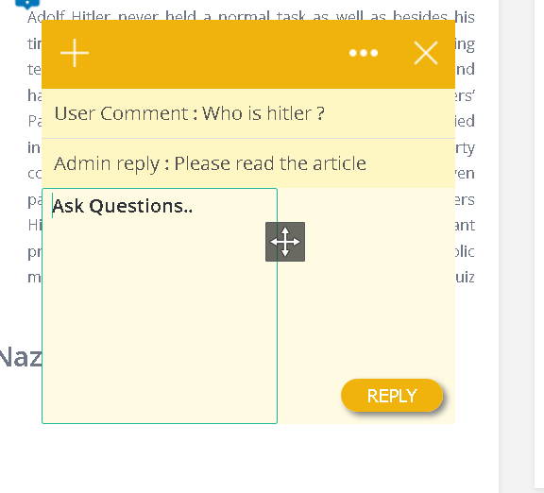

1. Even when “visitors can see comments” toggle button is ON , the comment is not appearing [Not Solved]

[Subscriber comments and admin reply are not showing for visitor]

1. When “visitors can see comments” toggle button is OFF, a user with role **Subscriber can’t comment**. Please note anyone with any role , if registered is allowed to comment . Editor also cannot comment.[Not Solved]
2. A visitor to a page with comment should be able to see the comment . But right now he can even comment as the button appears and he can click without logging . Watch the video <https://screencast-o-matic.com/watch/cYVDezvEua>

**9**. Blank comment is coming after closing the comment box. See the Attached video

**10**. The comment tables should have pagination and a small search field. Admin cannot search through the User Name. Pagination system is not in the Admin comment pages ALL or Approved or disapproved and it should be list as resent comment.

**11**. Post, Page, Comment, Media etc page style are effiected for WP sticky comment plugin.

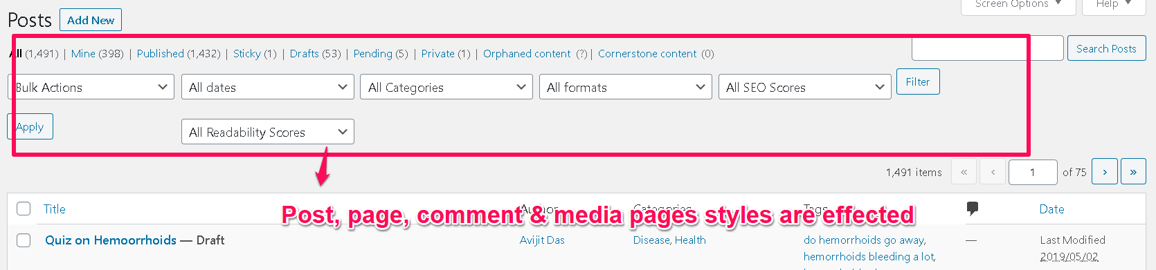

**12.** Admin’s reply is not showing, if the next conversation button is disabled. And Subscriber question is vanished. If the user comment on that new page. *Video attached*