API Automation with Newman’s node and newman.js
The original post is here: https://www.linkedin.com/pulse/apis-test-automation-3-easy-steps-talal-ibdah. The current post is a simplified version.

The process consists of:
- installing nodejs
- installing Newman
- accessing the API via postman and creating verifications there
- exporting the collections
- running newman from the command line

Installing nodejs
You can get it from https://nodejs.org/en/download/package-manager
Make sure you add the installation folder to the PATH

Installing Newman

Then as per https://www.linkedin.com/pulse/apis-test-automation-3-easy-steps-talal-ibdah also install newman with the command npm that is in the newly installed nodejs (C:\Program Files\nodejs1\npm.cmd):
npm install newman --global;
Make sure that you select a folder not in the protected c:\program files area, say in c:\temp.
The file we are insterested in is C:\temp\newman1\node_modules\newman\bin\newman.js (note: my first installations didn’t work in c:\temp\newman so I ended up having newman1, and similarly c:\program files\nodejs1 You should have it in newman and nodejs the first time ☺).

3. Accessing the API via postman and creating the verifications:
For this exercise we use the Federal Reserve non-key API:
http://www.quandl.com/api/v1/datasets/FRED/GDP.json

We create a collection with two GET calls:
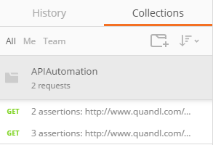
For the first one we have two test verifications:
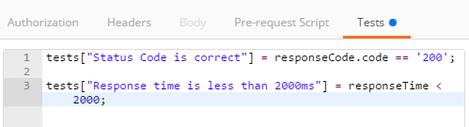

And for the second one we add a verification to ensure that the response should contain some expected data:

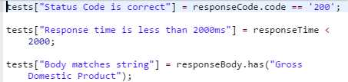
4. Exporting the collections
We export the collection as APIAutomation.postman_collection.json in the folder c:\temp\newman1\node_modules\newman\bin

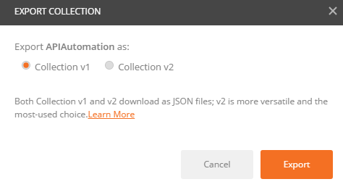
5. Running newman from the command line
We use newman to run the automation from the command line.
Once you do that navigate to the folder where newman.js is located (e.g. c:\temp\newman1\node_modules\newman\bin) and invoke it as follows:
node newman.js run APIAutomation.postman_collection.json

Here is the sample output:
