PAMS: Agile Practices Report
Paragon Apartment Management System
Group 28
Module: UFCF8S-30-2 Advanced Software Development
Assessment: Portfolio (Element 2, Methodology and Contribution Evidence)
Academic Year: 2025/26
Submission Date: 23 April 2026
Group Members
Name | Student ID | Primary Role
Omar Al Frouh | 24020879 | Group Leader, Scrum Master, Lead Architect
Feras Bader | 24033513 | Product Owner, Tenant Management
Ahmed Deraz | 24046227 | Payment and Billing
Numair | 24026758 | Maintenance

Table of Contents
Table of Contents 2
1. Introduction 4
2. Methodology Chosen: Scrum 4
2.1 Why Scrum 4
2.2 Sprint Length and Timeline 4
2.3 Scrum Roles 5
2.4 Ceremonies 5
2.5 Definition of Done 6
3. Tools Used 6
4. Sprint Summaries 7
4.1 Sprint 1: Foundation (End February to Early March 2026) 7
4.2 Sprint 2: Reporting, Notifications and QA (Mid March 2026) 8
4.3 Sprint 3: Brief Gap Closure (Late March to Early April 2026) 9
4.4 Sprint 4: UI Redesign and Submission Prep (13 to 23 April 2026) 9
5. Git Workflow in Practice 10
5.1 Sprint 3 Pull Requests 10
5.2 Sprint 4 Merges 11
6. Evidence of Collaboration 12
6.1 GitHub Project Board and Issues 12
6.2 Pull Requests 12
6.3 Contributor Stats 12
6.4 Automated Test Output 13
7. Individual Contributions 13
7.1 Omar Al Frouh (24020879) — Group Leader and Lead Architect 13
Sprint 1 — Foundation 13
Sprint 2 — Reporting, Notifications, QA Lead 14
Sprint 3 — Schema, Gap Closure, Reviewer 14
Sprint 4 — Largest Sprint by Line Count 14
7.2 Feras Bader (24033513) — Tenant Management 15
Sprint 1 15
Sprint 2 15
Sprint 3 16
Sprint 4 16
7.3 Ahmed Deraz (24046227) — Payment and Billing 17
Sprint 1 18
Sprint 2 18
Sprint 3 18
Sprint 4 18
7.4 Numair (24026758) — Maintenance and Testing 19
Sprint 1 19
Sprint 2 19
Sprint 3 20
Sprint 4 20
8. Retrospective and Lessons Learned 21
8.1 What Went Well 21
8.2 What Could Have Gone Better 22
8.3 What the Team Would Do Differently 22
8.4 How Agile Actually Helped 22
9. Conclusion 22
10. Appendices 23
Appendix A — Project Backlog 23
Appendix B — Pull Requests 23
Appendix C — Branches and Git Log 24
Appendix D — Contributor Stats 32
Appendix E — Automated Test Run 33
Appendix F — Sprint Planning Artefacts 34

1. Introduction
PAMS (Paragon Apartment Management System) is the desktop application developed for this assessment. The brief describes a UK-based apartment company operating offices in Bristol, Cardiff, London, and Manchester, which is struggling with paper records, weak role separation, and no means of viewing occupancy or finance data across cities. The objective was to replace that infrastructure with a single application usable by five distinct staff roles without compromising data integrity between them.
At the conclusion of the project, the system fulfils every core requirement in the brief. It handles account and user management, tenant registration and lifecycle, apartment records, invoicing and payment, reporting, and maintenance tickets. It enforces role-based access at both the login layer and the sidebar, stores passwords using bcrypt, uses parameterised SQL throughout, and ships with 330 automated tests.
This report does not describe the code. Its purpose is to explain how the four group members worked together to build PAMS, why Scrum was selected, what was delivered in each sprint, how Git was used, and what each member contributed. Evidence in the form of screenshots, git logs, and test output is included in the appendices and referenced from the relevant sections.

2. Methodology Chosen: Scrum

2.1 Why Scrum
Three methodologies were evaluated in the first lab week: Waterfall, Kanban, and Scrum. Waterfall was quickly dismissed: the brief is extensive and it was clear from the first read that not every requirement would be fully understood until some of the system had been built. Locking a design upfront would have necessitated rewriting the plan midway through, which is precisely the scenario Waterfall handles poorly.
Kanban was a better fit in principle, but it assumes a steady flow of tickets rather than a fixed deadline. With a firm submission date (23 April 2026, 14:00 UK), four separable components, and deliverables (UML, code, tests, report, demo) that were more tractable when the calendar was divided into fixed intervals, Scrum provided the appropriate structure.
The module teaching material on Blackboard also covered Scrum in detail, enabling us to consult lecture slides and the lab tutor's feedback when issues arose, rather than inventing process from scratch.

2.2 Sprint Length and Timeline
The project was divided into four sprints of approximately two calendar weeks each. The timeline is summarised in the table below.

Sprint | Dates | Theme
Sprint 1 | End Feb to early Mar 2026 | Core foundation and role based access
Sprint 2 | Mid Mar 2026 | Reports, notifications, QA polish
Sprint 3 | Late Mar to early Apr 2026 | Close brief gaps (edit tenant, notice period, complaints, receipts)
Sprint 4 | 13 Apr to 23 Apr 2026 | UI redesign, PDF export, submission prep

Sprints 1 to 3 were two weeks each. Sprint 4 was deliberately shorter (approximately ten days) so that the final days before the submission deadline were reserved for documentation and rehearsal rather than new code.

2.3 Scrum Roles
Scrum responsibilities were allocated as follows:
- Scrum Master and Lead Architect: Omar. Omar managed the Scrum process (sprint planning, project board, pull request reviews, merging to dev) and owned the shared backbone: database layer, authentication, application shell, seed script, test base class, design tokens, and component library. Cross-cutting fixes, resizing, scroll, styling, and the database migration, were routed through him.
- Product Owner: Feras. Feras owned the tenant module, the most requirement-intensive part of the system (NI numbers, lease dates, complaints, early termination). The gaps that drove the Sprint 3 plan originated partly from a closer re-read of the tenant sections of the brief.
- Development Team: all four members. Every member wrote both code and tests.

2.4 Ceremonies
Four ceremonies were conducted per sprint:
- Sprint planning. A single in-person meeting at the start of each sprint, typically at the end of the timetabled lab session. Each one left with a clear task and the agreed interface for their module (method names, return shapes, role permissions) defined in advance to ensure straightforward integration.
- Daily standup. Conducted asynchronously via WhatsApp. Each member posted three brief updates every working day: yesterday, today, blockers. This approach was more practical than daily meetings given timetable conflicts on non-lab days.
- Sprint review. Held in person on the Friday of the final sprint week. Each feature owner demonstrated their work to the group and, where possible, to the lab tutor. Incomplete items were moved to the next sprint's backlog rather than delaying the review.
- Sprint retrospective. Conducted immediately after the review in the same session. The team listed kept, drop, and try items. The retrospective at the end of Sprint 2 produced the Sprint 3 plan, as it was during that meeting that four missing brief requirements were identified (one month notice, complaints log, billing receipts, editing existing tenants).

2.5 Definition of Done
A Definition of Done was agreed in Sprint 1 and maintained throughout the project:
- Code runs locally with no errors after python3 seed_db.py && python3 main.py.
- Every new or changed public method has at least one unit test.
- Tests pass on the reviewer's machine, not only the author's.
- File header includes the student name and ID of the author.
- Pull request has been reviewed by at least Omar before merge into dev.
- No plaintext passwords, no f-string SQL, no messagebox import left over in a redesigned view.
Items 5 and 6 were retrospective additions following issues identified in Sprint 2.

3. Tools Used
The toolchain was kept deliberately small. The brief requires a desktop application in an object-oriented language, which we interpreted as a reason to minimise dependencies rather than introduce unnecessary third-party infrastructure.
- Python 3.13 as the implementation language, consistent with module teaching and providing tkinter as a standard library component on every platform.
- customtkinter 5.2.2 as the GUI layer over tkinter. This provides the dark theme and themed widgets without requiring a browser or web stack, and maintains the offline constraint implied by the brief's desktop application requirement.
- SQLite 3 for the database. Built into Python's standard library, zero-install, and file-based so that the marker can inspect pams.db directly. The schema grew to eight tables by Sprint 3.
- bcrypt 5.0.0 for password hashing. Salted by default, industry standard, and simple to use.
- fpdf2 2.8.7 for PDF output of invoices and receipts. Added in Sprint 4 when the invoices are wired to save a PDF copy.
- unittest (standard library) for automated testing. All 330 tests extend a shared tests/test_base.py:BaseTest class that creates a fresh test database per test.
- GitHub for version control and code review via pull requests.
- Astah Professional for UML diagrams (use case, class, and four sequence diagrams).
- Visual Studio Code as the primary IDE.
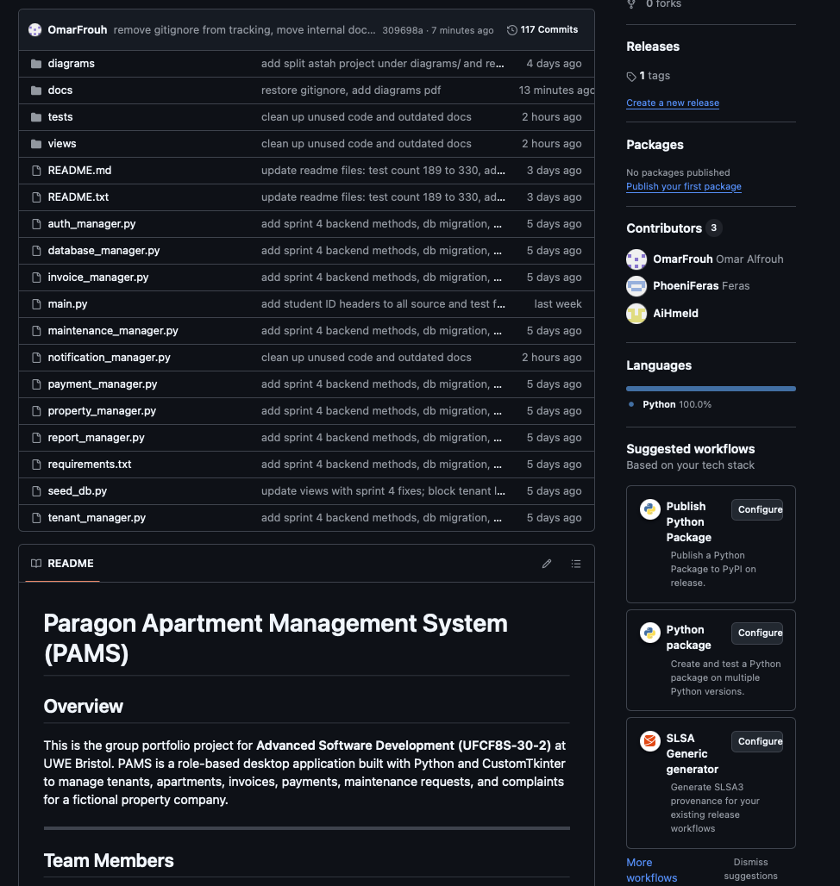

4. Sprint Summaries
The four sprints below follow a common template: goal, delivered items, and review note. Detailed per-member contributions for each sprint appear in Section 7.

4.1 Sprint 1: Foundation (End February to Early March 2026)
Goal. Establish the skeleton of every component in the brief at a basic but functional level, with role-based access already enforced.
Delivered:
- Database schema with 7 tables (users, staff, apartments, tenants, maintenance_requests, invoices, payments) and a constant role whitelist.
- Role-aware login and sidebar. Five roles (admin, front_desk, finance_manager, maintenance, manager) each see a different set of tabs.
- Tenant registration with NI number, lease dates, deposit, and monthly rent. Apartment assignment. Early termination with 5% penalty and automatic apartment vacating.
- Invoice generation from tenant monthly rent. Payment recording with atomic transactions (rollback on error). Overdue detection.
- Maintenance ticket lifecycle (Open, Assigned, In Progress, Fixed, Closed). Staff availability check.
- Security fundamentals: bcrypt hashing, parameterised SQL throughout, input validation on every manager method.
- 93 unit tests, all passing.
Review note. The base application worked end to end and the lab tutor Mr. Desmond confirmed in the Week 4 lab that the group was on track. A handful of UI rough edges were logged into the Sprint 2 backlog (small treeviews, no outer scroll on long forms, notification badge showing a count but no detail) rather than patching them in this sprint.

4.2 Sprint 2: Reporting, Notifications and QA (Mid March 2026)
Goal. Add the reporting component called for in the brief, build the notification badge, and resolve the UI defects from the Sprint 1 retrospective.
Delivered:
- report_manager.py with three reports: occupancy by city, financial summary (collected versus pending), and maintenance costs.
- notification_manager.py with overdue invoices, expiring leases (14-day window), upcoming maintenance, and a combined get_notifications() feed.
- Clickable notification bell in the header that opens a popup listing actionable items.
- Tenant module received search, status filter (Active, Archived, Terminated, All), and a separate archived tab.
- Finance module received overdue badges on the invoice list, late payment notifications, monthly revenue by payment method, and a six-month revenue chart.
- Maintenance module received cost reports by apartment and by city, and a notify tenant action recording a scheduled maintenance date.
- UI polish across the application: dark-themed treeviews, automatic column fitting, trackpad scroll support, resizable windows with a sensible minimum size, and outer scrollable frames on every long form.
- 40 additional tests (133 total) covering new managers and edge cases identified during QA.
Review note. At the end of this sprint the team conducted a slow read through of the brief together, which identified that editing tenant records, the one-month notice period, complaint logs, and billing receipts were all explicit requirements not yet delivered. A gap-closure sprint was scoped in response.

4.3 Sprint 3: Brief Gap Closure (Late March to Early April 2026)
Goal. Close the four brief gaps identified in the Sprint 2 retrospective and improve test coverage with edge case scenarios.
Delivered:
- Editing existing tenant records (the brief specifies adding, updating, and removing). Feras added an Edit Tenant tab with lookup by ID and an editable form that prefills from the database.
- One-month notice period on early termination. The existing 5% penalty calculation was retained, but termination now returns a dictionary containing the penalty and the effective date (today plus 30 days) so the view can display both.
- Complaints log with its own table (the eighth in the schema), a Log Complaint tab on the tenant view, and a Resolve action for admin users.
- Billing receipts. Ahmed added get_receipt_data() on PaymentManager and a receipt popup that opens after every successful payment.
- 56 additional tests (189 total), including edge case tests that Numair wrote for complaint isolation, notice period boundaries, and partial tenant updates.
Review note. The sprint was completed on time and every gap was closed before the 12 April cut-off. Three separate pull requests (#26 Feras, #27 Ahmed, #28 Numair) made the merge into dev straightforward because each touched a different module.

4.4 Sprint 4: UI Redesign and Submission Prep (13 to 23 April 2026)
Goal. Produce a submission-quality application: consistent visual design, all submission deliverables complete, and no last-day rush.
Delivered (UI redesign, merged 17 April):
- views/theme.py holds every colour, font, spacing, and radius constant. Updating a token propagates throughout the entire application.
- Sidebar with active-state highlight (3-pixel primary left border plus muted fill), header with a brand block and dynamic page title, and a notification dropdown replacing the Sprint 2 popup.
- Toast notifications replace every messagebox.showinfo/showerror/showwarning call, and a custom confirm_dialog replaces askyesno. All dialogs now honour the dark theme.
- Dashboard on first login with KPI tiles (apartments, tenants, tickets, revenue), recent activity, and alerts.
- Status and priority columns in every table render as coloured pills (Active, Overdue, Urgent, etc.) via tag swapping.
Delivered (backend and tests):
- views/pdf_generator.py using fpdf2 produces branded invoice and receipt PDFs.
- Database migration (_apply_migrations) runs on every boot and idempotently removes a legacy UNIQUE constraint on tenants.apartment_id so a tenant can be reactivated into a previously occupied unit.
- Tenant login blocked at the login screen with a clear staff-only system message. The tenant role still exists as FK infrastructure but cannot be used to sign in.
- Tenant reactivation, invoice search by status and tenant name, and CSV export on the report module.
- 9 new test files raise coverage from 189 to 330 tests, all passing.
- Merge dev into main; tag submission-final.
- Regenerate pams.db from seed_db.py immediately before zipping.
- Build the submission ZIP.
- Final demo rehearsal.
Review note. Sprint 4 was the most ambitious on paper because a full UI redesign was appended to what was intended as submission prep. It succeeded because nothing in *_manager.py, database_manager.py, auth_manager.py, or tests/* was changed, so the 189 existing tests continued passing while the view layer was rewritten. The redesign was isolated on feature/sprint4-redesign and merged to dev only once test count was verified.

5. Git Workflow in Practice
The branching model was simple and unchanged after Sprint 1:
main (protected, only Omar merges, final stable line)
└── dev (integration branch, every feature lands here first)
└── feature/* (per person, per feature)

Enforced rules:
- Nobody pushed directly to main. Only Omar merged dev into main at the end of a sprint.
- Every feature lived on its own branch named descriptively, e.g. feature/sprint3-missing-features or feature/sprint4-redesign.
- Every branch had a pull request and at least one review before merge, even for single-person features.

5.1 Sprint 3 Pull Requests

PR | Author | Content
#26 | Feras | Edit Tenant tab, 1 month notice period, complaint log methods
#27 | Ahmed | Billing receipt popup, get_receipt_data, record_payment returns payment_id
#28 | Numair | 16 edge case tests across complaint isolation, update field targeting, notice period boundaries

5.2 Sprint 4 Merges
- PR #29 (Omar): updated README.md, README.txt, and requirements.txt.
- feature/sprint4-redesign (Omar plus team backend additions): UI redesign plus backend and test expansion. Merged into dev on 17 April as commit e092958.
- diagrams/ folder added on 18 April (commit ca7f9a4) with the three split Astah project files and their PNG and SVG exports.

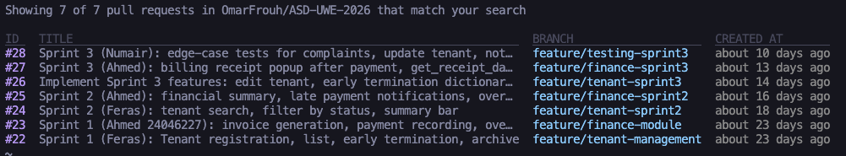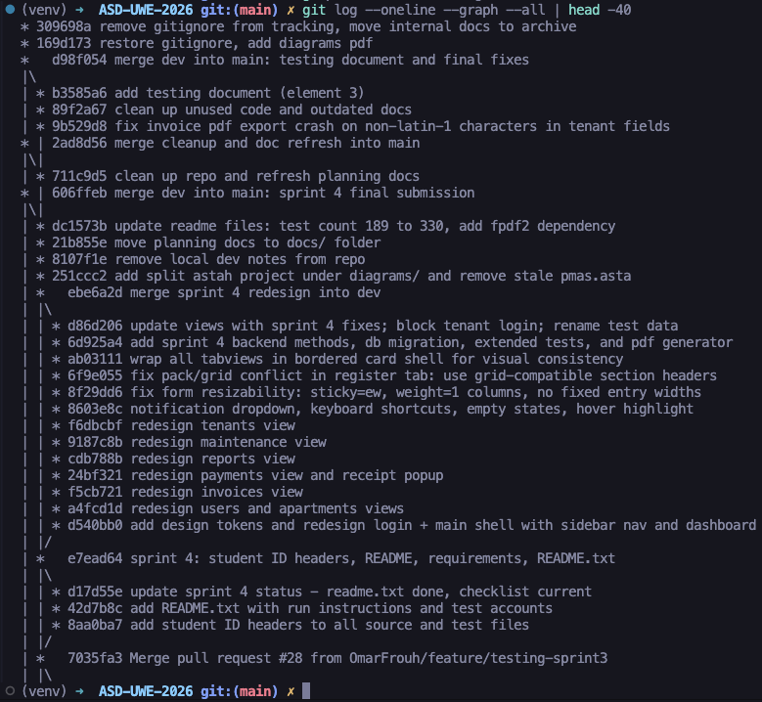

6. Evidence of Collaboration
Evidence of how the team worked together, rather than only what was produced is presented below and in the appendices.

6.1 Project Backlog: docs/Backlog.md
The product backlog was maintained as a Markdown file (docs/BACKLOG.md) in the team repository, version-controlled alongside the source code. User stories were organised by module and sprint, each prefixed with a checkbox ([ ] / [x]) to indicate completion status.

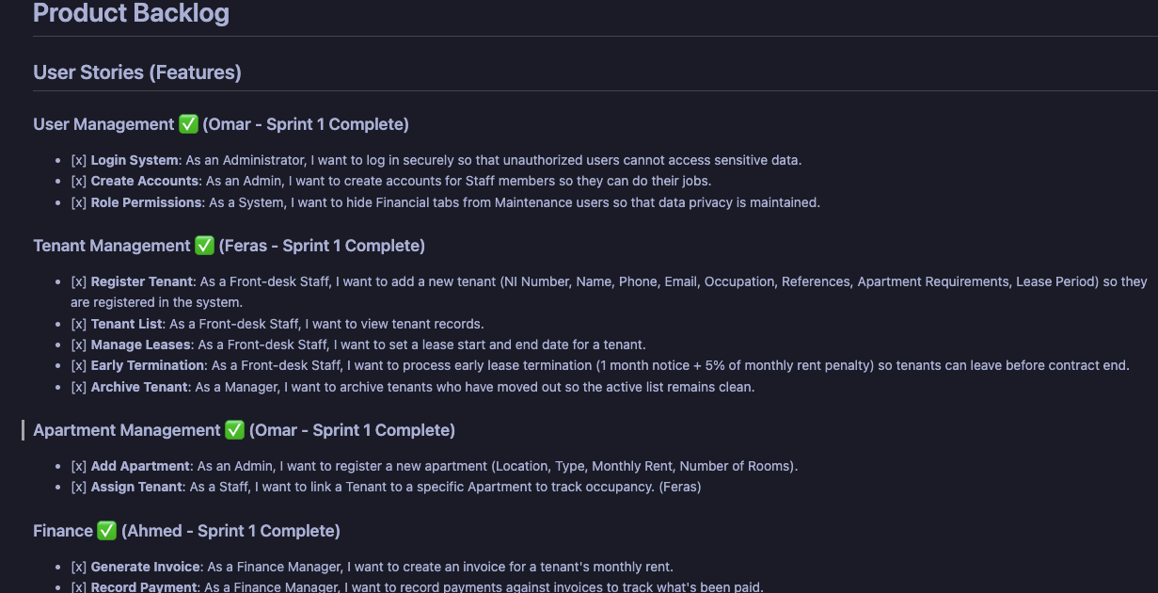6.2 Pull Requests
Every merge into dev went through a pull request. The merged PR list shows reviewer activity on each one.

6.3 Contributor Stats
The command git shortlog -sne shows the number of commits per author across the whole project.

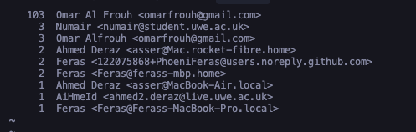 6.4 Automated Test Output
The final test run before writing this report reports 330 tests with zero failures.
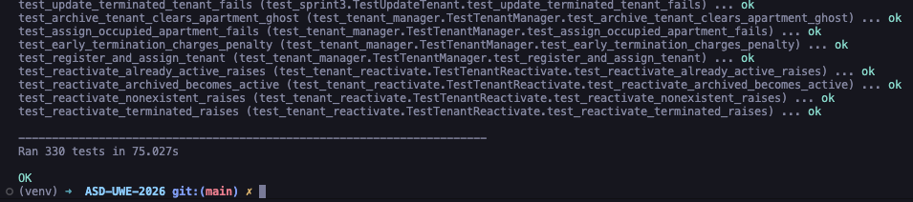

7. Individual Contributions
Each section below is authored by the member it names. File and line references are to the main branch.

7.1 Omar Al Frouh (24020879), Group Leader and Lead Architect

I led the group across all four sprints as Scrum Master and Lead Architect. That meant running the Scrum ceremonies (planning, standups, reviews, retrospectives), maintaining the project backlog, owning the shared backend infrastructure that every other module depends on, and coordinating the submission deliverables at the end.

Sprint 1, Foundation
The project was initialised. This included writing the initial database schema and database_manager.py (8 tables by completion, with PRAGMA foreign_keys, a centralised connection, and an idempotent create_tables method). auth_manager.py was written around bcrypt with a fixed role whitelist, the login and logout flows, and the dashboard statistics method. property_manager.py covered apartment CRUD; seed_db.py provided a one-command reset to a known good state; main.py constructs every manager and passes it to the view layer. On the view side: views/login_view.py, views/main_view.py (role-based sidebar, header, tab switching), views/user_view.py, views/apartment_view.py, and the first version of views/ui_helpers.py (shared helpers for dark Treeviews, scroll, and column autofit). The test infrastructure was established with tests/test_base.py:BaseTest (fresh database per test, clean teardown), along with the first approximately 30 tests exercising the base infrastructure. Module contracts (method names, return shapes, role permissions) were agreed upfront with each teammate so that integration onto dev was straightforward.

Sprint 2, Reporting, Notifications, QA Lead
I wrote report_manager.py (occupancy by city, financial summary, maintenance cost) and notification_manager.py (overdue invoices, expiring leases, combined get_notifications feed), then built the Reports tab in views/report_view.py with city filter dropdowns and KPI summary cards. I added the clickable notification bell to the header. At the end of the sprint I ran a QA pass that caught several issues: the missing user list on the Users tab (USR-01), auth_manager.get_all_users() and property_manager.get_cities() being absent, a hardcoded city dropdown that should have queried the database, broken resize and fullscreen support, missing CTkScrollableFrame on long form views, and a enable_trackpad_scroll bug that was overriding the Treeview’s own scroll handler.

Sprint 3, Schema, Gap Closure, Reviewer

I extended the schema with the complaints table, updated seed_db.py to seed realistic complaint data, and wrote tests/test_sprint3.py with 32 new tests covering the four brief requirements that were still outstanding. I also reviewed and merged all three Sprint 3 PRs: PR #26 (Feras), PR #27 (Ahmed), PR #28 (Numair). For each one I pulled the branch locally, ran the full test suite, read the diff line by line, and returned comments before merging.

Sprint 4, Largest Sprint by Line Count
I designed and built the new visual layer from scratch. views/theme.py became the single source of truth for every colour, font, spacing value, and border radius. I added a full component library to views/ui_helpers.py — cards, KPI tiles, toast notifications, a confirm dialog, pill badges, empty states, segmented controls, search bars, and the notification dropdown. I then restyled every existing view on top of these primitives: login, main shell, dashboard, users, apartments, tenants, invoices, payments, maintenance, and reports. Every messagebox call was replaced with toast notifications, and a custom confirm_dialog was added that honours the dark theme. I wired up global keyboard shortcuts and replaced the Sprint 2 notification popup with an inline dropdown.

On the backend I added views/pdf_generator.py for fpdf2 invoice and receipt PDFs; database_manager._apply_migrations() to idempotently remove a legacy UNIQUE constraint; tenant role blocking at the login screen; invoice search by status and name; and CSV export on the reports module. Nine new test files brought automated coverage from 189 to 330 tests, all passing.

Submission deliverables I owned directly: writing README.txt and the root README.md; regenerating requirements.txt; drawing all UML diagrams in Astah, use case, class, and four sequence diagrams and exporting them to diagrams.pdf (23 pages, A3, committed 18 April); and running the final demo rehearsal with the full team.

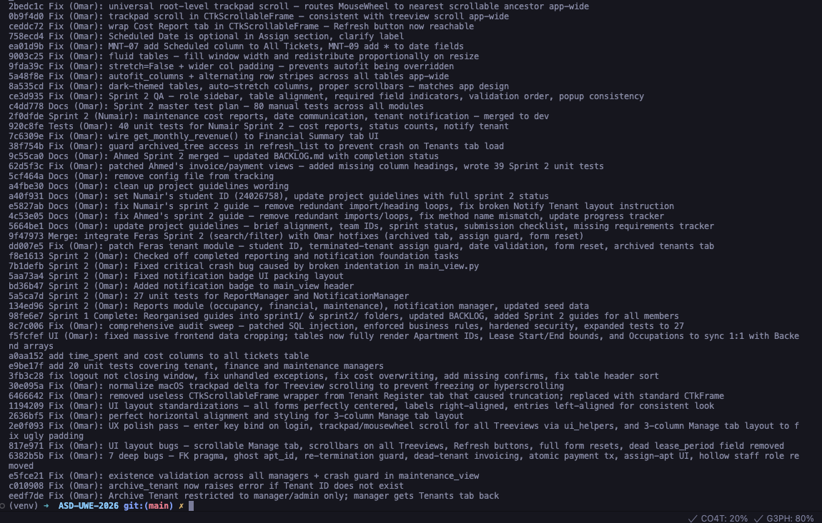

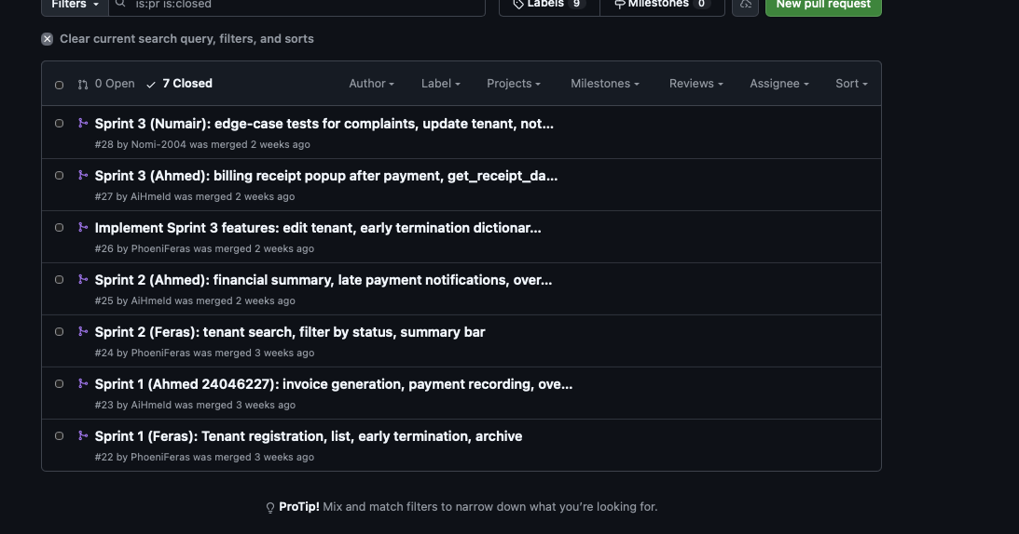7.2 Feras Bader (24033513), Tenant Management

I owned the tenant module across all four sprints.

Sprint 1
I wrote tenant_manager.py from scratch: register_tenant with bcrypt on the user row, assign_apartment flipping the apartment status to Occupied, archive_tenant, early_termination with the 5% penalty, and the list and filter helpers. I also wrote the first version of views/tenant_view.py with the Active Tenants tab, Register tab, and Assign Apartment tab. The tenant columns, ni_number, full_name, apartment_requirements, and the lease fields came from reading the case study paragraph by paragraph to make sure nothing was missed.

Sprint 2
I added search_tenants(), filter_tenants_by_status(), and get_tenant_count_by_status() to the manager, wired them into a new search bar and status dropdown on the Active tab, and built the Archived/Terminated tab. The summary counts strip above the table came out of a Sprint 1 retrospective point, front-desk staff had no quick way to see how many tenants were in each status at a glance.

Sprint 3
I added the Edit Tenant tab to views/tenant_view.py, wrote get_tenant_by_id() and update_tenant() in the manager, built the Log Complaint and Resolve Complaint flows, and updated early_termination to enforce the one-month notice period, returning a dict with both the penalty amount and the effective date. This was delivered as PR #26 on 8 April.

Sprint 4
I worked with Omar on the tenant view restructure to make sure the seven tabs mapped sensibly onto the new card-based layout. I also own the Testing Document PDF (Element 3), which is submitted separately, I ran the full automated test suite to capture the pass evidence and compiled the manual test case table covering all four modules.

My tests sit in tests/test_tenant_manager.py and, from Sprint 3 onwards, in tests/test_sprint3.py. My student header (# Student Name: Feras Bader, # Student ID: 24033513) appears on tenant_manager.py and views/tenant_view.py.
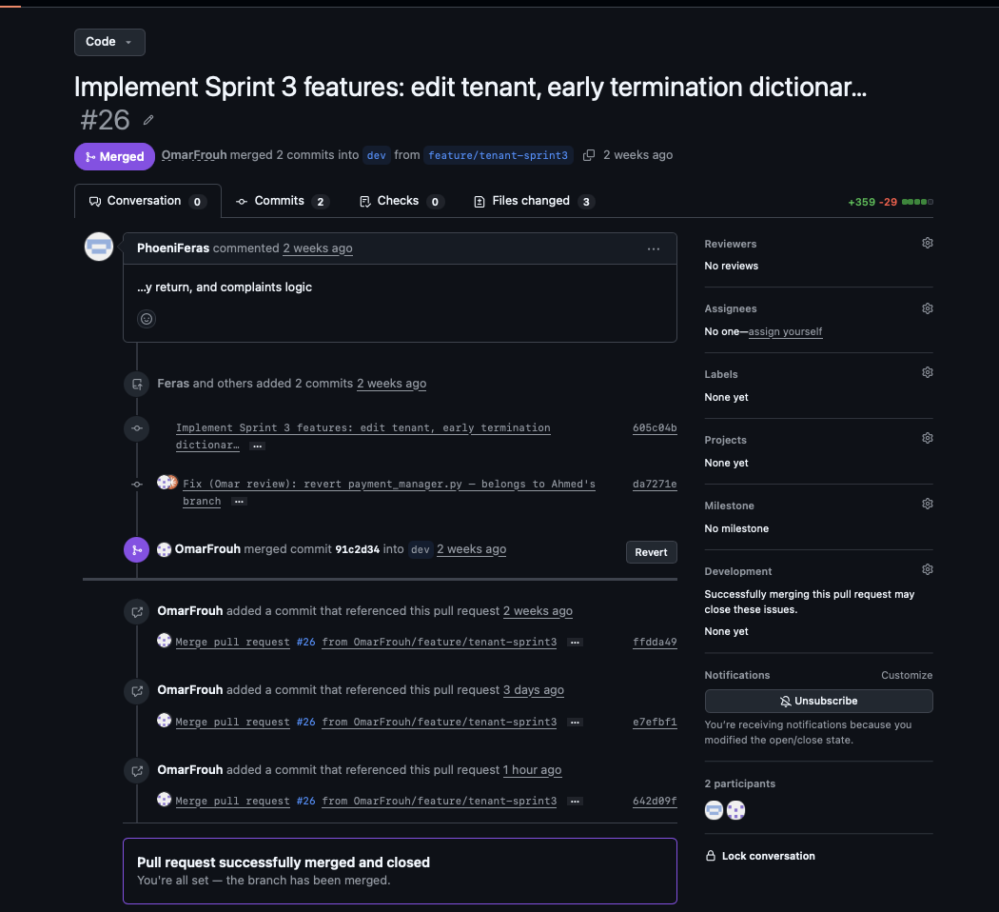

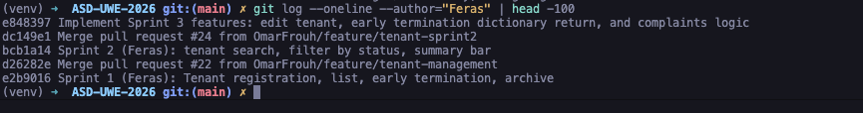

7.3 Ahmed Deraz (24046227) — Payment and Billing
I was responsible for the finance side of the application: invoices, payments, overdue tracking, and the receipt workflow.

Sprint 1

I wrote invoice_manager.py and payment_manager.py. The most important detail in record_payment was atomicity, recording a payment involves two related writes (an INSERT into payments, then an UPDATE to invoices.status when the balance is cleared) and both have to succeed or roll back together. generate_invoice reads monthly_rent from the tenant row and creates an invoice with a 14-day due date. On the UI side I built views/invoice_view.py and views/payment_view.py with the Generate, List, Overdue, and Record Payment tabs.

Sprint 2

I added get_overdue_with_details() and get_invoice_aging() to the invoice manager, and get_collected_vs_pending(), get_payment_history_by_method(), and get_monthly_revenue() to the payment manager. On the UI side I added the overdue badge on the invoice list, the Late Payment Notifications tab, and the Financial Summary tab with the payment method breakdown table and the six-month revenue chart. I wrote 39 unit tests in tests/test_ahmed_sprint2.py.

Sprint 3

I addressed the brief requirement for billing receipts. I added get_receipt_data() to PaymentManager, joining payment, invoice, tenant, and apartment rows into a single dictionary, and modified record_payment to return the new payment_id so the view could fetch the receipt immediately after recording. I then built the receipt popup as a CTkToplevel window and wrote eight additional tests. This was delivered as PR #27 on 9 April.

Sprint 4
I kept the receipt popup but rebuilt it on top of Omar’s new card primitives so it matches the dark theme. The PDF export was wired in so that after a payment is recorded, the receipt popup offers a Save PDF button that writes through views/pdf_generator.py:generate_receipt_pdf. I also took part in the QA run on the finance flows before the Sprint 4 merge.

My tests are in tests/test_ahmed_sprint2.py (39 Sprint 2 tests) and the Sprint 3 receipt tests in tests/test_sprint3.py. My student header (# Student Name: Ahmed Deraz, # Student ID: 24046227) appears on the relevant files.
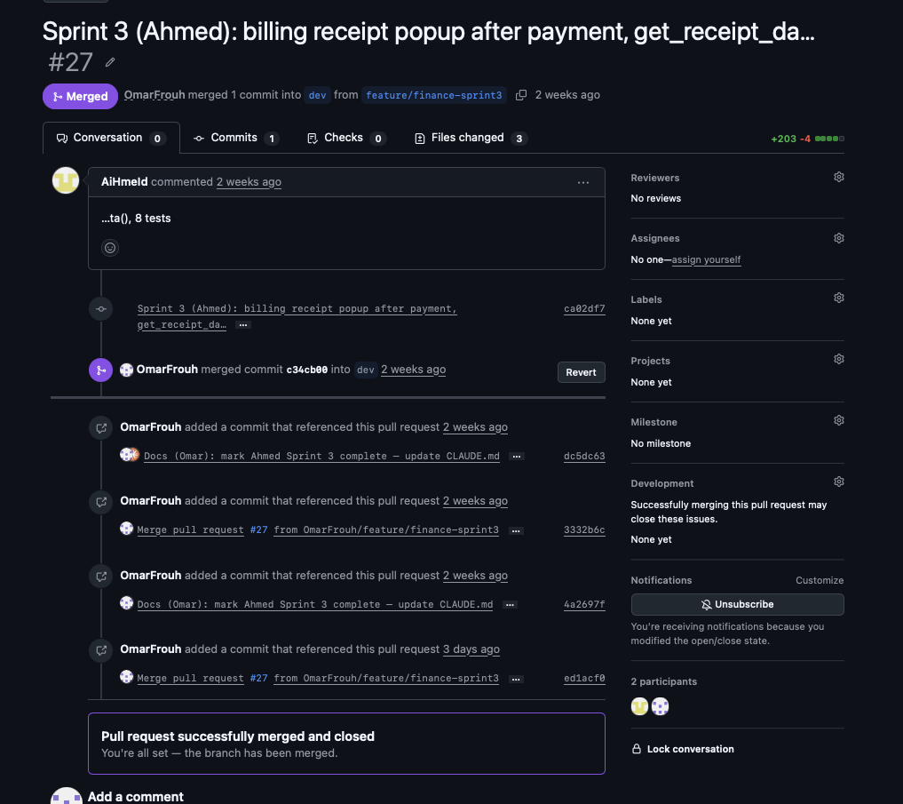

7.4 Numair (24026758) — Maintenance and Testing

I owned the maintenance component and, from Sprint 3, the edge-case testing work across the whole application.

Sprint 1

I wrote maintenance_manager.py with create_ticket, assign_staff, update_status, log_costs, and the list and filter helpers. I built the first version of views/maintenance_view.py with the New Ticket tab, All Tickets tab, and Manage tab (updating status, assigning staff, logging costs). The priority and status vocabularies, Low/Medium/High/Urgent and Open/Assigned/In Progress/Fixed/Closed came directly from the brief’s description of the maintenance workflow.
Sprint 2

I added the reporting side: get_cost_report_by_apartment() and get_cost_report_by_city() on the manager, and a new Cost Report tab with KPI summary cards and per-apartment and per-city tables. I also added the Notify Tenant section to the Manage tab, which writes a scheduled maintenance date onto the ticket for the tenant view to surface. I wrote 40 unit tests in tests/test_numair_sprint2.py, and added get_tickets_by_status_count() to feed the Sprint 4 dashboard KPI.
Sprint 3

My role broadened this sprint. On top of maintenance fixes, I wrote 16 edge-case tests in tests/test_numair_sprint3.py specifically designed to stress the system: logging a complaint for one tenant then verifying a second tenant cannot see it; partial tenant updates where only one field changes and the rest stay untouched; and notice period boundary dates — today, today plus exactly 30 days, and the day before. PR #28 was delivered on 12 April.
Sprint 4
I pair-debugged a notification dropdown edge case with Omar during the redesign merge, and did a full manual pass through the Maintenance view to confirm none of the ticket workflows were broken by the UI changes.

My tests are in tests/test_numair_sprint2.py (40 Sprint 2 tests) and tests/test_numair_sprint3.py (16 Sprint 3 edge-case tests). My student header (# Student Name: Numair, # Student ID: 24026758) appears on the relevant files.
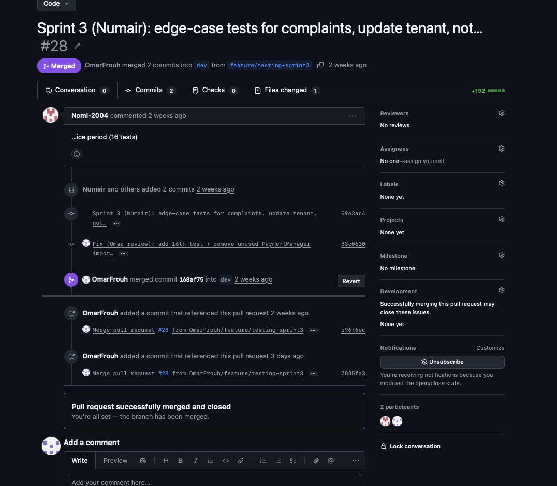

8. Retrospective and Lessons Learned

8.1 What Went Well
Sprint-by-sprint delivery prevented a last-week panic. Because dev was always runnable at the end of each sprint, there was never a decision in the final 48 hours about whether to cut a feature. By the time Sprint 4 opened, the only outstanding items were polish and paperwork.
Single reviewer worked at this team size. Routing every pull request through Omar was a theoretical bottleneck but in practice meant one person understood what was entering dev and could catch cross-cutting bugs early. This approach would not scale to a team of eight.
Automated tests enabled a confident UI redesign. With 189 tests passing before Sprint 4, the full UI redesign in ten days was feasible without fear of breaking invisible behaviour. When a Sprint 4 refactor did fail a test, it was usually caught within minutes.

8.2 What Could Have Gone Better
The brief was read too quickly initially. Four requirements (editing tenants, one-month notice, complaint logs, billing receipts) were only identified in the Sprint 2 retrospective. A line-by-line brief review during Sprint 1 planning would have been more thorough. The time saved by skipping it cost a full sprint later.
Async standups were low signal. WhatsApp updates were better than nothing, but a ten-minute voice call at the start of each lab day would have surfaced integration clashes earlier than the PR review stage.
UI polish was deferred too long. The functional application existed by end of Sprint 2, but visual consistency work was concentrated into Sprint 4. A small design-sweep slot in every sprint from Sprint 1 would have distributed this workload more evenly.

8.3 What the Team Would Do Differently
- Conduct a line-by-line brief check at Sprint 1 planning, verified against every sprint's backlog.
- Add a lightweight daily voice standup on lab days (10 minutes, not the full 15).
- Schedule a 20-minute design sweep slot at the end of every sprint from Sprint 1, so Sprint 4 does not absorb all UI work.

8.4 How Agile Actually Helped
Agile allowed the team to change the plan without experiencing the change as a failure. Without Scrum, discovering four missing requirements in week four would have felt like a crisis and might have resulted in cutting features or rushed implementation. Within the Scrum framework, it became a retrospective item that turned directly into the next sprint. Every feature that ended up in PAMS is present in the brief, and that outcome was achieved by iterating rather than by getting the plan right first time.

9. Conclusion
PAMS covers every core component listed in the brief: account and user management (five roles, bcrypt, role-based sidebar); tenant management (registration, update, lease, complaint log, early termination with one-month notice and 5% penalty); apartment management (register, assign, lifecycle); payment and billing (invoice, payment with atomic transactions, receipts, overdue tracking and notifications); reporting (occupancy, financial, maintenance cost, all filterable by city); and maintenance (tickets, priority, staff assignment, cost logging, tenant notification). All of this is built on parameterised SQL, bcrypt password hashing, and 330 automated tests.
On the process side, the team ran four two-week sprints, used GitHub pull requests and a project board, held retrospectives that produced concrete changes to the next sprint's plan, and generated per-member contribution evidence supported by both this report and the git history.

10. Appendices

Appendix A — Project Backlog

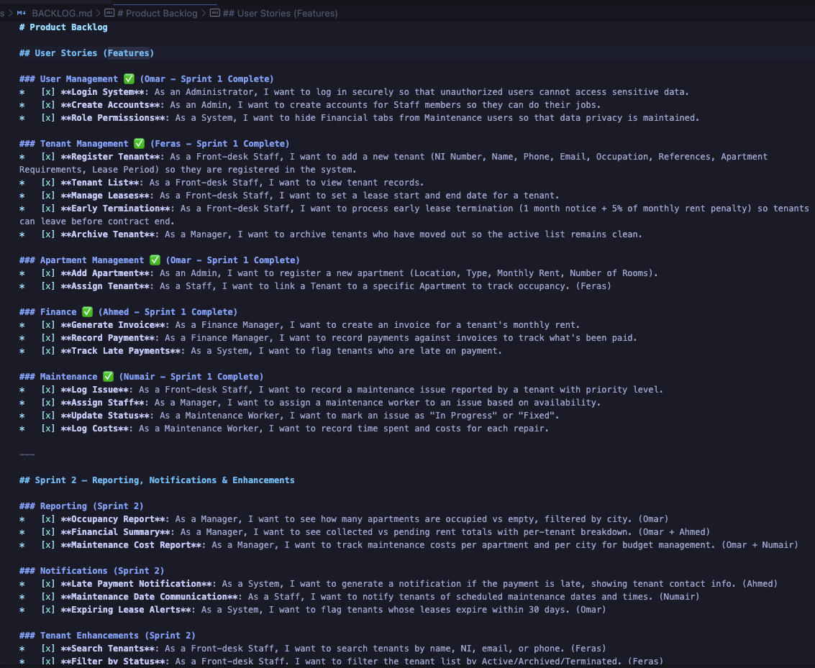

Appendix B — Pull Requests

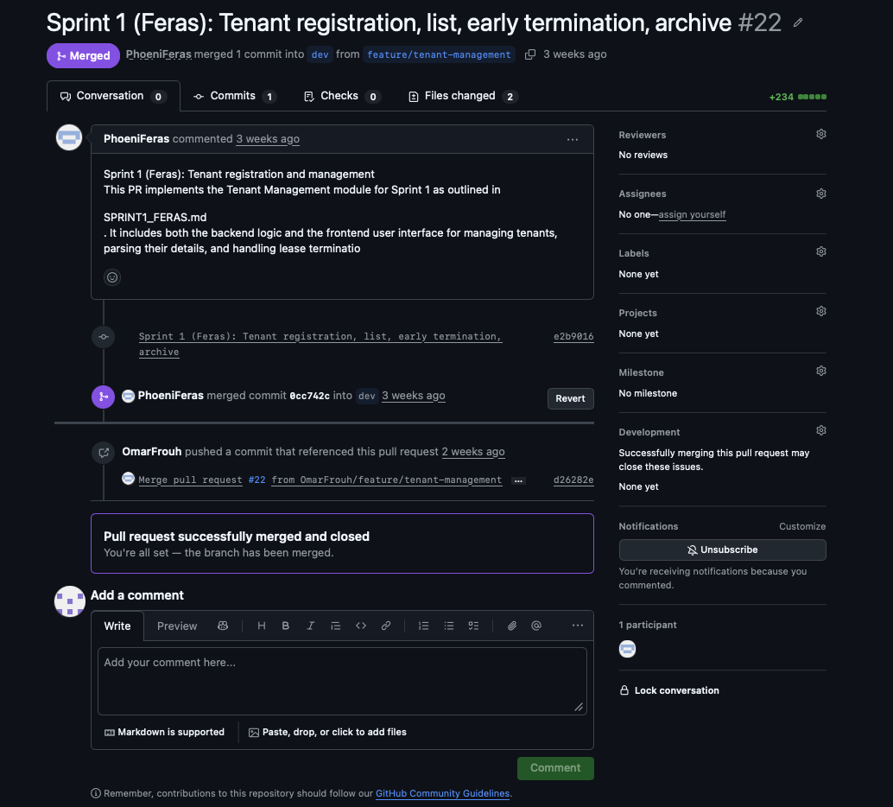

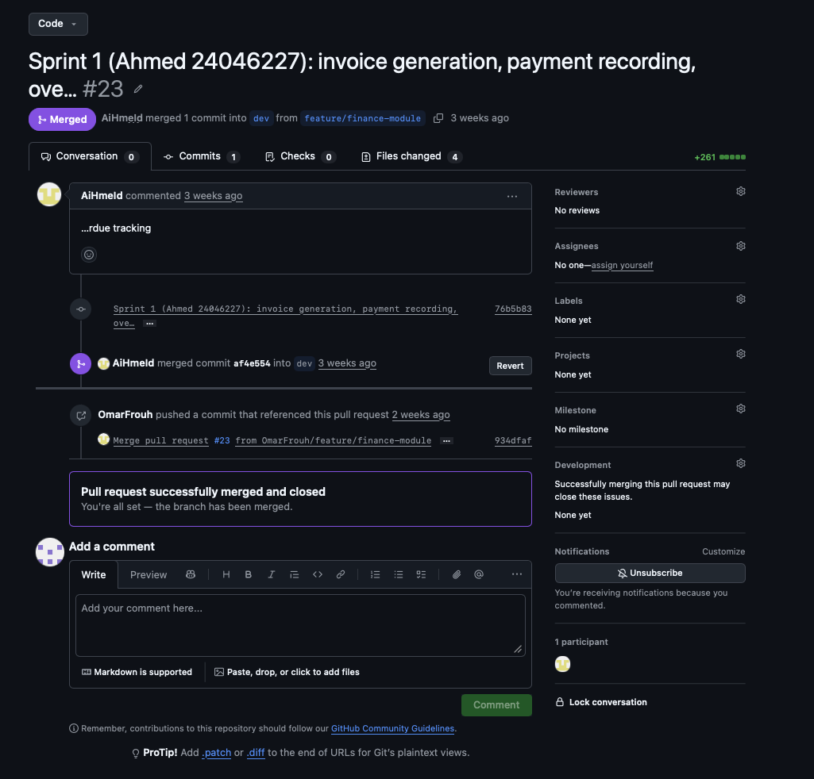

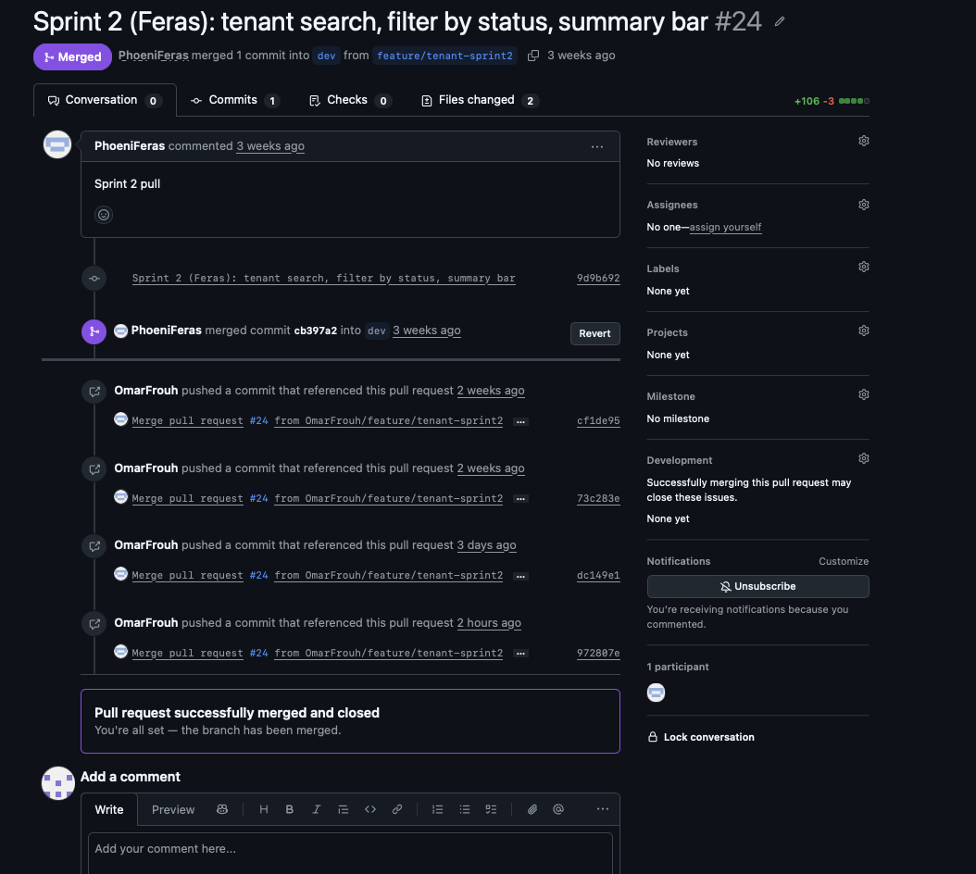

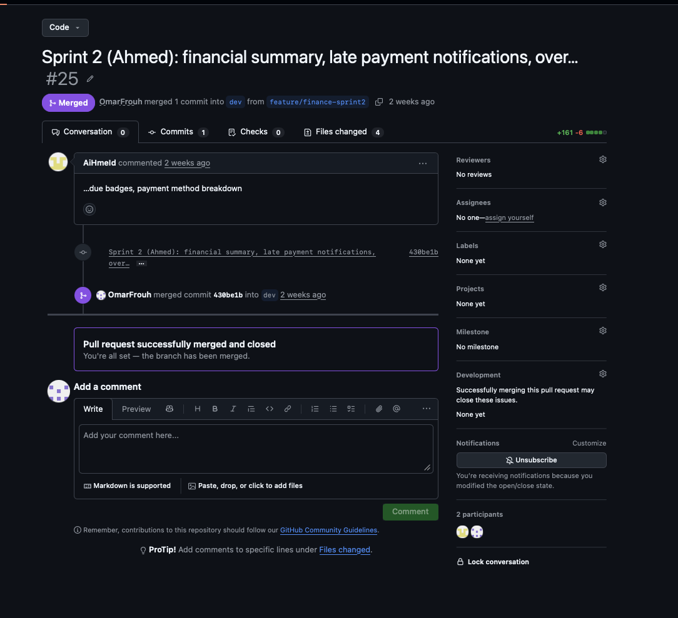

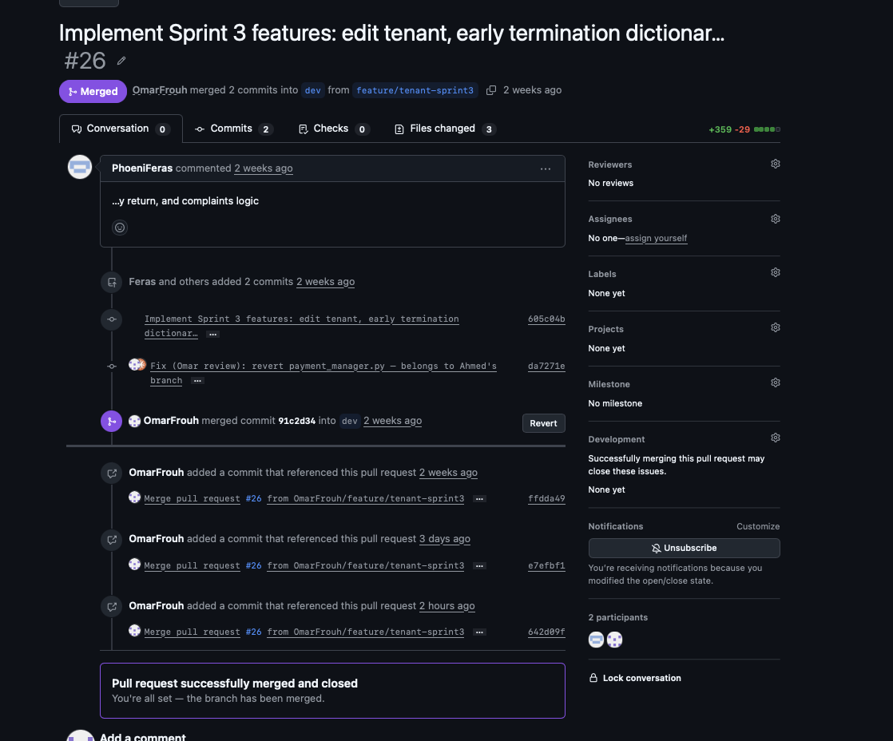

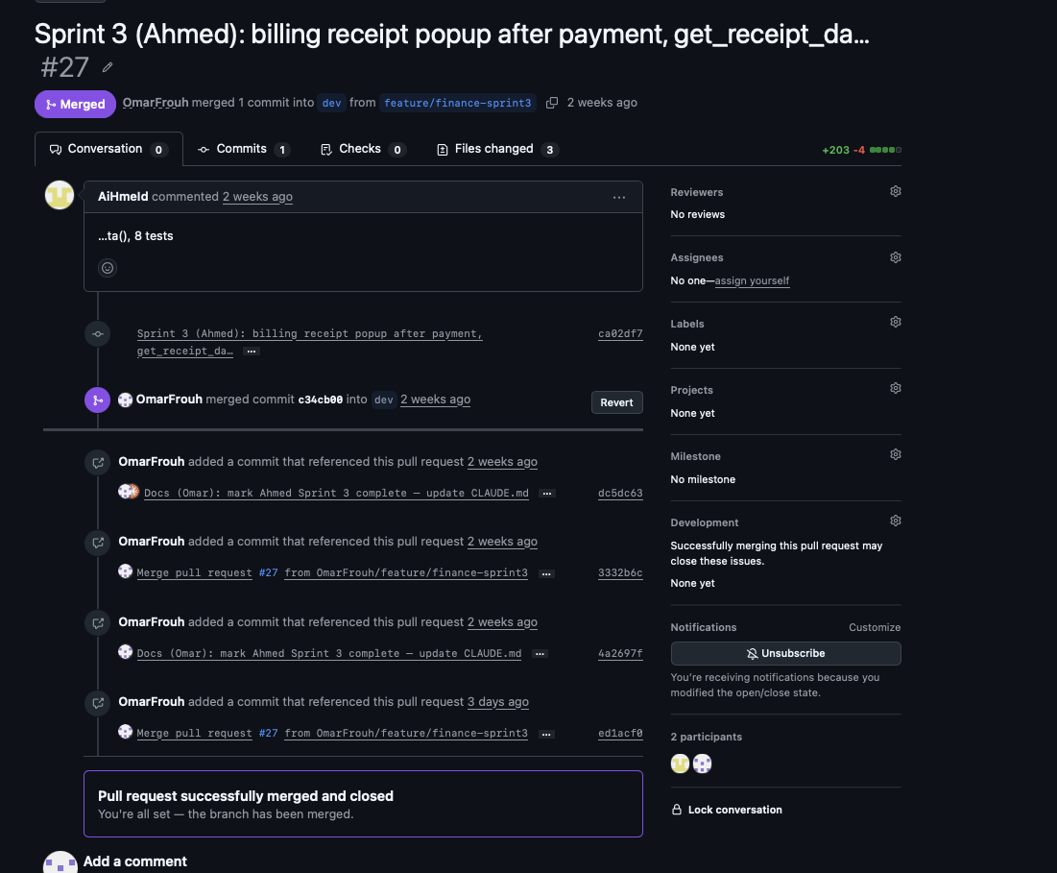

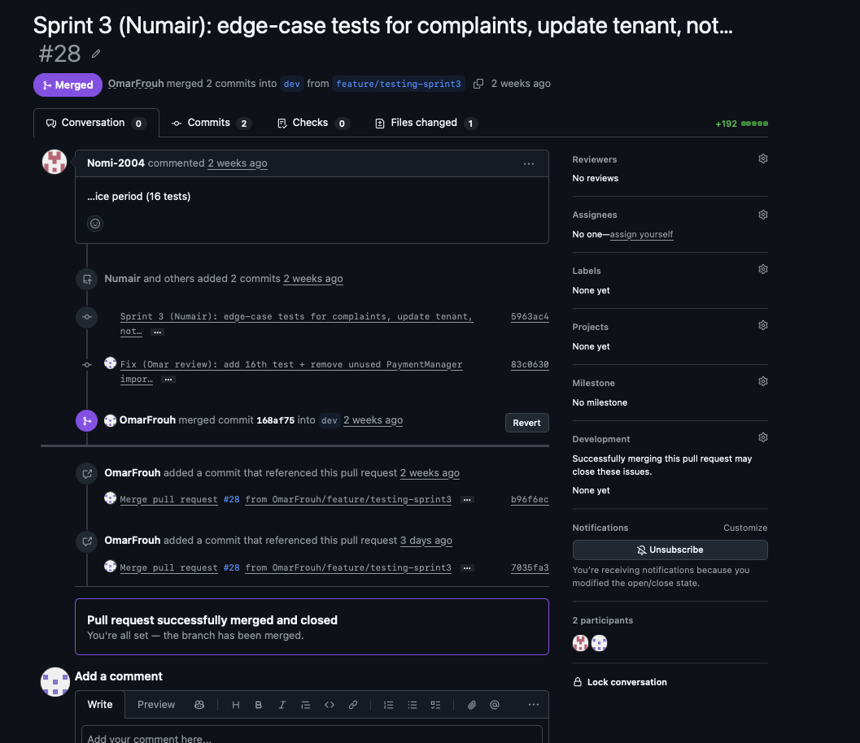

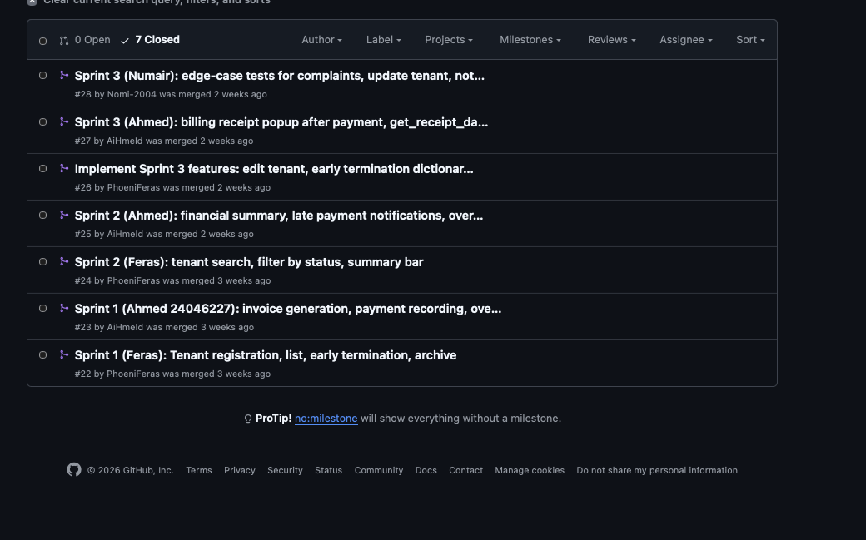

Appendix C — Branches and Git Log

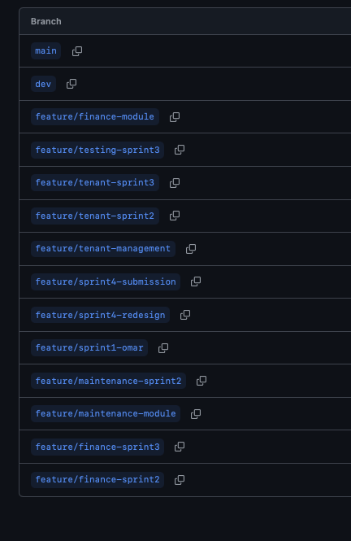 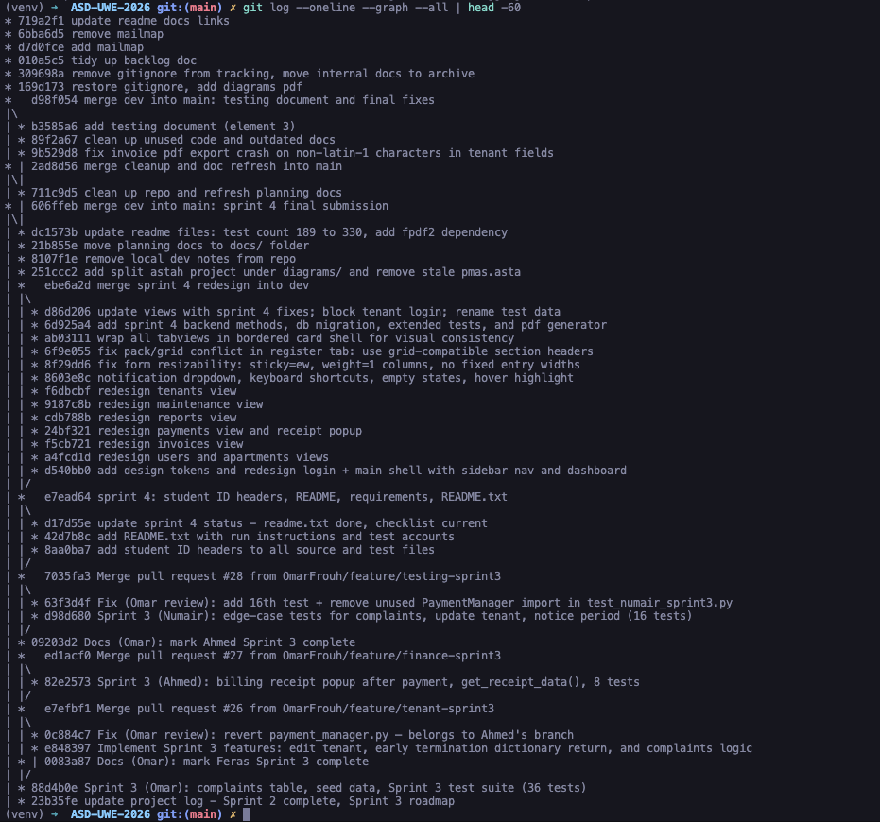 Appendix D — Contributor Stats

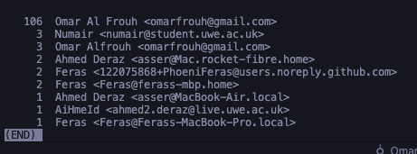

Appendix E — Automated Test Run

Appendix F — Sprint Planning Artefacts
Sprint planning was conducted in person at the start of each sprint. Task assignments, module contracts, and QA checklists were shared with the team via the WhatsApp group and confirmed at the sprint planning meeting. The GitHub Project Board cards and PR history (Appendix C) provide the timestamped record of what was planned and when it was delivered.
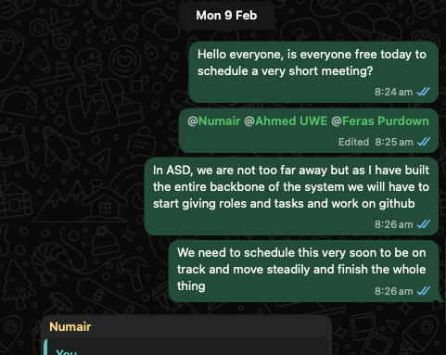
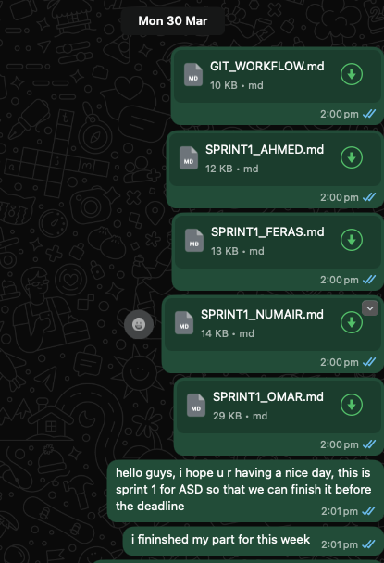
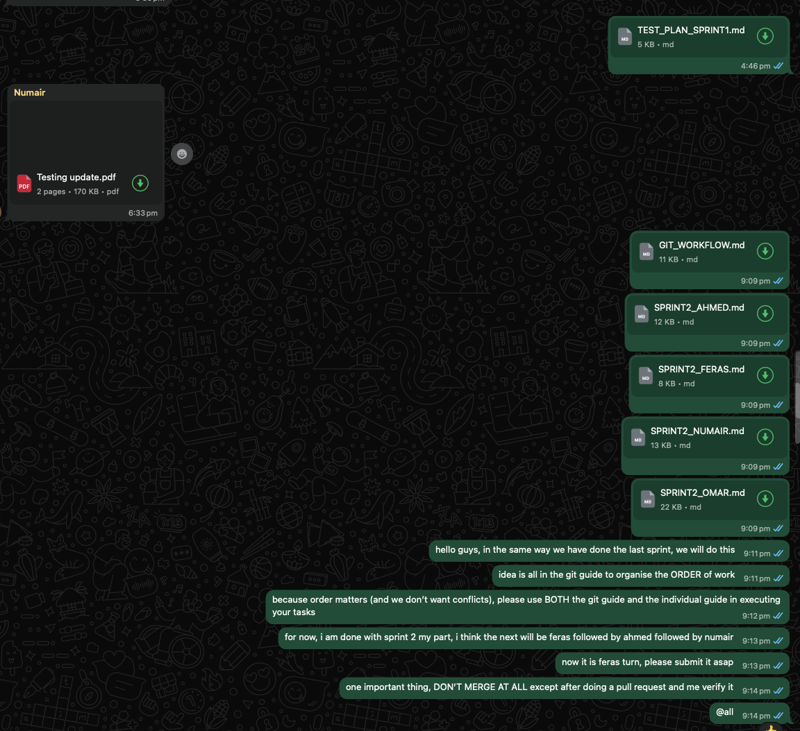
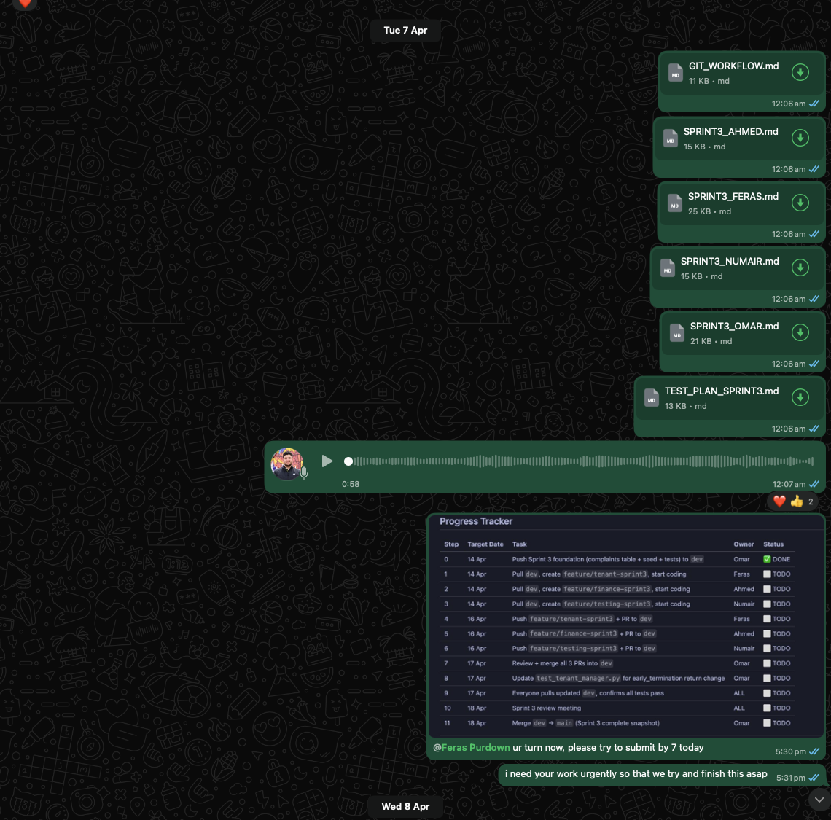
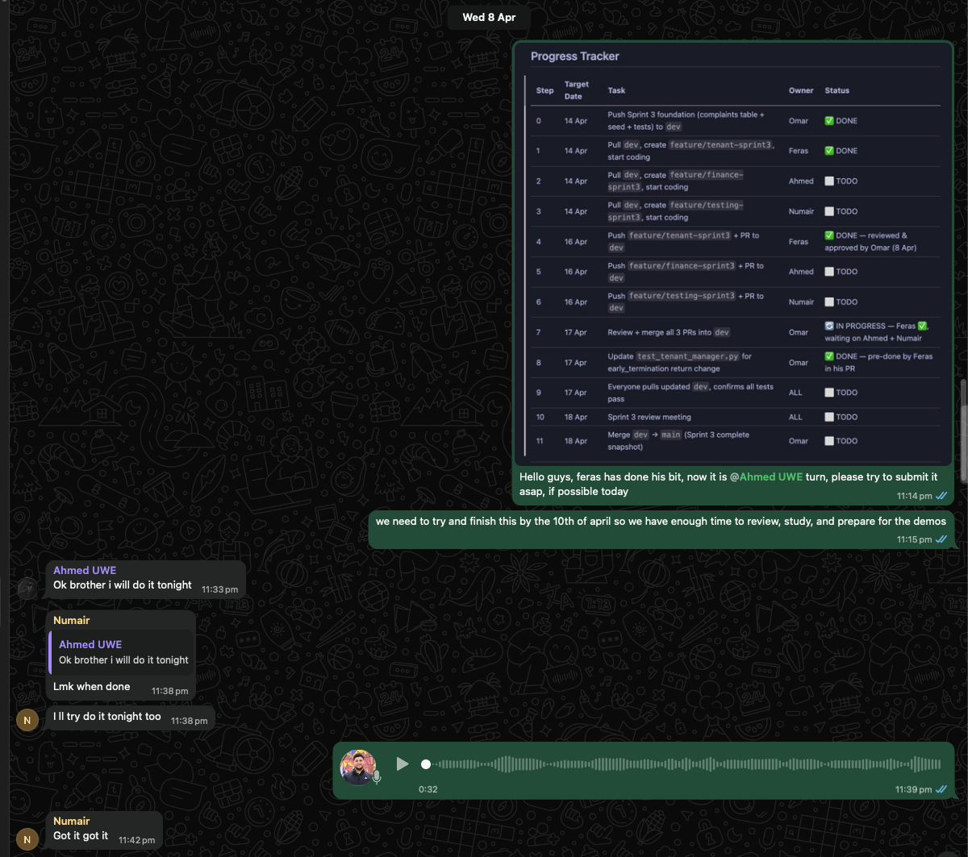
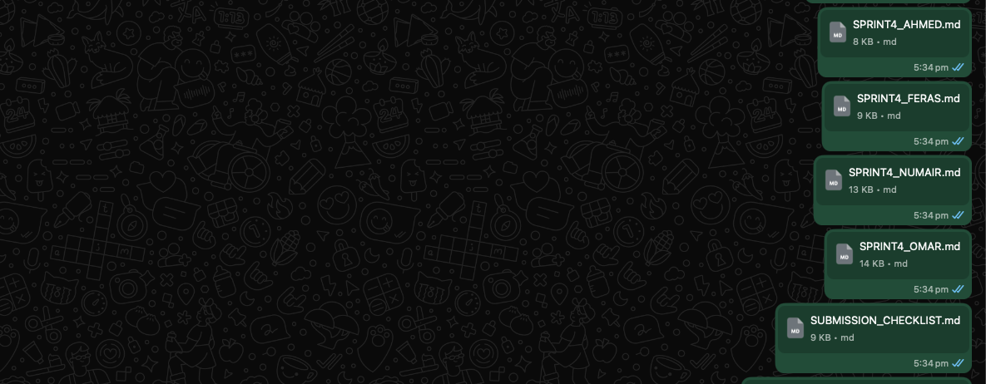

End of Report

