**Cairo University  
Faculty of Computers and Information** 

**CS251**

**Software Engineering I**

Project: Lost & Found

Software Design Specifications

<M & M’s>

12/2018

**Contents**

Team 3

Document Purpose and Audience 3

System Models 3

I. Class diagrams 3

Important Algorithm 5

II. Sequence diagrams 5

Class - Sequence Usage Table 7

Ownership Report 8

Policy Regarding Plagiarism: 8

References 8

Authors 8

# Team

|  |  |  |  |
| --- | --- | --- | --- |
| **ID** | **Name** | **Email** | **Mobile** |
| 20160158 | Omar Hatem Ismail | omarh.ismail1@gmail.com | 01012256897 |
| 20160080 | Bassem Mohamed Reda | basem.m.reda@gmail.com | 01000310523 |
| 20160255 | Mina Shafik Wadee | minashafik90@gmail.com | 01283304587 |
| 20160253 | Mona Ahmed Mohamed | monaahmed3040@outlook.com | 01000115210 |

# Document Purpose and Audience

* **Purpose: the SDS document should demonstrate how the design will accomplish the functional and nonfunctional requirements described in the SRS document. The document outlines the software architecture and design of the Lost & Found project for the developers. The document increases understanding of the system by providing several views of the system design.**
* **Audience: analysts, developers**

# System Models

## I. Class diagrams

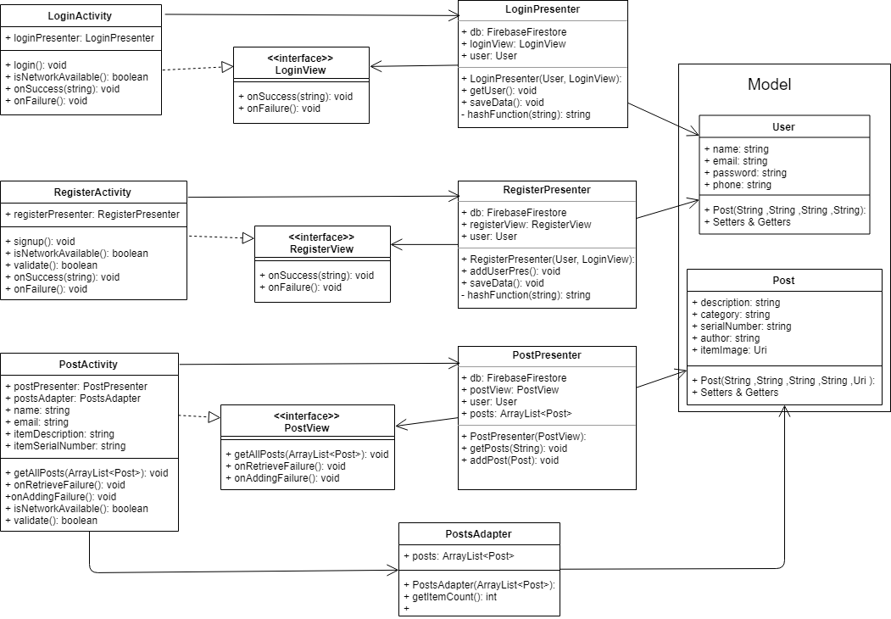

### 

### Class - Sequence Usage Table:

|  |  |  |
| --- | --- | --- |
| **Class ID** | **Class Name** | **Description & Responsibility** |
| RegrAct | RegisterActivity | The user registers with their Email, password, name, phone number, location  and the system validates the input and checks if entered email already exists. |
| LoginAct | LoginActivity | The user Sign in with their Email and Password and the system verifies that the user is registered. |
| User | User | Holds the data of the signed in user including a list of his posts. |
| Post | Post | takes the required info for a post  (Description, Category, Image) and saves the post in the data base for that user. |
| Pres | Presenter | Pass requests from user ( Activities ) to the Database to be processed |
| DataV | DataView | Interface to let Activities access the results returned from the Database through the Presenter Class |
| DB | DataBase | The Link between the App and the Database which makes the required queries |
| ProfAct | ProfileActivity | Activity to show user posts. |
| updateInfAct | UpdateInfoActivity | Allows User To edit his info |
| PostAct | PostActivity | Shows The user all posts sorted by recent date. |

### Important Algorithm

* **Hashing Algorithm: Encrypting users passwords and items serial number by using a Mathematical operation to generate an encrypted value.**

## II. Sequence diagrams

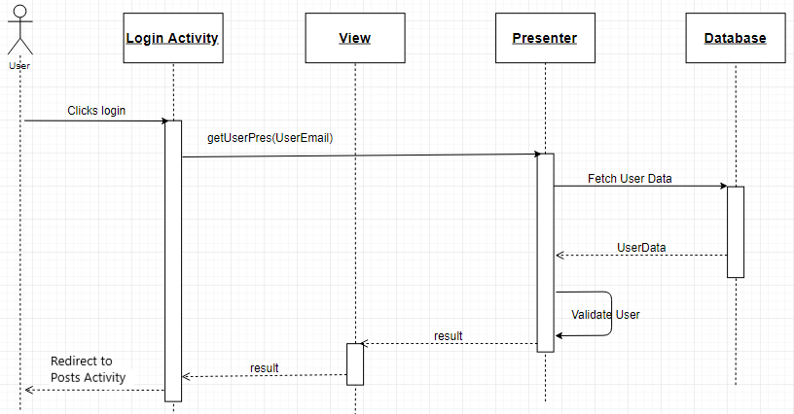

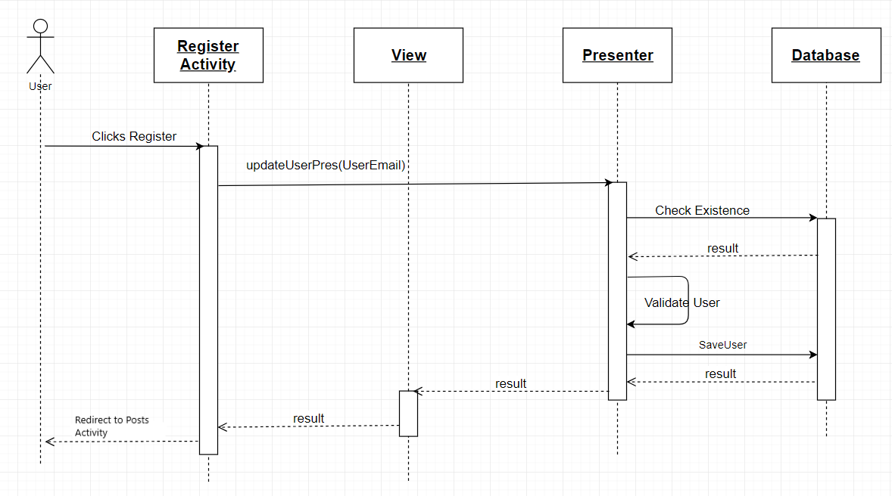

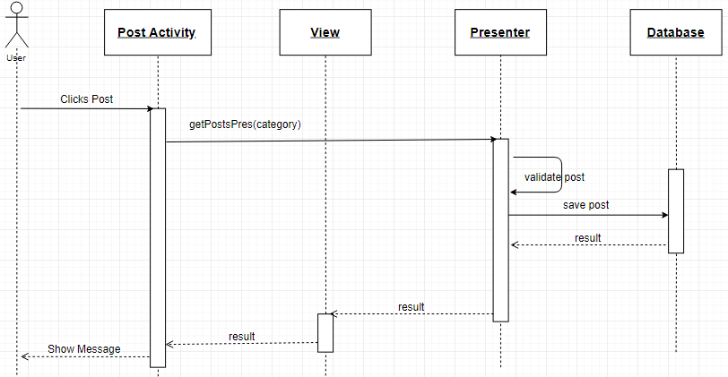

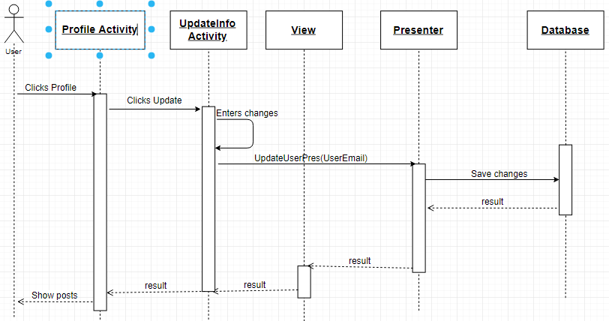

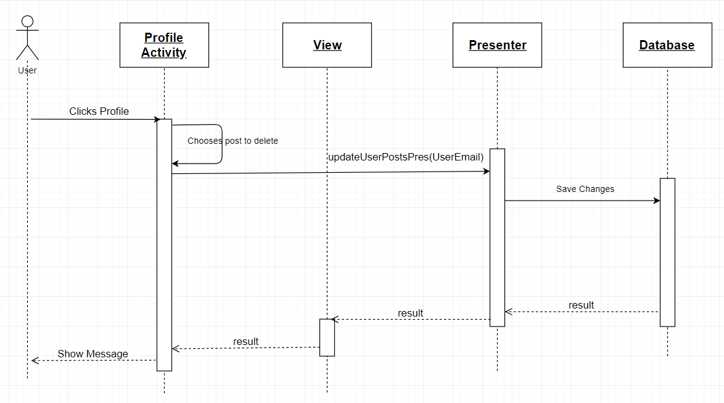

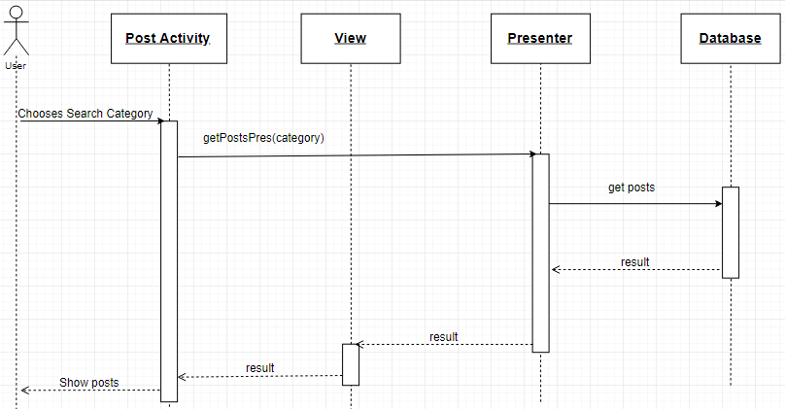

### Class - Sequence Usage Table

|  |  |  |
| --- | --- | --- |
| **Class Name** | **Sequence Diagrams** | **Overall used methods** |
| LoginActivity | 1 | getUserPres(userEmail) |
| RegisterActivity | 2 | getUserPres(userEmail) |
| PostActivity | 3, 6 | getPostsPres(category) |
| UpdateInfoActivity | 4 | updateUserPres(userEmail) |
| ProfileActivity | 4,5 | updateUserPostsPres(userEmail) |
| Presenter | All |  |

# Ownership Report

|  |  |
| --- | --- |
| **Item** | **Owners** |
| Login / Register Sequence Diagram, Frequency Usage Table and Class Diagram | *Omar Hatem / Bassem Reda* |
| Purpose, Post and User Sequence Diagram (Update Info) | *Mona Ahmed* |
| Audience, Search and User Sequence Diagram (Delete Post) | *Mina Shafik* |

# References

* http://www.mhhe.com/engcs/compsci/pressman/graphics/Pressman5sepa/common/cs1/design.pdf

# Authors

* Mostafa Saad and Mohammad El-Ramly (Edited by Mohamed Samir)