PlantUml & Domain analysis

Code:

@startuml

skinparam classAttributeIconSize 0

class User{

- username: string
- password: string
- email: string
+ login(): boolean
+ logout(): void

}

class Customer{

- customerId: string
+ browseFlights(): List<Flight>
+ checkout(): Booking

}

class Administrator{

- adminId: string
+ manageCatalog(): void
+ updateAvailability(): void

}

class Flight{

- flightNumber: string
- destination: string
- departureTime: LocalDateTime
- getFormattedDepartureTime(): string
- seats: integer
+ getSeatsAvailable(): integer
- price: double
+ getAvailabilityStatus(): string

}

class Cart{
- cartId: string
+ addItem(ticket: Flight, quantity: integer): void
+ clearCart(): void
}

class CartItem{
- quantity: integer
- originalPrice: double
}

class Booking{

- bookingId: string
- status: string
- totalAmount: double
+ commit(): void
}

class BookingItem{

- quantity: integer
- finalPrice: double
}

User <|-- Customer: Inherits <
User <|-- Administrator: Inherits <

Customer "1" *-- "1" Cart : owns >
Cart "1" *-- "0..*" CartItem : contains >
CartItem "0..*" --> "1" Flight : references >

Administrator "1" --> "0..*" Flight : manages >

Customer "1" --> "0..*" Booking : creates >
Booking "1" *-- "1..*" BookingItem: contains >
BookingItem "0..*" --> "1" Flight : references >

@enduml

The UML diagram:

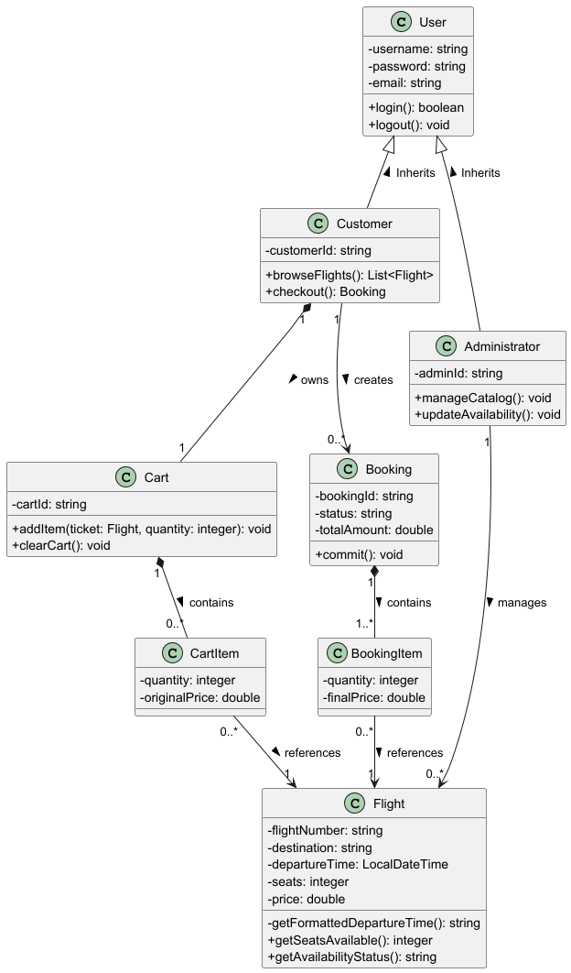

Domain analysis

Core Entities

- User: The default entity type that represents anyone using the system.

- Customer: A specific entity type that represents a user that searches for available flights, using a booking cart, and reserves flights.

- Administrator: A specific entity type that represents a user that is responsible for managing the flight catalog and updating ticket availability.

- Flight: The catalog entry represents a plane ticket, and includes information such as flight number, destination, date, seat, availability, and time.

- Cart: A private collection that is managed by the customer to add plane tickets to it. It will be persistently saved in the database.

- CartItem: An entity representing specific flight tickets added to the customers cart, it tracks the quantity added and it shows the original price of the ticket at time it was added.

- Booking: The final transaction record that is created when the customer checks out, this will clear the cart and update the availability of the tickets.

- BookingItem: A record of the specific flights that have been purchased in a booking, and it shows the final price.

Relationships Between Entities

Inheritance: The Customer and Administrator both inherit attributes and authentication methods from the base User class.

Composition:
- A customer owns exactly 1 cart.
- A cart contains zero to many CartItems, and if the cart is cleared then the CartItems will be removed.
- A booking contains one to many BookingItems.

Association:
- An Administrator manages zero to many Flights in the catalog.
- A Customer creates zero to many Bookings over time.
- Both CartItem and BookingItem reference exactly 1 Flight from the central catalog to avoid data duplication.

