**Cairo University**

**Faculty of Engineering – Credit Hours System**

**MTHS114 – Numerical Analysis**

**Fall 2024**

**Numerical Solution of the Simple Harmonic Oscillator ODE Using Runge-Kutta and Euler’s Method**

**Submitted to:**

**Eng. Shaimaa Ebid**

**Prepared by:**

**Abdelrahman sherif Ibrahim Nabil - 1220182**

**Amr Ayman Farouk - 1220071**

**Ahmed Mohammed Abdelaal - 1220009**

**Nada Medhat Fawzy - 1200295**

**Omar Ahmed Reda - 1220130**

**Reem Abdou Mostafa - 1200151**

**Plots of the numerical solutions compared to the exact solution:**

* 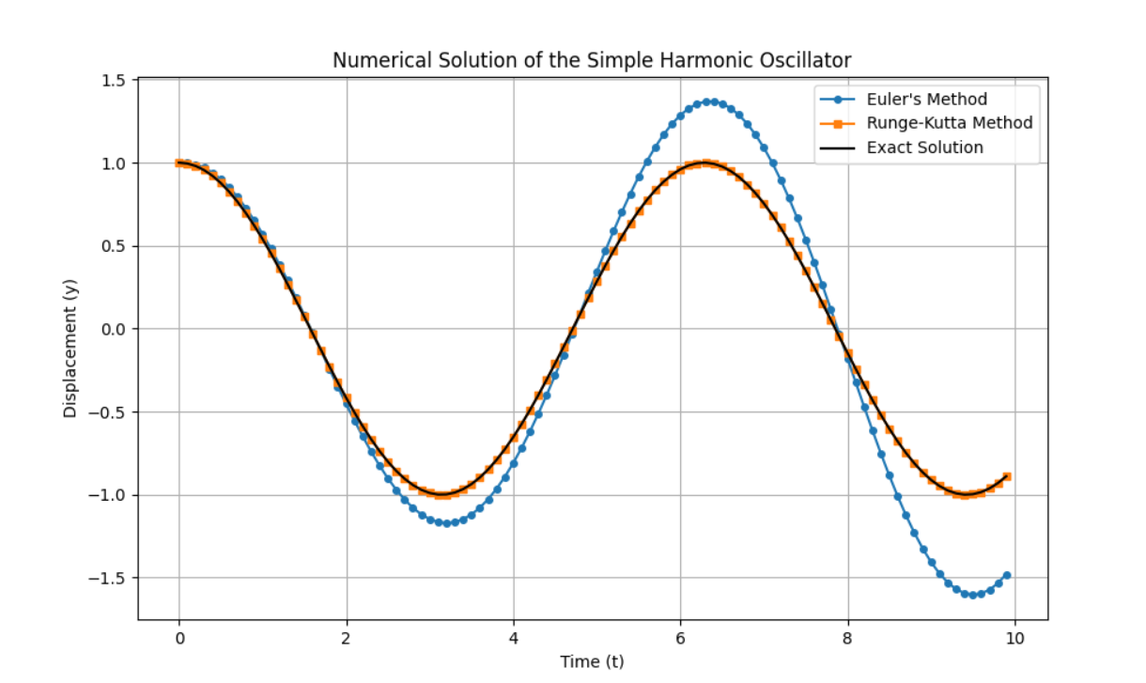**h = 0.1 (Optimum Time Step):**
* 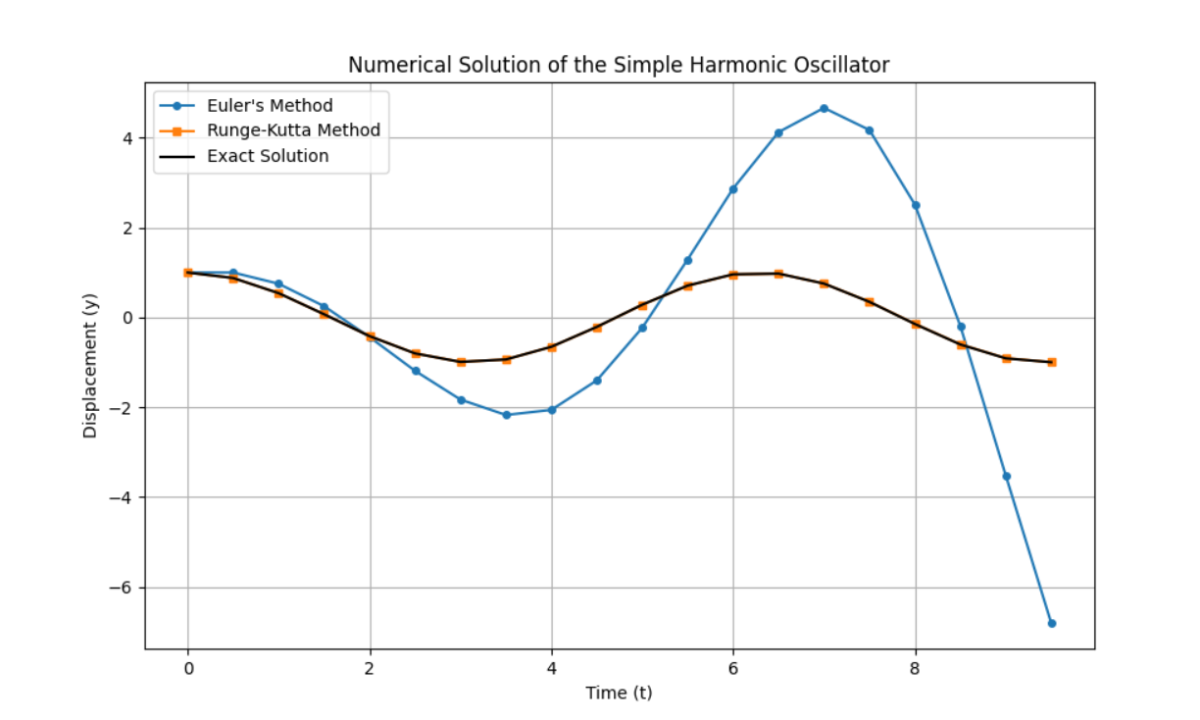**h = 0.5 (Medium Time Step):**
* **h = 1.0 (Large Time Step):**

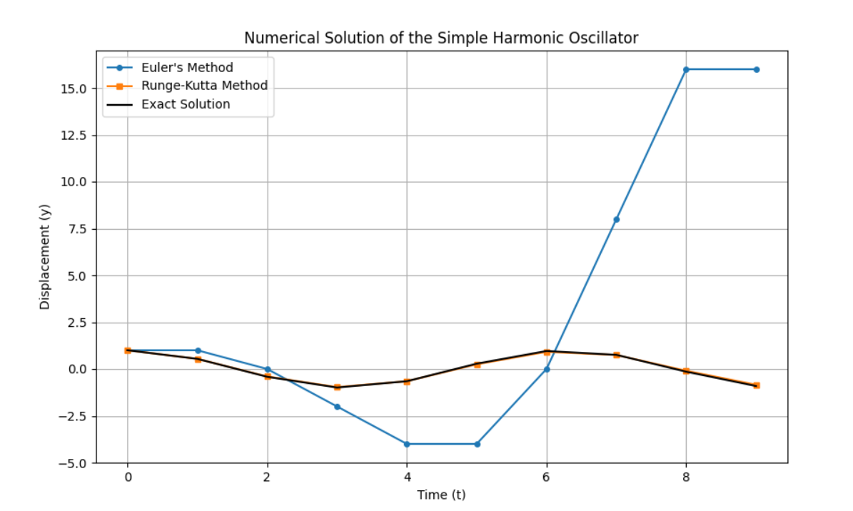

**Accuracy for different time steps:**

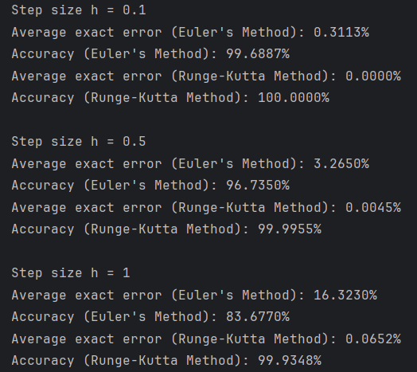

**Observations/Conclusions:**

The observed results shown demonstrate that the 4th-order Runge-Kutta method is significantly more accurate and stable than Euler’s method for solving ordinary differential equations. Runge-Kutta remained nearly identical to the exact solution across all tested step sizes, highlighting its superior stability and higher-order accuracy. In contrast, Euler’s method showed increasing deviations from the exact solution as the step size grew larger, indicating its lower accuracy and numerical instability. This difference arises because Euler’s method, being a 1st-order O(h) method, accumulates errors proportional to h, while Runge-Kutta, a 4th-order method O(h4), reduces errors proportional to h4. Thus, the 4th-order Runge-Kutta method is far better suited for problems requiring both precision and stability over a wide range of step sizes.