ICP1 **Omar Ismail** oaif2b@umsystem.edu

**1)** The answer for question will be in file Question1. I listed three differences between Python 2 and python 3.

**2)** code will be in Question 2. The question consisted of 2 parts I placed both parts in the same file.

**a)** The first part was reverse the input string. the program takes the input, removes 2 characters then prints out the reversed string.

**b)** the second part takes integer inputs from the user then prints out all the arithmetic operations using the inputs.

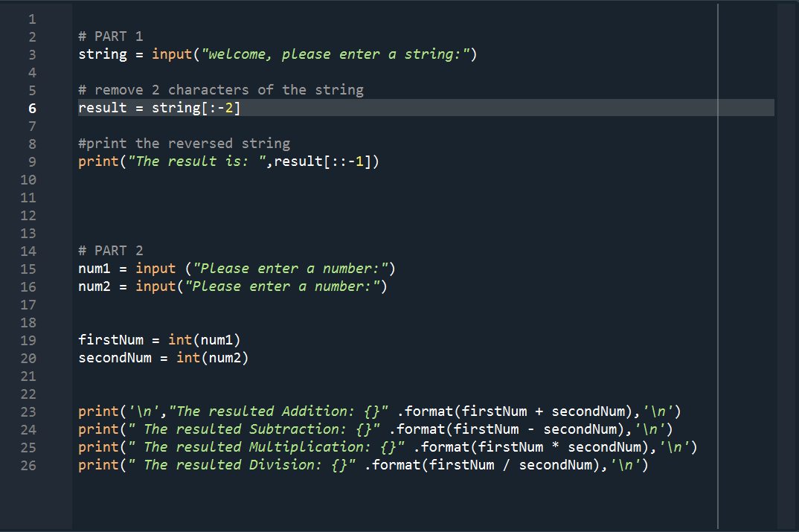

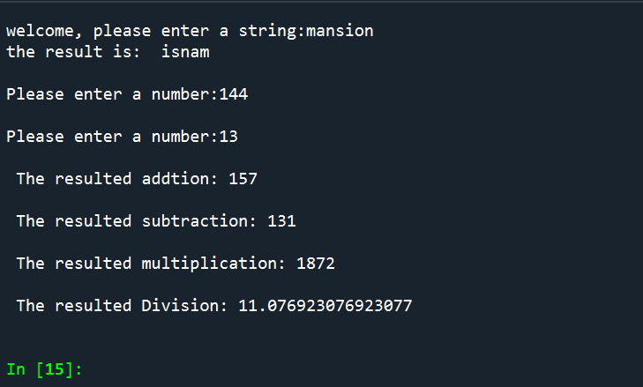

**3)** the code is in file Question3

The program successfully changes occurrence of python with pythons using the method called replace() then prints out the sentence with the new changes.



