**Student Name**: _Omar Mansour ___________________________________

**Assignment (3)**

* **Create a Flutter app for hotel reservation. The app will be designated into two screens as illustrated in figures below.**

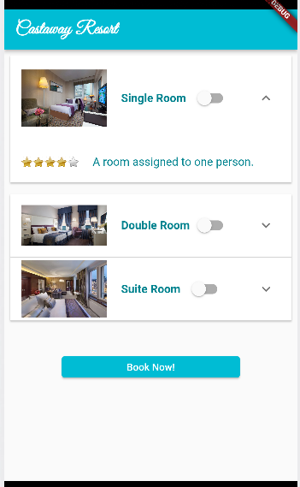

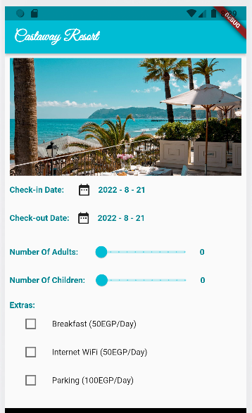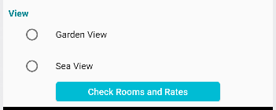

**Home Screen**

**Rooms and checkout Screen**

* **Rooms screen open when you click on “Check Rooms and Rates” button in Home Screen.**
* 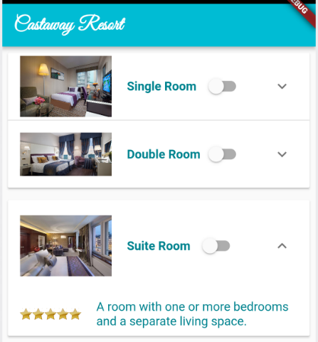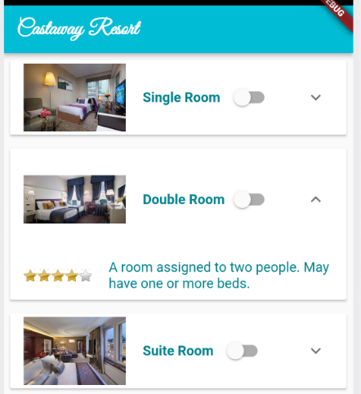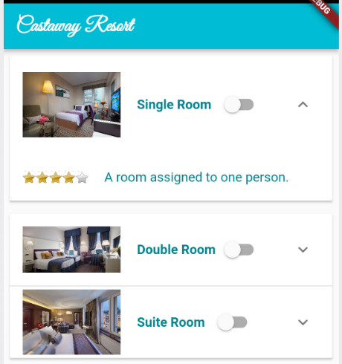**Rooms are created using Expansion Panel than shows its rating and description as follows:**
* 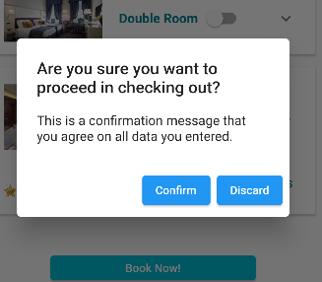**At Rooms screen, once “Book Now”   
  button is clicked, a dialog will appear   
  for confirmation, and data will be saved   
  in Cloud Firestore called “Hotel” as follows:**

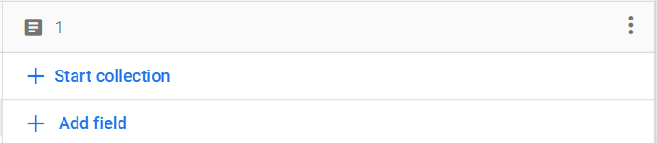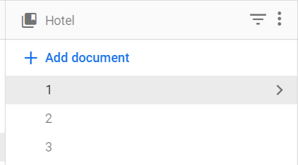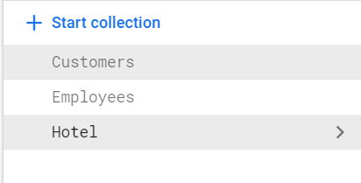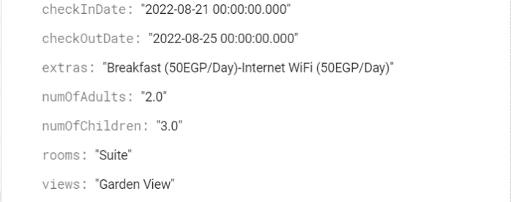

* **You must ensure that your assignment must fulfill all required tasks.**
* **User inputs must be the same as shown in figures above.**
* **Assignment should be delivered in form of compressed folder or GitHub repo link that contain your Dart file(s), any other files that you may configure to run your app, and any additional assets you might use in the app.**

**Assignment Grading Comments:**