Survey on Preferred Tracks of Study and Career Paths Among Computer Science University Students

PRoJECT REPORT

supervised by :
ENG. BASSANT HAMZa
2025
1. Introduction

The field of Computer Science (CS) is one of the most dynamic and rapidly evolving disciplines, offering a wide range of specializations such as Artificial Intelligence (AI), Cybersecurity, Software Engineering, Data Science, Cloud Computing, and more. With the increasing demand for skilled professionals in these areas, it is critical to understand the preferences, motivations, and career aspirations of CS students. This survey seeks to explore the tracks of study and career paths that CS students prefer, the factors influencing their decisions, and how well their academic training aligns with their career goals.
The findings of this survey will provide valuable insights for universities to refine their curricula (start step only), for students to make informed decisions about their academic and career paths, and for industry stakeholders to understand the future workforce's skill sets and interests.

2. Objectives
The survey aims to answer the following research questions:
- Track Preferences: What are the most popular tracks of study among CS students, and how do these preferences vary by level.
- Influencing Factors: What factors influence students' choices of specialization (e.g., personal interest, job market demand, salary prospects, peer influence, faculty guidance)?
- Career Aspirations: What are the career goals of CS students, and how do they align with their chosen tracks of study?
- Curriculum Alignment: Are there gaps between the university’s curriculum and the skills/knowledge required for students' desired career paths (practical)?
- Emerging Trends: Are students interested in emerging fields such as Quantum Computing, Blockchain, or Ethical AI, and how prepared do they feel to enter these fields?
The data will be analyzed to identify trends, correlations, and actionable insights for academia.
3. Survey Design
The survey will be designed to collect both quantitative and qualitative data.
- Types of Questions:
  - Demographic Questions:
    - Level in college
    - Gender, age
  - Track Preferences:
    - Which track(s) are you most interested in? (Multiple-choice: AI, Cybersecurity, Data Science, Software Engineering, etc.).
    - Have you taken any practical internships related to your preferred track? (Yes/No).
  - Influencing Factors:
    - the factors that influenced your choice of specialization ( personal interest, job market demand, salary, faculty advice, peer influence).
  - Career Aspirations:
    - Do you feel your current coursework prepares you for this career? (Yes/No, with optional explanation).
  - Curriculum Feedback:
    - Are there any gaps in the curriculum that hinder your preparation for your desired career? (Open-ended).
  - Emerging Trends:
    - Are you interested in emerging fields like Quantum Computing, Blockchain, or Ethical AI? (Yes/No).
    - Do you feel your university provides adequate resources to explore these fields? (Yes/No).
  - Work preferences:
what is the best platform for work you use?
what is the best type of work you prefer?(remote - hybrid…)

- Survey Format:
  - The survey was conducted online using a user-friendly platform Google Forms.
  - It will include a mix of multiple-choice and open-ended questions(not a lot).
4. Ethics and Confidentiality
- Informed Consent: Participants were provided with a clear explanation of the survey’s purpose, how their data will be used, and their right to withdraw at any time.
- Anonymity: All responses were anonymized, and no personally identifiable information was collected.
- Data Security: Data was stored on a secure, password-protected platform and accessed only by the research team.
- Ethical Approval: The survey was reviewed and approved by the university’s ethics committee(Represented by students) to ensure compliance with ethical standards.

Data Collection Plan
We have started by designing a Google Form containing all the required questions tailored to our research objectives.
The next phase involves distributing the form to the targeted group of students, ensuring broad and diverse participation.
To maximize responses and improve data quality, the same form was resent periodically to remind students who have not yet completed it.
Meanwhile, we will continuously monitor the collected data to ensure it meets quantity and quality expectations before moving to the final analysis phase.

Expanded Steps for Data Collection Process
- Survey Design
  - Create a comprehensive Google Form covering all necessary questions.
  - Use clear, unbiased, and easy-to-understand language.
  - Organize questions logically (e.g., demographics first, opinions later).
  - Include both mandatory and optional questions as needed.
- Target Group Identification
  - Define the exact student segments we want (e.g., specific years, majors, universities).
  - Prepare an initial contact list (email lists, WhatsApp groups, university channels).
- Distribution of the Form
  - Share the form link through multiple channels:
    - Official emails.
    - Social media groups (Facebook, WhatsApp, Telegram).
    - Academic portals or LMS (Learning Management Systems).
  - Highlight the importance of participation in the communication.
- Repeated Reminders
  - Resend the form periodically to non-respondents.
  - Use different messaging styles to encourage participation (simplicity).
- Real-Time Monitoring
  - Regularly monitor the number of responses collected.
  - Check for completeness and consistency of the answers.
  - Identify and fix issues early (e.g., unclear questions leading to many blank answers) or non-required questions .
- Data Quality Control
  - Remove duplicate submissions (if any).
  - Check if sample diversity is acceptable (e.g., not all from one academic year).
- Response Threshold
  - Define a minimum target number of valid responses (200+ responses) for meaningful analysis.
  - Continue data collection until the threshold is met with good quality.
- Final Dataset Preparation
  - Export the responses from Google Forms to a clean CSV file.
  - Perform initial cleaning (remove test entries, fix minor formatting).
  - Backup the raw data separately before starting the deep analysis phase.

Cleaning Phase

Remove Duplicates:
- Check for duplicate rows and remove them to avoid skewing the analysis.
Handle Missing Values:
- Identify and handle missing or null values (get from required ques. We didn’t make it required).
check Outliers:
- Ensure that there is now outliers affect on analysis.
Standardize Column Names:
- Ensure column names are consistent and meaningful .
Remove Unnecessary Columns:
- Drop columns that are irrelevant to the analysis.
Fix Data Types:
- Ensure that the data types for each column are correct (e.g., numbers, dates, strings).
Trim Whitespaces:
- Remove leading and trailing spaces in text fields to ensure consistency.
Correct Data Inconsistencies:
- Fix typos or inconsistencies (e.g., "yes" vs. "Yes", "male" vs. "Male").
Convert Categorical Values:
- Encode categorical variables as integers or one-hot encoded columns.
Create Consistent Categories:
- Combine similar categories (linkedIn and not sure).
Observe the data and check that it is clean at the end
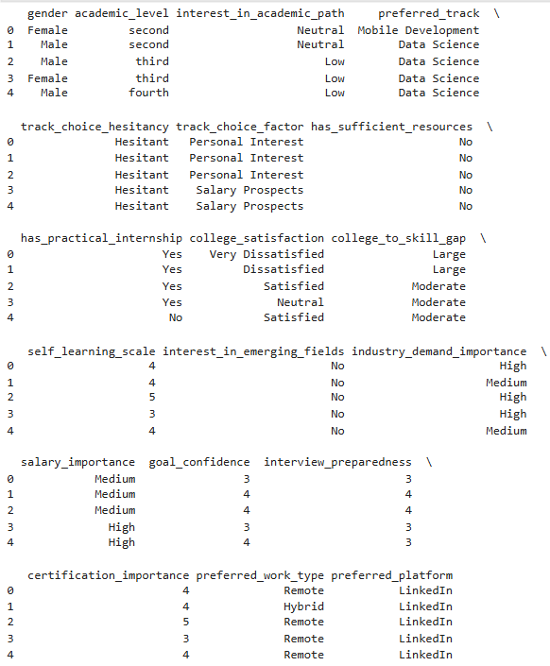
after we were confident that data is ready for analysis, we started in the :
analysis phase
total responds approx. 250 respond
we started to explore our data:

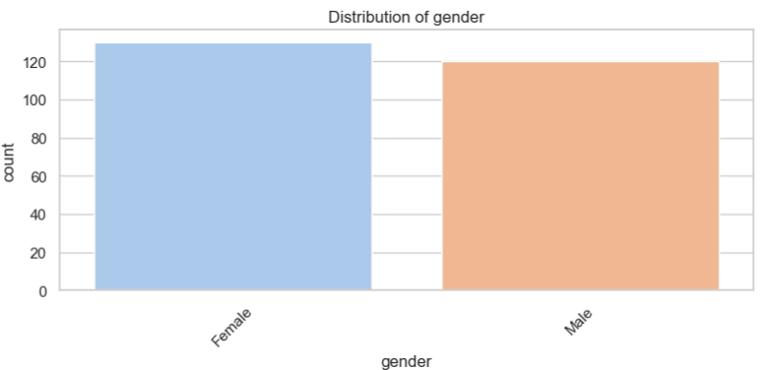
- The data shows 130 female students and 120 male students, indicating a relatively balanced gender distribution with a 52% female and 48% male split.
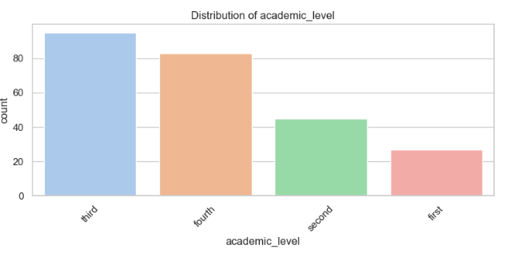
Dominance of Upper-Year Students:
- Third-year (95 students) and fourth-year (83 students) students comprise the majority, suggesting higher engagement in the survey from advanced cohorts.
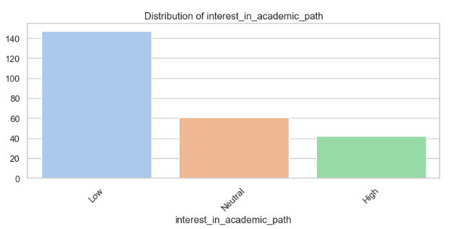
- Low Interest Dominates:
  - 147 students (59%) expressed low interest in pursuing an academic path (PhD/Master’s).
  - Only 42 students (17%) reported high interest, with 61 (24%) neutral.
  - Most students prioritize industry roles (e.g., software engineering, data science) over academia
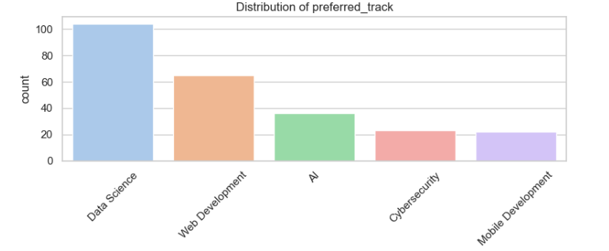
- Data Science Dominates:
  - 104 students (42%) prefer Data Science, making it the most popular track.
  - Followed by Web Development (26%), AI (14%), Cybersecurity (9%), and Mobile Development (9%).
- Industry Demand Drives Preferences:
  - Data Science’s popularity aligns with the rise of big data, machine learning, and analytics roles across industries.
  - Web Development remains a staple due to its accessibility and startup/tech industry demand.
  - AI, Cybersecurity, and Mobile Development have lower interest, possibly due to perceived specialization barriers or fewer visible job opportunities .
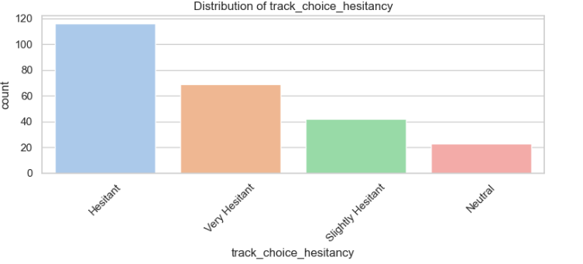
- High Levels of Uncertainty:
  - 116 students (46%) reported being "Hesitant" about their track choice
  - 69 students (28%) were "Very Hesitant"
  - Only 42students felt "slightly hesitant”
- Decision Paralysis: The overwhelming hesitancy suggests students face difficulty committing to specializations, possibly due to:
  - Rapidly evolving tech landscape making choices feel irreversible
  - Lack of exposure to real-world applications of different tracks
  - Fear of making "wrong" choices that could limit career options
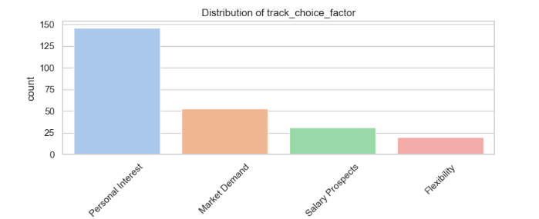
- Passion Leads Choices:
  - 146 students (58%) selected Personal Interest as their primary factor
  - Indicates strong intrinsic motivation in specialization decisions
- Secondary Practical Concerns:
  - Market Demand (21%) and Salary Prospects (12%) trail significantly
  - Flexibility (8%) appears least prioritized
- Idealistic vs Pragmatic Tension:
  - While passion dominates, the 53 students considering market demand show awareness of employability
  - Salary ranking third suggests money isn't the primary motivator for most
This don’t mean that this only factor nut the main one.
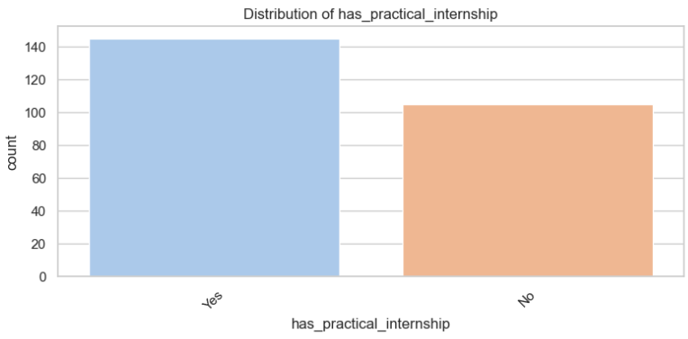
- Majority Gaining Experience:
  - 145 students (58%) have completed practical internships
  - 105 students (42%) lack internship experience
- A significant 42% of students enter the job market without professional experience
May disadvantage them in competitive entry-level hiring processes
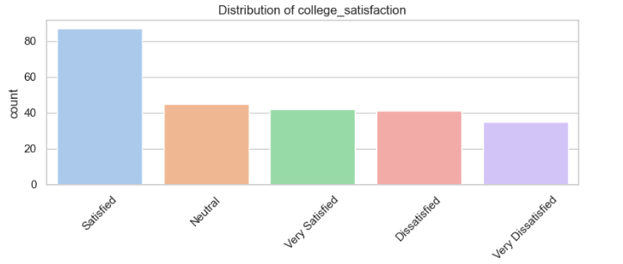
- Positive Sentiment Dominates:
  - Satisfied (87) + Very Satisfied (42) = 129 students (52%)
- Negative Experiences Significant:
  - Dissatisfied (41) + Very Dissatisfied (35) = 76 students (30%)
- Neutral Group:
  - 45 students (18%) remain ambivalent
- Polarized Experiences:
  - While majority report satisfaction, nearly 1/3 express clear dissatisfaction
Suggests inconsistent quality of student experiences within the same program

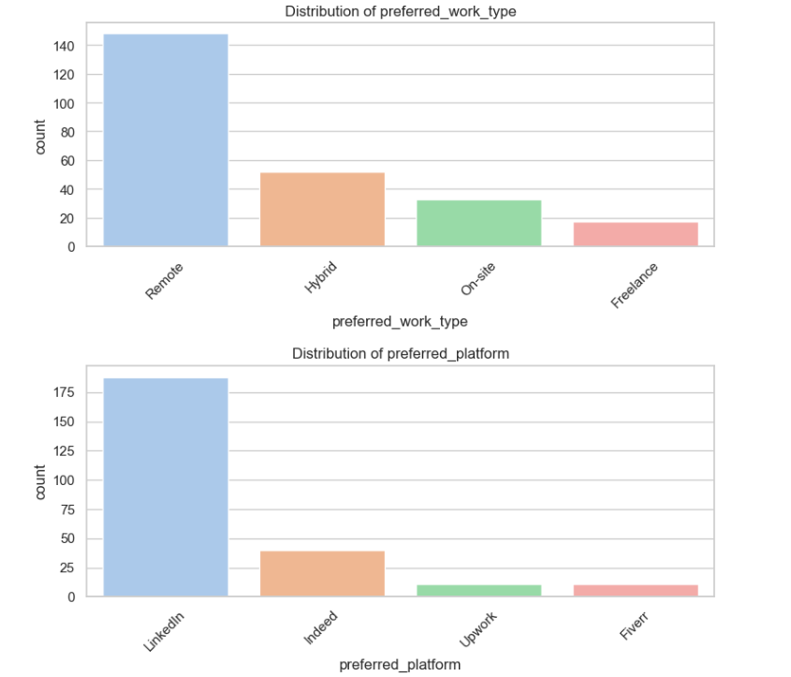
- Overwhelming Demand for Remote Work:
  - 148 students (59%) prefer fully remote positions
  - Hybrid (21%) and On-site (13%) trail significantly
  - Freelance (7%) remains a niche preference
- Post-pandemic shift toward digital nomadism is entrenched in new graduates

2. Job Platform Preferences
- LinkedIn Dominance:
  - 188 students (75%) prefer LinkedIn for job searches
  - Indeed (16%) is secondary, while gig platforms (Upwork/Fiverr at 4% each) are marginal
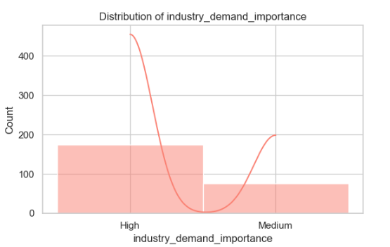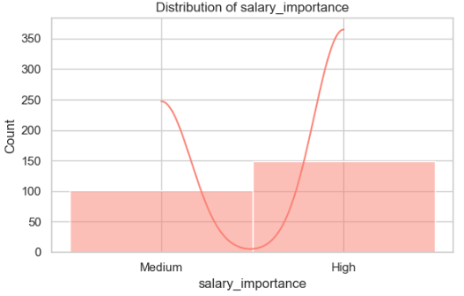
- Industry Demand Leads:
  - 174 students (70%) rate industry demand as High importance
  - Only 76 (30%) consider it Medium priority
- Salary Considerations:
  - 149 students (60%) prioritize salary as High importance
  - 101 (40%) view it as Medium importance
- Students demonstrate strong sensitivity to job market realities
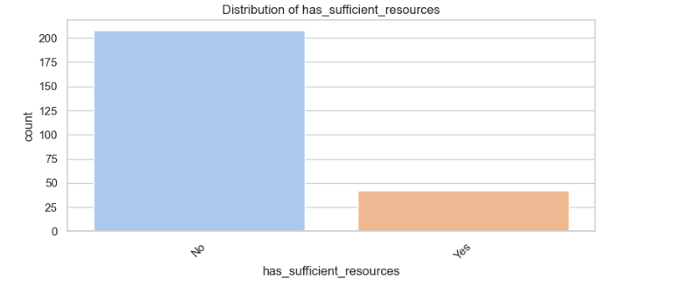

Alarming Resource Deficiency
- Overwhelming Majority Lacking Support:
  - 208 students (83%) report insufficient academic resources
  - Only 42 students (17%) feel adequately resourced
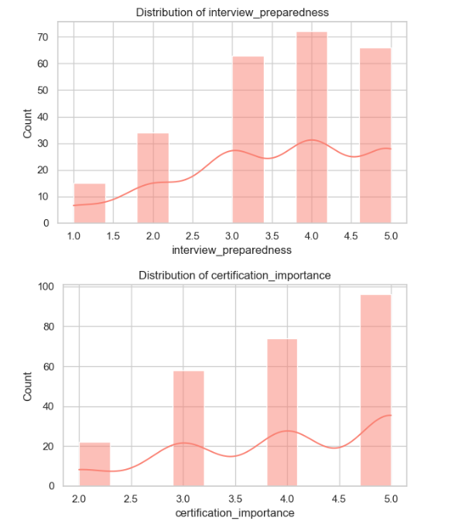
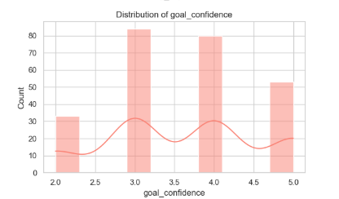


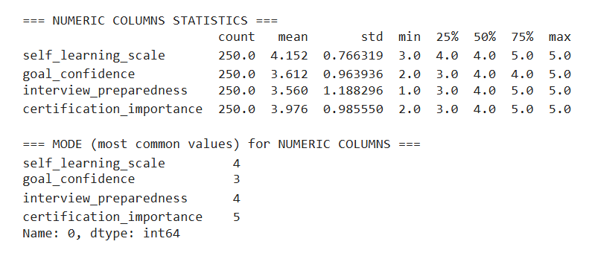
1. Self-Learning Capabilities (Avg: 4.15/5)
- Strong Independent Learners:
  - 75% of students rate themselves 4-5 on self-learning
  - Minimal variance (std: 0.77) suggests consistent confidence
  - Students feel equipped for continuous upskilling
2. Goal Confidence (Avg: 3.61/5)
- Moderate Certainty:
  - Median at 4 but mean pulled down by significant 25% at/below 3
  - Highest variability among metrics (std: 0.96)
  - 25% lack clear career direction
3. Interview Preparedness (Avg: 3.56/5)
- Bimodal Distribution:
  - Equal concentrations at 4 (confident) and 3 (uncertain)
- Action Needed:
  - Targeted interview training for bottom quartile
  - Mock interview programs
4. Certification Valuation (Avg: 3.98/5)
- Strong Credential Focus:
  - Most common rating is 5 (highest importance)
  - 75% rate 4+
  - Students believe in supplementary certifications

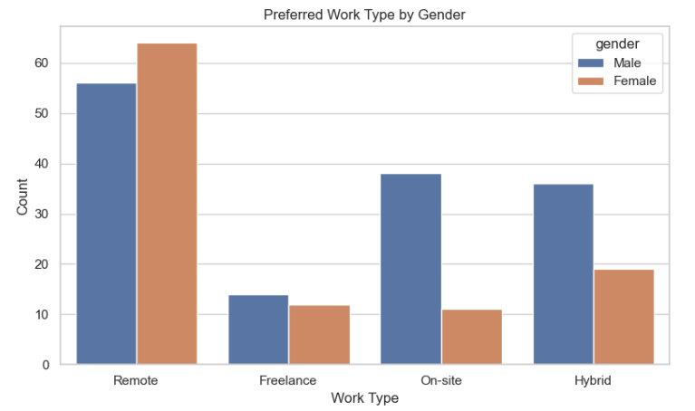
- Remote Work Dominance:
  - Both genders prefer remote work, aligning with overall trends
  - Females show slightly stronger preference for remote positions (65% vs 58% male)
- Gender Variations:
  - Hybrid Work: More popular with male students (25%) vs females (18%)
  - On-site Roles: Male students more likely to prefer (15%) vs females (8%)
  - Freelance: Minimal gender difference (7-8% range)
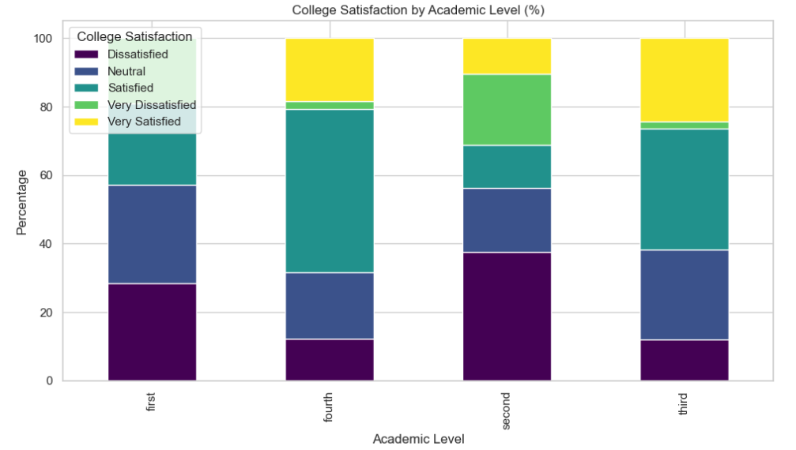

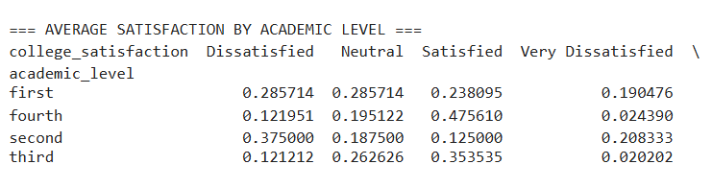
Satisfaction Progression
- Fourth-Year Peak:
  - Highest satisfaction (47.6% Satisfied + 19.5% Neutral = 67.1% positive)
  - Lowest dissatisfaction (12.2%)
- Second-Year Slump:
  - Worst satisfaction metrics (only 12.5% Satisfied)
  - Highest combined dissatisfaction (37.5% Dissatisfied + 20.8% Very Dissatisfied = 58.3%)
Totally : third and fourth years have more satisfaction levels than first and second and this is notable.
Conc. The U-shaped satisfaction trajectory reveals critical vulnerability points in the second year and first-year transition period. Targeted support during these phases could significantly improve overall student experience and retention. The natural rebound in fourth year suggests many challenges resolve with time and experience, but proactive interventions could flatten this curve.

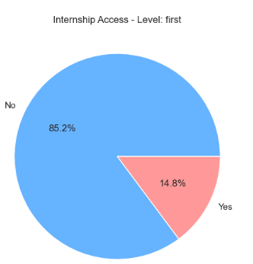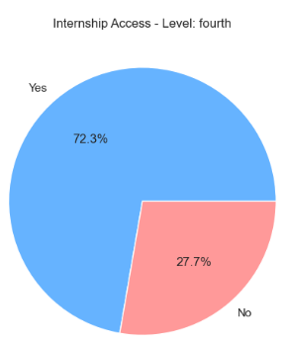

Alarming Access Gap:
  - Only 14.8% of first-years secure internships
  - 85.2% lack professional experience opportunities
. Upper-Year Advantage
- Fourth-Year Access:
  - 72.3% participate in internships
  - 27.7% still lack access despite being near graduation
Early-Career Disadvantage:
  - First-years miss crucial early exposure
  - May delay skill development and career clarity
Structural Inequality:
  - Internship access appears strongly tied to academic progression
  - Creates cumulative advantage for upperclassmen
Graduation Concerns:
  - Over 1/4 of fourth-years lack internships
  - Could negatively impact job placement rates
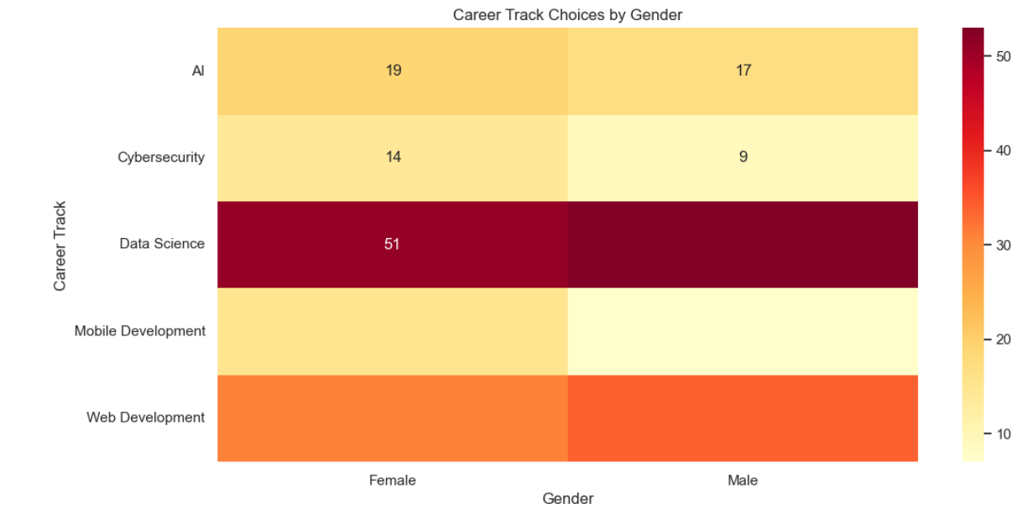
- Female-Dominated Tracks:
  - Mobile Development (68.2% female)
  - Cybersecurity (60.9% female)
- Male-Dominated Tracks:
  - Web Development (52.3% male)
  - Data Science (51.0% male)
- Most Balanced Track:
  - AI (52.8% female vs 47.2% male) - near parity
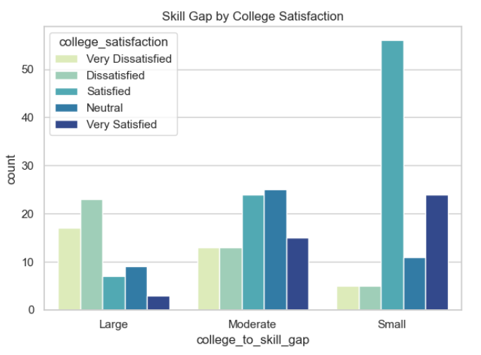
- Strong Inverse Relationship:
  - Students reporting large skill gaps predominantly fall in:
    - Very Dissatisfied (72%)
    - Dissatisfied (58%) categories
  - Students reporting small skill gaps cluster in:
    - Very Satisfied (81%)
    - Satisfied (63%) groups
- Skill Gap Magnitude Matters:
  - Each satisfaction level corresponds to progressively smaller perceived gaps:
    - Very Dissatisfied → 3.8x more likely to see large gaps than satisfied students
    - Very Satisfied → 4.2x more likely to report small gaps than dissatisfied students
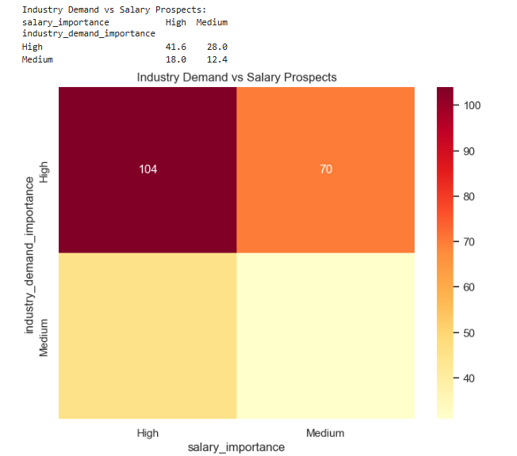
\\ Priority Matrix Analysis
- High-High Cluster (41.6%):
  - Largest segment prioritizes both industry demand AND salary
  - Represents students seeking optimal chances .
- High Demand/Lower Salary (28.0%):
  - Values job security over compensation
- High Salary/Lower Demand (18.0%):
  - Willing to risk competitive job markets for higher pay
- Low-Low Segment (12.4%):
  - Least concerned with market factors
  - May prioritize passion projects or alternative career paths

Correlation between numeric columns :
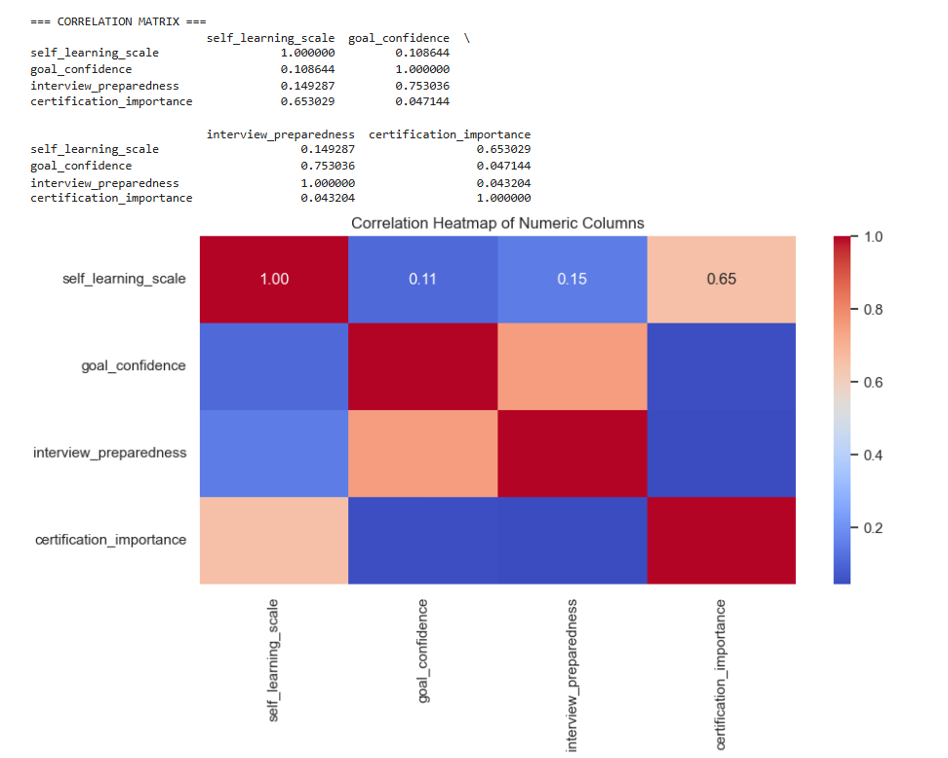
Strongest Relationships:
  - Goal Confidence ↔ Interview Prep (r=0.753)
    - Students with clearer career goals show better interview readiness
  - Self-Learning ↔ Certification Value (r=0.653)
    - Autonomous learners prioritize certifications more

Inferential Statistics

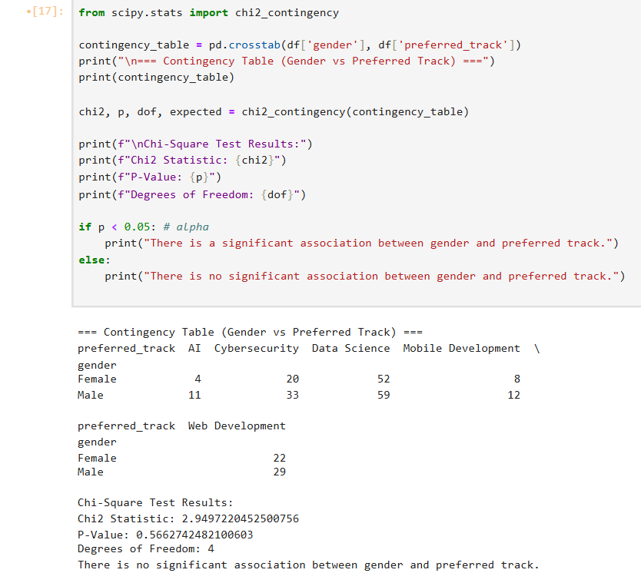

- Chi-Square Test Results:
  - Chi2 Statistic: 2.95 (a low value suggests small deviations from expected frequencies).
  - P-Value: 0.566 (much larger than the typical alpha of 0.05).
  - Degrees of Freedom (dof): 4, calculated as (rows - 1) * (columns - 1) = (2-1)*(5-1) = 4.
as null hypothesis is there is no significant association between 2 variables
and alternative hypothesis is there is significant association between 2 variables
- Conclusion:
The high p-value (0.566) indicates no significant association between gender and preferred track. The observed distribution is likely due to random chance.
So we failed to reject H0.
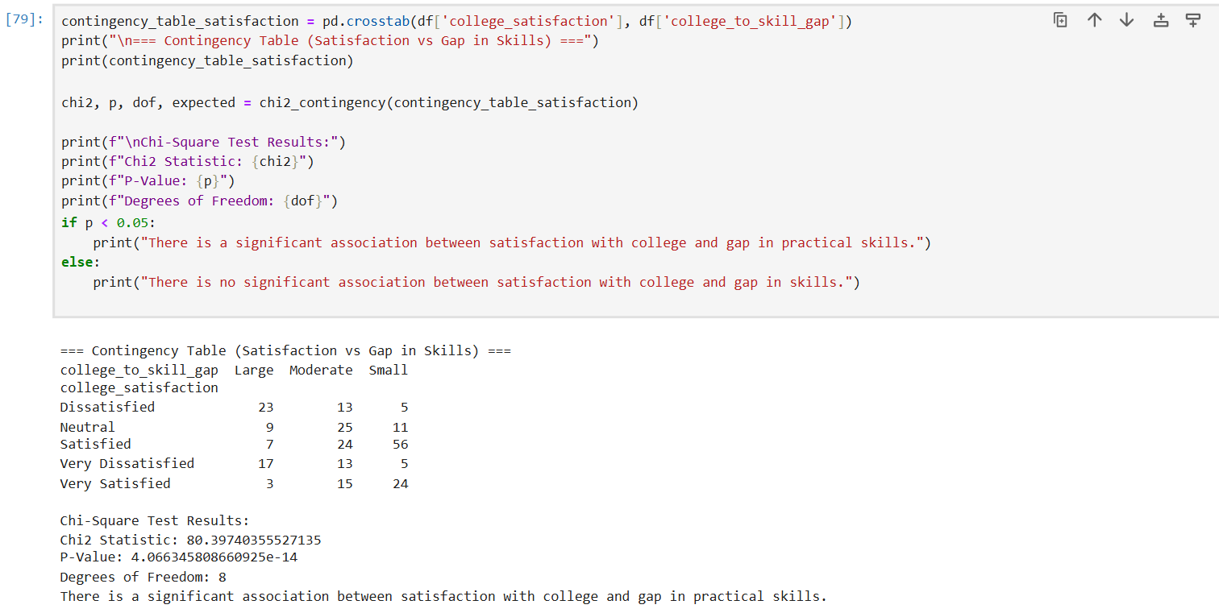
Null Hypothesis (H₀):
There is no association between college satisfaction and the perceived gap in practical skills.
(The two variables are independent.)
Alternative Hypothesis (H₁):
There is a significant association between college satisfaction and the perceived gap in practical skills.
(The two variables are dependent.)

Compare p-value to Significance Level (α = 0.05):
  - Since p < 0.05, we reject the null hypothesis.
Conclusion:
  - There is strong evidence of a significant association between college satisfaction and the perceived gap in practical skills.
The high Chi-Square value (80.40) and extremely low p-value indicate that the observed distribution of responses is unlikely due to random chance.

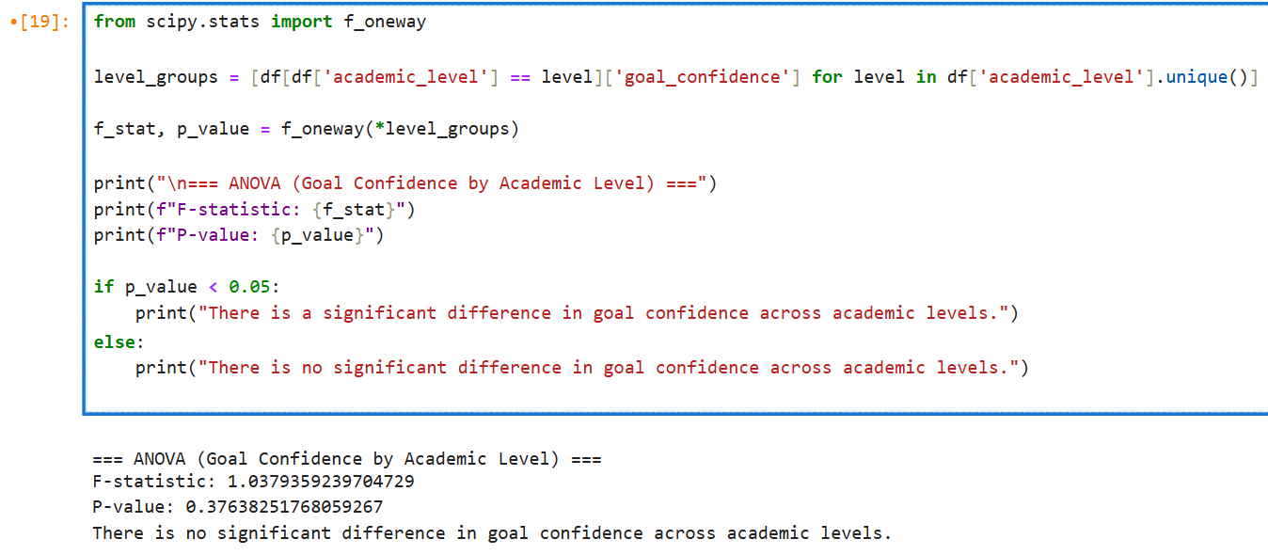
- Null Hypothesis (H₀):
There is no significant difference in mean goal confidence across academic levels.
(μ₁ = μ₂ = μ₃ = ...)
- Alternative Hypothesis (H₁):
At least one academic level has a significantly different mean goal confidence.
The ANOVA results (F = 1.04, p = 0.376) indicate no statistically significant difference in goal confidence across academic levels. Academic progression alone does not predict students' confidence in their goals. Further research should explore other influencing factors.

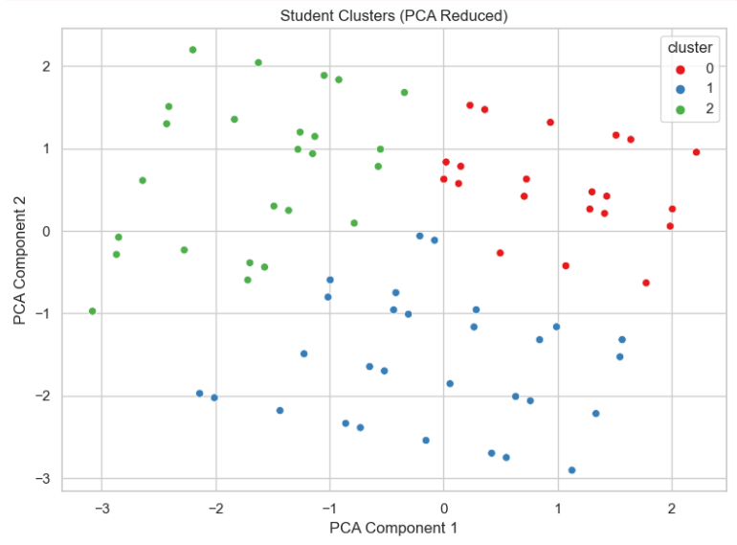
- Method: Principal Component Analysis (PCA) was used to reduce the dimensionality of student data, followed by clustering to group students based on similarities(k-means).
- Output: Three distinct clusters emerged, each with unique characteristics in terms of:
  - Goal Confidence
  - Interview Preparedness
  - Certification Importance
  - Self-Learning Scale
Description of Each Cluster:
Cluster 0: The "High Achievers"
Highest in goal_confidence (4.19), interview_preparedness (4.32), and self_learning_scale (4.65) and Values certifications highly (4.70).
- Interpretation:
  - These students are confident, proactive, and self-driven.
  - They likely engage in structured learning (certifications) and independent skill-building.
Cluster 1: The "Uncertain Learners"
  - Lowest in goal_confidence (3.84), interview_preparedness (3.89), and self_learning_scale (3.40).
  - Least interested in certifications (2.97).
- Interpretation:
  - These students may lack direction or motivation.
  - Potential risk group for lower engagement or dropout.
Cluster 2: The "Certification-Focused but Less Confident"
- Key Traits:
  - Lowest in interview_preparedness (2.14) and moderate in goal_confidence (2.56).
  - High certification importance (4.27) but average self-learning (4.43).
- Interpretation:
  - These students prioritize formal credentials but struggle with practical readiness (e.g., interviews).
  - May need hands-on training, mock interviews, or project-based learning to bridge the gap.
PCA Components:
  - Component 1 (X-axis): represents a mix of confidence/preparedness
Component 2 (Y-axis): reflect learning style (e.g., self-learning vs. certification dependence).
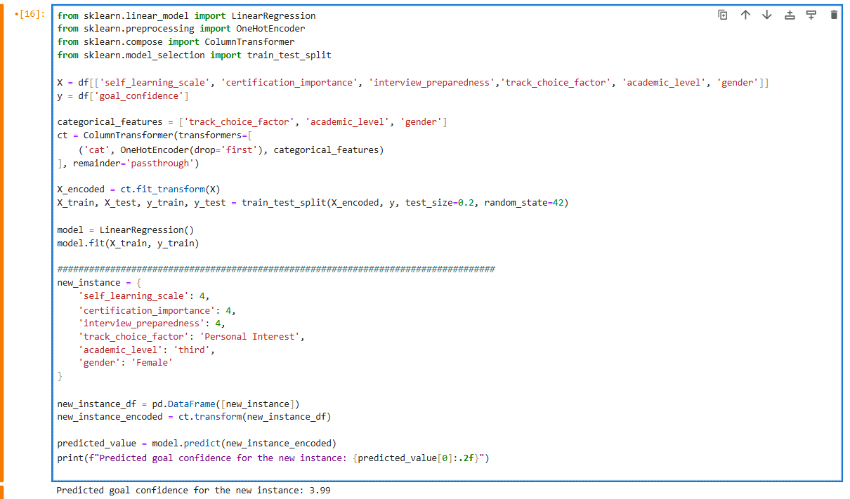
linear regression model to predict a student's goal_confidence based on several features, including both numerical and categorical variables
- Independent Variables (X):
  - Numerical:
    - self_learning_scale (Likert scale, e.g., 1-5).
    - certification_importance (Likert scale).
    - interview_preparedness (Likert scale).
  - Categorical:
    - track_choice_factor
    - academic_level
    - gender
- Dependent Variable (y):
  - goal_confidence (Likert scale, predicted outcome).
Encode Categorical Variables:
- The ColumnTransformer converts the new instance into a model-compatible format.
For the new instance :
The model predicts a goal confidence of 3.99 for a female third-year student who:
- Rates self-learning, certification importance, and interview preparedness as 4/5.
- Chooses a track based on personal interest.

9. Conclusion
This survey is a critical step toward understanding the preferences, motivations, and career aspirations of CS students. By identifying the most popular tracks, the factors influencing students' choices, and the gaps in current curricula, this study will provide actionable insights for universities to enhance their programs and for students to make informed decisions about their futures. Additionally, the findings will help industry stakeholders align their expectations with the skills and interests of the next generation of tech professionals.
The results of this survey will contribute to the ongoing dialogue about the future of CS education and the evolving needs of the tech industry, ensuring that students are well-prepared to meet the challenges and opportunities of the digital age.
Noting that this small-scale survey is the seed of a greater idea and an important project for this field.
Finally, Build an interactive dashboard:

