**Data Ops**

### Tools : Genie, Lentiq, DataKitchen, Badook, RightData, FirstEigen, Piper, Airflow

### Operations:

### 

**ML Ops**

* **Tools:** [**Kubeflow**](https://thechief.io/c/editorial/top-10-open-source-mlops-tools/#Kubeflow)**,** [**MLFlow**](https://thechief.io/c/editorial/top-10-open-source-mlops-tools/#MLFlow)**,** [**Pachyderm**](https://thechief.io/c/editorial/top-10-open-source-mlops-tools/#Pachyderm)**,** [**Metaflow**](https://thechief.io/c/editorial/top-10-open-source-mlops-tools/#Metaflow)**,** [**Kedro**](https://thechief.io/c/editorial/top-10-open-source-mlops-tools/#Kedro)**,** [**Seldon Core**](https://thechief.io/c/editorial/top-10-open-source-mlops-tools/#Seldon_Core)**,** [**Flyte**](https://thechief.io/c/editorial/top-10-open-source-mlops-tools/#Flyte)**,** [**ZenML**](https://thechief.io/c/editorial/top-10-open-source-mlops-tools/#ZenML)**,** [**MLRun**](https://thechief.io/c/editorial/top-10-open-source-mlops-tools/#MLRun)

### Operations:

### 

**Clean Code Vs Dirty Code**

Dirty Code:

1.

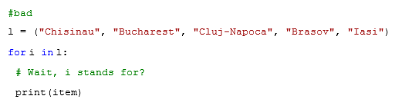

2.

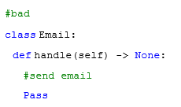

Clean Code:

1.

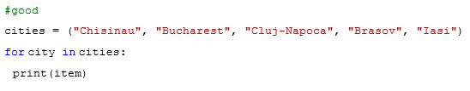

2.

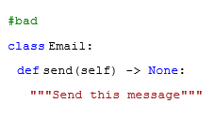

**Example Of Passing A Function As A Parameter In C++**

**#include <iostream>**

**using namespace std;**

**int add(int x, int y)**

**{**

**return x + y;**

**}**

**int multiply(int x, int y)**

**{**

**return x * y;**

**}**

**int invoke(int x, int y,**

**int (*func)(int, int))**

**{**

**return func(x, y);**

**}**

**int main()**

**{**

**cout << "Addition of 20 and 10 is ";**

**cout << invoke(20, 10, &add)**

**<< '\n';**

**cout << "Multiplication of 20"**

**<< " and 10 is ";**

**cout << invoke(20, 10, &multiply)**

**<< '\n';**

**return 0;**

**}**