1- Online Handwriting Recognition Using an Accelerometer-Based Pen Device

https://www.researchgate.net/publication/266643595_Online_Handwriting_Recognition_Using_an_Accelerometer-Based_Pen_Device

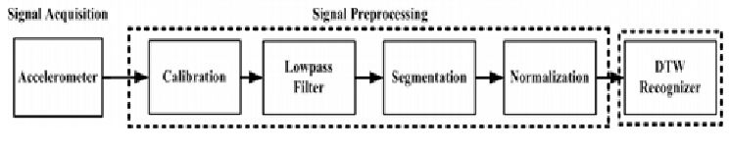

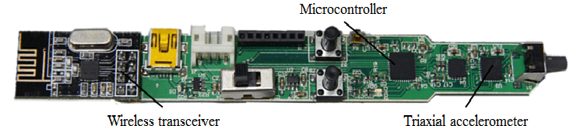

* Microcontroller ( STM32F103T8, STMicroelectronics)
* Accelerometer (LSM303DLH, STMicroelectronics)
* Wireless --> RF (nRF2401, Nordic).
* Specified number of training data
* Success rate is 90%
* DTW algorithm

# 2- nexonar pen (IR LED Camera Tracking ,imu)

# https://i1.wp.com/embedds.com/wp-content/uploads/2010/04/digitalpen-LinkInk.jpg?ssl=13- igital Pen equipped with such bunch sensors is able to track pens 3D position what allows writing on any surface, so later any drawing could be imported to any image software. Integrated microphone allows record audio notes along with digital writing. Pressure sensor enables to make your drawing line width variable. This digital pen is equipped with USB interface – so along with flash memory it can be used as regular USB flash drive. This makes easy data transfer. What about controlling? There is no much space for buttons or other input devices. So with Accelerometer it is possible to control pen with gestures. PIC32 microcontroller is powerful enough to be equipped with even more peripherals and features like 3D mouse, CCD camera, Laser pointer, digital ruler, mp3 player, pedometer, etc.

**3-D Drawing Digital Pen**

**V. S. Kayastha1, V. N. Supe2, S. U. Bhandari3**



|  |  |
| --- | --- |
| Operation modes | 1- writing mode for hand recognition (when the pen tip is contact with paper)  2-drawing mode (when the pin tip in the air) |
| Hardware modules | 1- digital pen (handheld module)  2- pocket module (connected to the pc) |
| Data transmission | 1-Wirelessly ( RF )for indoors applications or (GSM) for outdoors applications between the pen and the pocket  2-usb between the pocket and the pc |
| Microcontroller | MSP430 |
| Sensor | IMU (6DOF) |
| Possible errors | - limited performance of low cost inertial sensors  - cross-sensitivity  - misalignment  - bias  - broadband noise. |
| Error eliminations | - calibrate the IMU  - Extreme Point Sampling Method |
| Algorithm | Trajectory Recognition Algorithm |