uTrack: 3D Input Using Two Magnetic Sensors

we present *uTrack*, a pointing technique that enables 3D interactions for wearable devices. uTrack turns the user’s thumb and finger into an input device using magnetic field (MF) sensing

# Components

1. Two 3-axis MEMs magnetometers
2. I2c multiplexer
3. Micro controller

# Steps

* Align both sensors, *S1* and *S2* so that their axes remain parallel with 1.8 cm x-axis shift between them
* Knowing the reading form the sensors **H1 , H2** search for Roll, Pitch ,Yaw to convert it to 2D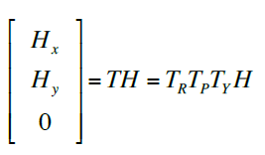
* Convert the two new vectors to spatial positions in the magnetic field space

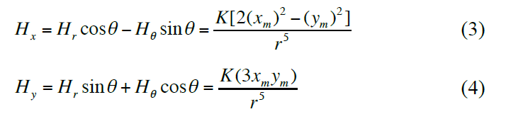

* The [xm1, ym1]T and [xm2, ym2]T are then transformed back into the sensor space

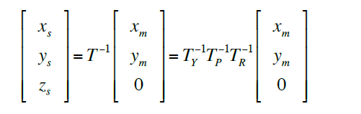

* **V1** as [xs1, ys1, zs1]T and **V2** as [xs2, ys2, zs2]T represent the magnet’s 3D position in their respective sensor space
* **Then**

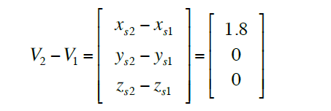

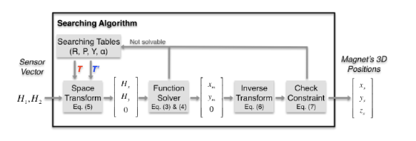.

# Issues

* Mapping the screen pixels to an allowed space of movement will create an error ( mapping 6 pixels to 1 mm to create 2 mm of movement error of the magnet )
* To reduce the search space, the magnet is constrained to stay in the first quadrant of the magnetic field space when the system initially launched.