Cairo University  
Faculty of Computers and Information



**CS251**

**Software Engineering I**

Inception Website

Software Design

T3

12/12/2016

Contents

Instructions [To be removed] 3

Team 3

Document Purpose and Audience 3

System Models 3

I. Class diagrams 3

Important Algorithm 5

II. Sequence diagrams 5

Class - Sequence Usage Table 7

Ownership Report 8

Policy Regarding Plagiarism: 8

References 8

Authors 8

# Team

|  |  |  |  |
| --- | --- | --- | --- |
| **ID** | **Name** | **Email** | **Mobile** |
| 201040189 | Omar Mohamed Osman | omar_13316@hotmail.com | 01008232911 |
| 20140106 | Khaled Taher | khaled@stud.fci-cu.edu.eg | 01113096654 |

# Document Purpose and Audience

* **This document is a software design specification (SDS) that should provide the basic Design and details for” Inception “website and how this software product will be used. The document is intended for the developers of the system and the clients.**

# GitHub repository

https://github.com/OmarOsman/SWtest

# System Models

## I. Class diagrams

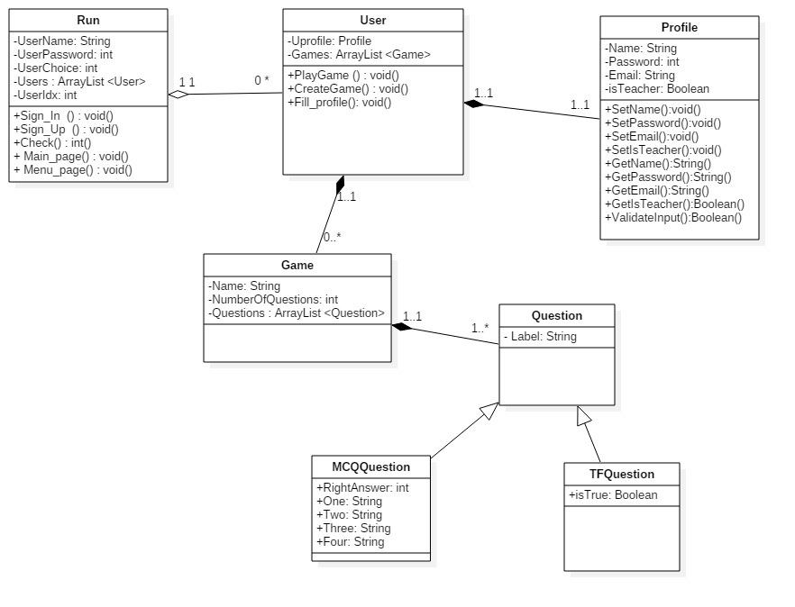

| **Class ID** | **Class Name** | **Description & Responsibility** |
| --- | --- | --- |
| 1 | Run | This Class will Run all the time and will be the Controller of the Program |
| 2 | User | This class will represent the registered users of the system and will have an array list of games, which he can play or create. In addition, User can Fill profile when signing up. |
| 3 | Profile | This class represents the personal information of the user |
| 4 | Game | This Class represents a game entity |
| 5 | Question | This Class represents a question of a game and specialized into two types : multiple choice question and true or false question |

### Important Algorithm

## II. Sequence diagrams

1)Registration

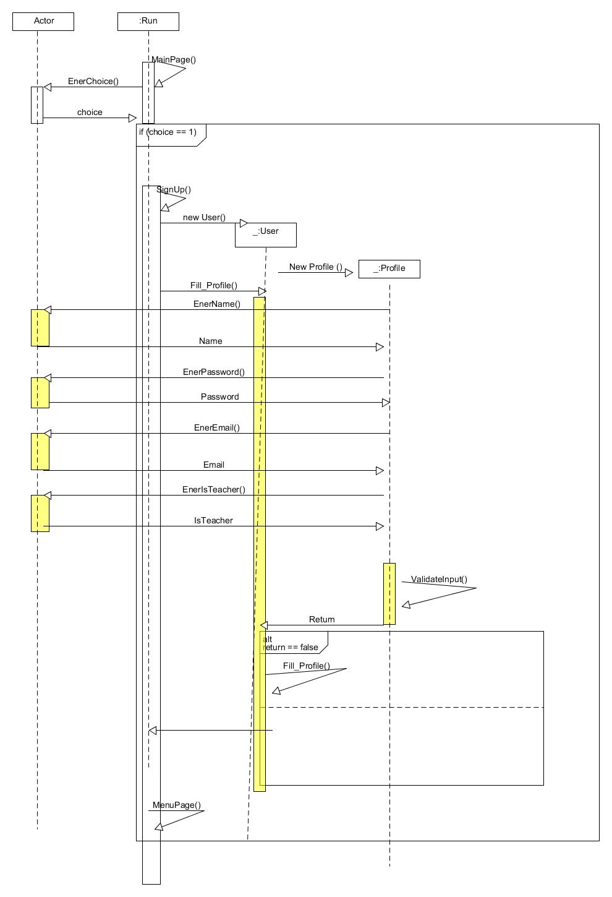

2) PlayGame:

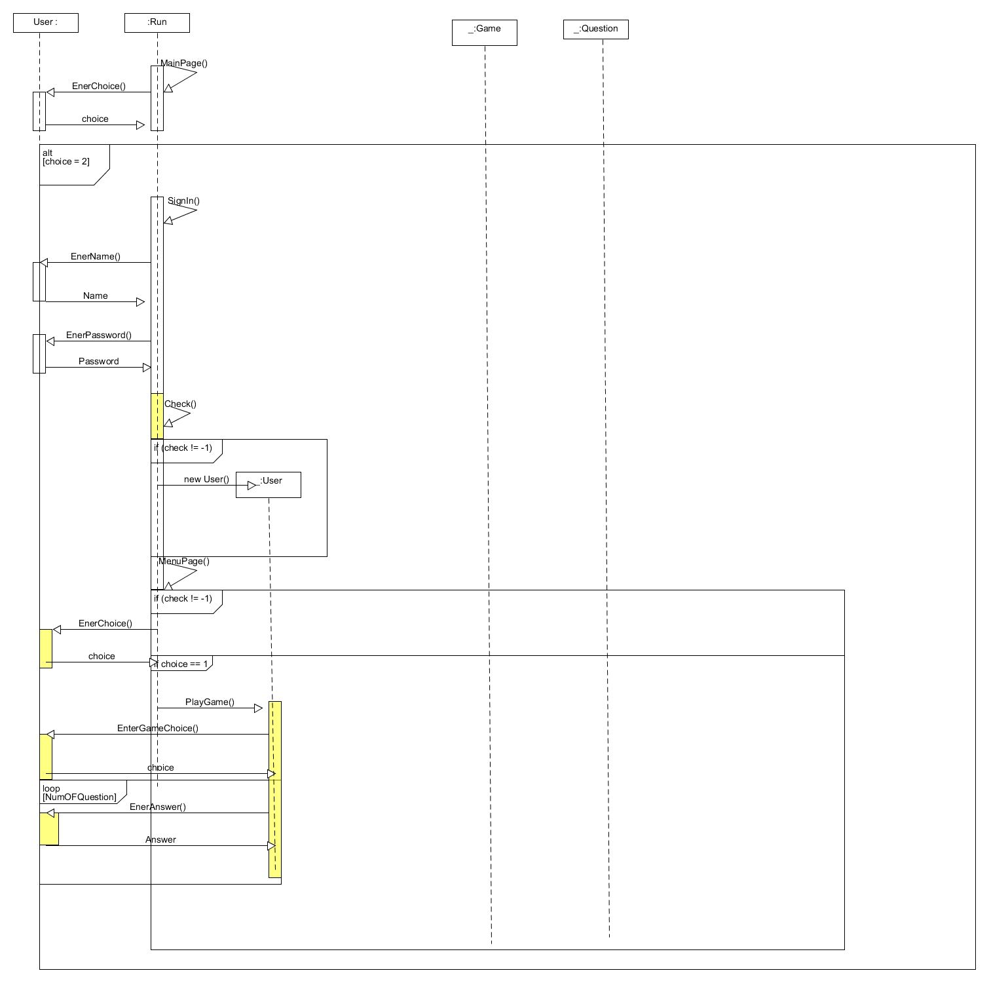

3)CreateGame:

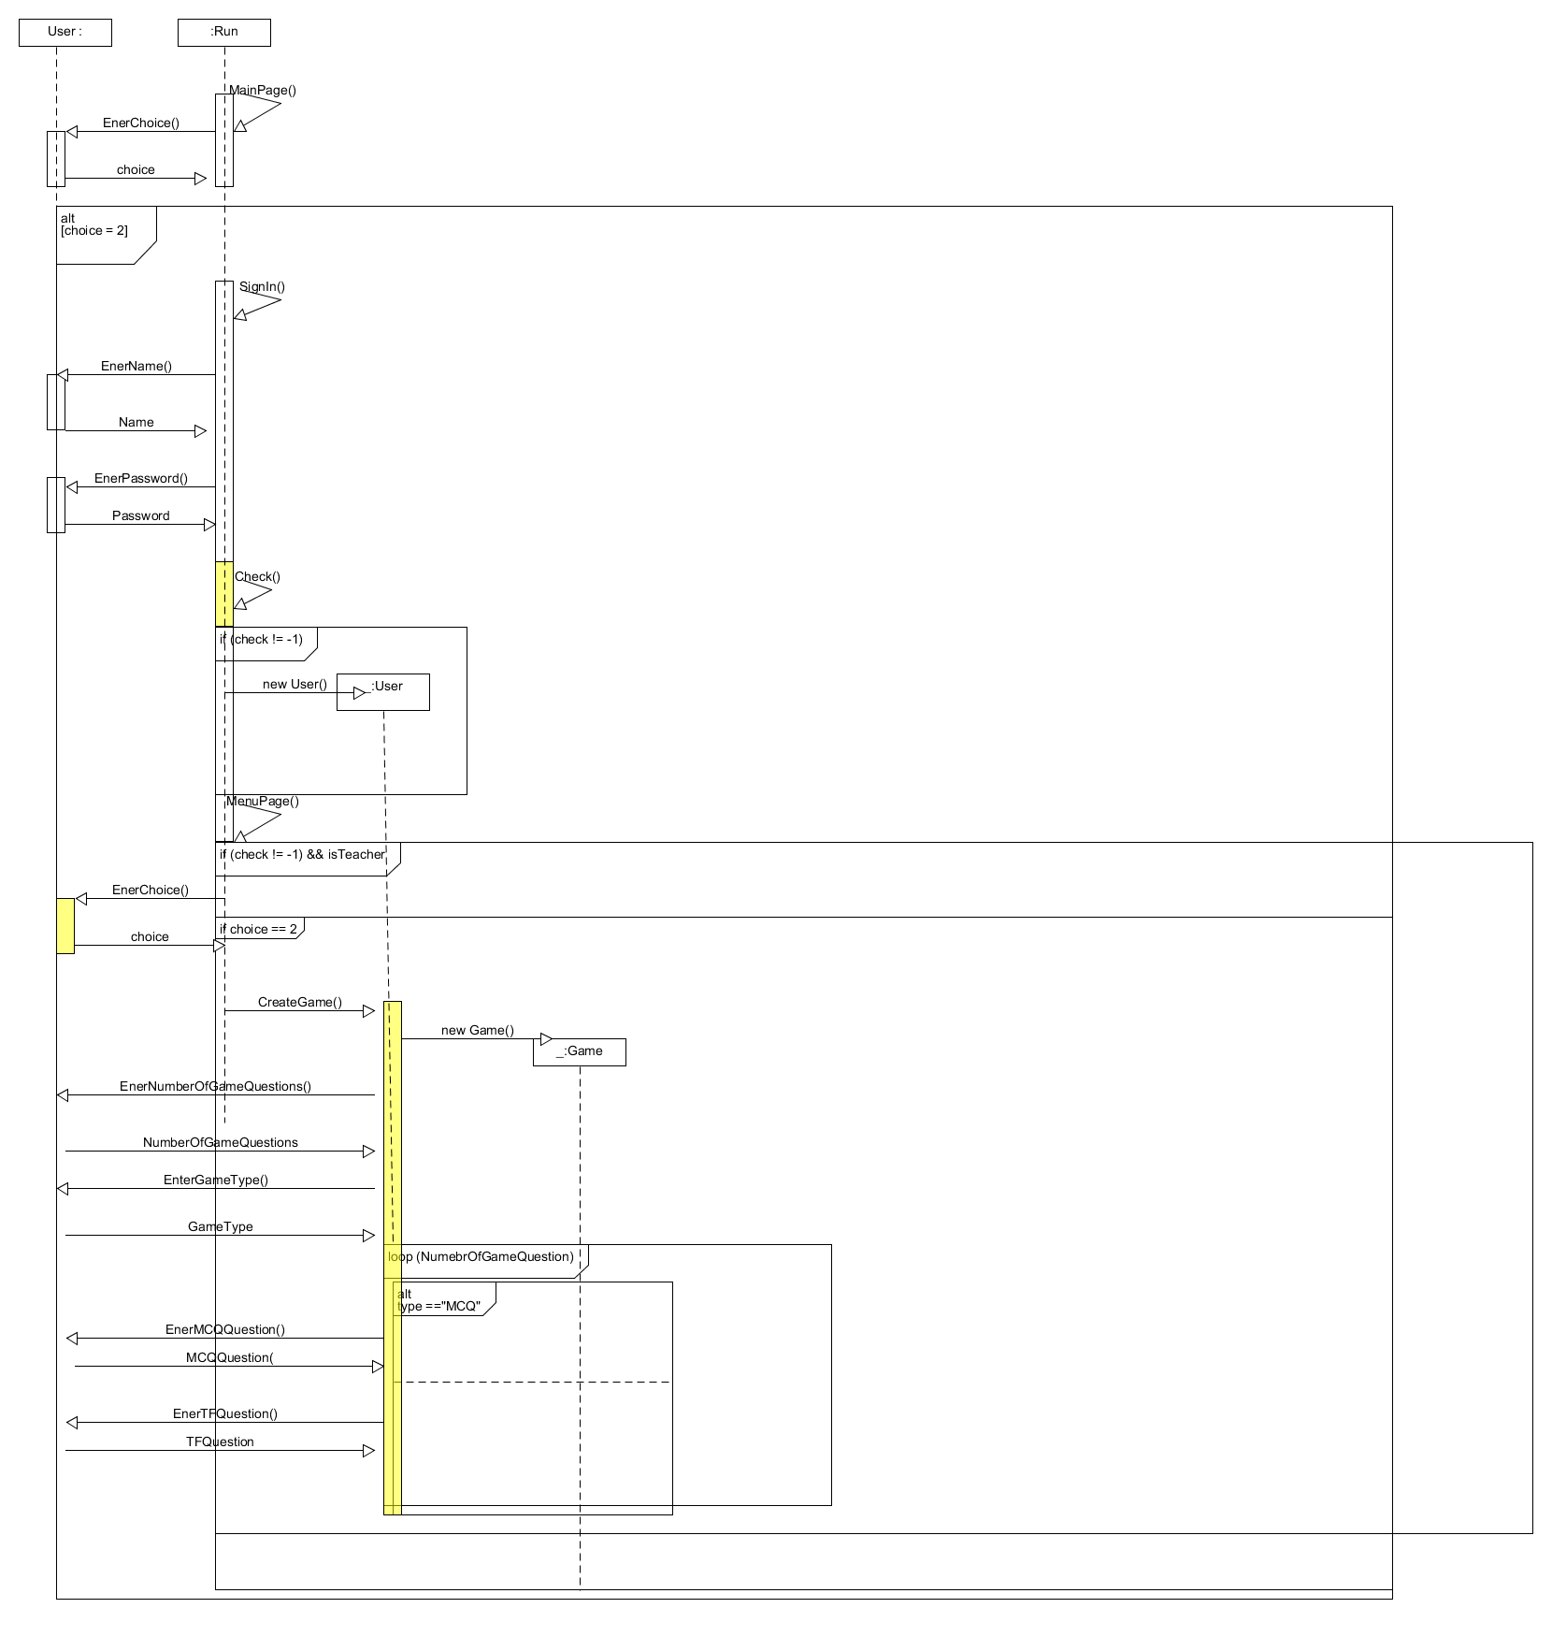

### Class - Sequence Usage Table

| **Class Name** | **Sequence Diagrams** | **Overall used methods** |
| --- | --- | --- |
| Run | 1, 2,3 | Signup(),Sign_in ();int Check()  Main_page,Menu_page() |
| Profile | 1 | ValidateInput() |
| User | 1,2 ,3 | PlayGame(),CreateGame(),Fill_Profile() |

.

# References

* http://www.mhhe.com/engcs/compsci/pressman/graphics/Pressman5sepa/common/cs1/design.pdf

# Authors

* Mostafa Saad and Mohammad El-Ramly (Edited by Mohamed Samir)