Cairo University  
Faculty of Computers and Information



**CS251**

**Software Engineering I**

(Inception website)

Software Requirements Specifications

Team : T3

Omar Osman (Team Leader)

Khaled Taher

11/5/2016

Contents

Instructions [To be removed] 3

Team 3

Document Purpose and Audience 3

Introduction 3

Software Purpose 3

Software Scope 4

Definitions, acronyms, and abbreviations 4

Requirements 4

Functional Requirements 4

Non Functional Requirements 4

System Models 5

Use Case Model 5

Use Case Tables 5

Ownership Report 6

Policy Regarding Plagiarism: 6

# Team

|  |  |  |  |
| --- | --- | --- | --- |
| **ID** | **Name** | **Email** | **Mobile** |
| 20140189 | Omar Mohamed Osman | omar_13316@hotmail.com | 01008232911 |
| 20140106 | Khaled Taher | khaled@stud.fci-cu.edu.eg | 01113096654 |

# Document Purpose and Audience

* **This document is a software requirements specification (SRS) that should provide the needed requirements and details for” Inception “website and how this software product will be used. The document is intended for the developers of the system and the clients.**

# Introduction

## Software Purpose

* **The Project is a web site aimed for interactive learning. The site contains different type of simple educational games that are created by teachers. Teachers can add any content they want to the predefined game templates and track the progress of their students using a simple interface.**

## Software Scope

* **The software is a game based educational platform that should provide mini educational games that cover any learnable subject like basic programming using java and C++ , math and science games that any visitor can play with. Teachers should be able to create new games using simple game templates, and can fill it with any content they like .The game templates are multiple choice, flashcards, drag and drop to the correct label and code snippets.**

## Definitions, acronyms, and abbreviations

* **User : includes guest(unregistered user) and teacher and student**
* **GUI : Graphical User Interface**

# Requirements

## Functional Requirements

* **Track progress: Students and teachers can track their progress in previously played games. The progress is shown at the specified game page or at the user’s profile page. ( Complexity : 2)**
* **Sign up: Users should be able to register to the website as students or teachers. The register processes require user to enter his name, password, birthdate, email and type of user. The site should verify that the email exists and username is unique. ( Complexity : 2)**
* **Adapt to level: The game adapts to User needs while playing. Which means the difficulty of the game increase or decrease dynamically according to user’s correct answer. ( Complexity : 5)**
* **Search: User can search a game by name, tag and content. Search results will be shown on the screen where the use can navigate them, also the user should be able to use search filters, as they will appear after the first initial search. ( Complexity : 3)**
* **List all games by category: User can see all games according to category (e.g. Math/Science/coding…etc.). This option should be available on the main page. ( Complexity : 2)**
* **Start game: User can start a game. The start game option will appear on the game page after the user selects a game ( Complexity : 1)**
* **Stop game: User can end the current game. This option will appear on the game page after the user has started a game. ( Complexity : 1)**
* **Write comments: Students and teachers can write comments on any game on the comment section. The comment section will be on the game page. Registered users can also reply to a comment. ( Complexity : 2)**
* **Rating games: Users can rate any game from a scale form one to five .The rating will appear on the game page and will only be unlocked after the user has tried the game. ( Complexity : 2)**
* **Create games: Teachers can create their own games from predefined templates using a simple wizard. After finishing the wizard, a new game will be created and added to games database and the teacher will have the option to make it public or private. ( Complexity : 4)**
* **Remove games: Teacher can remove their previously created games either from the specified game page or from teacher’s profile. After completing this action, the game will be removed from the system and any previous user progress will be deleted. ( Complexity : 3)**
* **Assign games to students: Teachers can assign a game to a group of students by entering to the specified game page and add the students usernames Teacher can list all assigned games from their profile page ( Complexity : 2)**
* **Make game public: Teacher can make their games public so any user can play them; this option will appear at the end of creating a new game wizard. ( Complexity : 1)**
* **Report inappropriate content: Teacher have the option to report any game or comment that they see that it do not serve and educational purpose or contain inappropriate language or images. These reports will be sent to the site administrator. ( Complexity : 2)**
* **Website documentation: The site will provide FAQ section that help new users. The FAQ will appear on the site’s main page ( Complexity : 1)**
* **Adding tags: Teacher can add tags to their games to categorize the game. This option will be available at the games main page. The teacher will select predefined tags. ( Complexity : 2)**

## Non Functional Requirements

* **Performance : The maximum delay for a game to start is 5 seconds**
* **Usability: A simple easy to use GUI should be provided to create and play games. Learning time to create a game shouldn’t exceed 10 minutes**
* **Compatibility** **: System should support desktop browsers and mobile browser (IOS and Android)**
* **Privacy: the student and the lead teacher only should see the student progress of games.**
* **Security: The system must not allow the user password to be shown. It only can be changed or reset on user request. Verification method is applied. (via mail or phone)**

# System Models

## Use Case Model

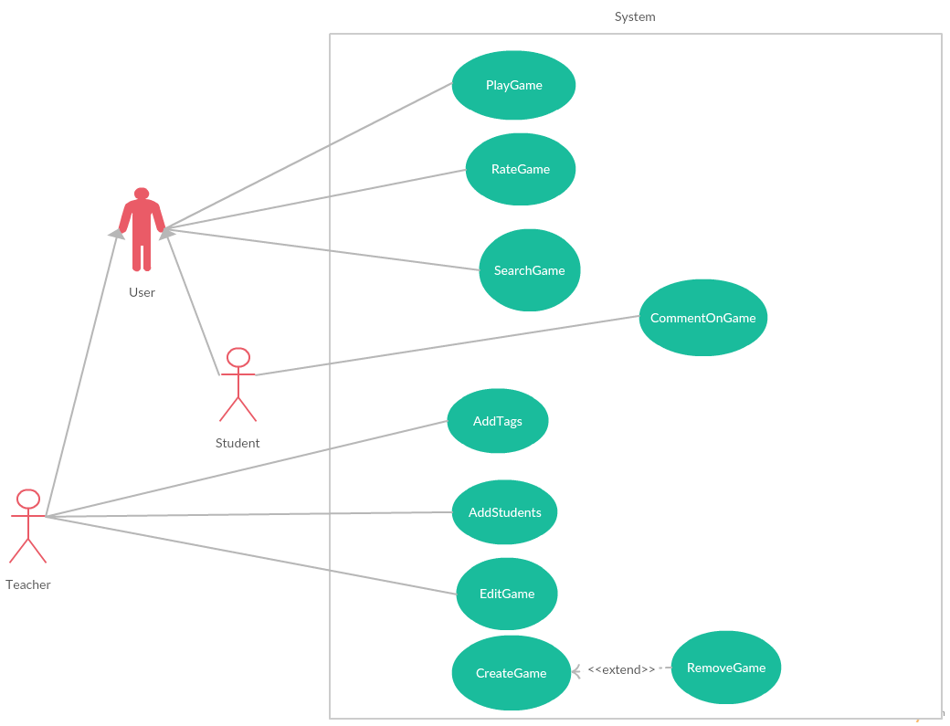

## Use Case Tables

|  |  |  |
| --- | --- | --- |
| Use Case ID: | 1 | |
| Use Case Name: | PlayGame | |
| Actors: | User | |
| Pre-conditions: | - | |
| Post-conditions: | Game progress is saved if the user is registered | |
| Flow of events: | **User Action** | **System Action** |
| 1- User click on a game icon from main page or after using |  |
|  | 2- System opens game menu and display a text that shows player how to play and the genre of the game |
| 3- User click on Play button |  |
|  | 4- System Runs the game and matches the difficulty of the game with the successive number of correct answers |
| 5- User click on stop button or the game finishes when user answer all questions correctly within the time limit |  |
|  | 6- System stops running the game |
| Includes: | - | |
| Notes and Issues: | - | |

|  |  |  |
| --- | --- | --- |
| Use Case ID: | 2 | |
| Use Case Name: | CreateGame | |
| Actors: | Teacher | |
| Pre-conditions: | Being registered as a teacher | |
| Post-conditions: | A new game is created | |
| Flow of events: | **User Action** | **System Action** |
| 1- Teacher click on create button that appears on the main toolbar of the website |  |
|  | 2- System opens the game templates that the teacher should choose from |
| 3-Teacher can select any of them |  |
|  | 4- System opens a specific wizard for she elected game that guide the teacher throughout the process |
| 5-Teacher completes wizard |  |
|  | 6-System asks Teacher if he want to make the game private or public |
| 7- if the teacher selects public |  |
|  | 7.1 System add the game to the public library and MyCreatedGames in the teachers profile |
| 8- if the teacher selects private |  |
|  | 8.1 System add the game to MyCreatedGames in the teachers profile only |
| Exceptions: | **User Action** | **System Action** |
| 1- Teacher Enters a name of an already existent game |  |
|  | 2- System asks teacher to enter another name. |
| Includes: | None | |
| Notes and Issues: | None | |

|  |  |  |
| --- | --- | --- |
| Use Case ID: | 3 | |
| Use Case Name: | RateGame | |
| Actors: | User | |
| Pre-conditions: | - | |
| Post-conditions: | Rating of the game is changed | |
| Flow of events: | **User Action** | **System Action** |
| 1- User Play a game and the game ends |  |
|  | 2- System shows five stars that represent a scale from 1 to 5 to rate the game |
| 3- User Select one of the 5 stars |  |
|  | 4- System Update the rating of the game |
|  |  |
| Exceptions: | **User Action** | **System Action** |
|  |  |
|  |  |
| Includes: | - | |
| Notes and Issues: | - | |

|  |  |  |
| --- | --- | --- |
| Use Case ID: | 4 | |
| Use Case Name: | SearchGame | |
| Actors: | User | |
| Pre-conditions: | - | |
| Post-conditions: | System will display matched results | |
| Flow of events: | **User Action** | **System Action** |
| 1- User type intended game name in the search text box |  |
|  | 2- System display first 15 games that matches the search |
| 3- User can click on search option and select appropriate tags to filter search |  |
| 4- User can navigate between search pages |  |
|  |  |
| Exceptions: | **User Action** | **System Action** |
| 1- User enters nonexistent game or tag in the website Database |  |
|  | 2- System display “No matches found” message |
| Includes: | - | |
| Notes and Issues: | - | |

|  |  |  |
| --- | --- | --- |
| Use Case ID: | 5 | |
| Use Case Name: | CommentOnGame | |
| Actors: | Student | |
| Pre-conditions: | Being registered as a student | |
| Post-conditions: | A new comment is added to game forum page | |
| Flow of events: | **User Action** | **System Action** |
| 1- User Play a game and game ends |  |
|  | 2- System unlocks the game comment section |
| 3- User type a comment in a textbox |  |
| 4-User click on the button submit |  |
|  | 5-System display the comment in the game forum page |
| Exceptions: | **User Action** | **System Action** |
| 1- User click on submit and textbox is empty |  |
|  | 2-System won’t submit comment |
| Includes: | - | |
| Notes and Issues: | - | |

|  |  |  |
| --- | --- | --- |
| Use Case ID: | 6 | |
| Use Case Name: | AddTags | |
| Actors: | Teacher | |
| Pre-conditions: | Teacher has created the intended game | |
| Post-conditions: | Being registered as a teacher | |
| Flow of events: | **User Action** | **System Action** |
| 1- Teacher click on the AddTags button associated with game. |  |
|  | 2- System display a list of predefined tags |
| 3-Teacher can select maximum 5 appropriate tags from the list |  |
| 4-Teacher click on Add button for every needed tag |  |
| 5- Teacher click on Finish button |  |
|  | 6– System accept results and show tags under the game |
| Exceptions: | **User Action** | **System Action** |
|  |  |
|  |  |
| Includes: | - | |
| Notes and Issues: | - | |

|  |  |  |
| --- | --- | --- |
| Use Case ID: | 7 | |
| Use Case Name: | AddStudents | |
| Actors: | Teacher | |
| Pre-conditions: | Being registered as a teacher | |
| Post-conditions: | A class of the assigned students is created on the teacher’s profile page | |
| Flow of events: | **User Action** | **System Action** |
| 1- Teacher click on AddSudents button from the required game page |  |
|  | 2-System opens a textbox |
| 3-Teacher type the username of his student |  |
| 4-Teacher click on Add button for every student |  |
| 5-Teachrer click on Finish Button |  |
| Exceptions: | **User Action** | **System Action** |
| 1- Teacher enter a nonexistent username |  |
|  | 2- System prompt the teacher to enter the name again |
| Includes: | - | |
| Notes and Issues: | Student won’t be added unless he accepts teacher invitation from student’s profile page | |

|  |  |  |
| --- | --- | --- |
| Use Case ID: | 8 | |
| Use Case Name: | EditGame | |
| Actors: | Teacher | |
| Pre-conditions: | Being registered as a teacher | |
| Post-conditions: | - | |
| Flow of events: | **User Action** | **System Action** |
| 1- Teacher clicks on EditGame button form the required game page |  |
|  | 2- System opens a wizard to edit the game similar to the CreateGame Use case Wizard |
| 3-Teacher make the same steps in CreateGame wizard |  |
| 4-Teacher finishes the wizard |  |
|  |  |
| Exceptions: | **User Action** | **System Action** |
|  |  |
|  |  |
| Includes: | - | |
| Notes and Issues: | If the game doesn’t belong to the teacher then a new game with a different name must be added to the GamesCollection | |

|  |  |  |
| --- | --- | --- |
| Use Case ID: | 9 | |
| Use Case Name: | RemoveGame | |
| Actors: | Teacher | |
| Pre-conditions: | Teacher created the game intended for deletion | |
| Post-conditions: | A game is deleted and all progress of students is deleted | |
| Flow of events: | **User Action** | **System Action** |
| 1- Teacher is on the game page of one of his created games |  |
| 2- Teacher click on DeleteGame button |  |
|  | 3-System prompt the teacher if he is sure with a message box with two buttons |
| 4-if teacher answers yes |  |
|  | 4.1-System display a message that the game has been deleted |
| 5-if teacher asnwers No |  |
|  | 5.1 System do nothing and close the message box |
| Exceptions: | **User Action** | **System Action** |
|  |  |
|  |  |
| Includes: | - | |
| Notes and Issues: | - | |