Cairo University Faculty of Computers and Information



**CS352 – Software Engineering II**

**Phase 2 Template**

**2017**

**Project Team**

|  |  |  |  |
| --- | --- | --- | --- |
| **ID** | **Name** | **Email** | **Mobile** |
| 201040189 | Omar Mohamed Osman | omar_13316@hotmail.com | 01008232911 |
| 20140106 | Khaled Taher | khaled@stud.fci-cu.edu.eg | 01113096654 |

**[Ragia Mohamed Aboulfadl]**

Title page has no header or footer.

Docs must be supplied as pdf –files re-named as requested

Contents

Instructions [To be removed] 3

Class diagram design 4

Trello workspace screenshot 5

Github repository link 6

# Class diagram design

User Subsystem

Course Subsystem

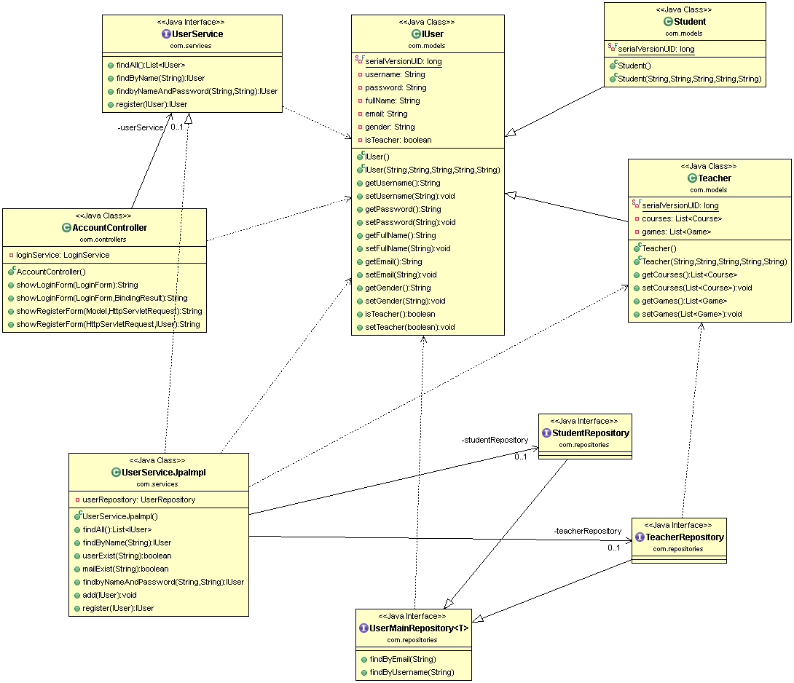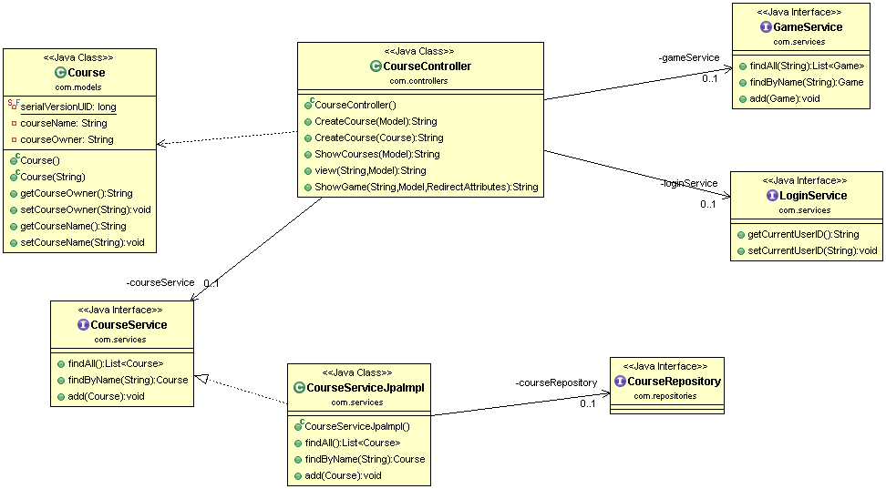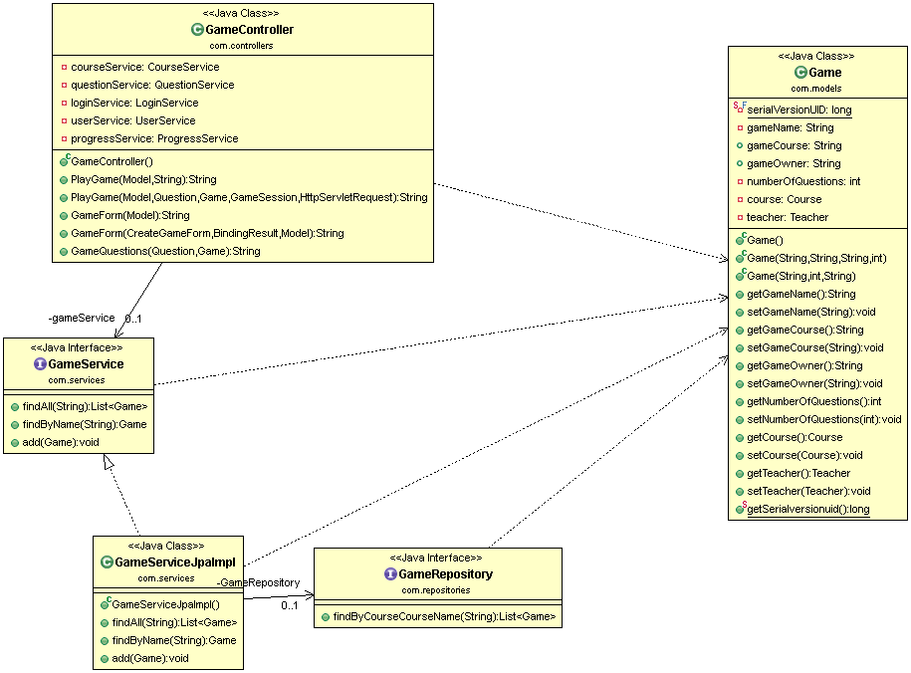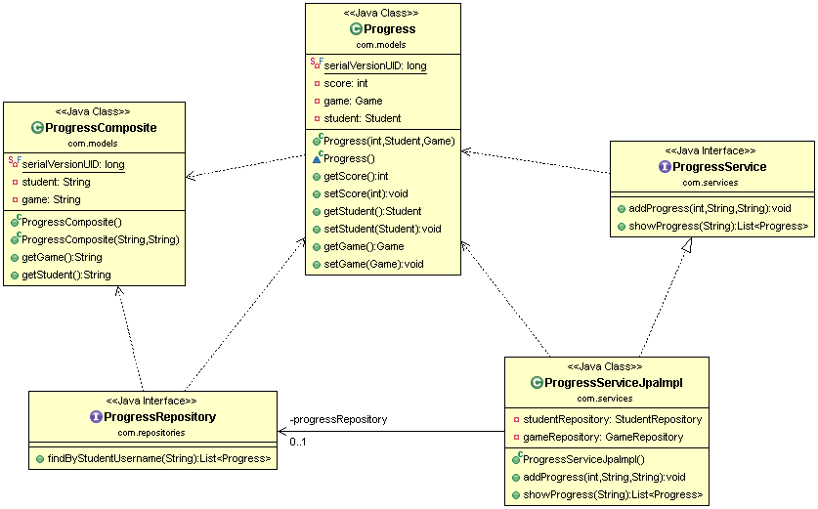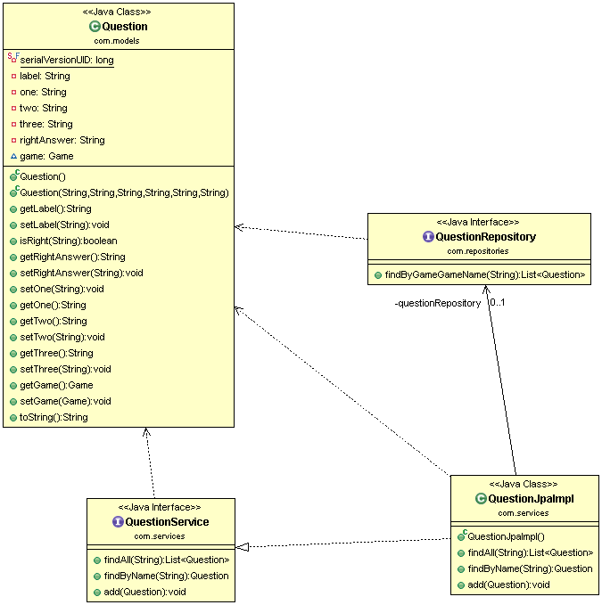

# Github repository link