Hash functions are extremely useful and appear in almost all information security applications.

A hash function is a mathematical function that converts a numerical input value into another compressed numerical value. The input to the hash function is of arbitrary length but output is always of fixed length.

Values returned by a hash function are called **message digest** or simply **hash values**. The following picture illustrated hash function −

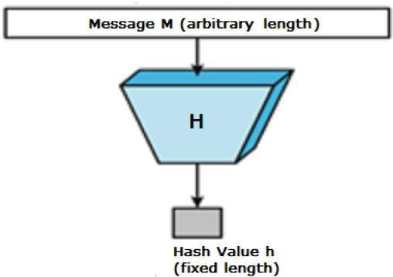

Features of Hash Functions

The typical features of hash functions are −

* **Fixed Length Output (Hash Value)**
  + Hash function coverts data of arbitrary length to a fixed length. This process is often referred to as **hashing the data**.
  + In general, the hash is much smaller than the input data, hence hash functions are sometimes called **compression functions**.
  + Since a hash is a smaller representation of a larger data, it is also referred to as a **digest**.
  + Hash function with n bit output is referred to as an **n-bit hash function**. Popular hash functions generate values between 160 and 512 bits.
* **Efficiency of Operation**
  + Generally for any hash function h with input x, computation of h(x) is a fast operation.
  + Computationally hash functions are much faster than a symmetric encryption.

Properties of Hash Functions

In order to be an effective cryptographic tool, the hash function is desired to possess following properties −

* **Pre-Image Resistance**
  + This property means that it should be computationally hard to reverse a hash function.
  + In other words, if a hash function h produced a hash value z, then it should be a difficult process to find any input value x that hashes to z.
  + This property protects against an attacker who only has a hash value and is trying to find the input.
* **Second Pre-Image Resistance**
  + This property means given an input and its hash, it should be hard to find a different input with the same hash.
  + In other words, if a hash function h for an input x produces hash value h(x), then it should be difficult to find any other input value y such that h(y) = h(x).
  + This property of hash function protects against an attacker who has an input value and its hash, and wants to substitute different value as legitimate value in place of original input value.
* **Collision Resistance**
  + This property means it should be hard to find two different inputs of any length that result in the same hash. This property is also referred to as collision free hash function.
  + In other words, for a hash function h, it is hard to find any two different inputs x and y such that h(x) = h(y).
  + Since, hash function is compressing function with fixed hash length, it is impossible for a hash function not to have collisions. This property of collision free only confirms that these collisions should be hard to find.
  + This property makes it very difficult for an attacker to find two input values with the same hash.
  + Also, if a hash function is collision-resistant **then it is second pre-image resistant.**

Design of Hashing Algorithms

At the heart of a hashing is a mathematical function that operates on two fixed-size blocks of data to create a hash code. This hash function forms the part of the hashing algorithm.

The size of each data block varies depending on the algorithm. Typically the block sizes are from 128 bits to 512 bits. The following illustration demonstrates hash function −

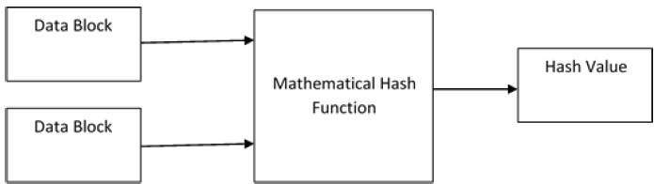

Hashing algorithm involves rounds of above hash function like a block cipher. Each round takes an input of a fixed size, typically a combination of the most recent message block and the output of the last round.

This process is repeated for as many rounds as are required to hash the entire message. Schematic of hashing algorithm is depicted in the following illustration −

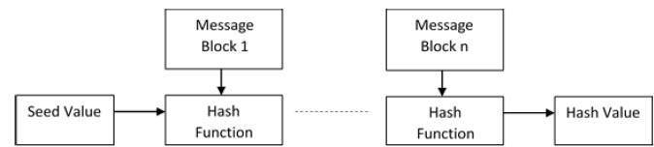

Since, the hash value of first message block becomes an input to the second hash operation, output of which alters the result of the third operation, and so on. This effect, known as an **avalanche** effect of hashing.

Avalanche effect results in substantially different hash values for two messages that differ by even a single bit of data.

Understand the difference between hash function and algorithm correctly. The hash function generates a hash code by operating on two blocks of fixed-length binary data.

Hashing algorithm is a process for using the hash function, specifying how the message will be broken up and how the results from previous message blocks are chained together.

Popular Hash Functions

Let us briefly see some popular hash functions −

Message Digest (MD)

MD5 was most popular and widely used hash function for quite some years.

* The MD family comprises of hash functions MD2, MD4, MD5 and MD6. It was adopted as Internet Standard RFC 1321. It is a 128-bit hash function.
* MD5 digests have been widely used in the software world to provide assurance about integrity of transferred file. For example, file servers often provide a pre-computed MD5 checksum for the files, so that a user can compare the checksum of the downloaded file to it.
* In 2004, collisions were found in MD5. An analytical attack was reported to be successful only in an hour by using computer cluster. This collision attack resulted in compromised MD5 and hence it is no longer recommended for use.

Secure Hash Function (SHA)

Family of SHA comprise of four SHA algorithms; SHA-0, SHA-1, SHA-2, and SHA-3. Though from same family, there are structurally different.

* The original version is SHA-0, a 160-bit hash function, was published by the National Institute of Standards and Technology (NIST) in 1993. It had few weaknesses and did not become very popular. Later in 1995, SHA-1 was designed to correct alleged weaknesses of SHA-0.
* SHA-1 is the most widely used of the existing SHA hash functions. It is employed in several widely used applications and protocols including Secure Socket Layer (SSL) security.
* In 2005, a method was found for uncovering collisions for SHA-1 within practical time frame making long-term employability of SHA-1 doubtful.
* SHA-2 family has four further SHA variants, SHA-224, SHA-256, SHA-384, and SHA-512 depending up on number of bits in their hash value. No successful attacks have yet been reported on SHA-2 hash function.
* Though SHA-2 is a strong hash function. Though significantly different, its basic design is still follows design of SHA-1. Hence, NIST called for new competitive hash function designs.
* In October 2012, the NIST chose the Keccak algorithm as the new SHA-3 standard. Keccak offers many benefits, such as efficient performance and good resistance for attacks.

RIPEMD

The RIPEMD is an acronym for RACE Integrity Primitives Evaluation Message Digest. This set of hash functions was designed by open research community and generally known as a family of European hash functions.

* The set includes RIPEMD, RIPEMD-128, and RIPEMD-160. There also exist 256, and 320-bit versions of this algorithm.
* Original RIPEMD (128 bit) is based upon the design principles used in MD4 and found to provide questionable security. RIPEMD 128-bit version came as a quick fix replacement to overcome vulnerabilities on the original RIPEMD.
* RIPEMD-160 is an improved version and the most widely used version in the family. The 256 and 320-bit versions reduce the chance of accidental collision, but do not have higher levels of security as compared to RIPEMD-128 and RIPEMD-160 respectively.

Whirlpool

This is a 512-bit hash function.

* It is derived from the modified version of Advanced Encryption Standard (AES). One of the designer was Vincent Rijmen, a co-creator of the AES.
* Three versions of Whirlpool have been released; namely WHIRLPOOL-0, WHIRLPOOL-T, and WHIRLPOOL.

Applications of Hash Functions

There are two direct applications of hash function based on its cryptographic properties.

Password Storage

Hash functions provide protection to password storage.

* Instead of storing password in clear, mostly all logon processes store the hash values of passwords in the file.
* The Password file consists of a table of pairs which are in the form (user id, h(P)).
* The process of logon is depicted in the following illustration −

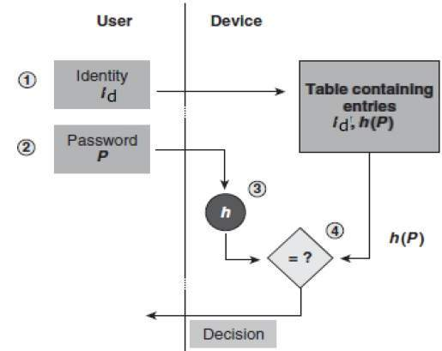

* An intruder can only see the hashes of passwords, even if he accessed the password. He can neither logon using hash nor can he derive the password from hash value since hash function possesses the property of pre-image resistance.

Data Integrity Check

Data integrity check is a most common application of the hash functions. It is used to generate the checksums on data files. This application provides assurance to the user about correctness of the data.

The process is depicted in the following illustration −

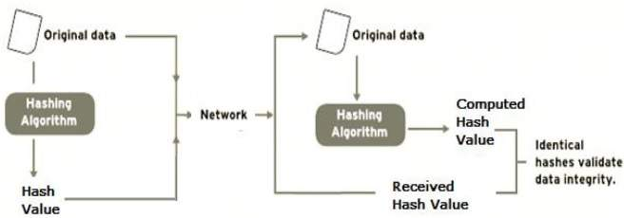

The integrity check helps the user to detect any changes made to original file. It however, does not provide any assurance about originality. The attacker, instead of modifying file data, can change the entire file and compute all together new hash and send to the receiver. This integrity check application is useful only if the user is sure about the originality of file.