**What is Private-Key Cryptography?**

Private key cryptography also known as symmetric-key cryptography is an encryption method in which a single key is used to encrypt and decrypt data. This key is kept secret between the sender and receiver and is used to encrypt and decrypt messages. Private key encryption is widely used to secure communications over the Internet because it ensures that only the intended recipient can read the message.

* In private key cryptography, to encrypt a message, the sender uses a key to scramble the plaintext into ciphertext. Cipher text can only be decrypted with the same key, known only to the sender and receiver.
* Although private key encryption is useful for secure communications, it has some limitations. One of the biggest limitations is key distribution. Since the same key is used for encryption and decryption, both the sender and receiver must have the key. This can be difficult to achieve, especially when communicating with multiple parties.
* To overcome this limitation, public key cryptography was developed. Public key cryptography, also known as asymmetric key cryptography, uses two keys (public and private) to encrypt and decrypt data. The public key is used for encryption and the private key is used for decryption. It allows users to communicate securely without sharing keys.

**Why Do We Need Private-Key Cryptography?**

Private key cryptography is an important part of blockchain technology because it provides a secure way to sign transactions and prove ownership of digital assets. Blockchain is a decentralized system in which multiple parties participate in transactions and ownership of digital assets can be transferred between them.

* **Ensures security and integrity of transactions:**To ensure the integrity and security of these transactions, private key cryptography is used. Each blockchain participant has a unique private key, which is used to sign transactions. When a private key is used to sign a transaction, it generates a digital signature to verify the authenticity of the transaction. This digital signature ensures that only the owner of a particular asset can transfer it, preventing unauthorized access to the asset.
* **Provides a secure way to prove ownership of digital assets:**Without private key encryption, there is no secure way to prove ownership of digital assets or verify the authenticity of transactions. This could lead to fraudulent transactions and could compromise the integrity of the blockchain system.
* **Provides anonymity of transactions:**In addition to ensuring transaction security and ownership of digital assets, private key cryptography can also provide anonymity for blockchain transactions. Since transactions are signed using private keys rather than personally identifiable information, users can remain anonymous while participating in the blockchain network.

In general, private key cryptography is essential in blockchain technology because it provides a secure and decentralized way to transfer ownership of digital assets while maintaining system integrity.

**How Does Private Key Cryptography Work?**

Private key cryptography, also known as symmetric-key cryptography, is an encryption method that uses a single key to encrypt and decrypt data. The key is kept secret and shared between the sender and receiver.

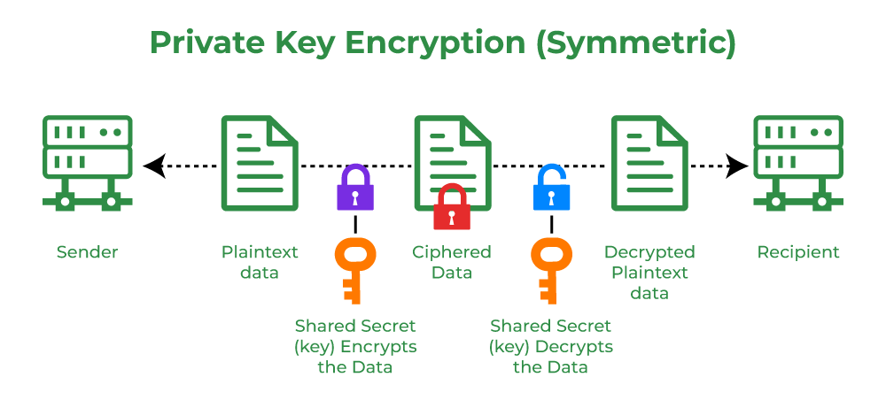

Here’s how private key encryption works:

1. **Key generation:** First, a secret key is generated. The key is a long string of random characters that are kept secret by the sender and receiver.
2. **Encryption:**To encrypt a message, the sender uses a key to scramble the plaintext into ciphertext. The sender then sends the ciphertext to the receiver.
3. **Decryption:** To decrypt the ciphertext, the recipient uses the same key that was used to encrypt the message. The receiver applies the reverse operation of the encryption algorithm to the ciphertext to recover the original plaintext message.

Private key cryptography provides security because the key is kept secret between the sender and receiver. Anyone intercepting the ciphertext cannot decrypt it without knowing the key. This means that private key cryptography can be used to ensure message confidentiality.

**Benefits of Private Key Cryptography**

Private key cryptography is an important part of blockchain technology, and it has several advantages that make it an invaluable tool for securing the network and enabling secure transactions. Here are some key benefits of private key cryptography in the blockchain context:

1. **Secure Transactions:**Private key cryptography guarantees the authenticity and integrity of transactions by providing a secure way to sign transactions and ownership of digital assets. Proof that transactions signed with a private key are verified by the blockchain network, preventing fraudulent transactions and ensuring that only the rightful owner can transfer digital assets.
2. **Hack Prevention:** Private key encryption protects blockchain networks from hacking and unauthorized access to digital assets. Each blockchain participant has a unique private key that is used to sign transactions, making it difficult for hackers to gain access to the network or steal digital assets.
3. **Anonymity:**Private key encryption provides anonymity to blockchain transactions by allowing users to remain anonymous while participating in the blockchain network. Transactions are signed using private keys rather than personally identifiable information to ensure user privacy.
4. **Scalability:** Compared to other encryption methods, private key encryption is relatively fast and suitable for expanding blockchain networks. Private key cryptography can be used to secure and process large volumes of transactions, allowing blockchain networks to scale and support growing numbers of users and transactions.

In general, private key cryptography is an important tool for securing blockchain networks, enabling secure transactions, preventing hacking attacks, and ensuring the integrity of blockchain systems.

**Limitations of Private Key Cryptography**

Private key cryptography, also known as symmetric-key cryptography, has several limitations that can make it difficult to use in some situations. Here are some key limitations of private key cryptography:

1. **Key distribution:**One of the most important limitations of private key cryptography is key distribution. To communicate securely using private key cryptography, both sender and receiver must have access to the same key. This can be difficult when communicating with many different parties, especially when the parties are geographically dispersed.
2. **Key management:** Private key encryption requires secure key management to prevent unauthorized access to keys.  
   If the key is compromised, it can be used to decrypt messages and access sensitive information. This requires the use of secure key management practices and infrastructure, which can be expensive and difficult to implement.
3. **Lack of forward secrecy:**Private key encryption does not provide forward secrecy, which means that if the key is compromised, all past and future communications can be decrypted. This contrasts with public-key cryptography, which provides forward secrecy by using a temporary session key for each transaction.
4. **Limited authentication:** Private key encryption provides limited authentication because the same key is used for encryption and decryption.  
   This means that anyone with access to the key can decrypt the message, which can be problematic in situations where a high level of authentication is required.
5. **Vulnerable to key length attacks:**Private key encryption is vulnerable to key length attacks, where an attacker tries to guess the key by brute force. This can be mitigated by using longer key lengths, but it also increases processing time and overhead.

In general, private key cryptography has several limitations that can make it difficult to use in some situations. Although it is an important tool for securing communications and transactions, it is important to be aware of its limitations and to use encryption methods appropriate to the situation.

**Applications of Private Key Cryptography:**

Private key cryptography has a multitude of applications that go beyond technology.

**1) Secure Communication:**Private key cryptography is utilized in forms of communication, such, as email exchanges secure messaging applications and virtual private networks (VPNs). Its purpose is to encrypt messages and data in such a way that only the intended recipient with the corresponding key can decrypt and access the content.

**2) Digital Signatures:** Private key cryptography plays a role in creating signatures. These signatures verify the authenticity and integrity of documents, contracts and transactions. This is especially important for conducting business related activities over the internet.

**3) SSL/TLS Encryption:** When you visit a website using “https ” private key cryptography comes into play. It ensures that any data exchanged between your web browser and the websites server remains encrypted. This level of security keeps information like passwords and credit card details.

**4) Security: I**n the realm of Internet of Things (IoT) devices private key cryptography is instrumental in securing communications and data exchange. It guarantees that data remains both tamper proof within networks.

**5) Software Licensing:**Software licensing relies on cryptography to generate unique license keys. These keys grant users access to features or functionalities within a software product.

**6) Two Factor Authentication (2FA):** Many 2FA systems utilize cryptography to generate one-time codes or tokens. These codes add a layer of security during login processes, for protection.

**7) Secure Boot:** Computer systems employ boot processes to guarantee that reliable software is loaded at startup thereby preventing the execution of unauthorized code.