## Secure Socket Layer Protocols

1. SSL Record Protocol
2. Handshake Protocol
3. Change-Cipher Spec Protocol
4. Alert Protocol

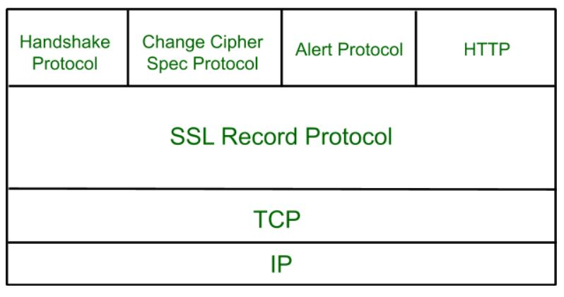

### ****SSL Record Protocol****

SSL Record provides two services to SSL connection.

* Confidentiality
* Message Integrity

In the SSL Record Protocol application data is divided into fragments. The fragment is compressed and then encrypted MAC (Message Authentication Code) generated by algorithms like SHA ([Secure Hash Protocol](https://www.geeksforgeeks.org/sha-1-hash-in-java/" \t "https://www.geeksforgeeks.org/secure-socket-layer-ssl/_blank)) and MD5 ([Message Digest](https://www.geeksforgeeks.org/what-is-the-md5-algorithm/" \t "https://www.geeksforgeeks.org/secure-socket-layer-ssl/_blank)) is appended. After that encryption of the data is done and in last SSL header is appended to the data.

### IMG_257Handshake Protocol

Handshake Protocol is used to establish sessions. This protocol allows the client and server to authenticate each other by sending a series of messages to each other. Handshake protocol uses four phases to complete its cycle.

* **Phase-1:** In Phase-1 both Client and Server send hello-packets to each other. In this IP session, cipher suite and protocol version are exchanged for security purposes.
* **Phase-2:** Server sends it certificate and Server-key-exchange. The server end phase-2 by sending the Server-hello-end packet.
* **Phase-3:** In this phase, Client replies to the server by sending it certificate and Client-exchange-key.
* **Phase-4:** In Phase-4 Change Cipher Spec occurs and after this the Handshake Protocol ends.

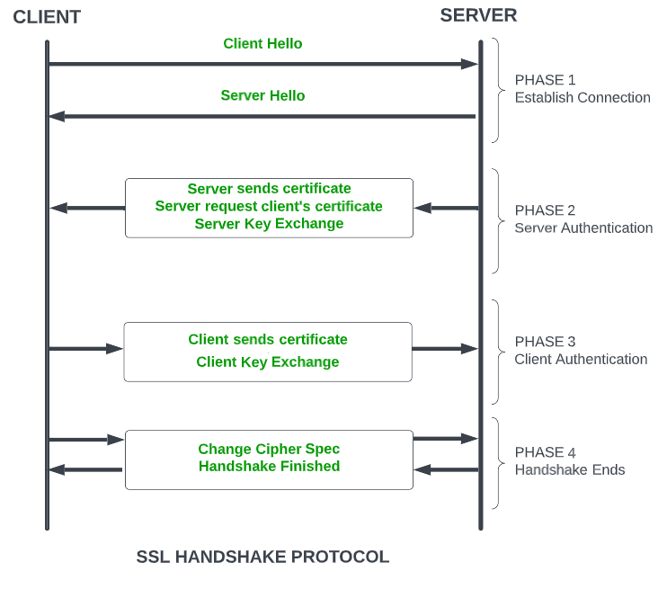SSL Handshake Protocol Phases diagrammatic representation

### Change-Cipher Protocol

This protocol uses the SSL record protocol. Unless [Handshake](https://www.geeksforgeeks.org/tcp-3-way-handshake-process/" \t "https://www.geeksforgeeks.org/secure-socket-layer-ssl/_blank)Protocol is completed, the SSL record Output will be in a pending state. After the handshake protocol, the Pending state is converted into the current state.   
Change-cipher protocol consists of a single message which is 1 byte in length and can have only one value. This protocol's purpose is to cause the pending state to be copied into the current state.

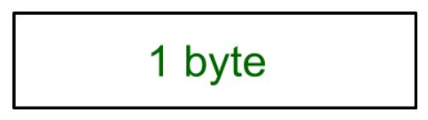

### Alert Protocol

This protocol is used to convey SSL-related alerts to the peer entity. Each message in this protocol contains 2 bytes.

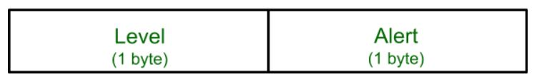

The level is further classified into two parts:

**Warning (level = 1)**  
This Alert has no impact on the connection between sender and receiver. Some of them are:

* **Bad Certificate:**When the received certificate is corrupt.
* **No Certificate:** When an appropriate certificate is not available.
* **Certificate Expired:** When a certificate has expired.
* **Certificate Unknown:** When some other unspecified issue arose in processing the certificate, rendering it unacceptable.
* **Close Notify**: It notifies that the sender will no longer send any messages in the connection.
* **Unsupported Certificate:**The type of certificate received is not supported.
* **Certificate Revoked:**The certificate received is in revocation list.

**Fatal Error (level = 2):**

This Alert breaks the connection between sender and receiver. The connection will be stopped, cannot be resumed but can be restarted. Some of them are :

* **Handshake Failure:** When the sender is unable to negotiate an acceptable set of security parameters given the options available.
* **Decompression Failure**: When the decompression function receives improper input.
* **Illegal Parameters:** When a field is out of range or inconsistent with other fields.
* **Bad Record MAC:**When an incorrect MAC was received.
* **Unexpected Message:**When an inappropriate message is received.

The second byte in the Alert protocol describes the error.

## Salient Features of Secure Socket Layer

* The advantage of this approach is that the service can be tailored to the specific needs of the given application.
* Secure Socket Layer was originated by Netscape.
* SSL is designed to make use of TCP to provide reliable end-to-end secure service.
* This is a two-layered protocol.

## ****Versions of SSL****

SSL 1 - Never released due to high insecurity  
SSL 2 - Released in 1995  
SSL 3 - Released in 1996  
TLS 1.0 - Released in 1999  
TLS  1.1 - Released in 2006  
TLS 1.2 - Released in 2008  
TLS 1.3 - Released in 2018

## SSL Certificate

SSL (Secure Sockets Layer) certificate is a digital certificate used to secure and verify the identity of a website or an online service. The certificate is issued by a trusted third-party called a Certificate Authority (CA), who verifies the identity of the website or service before issuing the certificate.

The SSL certificate has several important characteristics that make it a reliable solution for securing online transactions :

* **Encryption**: The SSL certificate uses encryption algorithms to secure the communication between the website or service and its users. This ensures that the sensitive information, such as login credentials and credit card information, is protected from being intercepted and read by unauthorized parties.
* **Authentication**: The SSL certificate verifies the identity of the website or service, ensuring that users are communicating with the intended party and not with an impostor. This provides assurance to users that their information is being transmitted to a trusted entity.
* **Integrity**: The SSL certificate uses message authentication codes (MACs) to detect any tampering with the data during transmission. This ensures that the data being transmitted is not modified in any way, preserving its integrity.
* **Non-repudiation**: SSL certificates provide non-repudiation of data, meaning that the recipient of the data cannot deny having received it. This is important in situations where the authenticity of the information needs to be established, such as in e-commerce transactions.
* **Public-key cryptography:** SSL certificates use public-key cryptography for secure key exchange between the client and server. This allows the client and server to securely exchange encryption keys, ensuring that the encrypted information can only be decrypted by the intended recipient.
* **Session management**: SSL certificates allow for the management of secure sessions, allowing for the resumption of secure sessions after interruption. This helps to reduce the overhead of establishing a new secure connection each time a user accesses a website or service.
* **Certificates issued by trusted CAs**: SSL certificates are issued by trusted CAs, who are responsible for verifying the identity of the website or service before issuing the certificate. This provides a high level of trust and assurance to users that the website or service they are communicating with is authentic and trustworthy.

In addition to these key characteristics, SSL certificates also come in various[levels of validation](https://www.namecheap.com/" \t "https://www.geeksforgeeks.org/secure-socket-layer-ssl/_blank), including Domain Validation (DV), Organization Validation (OV), and Extended Validation (EV). The level of validation determines the amount of information that is verified by the CA before issuing the certificate, with EV certificates providing the highest level of assurance and trust to users. For more information about SSL certificates for each Validation level type, please refer to [Namecheap](https://www.namecheap.com/" \t "https://www.geeksforgeeks.org/secure-socket-layer-ssl/_blank).

Overall, the SSL certificate is an important component of online security, providing encryption, authentication, integrity, non-repudiation, and other key features that ensure the secure and reliable transmission of sensitive information over the internet.

## Types of SSL Certificates

There are different types of SSL certificates, each suited for different needs:

* **Single-Domain SSL Certificate**: This type covers only one specific domain. A domain is the name of a website, like www.geeksforgeeks.org. For instance, if you have a single-domain SSL certificate for www.geeksforgeeks.org, it won't cover any other domains or subdomains.
* **Wildcard SSL Certificate**: Similar to a single-domain certificate, but it also covers all subdomains of a single domain. For example, if you have a wildcard certificate for \*.geeksforgeeks.org, it would cover www.geeksforgeeks.org, blog.www.geeksforgeeks.org, and any other subdomain under example.com.
* **Multi-Domain SSL Certificate**: This type can secure multiple unrelated domains within a single certificate.

These certificates vary in scope and flexibility, allowing website owners to choose the appropriate level of security coverage based on their needs.

SSL certificates have different validation levels, which determine how thoroughly a business or organization is vetted:

* **Domain Validation (DV)**: This is the simplest and least expensive level. To get a DV certificate, a business just needs to prove it owns the domain (like www.geeksforgeeks.org).
* **Organization Validation (OV)**: This involves a more hands-on verification process. The[Certificate Authority](https://www.geeksforgeeks.org/digital-signatures-certificates/" \t "https://www.geeksforgeeks.org/secure-socket-layer-ssl/_blank)(CA) directly contacts the organization to confirm its identity before issuing the certificate. OV certificates provide more assurance to users about the legitimacy of the organization.
* **Extended Validation (EV)**: This is the most rigorous level of validation. It requires a comprehensive background check of the organization to ensure it's legitimate and trustworthy. EV certificates are recognized by the green address bar in web browsers, indicating the highest level of security and trustworthiness.

These validation levels help users understand the level of security and trust they can expect when visiting websites secured with SSL certificates.

## Are SSL and TLS the Same thing?

SSL is the direct predecessor of TLS (Transport Layer Security). In 1999, the[Internet Engineering Task Force](https://www.geeksforgeeks.org/importance-of-internet-standardization/" \t "https://www.geeksforgeeks.org/secure-socket-layer-ssl/_blank)(IETF) proposed an update to SSL. Since this update was developed by the IETF without Netscape's involvement, the name was changed to TLS. The changes between the last version of SSL (3.0) and the first version of TLS were not significant; the name change mainly signified new ownership.

Because SSL and TLS are so similar, people often use the terms interchangeably. Some still call it SSL, while others use "SSL/TLS encryption" since SSL is still widely recognized.

## Difference Between Secure Socket Layer (SSL) and Transport Layer Security (TLS)

| **SSL** | **TLS** |
| --- | --- |
| SSL stands for Secure Socket Layer. | TLS stands for Transport Layer Security. |
| It supports the Fortezza algorithm. | It does not support the Fortezza algorithm. |
| It is the 3.0 version. | It is the 1.0 version. |
| In SSL( Secure Socket Layer), the Message digest is used to create a master secret. | In TLS(Transport Layer Security), a Pseudo-random function is used to create a master secret. |
| In SSL( Secure Socket Layer), the Message Authentication Code protocol is used. | In TLS(Transport Layer Security), Hashed Message Authentication Code protocol is used. |
| It is more complex than TLS(Transport Layer Security). | It is simple than SSL. |
| It is less secured as compared to TLS(Transport Layer Security). | It provides high security. |
| It is less reliable and slower. | It is highly reliable and upgraded. It provides less latency. |
| It has been depreciated. | It is still widely used. |
| It uses port to set up explicit connection. | It uses protocol to set up implicit connection. |